LAB 7
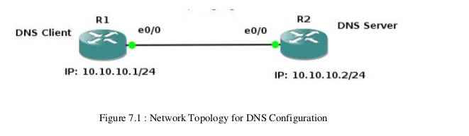
LAB EXERCISES

1. Configure the below topology to setup DNS server. R1 will use R2 as DNS server to make
DNS resolutions.
First, lets begin with R1. We’ll setup hostname and IP related information.

R1 IP configurations:
Enable
configure terminal
hostname R1
interface e0/0
ip address 10.10.10.1 255.255.255.0
no shut
do wr
end

R2 IP and Hostname Configurations:
enable
config t
hostname R2
int e0/0
ip address 10.10.10.2 255.255.255.0
no shut
do wr
end
Setting up R2 as DNS Server

config t
ip dns server
ip host loopback.R2.com 2.2.2.2

We mapped loopback.R2.com to ip address 2.2.2.2. Currently, we don’t have 2.2.2.2, we could
create loopback interface on R2 and assign ip 2.2.2.2.
interface loopback 1

ip address 2.2.2.2 255.255.255.255
end

Let’s verify that loopback interface we just created is working. This will show us that the
hostname correctly setup locally on R2.

ping loopback.R2.com
Now it’s time to setup R1 to resolve hostnames using R2. On R1 type;
config terminal
ip domain lookup
ip name-server 10.10.10.2

Set R1 to use R2 as default gateway to get to loopback interface on R2. So that after R1
resolves loopback.R2.com, it can reach 2.2.2.2 through its default route (R2).
on R1 type:

config t
ip route 0.0.0.0 0.0.0.0 10.10.10.2
end
This tells our router that to get to any network not in it’s routing table, it’s next hop is 10.10.10.2
which is our router R2.
Now on R1, do a ping to loopback.R2.com and you should get a success message.

ping loopback.R2.com repeat 3

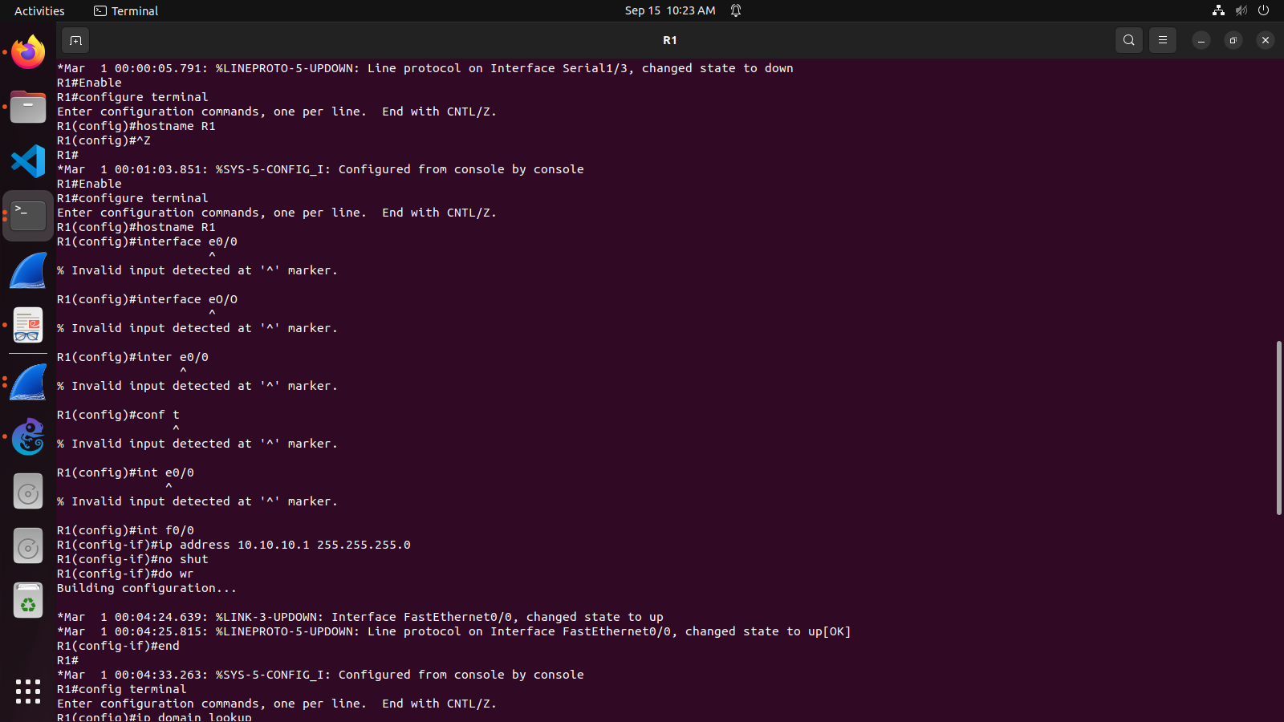

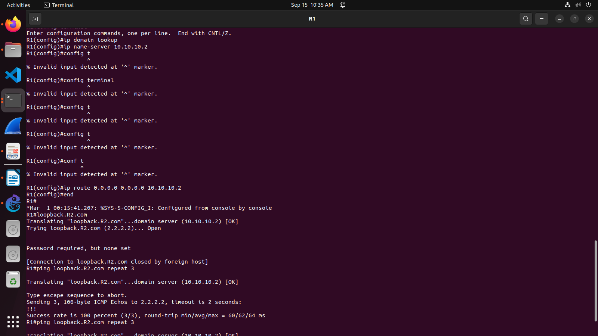
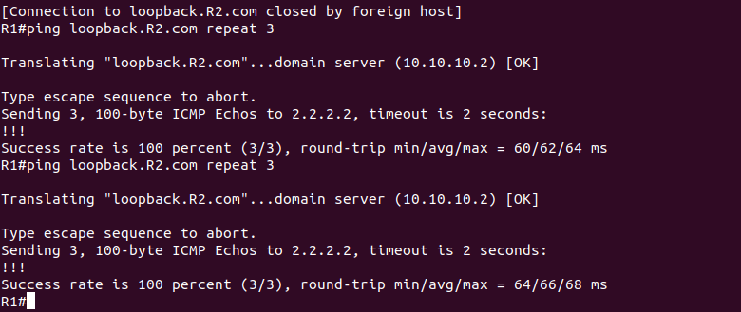
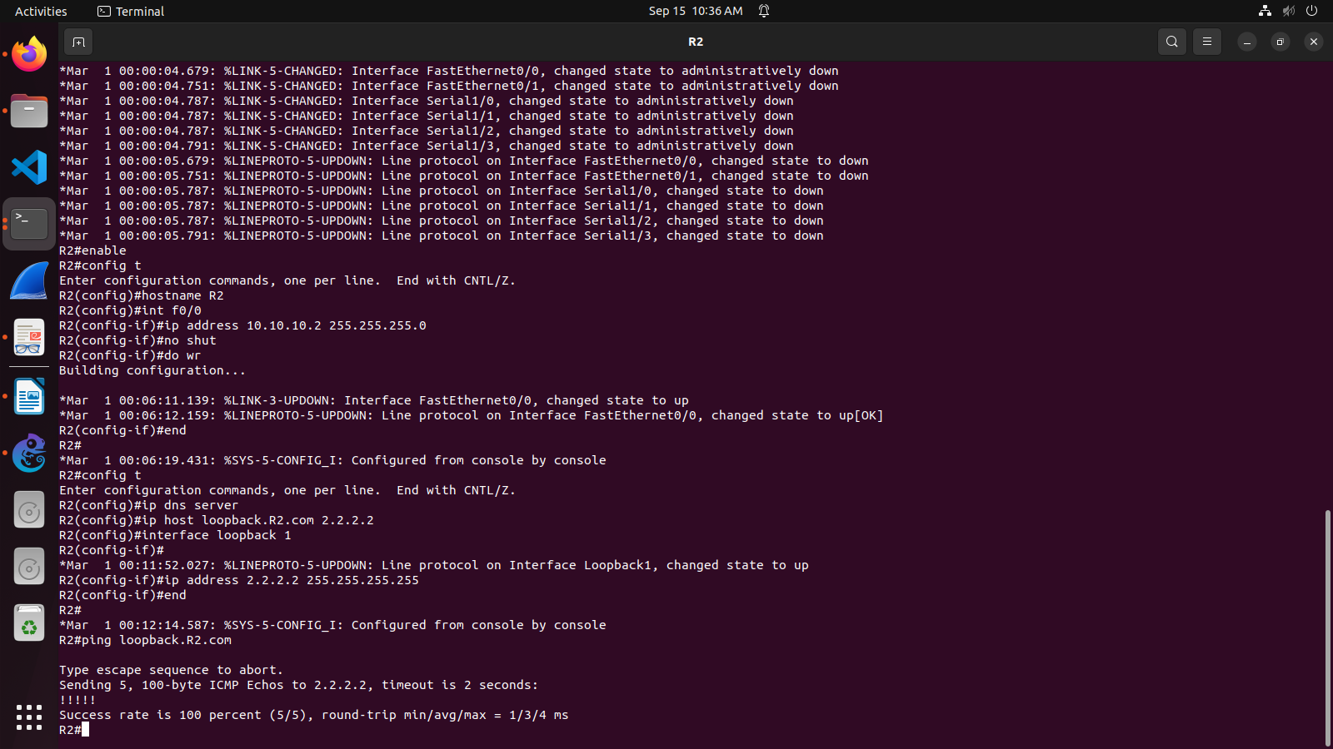
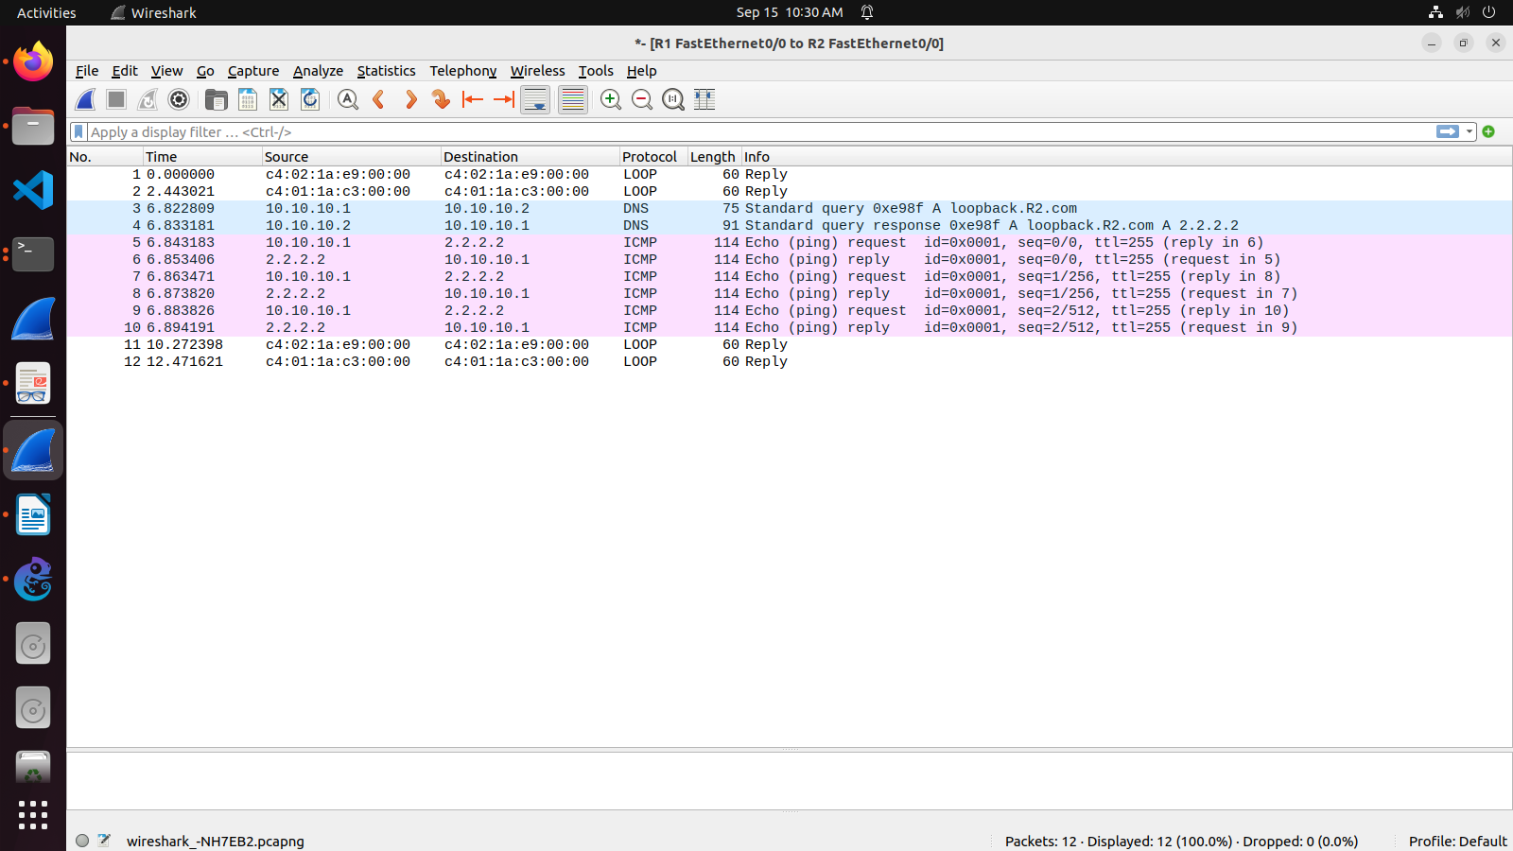

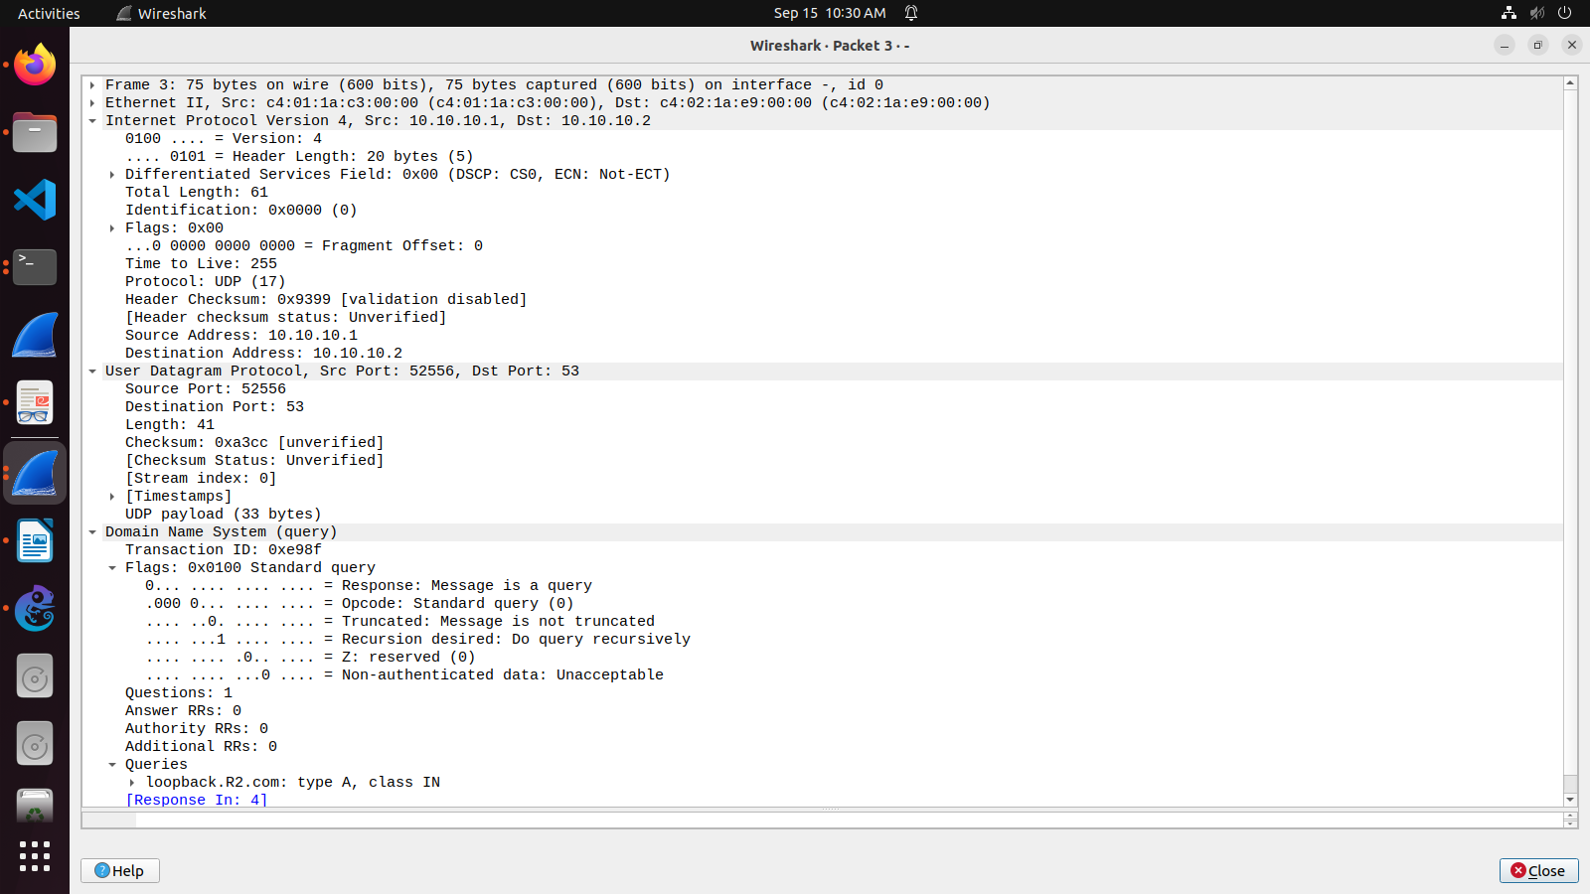
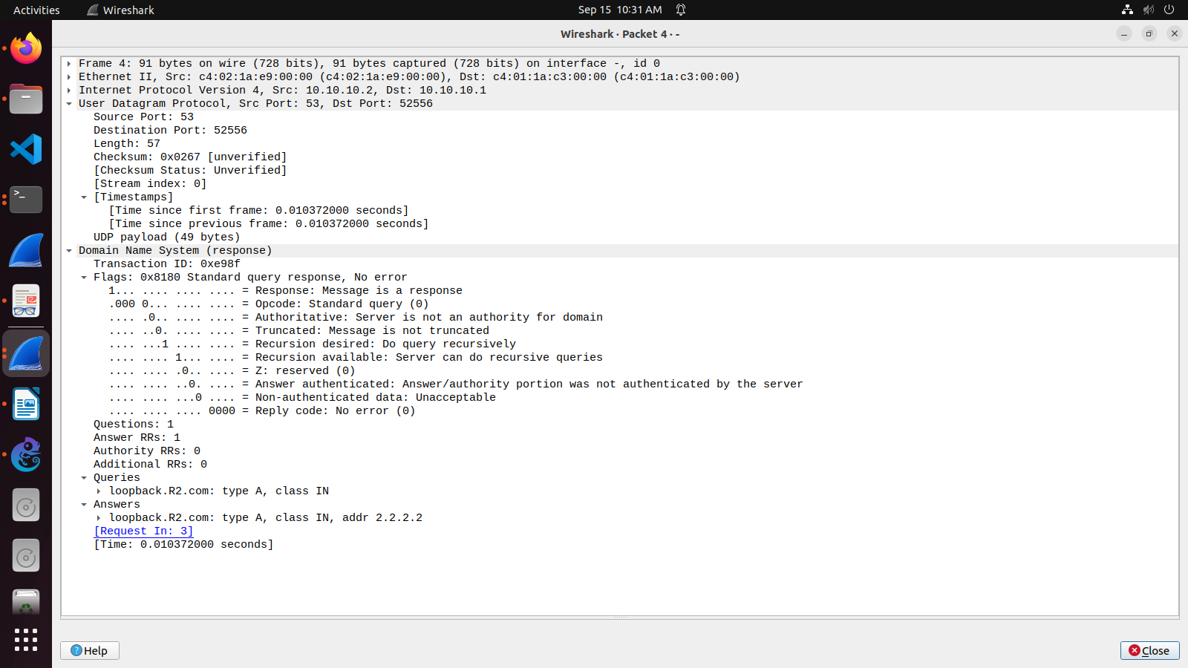

III. LAB EXERCISE
Suppose you are connecting to www.mycsemit.com to read a page, you are a user sitting at a client's machine. You can access the www.mycsemit.com web server. The server machine finds the page you requested and sends it to you.
Build a scenario using GNS3 to demonstrate the interaction of the DNS Server and DNS Client. Place DNS Server behind two routers.

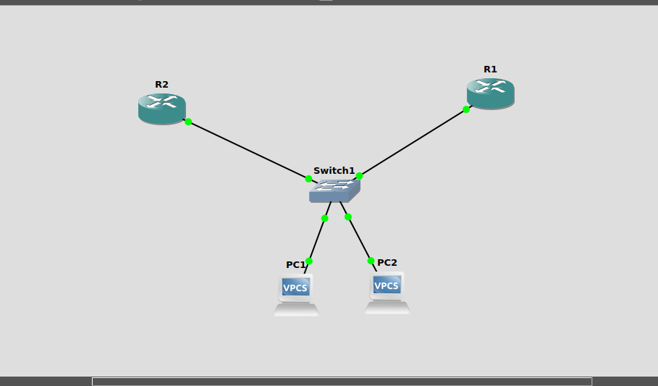

CONFIGURING PC’s

PC1

ip 10.0.0.1/8 10.255.255.254
ip dns 30.0.0.2

PC2

ip 10.0.0.2/8 10.255.255.254
ip dns 30.0.0.2

CONFIGURING ROUTER’s

R1

config t
int f0/1
ip address 10.255.255.254 255.0.0.0
no shut
end

config t
int f0/0
ip address 20.0.0.1 255.0.0.0
no shut
do wr
end

config t
ip domain lookup
ip name-server 20.0.0.2
ip route 30.0.0.0 255.0.0.0 20.0.0.2
end

R2

config t
int f0/0
ip address 20.0.0.2 255.0.0.0
no shut
do wr
end

config t
int f0/1
ip address 30.0.0.1 255.0.0.0
no shut
do wr
end

config t
ip domain lookup
ip name-server 30.0.0.2
ip route 30.0.0.0 255.0.0.0 30.0.0.2
ip route 10.0.0.0 255.0.0.0 20.0.0.1
end

PING COMMANDS

ping pc1.ronzz.com
ping pc2.ronzz.com

Pinging from PC1 to PC2 and Viceversa using DNS Name sends DNS Query and gets DNS Response.

