LAB 10

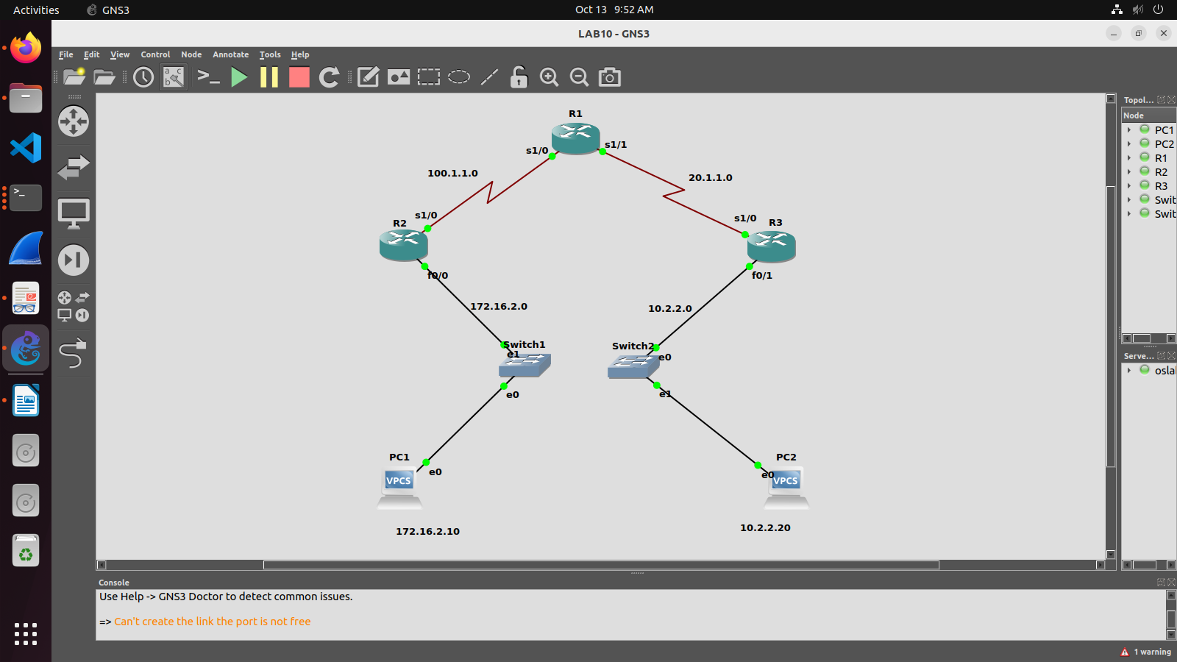
LAB EXERCISE:
Configure the below topology to setup connectivity using RIPv2. R1, R2, and R3 will use dynamic routing protocol (RIPv2).

Configuration for R1
R1#conf t
R1(config)#int s1/0
R1(config-if)#ip add 100.1.1.2 255.255.255.0
R1(config-if)#no shut
R1(config-if)#int s1/1
R1(config-if)#ip address 20.1.1.1 255.255.255.0
R1(config-if)#no shut
R1(config-if)#exit
R1(config)#router rip
R1(config-router)#version 2
R1(config-router)#network 20.1.1.0
R1(config-router)#network 100.1.1.0

Configuration for R2
R2#config t
R2(config)#int f1/0
R2(config-if)#ip address 172.16.2.1 255.255.0.0
R2(config-if)#no shut
R2(config-if)#int s2/0
R2(config-if)#ip address 100.1.1.1 255.255.255.0
R2(config-if)#no shut
R2(config-if)#exit
R2(config)#router rip
R2(config-router)#version 2
R2(config-router)#network 172.16.0.0
R2(config-router)#network 100.1.1.0

Configuration for R3
R3#config t
R3(config)#int s2/0
R3(config-if)#ip add 20.1.1.2 255.255.255.0
R3(config-if)#no shut
R3(config-if)#int f1/0
R3(config-if)#ip add 10.2.2.1 255.255.255.0
R3(config-if)#no shut
R3(config-if)#exit
R3(config)#router rip
R3(config-router)#ver 2
R3(config-router)#network 10.2.2.0
R3(config-router)#network 20.1.1.0

RIP Verification:
show ip route command should display all RIP networks and end to end ping should be successful.
show ip protocol command should display if necessary, ports are active.
show ip rip database command should displays the contents of RIP database inside the router.
debug ip rip command shows RIP updates occurring in the system undebug all Once you turn on
debug ip rip router will keep showing RIP updates. The command undebug all will stop such RIP updates.
show running-config command is used to get the current configuration from the Router.

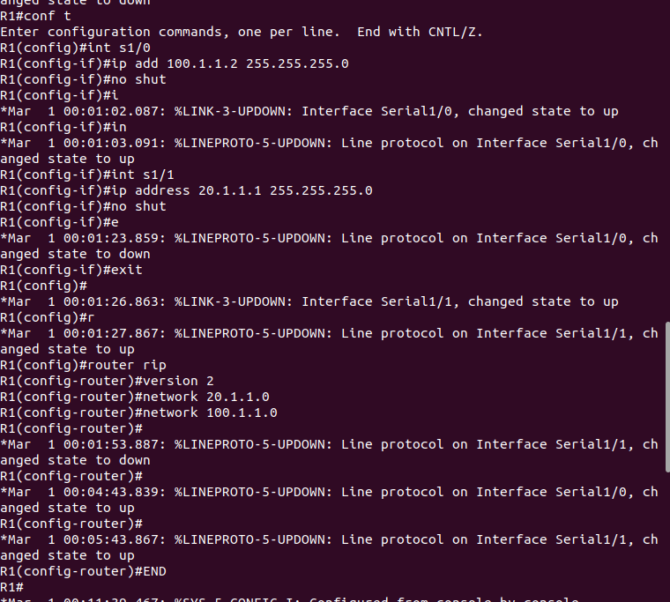
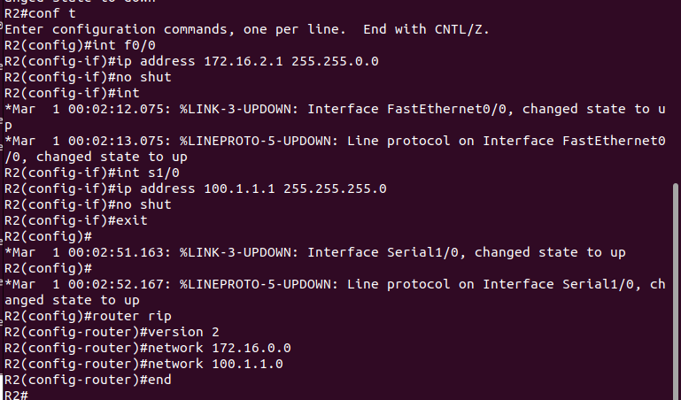
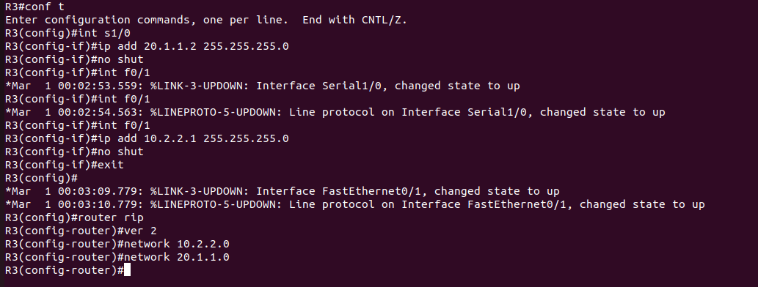
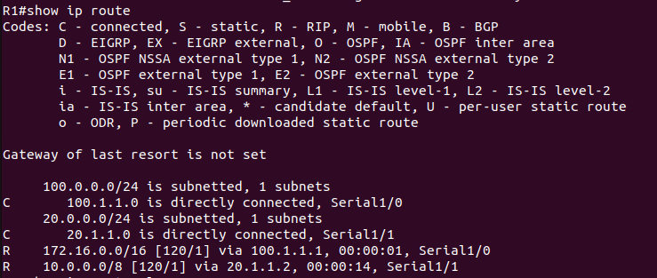
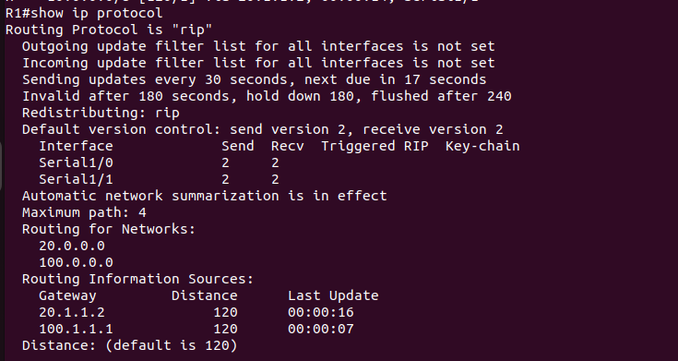
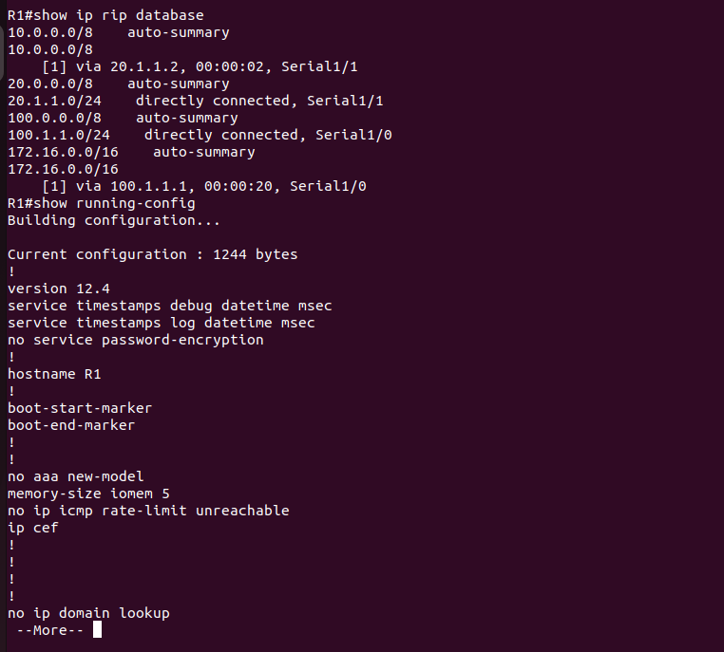
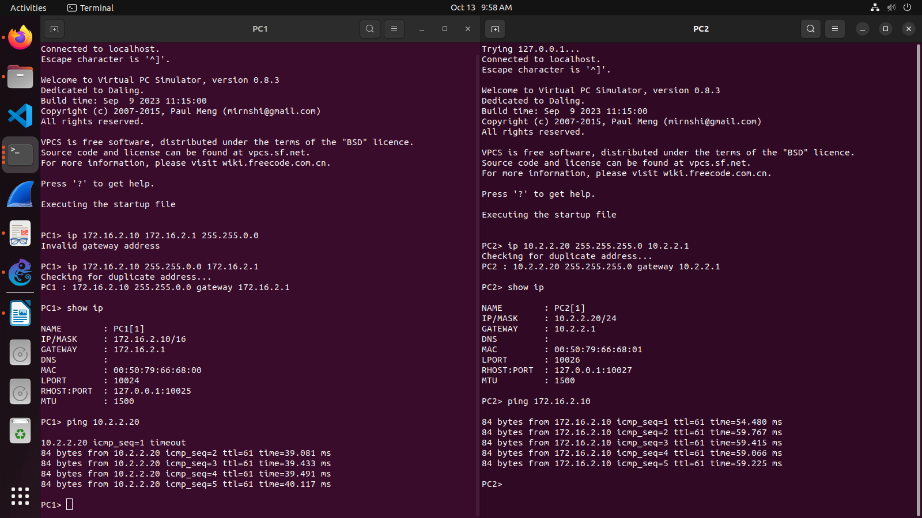

LAB EXERCISE:
Configure the below topology to setup connectivity using RIPv2. R1, R2, and R3 will use dynamic routing protocol (OSPF).

Configuration for R1
R1(config)#router ospf 200
R1(config-router)#network 10.0.0.0 0.255.255.255 area 0
R1(config-router)#network 192.168.1.0 0.0.0.255 area 0.0.0.0
R1(config-router)#exit

Configuration for R2
R2(config)#router ospf 200
R2(config-router)#network 20.0.0.0 0.255.255.255 area 0
R2(config-router)#network 192.168.1.0 0.0.0.255 area 0
R2(config-router)#network 150.150.150.0 0.0.0.255 area 1
R2(config-router)#exit
R2(config)#exit

Configuration for R3
R3(config)#router ospf 200
R3(config-router)#network 150.150.150.0 0.0.0.255 area 1
R3(config-router)#exit
R3(config)#exit

OSPF Verification:
show ip route
show ip ospf neighbor
show ip ospf database

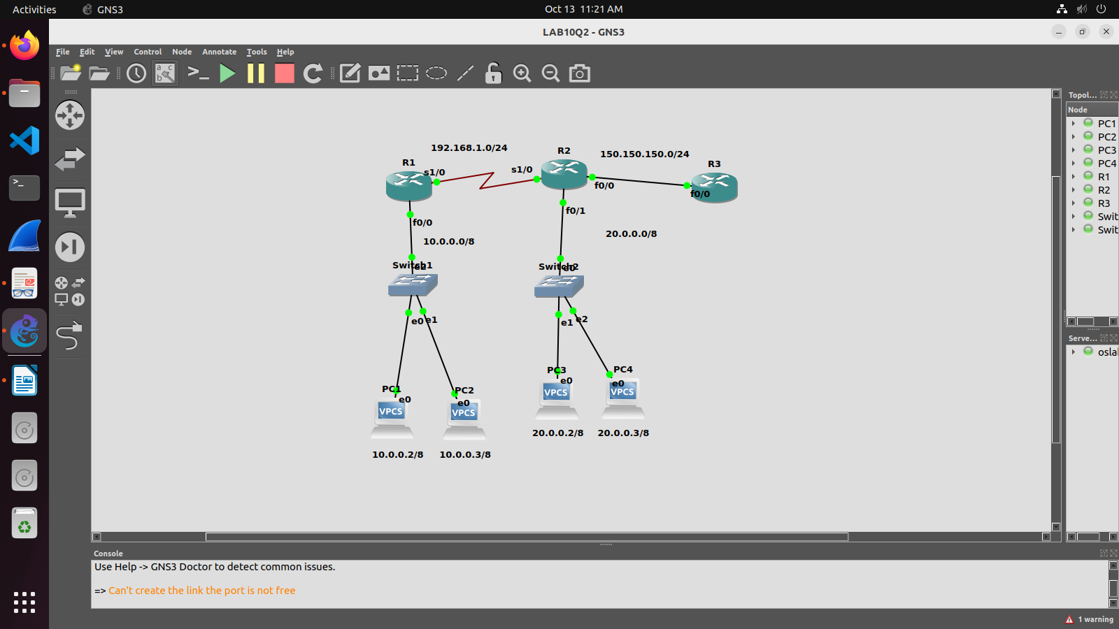
PINGING SUCCESSFUL !!!

