LAB 8

Ques1)
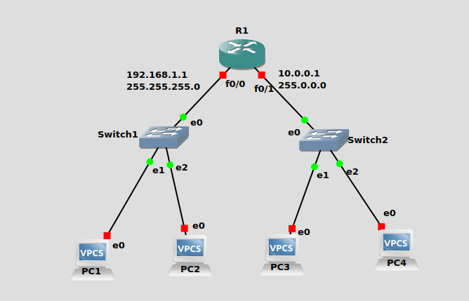

Configuring Router : -

conf t
ip dhcp pool LINUX-LAB
network 192.168.1.0 255.255.255.0
default-router 192.168.1.1
exit

ip dhcp pool DBS-LAB
network 10.0.0.0 255.0.0.0
default-router 10.0.0.1
exit

int f0/0
ip address 192.168.1.1 255.255.255.0
no shut
exit

int f0/1
ip address 10.0.0.1 255.0.0.0
no shut
exit
do wr

Ques2)

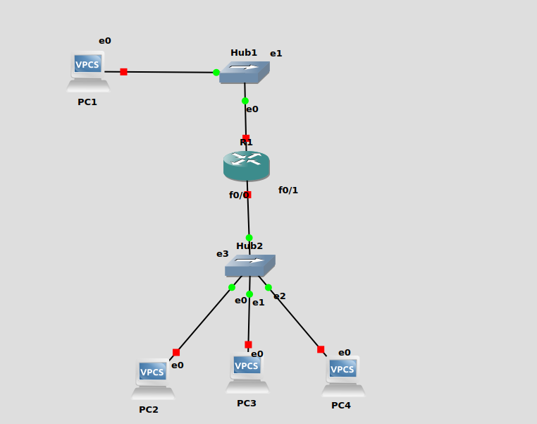
Configuring PC’s : -

PC1 : - ip 10.0.1.10/24 10.0.1.1
PC2 : - ip 10.0.2.10/24 10.0.2.138
PC3 : - ip 10.0.2.137/29 10.0.2.138
PC4 : - ip 10.0.2.139/24 10.0.2.138

Configuring Router : -

conf t
int f0/0
ip address 10.0.1.1 255.255.255.0
no shut
exit
int f0/1
ip address 10.0.2.138 255.255.255.0
no shut
exit
do wr

