Lab 6
QUESTION 1

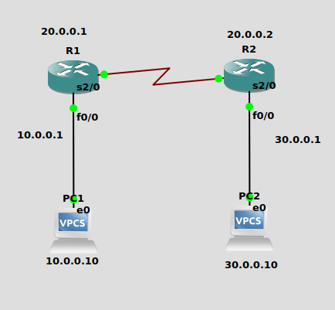

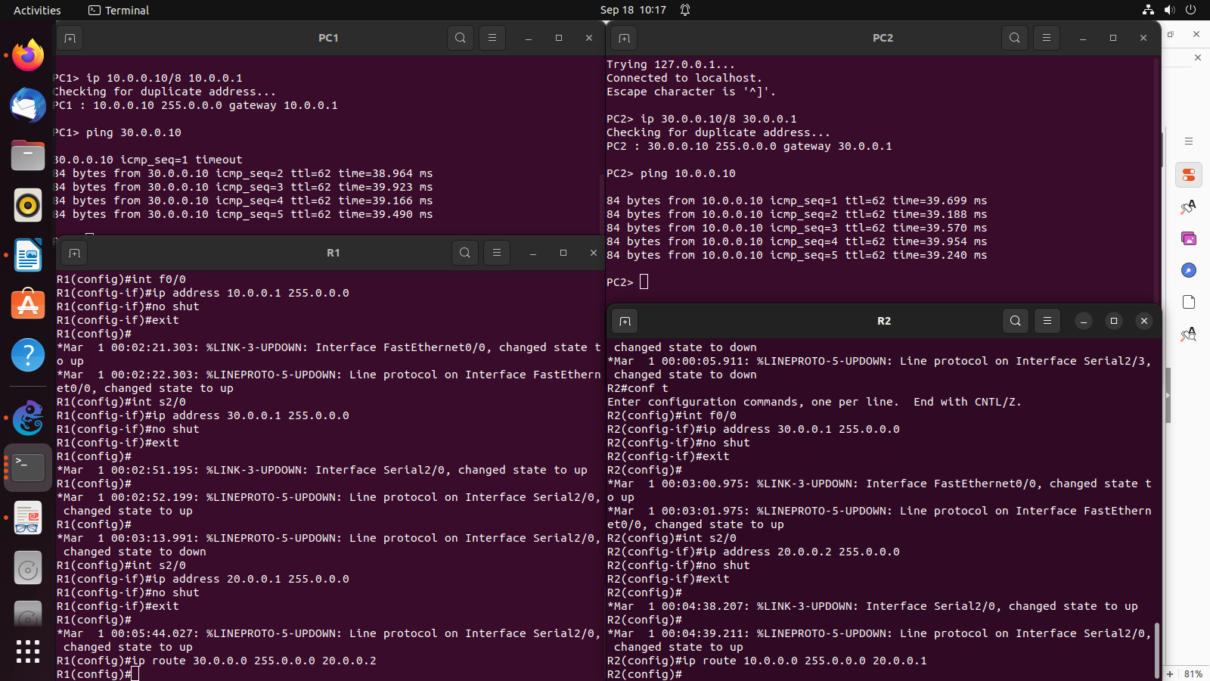
everything done in the screenshot

QUESTION 2 (GIVEN BY SIR)
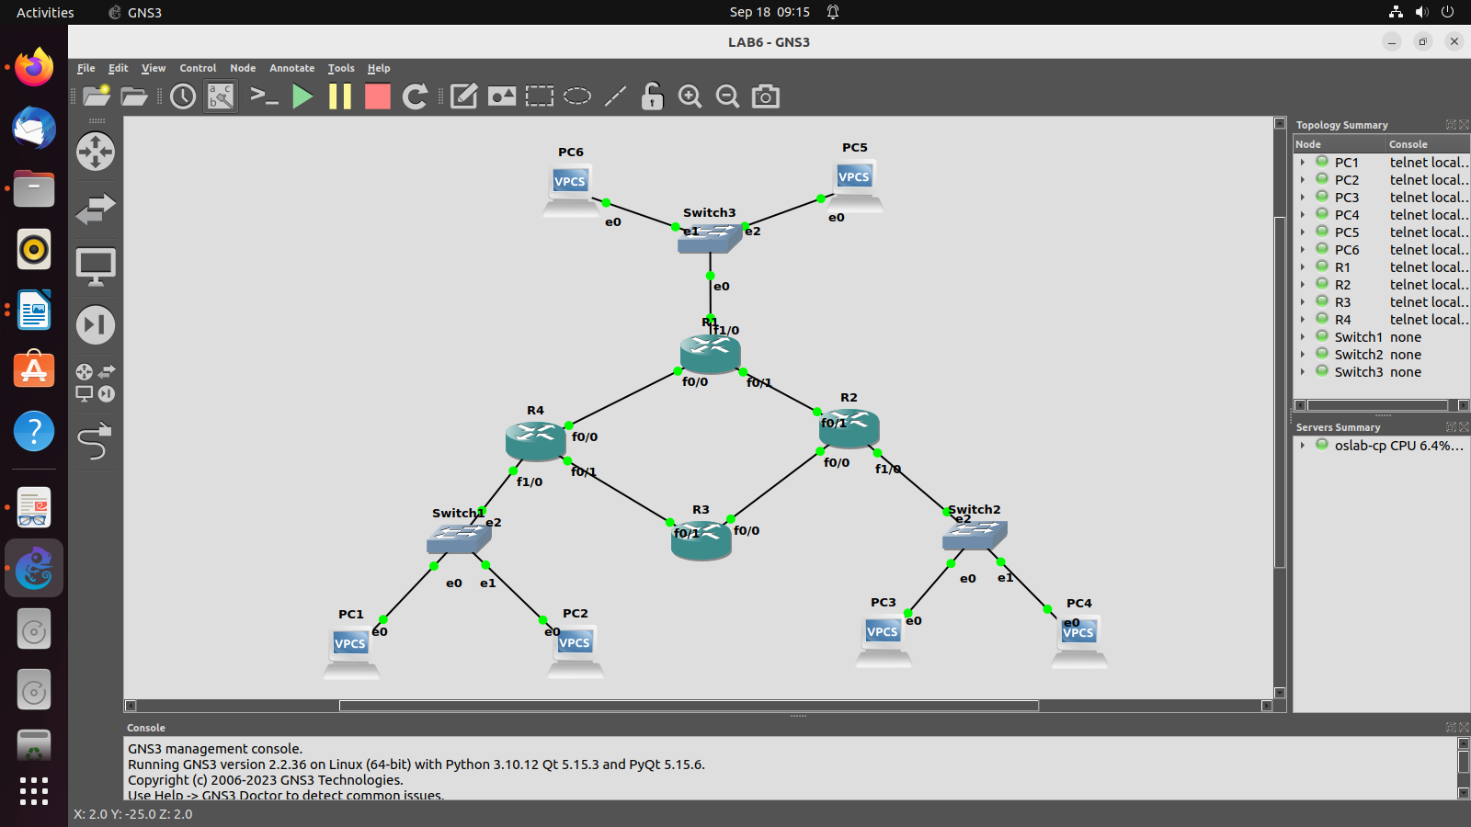

Configure IP addresses and Gateway address:

-->PC1:
ip 30.0.0.1/8 30.255.255.254

-->PC2:
ip 30.0.0.2/8 30.255.255.254

-->PC3:

ip 172.16.0.1/16 172.16.255.254

-->PC4:

ip 172.16.0.2/16 172.16.255.254

-->PC5:

ip 192.168.1.1/24 192.168.1.254

-->PC6:
ip 192.168.1.2/24 192.168.1.254

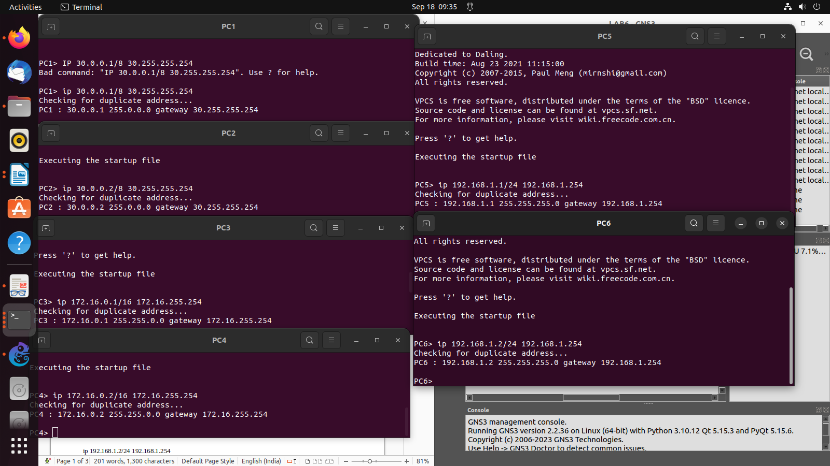

Configure Routers:
-->R4:

conf t
inter f1/0
ip address 30.255.255.254 255.0.0.0
no shutdown
exit

inter f0/0
ip address 10.0.0.1 255.0.0.0
no shutdown
exit

inter f0/1
ip address 20.0.0.1 255.0.0.0
no shutdown

-->R3:

conf t
inter f0/1
ip address 20.0.0.2 255.0.0.0
no shutdown
exit

inter f0/0
ip address 50.0.0.2 255.0.0.0
no shutdown

-->R2:

conf t
inter f1/0
ip address 172.16.255.254 255.255.0.0
no shutdown
exit

inter f0/0
ip address 50.0.0.1 255.0.0.0
no shutdown
exit

inter f0/1
ip address 40.0.0.1 255.0.0.0
no shutdown

-->R1:

conf t
inter f1/0
ip address 192.168.1.254 255.255.255.0
no shutdown
exit

inter f0/1
ip address 40.0.0.2 255.0.0.0
no shutdown
exit

inter f0/0
ip address 10.0.0.2 255.0.0.0
no shutdown

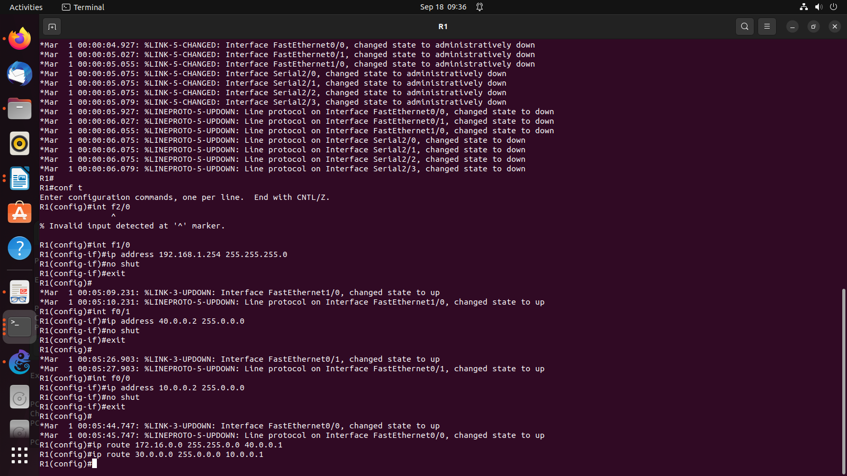

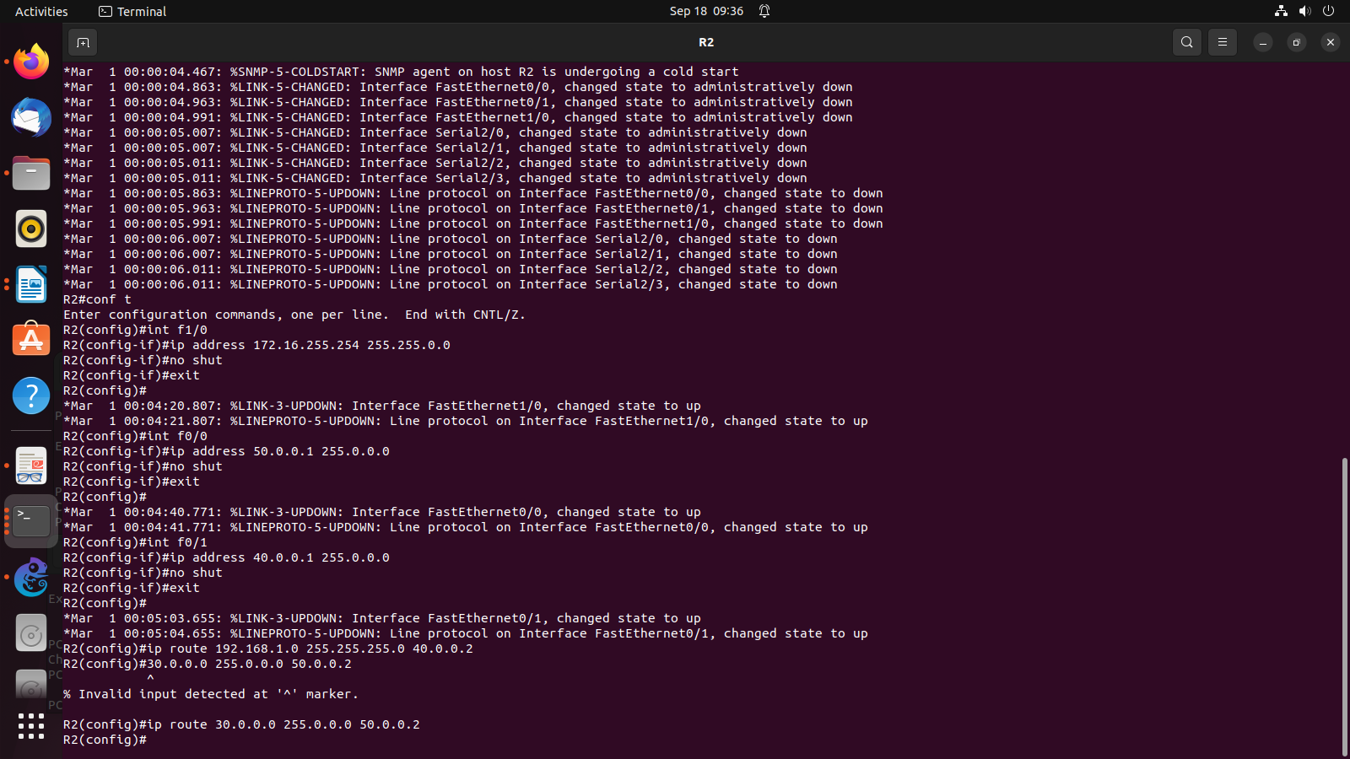
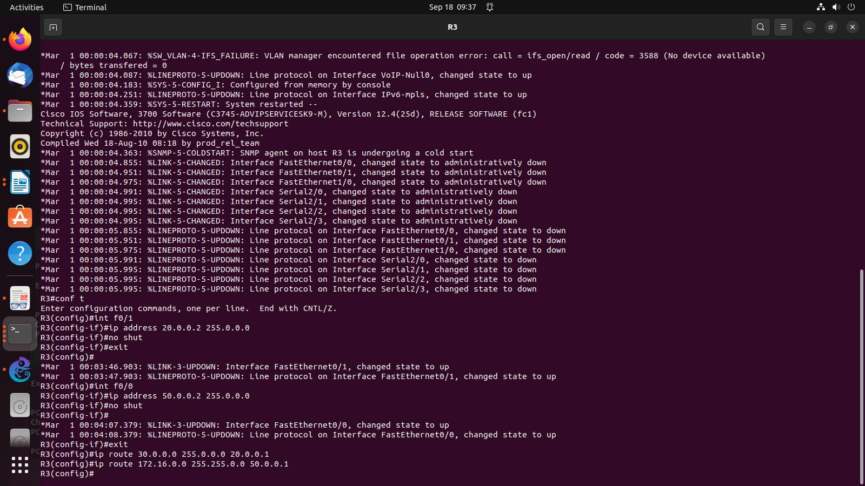
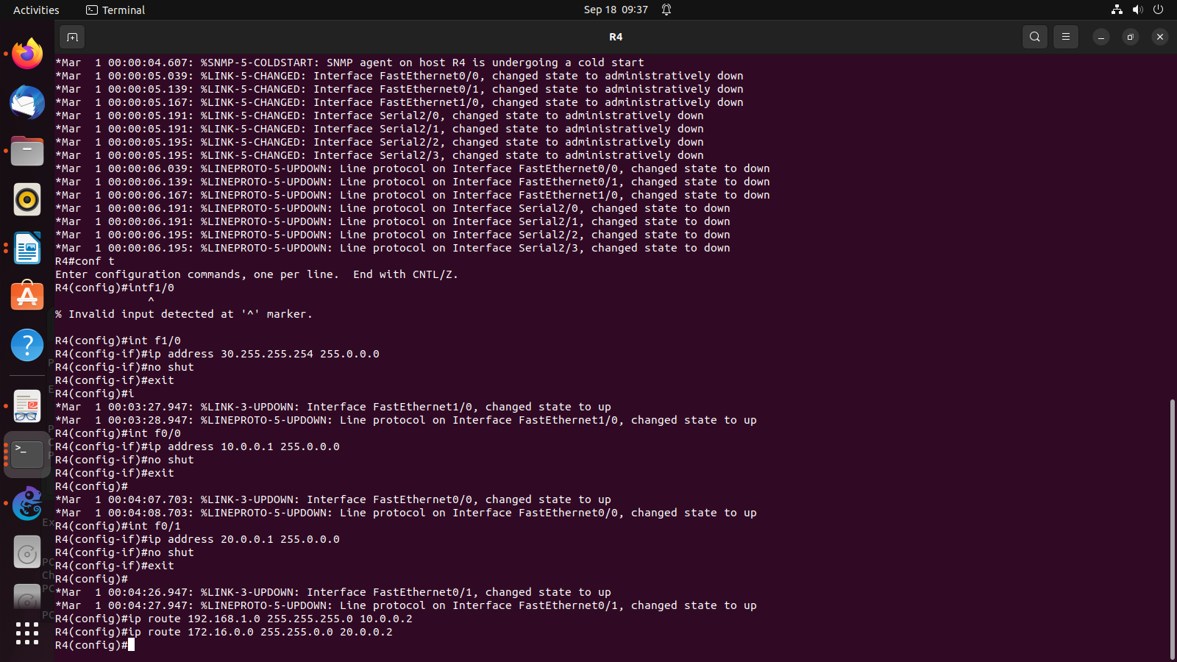
Configuring Routes:

-->R4:

ip route 192.168.1.0 255.255.255.0 10.0.0.2
ip route 172.16.0.0 255.255.0.0 20.0.0.2

-->R3:
ip route 30.0.0.0 255.0.0.0 20.0.0.1
ip route 172.16.0.0 255.255.0.0 50.0.0.1

-->R2:

ip route 192.168.1.0 255.255.255.0 40.0.0.2
ip route 30.0.0.0 255.0.0.0 50.0.0.2

-->R1:
ip route 172.16.0.0 255.255.0.0 40.0.0.1
ip route 30.0.0.0 255.0.0.0 10.0.0.1

PING
