LAB NO: 4 Network Data Analysis using tcpdump

1. While tcpdump host your_host is running in one command window, run ping 127.0.0.1 from another command window. From the ping output, is the 127.0.0.1 interface on? Can you see any ICMP message sent from your host in the tcpdump output? Why?
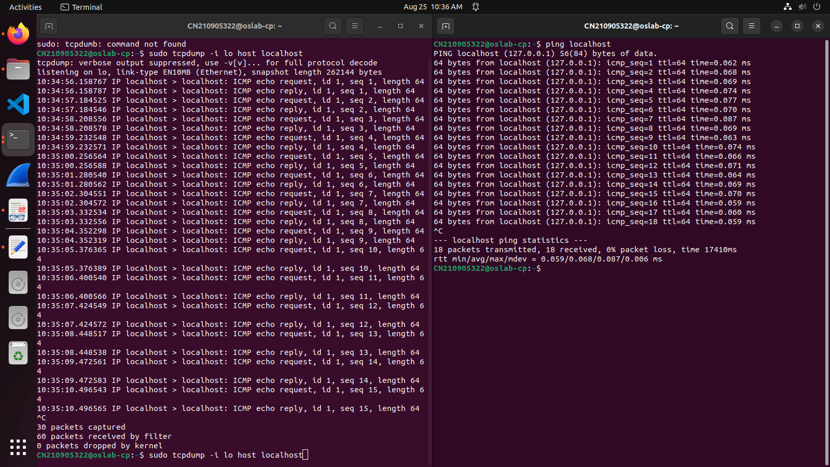
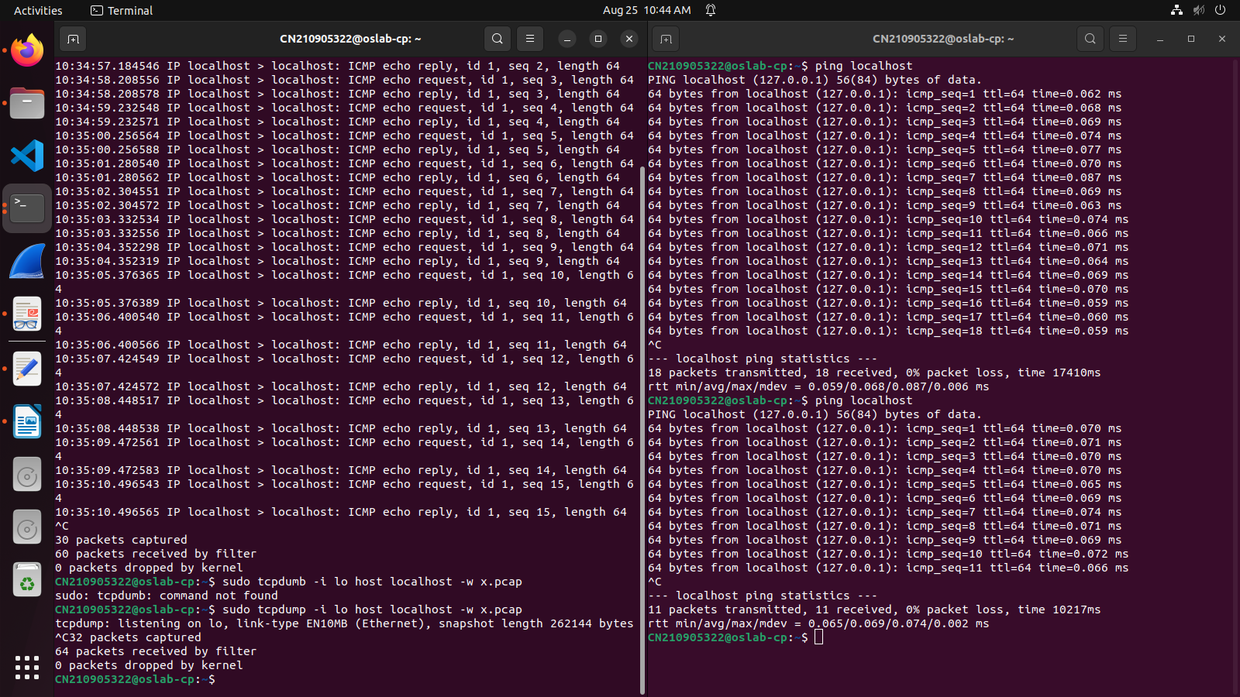

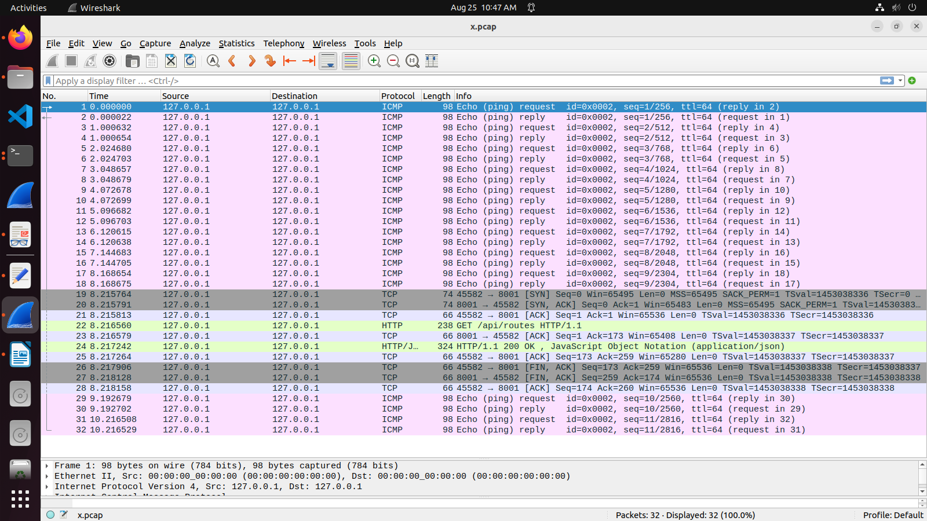
###How to run

Terminal 1:
$ sudo tcpdump -i lo host localhost

Terminal 2:
$ ping localhost

## Observation:

ICMP echo requests and replys are seen in the dump.

-- Note --

If interface is set to ethernet ( $ sudo tcpdump -i enp2s0 host localhost ), and then ping, then no
ICMP messages are seen. This is because you are creating a loopback, but listening on the hardware
level. If the interface is set to ethernet, then you will only see those packets which cross the physical
ethernet interface. The loopback interface (lo) is a logical interface, and you can only see loopback
messages when using this interface.

2. While tcpdump host your_host is running to capture traffic from your machine, execute telnet 128.238.66.200. Note there is no host with this IP address in the current configuration of the lab network. Save the tcpdump output of the first few packets for the lab report. After getting the necessary output, terminate the telnet session. From the saved tcpdump output, describe how the ARP timeout and retransmission were performed. How many attempts were made to resolve a non-existing IP address?

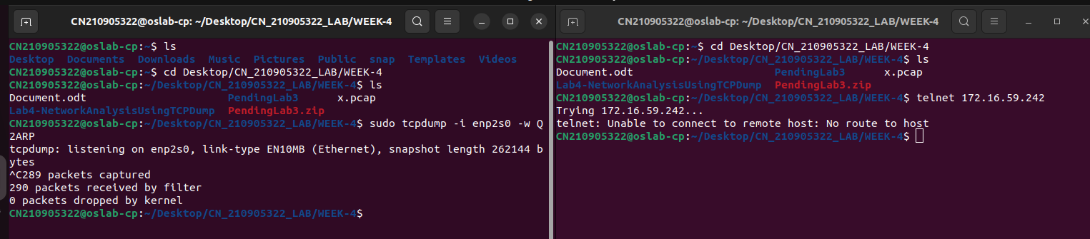
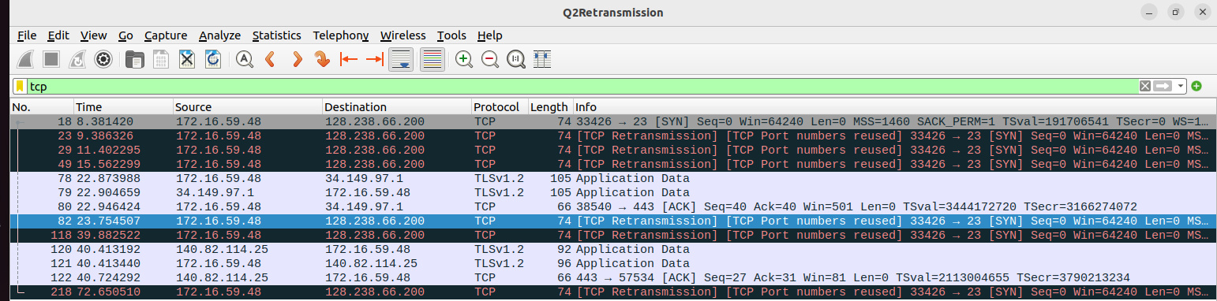
# Part 1: ARP

## How to run

Terminal 1:
$ sudo tcpdump -i enp2s0 -w Q2ARP

Terminal 2:
$ telnet 172.16.59.242

## Observation:

Open Q2ARP in Wireshark, and type arp in the filter. Find out the broadcasts from your machine by checking
the mac address. You will notice 3 total ARP attempts, each at 1 second from the previous.

-- Note --
The ARP is shown only because the destination IP address given is within the same LAN (172.16.59.xxx).

# Part 2: Retransmission

## How to run

Terminal 1:
$ sudo tcpdump -i enp2s0 -w Q2Retransmission

Terminal 2:
$ telnet 128.238.66.200

## Observation:

Since the destination IP is outside the LAN, it is observed that the request is communicated to the main lab router.
It is noticed that the TCP Retransmissions follow the following pattern: The delay between 2 retransmissions
increases by a factor of 2 after every attempt. (T2 - T1 = 1, T3 - T2 = 2, T4 - T3 = 4)
3. Briefly explain the purposes of the following tcpdump expressions.

a. tcpdump udp port 520
Ans: This will track all udp protocol packets where either the source or destination port is 520
which is reserved for Route Info Protocol (RIP)
Output : tcpdump: verbose output suppressed, use -v[v]... for full protocol decode
listening on enp2s0, link-type EN10MB (Ethernet), snapshot length 262144 bytes
0 packets captured
0 packets received by filter
0 packets dropped by kernel

b. tcpdump -x -s 120 ip proto 89
Ans: This will show packet contents in hex and ascii format. The size of the capture will
be at most 120 bytes. Only packets with ip protocol 89 (Open Shortest Path First (OSPF))
tcpdump: verbose output suppressed, use -v[v]... for full protocol decode listening on enp2s0, link- type EN10MB (Ethernet), snapshot length 120 bytes
0 packets captured
0 packets received by filter
0 packets dropped by kernel

c. tcpdump -x -s 70 host ip addr1 and (ip addr2 or ip addr3)
Ans: This will show packet contents in hex and ascii format. The size of the capture will
be at most 70 bytes. Only communication between addr1 and addr2 or addr1 and addr3 will be shown.

d. tcpdump -x -s 70 host ip addr1 and not ip addr2

Ans: This will show packet contents in hex and ascii format. The size of the capture will
be at most 70 bytes. Only communication to and from addr1 excluding communication to addr2
will be shown.

4. Basic packet decoding
1) Write a tcpdump command to dump network traffic from an Ethernet connection to the screen in human readable output format. Perform the following operation and write down the observations.
a) Capture all the traffic of maximum snap length of 65,535 bytes and provide the hexadecimal and ASCII decodes of all the traffic in each packet.
b) Find the IP addresses, IP packet length, TCP port numbers, TCP flags, etc. by using the reference chart to locate those fields on the hexadecimal dump.

1a)
