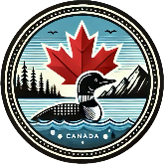
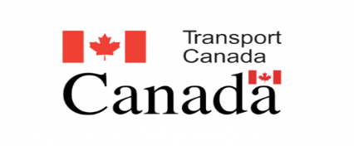
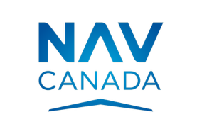

The Facts About Drone Flights in Canada

I am flying my drone in full compliance with Canadian Aviation Regulations. My drones are registered with Transport Canada where needed and I hold an RPAS pilot certification, issued by Transport Canada.
I am also a supporting member of the Drone Pilot Association of Canada and have kept records of pilot certifications and any required recency training every 24 months.
CARS - 901.56(1)(b)(iii) or 901.65(1)(b)(iii) in the Canadian Aviation Regulations

Before take-off the following points were considered

Category of Airspace

Environmental Conditions

Potential Ground Hazards

Proximity to People
Serviceability of my Drone and its controls

I have considered and if required, have obtained any necessary pre-flight authorization to operate my drone in this area, including permissions where required from Air Traffic Services (Nav Canada) or in the
case of any restricted airspace (Class F), their designated authority. If you have questions, or wish to
express a concern to me,
Please wait until the drone has landed before talking to me
This will ensure that I give my full attention to flying safely. If you are still concerned after we speak, you can further investigate and optionally file a written report to Transport Canada using the links I have provided below.
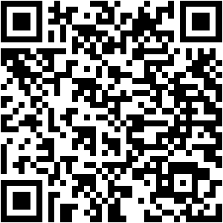  Canadian Aviation Regulations | 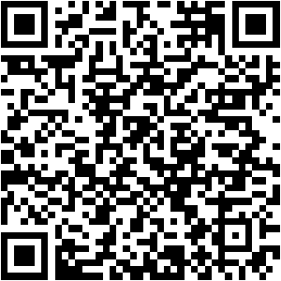  Drone Safety Rules & Guidelines | 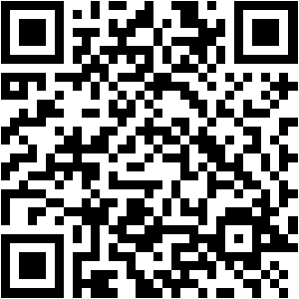  Report a Drone Incident
Drones weighing less than 250g are micro RPAS and do not need to be registered with Transport Canada and the pilot does not need to be certified.

