SUMA GUI - Comprehensive Documentation

# Signal Utility MRI Analysis - Professional GUI

# Overview

SUMA (Signal Utility MRI Analysis) is a professional desktop software designed for analyzing MRI and CT images of patients in clinical trials. The software automatically computes:

• TE₀ - Natural decay time  
• Iron accumulation in tissues  
• Changes over time between treatments

The software is designed for researchers and physicians engaged in clinical trials examining the effects of treatments on iron accumulation in brain tissues.

# Workflow

The software operates according to a simple and intuitive workflow:

1. Start Analysis: Startup Screen → New Analysis Dialog → Enter Patient Details → Select Folders → Perform Analysis  
2. View Results: Startup Screen → View Results Dialog → Select Patient/Treatment → Results Viewer  
3. Export Results: Results Viewer → Export PDF Button → Generate Professional Report

# System Screens

## 1. Startup Screen

The main screen of the software displaying the SUMA logo and two main action buttons.

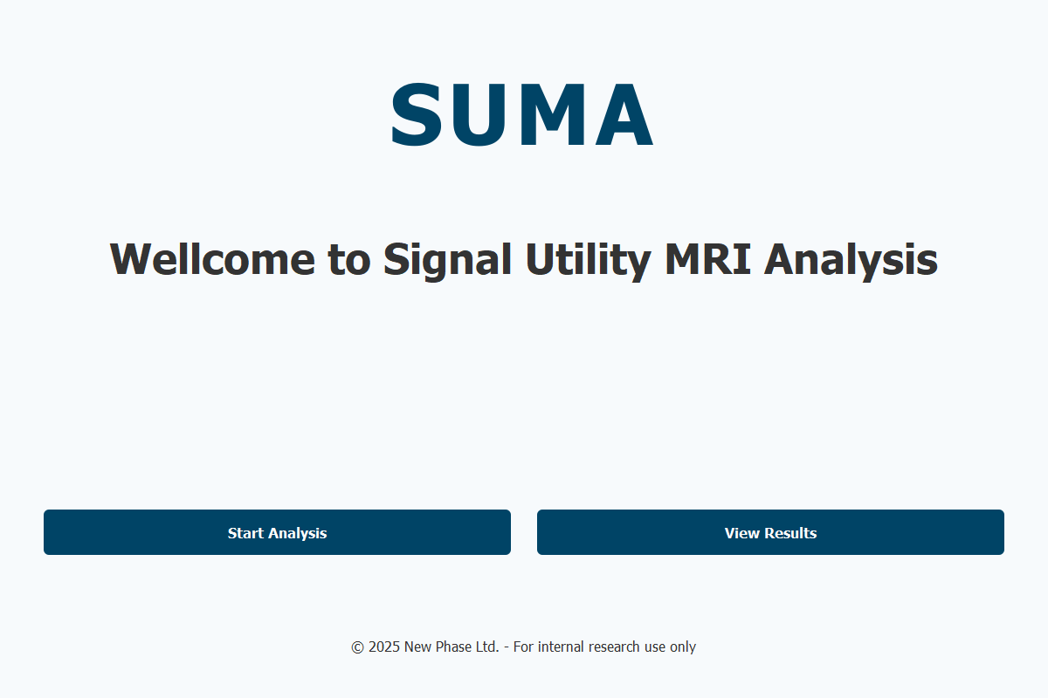

Key Components:  
• Main title "SUMA" in large font (96px) in dark blue color  
• Subtitle "Wellcome to Signal Utility MRI Analysis" in medium font (48px)  
• "Start Analysis" button for starting new analysis  
• "View Results" button for viewing existing results  
• Footer with copyright information

## 2. Start Analysis Dialog

Comprehensive dialog for performing new analysis on patient data.

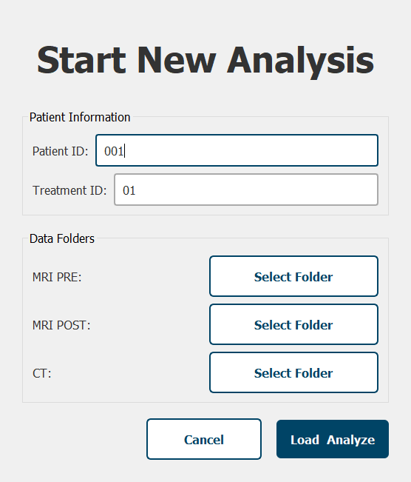

Core Functionality:  
• Patient information input (Patient ID, Treatment ID)  
• Data folder selection (MRI PRE, MRI POST, CT)  
• Progress Bar with percentage progress  
• Component disabling during analysis  
• Background execution with Worker Thread  
• Analysis stages:  
 - Loading DICOM files (15%)  
 - Calculating TE₀ maps (25%)  
 - Performing image alignment (20%)  
 - Computing ΔTE₀ and ΔIron (25%)  
 - Generating reports (15%)

## 3. View Results Dialog

Dialog displaying a list of existing patients and treatments in the system.

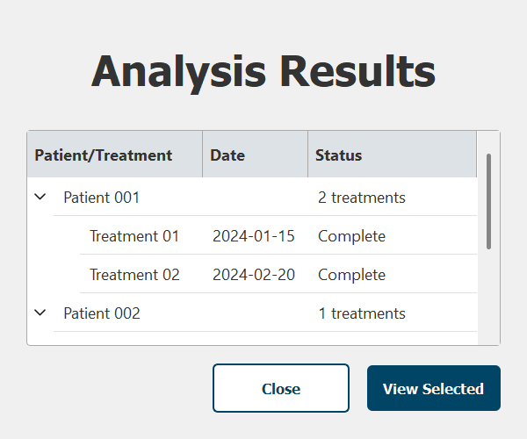

Features:  
• Hierarchical display of patients and treatments  
• Left alignment for better readability  
• Interactive selection with double-click  
• Detailed information: date and status for each treatment  
• Tree widget with expandable patient nodes  
• Column headers: Patient/Treatment, Date, Status

## 4. Results Viewer

Main screen for viewing and editing analysis results.

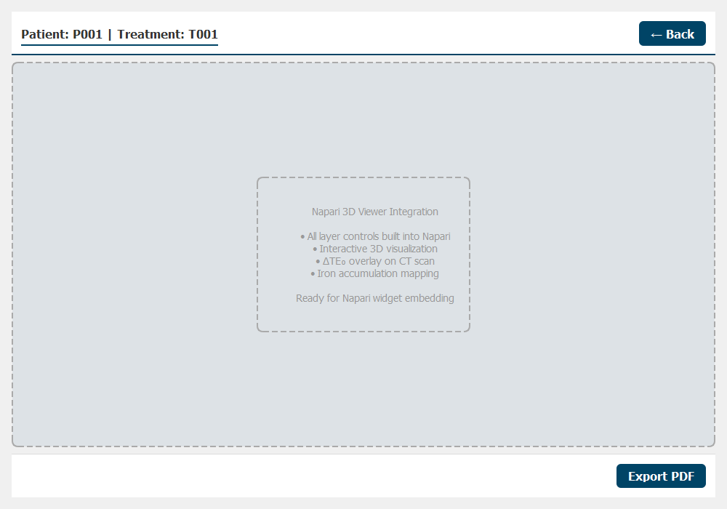

Advanced Components:  
• Top bar with patient information and action buttons  
• Display area ready for Napari integration  
• Visualization layers: CT, PRE TE₁, POST TE₁, PRE TE₀, POST TE₀, ΔTE₀, Iron  
• Controls: Slice slider, 3D toggle, Export PDF  
• Navigation between different image slices  
• Professional PDF export functionality

# Technical Specifications

System Requirements:  
• Operating System: Windows 10/11  
• Python: 3.8+  
• Memory: 8GB RAM minimum  
• Storage: 2GB for software and data  
  
Technical Dependencies:  
• PyQt5 - User interface framework  
• NumPy - Matrix processing  
• Napari - Image visualization (future integration)  
  
Supported Formats:  
• .dcm - DICOM files  
• .json - Analysis results  
• .npz - NumPy matrices  
• .pdf - Export reports

# Software Architecture

The software follows a modular architecture with clear separation of concerns:  
  
Code Structure:  
• config/ - Application constants and configuration  
• core/ - Central signal system for component communication  
• resources/ - Color palette, layer colors, and style management  
• ui/ - User interface components, dialogs, and windows  
  
Design Principles:  
• Modular architecture - Each component is independent  
• Centralized style management - All colors and styles in one place  
• Signal system - Component communication via PyQt signals  
• Responsive design - Adapts to different screen sizes

# Color Scheme

The software uses a defined color palette:  
• Dark Blue (#004466) - Primary brand color  
• Light Blue (#007acc) - Highlights and buttons  
• White (#FFFFFF) - Backgrounds  
• Dark Gray (#333333) - Primary text  
• Light Gray (#999999) - Secondary text  
  
Layer Colormaps for Visualization:  
• ΔTE₀: coolwarm colormap  
• Iron: inferno colormap  
• PRE TE₁: green colormap  
• POST TE₁: red colormap  
• CT: grayscale colormap  
• PRE TE₀: viridis colormap  
• POST TE₀: plasma colormap

# Data Processing

The software processes:  
• DICOM files - Standard medical images  
• TE₀ calculations - Natural decay times  
• Iron mapping - Detection and quantification of iron accumulation  
• Temporal comparisons - Calculation of changes between treatments  
  
Clinical Workflow:  
1. MRI PRE-treatment scan acquisition  
2. MRI POST-treatment scan acquisition  
3. CT scan for anatomical reference  
4. Automated calculation of TE₀, R², Iron accumulation  
5. Computation of ΔTE₀ and ΔIron maps  
6. Generation of ΔTE₀ map overlaid on CT sca