Algorithm: method for solving a problem
Data Structure: method to store information
Topic | Data Structures and Algorithms
Data Types | Stack, Queue, Bag, Union-Find, Priority Queue
Sorting | Quicksort, Mergesort, Heapsort
Searching | BST, Red-Black BST, Hash Table
Graphs | BFS, DFS, Prim, Kruskal, Dijkstra
Strings | Radix Sorts, Tries, KMP, Regexps, Data Compression
Advanced | B-Tree, Suffix Array, Maxflow

- Union-Find
How we develop a usable algorithm:
- Model the problem
- Find an algorithm to solve it
- Fast enough? Fits in memory?
- If not, figure out why.
- Find a way to address the problem.
- Iterate until satisfied.
It is a scientific approach to build an algorithm, build a mathematical model to solve the problem.

  - Dynamic connectivity:
Given a set of N object:
- Union command: connect two objects
- Find connected query: is there a path connecting the two objects?
When we see a complicated problem to find the solution efficiently, wee need to use a computer to do it.

Modeling the objects:
Applications involve manipulating objects of all types:
- Pixels in a digital photo.
- Computers in a network.
- Friends in a social network.
When programming, convenient to name objects 0 to N-1:
- Searching Algorithms

Connections is an equivalence relation:
- Reflexive
- Symmetric
- Transitive

Implementing the operations:
- Find query. Check if two objects are in the same component.
- Union command. Replace components containing two objects with their union.
Union-find data type (API):
Goal. Design efficient data structure for union-find:

  - Quick-Find:
Data Structure:
- Integer array id[] of size N.
- Interpretation: p and q are connected if and only if they have the same id
Find: Check if p and q have the same id.
Union: To merge components containing p and q, change all entries whose id equals id[p] to id[q].

Quick-Find is too slow.
Cost Model. Number of array accesses (for read or write).
N^2 quadratic time is too slow
  - Quick-Union:
Data Structure:
- Integer array id[] of size N.
- Interpretation: id[i] is parent of i.
- Root of I is id[id[id[…id[i]…]]].
Find: Check if p and q have the same root.
Union: To merge components containing p and q, set the id of p’s root to the id of q’s root.

  - Weighted Quick-Union:
Improvements:
- Modify quick-union to avoid tall trees.
- Keep track of size of each tree. (number of objects)
- Balance by linking root of smaller tree to root of larger tree.
Data structure: Same as quick-union, but maintain extra array size[i].
Find: Identical to quick-union.
Union: Modify quick-union to link root of smaller tree to root of larger tree update the size[] array.
Running time:
- Find: takes time proportional to depth of p and q.
- Union: takes constant time, given roots.
Proposition: Depth of any node x is at most log2 N
Proof: When does depth of x increase?
Increases by 1 when tree T1 containing x is merged into another tree T2:
- The size of the tree containing x at least doubles since |T2| >= |T1|
- Size of tree containing x can double at most lg2 N times.
Algorithm | Initialize | Union | Connected
Quick-Find | N | N | 1
Quick-Union | N | N+ | N
Weighted QU | N | Log2 N+ | Log2 N
- Analysis of Algorithms
  - Order-of-Growth Classifications
Order-of-Growth | Name | Typical Code Framework | Description | Example | T(2N) / T(N)
1 | Constant | a = b + c | Statement | Add two numbers | 1
log N | Logarithmic | while(N>1) {  N = N/2; } | Divide in half | Binary search | ~ 1
N | Linear | for (int i = 0; i < N; i++) {} | Loop | Find the maximum | 2
N log N | Linearithmic | Mergesort | Divide and conquer | Mergesort | ~ 2
N² | Quadratic | for (int i = 0; i < N; i++) {  for (int j = 0; j < N; j++) {} | Double loop | Check all pairs | 4
N³ | Cubic | for (int i = 0; i < N; i++) {  for (int j = 0; j < N; j++) {  for (int k = 0; k < N; k++) {} | Triple loop | Check all triples | 8
2^{N} | Exponential | Combinatorial search | Exhaustive search | Check all subsets | T(N)

  - Binary Search
Goal: Given a sorted array and a key, find index of the key in the array?
Binary Search: Compare key against middle entry.
- Too small, go left.
- Too big, go right.
- Equal, found.

public static int binarySearch(int[] a, int key) {
int lo = 0, hi = a.length – 1;
while (lo <= hi) {
int mid = lo + (hi – lo) / 2;
if (key < a[mid]) {
hi = mid – 1;}
else if (key > a[mid]) {
lo = mid + 1;}
else {return mid;}
}
return -1;}
Proposition: Binary Search uses at most 1 + log N key compares to search in a sorted array of size N.
Definition: T(N) = # key compares to binary search a sorted subarray of size <= N.
Binary search recurrence: T(N) <= T(N/2) + 1 for N > 1, with T(1) = 1.
Proof : T(N) <= T(N/2) + 1
<= T(N/4) + 1 + 1
<= T(N/8) + 1 + 1 + 1
…
<= T(N/N) + 1 + 1 + … + 1
= 1 + log N
Sorting based Algorithm:
- N² with the insertion sort. Sort the N (distinct) numbers.
- N²logN with binary search. For each pair of numbers a[i] and a[j], binary search for –(a[i] + a[j]).

  - Theory of Algorithms
Best case: Lower bound on cost.
- Determined by “easiest” input.
- Provides a goal for all inputs.
Worst case: Upper bound on cost.
- Determined by “most difficult” input.
- Provides a guarantee for all inputs.
Average case: Expected cost for random input.
- Need a model for “random” input.
- Provides a way to predict performance.
Goals:
- Establish “difficulty” of a problem.
- Develop “optimal” algorithms.
Approach:
- Suppress details in analysis: analyze “to within a constant factor”.
- Eliminate variability in input model by focusing on the worst case.
Optimal Algorithm:
- Performance guarantee (to within a constant factor) for any input.
- No algorithm can provide a better performance guarantee.
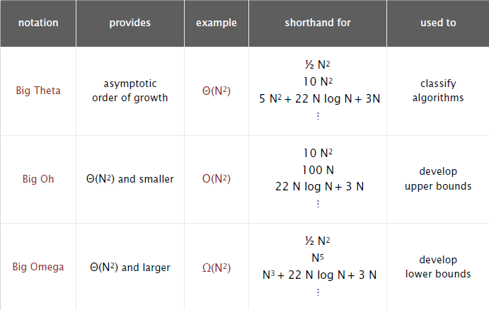

  - Memory
Bit: 0 or 1
Byte: 8 bits
Megabyte MB: 1 million or 2²⁰ bytes.
Gigabyte GB: 1 billion or 2³⁰ bytes.
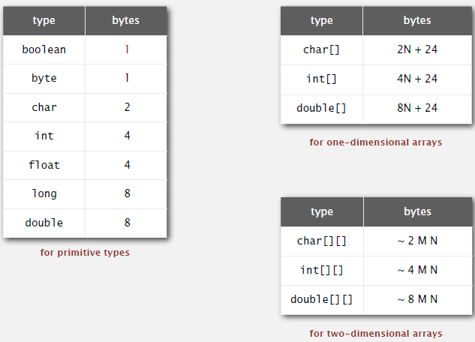

Empirical analysis:
- Execute program to perform experiments.
- Assume power law and formulate a hypothesis for running time.
- Model enables us to make predictions.
Mathematical analysis:
- Analyze algorithm to count frequency of operations.
- Use tilda notation to simplify analysis.
- Model enables us to explain behaviour.
Scientific method:
- Mathematical model is independent of a particular system; applies to machines not yet built.
- Empirical analysis is necessary to validate mathematical models and to make predictions.

- Bags, Queues, and Stacks
Fundamental data types:
- Value: collection of objects.
- Operations: insert, remove, iterate, test if empty.
- Intent is clear when we insert.
- Which item to remove.
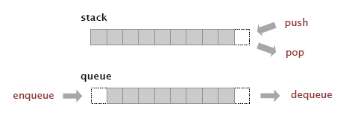
Stack: LIFO – last in first out, examine the item most recently added.
Queue: FIFO – first in first out, examine the item least recently added.

  - Stacks
Array Implementation:
- Use array s[] to store N items on stack.
- Push(): insert a new item at s[N].
- Pop(): remove and return the item most recently added from s[N-1].

  - Resizing arrays
Too expensive:
- Need to copy all items to a new array everytime when there is push and pop.
- Inserting first N items takes time proportional to 1 + 2 + … + N ~ N²/2.
Array capacity is always between 25% ~ 100% full.
  - Queues
Array Implementation:
- Use array q[] to store items in queue.
- Enqueue(): insert a new item at q[tail].
- Dequeue(): remove and return the item least recently added from q[head].
- Update head an tail modulo the capacity.
- Add resizing array.

  - Generics

  - Iterators
Iterable: has a method that returns an Iterator.
Iterator: has methods hasNext() and next().
Bag API: Adding items to a collection and iterating (when order doesn’t matter)

  - Applications

- Elementary Sorts
  - Rukes of the Game
A total oder is a binary relation <= that satisfies:
- Antisymmetry: if v <= w and w <= v, then v = w.
- Transitivity: if v <= w and w <= x, then v <= x.
- Totality: either v <= w or w <= v or both.
Implement comapreTo() so tha v.compareTo(w):
- Is a total order.
- Returns a negative integer, zero, or positive integer if v is less than, equal to, or greater than w, respectively.
- Throws an exception if incompatible types (or either is null).
Built-in comparable types: Integer, Double, String, Date, File, …
User-defined comparable types: implement the Comparable interface.

  - Selection Sort
In iteration i, find index min of smallest remaining entry.
Swap a[initial] and a [min].
Algorithm: pointer scans from left to right.
Invariants:
- Entries the left of pointer (including pointer) fixed and in ascending order.
- No entry to right of pointer is smaller than any entry to the left of pointer.
To maintain algorithm invariants:
- Move the pointer to the right. i++
- Identify index of minimum entry on right.
- Exchange into position.
Proposition: selection sort uses (N – 1) + (N – 2) + … + 1 + 0 ~ N²/2 compares and N exchanges.
Running time insensitive to input: Quadratic time, even if input is sorted.
Data movement is minimal: Linear number of exchanges.

  - Insertion Sort
In iteration i, swap a[initial] with each larger entry to its left.
Algorithm: pointer scans from left to right.
Invariants:
- Entries to the left of pointer (including pointer) are in ascending order.
- Entries to the right of pointer have not yet been seen.
To maintain algorithm invariants:
- Move the pointer to the right.
- Moving from right to left, exchange a[initial] with each larger entry to its left.
Proposition: to sort a randomly-ordered array with distinct keys, insertion sort uses ~ ¼ N² compares and ~ ¼ N² exchanges on average.
Proof: expect each entry to move halfway back.
Best case: If the array is in ascending order, insertion sort makes N – 1 compares and 0 exchanges.
Worst case: If the array is in descending order (and no duplicates), insertion sort makes ~ ½ N² compares and ~ ½ N² exchanges.

Definition: An inversion is a pair of keys that are out of order.
Definition: An array is partially sorted if the number of inversions is <= cN.
- A subarray of size 10 appended to a sorted subarray of size N.
- An array of size N with only 10 entries out of place.
Proposition: For partially-sorted arrays, insertion sort runs in linear time.
Proof: Number of exchanges equals the number of inversions.
Number of compares = exchanges + (N – 1)

  - Shellsort
Idea: Move entries more than one position at a time by h-sorting the array.
h-sort array for decreasing sequence of values of h.
- Insertion sort, with stride length h.
- Big increments small subarray.
- Small increments nearly in order.
Proposition: The worst case number of compares used by shellsort with the 3x + 1 increments is O(N^{3/2} ).
Property: Number of compares used by shellsort with the 3x + 1 increments is at most by a small multiple of N times the # of imcrements used.
  - Shuffling
Goal: Rearrange array so that result is a uniformly random permutation.
- Generate a random real number for each array entry.
- Sort the array.
Proposition: Shuffle sort produces a uniformly random permutation of the input array, provided no duplicate values.
Knuth Shuffle:
- In iteration i, pick integer r between 0 and i uniformly at random.
- Swap a[initial] and a[r].

  - Convex Hull
The convex hull of a set of N points is the smallest perimeter fence enclosing the points.
- Smallest convex set containing all the points.
- Smallest area convex polygon enclosing the points.
- Convex polygon enclosing the points, whose vertices are points in set.
Convex hull output: Sequence of vertices in counterclockwise order.
Application:
- Robot motion planning: Find shortest path in the plane from s to t that avoids a polygonal obstacle.
  - Shortest path is either straight line from s to t or it is one of two polygon chains of convex hull.
- Farthest pair problem: Given N points in the plane, find a pair of points with the largest Euclidean distance between them.
  - Farthest pair of points are extreme points on convex hull.
  - Can traverse the convex hull by making only counterclockwise turns.
  - The vertices of convex hull appear in increasing order of polar angle with respect to point p with lowest y-coordinate.

- Mergesort
  - Mergesort
Basic Plan:
- Divide array into two halves.
- Recursively sort each half.
- Merge two halves.
Goal: Given two sorted subarrays a[low] to a[mid] and a [mid+1] to a[high], replace with sorted subarray a[low] to a[high].
Assertion: Statement to test assumptions about your program.
- Helps detect logic bugs.
- Documents code.
Running time estimates:
- Laptop executes 10⁸ compares/second.
- Supercomputer executes 10¹² compares/second.
Bottom line: Good algorithms are better than supercomputers.
Proposition: Mergesort uses at most N log N compares and 6N log N array accesses to sort any array of size N.
Proof: The number of compares C(N) and array accesses A(N) to mergesort an array of size N satisfy the recurrences:
We solve the recurrence when N is a power of 2.

Improvements:
Use insertion sort for small subarrays:
- Mergesort has too much overhead for tiny subarrays.
- Cutoff to insertion sort for ~ 7items.
- Stop if already sorted: biggest item in first half <= smallest item in second half

  - Bottom-Up Merge Sort
Basic Plan:
- Pass through array, merging subarrays of size 1.
- Repeat for subarrays of size 2, 4, 8, 16, ….

  - Sorting Complexity
Computational complexity: Framework to study efficiency of algorithms for solving a particular problem X.
Model of computation: Allowable operations.
Cost model: Operation counts.
Upper bound (Worse Case): Cost guarantee provided by some algorithm for X.
Lower bound (Best Case): Proven limit on cost guarantee of all algorithms for X.
Optimal algorithm: Algorithm with best possible cost guarantee for X.

Sorting:
- Model of computation: decision tree.
- Cost Model: # compares
- Upper bound: ~N log N from mergesort
- Lower bound: ~N log N
- Optimal algorithm: mergesort

Height of tree = worst case number of compares

Compare-based lower bound for sorting:
Proposition: Any compare-based sorting algorithm must use at least log(N!) ~ N log N compares in the worst-case.
Proof:
- Assume array consists of N distinct values a₁ through a_{N}.
- Worst case dictated by height h of decision tree.
- Binary tree of height h has at most 2^{h} leaves.
- N! different orderings at least N! leaves.

Mergesort is optimal with respect to number compares.

  - Comparators
Sort music library by artist name / song name.
Comparable interface: sort using a type’s natural order.
Comparator interface: sort using an alternate order.
Required property: must be a total order.
Bottom line. Decouples the definition of the data type from the definition of what it means to compare two objects of that type.

  - Stability
A stable sort preserves the relative order of items with equal keys.
Insertion sort and mergesort (but not selection sort or shellsort or quicksort).
- Insertion sort: Equal items never move past each other.
- Selection sort: Long-distance exchange might move an item past some equal item.
- Shellsort: Long-distance exchanges
- Mergesort: Suffices to verify that merge operation is stable. Takes from left subarray if equal keys.
- Quicksort: Partition does long-distance exchanges.

- Quicksort
  - Quicksort
Basic plan:
- Shuffle the array
- Partition so that, for some j
  - Entry a[j] is in place.
  - No larger entry to the left of j.
  - No smaller entry to the right of j.
- Sort each piece recursively.
Phase I: Repeat until i and j pointers cross.
- Scan i from left to right so long as (a[i] < a[low])
- Scan j from right to left so long as (a[j] > a[low])
- Exchange a[i] with a[j]
Phase II: When pointer cross.
- Exchange a[low] with a[j].
Running time estimates:
- Home PC executes 10⁸ compares/second.
- Supercomputer executes 10¹² compares/second.
Best case: Number of compares is ~ N log N.
Worst case. Number of compares is ~ ½ N² .
Proposition: The average number of compares CN to quicksort an array of N distinct keys is ~ 2N ln N (and the number of exchanges is ~ ⅓ N ln N).

Improvements:
Insertion sort small subarrays:
- Even quicksort has too much overhead for tiny subarrays.
- Cutoff to insertion sort for ≈ 10 items.
- Note: could delay insertion sort until one pass at end.

  - Selection
Goal: Given an array of N items, find a k^{th} smallest item.
Applications:
- Order statistics.
- Find the “top k”.
Use theory as a guide:
- Easy N log N upper bound.
- Easy N upper bound for k = 1, 2, 3.
- Easy N lower bound.
- N log N lower bound.
- N upper bound.

Quick-select:
Partition array so that :
- Entry a[j] is in place.
- No larger entry to the left of j.
- No smaller entry to the right of j.
Repeat in one subarray, depending on k; finished when j = k.
Proposition: Quick-select takes linear time on average.
Remark： Quick-select uses ~ ½ N² compares in the worst case, but (as with quicksort) the random shuffle provides a probabilistic guarantee.

  - Duplicate keys
Mergesort with duplicate keys: Always between ½ N log N and N log N compares.
Quicksort with duplicate keys:
- Algorithm goes quadratic unless partitioning stops on equal keys.

Mistake: Pull all items equal to the partitioning item on one side.
Consequences: ~ ½ N² compares when all keys equal.
Recommended: Stop scans on items equal to the partitioning item.
Consequence: ~ N log N compares when all keys equal.
Desirable: Pull all items equal to the partitioning item in place.

3-way partitioning:
Goal: Partition array into 3 parts so that:
- Entries between less than and greater than equal to partition item v.
- No larger entries to left of less than.
- No smaller entries to right of greater than.

  - System sorts
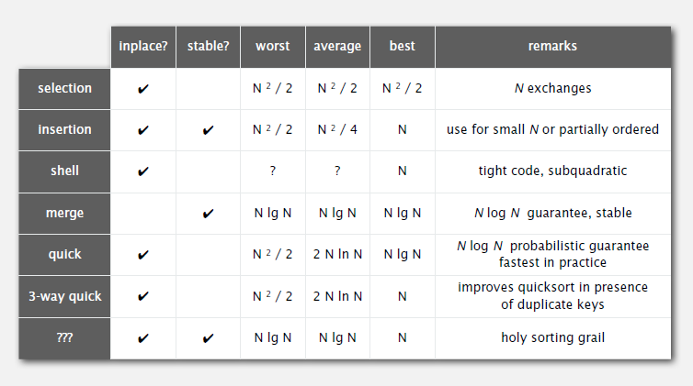

- Priority Queue
  - API and Elementary Implementations
Stack: Remove the item most recently added.
Queue: Remove the item least recently added.
Randomized queue: Remove a random item.
Priority queue: Remove the largest (or smallest) item.
Applications:
- Event-driven simulation.
- Numerical computation.
- Data compression.
- Graph searching.
- Number theory.

  - Binary Heaps
Binary Tree: Empty or node with links to left and right binary trees.
Complete Tree: Perfectly balanced except for bottom level.
Property: Height of complete tree with N nodes is logN.
Proof: Height only increases when N is a power of 2.

Binary Heap: Array representation of a heap-ordered complete binary tree.
Heap-ordered binary tree:
- Keys in nodes
- Parent’s key no smaller than children’s keys.
Array representation:
- Indices start at 1.
- Take nodes in level order.
- No explicit links needed.
Proposition: Largest key is a[1], which is root of binary tree.
Proposition: Can use array indices to move through tree.
- Parent of node at k is k/2.
- Children of node at k are 2k and 2k + 1.

Scenario: child’s key becomes larger key than its parent’s key
- Exchange key in child with key in parent.
- Repeat until heap order restored.
Insert: Add node at end, them swim it up.
Cost: At most 1 + log N compares.

Scenario: Parent’s key becomes smaller than one (or both) of its children’s.
- Exchange key in parent key in larger child.
- Repeat until heap order.

Delete max: Exchange root with node at end, then sink it down.
Cost: At most 2 logN compares.
Insert: Add note at end, then swim it up.
Remove the maximum. Exchange root with node at end, then sink it down.

  - Heapsort
Basic Plan:
- Create max-heap with all N keys.
- Repeatedly remove the maximum key
Heap construction: Build max heap using bottom-up method.
Sortdown: Repeatedly delete the largest remaining item.
First pass: Build heap using bottom-up method.
Second pass: Remove the maximum, one at a time. Leave in array, instead of nulling out.

Proposition: Heap construction uses <= 2N compares and exchanges.
Proposition: Heapsort uses <= 2N log N compares and exchanges.
Significance: In-place sorting algorithm with N log N worst-case：
- Mergesort: no, linear extra space.
- Quicksort: no, quadratic time in worst case.
- Heapsort: Yes!
Bottom line: Heapsort is optimal for both time and space, but:
- Inner loop longer than quicksort’s
- Makes poor use of cache memory.
- Not stable
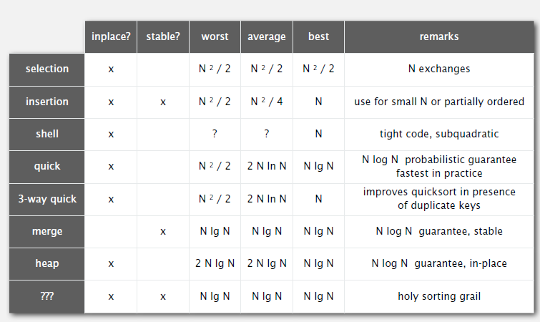
  - Event-driven simulation

- Symbol Tables
  - API

  - Elementary Implementations

  - Ordered Operations

- Binary Search Trees
  - BSTs
  - Ordered Operations
  - Deletion

- Balanced Search Trees
  - 2-3 Search Trees
  - Red-black BSTs
  - B-trees

- Geometric Applications of BSTs

- Hash Tables
  - Hash Functions
  - Separate Chaining
  - Linear Probing
  - Context

- Searching Applications

- Undirected Graphs

- Directed Graphs

- Minimum Spanning Trees

- Questions:
  - Consider the maximum number of array accesses during a find operation when using the quick-union data structure on n elements. How does this quantity grow as function of n?
Constant
Logarithmic
Linear
Quadratic
  - Which of the following order-of-growth classifications represents the maximum number of array accesses used to binary search a sorted array of length n?
Constant
Logarithmic
Linear
Linearithmic
  - Suppose that, starting from an empty data structure, we perform n push operations in our resizing-array implementation of a stack. How many times is the resize() method called?
Constant
Logarithmic
Linear
Quadratic
Hint: The resize() method is called only when the size of the stack is a power of 2. How many powers of 2 are there between 1 and n?
The resize() method is called only when the size of the stack is a power of 2. There are ∼log₂​n powers of 2 between 1 and n.
  - Suppose that you implement a queue using a null-terminated singly-linked list, maintaining a reference to the item least recently added (the front of the list) but not maintaining a reference to the item most recently added (the end of the list). What are the worst-case running times for enqueue and dequeue?
constant time for both enqueue and dequeue
constant time for enqueue and linear time for dequeue
linear time for enqueue and constant time for dequeue
linear time for both enqueue and dequeue
Hint: How could you enqueue an item (by adding it to the end of the linked list) in constant time?
Removing a node from the front of a linked list takes constant time. However, it takes linear time to find the last node of a linked list (unless we maintain an explicit reference to it, which is not done here).
  - Which of the following statements is a type safe way to declare and initialize a StackStack of integers?
Stack<int> stack = new Stack<int>();
Stack<Integer> stack = new Stack();
Stack stack = new Stack<Integer>();
Stack<Integer> stack = new Stack<Integer>();
  - Suppose that we copy the iterator code from our linked list and resizing array implementations of a stack to the corresponding implementations of a queue. Which queue iterator(s) will correctly return the items in FIFO order?
neither
linked-list iterator only
array iterator only
both
Hint: The array iterator will fail for two reasons. First, the items should be iterated over in the opposite order. Second, the items won't typically be stored in the array as entries 0 to n - 1.
The linked-list iterator will work without modification because the items in the linked list are ordered in FIFO order (which is the main reason we dequeue from the front and enqueue to the back instead of vice versa).
  - How many compares does selection sort make when the input array is already sorted?
logarithmic
linear
quadratic
exponential
The number of compares and exchanges made by selection sort does not depend on the order of the input.
  - How many compares does insertion sort make on an input array that is already sorted?
constant
logarithmic
linear
quadratic
Each item (except the first) is compared against the item to its left (and to no other items), for a total of n – 1 compares.
  - How many compares does shellsort (using the 3x+1 increment sequence) make on an input array that is already sorted?
constant
logarithmic
linear
linearithmic
Since successive increment values of ℎ differ by at least a factor of 3, there are ∼log3​n increment values. For each increment value ℎ, the array is already ℎ-sorted so it will make ∼n compares.
  - How many compares does mergesort—the pure version without any optimizations—make to sort an input array that is already sorted?
Constant
logarithmic
linear
linearithmic
It makes ∼ ½ n log₂ ​n compares, which is the best case for mergesort. We note that the optimized version that checks whether a[mid] ≤ a[mid+1] requires only n−1 compares.
  - How many passes (over the input array) does bottom-up mergesort make in the worst case?
constant
logarithmic
linear
linearithmic
  - Under which of the following scenarios does the NlogN lower bound for sorting apply? Assume that the keys are accessed only through the compareTo() method unless otherwise specified.
five distinct keys
no two keys are equal
keys in descending order
keys are strings and accessed via charAt() instead of compareTo()
  - Which of the following is a compelling reason to implement the Comparator interface instead of the Comparable interface in Java?
easier to use Comparator Arrays.sort()
Comparator supports multiple orderings of a given data type
easier to implement a total order with Comparator than Comparable
All of the above
  - Given an array of points, which of the following approaches would be least useful for removing duplicate points? Assume the point data type has the following three orders:
- A natural order that compares by x-coordinate and breaks ties by y-coordinate.
- One comparator that compares by x-coordinate; another by y-coordiante.
- Note: quicksort is an efficient, but unstable, sorting algorithm.
quicksort by the natural order
quicksort by x-coordinate; mergesort by y-coordinate
mergesort by x-coordinate; quicksort by y-coordinate
mergesort by x-coordinate; mergesort by y-coordinate
Since quicksort is not stable, if you mergesort by x-coordinate and then quicksort by y-coordinate, there is no guarantee that equal points will be adjacent in the sorted order.
  - What is the expected running time of randomized quicksort to sort an array of n distinct keys when the array is already sorted?
linear
linearithmic ?
quadratic
exponential
  - What is the expected running time to find the median of an array of n distinct keys using randomized quickselect?
constant
linear
linearithmic
quadratic
Hint： The worst-case running time of randomized quickselect is quadratic, but not the expected running time.
This is the main advantage of quickselect over quicksort—the expected number of compares is linear instead of linearithmic.
  - Using 3-way partitioning with quicksort is most effective when the input array has which of the following properties?
all items distinct
a few distinct items
items in strictly increasing order
items in strictly decreasing order
The goal of 3-way partitioning is to speed up quicksort in the presence of duplicate keys.
  - Why does Arrays.sort() in Java use mergesort instead of quicksort when sorting reference types ?
stability
nlogn guaranteed performance
both A and B
neither A nor B
The Java API for Arrays.sort() for reference types requires that it is stable and guarantees nlogn performance. Neither of these are properties of standard quicksort.
Quicksort uses less memory and is faster in practice on typical inputs (and is typically used by Arrays.sort() when sorting primitive types, where stability is not relevant).
  - Why does Arrays.sort() in Java use quicksort instead of mergesort when sorting primitive types ?
uses less memory on typical inputs
faster on typical inputs
both A and B
neither A nor B
Quicksort is in-place and is typically the fastest general-purpose sorting algorithm in practice.
  - What is the expected number of array accesses and compares, respectively, to insert a random key into an ordered-array implementation of a priority queue?
logarithmic and logarithmic
logarithmic and linear
linear and logarithmic
linear and linear
Hint: use binary search.
We can use binary search to find the insertion point using a logarithmic number of compares. On average, the key to be inserted must be placed in the middle of the array—to keep the array in order, we must shift over all larger keys.
  - Which of the following arrays does not represent a max-oriented binary heap?
19 18 17 16 15 14 13 12 11 10
10 10 10 10 10 10 10 10 10 10
34 30 29 27 25 17 16 19 22 24
30 27 23 17 16 15 13 14 18 11
In the corresponding binary tree, 17 is a parent of 18, which violates the heap-order property.
  - Suppose that an array a[] is a max-heap that contains the distinct integer keys 1,2,…,N with N≥7. The key N must be in a[1] and the key N−1 must be in either a[2] or a[3]. Where must the key N−2 be?
2 or 3
4, 5, 6, or 7
2, 3, 4, 5, 6, or 7
1, 2, 3, 4, 5, 6, or 7
  - How many compares does bottom-up (sink-based) heap construction perform in the worst case when sorting an array of n keys?
constant
logarithmic
linear
linearithmic
Hint: Inserting n keys one-at-a-time into a binary heap would require a linearithmic number of compares. The bottom-up construction has a superior worst-case running time.
As stated in lecture, the bottom-up version of heapsort makes ∼2n compares in the worst case. For a proof of this fact, see Exercise 2.4.20
  - How many priority-queue operations are performed for each collision in the worst case?
constant
logarithmic
linear
quadratic
In the worst case, each of the two colliding particle might be predicted to collide with each of the other particles (and two walls). In practice, the number of priority queue operations will be much much smaller.
  - What is the maximum number of array accesses needed to search for a key in a symbol table that is implemented with a sorted array?
constant
logarithmic
linear
linearithmic
Use binary search.
  - What is the maximum number of compares to determine the rank of a key in a symbol table that is implemented using a sorted array?
Constant
logarithmic
linear
linearithmic
Use binary search.
  - Suppose that n distinct keys are inserted into a binary search tree in random order. What is the expected number of compares to search for one of the n keys?
constant
logarithmic
linear
linearithmic
As stated in lecture, the expected number of compares is ∼2lnn.
  - What is the order of growth of the expected height of a binary search tree with n keys after a long intermixed sequence of random insertions and random Hibbard deletions?
logn
square root n​
n
nlogn
The main defect of Hibbard deletion is that it unbalances the tree, leading to �n​ height.
If instead of replacing the node to delete with its successor, you flip a coin and replace it with either its successor or predecessor, then, in practice, the height becomes logarithmic (but nobody has been able to prove this fact mathematically).

