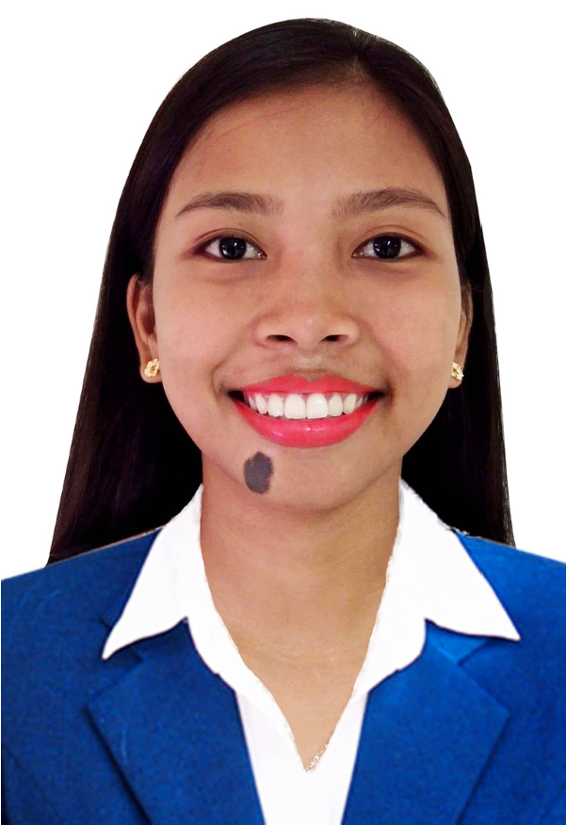

**RONA MAE**

**ABONAL**

**GET IN CONTACT**

Home: City Of Bacoor Cavite

Mobile: 09159123294

#52 Hilltop St. GreenValley San Nicolas 3

Email: ronabelss27@gmail.com

# PERSONAL PROFILE

I am looking for a suitable job where I will be able to utilize my skills, educational background, and ability to work well with people that will allow me to grow personally and professionally.

# AREAS OF EXPERTISE

Computer Literate: Proficiency in Microsoft Office Applications Customer Service  
Dedicated and hardworking individual  
Bilingual Filipino and English**OTHER SKILLS**  
The ability to analyze complex technical information

Keen eye for details

Oriented Ability to work  
 efficiently under pressure

# WORK EXPERIENCE

## COMPUTER SYSTEM SERVICING Work Immersion @Datacom Institute of Computer Technology (2017-2018) PRESTEA MILKTEA SHOP Barista (2021-2023)

## AWARD AND ACHIEVEMENTS

NATIONAL CERTIFICATE II IN COMPUTER SYSTEM SERVICING

-BATCH 2018

Completing the Cisco Networking Academy in Entrepreneurship

-2021

# EDUCATIONAL ATTAINMENT Tertiary CAVITE STATE UNIVERSITY Bacoor Campus Bachelor of Science in Information Technology School Year: 2019-Present

***I DECLARE UNDER OATH THAT THIS RESUME HAS BEEN ACCOMPLISHED BY ME, AND ITS TRUE AND CORRECT, AND COMPLETE STATEMENT TO THE PROVISIONS OF PERMANENT LAWS, RULES, AND REGULATION OF THE REPUBLIC OF THE PHILIPPINES.***

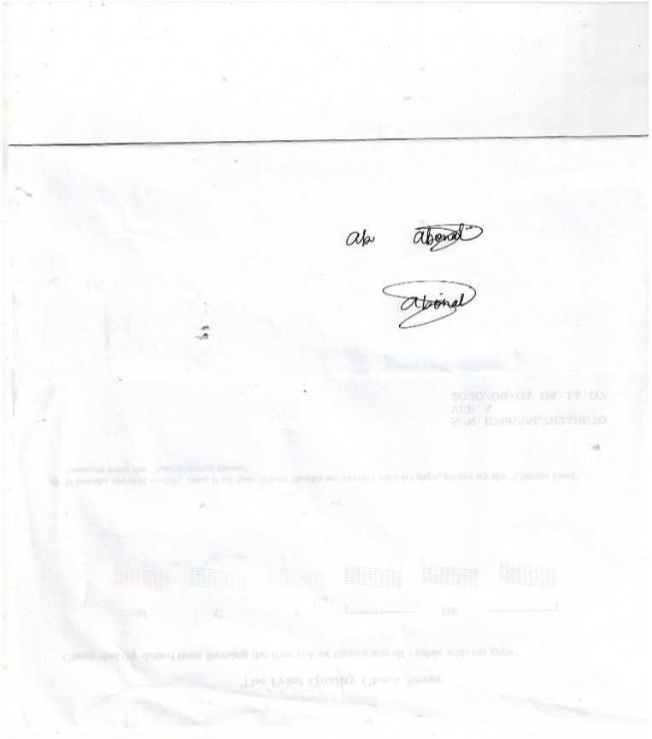

***RONA MAE 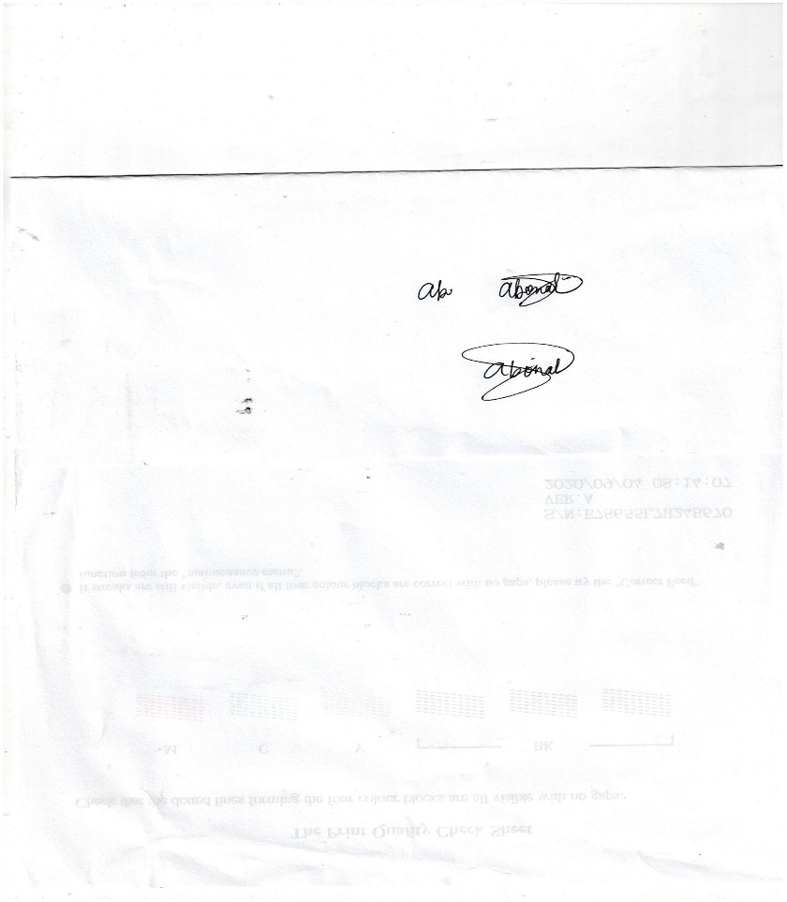ABONAL*** Signature Over Printed Name