Fake news detection using NLP (Natural Language Processing) is the process of identifying and classifying news articles or other textual content that contains false or misleading information. The project typically involves several steps, including data collection and preparation, feature engineering, model selection, and evaluation.

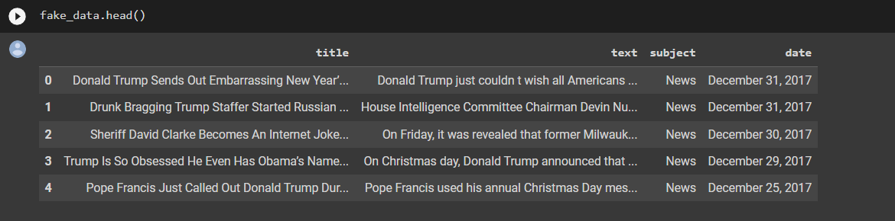First, the data is collected from various sources such as news websites or social media platforms, and then preprocessed to remove noise, stop words, and other irrelevant content. The preprocessed data is then transformed into a numerical representation using techniques such as bag-of-words or TF-IDF.

* Make plots to show the titles that found in Fake News compared to that in True News

* Searching for (@,#,…..)to know which source have more fake data twitters or the news articles

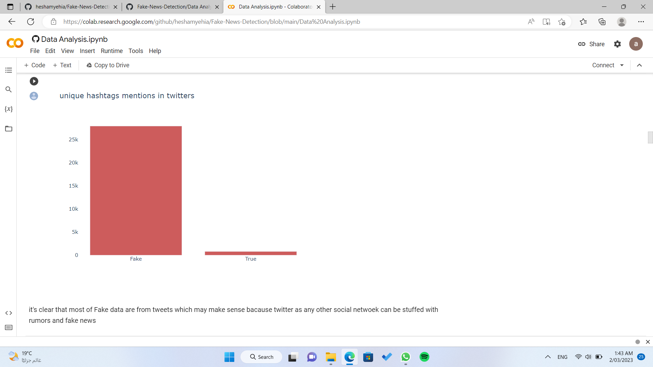

* Where is the highest number of words

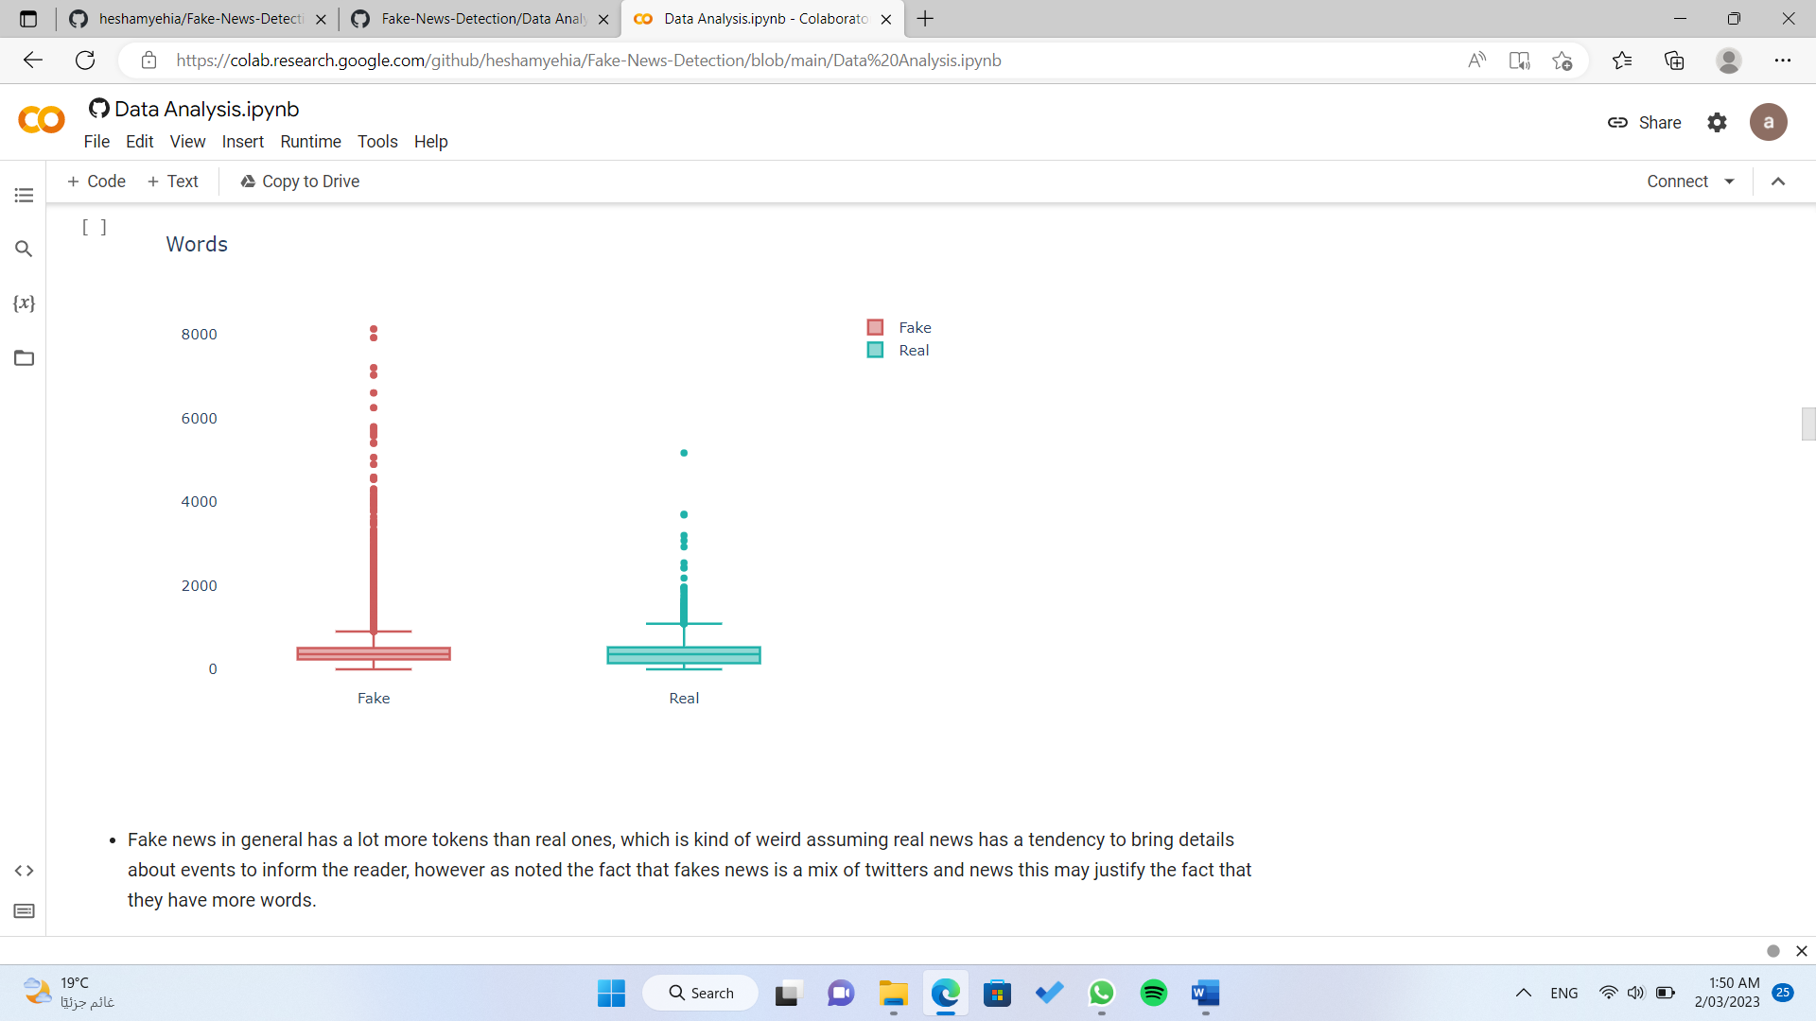

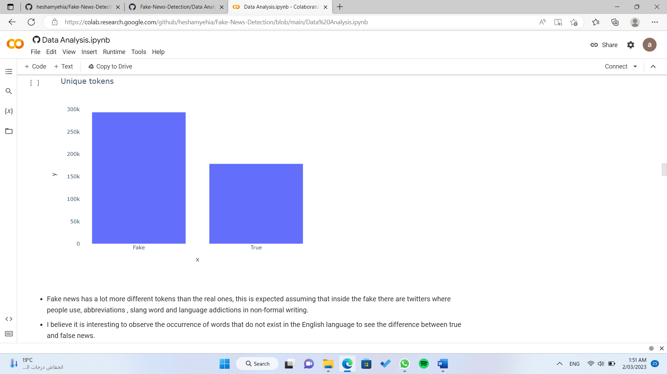

* percentage of error words before and after preprocessing on the text and removing stop words

-Before:

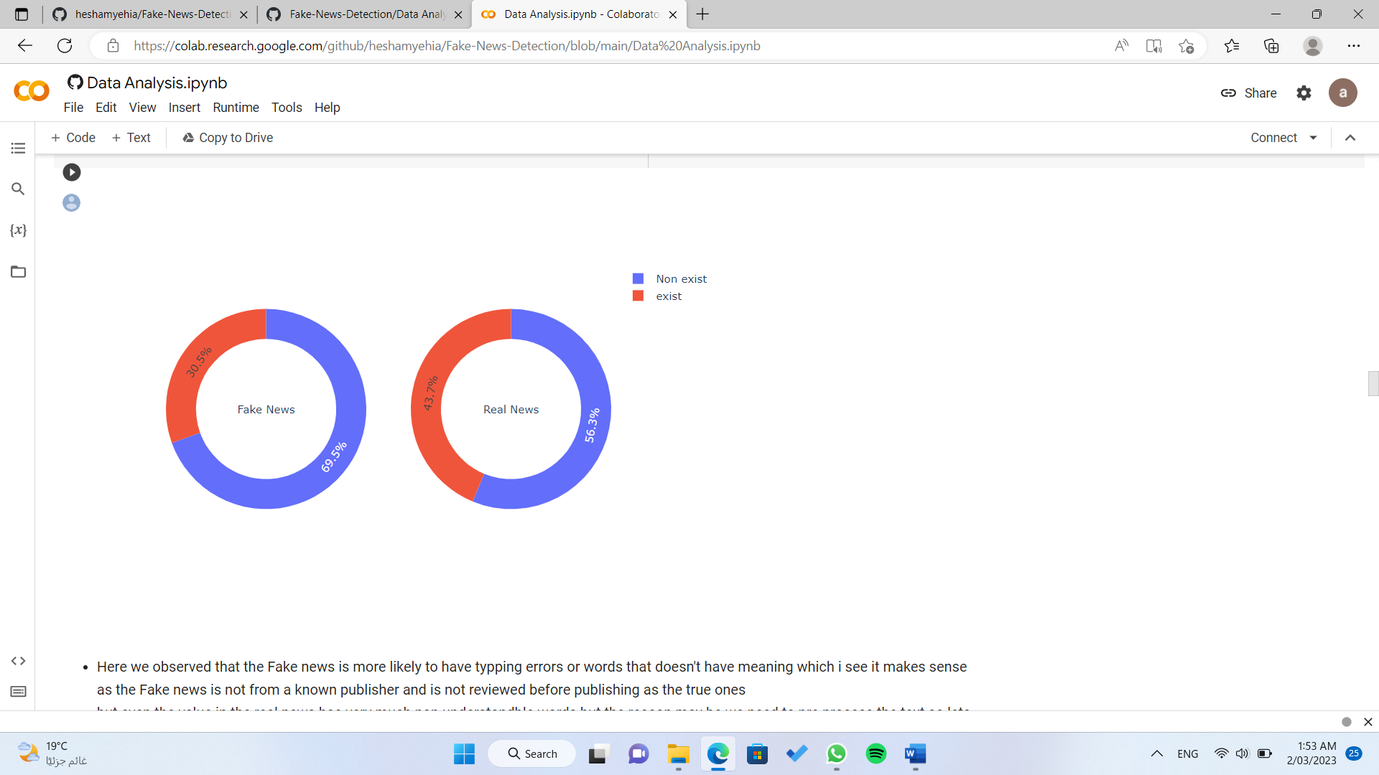

-After:

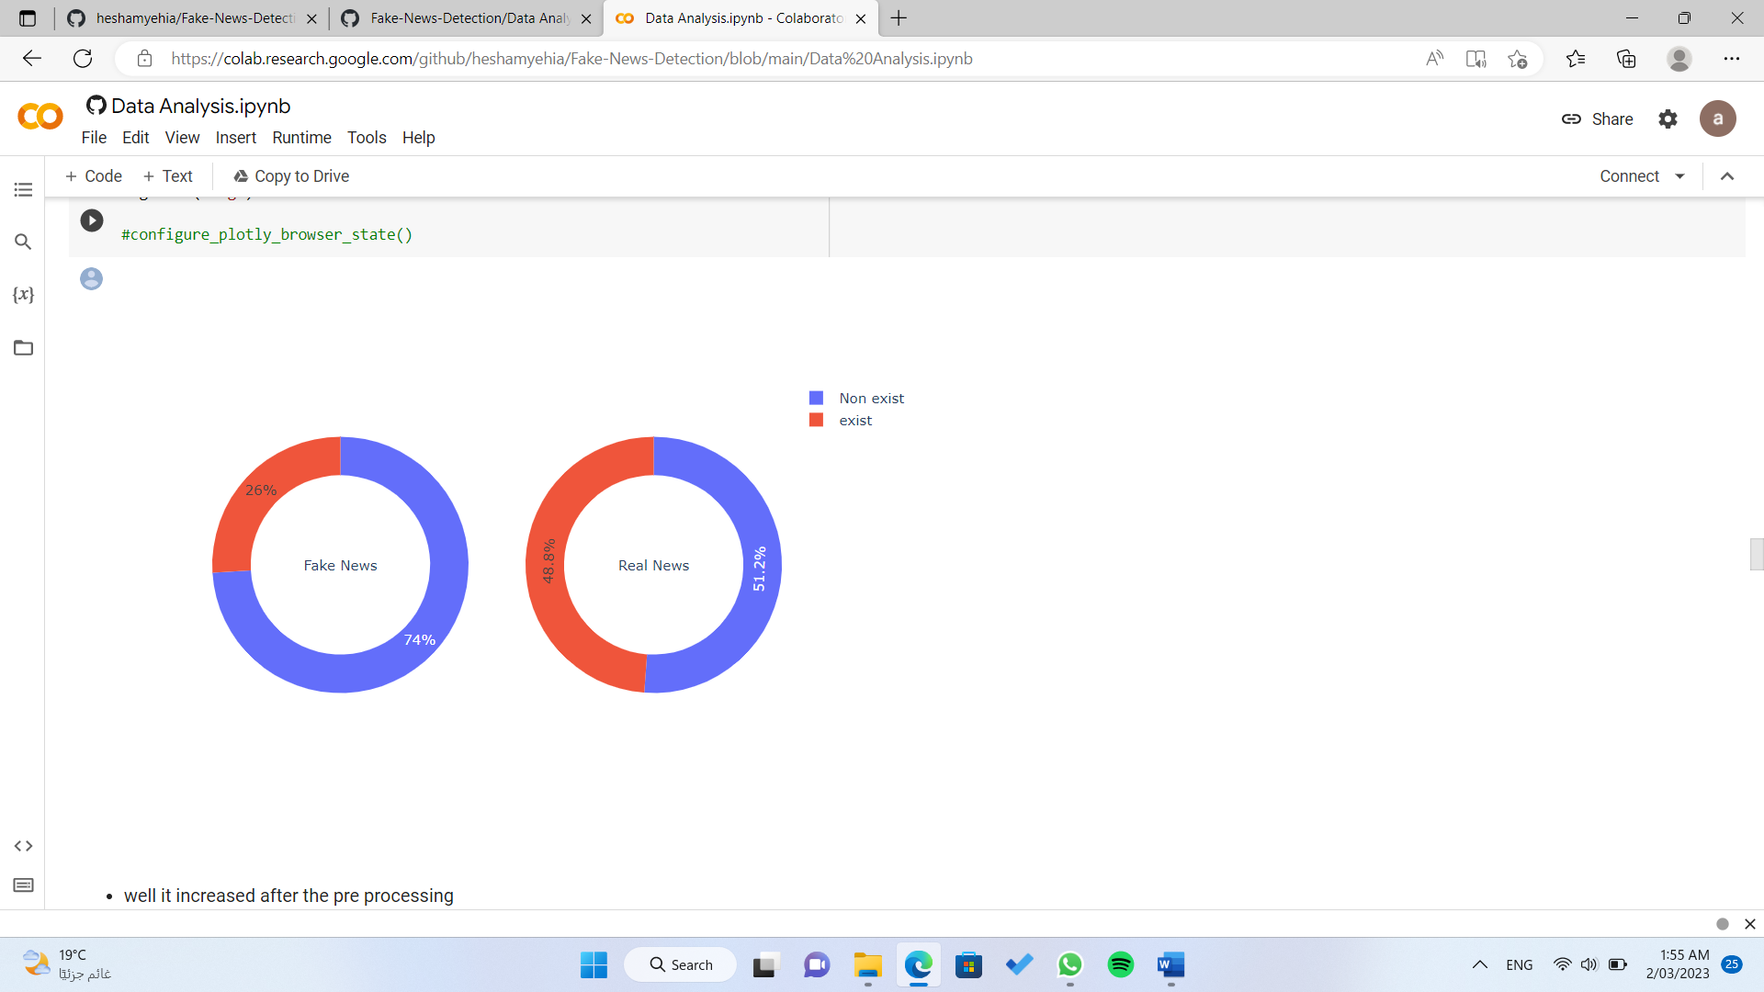

* Show the word cloud plot trying to know the pattern

* Make a plot to compare between fake news and true news over time

Next, a machine learning model is trained on the preprocessed data to classify news articles into fake or genuine categories. Several algorithms such as Logistic Regression and SVC can be used to train the model. The model is evaluated on a test set to determine its accuracy, precision, and recall.

+ SVC + Logistic Regression

Finally, the model is deployed to a production environment where it can be used to classify new news articles in real-time. The accuracy and effectiveness of the model can be improved over time by fine-tuning the model, retraining it with new data, or using more advanced algorithms.

* Using Tkinter GUI

* Using Streamlit

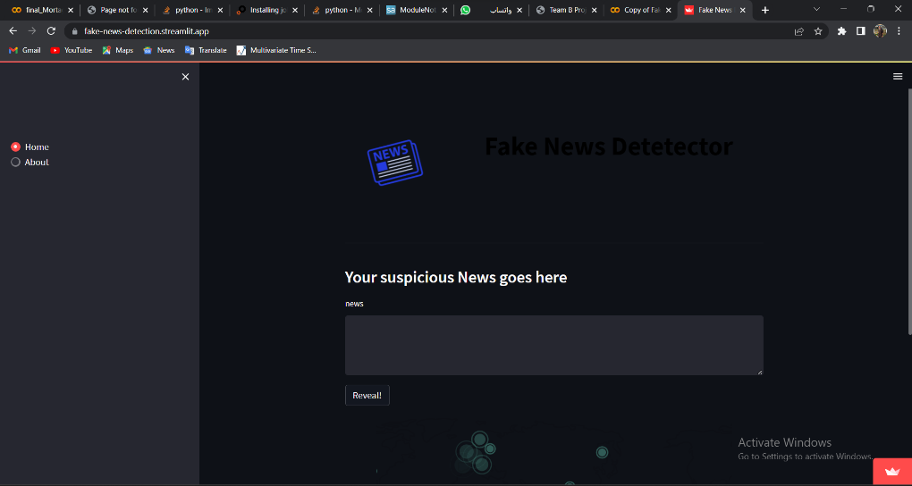

This project made by :

Ahmed Sameh Ahmed : https://www.linkedin.com/in/ahmedsamehahmed

Ammar Thabet : https://www.linkedin.com/in/ammar-thabett

Hesham Yehia : https://www.linkedin.com/in/hesham-yehia-7236b822a