Detumbling of Spacecraft with electromagnets and geomagnetic field after deployment from launch vehicles

# 

# 

# By

Pranshu Maheshwari

Prayag Jain

Vikram Kushwaha

Dhananjay Diwakar

# 

# Inputs:

# The following inputs are required:-

1)Inertia Matrix(3 * 3)

2)Time in YMDhms format

3)Initial Angular Velocity and Quaternion

4)Keplerian orbital elements:

a)Semi-Major Axis

b)Eccentricity(e)

c)The inclination of the orbit(*in degrees*)(i)

d)Longitude of ascending node(*in degrees*)(Ω)

e)Argument of Perigee(*in degrees*)(ω)

f)Mean anomaly of the epoch(*in degrees*)(M)

# Procedure:

STEP 1: Calculating Eccentric anomaly(E)

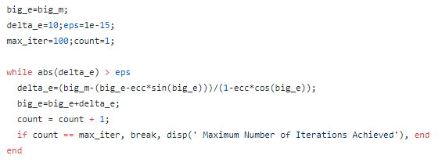

Initializing, E0 = M (Initial Guess)

Using Newtons Method of approximation



Where



STEP 2:Calculating initial position (**r**) and velocity(**v**=**r**-dot)

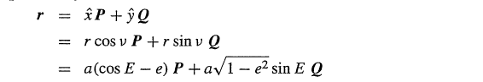

And the velocity(**v**) by

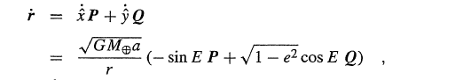

Now,

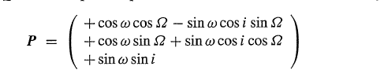

And

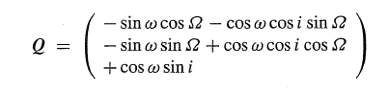

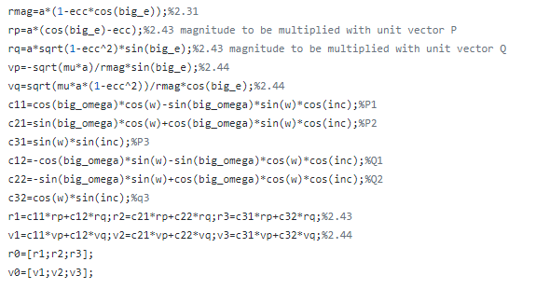

STEP 4:

Using Runge Kutta approximation we find the coordinates and velocity of the whole orbit such that

d*y*/d*t* = *f*(*t, y*)



Where, (d*t* = h)

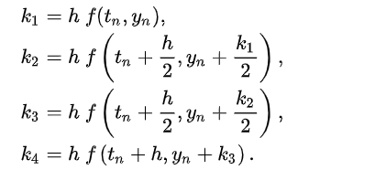

STEP 5:

We find the magnetic field for the whole orbit using WMM (World Magnetic Model)

STEP 6: Main Loop

Part A) Change the frame of the magnetic field from eci to body frame using

Bbody = ABeci

Where, A is Attitude Matrix formed using quaternion such that

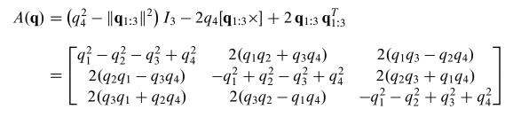

L = -k(I3 - bbodybTbody)ω

m= (+k/||B||)ω*bbody

Calculating next quaternion and angular velocity using Runge Kutta after d*t* time.;o9[