MODULE 1
Learning checkpoint - the basics of augmented reality
- Humankind’s first foray into immersive reality through a head-mounted display was the “Sword of Damocles,” created by Ivan Sutherland in 1968.
- HMD is the acronym for “head-mounted display.”
- The term “Augmented Reality” was coined by two Boeing researchers in 1992.
- A standalone headset is a VR or AR headset that does not require external processors, memory, or power.
- Through the combination of their hardware and software, many smartphones can view AR experiences that are less immersive than HMDs.
- Many of the components in smartphones—gyroscopes, cameras, accelerometers, miniaturized high-resolution displays—are also necessary for AR and VR headsets.
- The high demand for smartphones has driven the mass production of these components, resulting in greater hardware innovations and decreases in costs.
- Project Tango was an early AR experiment from Google, utilizing a combination of custom software and hardware innovations that led to a phone with depth-sensing cameras and powerful processors to enable high-fidelity AR.
- An evolution of Project Tango, ARCore is Google’s platform for building augmented reality experiences.

MODULE 2

The hardware that makes mobile AR work

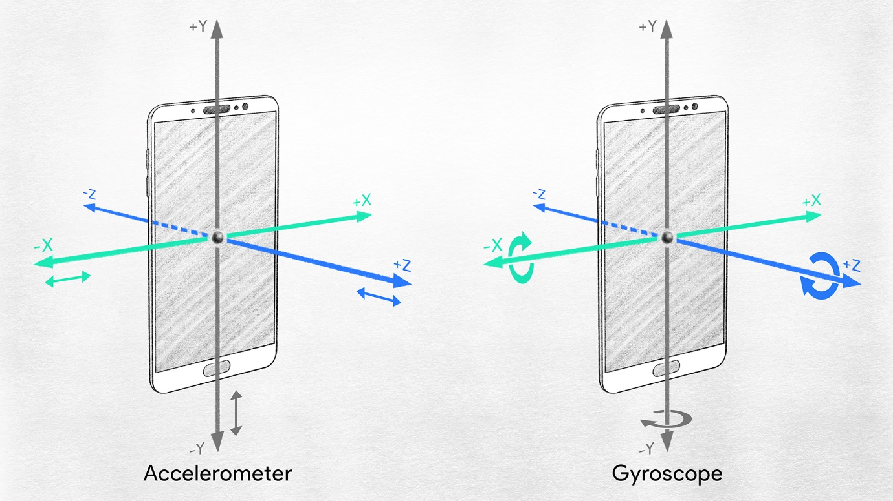

- Enables: motion tracking for AR
- Accelerometer: measures acceleration, which is change in speed divided by time. Simply put, it’s the measure of change in velocity. Acceleration forces can be static/continuous—like gravity—or dynamic, such as movement or vibrations.
- Gyroscope: measures and/or maintains orientation and angular velocity. When you change the rotation of your phone while using an AR experience, the gyroscope measures that rotation and ARCore ensures that the digital assets respond correctly.
- Phone Camera: with mobile AR, your phone camera supplies a live feed of the surrounding real world upon which AR content is overlaid. In addition to the camera itself, ARCore-capable phones like the Google Pixel rely on complementary technologies like machine learning, complex image processing, and computer vision to produce high-quality images and spatial maps for mobile AR.

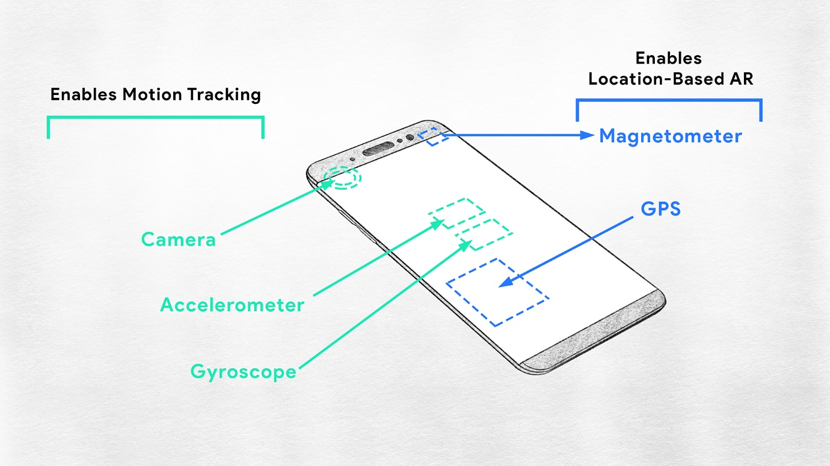

- Enables: location-based AR
- Magnetometer: gives smartphones a simple orientation related to the Earth's magnetic field. Because of the magnetometer, your phone always knows which direction is North, allowing it to auto-rotate digital maps depending on your physical orientation. This device is key to location-based AR apps.
- GPS: a global navigation satellite system that provides geolocation and time information to a GPS receiver, like in your smartphone. For ARCore-capable smartphones, this device helps enable location-based AR apps.
- Enables: view of real-world with AR
- Display: the display on your smartphone is important for crisp imagery and displaying 3D-rendered assets. For instance, Google Pixel XL’s display specification is a 5.5" AMOLED QHD (2560 x 1440) 534ppi display, which means that the phone can display 534 pixels per inch—making for rich, vivid images.

Learning checkpoint - AR functionality
- In order to seem real, an AR object has to act like its equivalent in the real world. Immersion is the sense that digital objects belong in the real world.
- Breaking immersion means that the sense of realism has been broken; in AR this is usually by an object behaving in a way that does not match our expectations.
- Placing is when the tracking of a digital object is fixed, or anchored, to a certain point in the real world.
- Scaling is when a placed AR object changes size and/or dimension relative to the AR device's position. For example, when a user moves away or towards an AR object, it feels like the object is getting larger or smaller depending on the distance of the phone in relation to the object. AR objects further away from the phone look smaller and objects that are closer look larger. This should mimic the depth perception of human eyes.
- Occlusion occurs when one object blocks another object from view.
- AR software and hardware need to maintain “context awareness” by tracking the physical objects in any given space and understanding their relationships to each other -- i.e. which ones are taller, shorter, further away, etc.

Learning checkpoint - inside-out vs. outside-in tracking
- There are two basic ways to track the position and orientation of a device or user: outside-in tracking and inside-out tracking.
- Outside-in tracking uses external cameras or sensors to detect motion and track positioning. This method offers more precision tracking, but a drawback is the external sensors lower the portability.
- Inside-out tracking uses cameras or sensors located within the device itself to track its position in real-world space. This method requires more hardware in the AR device but offers more portability.
- On the AR headset side, the Microsoft HoloLens is a device that uses inside-out tracking. On the VR headset side, the HTC Vive is a device that uses outside-in tracking.
- On the AR mobile side, the Google Pixel is a smartphone that uses inside-out tracking for AR.

Learning checkpoint - fundamentals of ARCore
- ARCore integrates virtual content with the real world as seen through your phone's camera and shown on your phone's display with technologies like motion tracking, environmental understanding, and light estimation.
- Motion tracking uses your phone's camera, internal gyroscope, and accelerometer to estimate its pose in 3D space in real-time.
- Environmental understanding is the process by which ARCore “recognizes” objects in your environment and uses that information to properly place and orient digital objects. This allows the phone to detect the size and location of flat horizontal surfaces like the ground or a coffee table.
- Light estimation in ARCore is a process that uses the phone’s cameras to determine how to realistically match the lighting of digital objects to the real world’s lighting, making them more believable within the augmented scene.
- Feature points are visually distinct features in your environment, like the edge of a chair, a light switch on a wall, the corner of a rug, or anything else that is likely to stay visible and consistently placed in your environment.
- Concurrent odometry and mapping (COM) is a motion tracking process for ARCore, and tracks the smartphone’s location in relation to its surrounding world.
- Plane finding is the smartphone-specific process by which ARCore determines where surfaces are in your environment and uses those surfaces to place and orient digital objects. ARCore looks for clusters of feature points that appear to lie on common horizontal or vertical surfaces, like tables or walls, and makes these surfaces available to your app as planes. ARCore can also determine each plane's boundary and make that information available to your app. You can use this information to place virtual objects resting on flat surfaces.
- Anchors “hold” the objects in their specified location after a user has placed them.
- Motion tracking is not perfect. As you walk around, error, referred to as drift, may accumulate, and the device's pose may not reflect where you actually are. Anchors allow the underlying system to correct that error by indicating which points are important.

Learning checkpoint - constraints with current AR
- Currently AR has a lack of user interface metaphors, meaning that a commonly understood method or language of human interaction has not been established.
- The purpose of the interface metaphor is to give the user instantaneous knowledge about how to interact with the user interface. An example is a QWERTY keyboard or a computer mouse.
- The details of what makes AR challenging from a technical standpoint are complex, but three influential factors are power, heat, and size.
- AR requires high processing power, batteries generate heat, and a current challenge is fitting all the necessary components into a small enough form factor to wear on your face comfortably for extended periods of time.
- Not everything in AR has to be 3D, but the vast majority of assets, applications, and experiences will require at least a little 3D design.
- Currently, there is a limited base of people with 3D design and interaction skills, such as professional animators, graphic designers, mechanical engineers, or video game creators. For AR to grow, the adoption of 3D design theory, skills, and language needs to become much more widespread. Later on in this course, we’ll be discussing a few programs that are helping overcome this challenge, like Sceneform or Poly API.
- Computer vision is a blend of artificial intelligence and computer science that aims to enable computers (like smartphones) to visually understand the surrounding world like human vision does. This technology needs to improve in terms of object detection and segmentation to make AR processes more effective.

MODULE 3
Cloud Anchors for shared AR
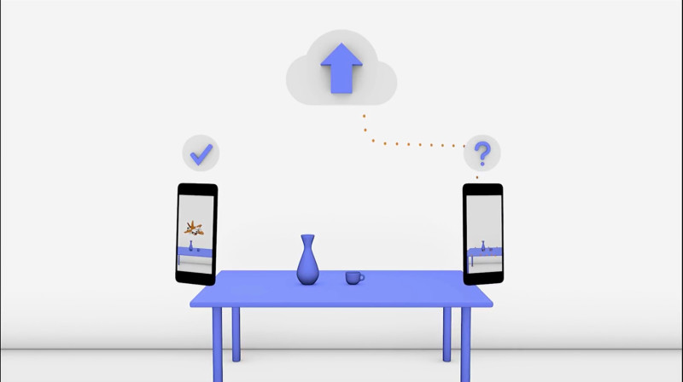

Cloud Anchors are a cross-platform feature that allow both iOS and Android device users to share the same AR experience despite using different underlying AR technologies. Where traditionally anchors have been isolated to one device—or one augmented reality—these anchors can be shared by multiple different devices simultaneously.
This makes AR possible for groups of people rather than just individuals, allowing for shared, collaborative experiences like redecorating your home, playing games and making art in 3D space together.
Cloud Anchors are critical to the growth of AR as a computing platform because so much of AR is dependent on sharing digital information with other people in the real world.

Here's how users set up cloud anchors for shared AR:
1. Host a native anchor to the cloud.
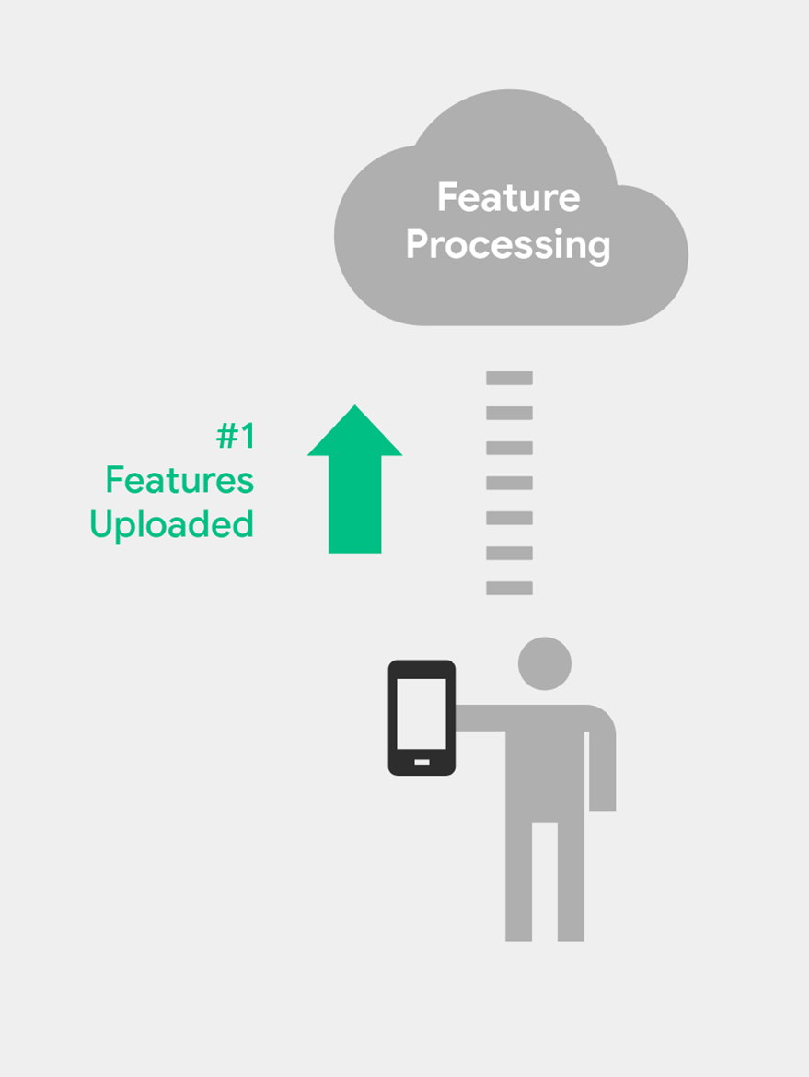

2. Create a Cloud Anchor (requires Cloud Anchor ID).
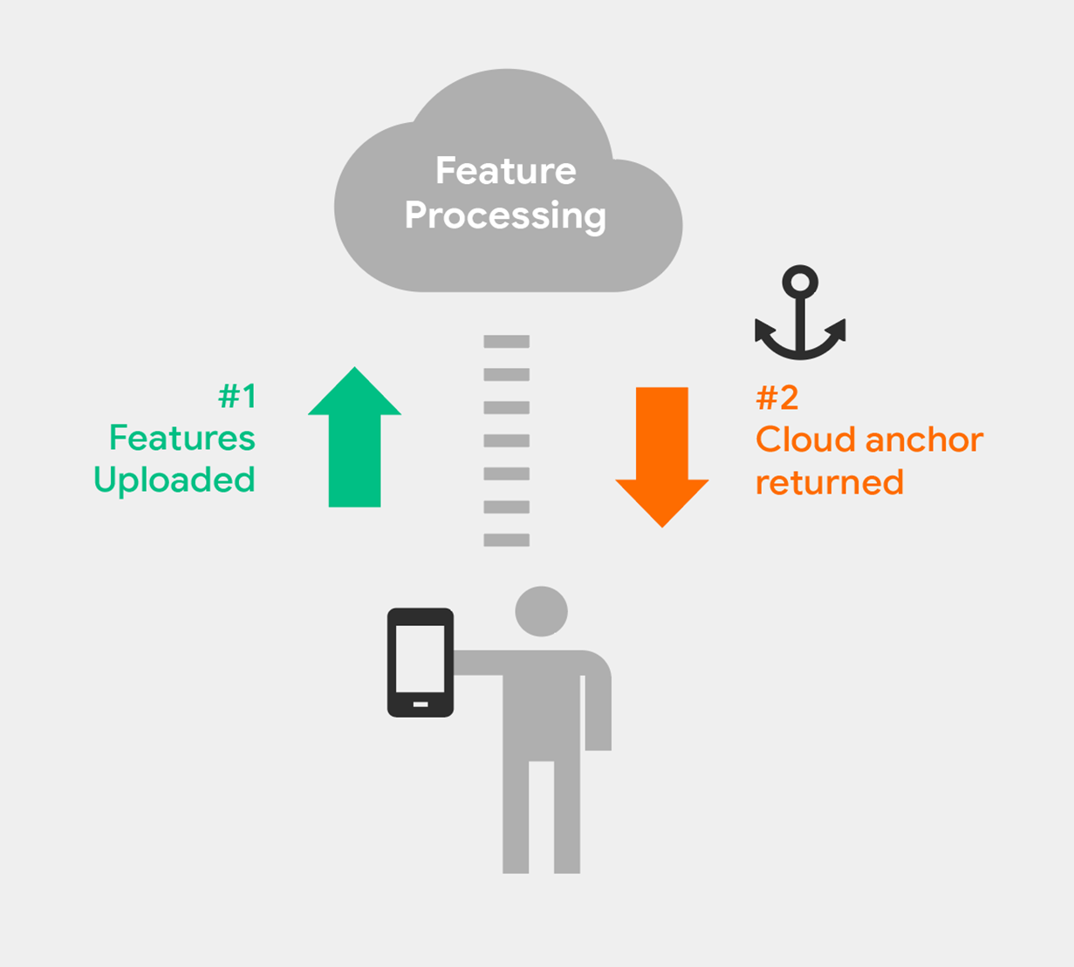

3. Cloud Anchor ID shared.
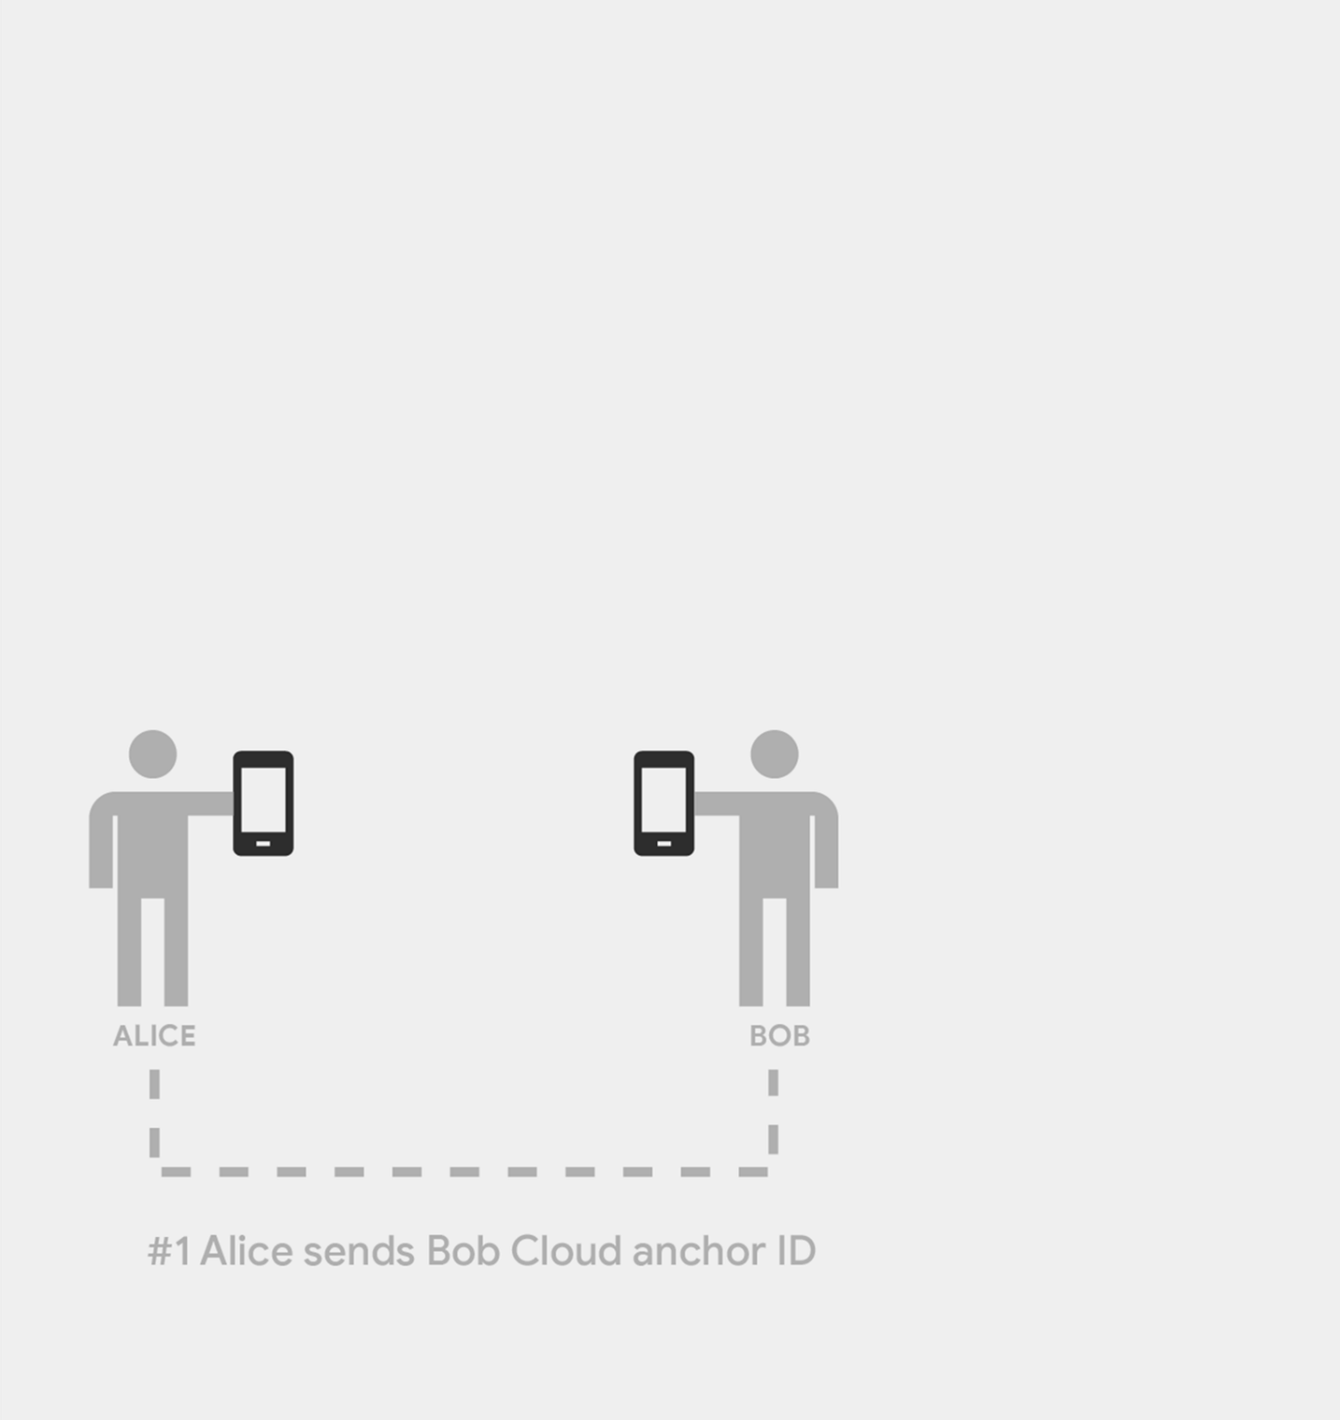

4. Resolve a Cloud Anchor with the ID.
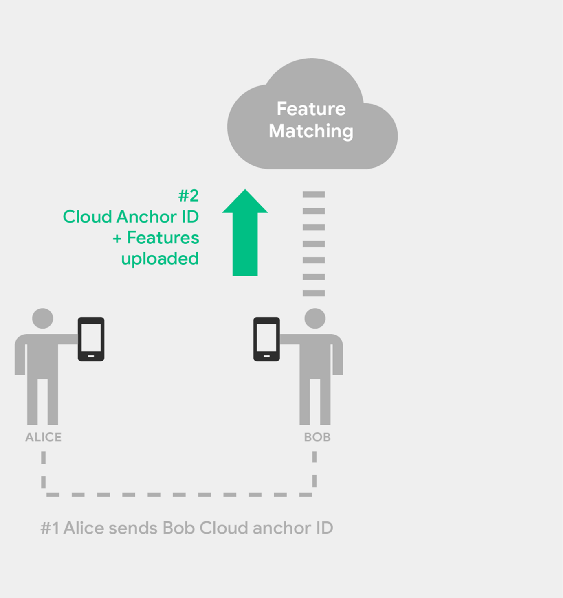
5. Cloud Anchor resolved.
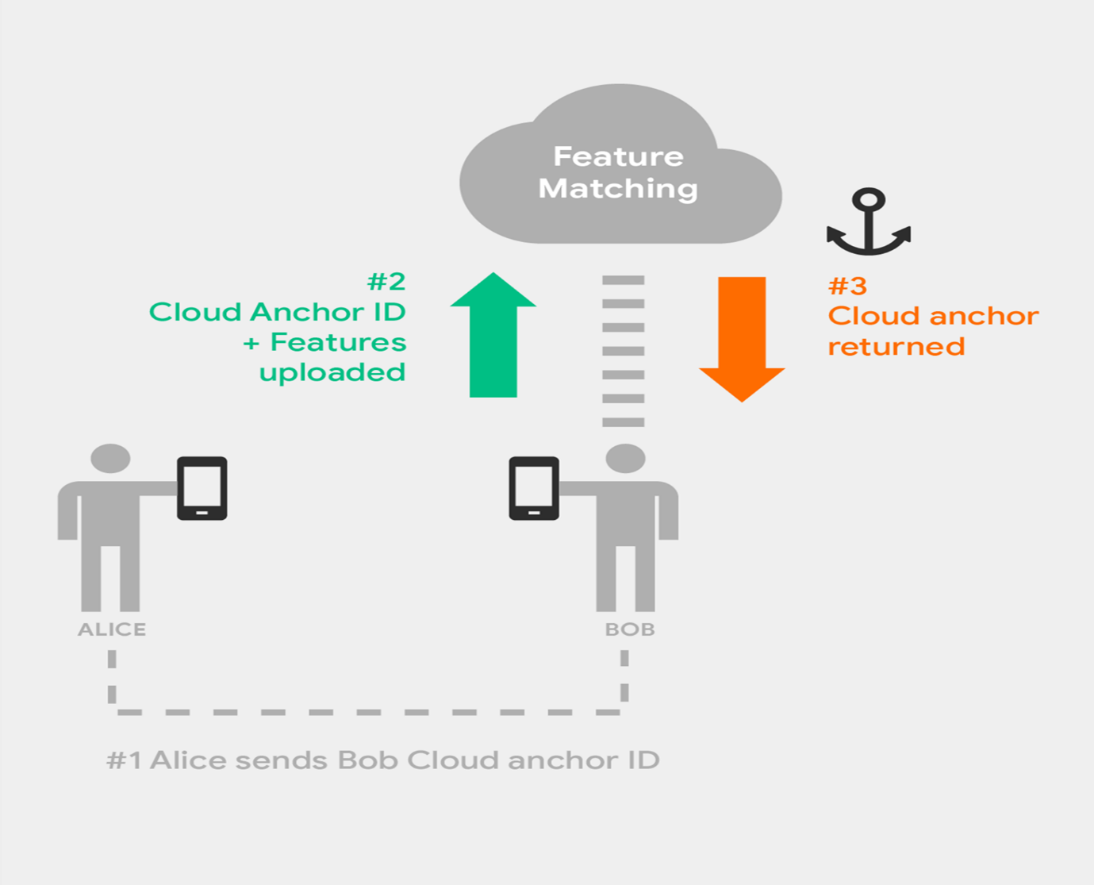
Learning checkpoint-use cases and current powers/limitations of AR
- ARCore can be used to create dynamic experiences for businesses, nonprofits, healthcare, schools, and more.
- ARCore’s strengths are its phone-based spatial mapping capabilities and addressable user base. Approximately 85% of phones around the world run on the Android operating system.
- At the beginning of 2018, ARCore is already available on 100 million Android-powered smartphones and that number continues growing. ARCore requires a lot of processing power, so not all older Android models have the necessary specifications yet. ARCore is also available in China.
- Limitations to consider with contemporary AR technology include: low-light environments, a lack of featured surfaces, and the availability of powerful mobile processors in new phones.
User experience (UX) and user interface (UI) to consider
- User interface (UI) and user experience (UX) are two complementary fields of product design. They have a lot in common, but generally speaking, UX is the more technical of the two.
- UX is the process and underlying framework of enhancing user flow to create products with high usability and accessibility for end users while UI is more akin to graphic design and focuses on the front-end design elements of the interface.
- At the most basic level, UI is the visuals of your app and everything that a user interacts with and UX is the process that supports the user's journey and interactions.
- Before creating an AR app it is important to deeply consider the design so that you are utilizing the minimal space of a phone display in the best possible way. By creating the most intuitive UX/UI for your app, you give it the best chance to succeed with users.
- When using an AR app your smartphone’s screen will mostly be filled with input from the camera, showing the live feed of the real world. It’s important to not overly clutter the screen with buttons or other elements that are nonessential and might be confusing for users.
- For example, the AR Stickers app displays placeable 3D objects at the top of the screen, so you can drag and drop a character into your scene. The app also allows you to hide the objects menu by clicking the “ ^ “ button. This lets the user concentrate on the character without the additional noise of the objects menu.
- If your app demands a lot of features, make sure the icons are displayed at the corners of the screen and don’t take up the crucial real estate in the middle of the screen. This is usually where most of the interaction with AR objects take place. Giving users the option to hide the menu is also a great feature to ensure immersion.
- It is important not to crowd the screen with too much information at once. However, with AR you’re not restricted to just the screen when it comes to UI menus. One option that allows creators to incorporate a lot of information is to use the environment as a menu, letting users interact with items or display information tagged to specific features, such as buildings.
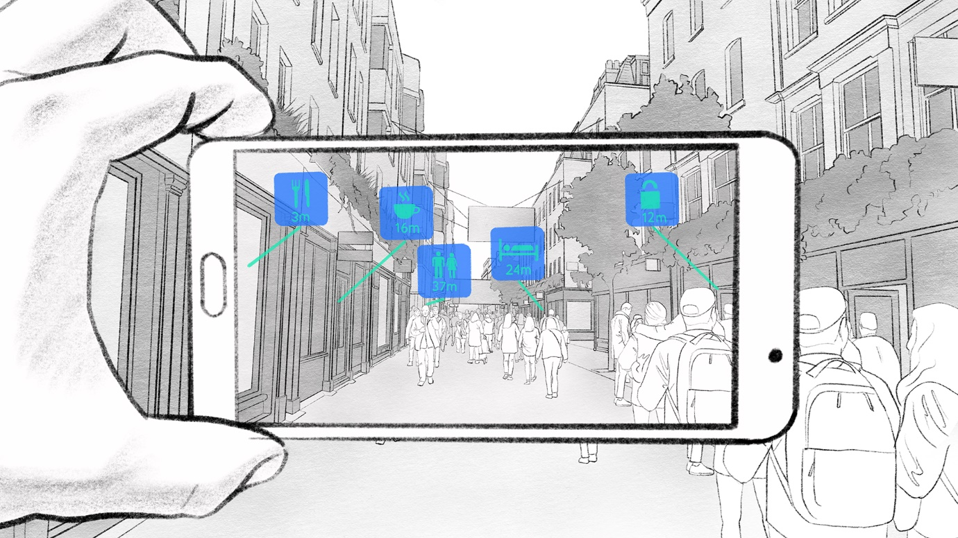

- You could also use interactable arrows, as pictured below, to display the information only when the user clicks on the arrow.

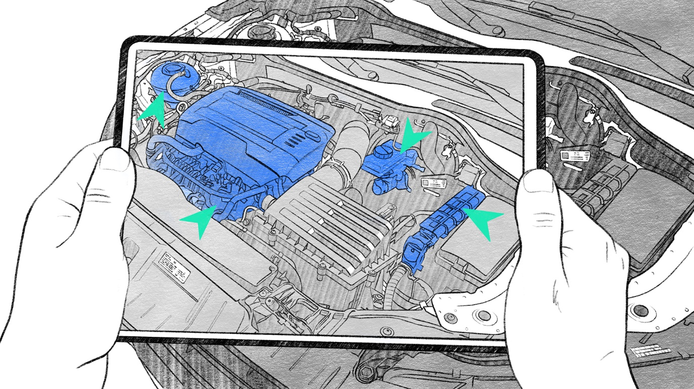

- Creators are best served by planning in advance the user flow—addressing its initial presentation, available input options as users progress, audio cues, and any other specific user actions the app might entail. This is crucial to a successful AR app.

Basic AR interaction options
The types of interaction options AR app creators can give users. Mobile AR is young, and creators are discovering new interaction mechanics all the time.

- Drag and Drop: This feature lets users drag and drop objects from a menu of 3D digital assets “onto” the screen to place them on a real-world surface (that has been spatially mapped by ARCore).
- Voice: Voice is quickly emerging as a powerful interaction tool that creators can build into AR apps. Building in pre-programmed voice commands allows users to execute specific actions within the AR app. This is often best achieved by embedding the Google Assistant SDK to add voice-enabled smart interaction
- Tap: With the tap mechanic, users can place objects in the real world by tapping on the screen. ARCore uses raycasting (the use of ray-to-surface as an intersection test) and projects a ray to help estimate where the AR object should be placed in order to appear on the real-world surface in a believable way. Another way to use tap is as a mechanic to interact with a digital object that is already placed in the scene. For example, maybe the app allows users to animate a 3D object when users tap on it.
- Pinch and Zoom: Pinch and zoom lets users enlarge or scale down a 3D object—or use the interaction in creative ways to build a game or user experience. For example, this could be used to pull back the string of a bow in a bow-and-arrow target game.
- Slide: Users can interact with 3D objects through sliding, which translates (or moves) objects in-scene, or use it as a game mechanic. For example, say you are creating an AR paper toss game. You could enable a slide interaction to let users project or throw papers into a trash can.
- Tilt: Using the accelerometer and gyroscope, a tilt of the phone can also be used as an input for creative interactions. An easy example would be to make a “steering wheel” mechanic for a racing tabletop AR game.

Learning checkpoint - think like a user
- User flow is the journey of your app's users and how a person will engage, step by step, with your AR experience.
- Planning your user flow needs to take into account the scene, the user interactions, any audio cues, and the final user actions.
- A user flow can be created with simple sketches and panels all collected into one cohesive diagram.
- UX and UI are complementary fields of product design, and generally speaking UX is the more technical of the two.
- When considering UX/UI, one good rule of thumb to remember with AR is to avoid cluttering the screen with too many buttons or elements that might be confusing to users.
- Choosing to use cartoonish designs or lighting can actually make the experience feel more realistic to the user, as opposed to photorealistic assets that fail to meet our expectations when they don't blend in perfectly with the real world.
- Users might try to “break” your experience by deliberately disregarding your carefully planned user flow, but your resources are better spent on improving your app’s usability rather than trying to prevent bad actors.

Next steps on the AR journey
- Advanced 3D design tools like Maya, Zbrush, Blender, and 3ds Max are powerful professional tools.
- Google’s Poly can be a good starting resource for building your first ARCore experience.
- Poly by Google is a repository of 3D assets that can be quickly downloaded and used in your ARCore experience.
- The recommended guide for your AR experience is a design document that contains all of the 3D assets, sounds, and other design ideas for your team to implement.
- You may need to hire advanced personnel to help you build your experience, such as 3D artists, texture designers, level designers, sound designers, or other professionals.

MODULE 4

Learning checkpoint - a closer look at mechanics of ARCore

- Surface detection allows ARCore to place digital objects on various surface heights, render different objects at different sizes and positions, and create more realistic AR experiences in general.
- Pose is the position and orientation of any object in relation to the world around it. Everything has its own unique pose: from your mobile device to the augmented 3D asset that you see on your display.
- Hit-testing lets you establish a pose for virtual objects and is the next step in the ARCore user process after feature-tracking (finding stationary feature points that inform the environmental understanding of the device) and plane-finding (the smartphone-specific process by which ARCore determines where horizontal surfaces are in your environment).
- Light estimation is a process that allows the phone to estimate the environment's current lighting conditions. ARCore is able to detect objects in suboptimal light and map a room successfully, but it’s important to note that there is a limit to how low the light can be for the experience to function.
- Occlusion is when one 3D object blocks another 3D object. Currently, this is only possible with digital objects, and AR objects cannot be occluded by a real-world object. For example, in an AR game, the digital object would not be able to be behind a real couch in the real world.
- Assets in multi-plane detection are scaled appropriately in relationship to the established planes, though only need to be placed on them (via anchor points) when it causes them to function like their real-world counterparts.
- Immersion can be broken by users interacting with AR objects as if they were physically real. Framing can be used to combat these immersion-breaking interactions.
- Spatial mapping is the ability to create a 3D map of the environment and helps establish where assets can be placed.
- Feature points are stationary and are used to further environmental understanding and place planes in an experience. ARCore assumes planes are unmoving, so it is inadvisable to attempt to anchor a digital object to a real world object that is in motion. In general, it’s best not to place an object until the room has been sufficiently mapped and static surfaces have been recognized and designated as feature points.

Poly, a library of 3D assets for your AR app

Google's Poly is a 3D asset library that lets you quickly find 3D objects and scenes for use in your apps, and it was built from the ground up with AR and VR development in mind.
You can use VR creation tools from Google like Tilt Brush and Blocks to build 3D assets and store them on Poly for use in AR apps.
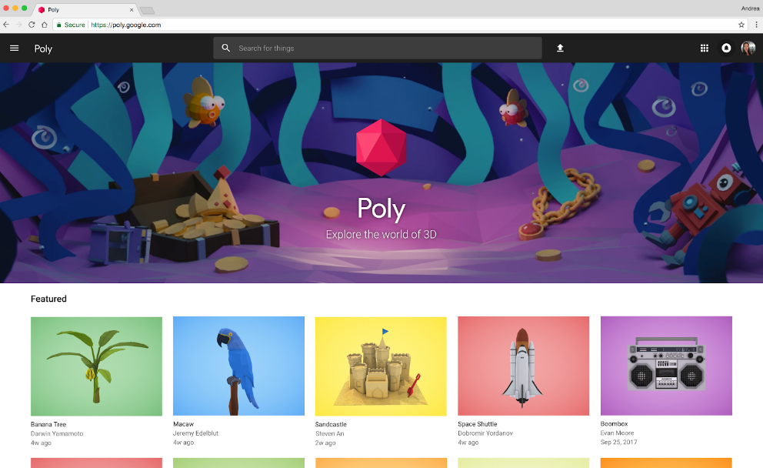

Poly allows you to browse, search, view and download thousands of objects and scenes for your project.
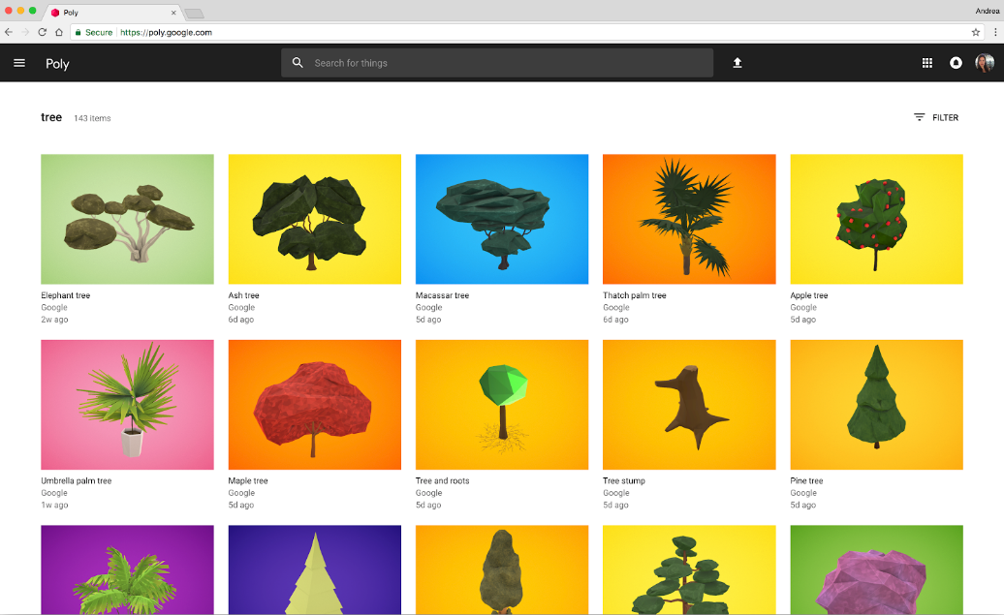

Poly is available on desktop, mobile, and in VR.

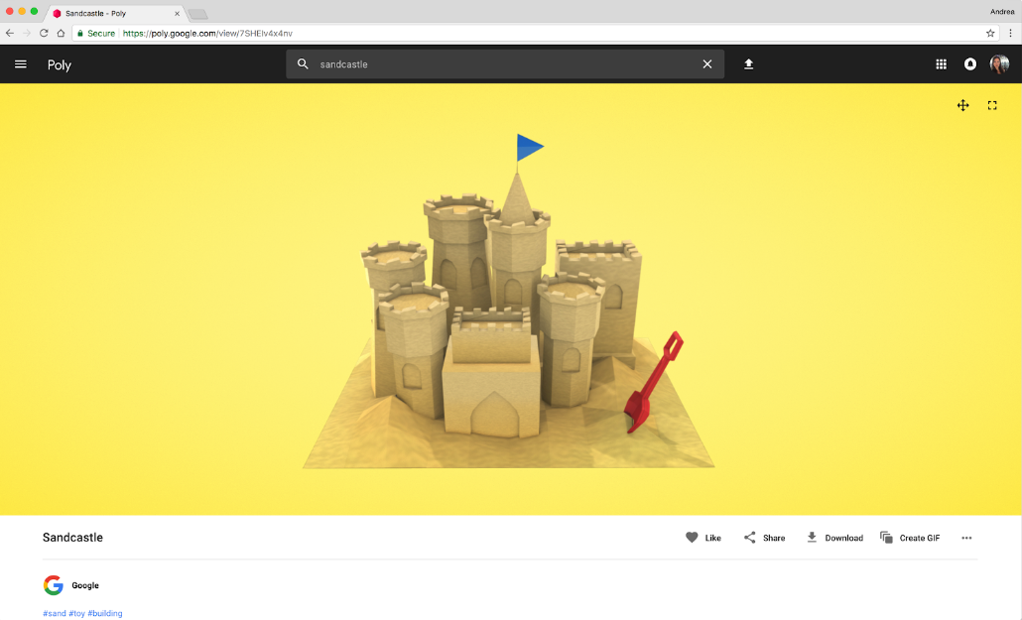

Poly can also create gifs and publish creations to the web.
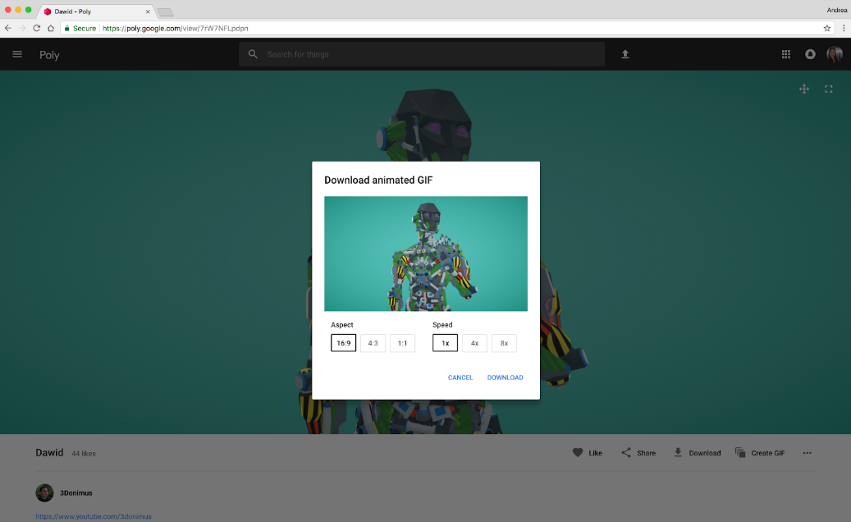

The Poly API provides read access to assets in the Poly library.

With the Poly API, users can access Google’s growing collection of Creative Commons 3D assets and interact directly with Poly to search, download, and import objects dynamically across desktop, mobile, virtual reality, and augmented reality.

Creators can find all types of assets for applications and easily search for remixable, free assets licensed under a Creative Commons license by keyword, category, format, popularity, or date uploaded.

Creators can filter by model complexity, or create a personalized experience by letting users sign into the app with their Google account to access any assets they’ve uploaded or liked on Poly.

Sceneform for easier AR content creation

Sceneform SDK is a high-level 3D framework that makes it easy for users to build AR apps in Java. It offers a new library for Android that enables the rapid creation and integration of AR experiences and combines ARCore with a powerful physically-based 3D renderer. It includes a runtime API for working with graphics and rendering, and a plugin to help you import, preview, and tweak the look and feel of your assets directly in Android Studio.
Sceneform is highly optimized for mobile. Java developers can now build immersive, 3D apps without having to learn complicated APIs like OpenGL. They can use it to build AR apps from scratch as well as add AR features to existing ones.
What follows is a walkthrough of how to use Sceneform. It's more technically advanced than most of the other content in this course--it's very helpful to have a little background in Java to fully appreciate how you might use it yourself--but we've included it so that aspiring creators can start to learn how to use Sceneform to make their own AR content.

Using Sceneform
To use Sceneform, first get the plugin. Like most other Android Studio Plugins, you can download this from the Android Studio Plugins page.
Preferences
> Plugins
>Browse Repositories
Google Sceneform Tools (Beta)
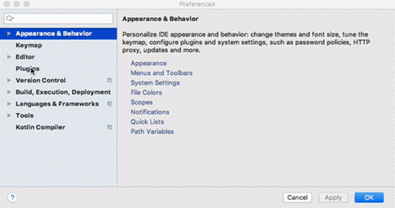
Once you have the plugin, it's easy to get assets imported. The first thing you'll need to do is place source files in your project. We recommend the sample data folder because sample data does not get bundled into your final project. This is important because you actually aren't going to want to include these raw source assets in your app. Supported files include:
- obj
- fbx
- glTF
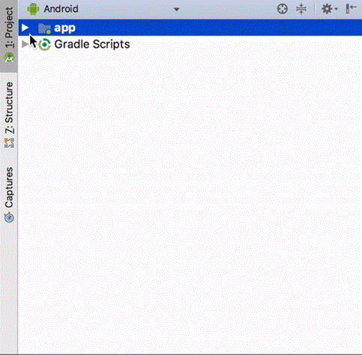
This is because Sceneform will convert these source files into a runtime-optimized format so that it performs well and looks great on a phone.
This new 'Runtime Optimized Binaries' format is called .sfb (or SFB), and it's what you'll eventually want to include in your APKs.
To import a Sceneform asset, right-click on the model, which will trigger an import wizard flow.
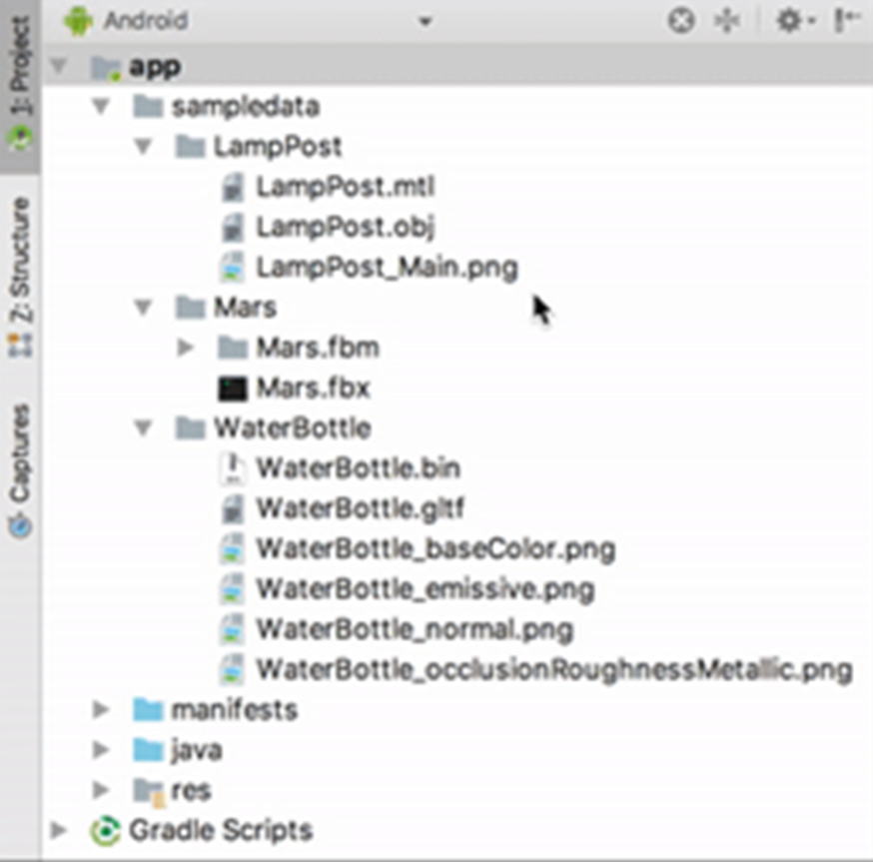
All the import wizard does is set up the connections between your model file and the generated files. The file path is automatically filled in when you import from the context menu. The "SFA" and "SFB" are created when you import, so in the example below we're just telling the importer where to put them once they're generated.
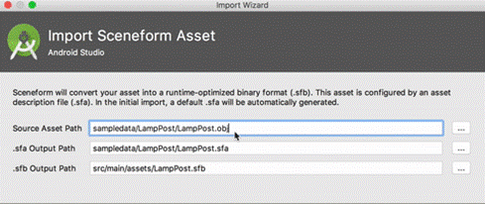
Now just click the finish button and your asset will be imported. From here, you'll want to see your new files.
The plugin will add your asset to the gradle build, hook it up to your build dependencies so it's always up-to-date with source assets, and generate the new SFB runtime-optimized file.
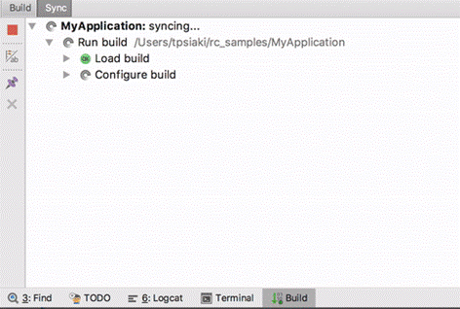
You'll notice that as soon as we finish, we pop up the SFB file viewer.
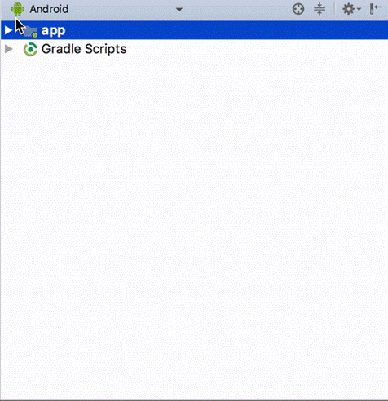
This viewer lets you see what your asset will look like without deploying it. The plugin uses the same renderer as we do on the phone: WYSIWYG.
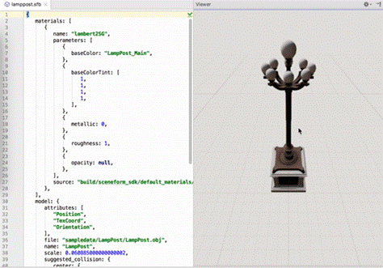
Let's say you wanted to tweak the object, like making it look shinier. You can customize your assets with the SFA. The SFA file defines how Sceneform renders an asset. You can change the parameters of the look and feel of the asset. And when you change it, the SFB will be built using the new settings we selected.
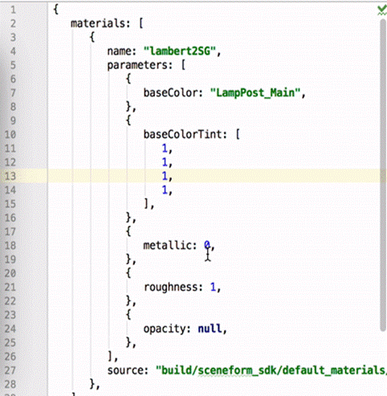
Once the file is saved with new parameters, the SFB will be regenerated and reloaded in the viewer. When you have the SFB open in the editor you can edit the asset definition, and as soon as we get your SFB updated with the new parameters you'll see exactly how the asset will look in your app.
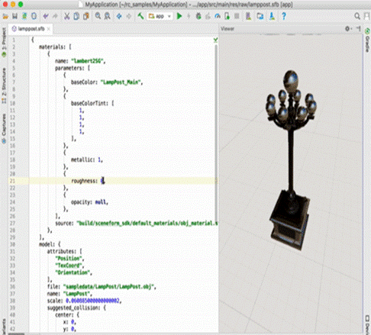
This is just one possible parameter tweak of many. To learn more about Material Parameters, including options for each of our supported file types, visit: https://developers.google.com/ar/develop/java/sceneform/sfa
Now it's time to put the asset in AR by loading it at runtime. This is code from the HelloSceneform app:
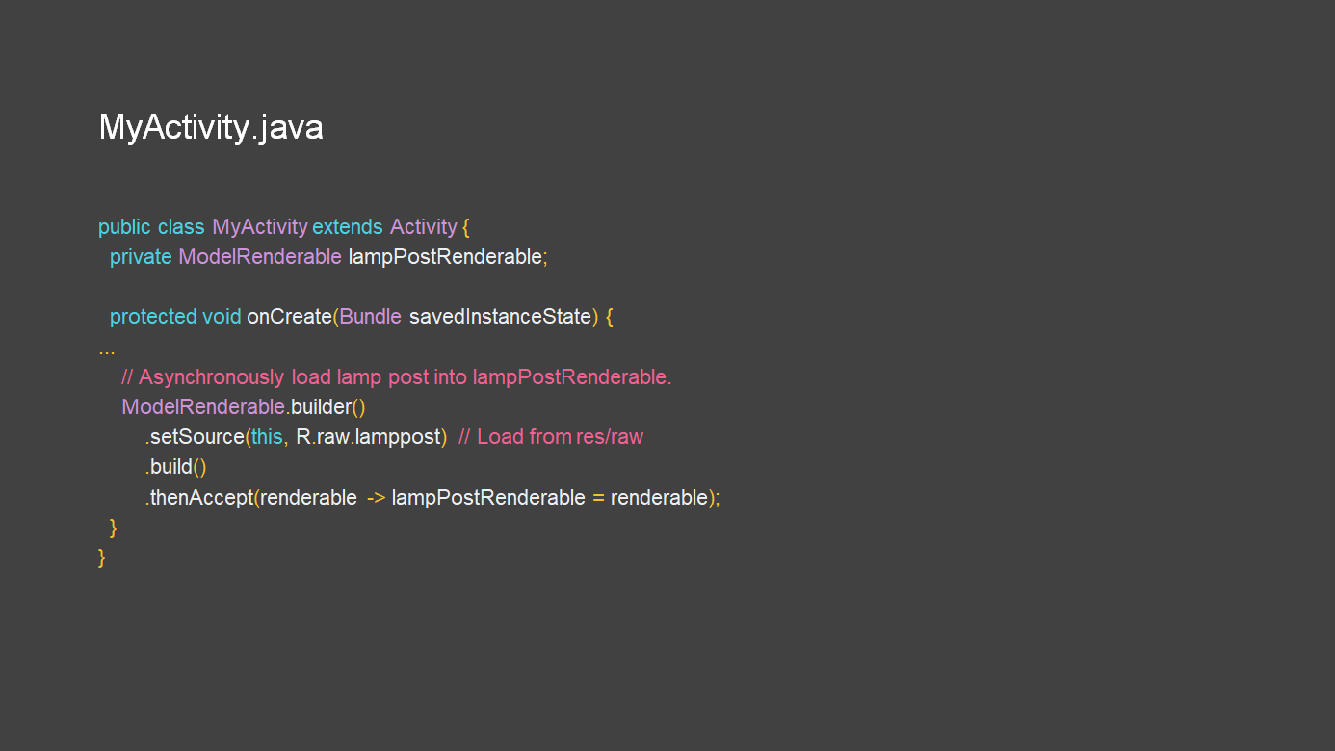
As you can see, we've changed the setSource line to just load with a Uri.
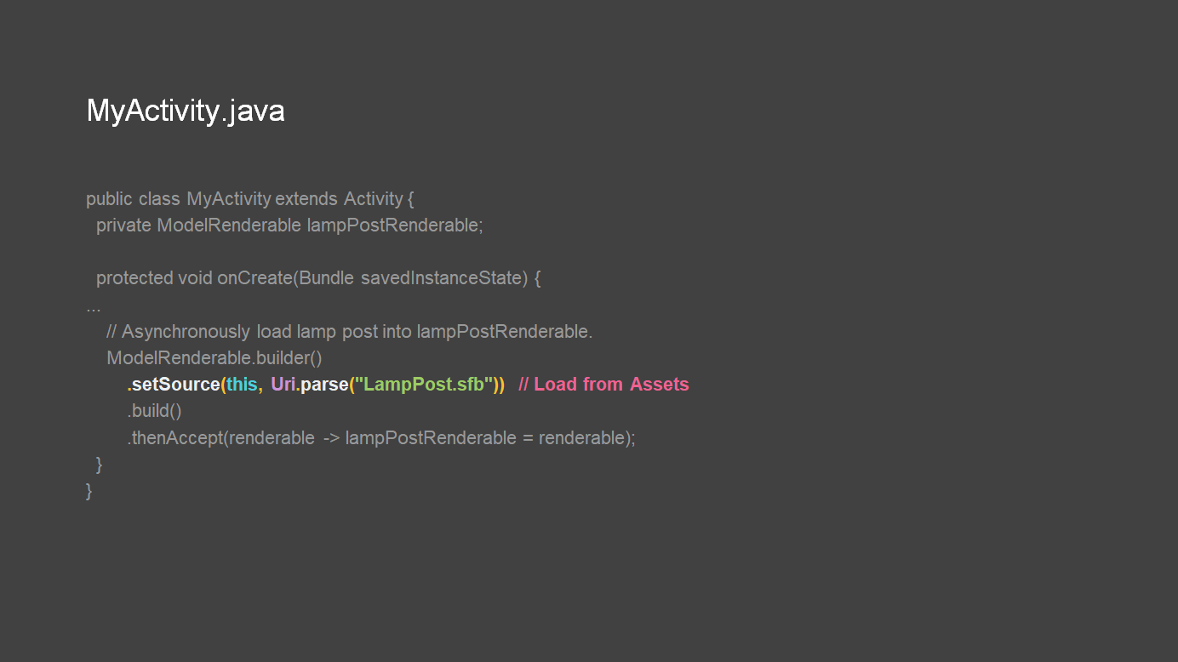
From here, you've created the first iteration of your AR app using Sceneform!
To learn more about the Sceneform SDK, and how to work with these ModelRenderables now that they are in the runtime, check out the "Rendering for Android AR apps" session from Google I/O 2018 here: https://www.youtube.com/watch?v=jzaMMV6w_OE

Learning checkpoint - using Poly and Unity to create ARCore assets

- Unity is a cross-platform game engine and development environment for both 3D and 2D interactive applications. It has a variety of tools, from the simple to the professionally complex, to allow for the streamlined creation of 3D objects and environments.
- Poly toolkit for Unity is a plugin that allows you to import assets from Poly into Unity at edit time and at runtime.
- Edit-time means manually downloading assets from Poly and importing them into your app's project while you are creating your app or experience.
- Runtime means downloading assets from Poly when your app is running. This allows your app to leverage Poly's ever-expanding library of assets.

