**R1.**

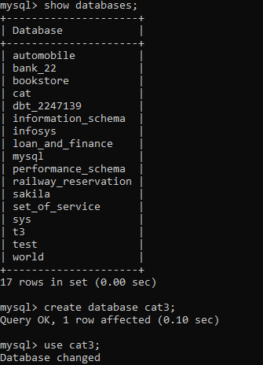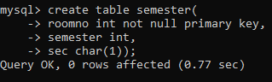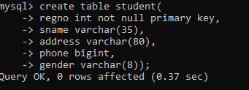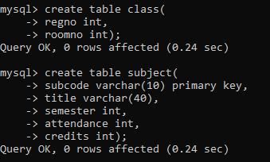

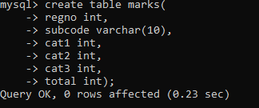

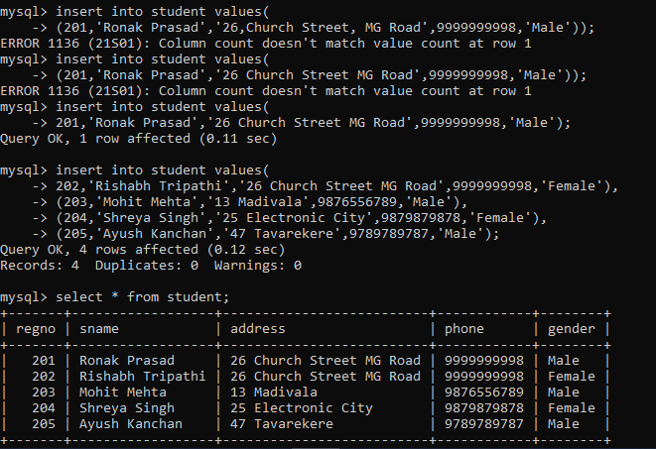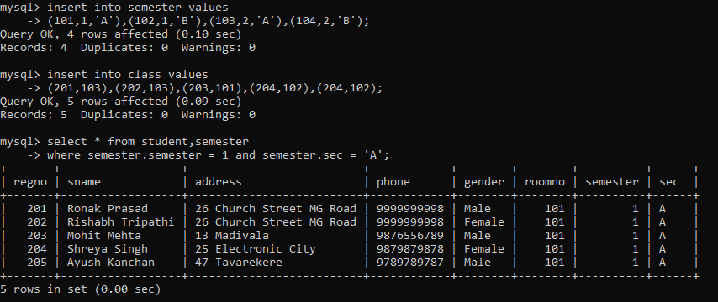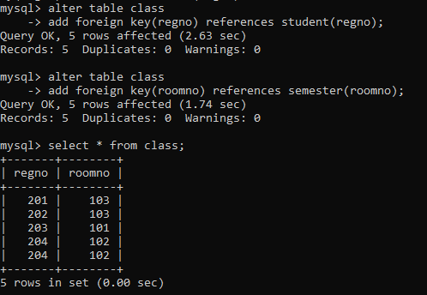

**R2.**

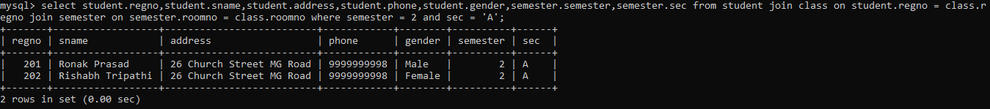

**ii)**



**v)**

mysql&gt; delimiter //

mysql&gt; create trigger msg

-&gt; after insert on marks

-&gt; for each row

-&gt; if new.total&lt;10 then

-&gt; insert into message(message_id,message)

-&gt; values(message_id,&quot;Fail&quot;);

-&gt; end if;

-&gt; end//

Query OK, 0 rows affected (0.18 sec)

**vi)**

mysql&gt; delimiter //

mysql&gt; create trigger updatecredits

-&gt; before update on subject

-&gt; for each row

-&gt; if new.attendance&gt;85 then set new.credits=credits+2;

-&gt; end if;

-&gt; //

Query OK, 0 rows affected (0.13 sec)

**vii)**

mysql&gt; delimiter //

mysql&gt; create trigger deleteinsert

-&gt; before delete on semester

-&gt; for each row

-&gt; if new.sem=2 then set new.sem=0;

-&gt; end if;//

mysql&gt; delimiter //

mysql&gt; end //

**R3:**

mysql&gt; delimiter //

mysql&gt; create procedure sp_getsec(in sec varchar(20))

-&gt; begin

-&gt; select count(id) from student_details where att_perc&gt;=85 and marks&gt;= 75 and section=sec;

-&gt; end //

Query OK, 0 rows affected (0.08 sec)

**R4:**

mysql&gt; create view MyMarks as

-&gt; select * from marks

-&gt; where reg_no = 2247243;

Query OK, 0 rows affected (0.16 sec)

mysql&gt; select * from MyMarks,marks;

+---------+-------------+------+------+------+-------+---------+-------------+------+------+------+-------+

| reg_no | subjectcode | cat1 | cat2 | cat3 | total | reg_no | subjectcode | cat1 | cat2 | cat3 | total

|

+---------+-------------+------+------+------+-------+---------+-------------+------+------+------+-------+

| 2247203 | 211 | 30 | 40 | 25 | 95 | 2247203 | 211 | 30 | 40 | 25 | 95 |

| 2247203 | 211 | 30 | 40 | 25 | 95 | 2247204 | 212 | 20 | 20 | 25 | 65 |

| 2247203 | 211 | 30 | 40 | 25 | 95 | 2247205 | 213 | 40 | 10 | 28 | 78 |

| 2247203 | 211 | 30 | 40 | 25 | 95 | 2247206 | 214 | 15 | 35 | 20 | 70 |

| 2247203 | 211 | 30 | 40 | 25 | 95 | 2247207 | 215 | 20 | 24 | 10 | 54 |

+---------+-------------+------+------+------+-------+---------+-------------+------+------+------+-------+

5 rows in set (0.00 sec)