<Document Title>

<Your Name>

<Student ID>

<Course Code>

<Professor Name>

<Due Date>

# Table of Contents

Table of Contents 2

Lab <n> - <Lab Name> 3

Part <n> 3

Description 3

Preparation 3

Observations 3

Screenshots 3

Reflection 3

References 3

# Lab <1> - <Lab Name>

# Part <1>

## Description

In this lab, I, a student studying computer system technician, discover the root bridge of the Spanning Tree Protocol (STP) network and use Cisco Packet Tracer to create a network. It's critical to understand STP in order to guarantee dependability and avoid network loops. We examine the switch configurations in order to identify the root bridge.

## Observations

I must look up each switch's bridge ID (BID), which is made up of its priority value and MAC address, in order to comprehend Cisco Packet Tracer. By choosing the switch with the lowest priority value to serve as the hub for network traffic routing and to provide a topology free of loops, this aids in locating the root bridge. Maintaining network stability and improving network architecture need an understanding of the function of the root bridge. Monitoring spanning tree configurations on a regular basis makes it possible to identify root bridge modifications or failures early on, enabling timely maintenance and troubleshooting to guarantee seamless network operation.

## Screenshots

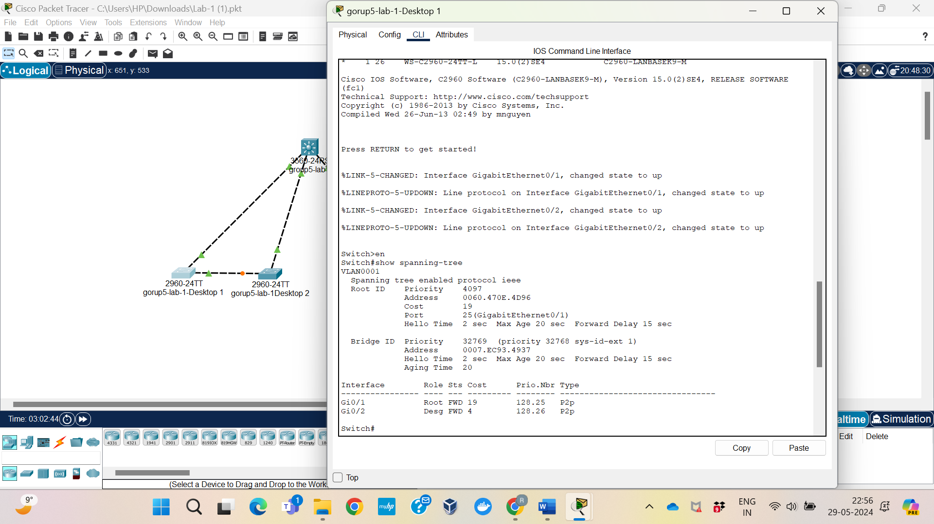

## Reflection

As a student studying computer system technologies, this Cisco Packet Tracer lab has been quite beneficial. I gained a lot of knowledge on the significance of the Spanning Tree Protocol (STP) for maintaining network stability and preventing loops. I learned in the lab to go through switch configurations to identify the root bridge with the lowest priority. It all comes down to maintaining network stability, streamlining its design, and routinely verifying STP setups to identify issues early. My practical abilities for networking and IT maintenance jobs in the real world have come from this hands-on experience.

# Lab <1> - <Lab Name>

# Part <2>

## Description

Spanning Tree Protocol (STP) priority for VLAN 1 may be manually changed on the Distribution switch using the command "spanning-tree vlan 1 priority 4096". By setting its priority to 4096, this configuration identifies the Distribution switch as VLAN 1's root bridge.

## Observations

Verify that Distribution is now recognized as the root bridge for VLAN 1 by running the "show spanning-tree" command on each switch in the network after the Distribution switch's configuration was changed. Make sure Distribution's priority value corresponds to the 4096 value that has been set.

## Screenshots

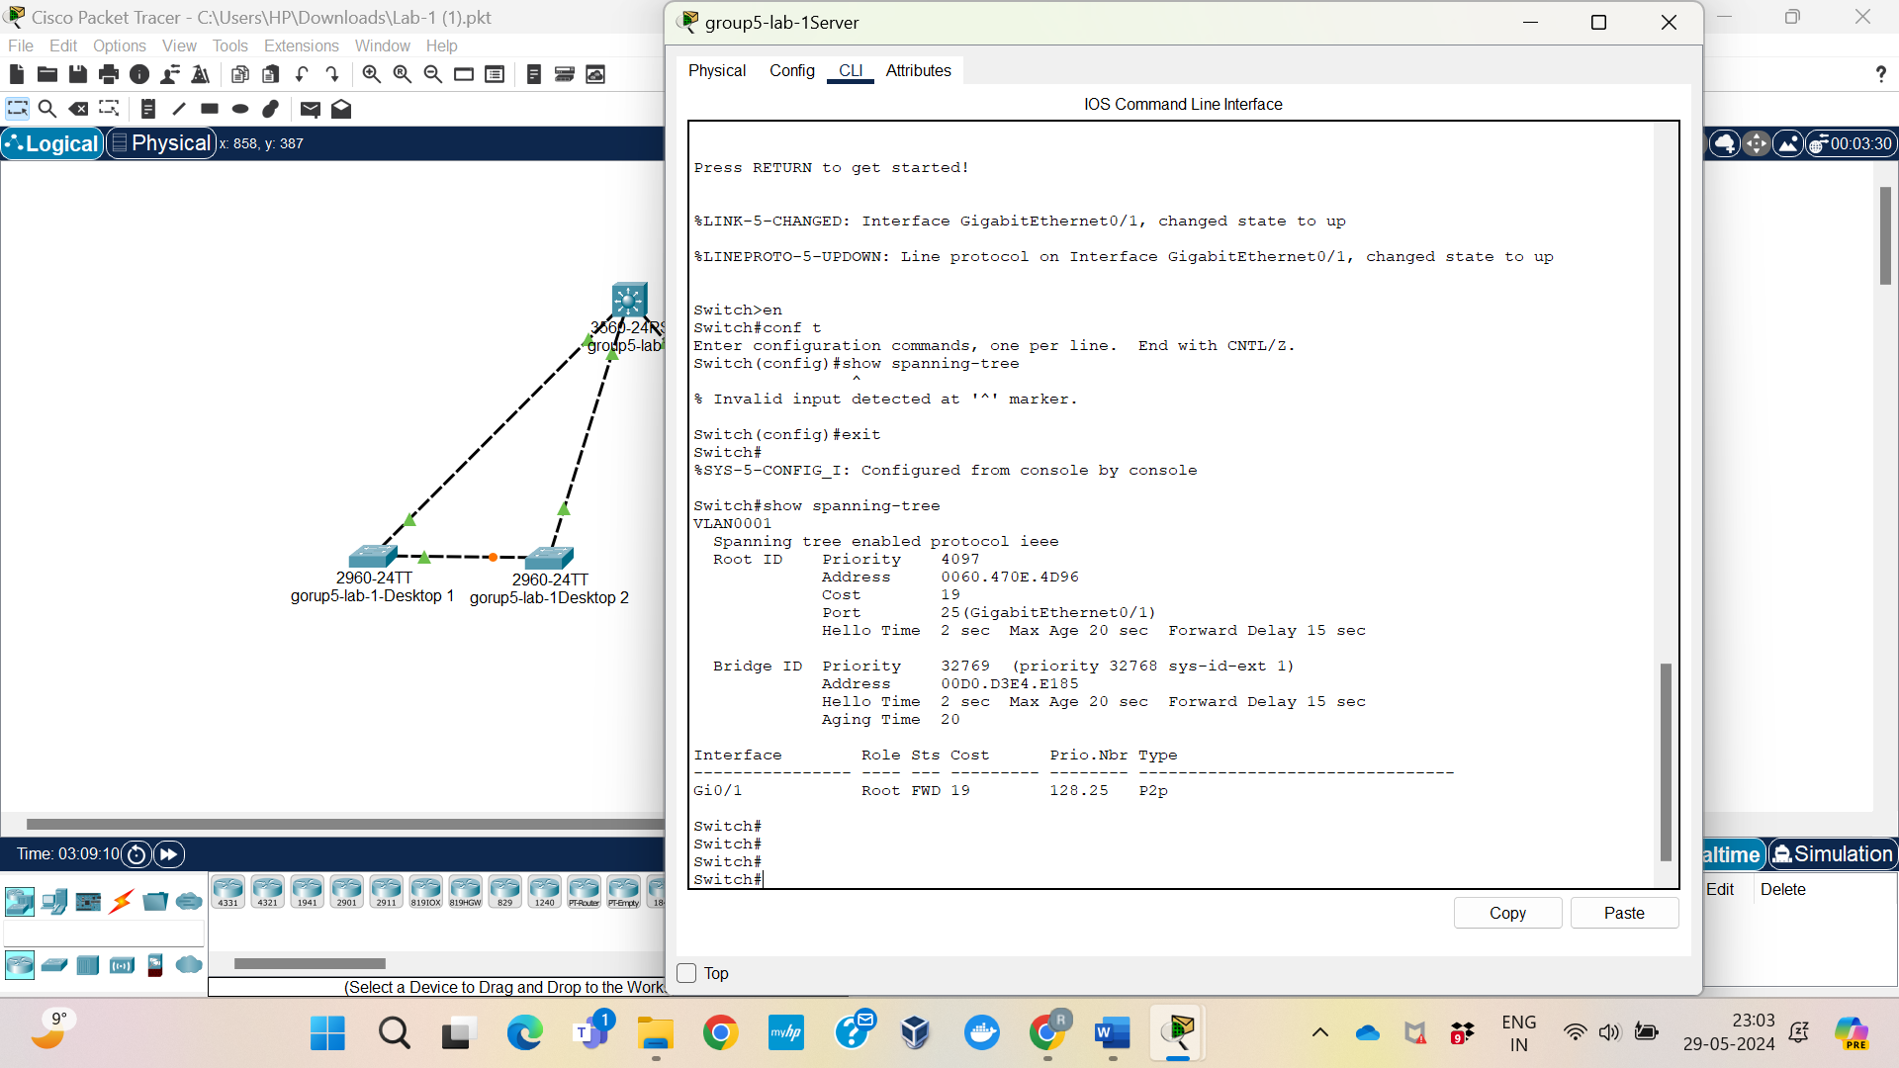

## Reflection

A more manual root bridge selection for VLAN 1 gives you more control over how the network's spanning tree is configured. This strategy makes sure that Distribution is in charge of effectively forwarding traffic and preserving network stability, regardless of whether it is functioning as a core or central switch in the network architecture. By selecting Distribution as the root bridge, network managers may improve overall network performance and traffic management to satisfy the needs of the enterprise.

# Lab <1> - <Lab Name>

# Part <3>

## Description

Observing and comprehending the functions and status changes of ports in a spanning tree network is the goal of the third lab segment. To find out how each port helps to keeping a loop-free network topology by adopting particular roles (Root, Designated, or Non-Designated) and states (Forwarding or Blocking), we will use the "show spanning-tree" command on each switch. Through this procedure, the network's Spanning Tree Protocol (STP) is guaranteed to be properly setup and functional.

## Observations

Make sure the network topology is established correctly and that the Distribution switch is selected as the root bridge in Packet Tracer before continuing with this lab part. By logging into each switch's CLI, make sure you're in the privileged EXEC mode, and make sure the "display spanning-tree" command can be executed on each switch. This command will provide complete STP status information as well as the necessary port responsibilities and statuses for the lab.

## Screenshots

## Reflection

The STP configuration's responsibilities and statuses guarantee effective data paths and avoid loops, ensuring the network's correct operation. In the Forwarding state, Root Ports and Designated Ports help to ensure smooth data flow, while Blocking Ports stop broadcast storm problems. Comprehending these responsibilities and statuses is essential for diagnosing and enhancing network performance. This illustration highlights how crucial STP is for preserving network stability and efficiency by controlling the quantity of data transfer paths.