<Document Title>

<Your Name>

<Student ID>

<Course Code>

<Professor Name>

<Due Date>

# Table of Contents

Table of Contents 2

Lab <n> - <Lab Name> 3

Part <n> 3

Description 3

Preparation 3

Observations 3

Screenshots 3

Reflection 3

References 3

# Lab <n> - <Lab Name>

# Task <1>

## Description

The network topology project entails creating and deploying a fiber-optic network that connects two buildings to form an organization's network infrastructure. The business headquarters and engineering/test departments, each with distinct departments and network needs, are located on the organization's main campus.

## Preparation

VLAN Definition: List the names of the VLANs and their functions for each department in the two buildings.

Inter-VLAN Routing: Set up routing to facilitate departmental communication inside the same structure.

Use access control lists, or ACLs, to manage departmental traffic flow and maintain security.

DHCP Setup: To enable dynamic IP addressing, set up DHCP servers for every VLAN.

Quality of Service (QoS): Set up policies to provide priority to traffic related to important applications.

Use the Spanning Tree Protocol (STP) to maintain redundancy and stop network loops.

Wireless Networks: Configure WiFi networks for visitors and employees that are appropriately secured.

Network Address Translation (NAT): To access the internet, set up NAT on the router.

VLAN Tagging: For VLAN segmentation, apply VLAN tagging to switch ports.

Testing: To guarantee appropriate functioning and connection, carry out thorough testing.

## Observations

For logical segmentation, VLANs need to be appropriately designed and linked to the departments for which they are intended.

While preserving security, inter-VLAN routing need to enable easy departmental collaboration.

It is important to properly establish ACLs in order to manage traffic flow and prevent unwanted access.

Within each VLAN, IP addresses should be assigned appropriately by DHCP servers.

To guarantee optimal performance, QoS regulations should provide priority to traffic related to key applications.

STP is supposed to keep the network stable and avoid loops.

Secure configuration of wireless networks is necessary to thwart unwanted access.

Internal devices should be able to access the internet via the ISP connection thanks to NAT.

In order to guarantee appropriate routing and traffic separation, VLAN tagging must be applied appropriately.

The complete network infrastructure's connection and operation should be confirmed through testing.

## Reflection

This organization's network topology design and implementation was a difficult but worthwhile experience that greatly improved my knowledge of and proficiency with network architecture. Every step of the project—from creating VLANs and setting up inter-VLAN routing to putting access control lists (ACLs) into place, setting up DHCP, establishing Quality of Service (QoS) policies, configuring wireless networks, implementing NAT, tagging VLANs, and conducting extensive testing—contributed to a comprehensive understanding of network design and management. This project was a crucial networking learning experience because of the careful planning and execution needed to satisfy the unique needs of each department while maintaining overall network efficiency and security. These efforts also yielded insightful knowledge about the deployment of network infrastructure in the real world.

# task <2>

## Description

The assignment involves setting up a company's main office and engineering/testing building's network topology in Packet Tracer. Routers (2911), switches (2960 for access, 3650 for distribution), and a few PCs as endpoints must be configured. Certain guidelines should be adhered to, such as having different switches for data centers, bonded channels for connections, and a router connected to the distribution switch of the main office for internet access. It's about ensuring that everything is correctly linked and functions as required for the network configuration.

## Preparation

Compile the necessary network elements in Packet Tracer: generic PCs, edge/access switches (2960), distribution switches (3650), and 2911 routers.

Arrange the topology's configuration, taking into account the specifications, including the quantity and positioning of switches, routers, and endpoints.

Observe the naming guidelines for network devices, making sure that the final four digits of the Condor ID come after the first four characters.

Set up bonded channel connections between distribution switches and edge switches, as well as between edge switches.

Assemble links between switches and routers in accordance with the topology specifications; don't forget to connect to the ISP router to get internet access.

## Observations

Check that the names of all network devices accurately reflect the naming scheme based on the Condor ID.

Verify that link aggregation and redundancy are configured correctly for bonded channel connections.

Verify that the devices are connected to each other and that the edge switches are connected to the appropriate distribution switches and routers in the correct ways.

Verify that the distribution switch in the headquarters building is linked to the router that offers internet connection.

To make sure that traffic flows appropriately in accordance with the topology design, test device connection and communication.

## Screenshots

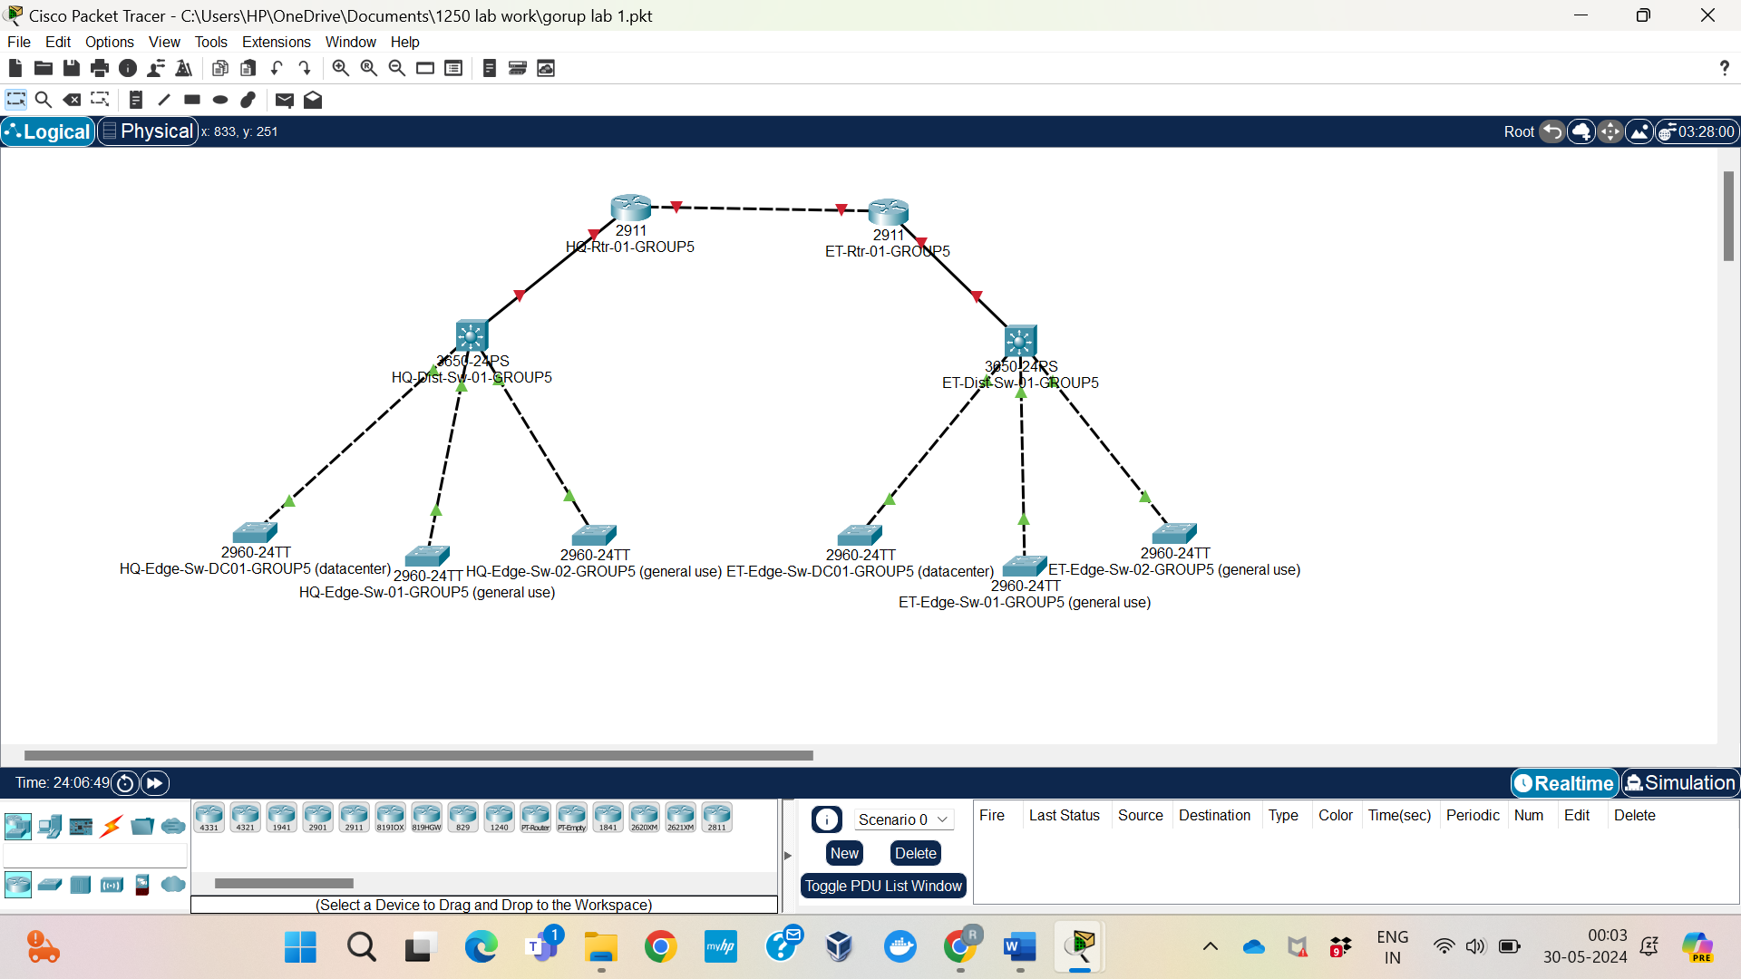

## Reflection

Creating the network topology in Packet Tracer gave me first-hand experience converting the specifications for network architecture into a workable implementation. A crucial component of the endeavor was setting up bonded channel connections and adhering to the naming guidelines, highlighting how crucial precise device naming and network connectivity are. The method demonstrated the complexities of network design, such as appropriate device location, connection planning, and functionality and reliability testing. Overall, utilizing simulation tools like Packet Tracer to design and build network topologies improved my abilities.