# **Practical No : 1**

# **Problem Statement : Write a program to print “hello world”**

# **Code :**

#include<stdio.h>

void main(){

printf("Hello World");

}

# **Output :**

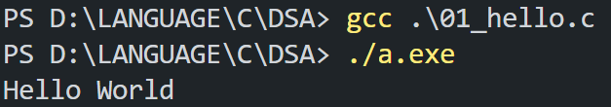

# **Practical No : 2**

# **Problem Statement : Write a program to take two input variable from user and swap that values.**

# **Code :**

#include<stdio.h>

void main(){

int a,b,c;

printf("Enter Your Value A:");

scanf("%d",&a);

printf("Enter Your Value B :");

scanf("%d",&b);

c=a;

a=b;

b=c;

printf("Your Value of A:%d",a);

printf("\n Your Value of B:%d",b);

}

# **Input :**

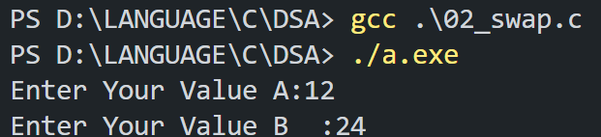

**Output :**



# **Practical No : 3**

# **Problem Statement : Write a program that computes x raised to the power y.**

# **Code :**

#include<stdio.h>

void main(){

int x,y,i,ans=1;

printf("Enter Your Value x:");

scanf("%d",&x);

printf("Enter Your Value Y:");

scanf("%d",&y);

for ( i = 1; i < y; i++)

{

ans *= x*ans;

}

printf("Your Value X raised Y:%d",ans);

}

# **Input :**

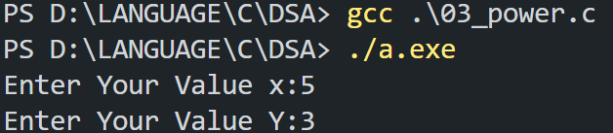

**Output :**



# **Practical No : 4**

# **Problem Statement : Perform program no. 2 and 3 using function.**

# **Code :**

#include<stdio.h>

#include<math.h>

void swap(int a,int b){

int c;

c=a;

a=b;

b=c;

printf("Your Value of A:%d",a);

printf("\n Your Value of B:%d",b);

}

void power(int a,int b){

int i,ans=1;

for ( i = 0; i < b; i++)

{

ans = a*ans;

}

printf("\nYour Value A raised B:%d",ans);

}

void main(){

int a,b;

printf("Enter Your Value A:");

scanf("%d",&a);

printf("Enter Your Value B:");

scanf("%d",&b);

swap(a,b);

power(a,b);

}

# **Input :**

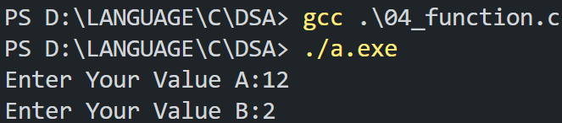

**Output :**

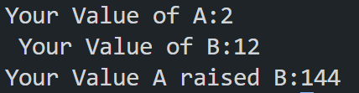

# **Practical No : 5**

# **Problem Statement : Write a calculator program(add,subtract,multiply,divide). Prepare user defined function for each functionality.**

# **Code :**

#include<stdio.h>

#include<math.h>

void add(int a,int b){

int c;

c=a+b;

printf("\nYour Addition :%d",c);

}

void sub(int a,int b){

int c;

c=a-b;

printf("\nYour Substraction :%d",c);

}

void mul(int a,int b){

int c;

c=a*b;

printf("\nYour Multification :%d",c);

}

void div(int a,int b){

int c;

c=a/b;

printf("\nYour Divide :%d",c);

}

void main(){

int a,b;

printf("Enter Your Value A:");

scanf("%d",&a);

printf("Enter Your Value B:");

scanf("%d",&b);

add(a,b);

sub(a,b);

mul(a,b);

div(a,b);

}

# **Input :**

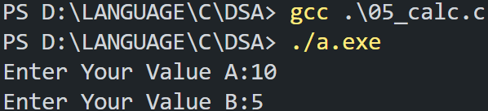

**Output :**

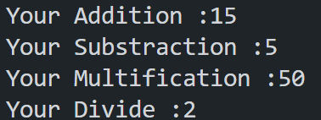

# **Practical No : 6**

# **Problem Statement : Write a program to find the maximum value from given array.**

# **Code :**

#include<stdio.h>

void main(){

int n,rk[100],x,i,max=1;

printf("Enter Your Value N:");

scanf("%d",&n);

for (i = 0; i < n; i++)

{

scanf("%d",&x);

rk[i] = x;

}

for (i = 0; i < n; i++){

if(max < rk[i]){

max=rk[i];

}

}

printf("Your Max Value:%d",max);

}

# **Input :**

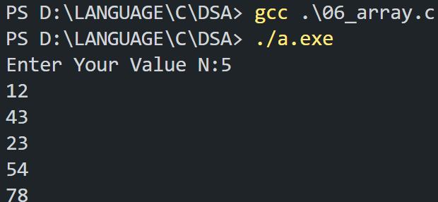

**Output :**



# **Practical No : 7**

# **Problem Statement : Perform program no.6 using function.**

# **Code :**

#include<stdio.h>

void maxi(int rk[100], int n){

int max=1,i;

for (i = 0; i < n; i++){

if(max < rk[i]){

max=rk[i];

}

}

printf("Your Max Value:%d",max);

}

void main(){

int i,rk[100],x,n;

printf("Enter Your Value N:");

scanf("%d",&n);

for (i = 0; i < n; i++)

{

scanf("%d",&x);

rk[i] = x;

}

maxi(rk, n);

}

# **Input :**

**Output :**



# 

# 

# 

# 

# 

# 

# 

# **Practical No : 8**

# **Problem Statement : Implement a program for ARRAY that performs following operations using function.**

# **(a) INSERT (b) DELETE (c) DISPLAY (d) SEARCH (e) MAX**

# 

# **Code :**

#include<stdio.h>

int n;

void ispop(int a[], int n){

int i,index,x;

printf("Enter the value of index:");

scanf("%d",&index);

for ( i = 0; i > n; i++)

{

if(i>=index){

a[i]=a[i+1];

}

}

n=n-1;

isdis(a,n);

}

void ispush(int a[], int n){

int i,index,x;

printf("Enter the value of index:");

scanf("%d",&index);

for ( i = n+1; i > index; i--)

{

a[i]=a[i-1];

}

printf("Enter the value of element:");

scanf("%d",&x);

a[index]=x;

n=n+1;

isdis(a,n);

}

int ischange(int a[], int n){

int i,index,x;

printf("Enter the value of index:");

scanf("%d",&index);

for ( i = 0; i < n; i++)

{

if(i==index){

printf("Enter the value of element:");

scanf("%d",&x);

a[i]=x;

}

}

isdis(a,n);

}

void isdis(int a[],int n){

int j;

printf("Each value of array:");

for ( j = 0; j < n; j++)

{

printf("%d ",a[j]);

}

}

void main(){

int a[50],i,x,j,b;

printf("Enter the value of number of element:");

scanf("%d",&n);

printf("Enter the value of element:");

for ( i = 0; i < n; i++)

{

scanf("%d",&x);

a[i]= x;

}

isdis(a,n);

printf("\n******************************************************************");

printf("\n1.Change");

printf("\n2.Display");

printf("\n3.Insert");

printf("\n4.Delete");

printf("\n******************************************************************");

printf("\nEnter the value:");

scanf("%d",&b);

switch(b)

{

case 1:

ischange(a,n);

break;

case 2:

isdis(a,n);

break;

case 3:

ispush(a,n);

break;

case 4:

ispop(a,n);

break;

default:

printf("Your Value is Not Match");

break;

}

}

# **Input :**

**Output :**

