# A

## Project Report

**On**

**AI ENHANCED CARRER COUNSELLING**

***Submitted in partial fulfillment for the award of degree of***

**Bachelor of Technology in**

**Computer Science & Engineering**

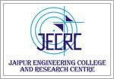

## Submitted By Project guide

**Group id - B12** Amit Mithal

DARSHAN RATHI (20EJCCS076) Associate Professor

HARDIK RATHI (20EJCCS100) HARSHAL POKHARNA (20EJCCS104) KISHNA GUPTA (20EJCCS143)

**Department of Computer Science & Engineering** Jaipur Engineering College & Research Centre Jaipur, Rajasthan

2023-24

# CANDIDATE’S DECLARATION

We, hereby declare that the work presented in this project entitled “**AI Enhanced Career Counselling”** in the partial fulfillment of the requirements for the award of the Degree of Bachelor of Technology in Computer Science & Engineering at Jaipur Engineering College and Research Centre, Jaipur is an authentic work of our own.

We have not submitted the matter embodied in this project work anywhere for the award of degree of Bachelor of Technology in Computer Science & Engineering.

**Group-ID:B-12**

**Darshan Rathi-(20EJCCS076) Hardik Rathi - (20EJCCS100) Harshal Pokharna-(20EJCCS104) Kishna Gupta-(20EJCCS143) Date: 27-04-2024**

**Place: Jaipur**

# BONAFIDE CERTIFICATE

This is to certify that the project entitled **"AI Enhanced Carrer Counselling"** is the bonafide work carried out by **Darshan Rathi ,Hardik Rathi, Harshal Pokharna, Kishna Gupta** students of B.Tech. in Computer Science & Engineering at Jaipur Engineering College and Research Centre, during the year 2023-24 in partial fulfillment of the requirements for the award of the Degree of Bachelor of Technology in Computer Science & Engineering and the project has not formed the basis for the award previously of any degree, diploma, fellowship or any other similar title.

**Name of Guide :- Mr Amit Mithal Designation :- Associate Professor Place: Jaipur**

**Date: 27-04-2024**

# VISION OF CSE DEPARTMENT

To become renowned Centre of excellence in computer science and engineering and make competent engineers and professionals with high ethical values prepared for lifelong learning.

# MISSION OF CSE DEPARTMENT

1. To impart outcome based education for emerging technologies in the field of computer science and engineering.
2. To provide opportunities for interaction between academia and industry.
3. To provide platform for lifelong learning by accepting the change in technologies.
4. To develop aptitude of fulfilling social responsibilities.

## PROGRAM OUTCOMES (POs)

1. **Engineering knowledge:** Apply the knowledge of mathematics, science, engineering fundamentals, and an engineering specialization to the solution of complex engineering problems.
2. **Problem analysis**: Identify, formulate, research literature, and analyze complex engineering problems reaching substantiated conclusions using first principles of mathematics, natural sciences, and engineering sciences.
3. **Design/development of solutions**: Design solutions for complex engineering problems and design system components or processes that meet the specified needs with appropriate consideration for the public health and safety, and the cultural, societal, and environmental considerations.
4. **Conduct investigations of complex problems**: Use research-based knowledge and research methods including design of experiments, analysis and interpretation of data, and synthesis of the information to provide valid conclusions.
5. **Modern tool usage**: Create, select, and apply appropriate techniques, resources, and modern engineering and IT tools including prediction and modeling to complex engineering activities with an understanding of the limitations.
6. **The engineer and society**: Apply reasoning informed by the contextual knowledge to assess societal, health, safety, legal and cultural issues and the consequent responsibilities relevant to the professional engineering practice.
7. **Environment and sustainability**: Understand the impact of the professional engineering solutions in societal and environmental contexts, and demonstrate the knowledge of, and need for sustainable development.
8. **Ethics**: Apply ethical principles and commit to professional ethics and responsibilities and norms of the engineering practice.
9. **Individual and team work**: Function effectively as an individual, and as a member or leader in diverse teams, and in multidisciplinary settings.
10. **Communication**: Communicate effectively on complex engineering activities with the engineering community and with society at large, such as, being able to comprehend and write effective reports and design documentation, make effective presentations, and give and receive clear instructions.
11. **Project management and finance**: Demonstrate knowledge and understanding of the engineering and management principles and apply these to one’s own work, as a member and leader in a team, to manage projects and in multidisciplinary environments.
12. **Life-long learning**: Recognize the need for, and have the preparation and ability to engage in independent and life-long learning in the broadest context of technological change.

## PROGRAM EDUCATIONAL OBJECTIVES (PEOs)

The PEOs of the B.Tech (CSE) program are:

**PEO1**: To provide students with the fundamentals of Engineering Sciences with more emphasis in computer science and engineering by way of analyzing and exploiting engineering challenges.

**PEO2:** To train students with good scientific and engineering knowledge so as to comprehend, analyze, design, and create novel products and solutions for the real life problems.

**PEO3**: To inculcate professional and ethical attitude, effective communication skills, teamwork skills, multidisciplinary approach, entrepreneurial thinking and an ability to relate engineering issues with social issues.

**PEO4:** To provide students with an academic environment aware of excellence, leadership, written ethical codes and guidelines, and the self-motivated life-long learning needed for a successful professional career.

**PEO5**: To prepare students to excel in Industry and Higher education by educating Students along with High moral values and Knowledge.

## PROGRAM SPECIFIC OUTCOMES (PSOs)

**PSO1:** Ability to interpret and analyze network specific and cyber security issues in real world environment.

**PSO2:** Ability to design and develop Mobile and Web-based applications under realistic constraints.

## COURSE OUTCOMES (COs)

On completion of project Graduates will be able to-

* CO1: Gather, organize, summarize and interpret technical literature with the purpose of formulating a project proposal.
* CO2: Design/Develop the solution using latest technologies and communicate via modern tools.
* CO3 Understand and develop the professional, social ethics, and team management principles.

**MAPPING: CO’s & PO’s**

|  |  |  |  |  |  |  |  |  |  |  |  |  |  |  |  |
| --- | --- | --- | --- | --- | --- | --- | --- | --- | --- | --- | --- | --- | --- | --- | --- |
| **Subjec t** | **Code** | **L**  **/ T**  **/ P** | **CO** | **P O 1** | **P O 2** | **P O 3** | **P O 4** | **P O 5** | **P O 6** | **P O 7** | **P O 8** | **P O 9** | **P O 1**  **0** | **P O 1**  **1** | **P O 1**  **2** |
|  |  |  | Graduates will be able to: |  |  |  |  |  |  |  |  |  |  |  |  |
|  |  |  | gather, organize, summarize |  |  |  |  |  |  |  |  |  |  |  |  |
|  |  | P | and interpret technical literature with the purpose of formulating a project proposal. | 3 | 3 | 3 | 2 | 2 | 2 | 1 | 2 | 1 | 2 | 2 | 3 |
|  |  |  | Graduates will be able to: |  |  |  |  |  |  |  |  |  |  |  |  |
|  |  |  | Design/Develop the solution |  |  |  |  |  |  |  |  |  |  |  |  |
| **Project** | 8CS7-50 | P | using latest technologies and  communicate via modern | 3 | 3 | 3 | 2 | 2 | 2 | 1 | 2 | 2 | 2 | 2 | 3 |
|  |  |  | tools. |  |  |  |  |  |  |  |  |  |  |  |  |
|  |  |  | Graduates will be able to: |  |  |  |  |  |  |  |  |  |  |  |  |
|  |  |  | Understand and develop the |  |  |  |  |  |  |  |  |  |  |  |  |
|  |  | P | professional, social ethics, and team management principles. | 3 | 3 | 3 | 2 | 2 | 2 | 1 | 2 | 2 | 2 | 2 | 3 |

# ACKNOWLEDGEMENT

We wish to express our deep sense of gratitude to our Project Guide **Mr. Amit Mithal**, Jaipur Engineering College and Research Centre, Jaipur for guiding us from the inception till the completion of the project. We sincerely acknowledge him for giving his valuable guidance, support for literature survey, critical reviews and comments for our Project.

We would like to first of all express our thanks to **Mr. Arpit Agrawal** Director of JECRC, for providing us such a great infrastructure and environment for our overall development.

We express sincere thanks to **Dr. V. K. Chandna**, Principal of JECRC, for his kind cooperation and extendible support towards the completion of our project.

Words are inadequate in offering our thanks to **Dr. Sanjay Gaur,** HOD of CSE department, for consistent encouragement and support for shaping our project in the presentable form.

We also like to express our thanks to all supporting CSE faculty members who have been a constant source of encouragement for successful completion of the project.

Also, our warm thanks to **Jaipur Engineering College and Research Centre**, who provided us this opportunity to carryout, this prestigious Project and enhance our learning in various technical fields.

**Group-ID: B-12**

**Darshan Rathi - (20EJCCS076) Hardik Rathi - (20EJCCS100) Harshal Pokharna-(20EJCCS104) Kishna Gupta - (20EJCCS143)**

# ABSTRACT

AI-Based Career Counseling is like a new way to help high school students pick their future jobs. It uses smart computers to give personalized advice to students. The goal is to make sure all students can easily get the help they need.

It works by testing students to see what they're good at. Then, using fancy computer programs, it suggests jobs that match their skills and interests. This helps students explore different options and find careers they might not have thought about before.

The main aim of AI-Based Career Counseling is to give students clear information about different jobs. It tells them about things like what the job involves, how much money they can make, and if there are chances for growth.

It also wants to make students feel confident about picking a career. By guiding them and supporting them along the way, it helps them choose paths that suit them best.

The platform is easy to use, so students from all backgrounds can access it. Whether they live in cities or small towns, they can find help to make smart choices about their future.

By using the latest technology, AI-Based Career Counseling could change how students think about planning their careers. It fills in gaps left by old ways of giving career advice, giving students more options and helping them reach their full potential.

In short, AI-Based Career Counseling is a new way to help high school students with career planning. It gives them personal support, clear information, and tools to feel confident about choosing the right job. With the help of artificial intelligence, it wants to make sure every student is ready to pick a career that suits them well.

**Table Of Content**

Candidates Declaration i

Bonafide Certificate ii

Vision and Mission iii

Program Outcomes (POs) iv

Program Education Objectives (PEOs) v

Program Specific Outcomes (PSOs) v

Course Outcomes (COs) vi

Mapping: COs and POs vi

Acknowledgement vii

Abstract viii

1. INTRODUCTION 12
   1. Purpose 13
   2. Project Scope 14
2. REQUIREMENT ANALYSIS 19
   1. Hardware Requirement 19
   2. Software Requirement 19
   3. Functional Requirement 20
   4. Non Functional Requirements 20
3. SYSTEM DESIGN 21
   1. Use Case Diagram 21
   2. Data Base Design and Databases 22
   3. Sequence Diagram 23
   4. Activity Diagram 24
   5. Data flow 25
   6. Flow chart 27
   7. UML 29
4. SCREEN SHOTS 31
5. TESTING 38
6. LIMITATIONS OF PROJECT 44
7. FUTURE SCOPE OF PROJECT 46
8. REFERENCES 48

# INTRODUCTION

Choosing a career isn't constantly a simple task for students, particularly since the decision should be based on a few criteria and at a generally early age. This significant decision influences the academic and professional existence of the student. An awful educational or professional guidance might be at the inception of a few educational and social issues: failure, dropout, lack of skills, integration difficulties, unemployment and so on. Career development is a lifelong procedure. There are various components that impact your career development, including your interests, abilities, values, personality, background, and circumstances. Guidance is a term sometimes utilized extensively to refer to advising or helping an individual with any sort of educational, vocational or personal issue. It can likewise be referred to as a service gave by the specific school to help a person in settling on clever decision and changes to build up their potentials as an individual and a contributing member from the society. Guidance is a procedure of helping a person to acknowledge and develop his/her vocational, educational, and psychological potentials and additionally accomplishing the best degree of individual joy and cultural value. Career guidance comprises of services that help individuals effectively deal with their career planning and development. The proposed system is an online career guidance system which will address the concerned issues. The proposed system will assess students on different parameters to recommend a career path. The parameters are personal interests, personality traits, skills, aptitude, comfort, and so on. The system is utilized in a useful way, an online career counselor can be more successful and open than a genuine counselor. An artificial intelligence system is a computer program that works a similar way that a biological brain does, just that it functions in an electronic path rather than by activating neurons. characterizes artificial intelligence as the science and engineering of making intelligent machines, particularly intelligent computer programs. Expert system approach is valuable to enable human expert (to career counselors), additionally as an authentic and effective device for the computerization and automation of the reasoning of human career instructor, by investigating the expert system highlights, for example, questioning ability, reasoning power, providing explanations, providing alternative solutions.

# PURPOSE

AI-enhanced career counseling stands at the forefront of transforming traditional career guidance methods through the utilization of artificial intelligence. This innovative approach aims to provide individuals with personalized, efficient, and data-driven guidance as they navigate their career journeys. By tapping into the power of AI, these systems analyze extensive datasets encompassing individuals' skills, interests, personality traits, and market trends. This comprehensive analysis enables AI systems to generate tailored recommendations that align closely with each individual's unique profile.

The personalization offered by AI-enhanced career counseling not only enhances the relevance of the guidance provided but also empowers individuals to make more informed decisions about their career paths. By presenting insights derived from in-depth data analysis, these platforms enable individuals to gain a deeper understanding of their strengths, weaknesses, and potential opportunities in the job market.

Moreover, AI streamlines the counseling process by automating tasks such as initial assessments and resource recommendations. This automation not only saves time for both counselors and clients but also ensures consistency and accuracy in the guidance provided. Furthermore, the accessibility of AI-powered platforms ensures that career guidance is available anytime, anywhere, catering to diverse populations regardless of geographical constraints.

The overarching goal of AI-enhanced career counseling is to equip individuals with the tools and insights necessary to navigate the complexities of the modern job market successfully. By leveraging AI technologies, these platforms aim to empower individuals to make strategic career decisions that align with their aspirations and maximize their potential for professional growth and fulfillment. In essence, AI-enhanced career counseling represents a paradigm shift in career guidance, ushering in a new era of personalized, efficient, and accessible support for individuals as they pursue their professional goals.

# PROJECT SCOPE

The scope of the AI-Based Career Counseling project encompasses the following areas:

1. **Development of AI Algorithms:** The project involves the development and implementation of advanced AI algorithms that can analyze individual talents, skills, and preferences to provide personalized career guidance and recommendations.
2. **User Interface Design:** A user-friendly and intuitive interface will be designed to facilitate easy interaction between students and the AI-based career counseling system. The interface should accommodate diverse user needs and enable seamless navigation through the system's features.
3. **Natural Talent Testing:** The project includes the integration of natural talent testing methodologies to assess students' aptitudes and identify their inherent strengths. This testing process will contribute to generating personalized career suggestions.
4. **Career Path Information:** The system will provide comprehensive and up-to-date information on various career paths, including job descriptions, required qualifications, salary ranges, growth prospects, and industry trends. The information will assist students in making informed decisions about their future careers.
5. **Scalability and Accessibility**: The project will focus on developing a scalable system that can accommodate a large number of users, ensuring that the AI-based career counseling services are accessible to all students. The system should be designed to handle increasing user demands without compromising performance**.**
6. **Data Security and Privacy**: Adequate measures will be implemented to ensure the security and privacy of user data. The project will comply with relevant data protection regulations and employ encryption techniques and access controls to safeguard personal information.

# METHODOLOGY

The Iterative model is a software development lifecycle model that emphasizes an iterative, repetitive approach to development. It involves breaking down the development process into smaller cycles or iterations, each of which encompasses the phases of planning, analysis and design, implementation, testing, and deployment. Here's an explanation of each phase:

1. **Planning**: In the planning phase, the project objectives, requirements, scope, and constraints are identified and defined. This includes determining the project timeline, budget, resources, and potential risks. The planning phase sets the foundation for the entire development process by establishing clear goals and guidelines.
2. **Analysis and Design:** During the analysis and design phase, the requirements gathered in the planning phase are analyzed in detail. This involves understanding the needs of the end-users and stakeholders and translating them into a design for the software system. The design phase includes architectural design, database design, user interface design, and other aspects necessary to create a blueprint for the software solution.
3. **Implementation:** The implementation phase involves the actual coding or development of the software based on the design specifications. Developers write code according to the design documents and implement the functionality outlined in the requirements. This phase focuses on turning the design into a working software product.
4. **Testing:** In the testing phase, the developed software is thoroughly tested to ensure it meets the specified requirements and functions correctly. Testing includes various types such as unit testing, integration testing, system testing, and acceptance testing. Defects and bugs are identified, reported, and fixed during this phase to improve the quality and reliability of the software.
5. **Deployment**: The deployment phase marks the release of the software to the end-users or customers. It involves installing the software on production servers, configuring it for use, and making it available to users. Deployment also includes activities such as user training, documentation, and ongoing support to ensure a smooth transition to the new software system.

The Iterative model differs from traditional linear models like the Waterfall model in that it allows for flexibility and adaptation throughout the development process. Instead of completing each phase sequentially and moving on to the next, iterations allow for feedback, adjustments, and refinements to be made at each stage. This iterative approach enables continuous improvement and incremental delivery of software, leading to better alignment with customer needs and reduced risks of project failure.

## Project Planning

### User Interfaces:

* + - The user interface will feature a menu bar with options such as:
      1. Counselor’s panel: Access to interact with career counselors or experts.
      2. Career details lists for 10th, 12th, and after graduation: Information about various career options.
      3. Link to the Home page: Navigation back to the main page.
    - The UI will be responsive, ensuring smooth viewing on various devices like mobile phones, tablets, laptops, and desktop computers.

### Hardware Interfaces:

* + - The system will support compatible hardware devices to be connected, although specific hardware requirements are not mentioned. This could include peripherals like printers, scanners, or any other relevant hardware needed for accessing or utilizing the system's features.

### Software Interfaces:

* + - Browser Compatibility: The system will be compatible with all major web browsers, allowing users to access career guidance services, take tests, and consult counselors using their preferred browser.
    - Operating System: The system has been developed for the Windows operating system due to its widespread usage and user-friendliness, ensuring broad accessibility to users.
    - Database: A database will be utilized to store career details and user information. The choice of database management system (DBMS) is not specified, but it will be integral for efficiently managing and retrieving stored data.
    - Programming Language: Python will be used as the programming language for implementing machine learning algorithms for career prediction. Python is chosen for its versatility, extensive libraries for data analysis and machine learning, and ease of integration with web applications.

### Communications Interfaces:

* + - Good Internet Connectivity: Users are required to have a stable internet connection to access the system and avail of career guidance services. This will facilitate seamless communication between users and the platform, ensuring efficient delivery of guidance and support.

# REQUIREMENT ANALYSIS

**Hardware Requirement**

* Processor :- Intel Pentium 4 or later, Intel
* Memory :- 2 GB minimum, 4 GB recommended
* Screen resolution :- 1280x1024 or larger
* Application window size :- 1024x680 or larger
* Internet connection :- Required

**Software Requirement**

* Operating system :- Windows 11 or later, Mac OS High Sierra 10.13 or later
* Application :- Atom , React Js, etc.
* Internet :- Stable internet connection.

**Functional Requirement**

In software engineering, a functional requirement defines a function of a software system or its component. A function is described as a set of inputs, the behavior, and outputs. Functional requirements may be calculations, technical details, data manipulation and processing and other specific functionality that define what a system is supposed to accomplish. Behavioral requirements describing all the cases where the system uses the functional requirements are captured in use cases. The following list shows functional requirement of our project:

* We should apply correct HTML, CSS and JavaScript code according to the requirements.
* Use Bootstrap for codes and methods which are used in web development.
* Use Database correctly to store and use the data of user in appropriate way.
* CSS is used to make web page presentable and it allows us to apply style on web pages.
* JavaScript is a famous scripting language used to create the magic on the sites to make the site interactive for the user.
* JavaScript is used to enhancing the functionality of a website to running cool games and web- based software.
* It also requires some design skill to make layout and look better.

**Non-Functional Requirements**

In systems engineering and requirements engineering, a non-functional requirement is a requirement that specifies criteria that can be used to judge the operation of a system, rather than specific behaviors. This should be contrasted with functional requirements that define specific behavior or functions.

## Use Case Diagram

A use case diagram is a dynamic or behavior diagram in UML. Use case diagrams model the functionality of a system using actors and use cases. Use cases are a set of actions, services, and functions that the system needs to perform.

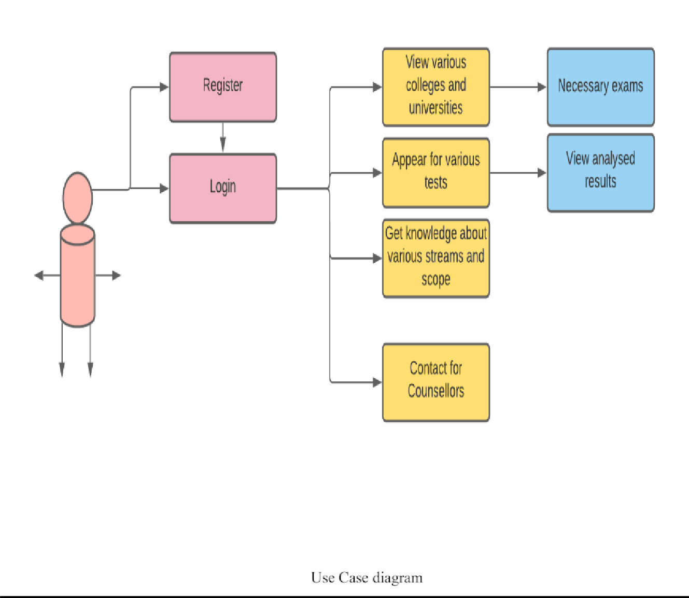

## Classes / Objects

A class diagram in the Unified Modelling Language (UML) is a type of static structure diagram that describes the structure of a system by showing the system's classes, their attributes, operations (or methods), and the relationships among objects

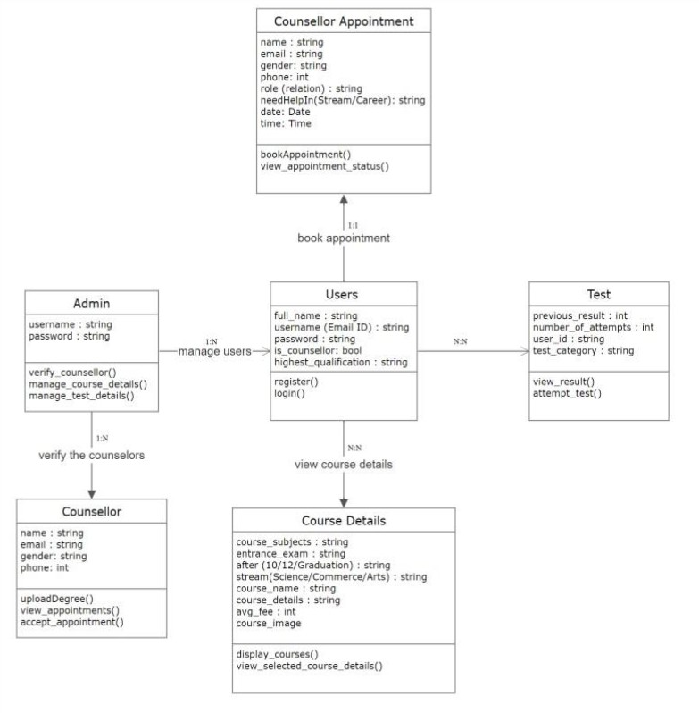

Class Diagram

## Sequence Diagram

A sequence diagram simply depicts interaction between objects in a sequential order i.e. the order in which these interactions take place. We can also use the terms event diagrams or event scenarios to refer to a sequence diagram. Sequence diagrams describe how and in what order the objects in a system function.

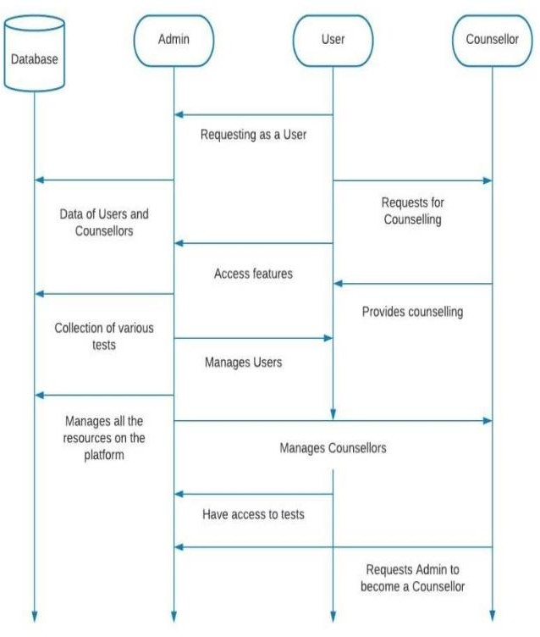

## Activity Diagram

Activity diagram is used to describe the dynamic aspects of the system. Activity diagram is basically a flowchart to represent the flow from one activity to another activity. The activity can be described as an operation of the system. The control flow is drawn from one operation to another.

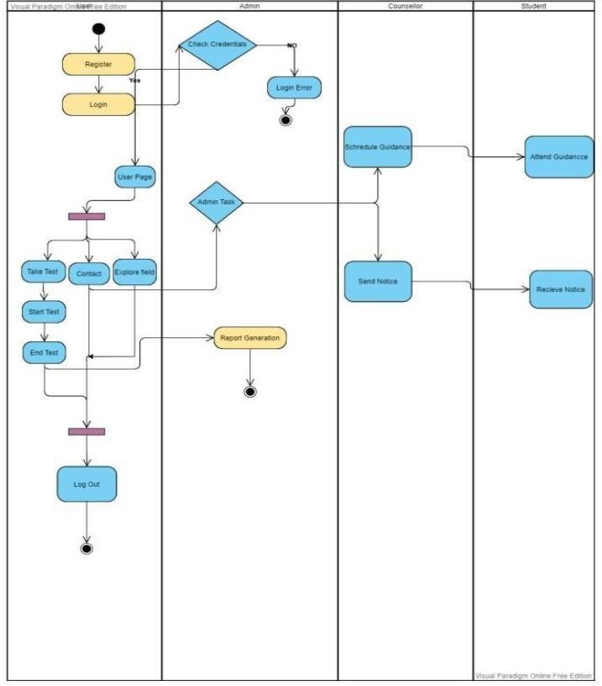

A data-flow diagram (DFD) is a way of representing a flow of a data of a process or a system (usually an information system) The DFD also provides information about the outputs and inputs of each entity and the process itself.

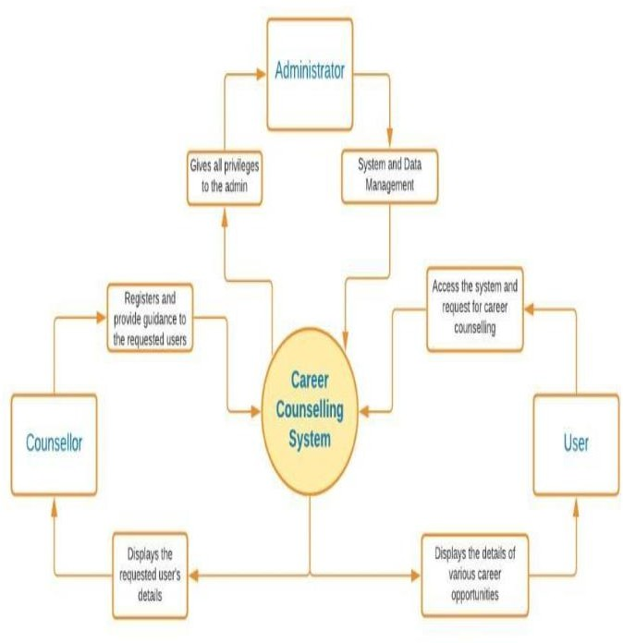

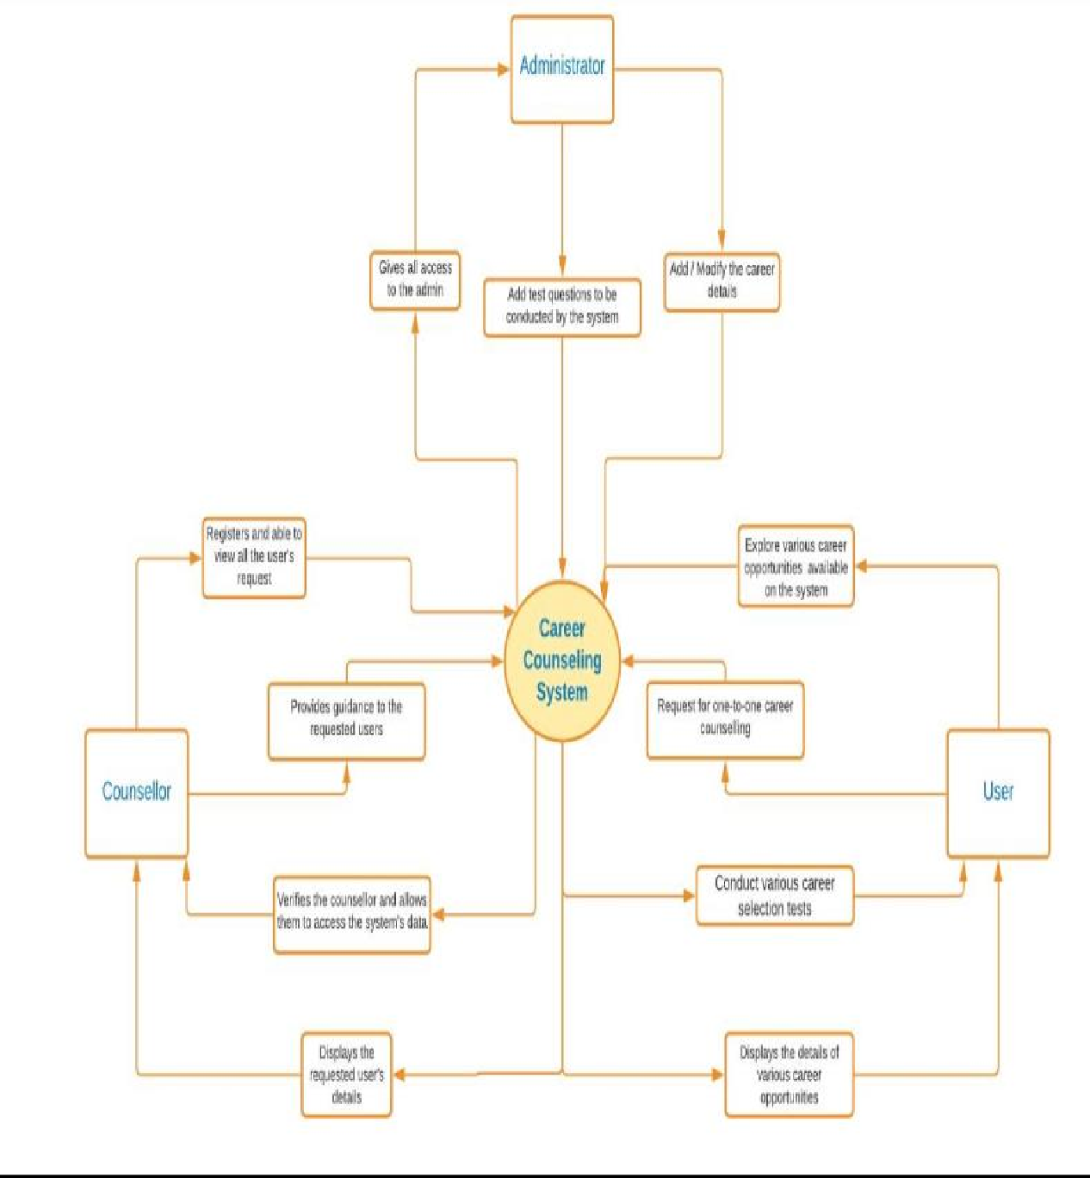

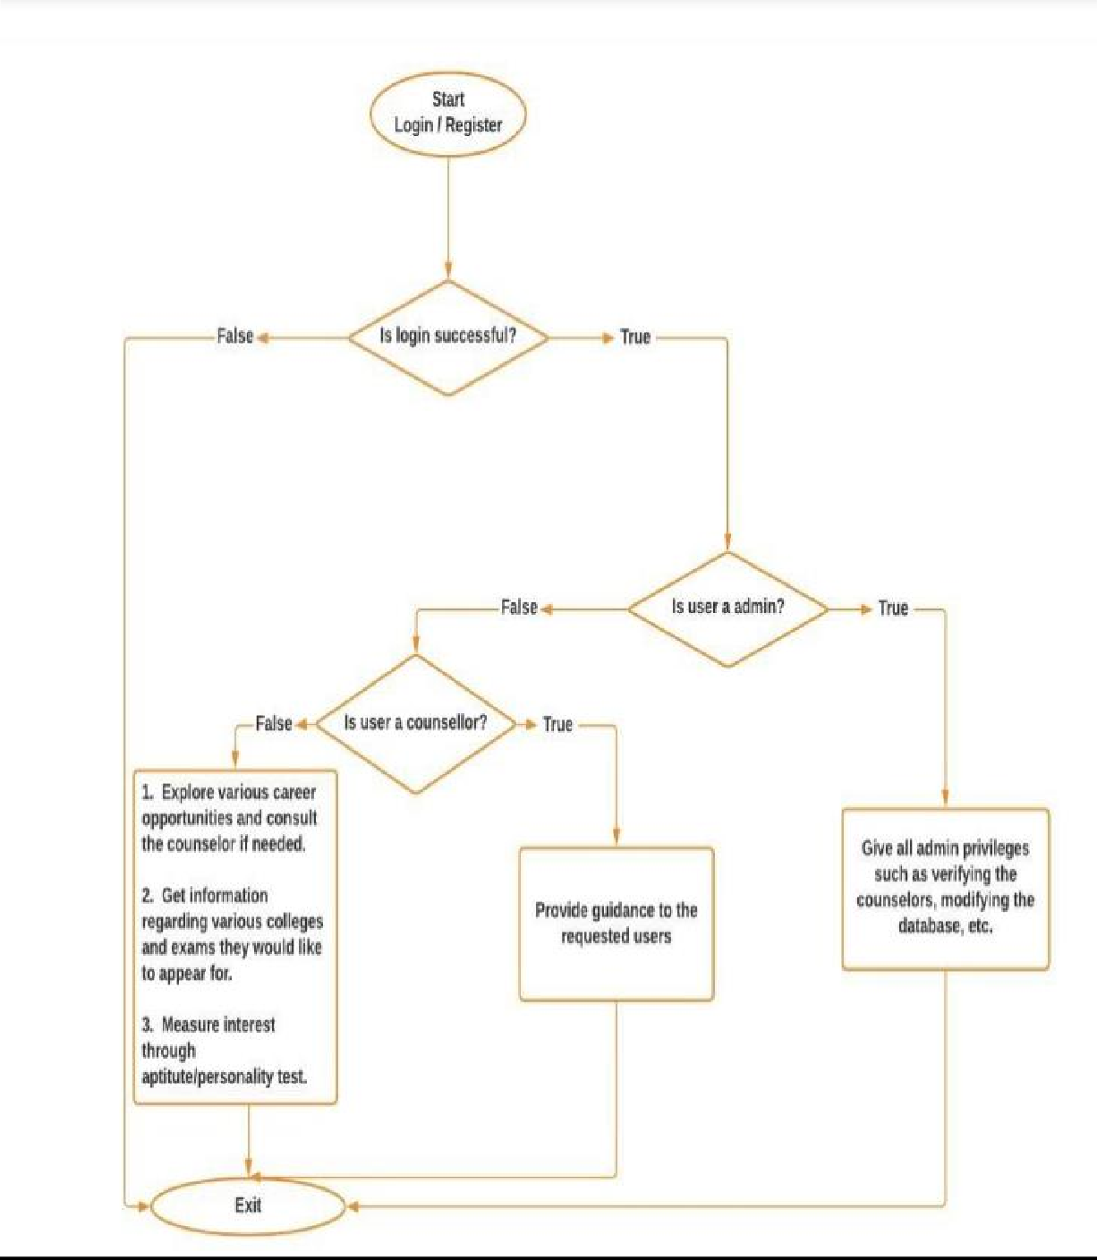

## UML Activity Diagram

**Overview**: Activity diagram is another important diagram in UML to describe dynamic aspects of the system.

Activity diagram is basically a flowchart to represent the flow from one activity to another activity. The activity can be described as an operation of the system. So the control flow is drawn from one operation to another. This flow can be sequential, branched or concurrent. Activity diagrams deal with all types of flow control by using different elements like fork, join etc.

**Purpose:** The basic purposes of activity diagrams are similar to the other four diagrams. It captures the dynamic behavior of the system. Other four diagrams are used to show the message flow from one object to another but the activity diagram is used to show message flow from one activity to another. Activity is a particular operation of the system. Activity diagrams are not only used for visualizing the dynamic nature of a system but they are also used to construct the executable. system by using forward and reverse engineering techniques. The only missing thing in the activity diagram is the message part. It does not show any message flow from one activity to another. Activity diagram is sometimes considered as the flow chart. Although the diagram looks like a flow chart, it is not. It shows different flows like parallel, branched, concurrent and single. So the purposes can be described as:

Draw the activity flow of a system.

Describe the sequence from one activity to another.

Describe the parallel, branched and concurrent flow of the system.

### Basic Activity Diagram Symbols and Notations Action states

Action states represent the non interruptible actions of objects. You can draw an action state in Smart Draw using a rectangle with rounded corners.

## Action Flow

Action flow arrows illustrate the relationships among action states.

## Object Flow

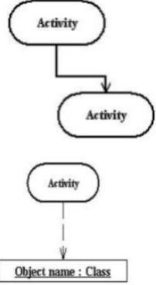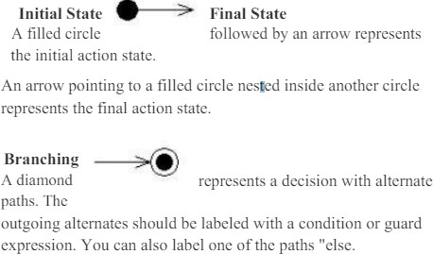Object flow refers to the creation and modification of objects by activities. An object flow arrow from an action to an object means that the action creates or influences the object. An object flow arrow from an object to an action indicates that the action state uses the object.

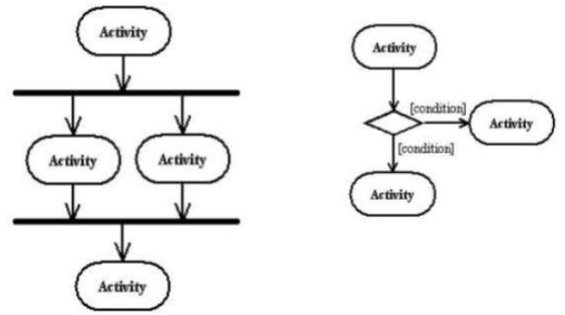

### Synchronization

A synchronization bar helps illustrate parallel transitions. Synchronization is also called forking and joining. **Swim lanes**

Swim lanes group related activities into one column.

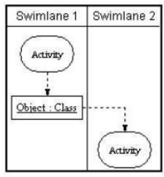

### Where to use Activity Diagrams?

The basic usage of the activity diagram is similar to the other four UML diagrams. The specific usage is to model the control flow from one activity to another. This control flow does not include messages. The activity diagram is suitable for modeling the activity flow of the system. An application can have multiple systems. Activity diagram also captures these systems and describes flow from one system to another. This specific usage is not available in other diagrams. These systems can be database, external queues or any other system. Now we will look into the practical applications of the activity diagram. From the above discussion it is clear that an activity diagram is drawn from a very high level. So it gives a high level view of a system. This high level view is mainly for business users or any other person who is not a technical person. This diagram is used to model the activities which are nothing but business requirements.

So the diagram has more impact on business understanding rather than implementation details. Following are the main usages of activity diagram: Modeling workflow by using activities. Modeling business requirements. High level understanding of the system's functionalities. Investigate business requirements at a later stage.

**SCREEN SHOTS**

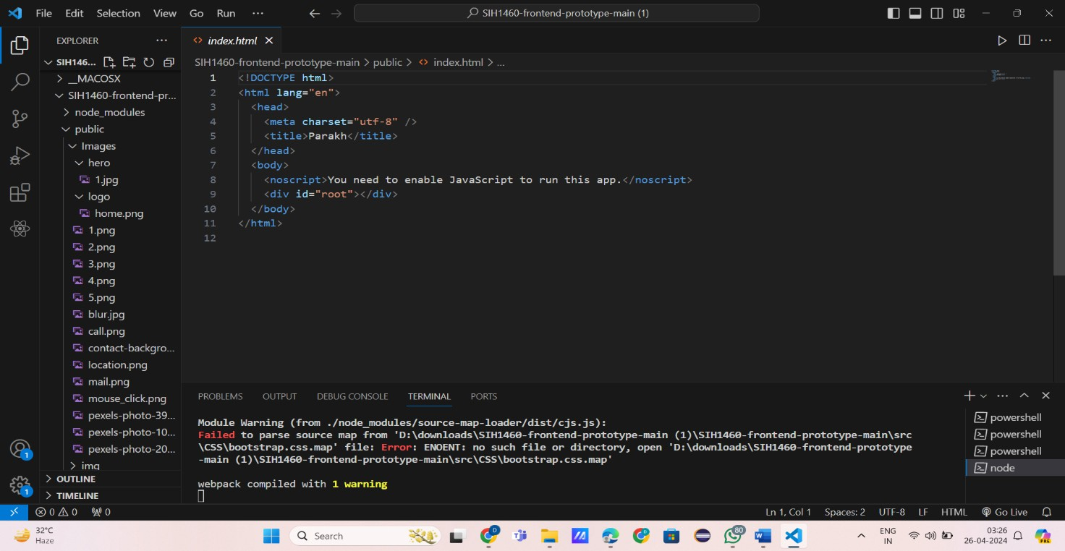

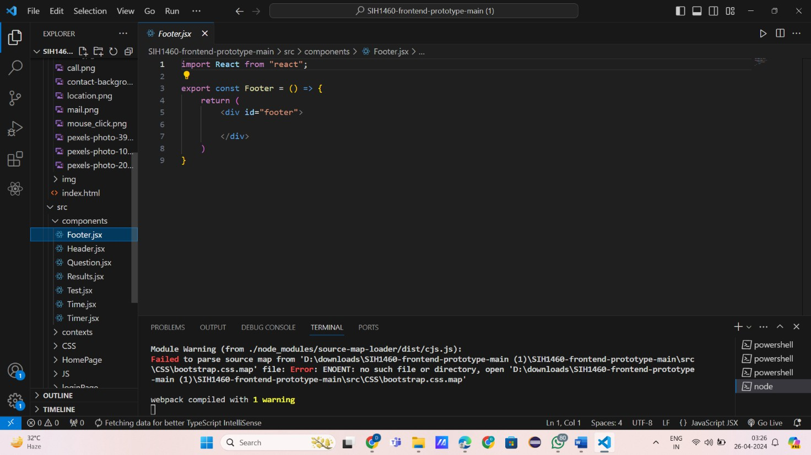

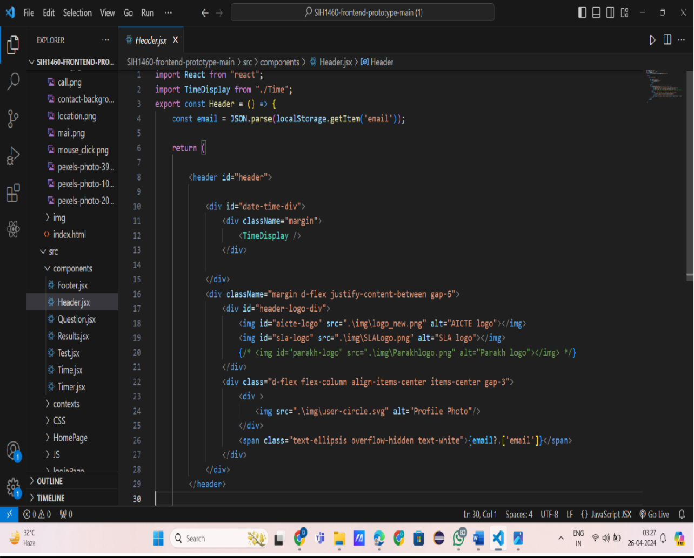

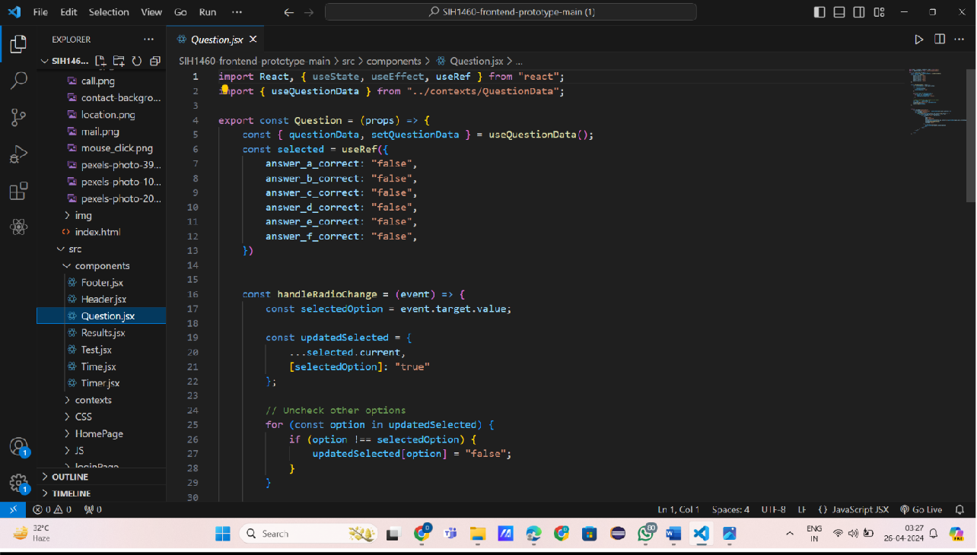

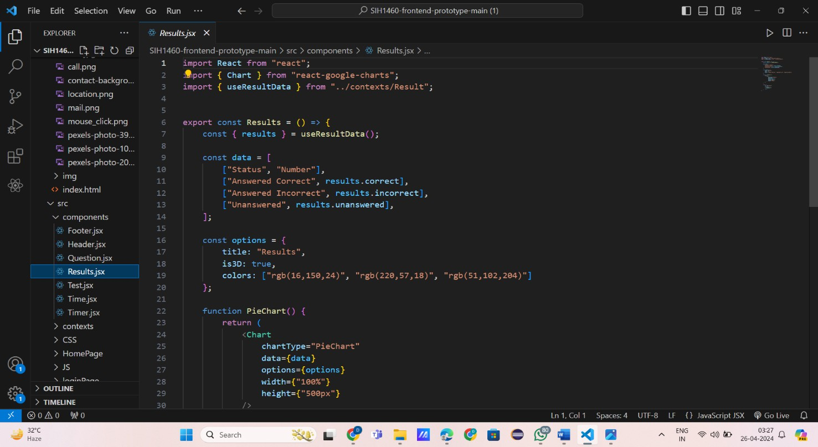

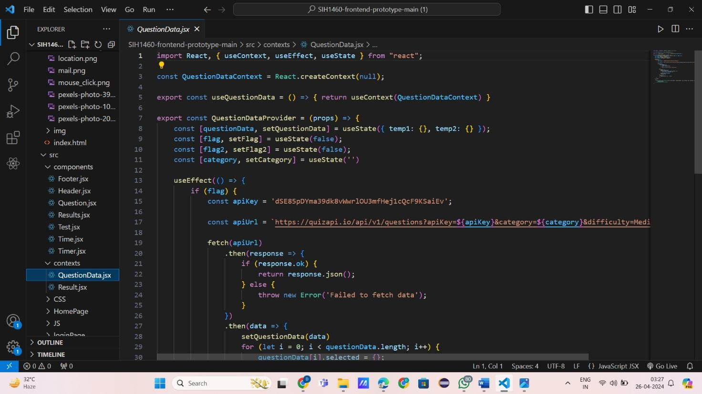

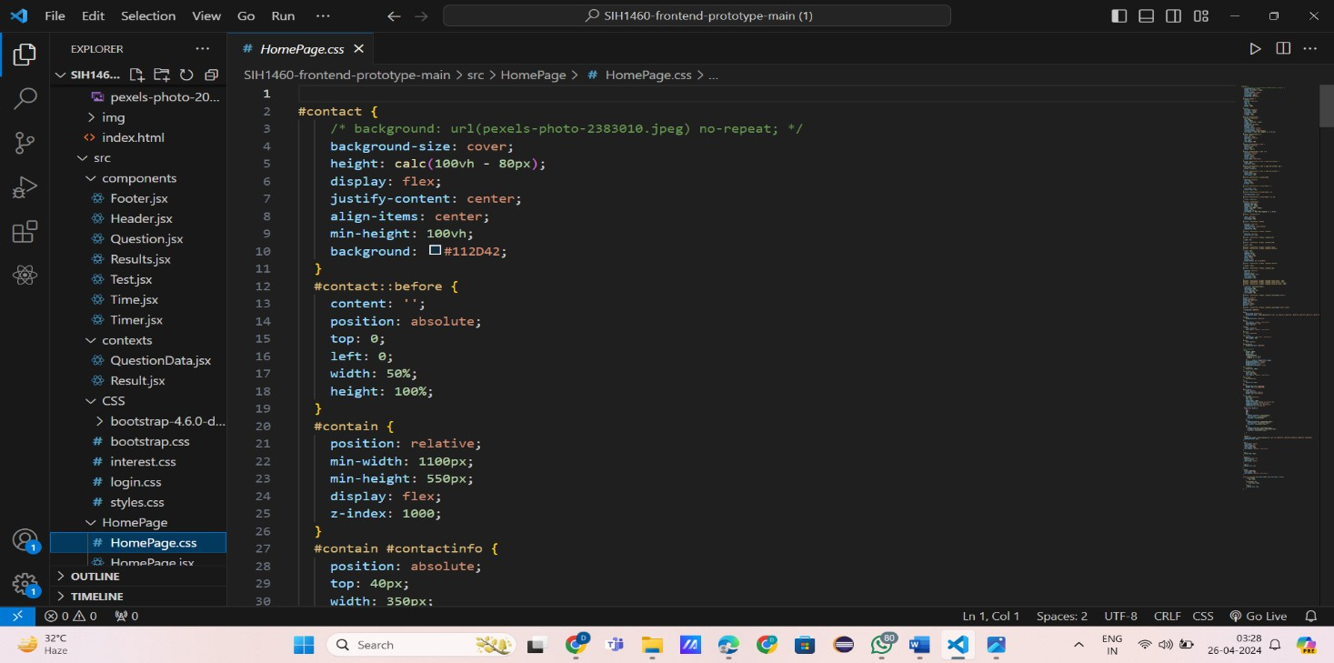

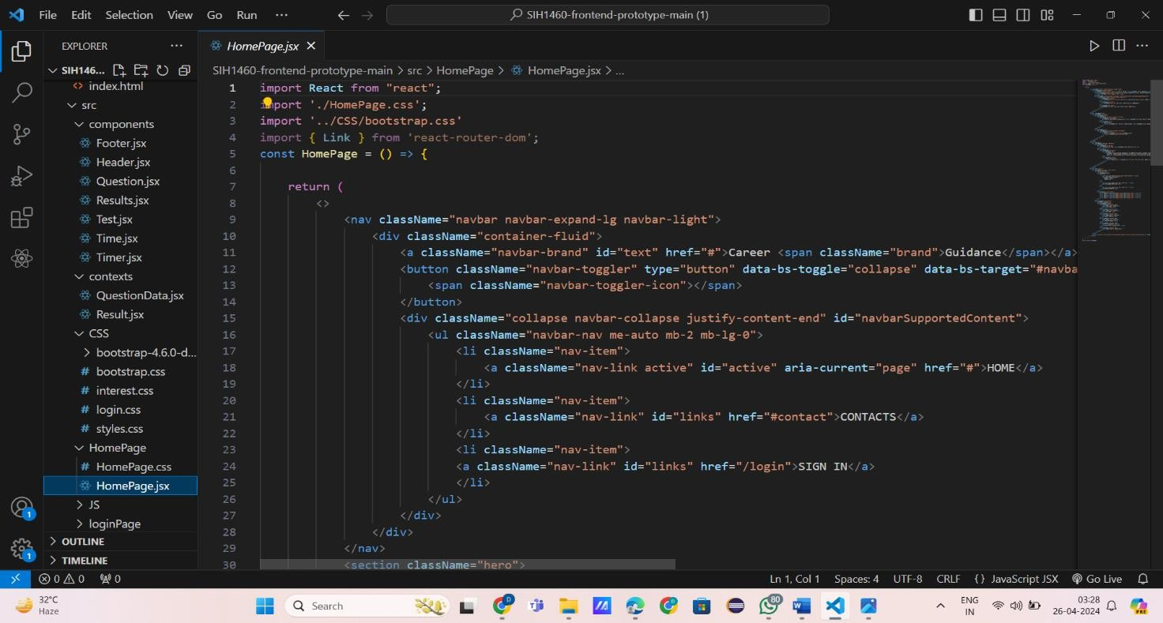

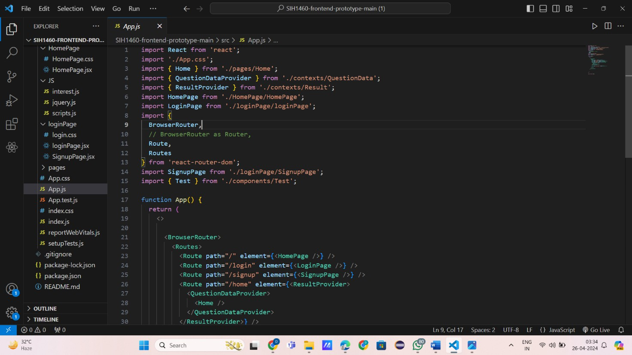

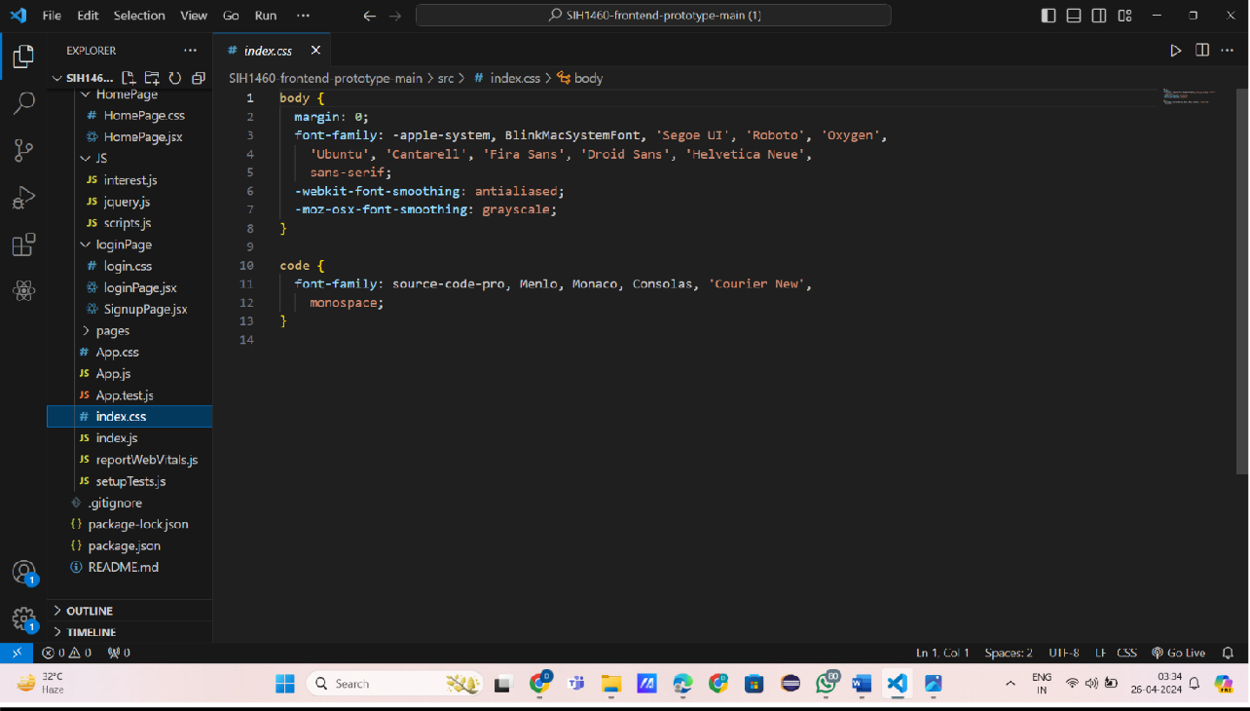

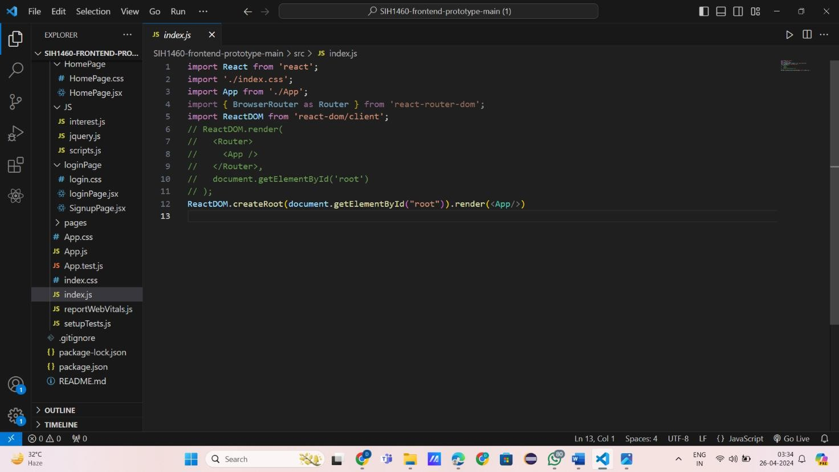

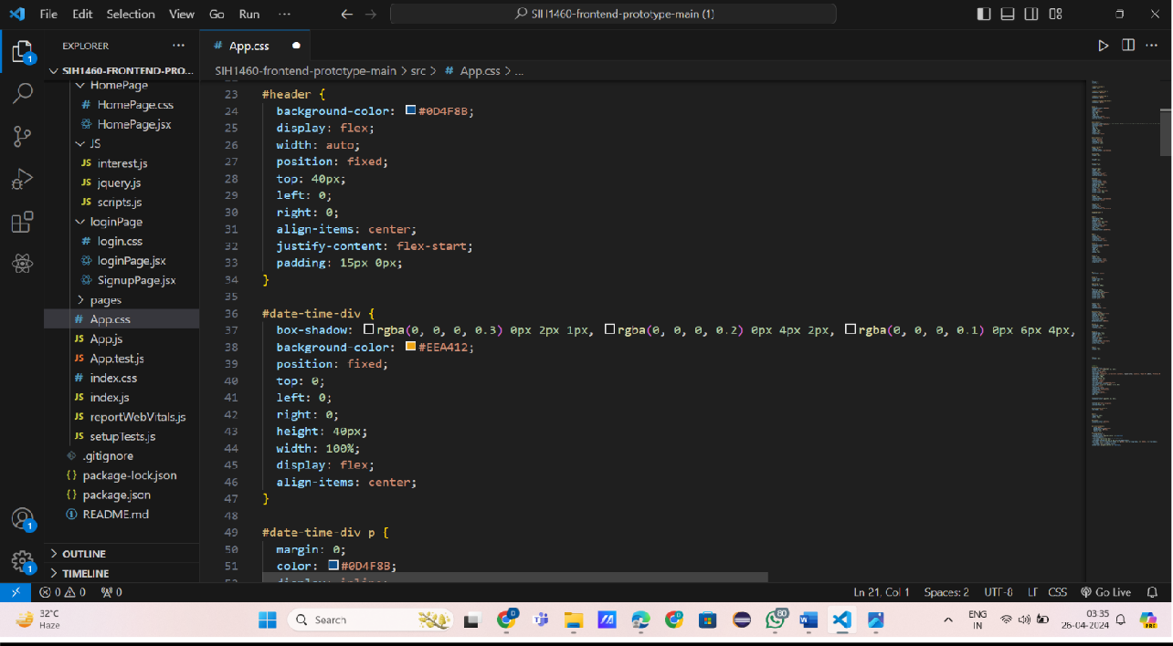

**TESTING**

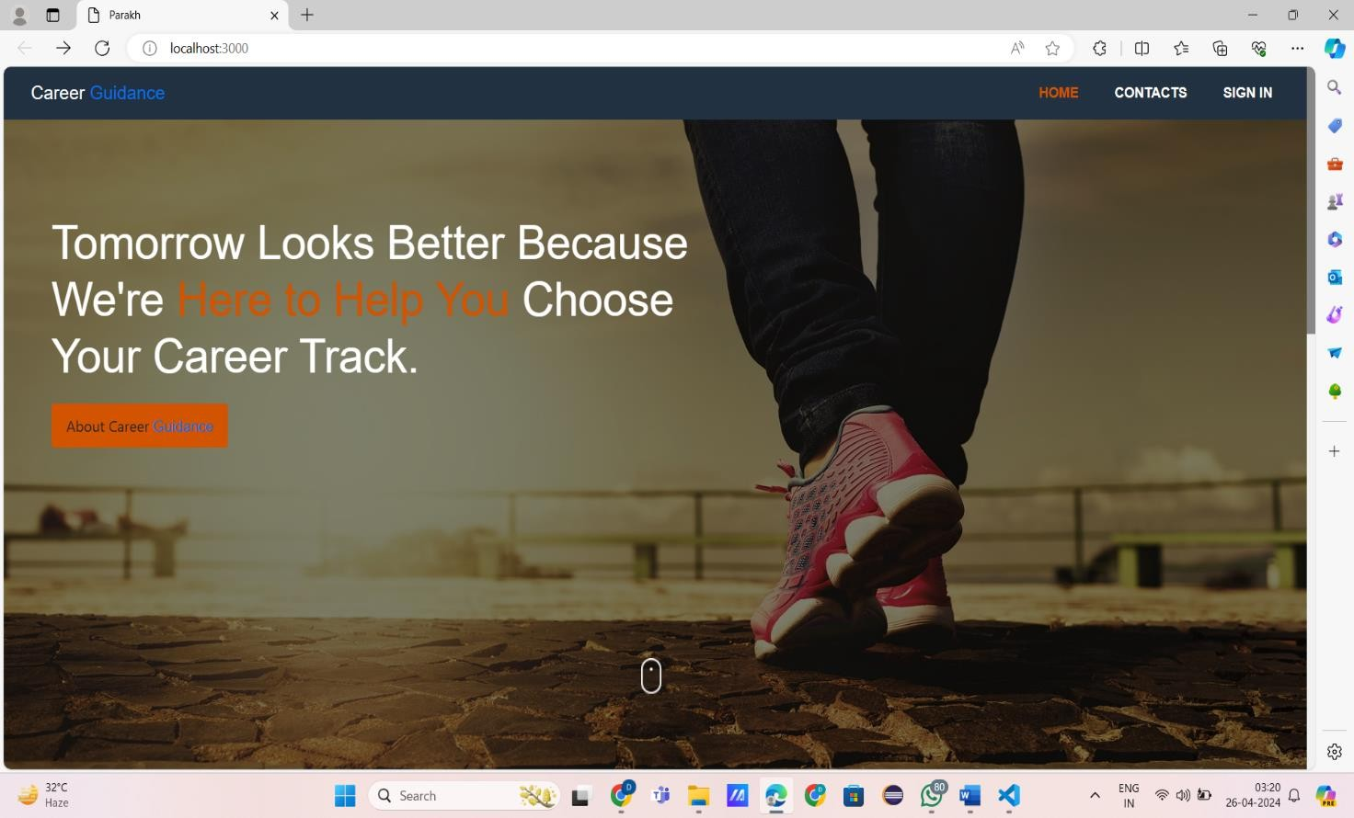

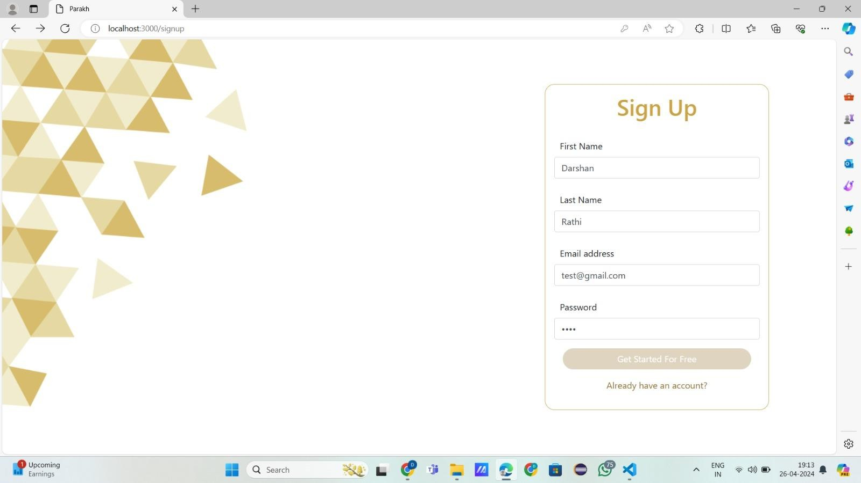

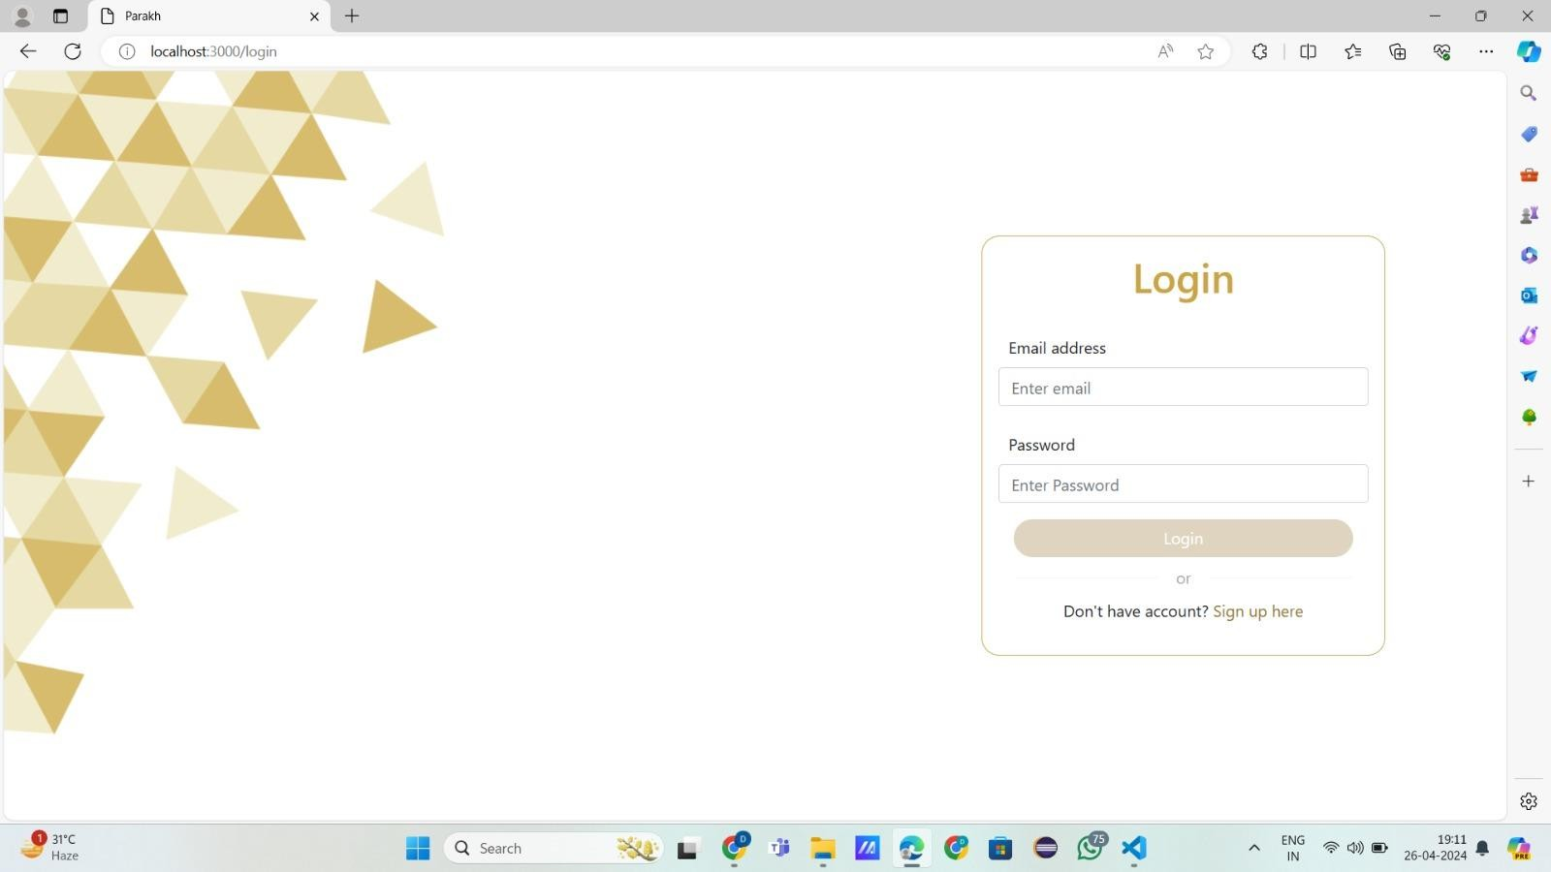

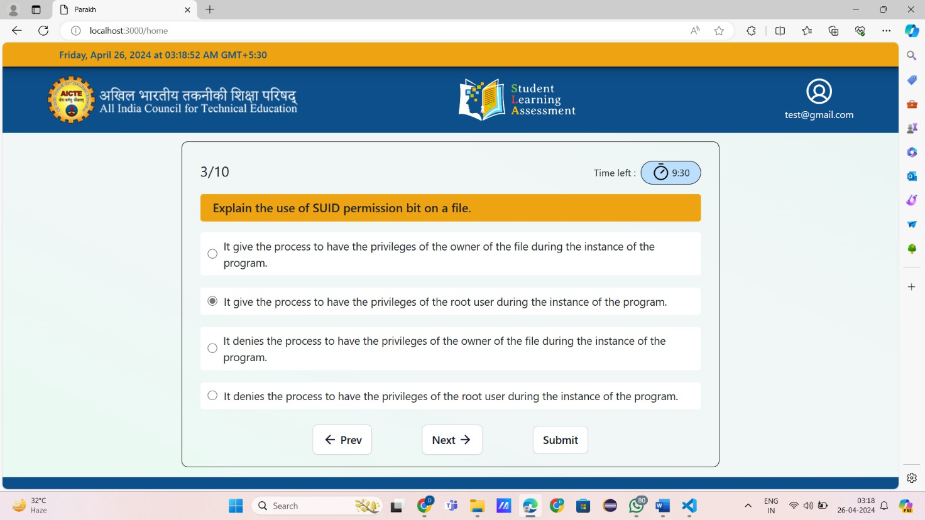

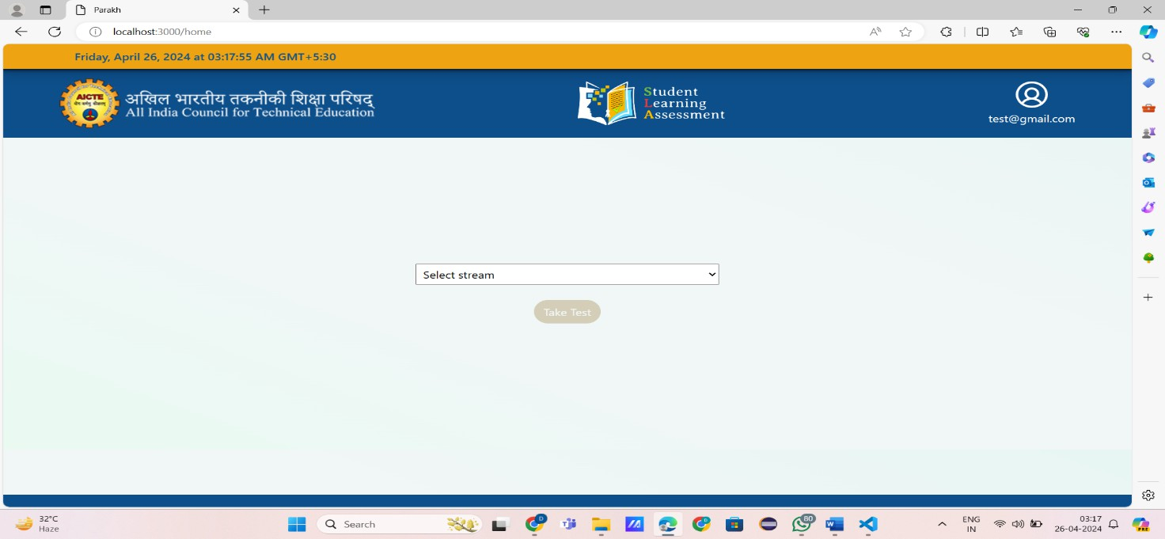

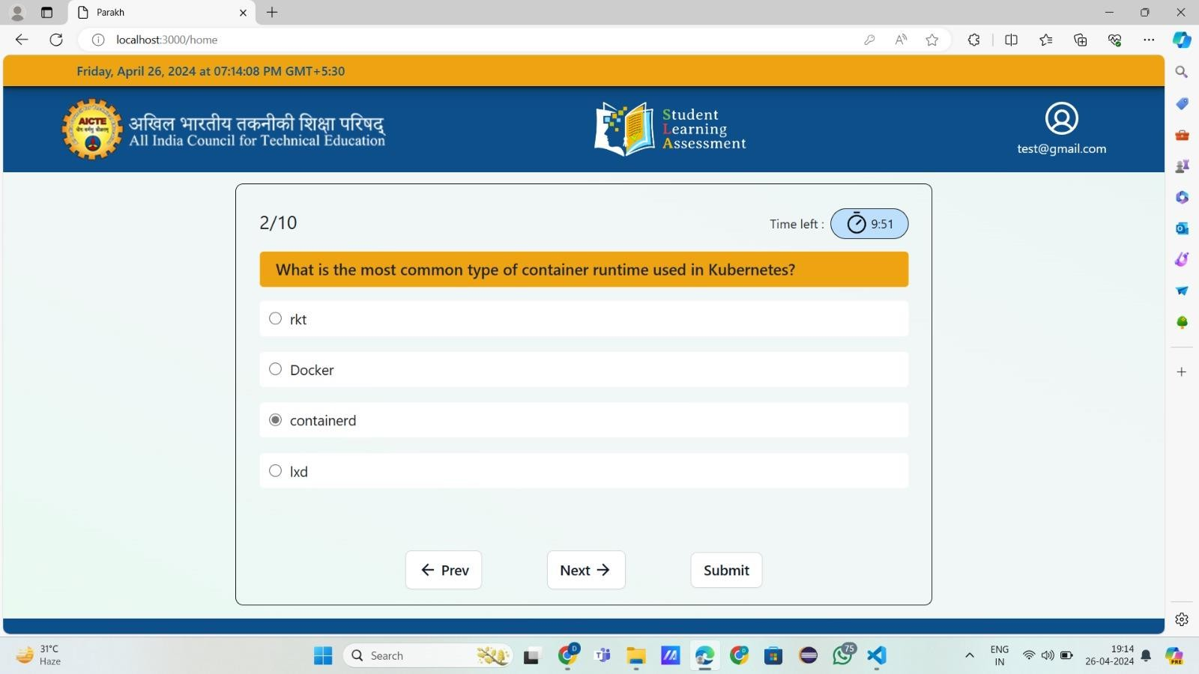

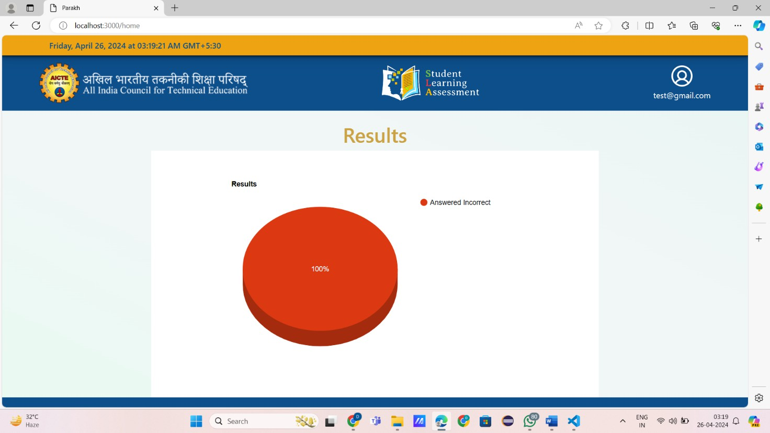

**LIMITATIONS OF PROJECT**

AI-enhanced career counseling offers numerous benefits, but it's also important to acknowledge its limitations to ensure users have realistic expectations and are well-informed about its capabilities. Here are some key limitations:

1. **Lack of Human Connection:** While AI can provide personalized recommendations based on data analysis, it lacks the empathetic understanding and emotional support that a human counselor can offer. Many individuals seeking career guidance may value the human connection and rapport built with a counselor, which AI cannot fully replicate.
2. **Bias in Data and Algorithms:** AI systems are trained on historical data, which may contain biases. If the data used to train the AI model is biased, it can lead to biased recommendations. For example, if certain demographics are underrepresented in the data, the AI system may not provide equitable guidance for all users.
3. **Limited Understanding of Context:** AI systems may struggle to understand the full context of an individual's situation, including their unique skills, experiences, and personal circumstances. Career decisions are often influenced by factors beyond just qualifications and interests, such as family responsibilities, financial constraints, and personal values. AI may not be able to adequately incorporate these nuanced factors into its recommendations.
4. **Inability to Account for Rapid Changes:** The job market is constantly evolving due to technological advancements, economic shifts, and societal changes. AI systems may struggle to keep up with these rapid changes and may not always provide the most up-to-date or relevant guidance. Additionally, AI models trained on past data may not accurately predict future trends or emerging career opportunities.
5. **Privacy and Security Concerns:** AI-enhanced career counseling relies on collecting and analyzing personal data from users. This raises concerns about privacy and data security, especially if sensitive information is not properly safeguarded. Users may be hesitant to share personal details with an AI system, particularly if they are unsure how their data will be used or protected.
6. **Limited Scope of Expertise:** AI systems are typically trained on specific domains or areas of expertise. While they can provide general career advice and recommendations, they may lack the depth of knowledge and expertise that human specialists possess in niche fields or industries. Users with highly specialized career goals may require additional guidance from human experts.
7. **Overreliance on Technology:** There is a risk that users may become overly reliant on AI systems for career decisions, without critically evaluating the recommendations or considering alternative perspectives. Overreliance on technology could lead to decision-making based solely on algorithmic outputs, rather than a holistic assessment of individual goals and aspirations**.**

# FUTURE SCOPE OF PROJECT

The future scope of AI-enhanced career counseling is vast and holds significant potential for revolutionizing how individuals navigate their career paths. Here are some key areas where AI- enhanced career counseling can continue to evolve:

1. **Personalized Guidance**: AI can leverage vast amounts of data to provide highly personalized career guidance tailored to individual skills, interests, and goals. As AI algorithms become more sophisticated, they can analyze a wider range of factors, including personality traits, learning styles, and past experiences, to offer recommendations that align closely with each person's unique profile.
2. **Predictive Analytics:** AI can use predictive analytics to forecast future trends in the job market, helping individuals make informed decisions about which career paths are likely to be in high demand. By analyzing patterns in job postings, labor market data, and industry trends, AI can identify emerging opportunities and potential areas of growth for job seekers.
3. **Skill Development and Training:** AI can assist individuals in identifying skill gaps and recommending relevant training programs or courses to enhance their employability. Through continuous monitoring of skill development and performance, AI can provide real-time feedback and adaptive learning experiences to help individuals progress in their careers.
4. **Career Path Exploration**: AI can simulate different career paths and scenarios based on an individual's interests and aspirations, allowing them to explore various options before making a decision. Virtual reality (VR) and augmented reality (AR) technologies can further enhance this experience by providing immersive simulations of different workplaces and job roles.
5. **Accessibility and Scalability**: AI-enhanced career counseling can reach a broader audience and provide on-demand support to individuals around the world. Through online platforms, chatbots, and mobile applications, AI can deliver instant guidance and support to users regardless of their location or time zone, increasing accessibility to career counseling services**.**
6. **Integration with HR and Recruitment Processes:** AI can streamline the recruitment process by matching candidates with job opportunities that align with their skills and preferences. By integrating with HR systems and applicant tracking software, AI-enhanced career counseling platforms can help employers identify top talent more efficiently while ensuring a better fit between candidates and job roles.
7. **Continuous Learning and Adaptation:** AI systems can continuously learn from user interactions and feedback, improving the accuracy and effectiveness of their recommendations over time. By incorporating machine learning algorithms, AI-enhanced career counseling platforms can adapt to changing user needs and preferences, providing increasingly relevant guidance and support.

# REFERENCES

* + https:/[/www](http://www.asapitalia.com/en/references-career-counseling).[asapitalia.com/en/references-career-counseling](http://www.asapitalia.com/en/references-career-counseling)
  + [https://medium.com/@adityaver/artificial-intelligence-ai-powered-career-counselling-](https://medium.com/%40adityaver/artificial-intelligence-ai-powered-career-counselling-) ca00a7 1a61ed
  + javatpoint.com
  + w3schools.com
  + https://oeb.global/oeb-insights/artificial-intelligence-ai-and-career-guidance-transformation- or-extinction-the-coming-age-of-the-robo-careers-advisers/
  + https:/[/www](http://www.weforum.org/agenda/2023/09/how-could-ai-shape-the-future-of-career-).[weforum.org/agenda/2023/09/how-could-ai-shape-the-future-of-career-](http://www.weforum.org/agenda/2023/09/how-could-ai-shape-the-future-of-career-) coaching/
  + https:/[/www](http://www.resumely.ai/blog/single/unlocking-success-the-role-of-artificial-intelligence-ai-).[resumely.ai/blog/single/unlocking-success-the-role-of-artificial-intelligence-ai-](http://www.resumely.ai/blog/single/unlocking-success-the-role-of-artificial-intelligence-ai-) in-career-development
  + https:/[/www](http://www.businessinsider.in/careers/news/some-gen-z-workers-are-turning-to-ai-for-).[businessinsider.in/careers/news/some-gen-z-workers-are-turning-to-ai-for-](http://www.businessinsider.in/careers/news/some-gen-z-workers-are-turning-to-ai-for-) career-advice-and-its-actually-not-a-bad-idea/articleshow/107946084.cms
  + https://aipioneers.org/ai-and-career-counseling-advice-and-guidance/
  + https://hashtagcounseling.in/effective-career-counselling-in-the-artificial-intelligence-ai-era/