Writeup

I have designed and analysed the Medical Record Smart Contract named as ‘MedicReady’. As part of my development, I created three structures- doctor, patient and medicine. I also applied mapping, modifiers wherever required and I am able to implement the functions as per the need for the contract. Correcting errors was one of the most difficult parts but I did it well and thoroughly.

Screenshots

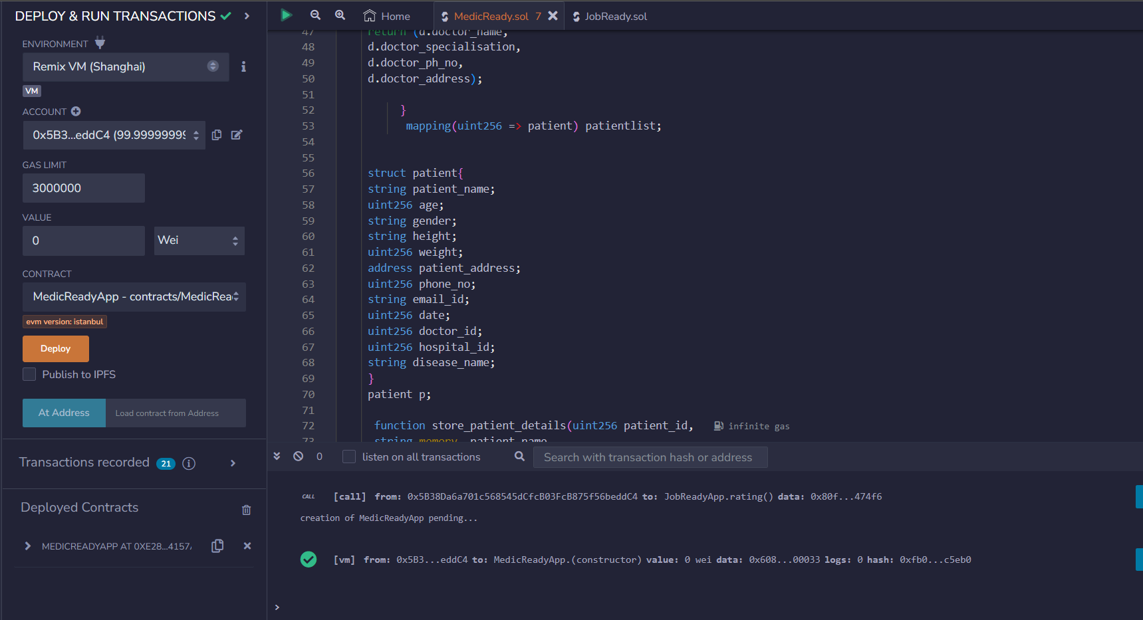

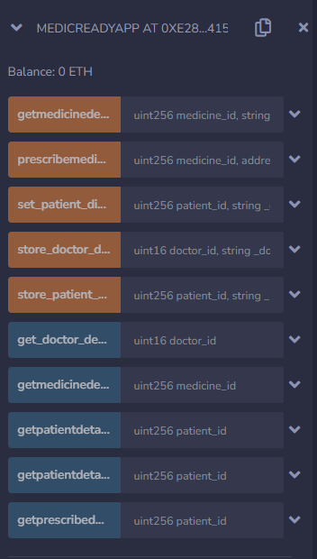 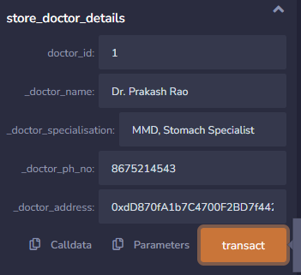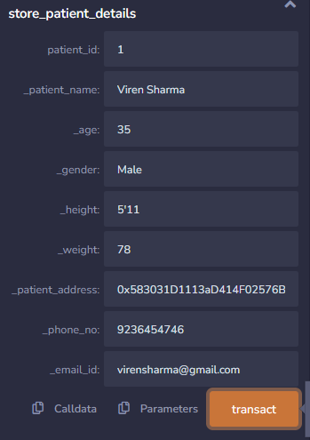 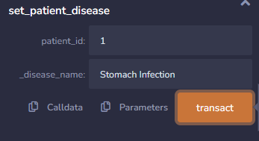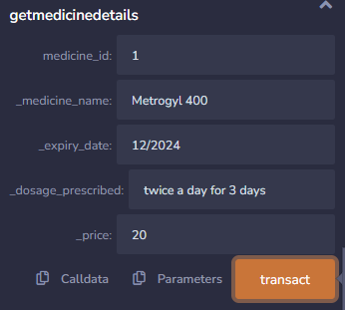 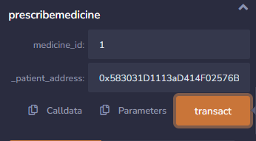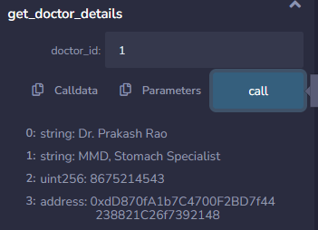 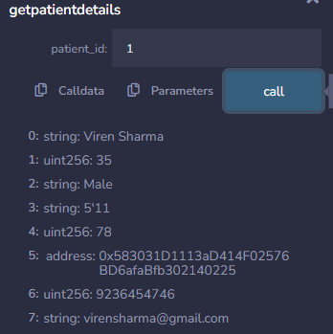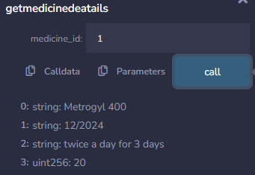 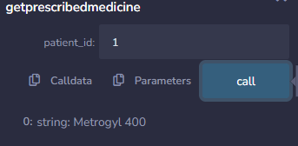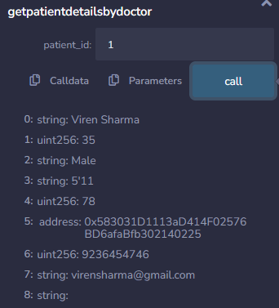

Source Code

// SPDX-License-Identifier: MIT

pragma solidity ^0.8.0;

contract MedicReadyApp {

    mapping(uint256 => doctor) doctorlist;

     struct doctor{

         string doctor_name;

         string doctor_specialisation;

         uint256 doctor_ph_no;

         address doctor_address;

     }

     doctor d;

     address owner;

      constructor()  public {

          owner = 0xdD870fA1b7C4700F2BD7f44238821C26f7392148;

      }

       modifier isOwner() {

         _;

     }

   function store_doctor_details(

    uint16 doctor_id,

   string memory _doctor_name,

   string memory _doctor_specialisation,

   uint256 _doctor_ph_no,

   address _doctor_address)public isOwner {

         d.doctor_name = _doctor_name;

         d.doctor_specialisation = _doctor_specialisation;

         d.doctor_ph_no = _doctor_ph_no;

         d.doctor_address = _doctor_address;

        doctorlist[doctor_id] = d;

   }

         function get_doctor_details(uint16 doctor_id) public view returns (

            string memory,

            string memory,

            uint256,

            address) {

     doctor memory d = doctorlist[doctor_id];

     return (d.doctor_name,

     d.doctor_specialisation,

     d.doctor_ph_no,

     d.doctor_address);

          }

           mapping(uint256 => patient) patientlist;

     struct patient{

     string patient_name;

     uint256 age;

     string gender;

     string height;

     uint256 weight;

     address patient_address;

     uint256 phone_no;

     string email_id;

     uint256 date;

     uint256 doctor_id;

     uint256 hospital_id;

     string disease_name;

     }

     patient p;

      function store_patient_details(uint256 patient_id,

      string memory _patient_name,

      uint256 _age,

      string memory _gender,

      string memory _height,

      uint256 _weight,

      address _patient_address,

      uint256 _phone_no,

      string memory _email_id)public isOwner {

         p.patient_name=_patient_name;

         p.age=_age;

         p.gender=_gender;

         p.height=_height;

         p.weight=_weight;

         p.patient_address=_patient_address;

         p.phone_no=_phone_no;

         p.email_id=_email_id;

        patientlist[patient_id] = p;}

        function getpatientdetails(uint256 patient_id) public view returns (

        string memory,

        uint256,

        string memory,

        string memory,

        uint256,

        address,

        uint256,

        string memory)

       { patient memory p = patientlist[patient_id];

     return (p.patient_name,

     p.age,

     p.gender,

     p.height,

     p.weight,

     p.patient_address,

     p.phone_no,

     p.email_id);

    }

    function set_patient_disease(uint256 patient_id, string memory _disease_name) public isOwner{

        p.disease_name;

        patientlist[patient_id] = p;

    }

               mapping(uint256 => medicine) medicinelist;

    struct medicine{

        string medicine_name;

        string expiry_date;

        string dosage_prescribed;

        uint256 price;

    }

    medicine m;

    function getmedicinedetails(

        uint medicine_id,

        string memory _medicine_name,

        string memory _expiry_date,

        string memory _dosage_prescribed,

        uint256 _price) public isOwner{

            m.medicine_name= _medicine_name;

            m.expiry_date= _expiry_date;

            m.dosage_prescribed= _dosage_prescribed;

            m.price= _price;

        medicinelist [medicine_id]=m;

        }

    function getmedicinedeatails(uint medicine_id) public view returns(

        string memory,

        string memory,

        string memory,

        uint

    ) { medicine memory m= medicinelist[medicine_id];

    return

        (m.medicine_name,

            m.expiry_date,

            m.dosage_prescribed,

            m.price);

    }

        function prescribemedicine(uint256 medicine_id, address _patient_address) public isOwner{

            p.patient_address=_patient_address;

            medicinelist [medicine_id]=m;

        }

        function getprescribedmedicine(uint patient_id) public view returns(

            string memory

        ){medicine memory m = medicinelist[patient_id];

        return(m.medicine_name);

        }

       modifier onlydoctor(){

        _;

       }

       function getpatientdetailsbydoctor(uint256 patient_id) public view onlydoctor returns (

        string memory,

        uint256,

        string memory,

        string memory,

        uint256,

        address,

        uint256,

        string memory,

        string memory)

       { patient memory p = patientlist[patient_id];

     return (p.patient_name,

     p.age,

     p.gender,

     p.height,

     p.weight,

     p.patient_address,

     p.phone_no,

     p.email_id,

     p.disease_name);

    }

}

ThankYou.