INTERNSHIP REPORT
ON
ARTIFICIAL INTELLIGENCE AND MACHINE LEARNING
Submitted To
School of Computer Science and Engineering
IILM University, Greater Noida, U.P.
In partial fulfilment of the requirement of degree of
B.Tech CSE
By
RONAK SAINI
Roll Number: 2410031471
Batch: 2026-27
Internship: 30-Day Virtual Internship
KODACY in association with Scientific Platforms and Cosmic Explorations (SPACE)

CANDIDATE’S DECLARATION
I, RONAK SAINI, do hereby declare that the internship report titled “Artificial Intelligence and Machine Learning” has been prepared by me to fulfil the requirement for the award of the degree of Bachelor of Technology in CSE. The report presents the learning and subject matter associated with my 30-day virtual internship in Artificial Intelligence and Machine Learning conducted by KODACY in association with Scientific Platforms and Cosmic Explorations (SPACE). I have acknowledged the references and sources used in preparing this report. I further declare that this report has not been submitted to any other institute for any degree or diploma requirement and that I shall be responsible for any copyright violation arising from material submitted by me.

Signature: ____________________
Student Name: RONAK SAINI
Roll No.: 2410031471

ACKNOWLEDGEMENT
I am using this opportunity to express my gratitude to everyone who supported me throughout the Internship Program. I am thankful for their guidance, constructive feedback and advice during this work.
I sincerely acknowledge KODACY and Scientific Platforms and Cosmic Explorations (SPACE) for providing the opportunity to participate in a virtual internship focused on Artificial Intelligence and Machine Learning. The internship provided a structured opportunity to study important concepts and understand their practical relevance.
I also express my gratitude to the faculty members of the School of Computer Science and Engineering, IILM University, Greater Noida, for their academic support and encouragement.
Finally, I express my gratitude to my parents for their blessings and continued support.

Signature: ____________________
Student Name: RONAK SAINI
Roll No.: 2410031471

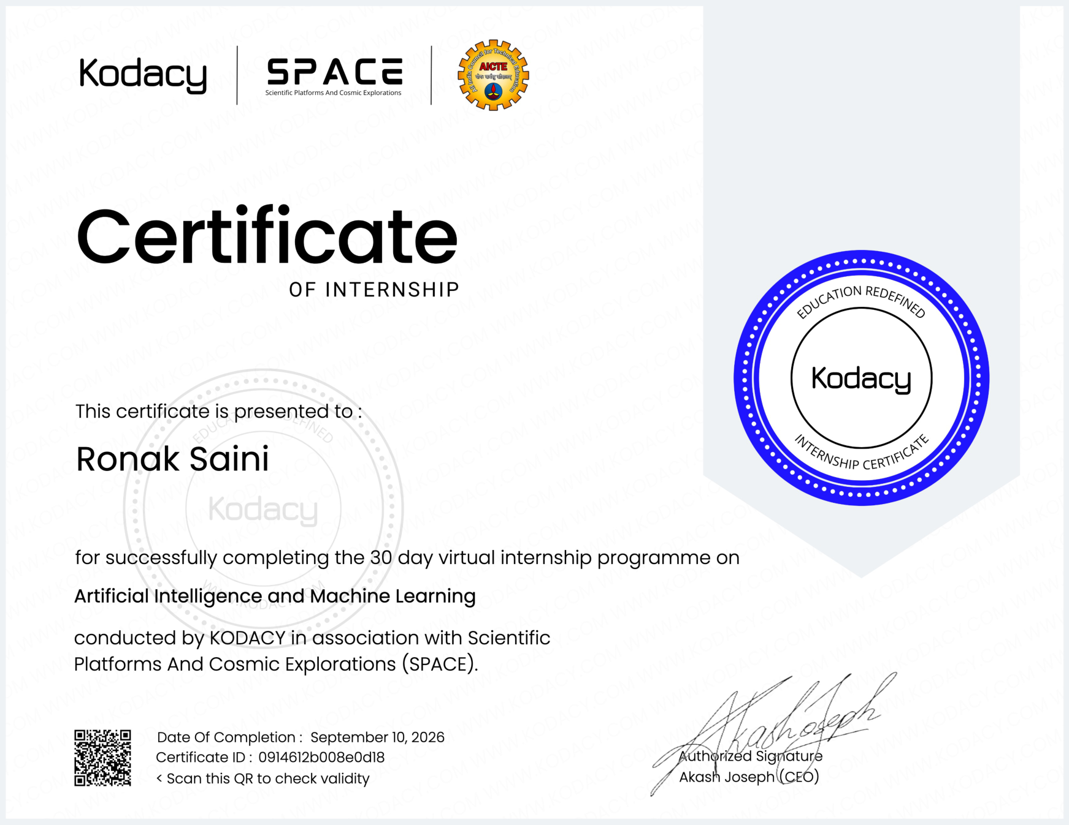

TABLE OF CONTENTS
Chapter / Section | Page No.
Cover Page | —
Candidate’s Declaration | i
Acknowledgement | ii
Internship Completion Certificate | iii
Project Description | 1
4.1 Introduction | 1
4.2 Organization Profile | 2
4.3 Problem Statement | 3
4.4 Project Objectives | 4
4.5 Scope of the Project | 5
4.6 Technologies and Tools Used | 6
4.7 System Architecture | 7
4.8 Methodology | 8
4.9 Expected Outcomes | 9
4.10 Certificates of completion and other communication mail proof | 10
Bibliography / References | 11

PROJECT DESCRIPTION

4.1 Introduction
Artificial Intelligence (AI) is a field of computer science concerned with developing systems that can perform tasks that normally require aspects of human intelligence, such as learning, reasoning, pattern recognition and decision making. Machine Learning (ML) is a major area within AI in which computer systems learn patterns from data and use those patterns to make predictions or decisions.
The internship topic, Artificial Intelligence and Machine Learning, provides a foundation for understanding how data-driven intelligent systems are designed. The subject connects mathematical concepts, programming, data preparation, model development and evaluation. A typical machine-learning workflow begins with identifying a problem, collecting or obtaining suitable data, preparing that data, selecting an appropriate algorithm, training a model, evaluating its performance and interpreting the results.
The purpose of this report is to present a structured overview of the topic studied during the internship and to document the concepts, workflow, technologies and expected learning outcomes relevant to an introductory AI and ML project.

4.2 Organization Profile
The internship completion certificate supplied for this report states that Ronak Saini successfully completed a 30-day virtual internship programme on Artificial Intelligence and Machine Learning conducted by KODACY in association with Scientific Platforms and Cosmic Explorations (SPACE). The certificate records the date of completion as September 10, 2026.
The internship format was virtual and focused on Artificial Intelligence and Machine Learning. In the context of this report, the organization profile is therefore presented around the internship opportunity and its subject area rather than adding organizational claims that are not present in the supplied certificate.
The internship provided an opportunity to connect academic concepts in computer science with a structured learning experience in AI and ML.

4.3 Problem Statement
Many real-world applications generate large quantities of data that are difficult to analyze effectively using only manually written rules. A suitable AI or ML system can learn useful patterns from historical data and support prediction, classification, recommendation or other decision-making tasks.
The central problem considered in an introductory AI and ML project is how to transform raw data into a reliable predictive or analytical model. This involves dealing with data quality, selecting meaningful features, choosing an appropriate learning approach, training the model and evaluating whether its results are sufficiently accurate and generalizable.
The report therefore focuses on a systematic machine-learning problem-solving process rather than a single application domain. This approach makes the concepts reusable for future projects in areas such as classification, regression, clustering and intelligent automation.

4.4 Project Objectives
The major objectives of studying and developing an Artificial Intelligence and Machine Learning project are:
• To understand fundamental concepts of Artificial Intelligence and Machine Learning.
• understand the difference between supervised and unsupervised learning.
• learn the importance of data collection, cleaning and preprocessing.
• understand feature selection and the preparation of data for model training.
• study commonly used machine-learning algorithms and their applications.
• understand model training, validation and performance evaluation.
• develop a structured approach for solving data-driven problems.
• understand how AI/ML concepts can be integrated into practical software solutions.
• document the learning process in a clear and reproducible manner.

4.5 Scope of the Project
The scope of an introductory Artificial Intelligence and Machine Learning project includes the complete conceptual workflow from problem definition to evaluation. The work can cover data preparation, exploratory analysis, model selection, training, testing and interpretation.
For supervised learning, the project scope may include classification or regression depending on the target variable. For unsupervised learning, it may include clustering or pattern discovery. The same workflow can be adapted to different datasets and application domains.
The project is primarily educational in scope. It is intended to demonstrate understanding of AI and ML concepts and the stages of a machine-learning workflow. Production deployment, large-scale distributed training, domain-specific compliance and long-term model monitoring are outside the scope unless separately specified by a particular project.

4.6 Technologies and Tools Used
A typical implementation of the concepts covered in this report can use Python as the primary programming language because of its broad ecosystem for data analysis and machine learning.
Common tools and libraries include:
• Python – programming language used for implementing data-processing and machine-learning workflows.
• pyter Notebook – interactive environment useful for experimentation, documentation and visualization.
• mPy – numerical computing and array operations.
• ndas – data loading, cleaning, transformation and tabular analysis.
• tplotlib – visualization of data and model-related results.
• ikit-learn – machine-learning algorithms, preprocessing utilities, model selection and evaluation metrics.
The exact tools used in a particular internship exercise may vary. The list above represents standard tools relevant to the AI/ML workflow described in this report and is included to explain the technical environment rather than to claim unsupported project-specific usage.

4.7 System Architecture
A general machine-learning system can be represented as a sequence of connected stages:
1. Problem Definition – identify the objective, inputs, expected output and evaluation criteria.
2. Data Acquisition – obtain the dataset relevant to the problem.
3. Data Preprocessing – handle missing values, inconsistent entries, duplicate records and unsuitable formats.
4. Feature Preparation – select or transform useful input variables.
5. Dataset Splitting – separate data into training and testing sets, with validation where appropriate.
6. Model Training – fit the selected algorithm to the training data.
7. Model Evaluation – assess performance using suitable metrics.
8. Interpretation and Improvement – analyze errors, tune the approach and compare alternatives.
9. Final Output – use the evaluated model for prediction, classification or another defined task.
This architecture emphasizes that a successful ML solution depends not only on the algorithm but also on the quality of the data and the correctness of the overall workflow.

4.8 Methodology
The methodology for an AI and ML project can be organized into the following steps.
Step 1 – Requirement and Problem Analysis: Clearly define the problem and determine whether the task is classification, regression, clustering or another type of learning problem.
Step 2 – Data Understanding: Inspect the dataset, identify the variables, understand their meanings and examine the distribution and quality of the data.
Step 3 – Data Preprocessing: Clean the data and transform it into a form suitable for analysis. Depending on the dataset, this may involve handling missing values, encoding categorical values and scaling numerical features.
Step 4 – Exploratory Data Analysis: Use descriptive statistics and visualizations to identify relationships, trends, outliers and possible issues in the data.
Step 5 – Model Selection: Select one or more algorithms appropriate to the problem. Baseline models should be considered before moving to more complex approaches.
Step 6 – Training and Validation: Train the selected model on the training data and use validation techniques where appropriate to assess generalization.
Step 7 – Evaluation: Use metrics suitable for the task. For classification these may include accuracy, precision, recall and F1-score; for regression, metrics such as mean absolute error and mean squared error may be relevant.
Step 8 – Interpretation and Documentation: Review the results, identify limitations and document the decisions made during the workflow.
Step 9 – Improvement: Where necessary, refine preprocessing, features or model parameters and compare the revised results with the baseline.

4.9 Expected Outcomes
The expected outcomes of the internship report and associated AI/ML learning activity are:
• A clear understanding of fundamental AI and ML terminology.
• miliarity with the standard machine-learning lifecycle.
• proved ability to prepare and analyze datasets.
• derstanding of the role of training, validation and testing.
• ility to select evaluation metrics appropriate to a problem.
• proved programming and analytical problem-solving skills.
• tter understanding of how data quality influences model performance.
• structured report documenting the internship topic, methodology and learning outcomes.
The completion certificate confirms successful completion of the 30-day virtual internship programme on Artificial Intelligence and Machine Learning. The report expands the academic explanation of the topic while keeping the supplied certificate as the basis for the internship-specific facts.

4.10 Certificates of completion and other communication mail proof
The internship completion certificate supplied with this report is attached as supporting evidence. It identifies the intern as Ronak Saini and states that a 30-day virtual internship programme on Artificial Intelligence and Machine Learning was successfully completed. The certificate also identifies KODACY and Scientific Platforms and Cosmic Explorations (SPACE), and records September 10, 2026 as the date of completion.
The original certificate copy is included immediately after the preliminary pages of this report. Any additional internship communication emails or completion documents may be appended in the same section if required by the university.

BIBLIOGRAPHY / REFERENCES
Russell, S. and Norvig, P., Artificial Intelligence: A Modern Approach, Pearson.
Géron, A., Hands-On Machine Learning with Scikit-Learn, Keras, and TensorFlow, O’Reilly Media.
Pedregosa, F. et al., Scikit-learn: Machine Learning in Python, Journal of Machine Learning Research.
McKinney, W., Python for Data Analysis, O’Reilly Media.
The internship completion certificate supplied with this report, issued for the 30-day virtual internship on Artificial Intelligence and Machine Learning conducted by KODACY in association with Scientific Platforms and Cosmic Explorations (SPACE), dated September 10, 2026.

