Elements of AIML

LAB – 1



Name - Ronak Singh

SAP ID - 500120683

Batch – 12

Roll No. – R2142230381

Teachable Machines

Google's tool, Teachable Machines, lets folks craft machine learning models with ease kind of cutting out the need for a big brain in programming. It's pretty much about giving everyone the power to train a learning machine with just a few clicks and drags in a user-friendly setup.

Here's how it works broken down into simple steps:

**Input Data:** You start by feeding your data into the machine learning model. This might include a set of images sound files, or even data about movement based on what your model is built to handle.

**Training:** After you've loaded your data, the tool begins to teach the model to spot patterns and key features in the info you gave it.

**Testing and Feedback:** When the model finishes learning, you can test it with some new data. You'll observe how well it does, and if it's not quite good enough, you can help it get better by adding more data or adjusting the settings.

**Exporting:** When the model works well and lives up to your hopes, you can shift it to use in different applications. These include websites mobile apps, and other online platforms.

Teachable Machines try to make AI easy for everyone to use, not just people who know a lot about machine learning or data science.

About My Project

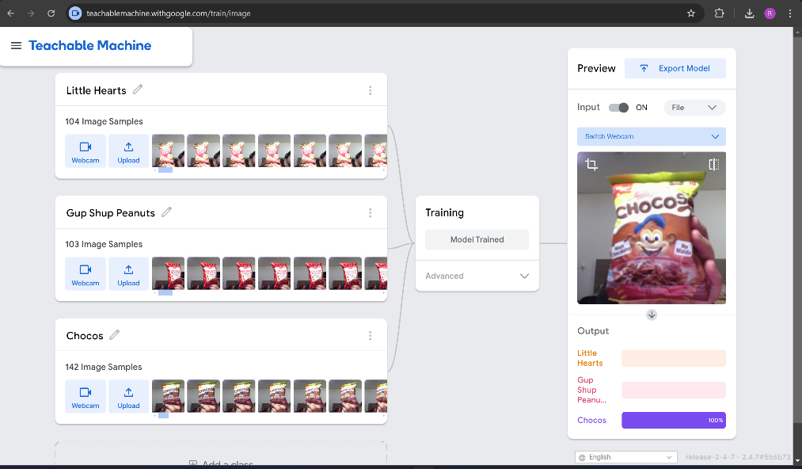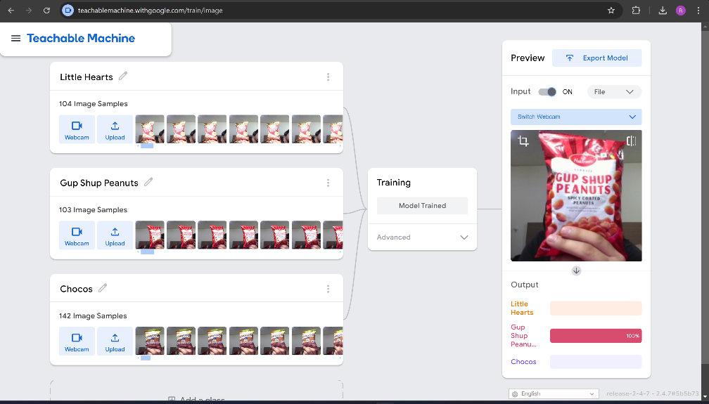This model has been taught to tell apart three different packaged snacks: 'Little Hearts', 'Gup Shup Peanuts', and 'Chocos'. The model was trained using pictures giving it the ability to spot these items in the real world when viewed through a webcam