Elements of AIML

LAB – 2



Name - Ronak Singh

SAP ID - 500120683

Batch – 12

Roll No. – R2142230381

Palindrome Checker

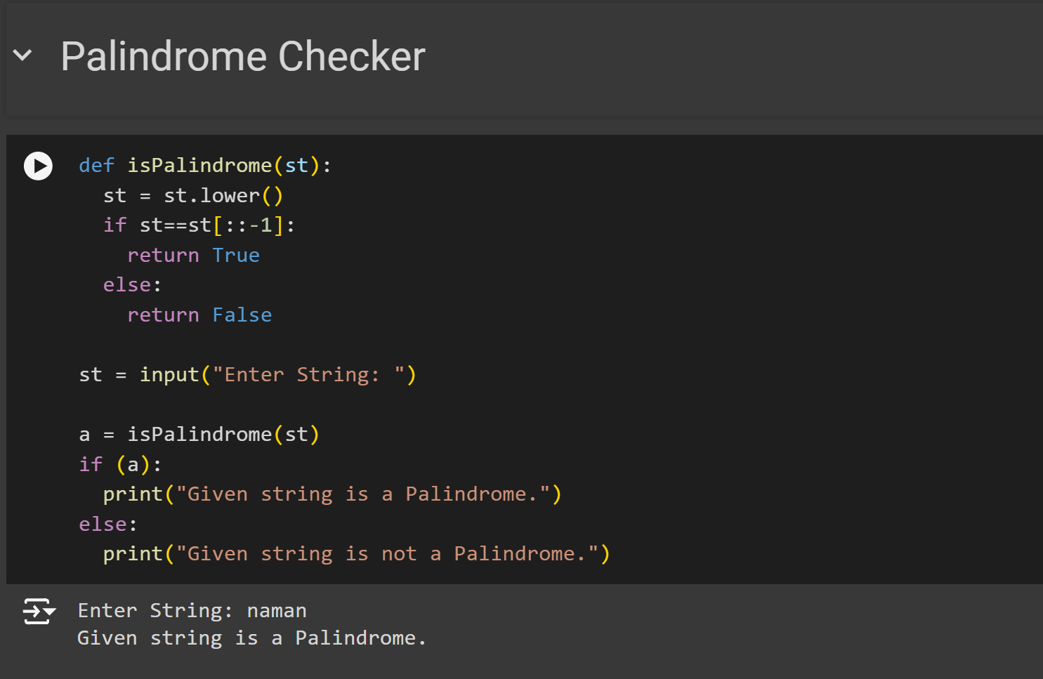

Prime Checker

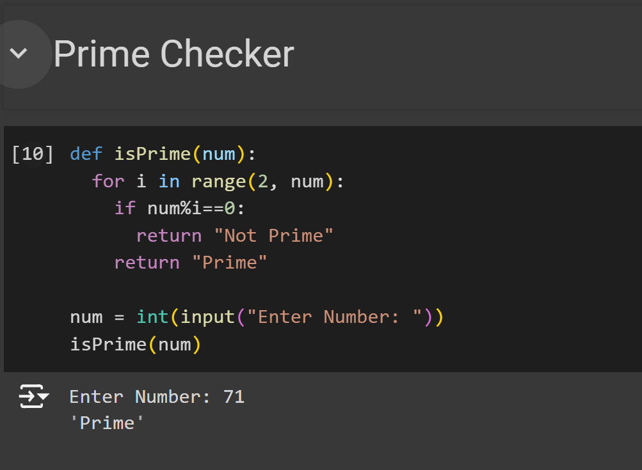

Fibonacci Series Generator

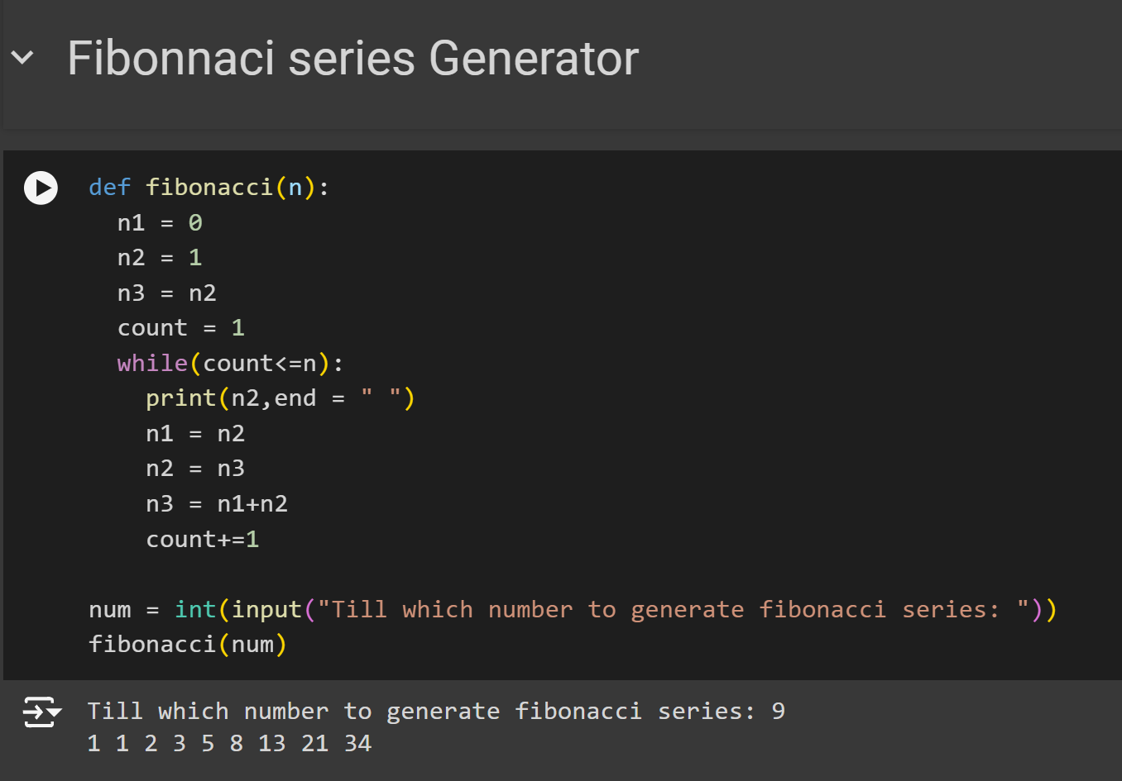

Temperature Converter

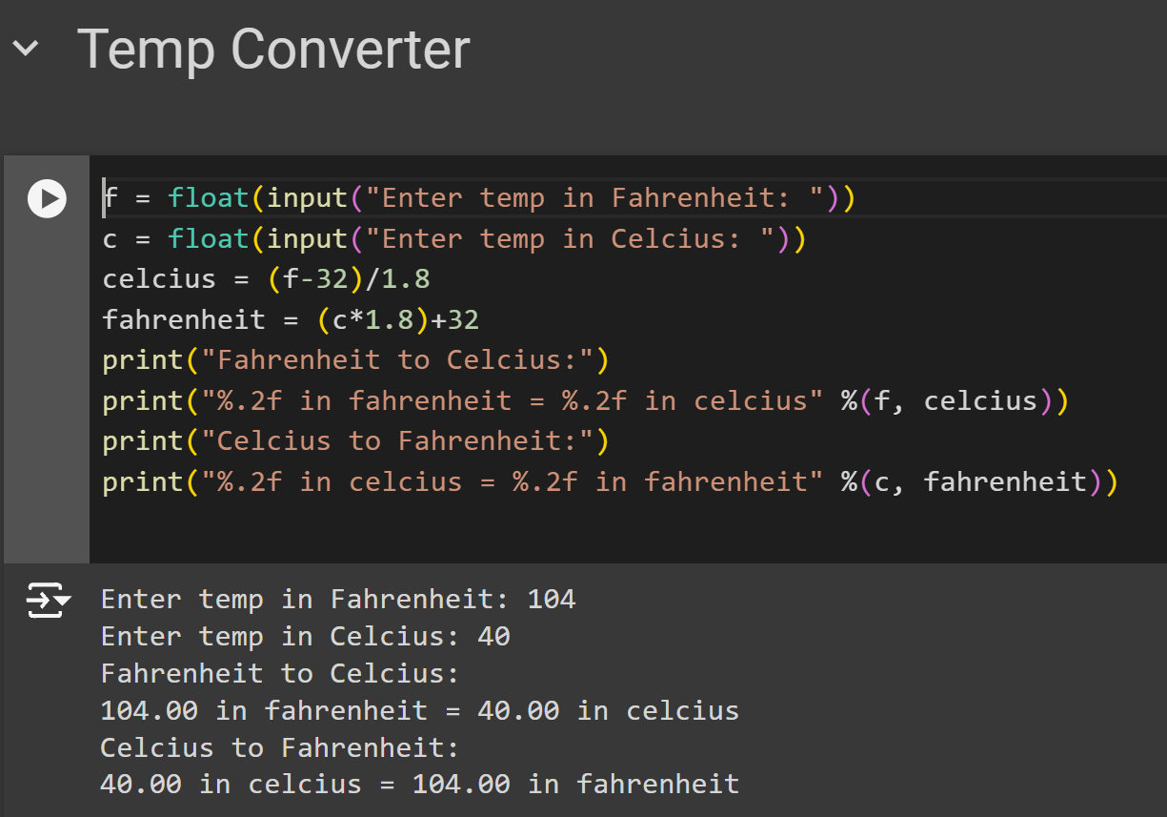

Dataset using Pandas Lib

