Elements of AIML

LAB – 4



Name - Ronak Singh

SAP ID - 500120683

Batch – 12

Roll No. – R2142230381

**Regression Using WEKA**

***In this project, we leveraged the Weka machine learning toolkit to build and evaluate regression models. Our goal was to predict a continuous target variable based on input features***

Screenshots of Process

1. Loading the data: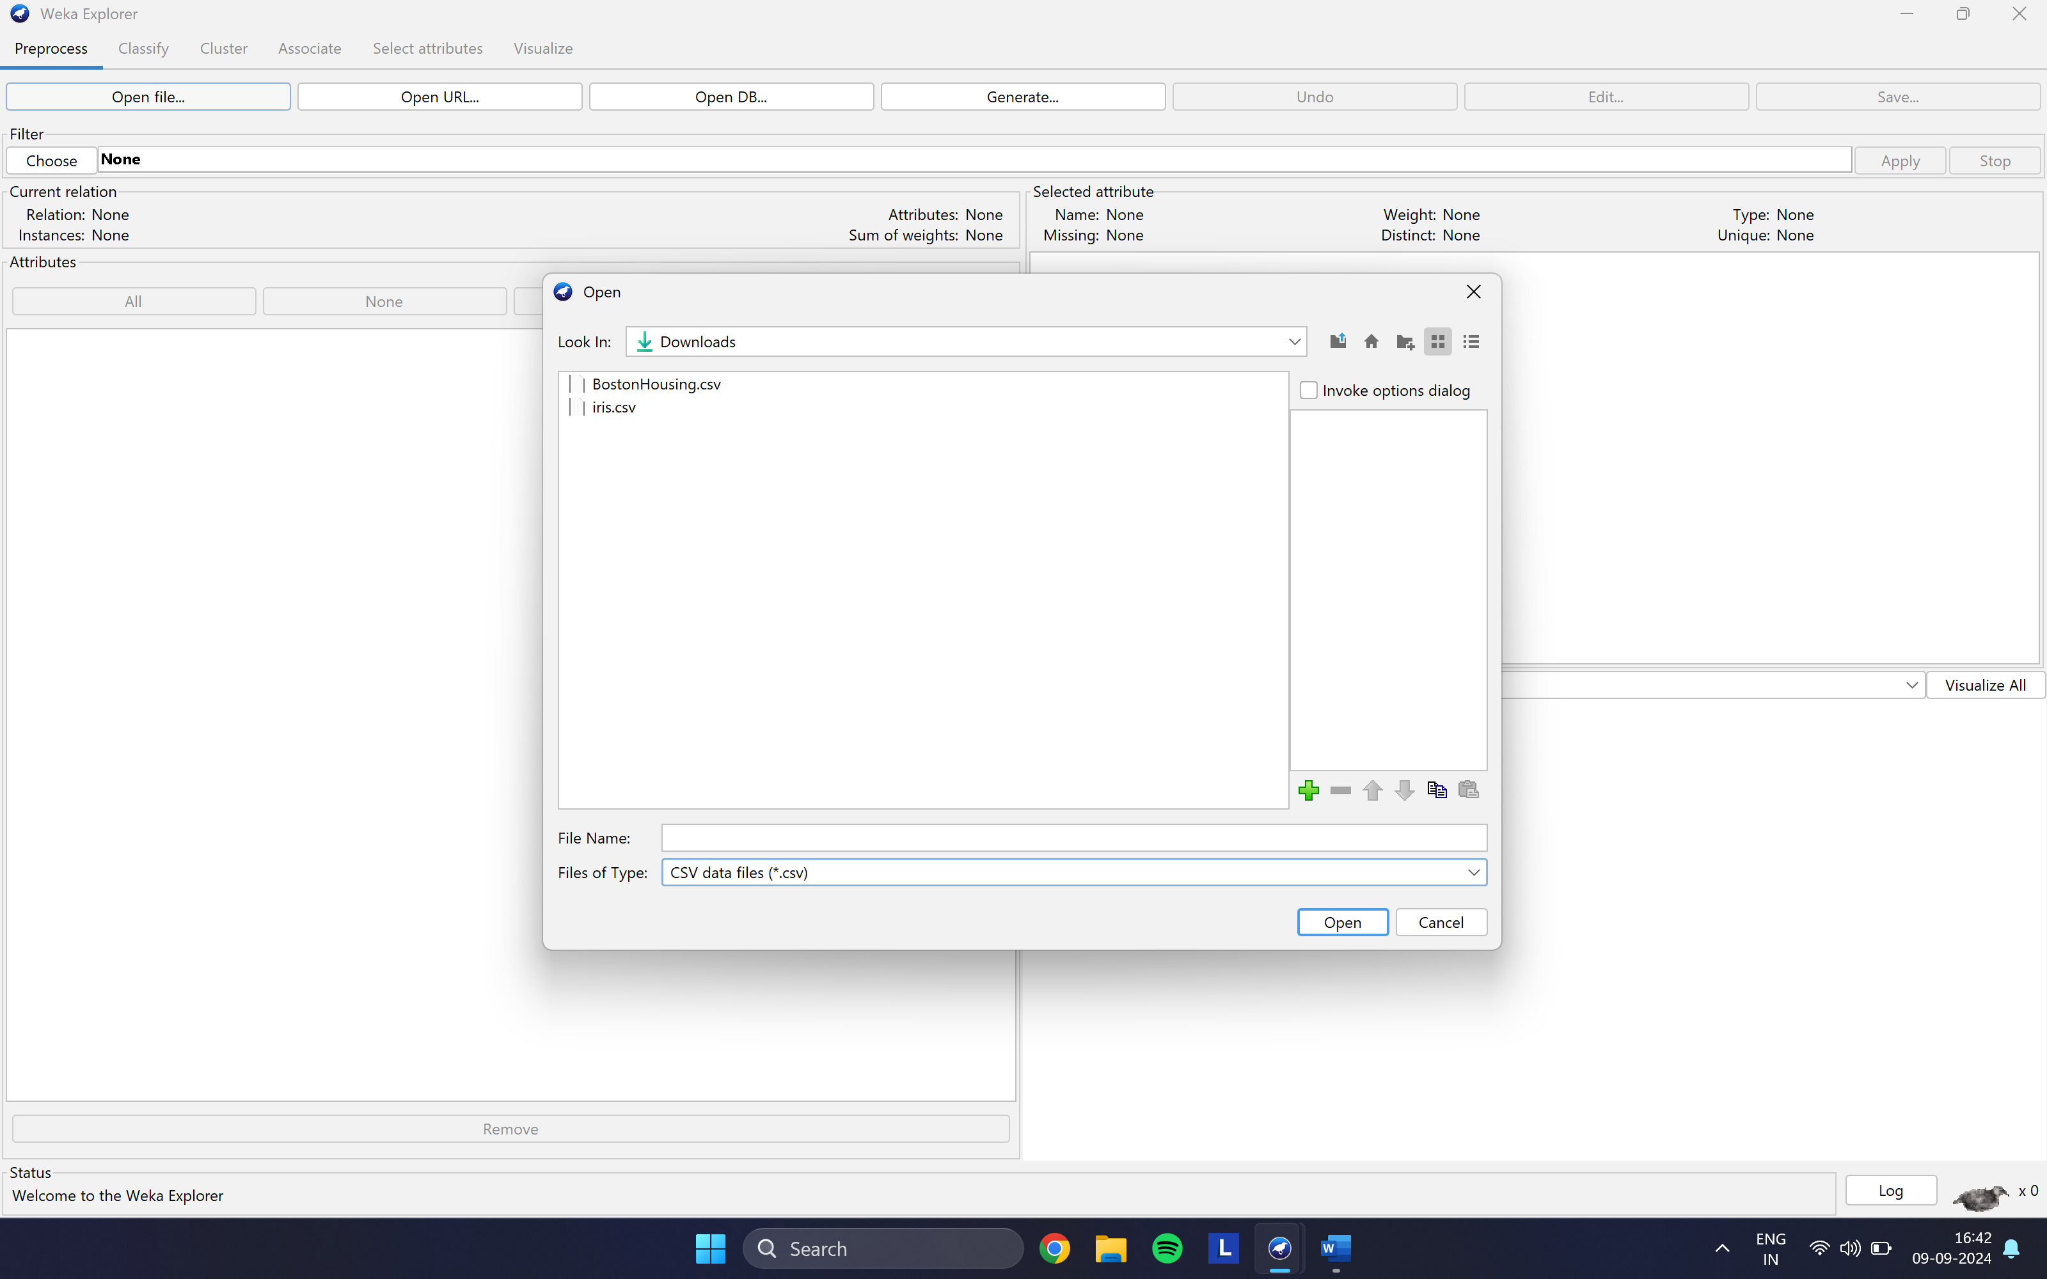
2. Linear regression model:

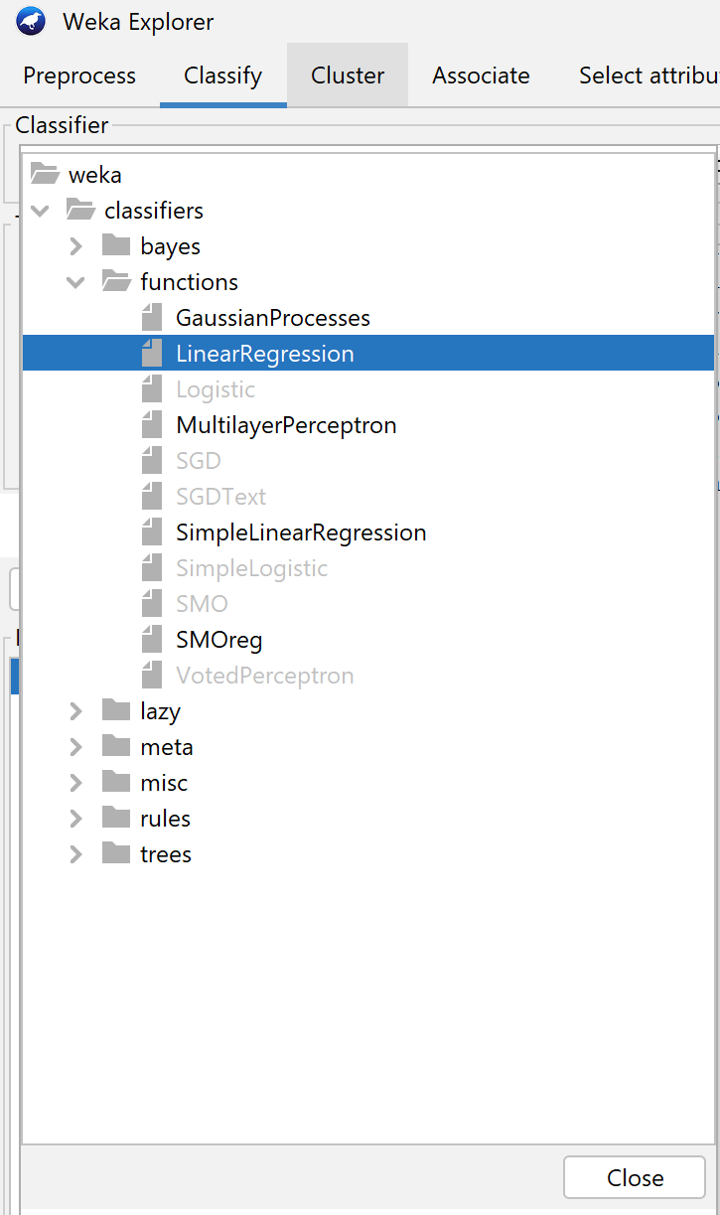

1. Fitting Model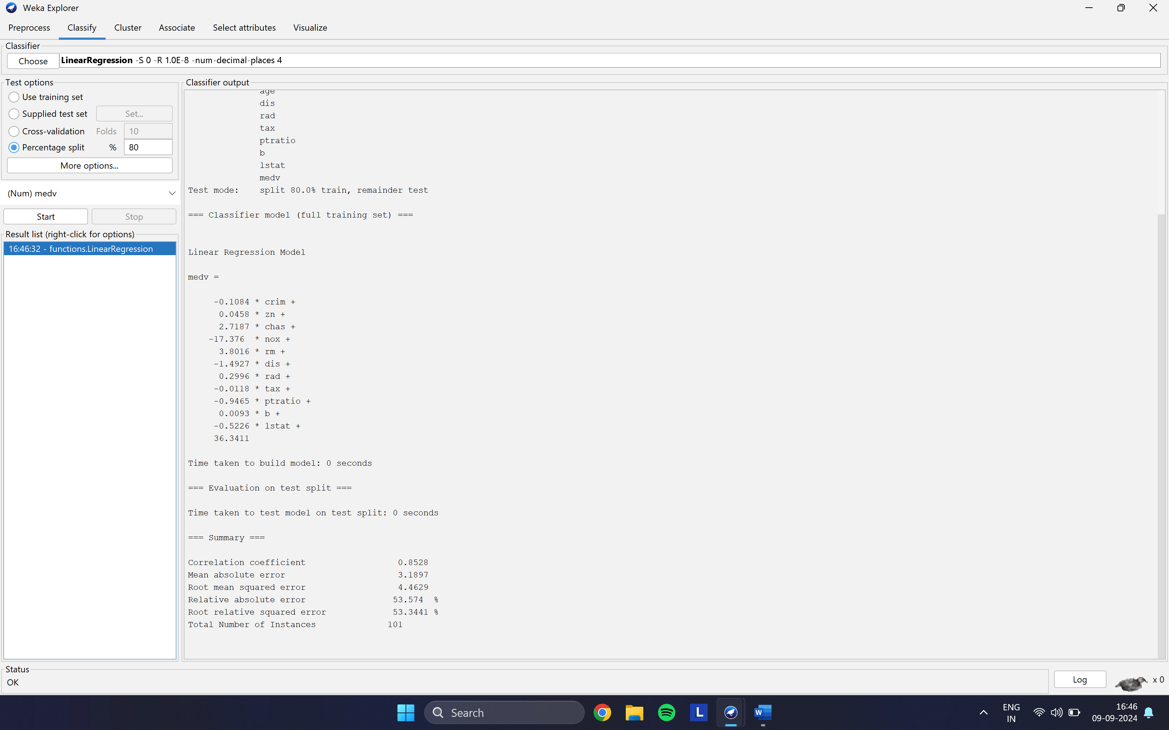

Comparison between Normalized and Non-Normalized data

1. Normalized Data

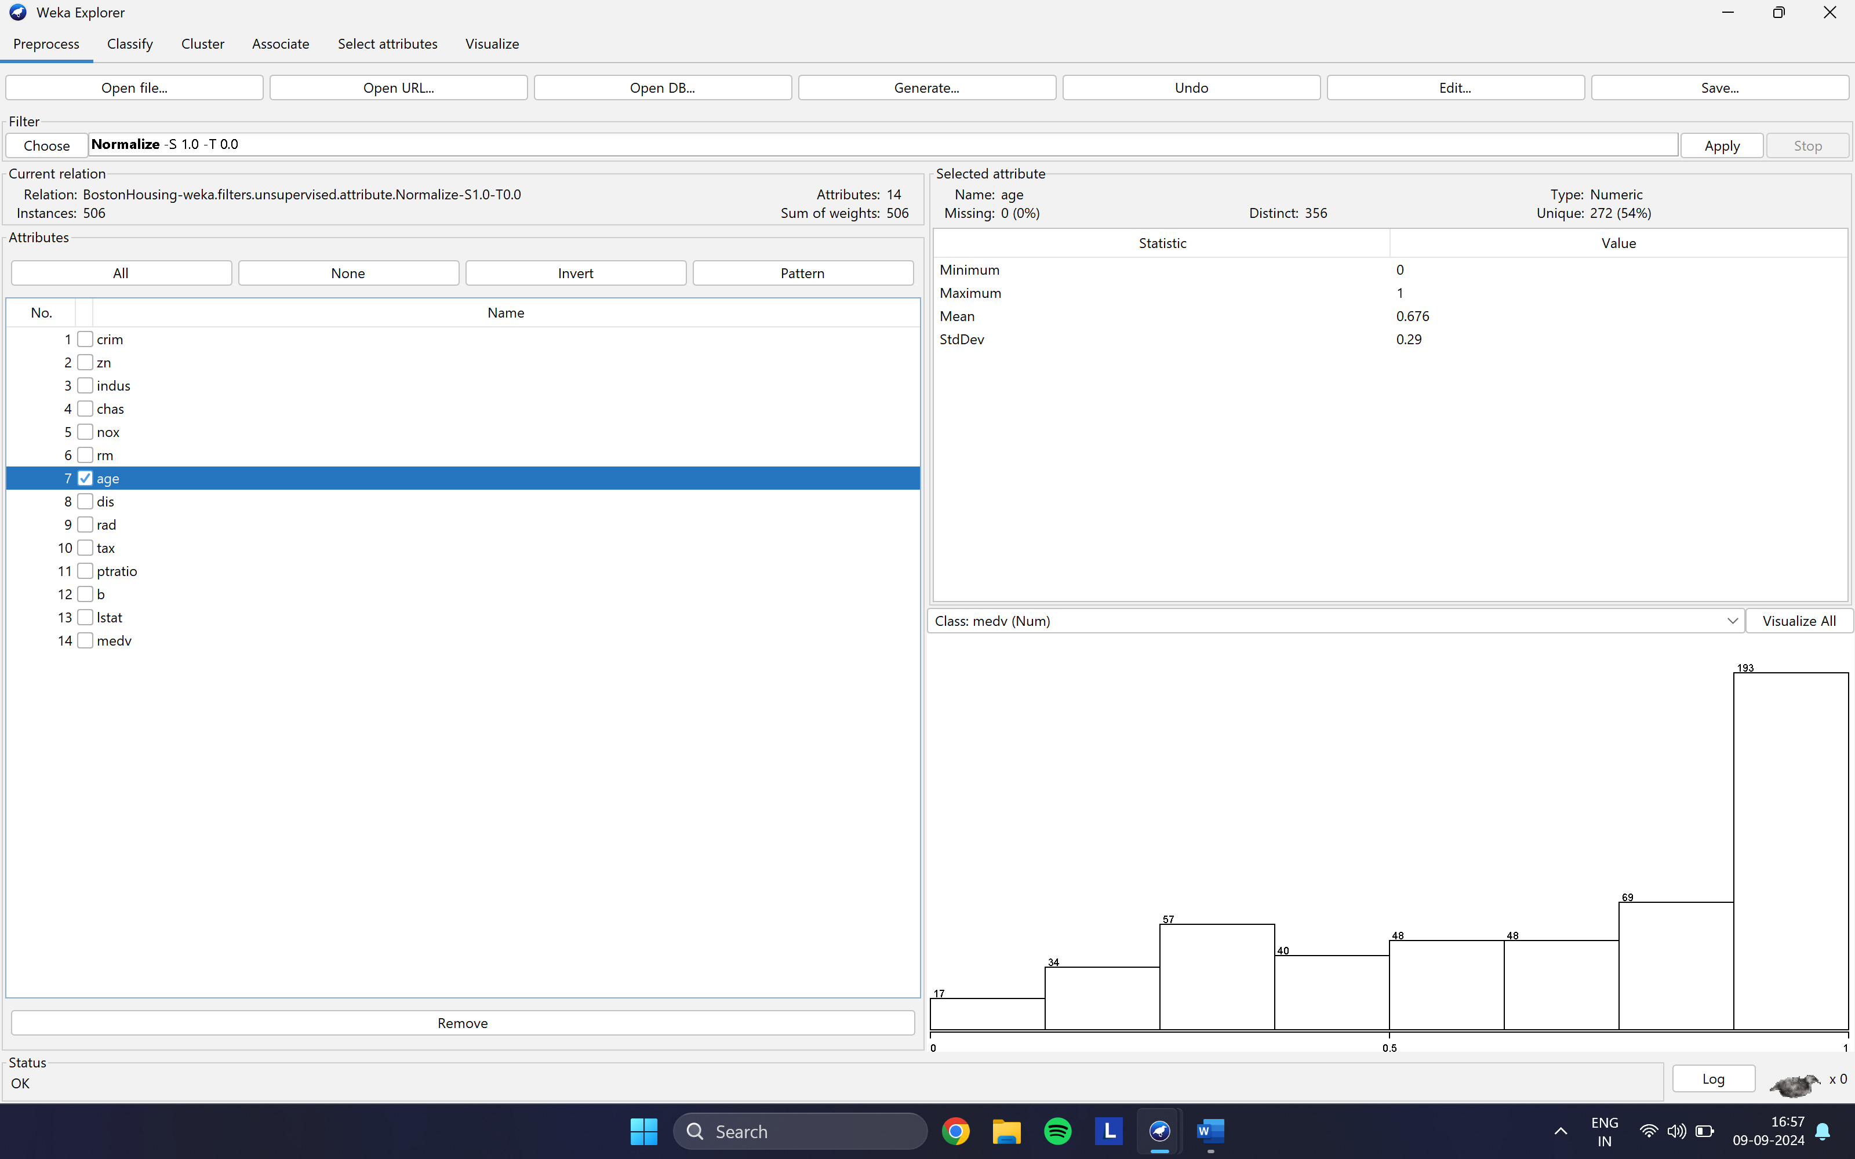

1. Non-Normalized Data

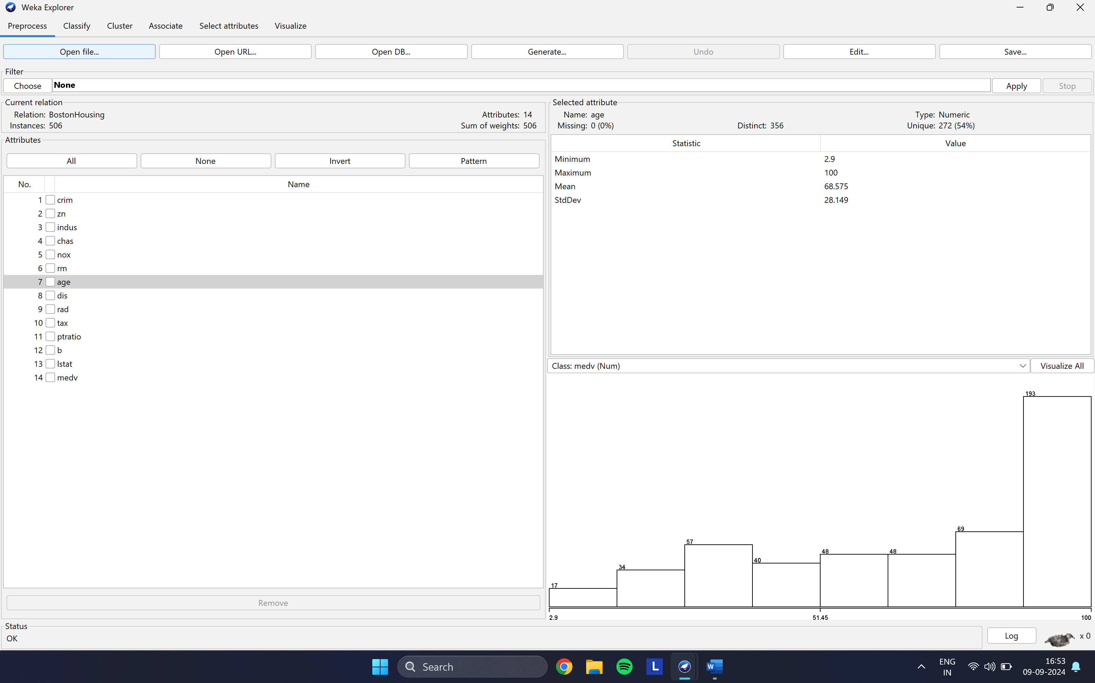

Saving & Re-Loading

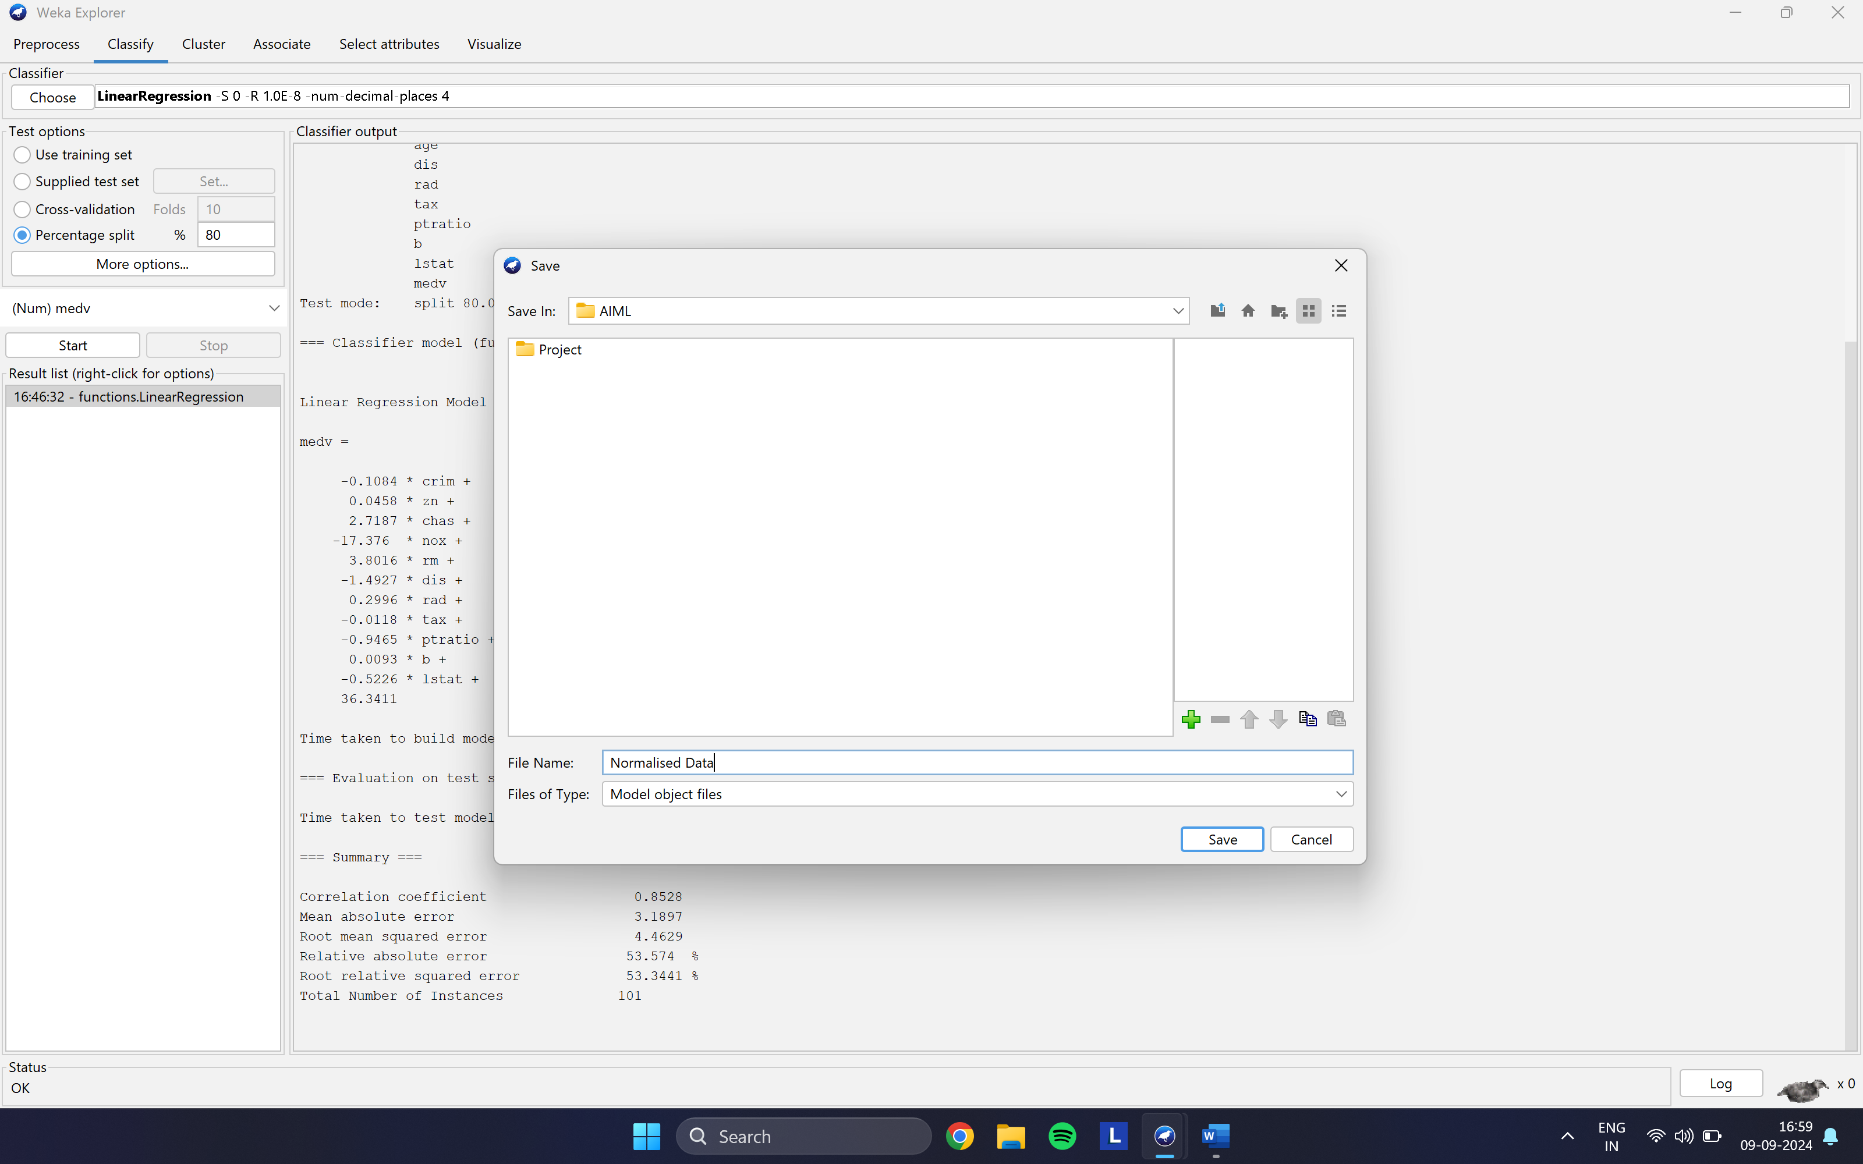

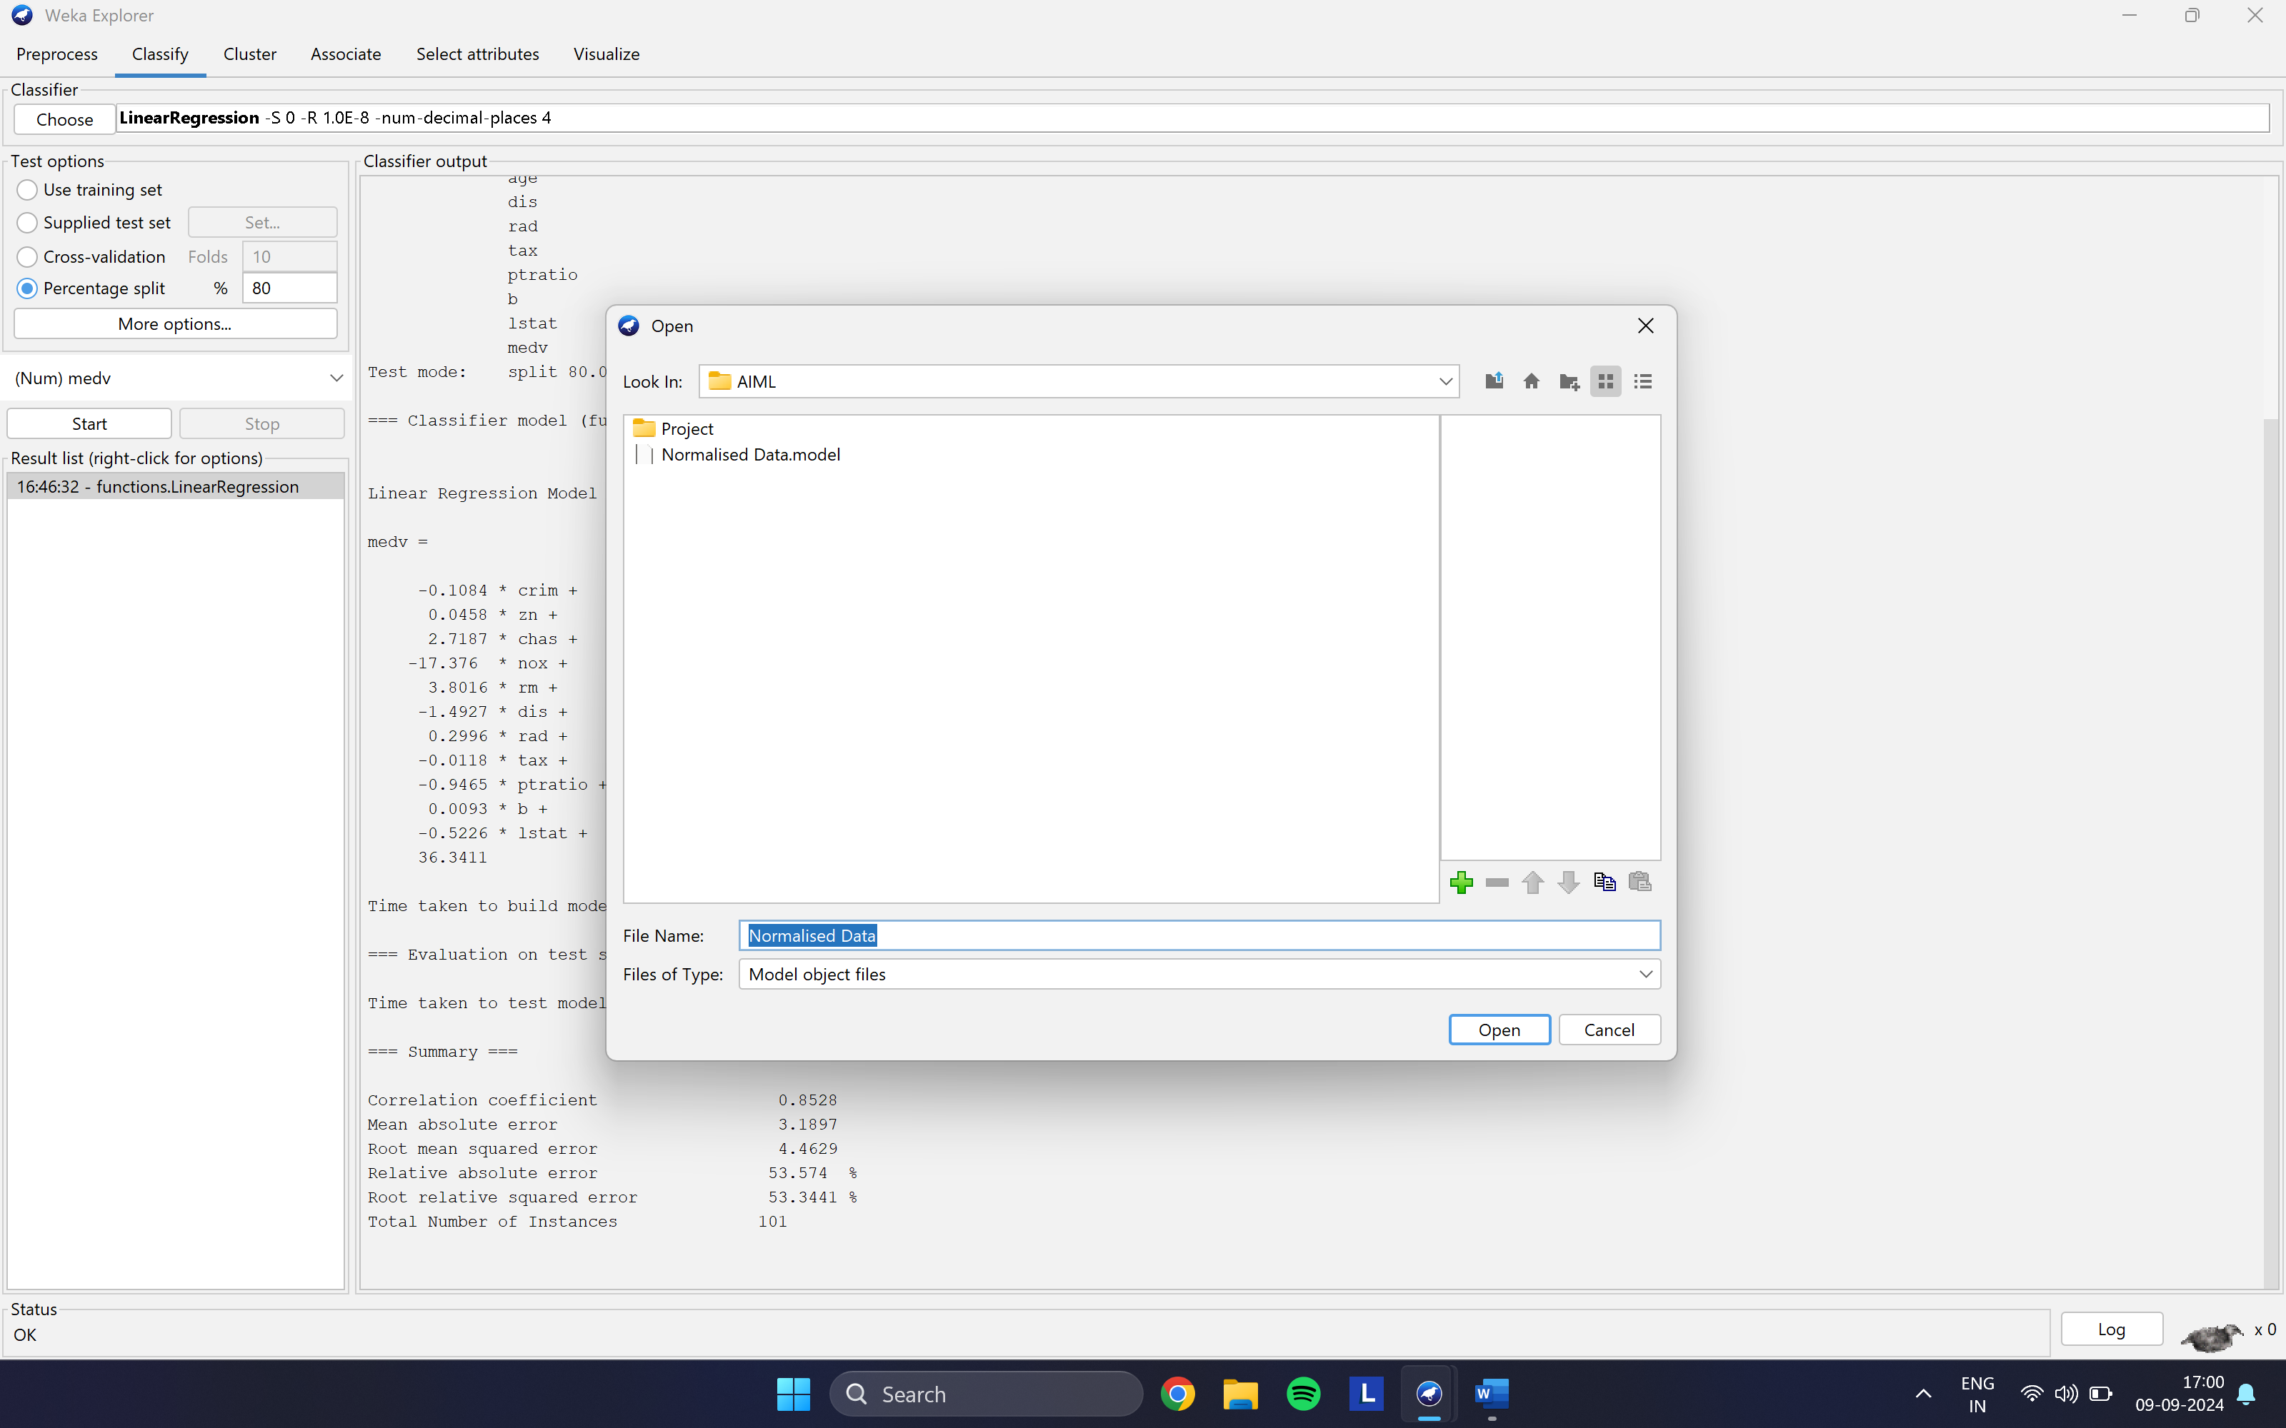

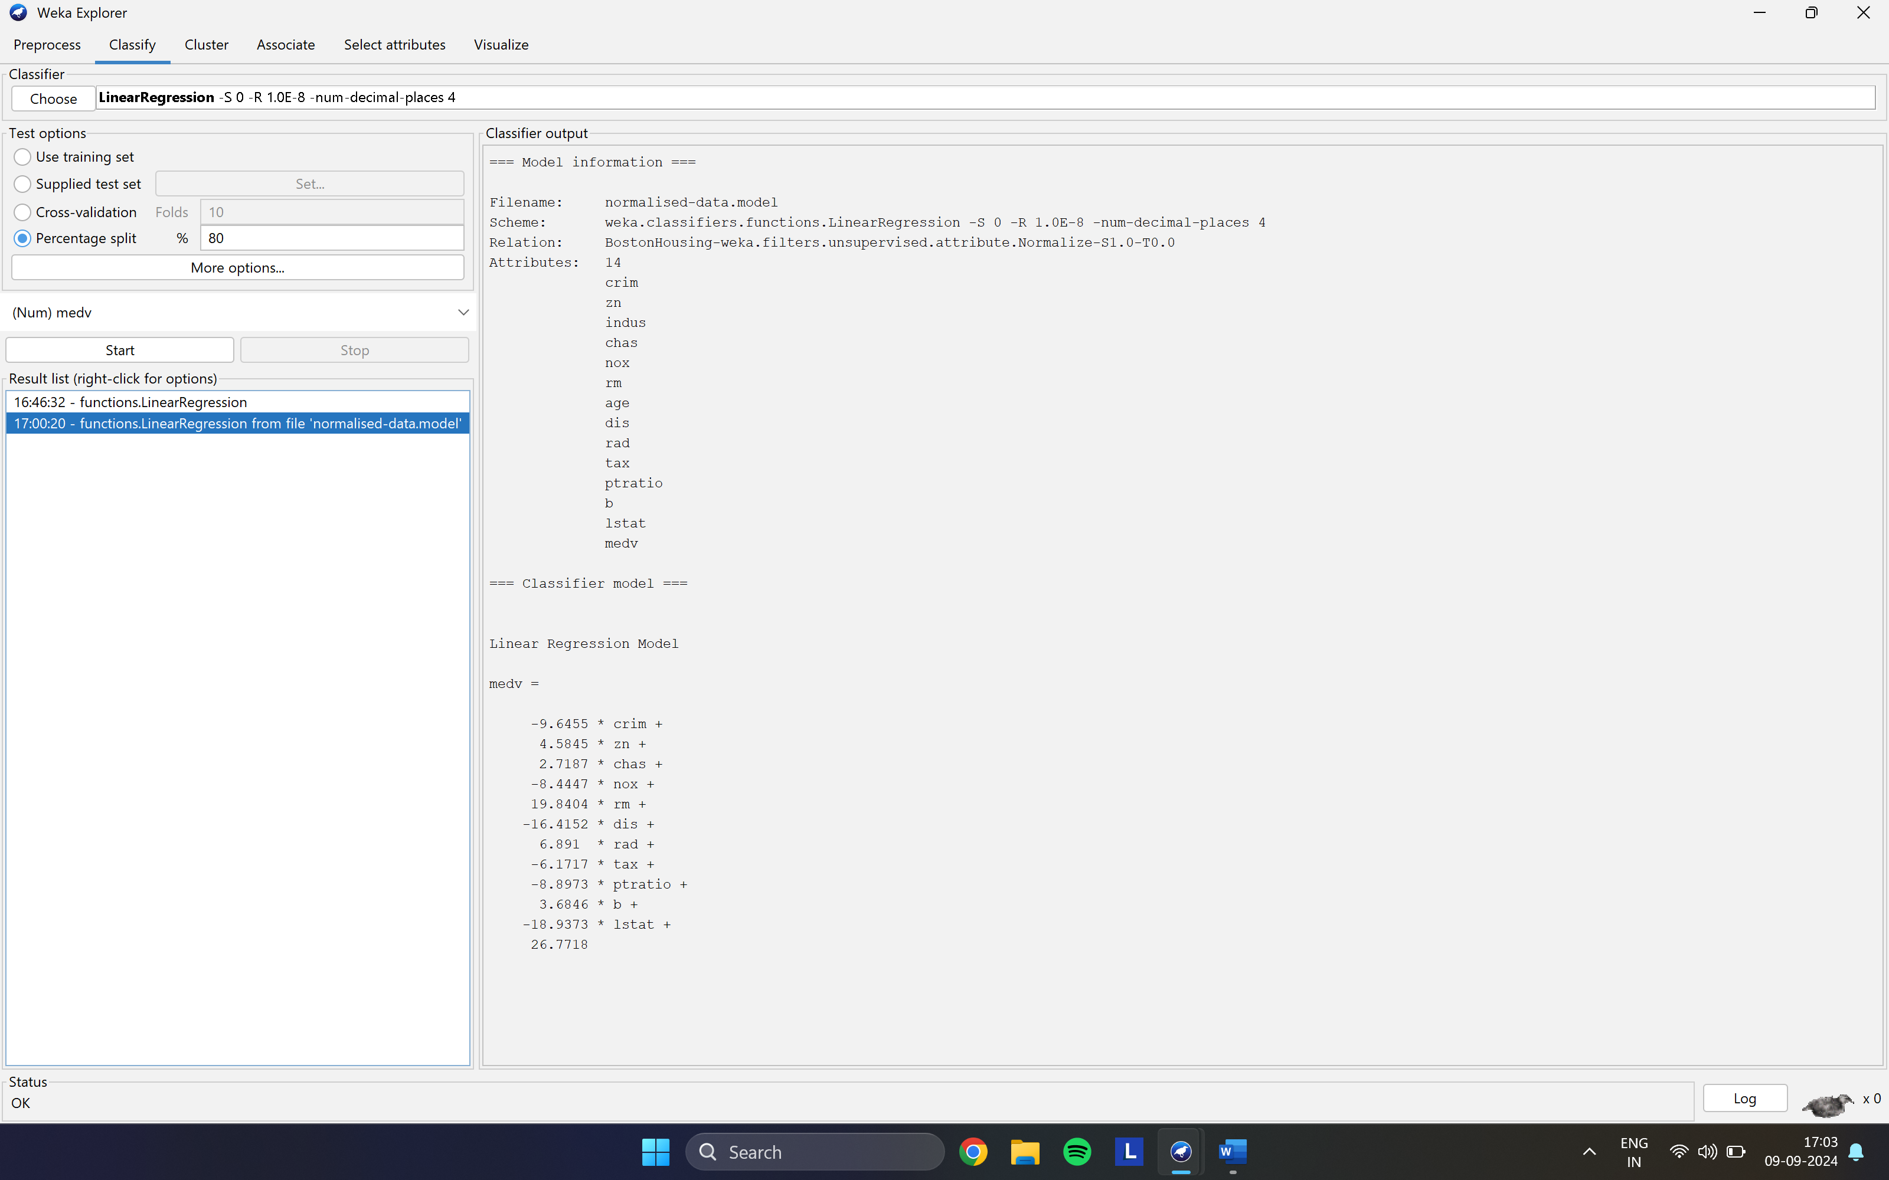

Visualizing Model Error

