Elements of AIML

LAB – 4



Name - Ronak Singh

SAP ID - 500120683

Batch – 12

Roll No. – R2142230381

# Screenshots Of the Loading Process

1 Loading Data (.arff file)

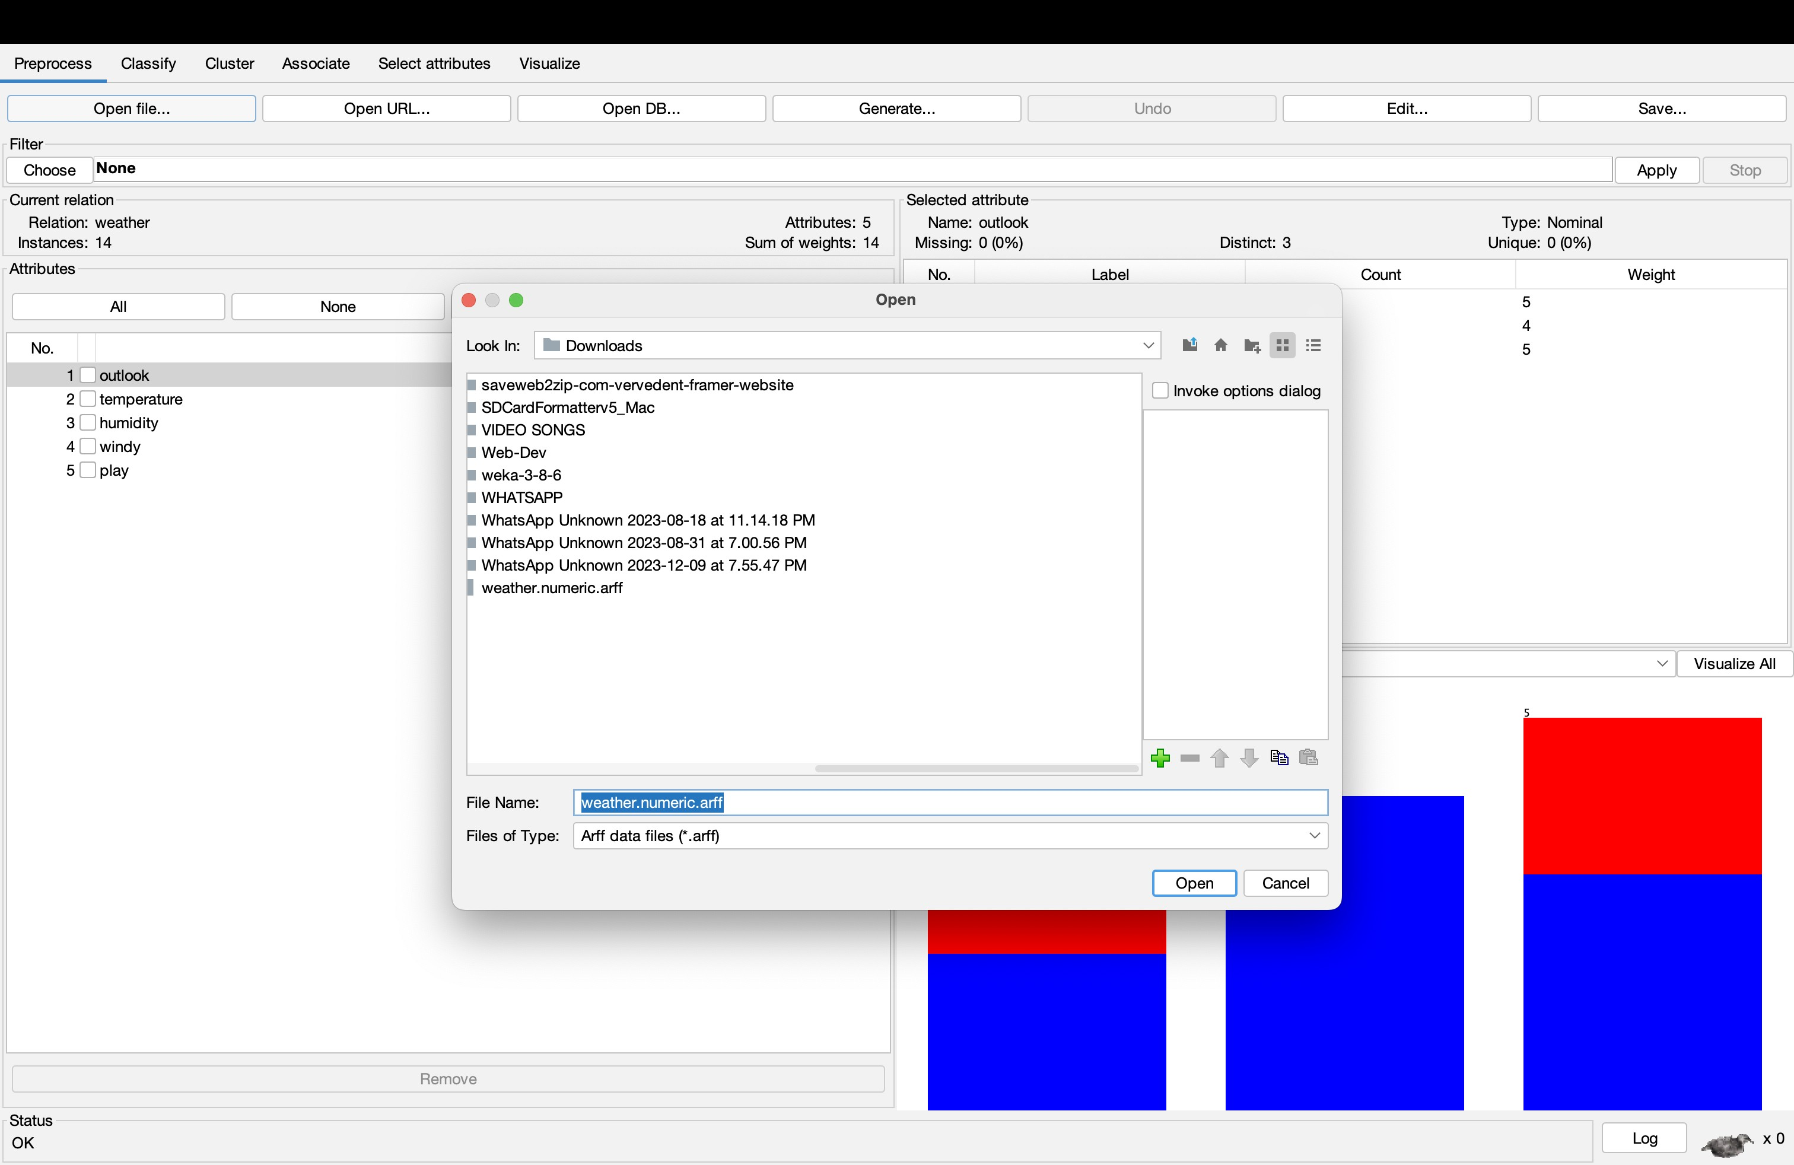

# Screenshots Of the Clustering Data

1 Keeping the Distance Function Constant Euclidean Distance)

When Number of Cluster = 2

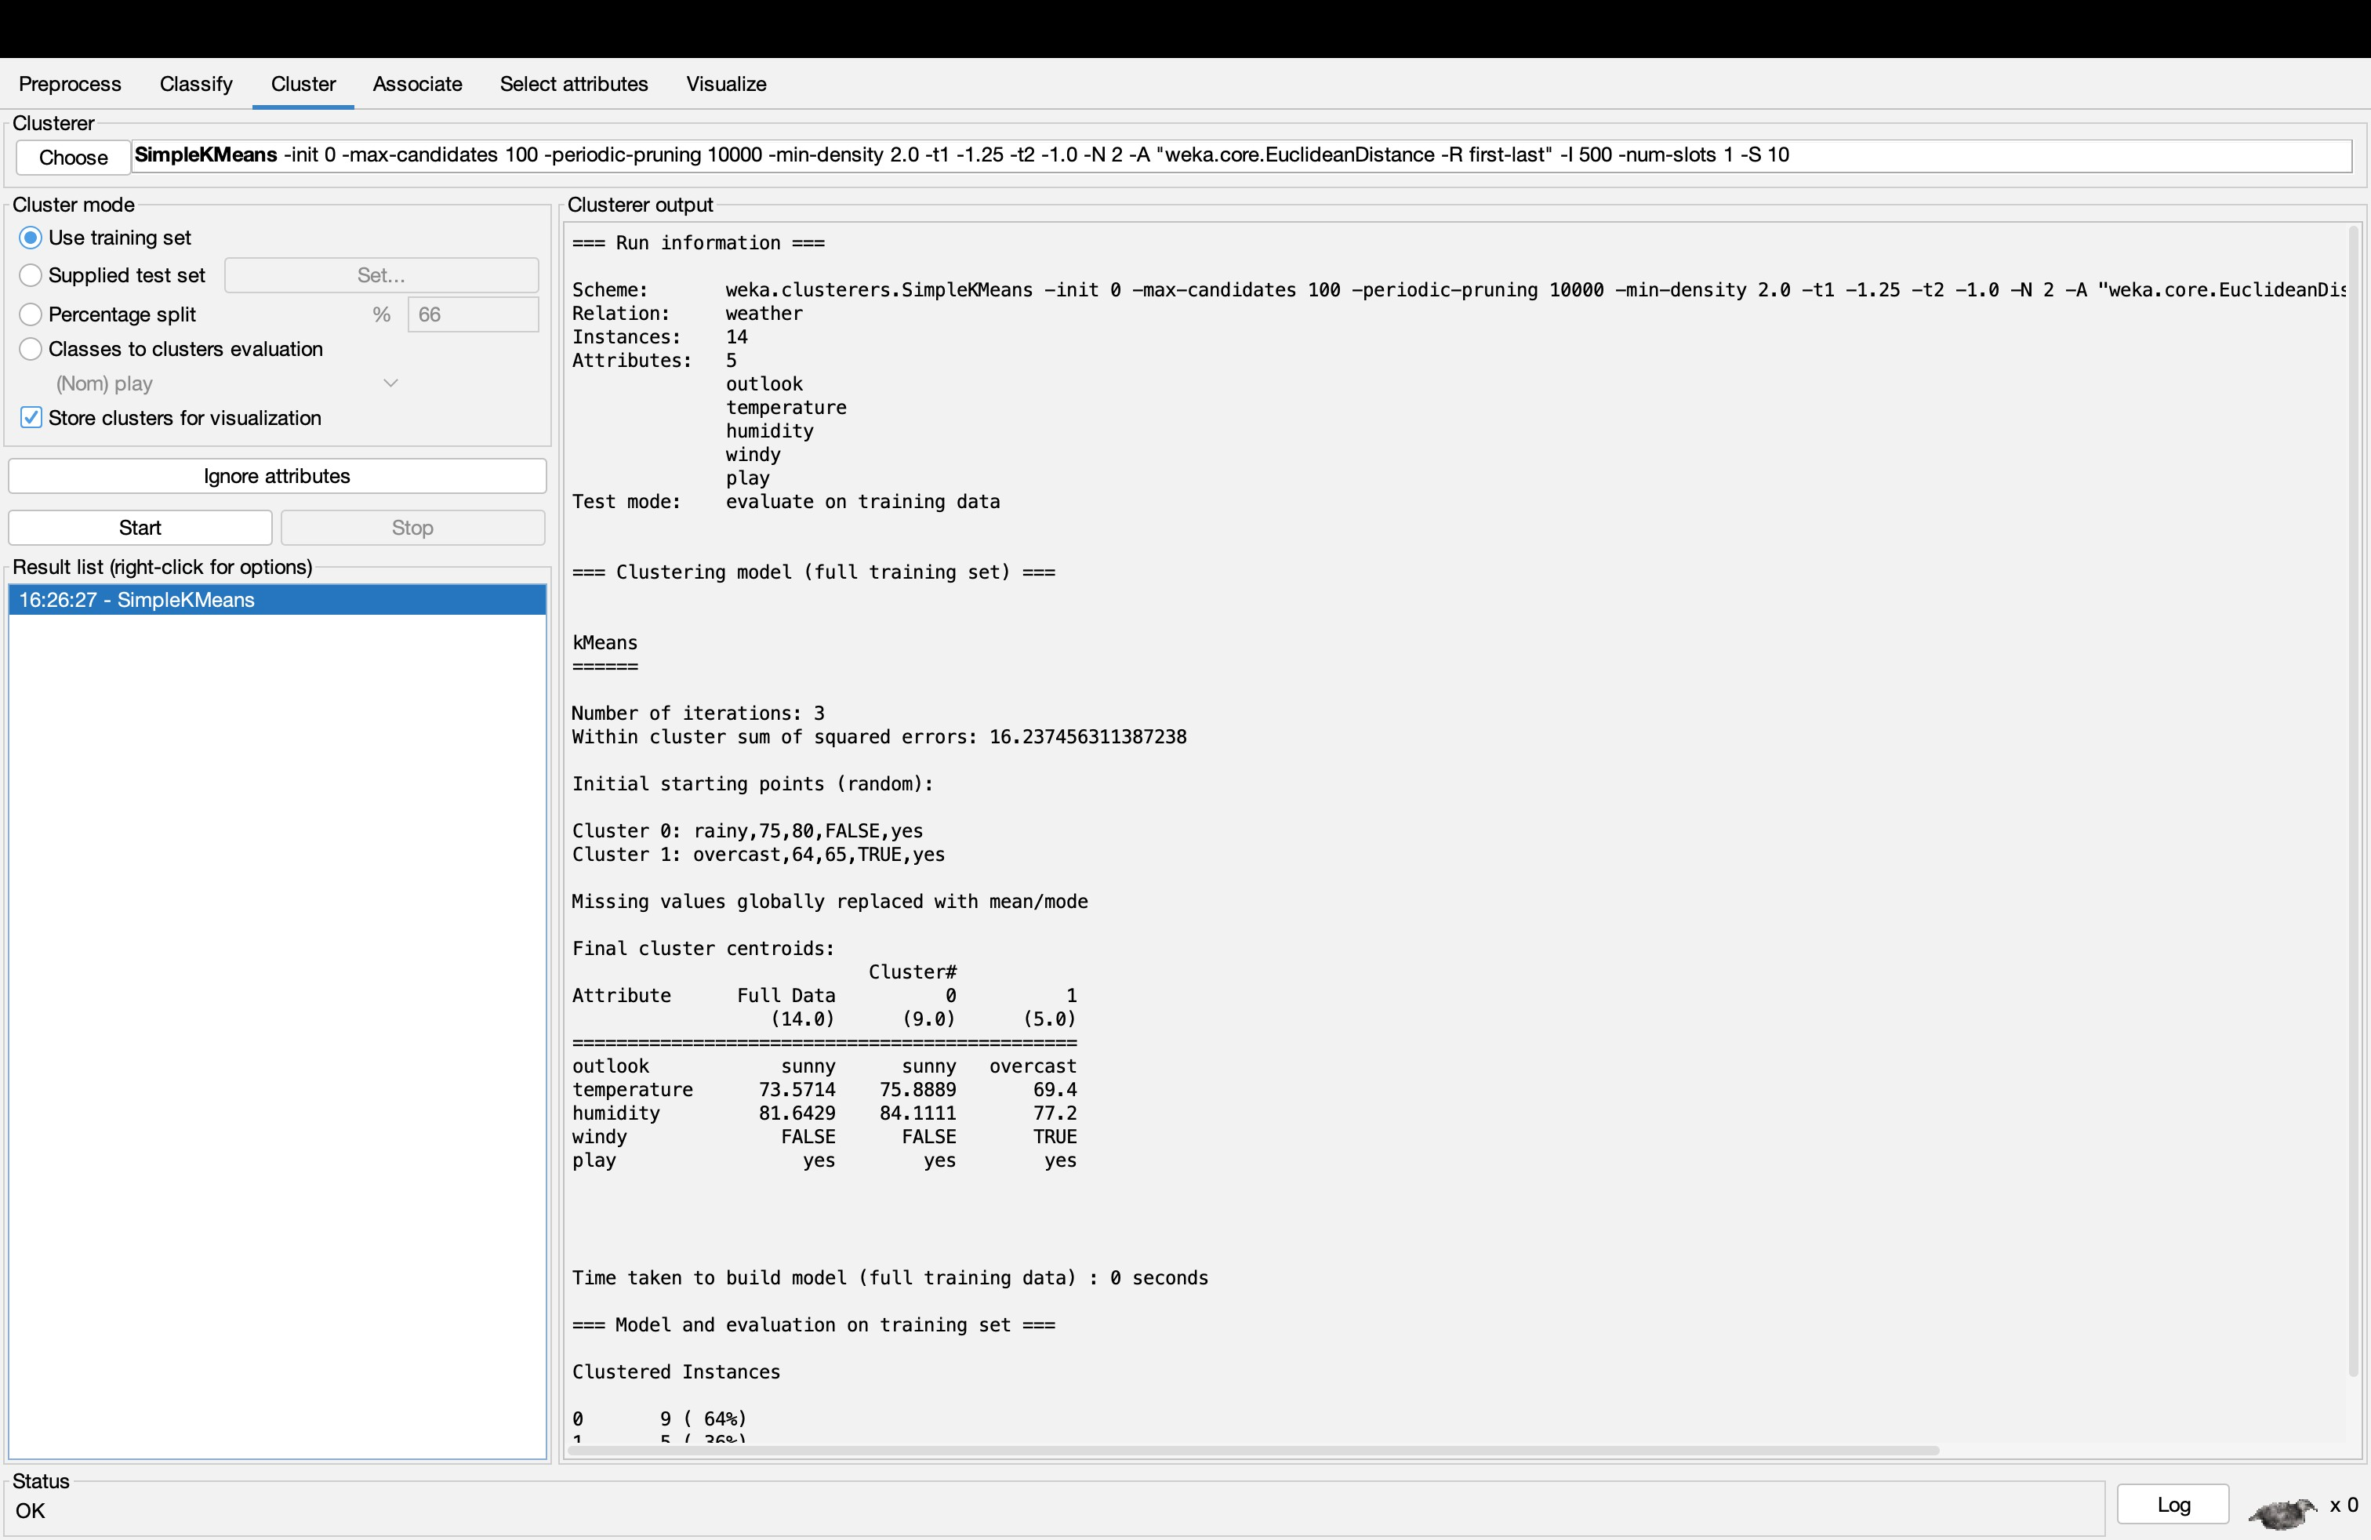

When Number of Cluster = 5

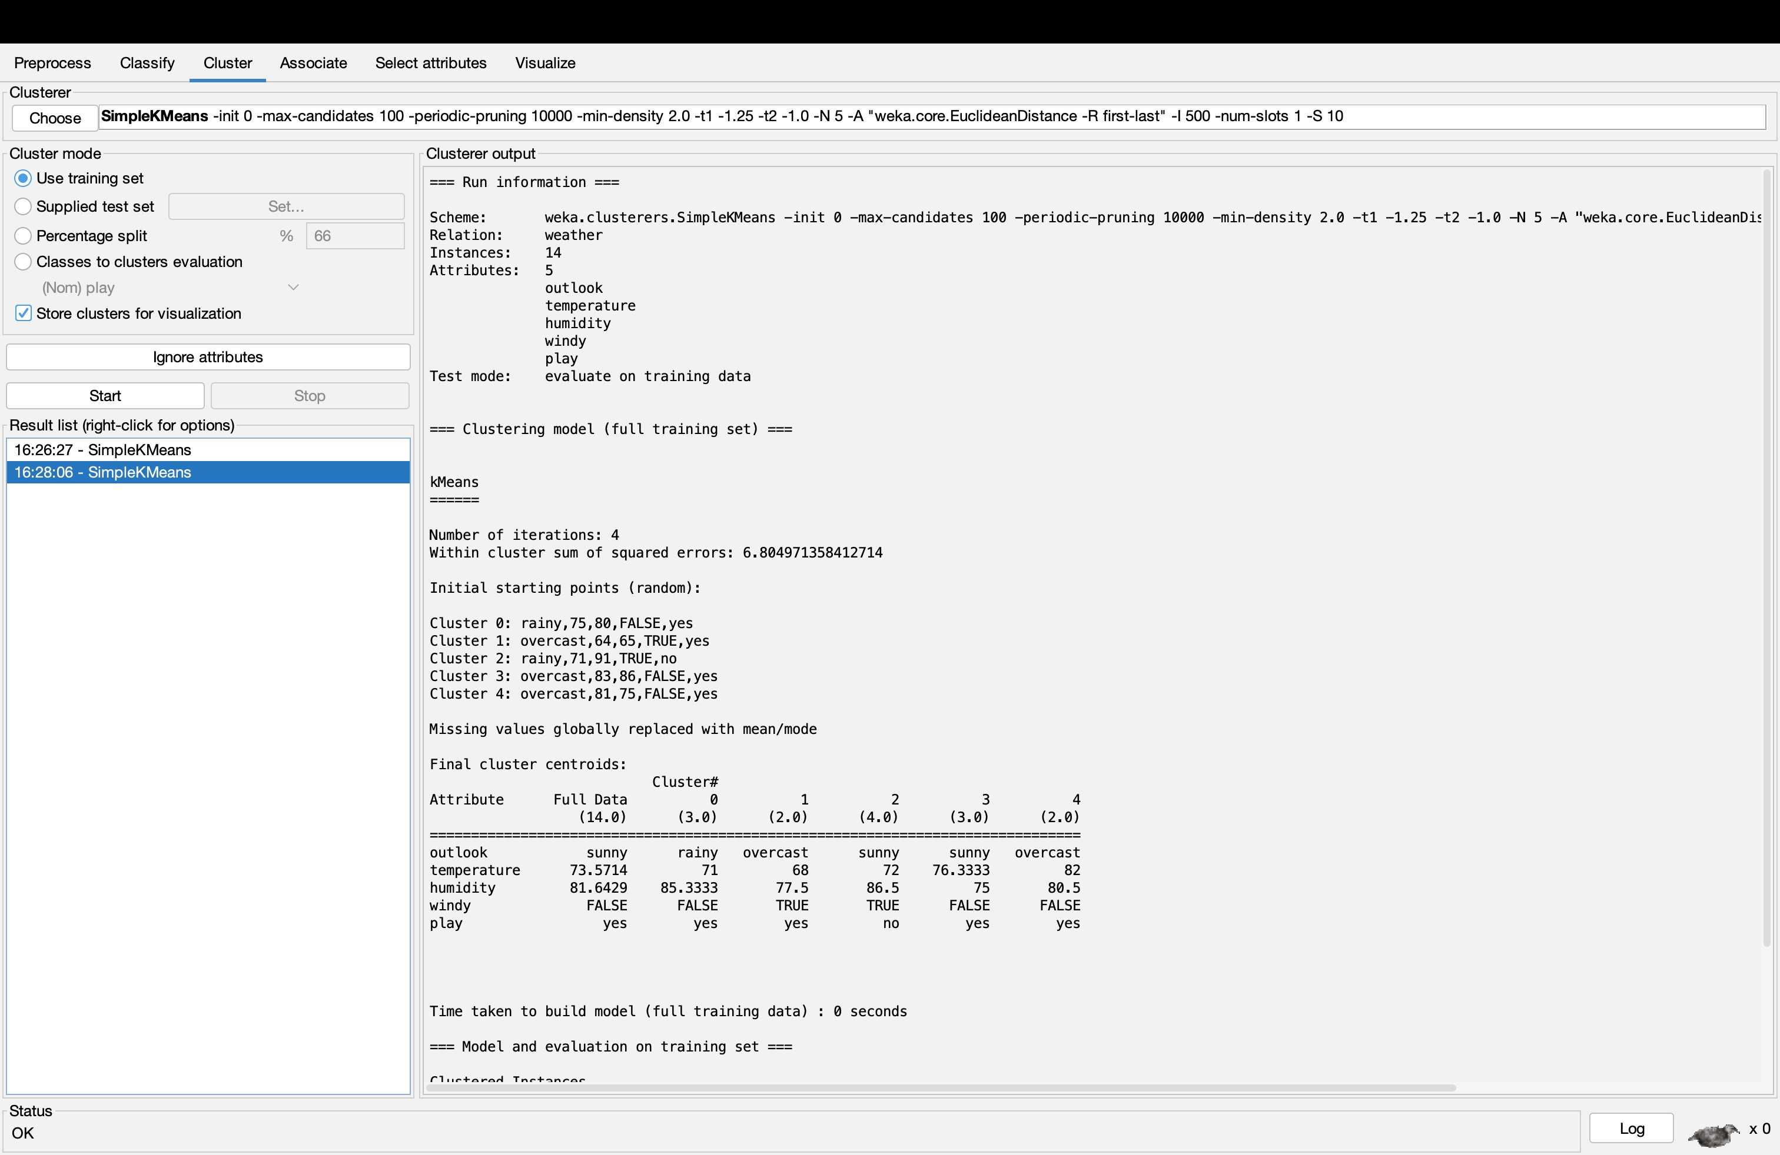

When Number of Cluster = 8

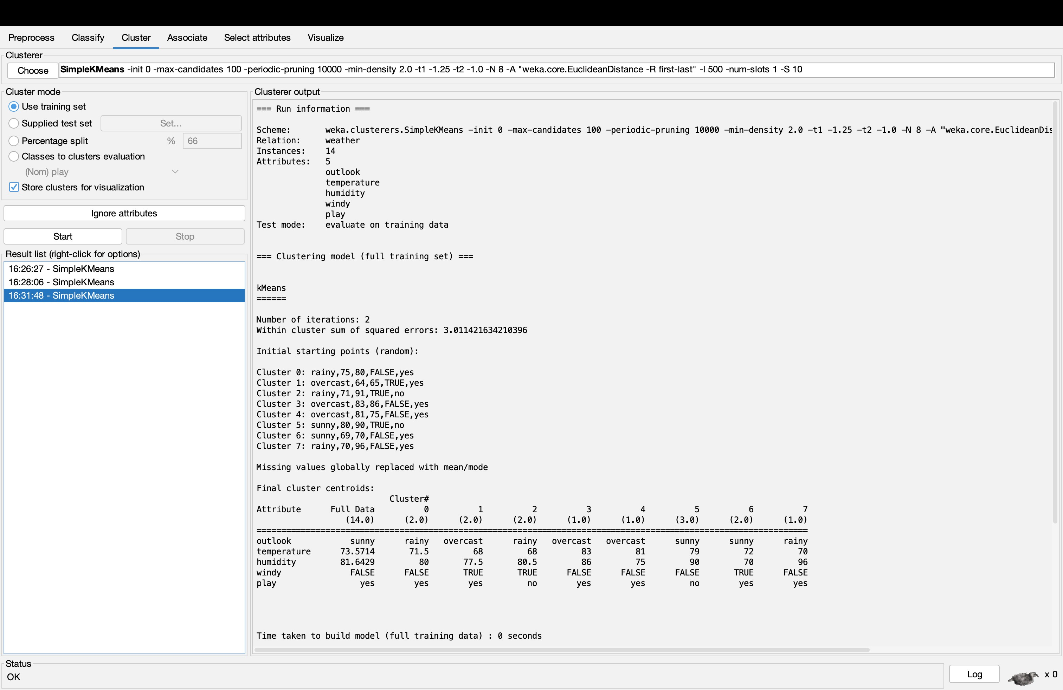

2 Keeping the Number of Cluster Constant Number of Cluster  2

When Distance Function = Euclidean Distance

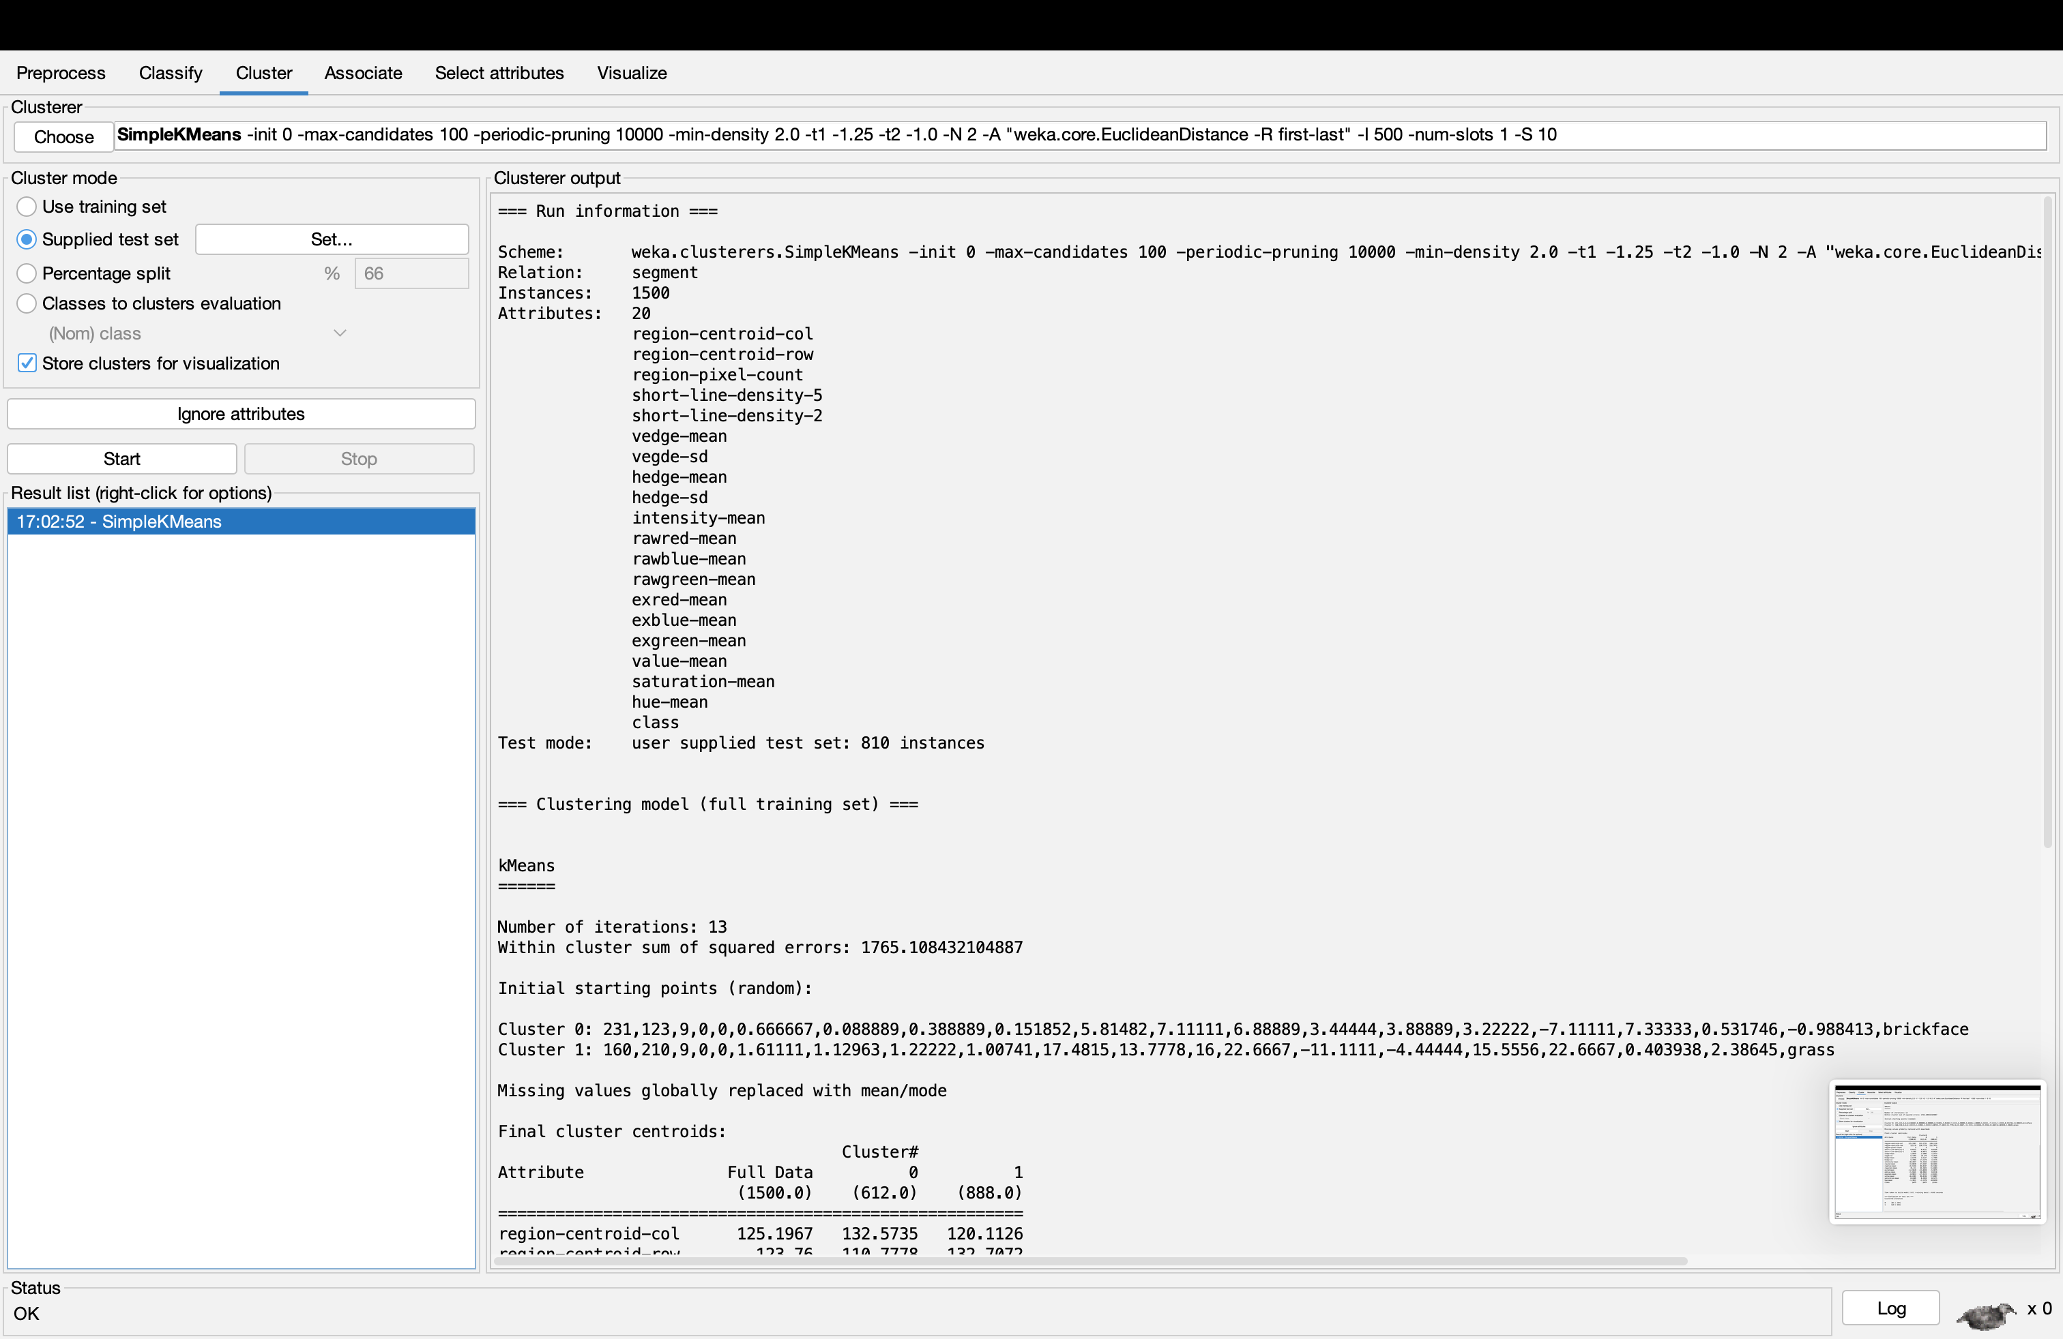

When Distance Function = Manhattan Distance

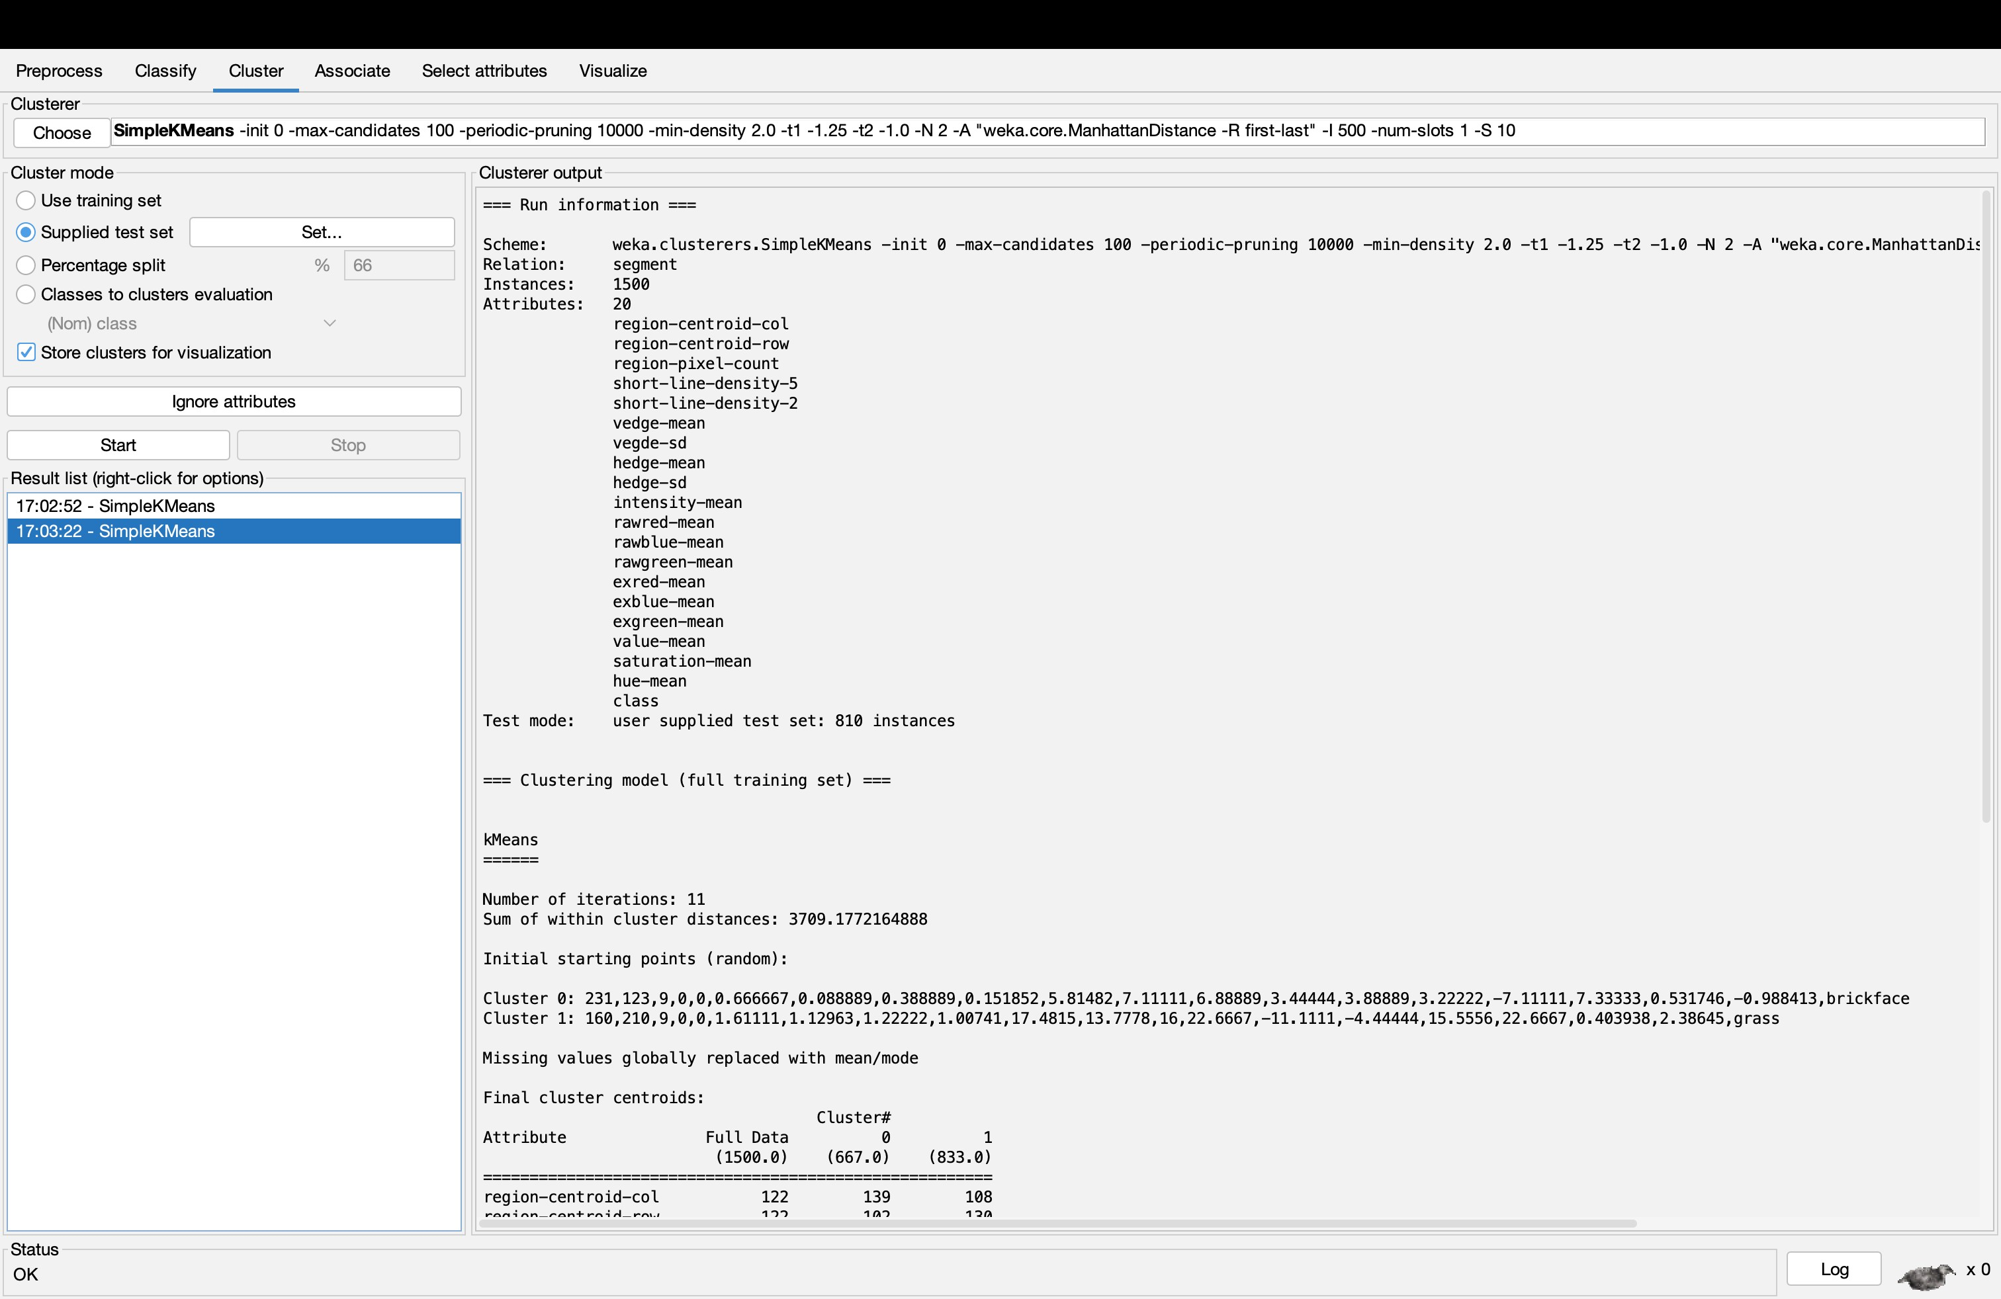

# Visualising Clustering a Supplied Data set on other Data set

