Elements of AIML

LAB – 6



Name - Ronak Singh

SAP ID - 500120683

Batch – 12

Roll No. – R2142230381

**Topic: Dimensional Analysis**

**Experiment Question**

**Experiment 6 - Use PCA, LDA and ICA to apply it on the dataset of your choice that you have used for creating a Flask App. Visualise the graphs and make a submission on LMS.**

**Introduction:**

Dimensionality reduction is a vital technique in data analysis and machine learning, aimed at simplifying datasets while retaining their essential characteristics. It helps reduce computational cost, mitigates the curse of dimensionality, and enhances data visualization. This experiment focuses on three popular dimensionality reduction techniques: Principal Component Analysis (PCA), Linear Discriminant Analysis (LDA), and Independent Component Analysis (ICA). The dataset used for this analysis is the same as that used in the development of my Flask app, which focuses on [brief description of the Flask app and its functionality].

**Wine Quality Dataset**

**STEPS OF THE CODE:**

1. **Import Necessary Libraries**
   * **Start by importing the required libraries for data manipulation, visualization, and machine learning. This includes libraries for handling datasets, performing PCA, LDA, and ICA, and scaling the data.**
2. **Load the PIMA Dataset**
   * **Load the Wine Quality dataset from a specified URL or local path using a data reading function. This dataset contains information relevant to diabetes diagnosis in Indian women.**
3. **Data Preprocessing**
   * **Preprocess the data by standardizing the features. Standardization ensures that each feature contributes equally to the analysis by centering the data around zero and scaling it based on the variance.**

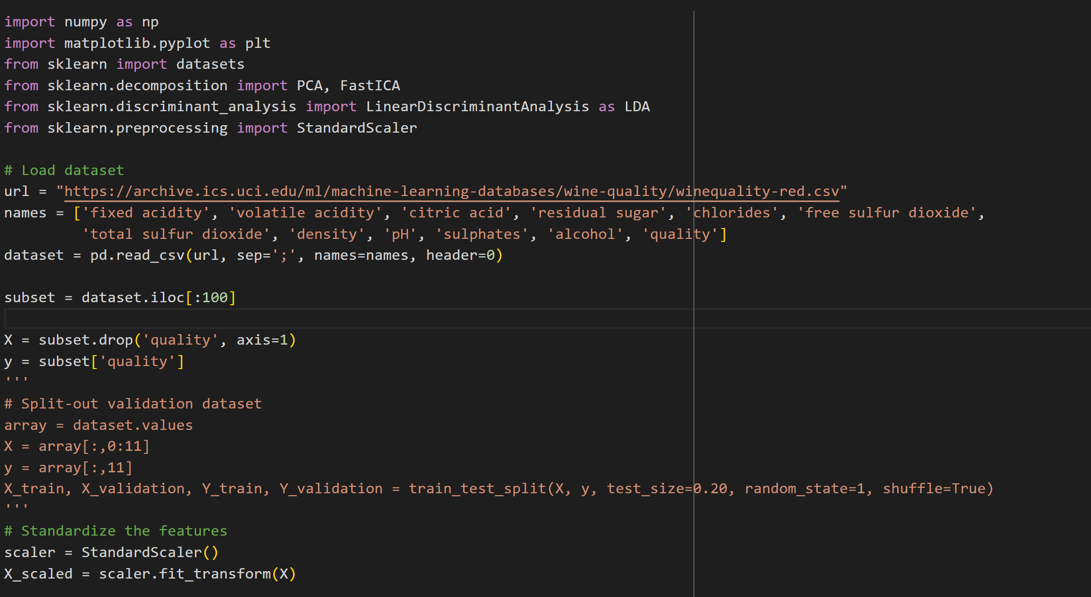

1. **Apply PCA (Principal Component Analysis)**
   * **Implement PCA to reduce the dimensionality of the dataset while preserving as much variance as possible. This technique transforms the original features into a new set of uncorrelated variables (principal components).**
2. **Apply LDA (Linear Discriminant Analysis)**
   * **Use LDA to maximize the separation between different classes in the dataset. LDA will transform the features into a space where the classes are more distinguishable.**

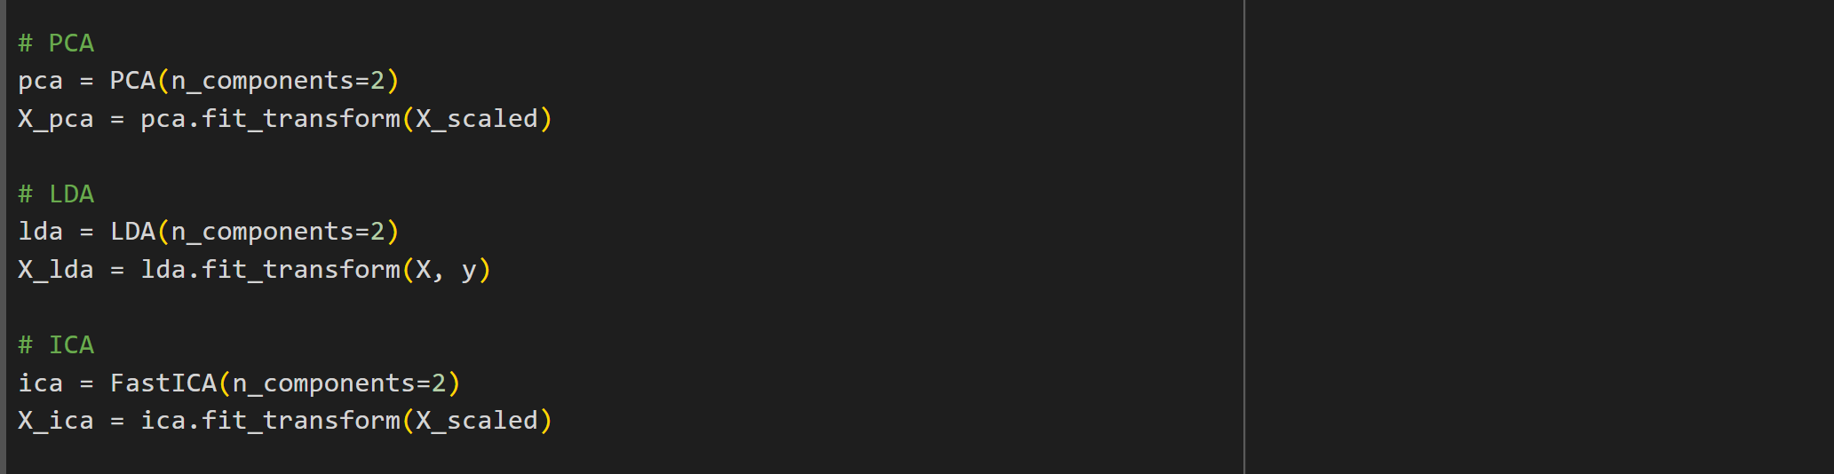

1. **Apply ICA (Independent Component Analysis)**
   * **Apply ICA to separate the independent components in the dataset. This technique is particularly useful for separating mixed signals into their original components.**

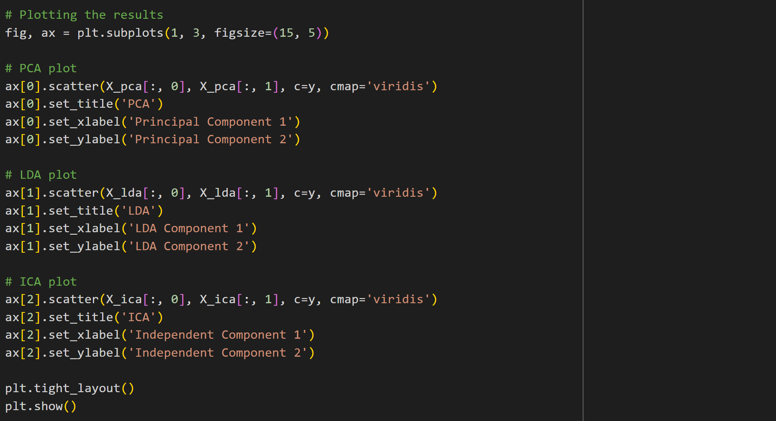

1. **Visualize the Results**
   * **Create visualizations to compare the results of PCA, LDA, and ICA. Use scatter plots to illustrate how the data points are distributed in the transformed feature space for each method.**

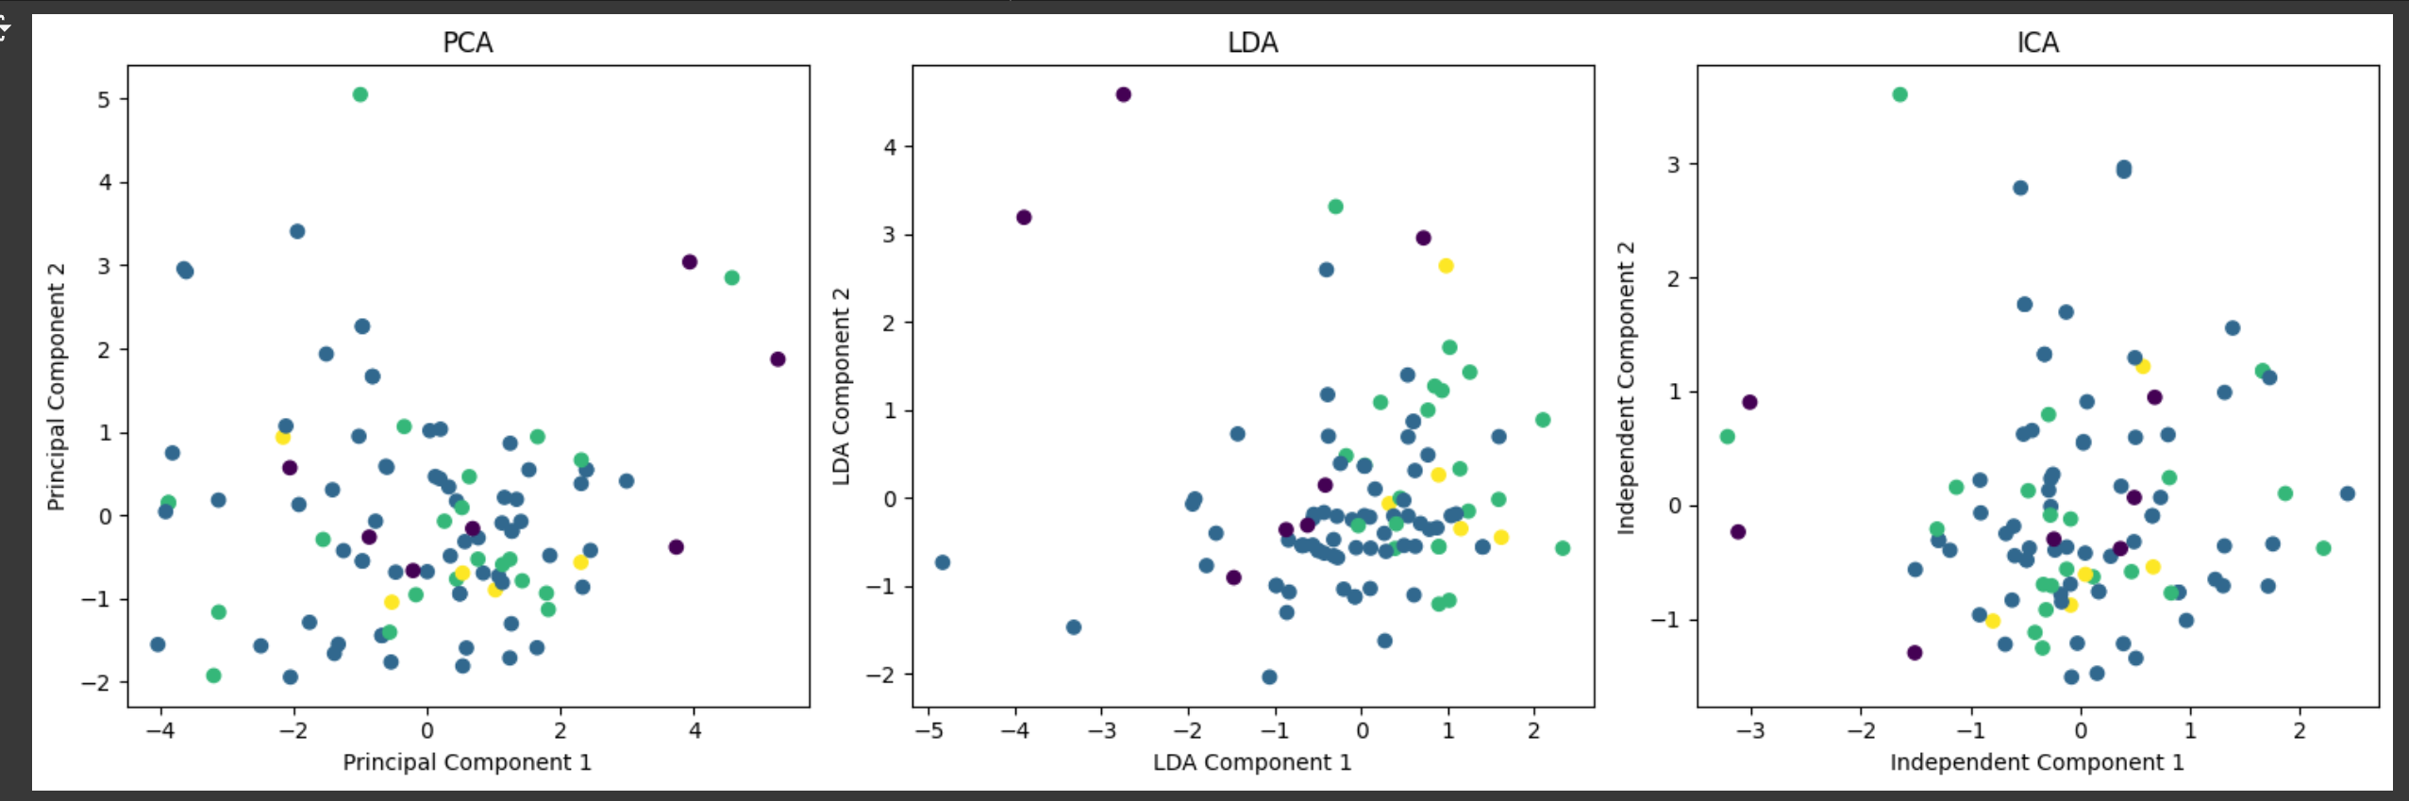

1. **Conclusion**
   * **Summarize the findings from the visualizations and the effectiveness of each dimensionality reduction technique on the Wine Quality dataset.**