TECHNICAL PROJECT DOCUMENTATION

Career
Copilot
  - Current-state architecture, AI/ML design, data model, APIs, security, operations and delivery roadmap
REPOSITORY-VERIFIED BASELINE
Branch main • Commit bfa1f05ec597dec32f9c0b4fe9bb544d129a7327
Prepared 09 August 2026 • A4 grayscale edition

AUTHORITY RULE
The repository is the source of truth. The supplied earlier project document was treated as secondary context and was not allowed to override current code, configuration, tests or committed operational artifacts.

Prepared as a senior software architecture, AI/ML architecture and technical documentation assessment.

Document control
Field | Value
Document | Career Copilot Technical Project Documentation
Authority | Repository source at the reviewed baseline; code and committed configuration override earlier prose
Repository | https://github.com/Pratik-Bamhane/career-copilot.git
Branch / commit | main / bfa1f05ec597dec32f9c0b4fe9bb544d129a7327
Commit date | 2026-08-09 01:57:28 +05:30
Review date | 2026-08-09 (Asia/Calcutta)
Format | A4 portrait; grayscale; editable Microsoft Word (.docx)
Supplied predecessor | Career_Copilot_Project_Documentation.docx — reviewed as secondary, partially obsolete context
Classification vocabulary | CURRENT; PARTIAL; PROPOSED; NOT IMPLEMENTED; operational state not established
Table 1 — Document-control baseline

Revision history
Version | Date | Authoring role | Change
1.0 | 2026-08-09 | Senior Software / AI-ML Architect | Repository-grounded replacement documentation generated and visually verified.
Table 2 — Revision history

Executive abstract
Career Copilot is a private candidate workspace that connects profile management, source-document review, deterministic applicant-tracking-system (ATS) evidence, interview practice, ATS-derived learning plans and job discovery. The current implementation is a Vite/React single-page application backed by a FastAPI modular monolith, Firestore persistence and private Supabase object storage. Supabase and Firebase provide external identity routes that are exchanged for an application JWT.
The design’s strongest technical property is its evidence-first boundary: persisted ATS scoring is deterministic and source-linked; resume rewrite suggestions are subjected to novelty and grounding checks; candidate confirmation remains a first-class control. The primary production risks are session-token exposure in browser-readable storage, cross-origin authenticated media delivery, synchronous external-provider work, application-enforced Firestore relationships, non-atomic multi-service operations, incomplete deployment automation and the absence of formal observability/model-evaluation infrastructure.
PRINCIPAL CONCLUSION
Retain the modular monolith and deterministic evidence core for the next delivery stage. Harden identity/session delivery, establish same-origin media access, make provider-heavy work asynchronous and idempotent, add CI/CD/IaC/observability, and close confirmation-gate inconsistencies before scaling traffic or adding new AI features.

Table of contents
Right-click and update field if page numbers are not refreshed automatically.
The table of contents is a Word field. Page numbers are recalculated by Word/LibreOffice when fields are updated.
1 / INTRODUCTION

1. Introduction
Purpose, audience, scope and evidence method

1.1 Purpose
This document is the maintainable technical baseline for engineering, product, security, operations, QA and technical interview stakeholders. It describes what exists, how it works, where trust boundaries lie, what has been verified and what remains partial or proposed.

1.2 Intended audience
- Software architects and senior engineers evaluating boundaries, data ownership and evolution options.
- AI/ML engineers evaluating provider routing, deterministic scoring, grounding, fallbacks and model risk.
- Backend, frontend and platform engineers maintaining features and deployments.
- QA/security reviewers assessing test evidence, privacy, abuse paths and operational controls.
- Interviewers and stakeholders needing a concise but code-backed explanation of design trade-offs.

1.3 Scope and exclusions
In scope | Out of scope / not claimed
Tracked source, tests, scripts, committed configuration, canonical repository docs and supplied predecessor DOCX | Live-cloud configuration, production traffic, provider quotas, billing, dashboards and secrets
Frontend, backend, persistence, object storage, external providers, security, deployment pattern and roadmap | Recruiter workflows, hiring decisions, vector search/RAG, queues/workers, CI/CD and IaC as current capabilities
Static code inspection plus locally executable checks | Penetration test, load test, accessibility certification, disaster-recovery exercise or provider-output benchmark
Table 3 — Scope boundary

1.4 Evidence and classification method
1. Inventory repository structure, tracked state, runtime manifests and Git baseline.
2. Trace frontend routes and API calls into backend routes, feature services, repositories and providers.
3. Inspect persistence allowlists, security rules, storage access paths and ownership checks.
4. Read tests and run available validation without changing application source.
5. Classify every significant claim as CURRENT, PARTIAL, PROPOSED, NOT IMPLEMENTED or operational state not established.
6. Treat canonical repository documents as navigation aids; resolve conflicts in favor of implementation and committed configuration.
SECRET-HANDLING RULE
Environment-variable names and purposes are documented; credential values, local .env contents and provider secrets are intentionally excluded.

2 / PROJECT OVERVIEW

2. Project Overview
Business purpose, users, value proposition and principal use cases

2.1 Problem statement
Candidates typically maintain career data across disconnected resumes, job descriptions, interview notes, learning links and application trackers. Career Copilot creates a private, source-aware workspace where a candidate can review extracted content before using it, inspect reproducible ATS evidence, practice interviews, build a learning plan from observed gaps and rank jobs against a confirmed resume.

2.2 Business purpose and value
Stakeholder need | Current value | Boundary
Understand resume-to-role gaps | Deterministic, source-line ATS evidence and normalized score | Keyword coverage; not recruiter-system emulation or hiring probability
Improve application materials safely | Grounded suggestions with candidate decisions and export APIs | Complete workspace UI is partial
Prepare for interviews | Role/JD preparation, practice questions, answer coaching and report | Coaching heuristic; not automated hiring assessment
Close skill gaps | ATS-derived learning paths with validated/search-safe resources | No learning-outcome evaluation
Find and track jobs | External catalog sync, deterministic ranking and saved status | Provider and catalog coverage are limited
Table 4 — Business value and responsible-use boundary

2.3 Primary personas
- Candidate — owns all personal content and confirmation decisions; uses every workspace feature.
- Operator / maintainer — configures services, monitors health/logs and resolves cross-service failures.
- Engineering / QA reviewer — validates changes, security boundaries, provider behavior and release evidence.
- External providers — identity, AI, speech, job and learning-data services; never direct owners of application authorization.
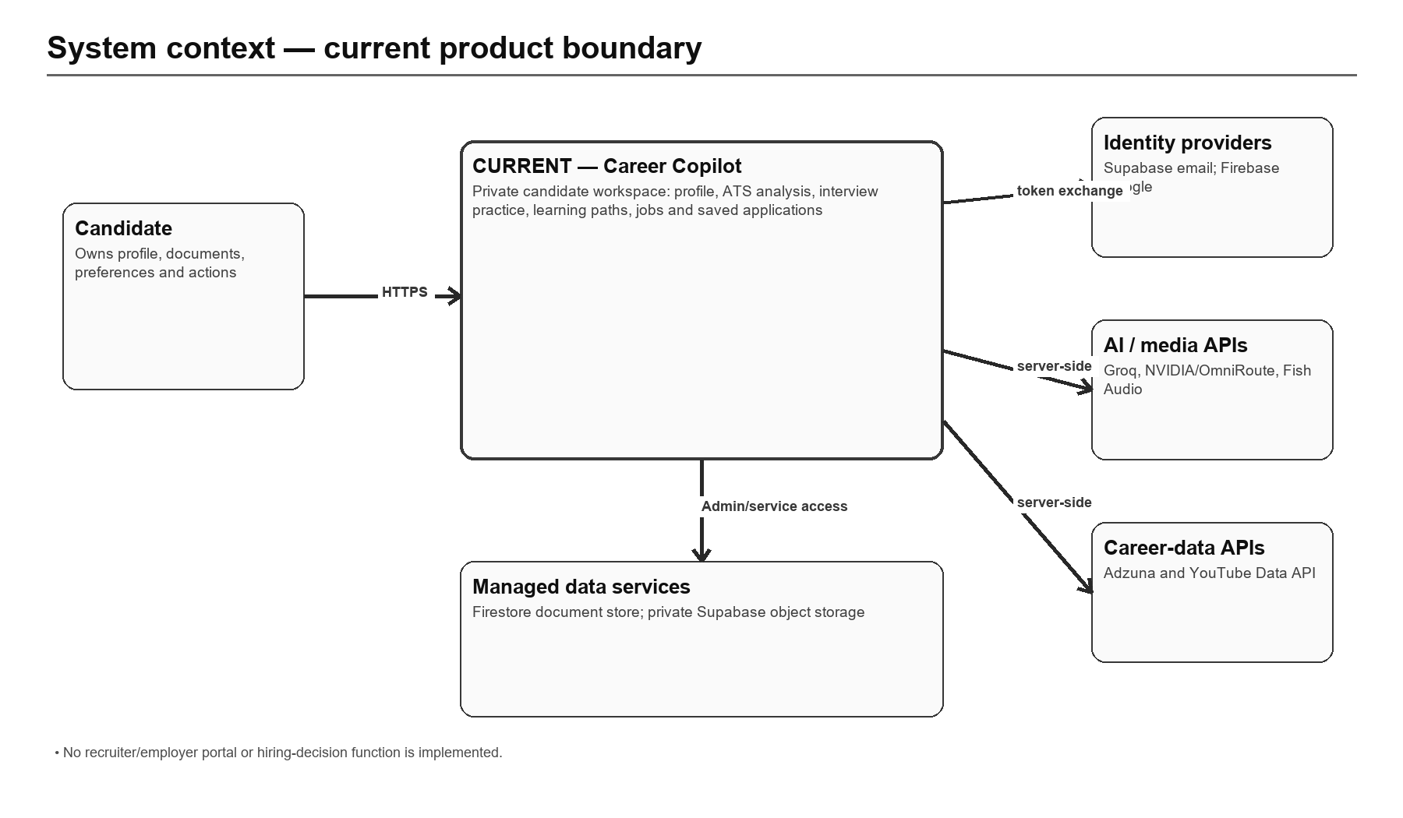
Figure 1 — Current system context and product boundary
3 / REPOSITORY AND TECHNOLOGY STACK

3. Repository and Technology Stack
Repository anatomy, build system, runtimes and major libraries

3.1 Repository snapshot
Metric | Observed baseline
Tracked files | 335
Python files | 133
TSX files | 54
TypeScript files | 31
Test/e2e paths | 84 matched tracked paths
Backend route decorators | 94
Working tree | Dirty before documentation work; existing untracked build/document artifacts preserved
Table 5 — Repository snapshot

3.2 Folder structure
Path | Responsibility
frontend/src | React routes, workspace shell, feature components, API/auth clients and shared state
frontend/e2e | Playwright browser scenarios
backend/app/api/router.py | Primary FastAPI route surface and request orchestration
backend/app/features | Domain services for ATS, auth, jobs, learning and resume improvement
backend/app/agents | Provider clients, routing, prompts, registry and orchestration support
backend/app/database | Firestore query abstraction, storage adapter and user-owned repository helpers
backend/app/documents | Upload validation, extraction, layout parsing and source-grounding utilities
backend/tests | Backend unit/integration-style tests with in-memory adapters/mocks
scripts | Setup, local development, environment diagnostics, boundary and secret checks
docs | Canonical architecture, API, flow, operations and deployment prose
Table 6 — Repository map

3.3 Technology matrix
Layer | Technology | Current role | Repository evidence
Web | Vite 8, React 19, TypeScript 5.9, React Router 7, Tailwind CSS 4 | Single-page candidate workspace | frontend/package.json; vite.config.mjs
API | Python 3.11–3.13, FastAPI, Pydantic, Uvicorn | Synchronous request/response modular monolith | backend/pyproject.toml; app/main.py
Data | Google Firestore via Firebase Admin SDK | Document persistence with application-level ownership | backend/app/database/client.py
Objects | Supabase private Storage | Resumes, JDs, exports and avatars | backend/app/database/client.py
Identity | Supabase Auth; Firebase Auth; local password fallback | External identity exchange and legacy compatibility | frontend/src/features/auth; backend/app/features/auth
AI | Groq; NVIDIA; optional OmniRoute adapter; CrewAI optional | Feature-specific generation with deterministic fallbacks | backend/app/agents; backend/pyproject.toml
Media/data | Fish Audio; YouTube Data API; Adzuna | TTS, learning-resource IDs and job catalog | backend/app/integrations
Quality | Pytest; Vitest; Playwright; ESLint; TypeScript | Backend/frontend/unit/browser validation | package.json; frontend/package.json
Table 7 — Technology stack

3.4 Build and local-development model
Root Node scripts orchestrate setup, frontend commands, backend startup, environment diagnostics, boundary checks and secret scanning. Vite development and preview proxy /api/backend to /api/v1 and /api/files to /api/v1/files. The backend uses a local virtual environment in repository scripts. No monorepo task graph, container build, package workspace declaration or committed CI workflow is present.

3.5 Build-command and dependency observations
Command family | Purpose | Audit observation
npm run setup / dev:* | Install/check prerequisites and launch local services | Useful developer orchestration; environment-specific and not a release pipeline
npm run lint / typecheck / build:frontend | Static frontend quality and production bundle | Root delegates into frontend; full lint currently includes an untracked legacy .next tree
npm run test:backend | Backend pytest suite | Passed at baseline using backend/.venv
npm run check:boundaries / check:secrets | Architecture and credential-pattern diagnostics | Both passed; appropriate candidates for mandatory CI gates
frontend npm ci | Locked dependency installation | Required for reproducible verification; current node_modules is incomplete
Table 7A — Build and diagnostic commands
Recent history is short and authentication-heavy: the baseline commit adds Supabase email authentication after several sign-in fixes on the same day. That concentration raises regression risk around provider linking, recovery and session migration and justifies preserving provider-specific E2E cases in the first CI baseline.
4 / IMPLEMENTATION STATUS

4. Implementation Status
Code-backed classification of significant product and platform capabilities
Capability | Status | What is established | Principal caveat
Landing, routing and workspace shell | CURRENT | Public landing; protected workspace routes; lazy-loaded features; responsive shell; theme and development-only demo session. | Demo data is explicitly development-only; transient bootstrap failures retain the last good snapshot.
Authentication and session exchange | CURRENT / SECURITY HARDENING NEEDED | Supabase email identity, Firebase Google identity and legacy local/Firebase fallbacks exchange into an application JWT. | JavaScript-readable localStorage/cookie token increases XSS exposure; sign-out does not revoke a copied JWT; recovery paths are uneven across providers.
Onboarding and profile management | CURRENT | Profile, preferences, skills, experience, projects, education, certifications, languages, links and completion scoring. | Application-level ownership and relationships; no database constraints or transactions.
Profile fill from resume | CURRENT | Preview candidate profile fields inferred from resume content and selectively apply them. | Explicit experience years are required; inferred estimates are intentionally rejected. Preview/apply may use a source not confirmed for ATS.
Avatar and private file delivery | CURRENT / DEPLOYMENT CAVEAT | Upload and fetch avatars, source documents and generated exports without public buckets. | Separate frontend/backend origins complicate cookie-authenticated image/file GETs unless a same-origin proxy or signed-delivery pattern is used.
Resume and job-description ingestion | CURRENT | Upload PDF/DOCX, extract text and sections, review/edit, then confirm candidate-approved content. | No OCR; text-poor scans are rejected. LLM section extraction code exists but is not used by the current upload request path.
Deterministic ATS analysis | CURRENT | Compare confirmed resume and JD content and produce a reproducible, evidence-linked score. | Authenticated stateless /ats/score accepts raw text without the persisted confirm gate. Keyword coverage is not a hiring prediction.
ATS improvement brief | CURRENT | Explain prioritized missing terms without inventing experience. | Provider availability and prompt behavior are not covered by a formal model-evaluation suite.
Resume improvement and exports | PARTIAL | Generate evidence-checked section suggestions, capture candidate decisions, apply approved changes and export DOCX/PDF. | Backend is implemented and tested, but no complete workspace UI was found. In-place content update and ATS invalidation are not transactional; initial run provider metadata can be inaccurate.
Mock interview practice | CURRENT / GATE INCONSISTENCY | Create sessions, generate questions, submit typed/transcribed answers, receive coaching and complete reports. | Mock-session start does not universally enforce confirmed resume status, unlike interview preparation. Scores are coaching heuristics, not hiring decisions.
Voice, filler and gaze coaching | PARTIAL / ENVIRONMENT-DEPENDENT | Read questions aloud and provide practice signals for delivery. | Browser/API availability varies; raw audio/video upload is disabled by default and no persistent media-review pipeline exists.
Interview preparation | CURRENT | Build role/JD-specific preparation guidance from confirmed resume and JD content. | Synchronous provider work is request-bound; no queue or resumable job model.
Learning-path generation | CURRENT | Turn missing/partial ATS evidence into a sequenced learning plan with resources and progress. | Manual path creation is exposed, but full manual item/resource authoring and a complete UI flow were not found.
Job catalog synchronization | PARTIAL / OPTIONAL PROVIDER | Import job listings from Adzuna into a shared catalog. | Provider credentials are optional; the global lock is per process, only page one is fetched and stale jobs are not archived.
Job recommendations and saved jobs | CURRENT | Rank catalog jobs against a confirmed resume, filter results and track saved application status. | Reads at most 500 jobs; ranking is lexical; pagination/generation state is process-local and not suitable for multi-instance coordination.
Settings, privacy and account deletion | CURRENT / NON-ATOMIC DELETION | Manage notification/privacy preferences, update password and delete the account and stored files. | Cross-service deletion is not atomic. A late failure can leave a partially deleted account requiring operational repair.
Health, diagnostics and activity | CURRENT | Expose liveness/readiness, agent capability status, request IDs, recent activity and workspace bootstrap. | No metrics backend, distributed tracing, alert rules, dashboards or SLO definitions are committed.
Table 8 — Implementation-status matrix

4.1 Explicitly not implemented
- A recruiter/employer portal, applicant-tracking workflow or automated hiring decision.
- A product vector database, embeddings index, semantic retrieval or RAG pipeline.
- Background queue/workers, scheduled job runner, distributed locks or dead-letter handling.
- Committed CI/CD workflows, infrastructure as code, containerization or a Render deployment manifest.
- Formal ML evaluation datasets, prompt regression thresholds, bias/fairness evaluation or model monitoring.
- Central metrics, distributed tracing, alert rules, SLOs, runbook automation or audited disaster recovery.
- OCR for scanned resumes/JDs and persistent audio/video interview review.
CLASSIFICATION NOTE
A documented deployment procedure is not proof that an environment exists. The current split Vercel/Render pattern is described as supported/documented, while live operational state is not established by the reviewed repository.

4.2 Status interpretation
Status | Meaning in this document
CURRENT | Executable path, persistence/API behavior and relevant UI or operational surface are present at the reviewed baseline.
PARTIAL | Substantial implementation exists, but a required UI, policy, automation, provider or end-to-end behavior is incomplete.
PROPOSED | Recommended design only; it is not represented as deployed or coded.
NOT IMPLEMENTED | No product implementation was found; adjacent utilities or prose do not change this classification.
Operational state not established | Code/procedure may exist, but the repository cannot prove live environment state or configuration.
Table 8A — Classification legend

4.3 Maturity summary
The candidate workflow is functionally broad and the backend test surface is strong for a project at this stage. Product maturity is uneven at deployment and governance boundaries: deterministic ATS and confirmation controls are comparatively disciplined, while sessions, cross-origin file access, multi-service consistency, provider-heavy concurrency, release automation, observability and model evaluation require production hardening.
5 / CURRENT SYSTEM ARCHITECTURE

5. Current System Architecture
Logical layers, runtime boundaries, trust boundaries and deployment reality

5.1 Architectural style
The backend is a modular monolith: one FastAPI process exposes all feature APIs and performs persistence, provider calls, parsing and exports within the request path. Domain services and adapters exist, but the main router remains a large orchestration surface. The frontend is a route-oriented SPA with shared authentication and workspace-bootstrap infrastructure.
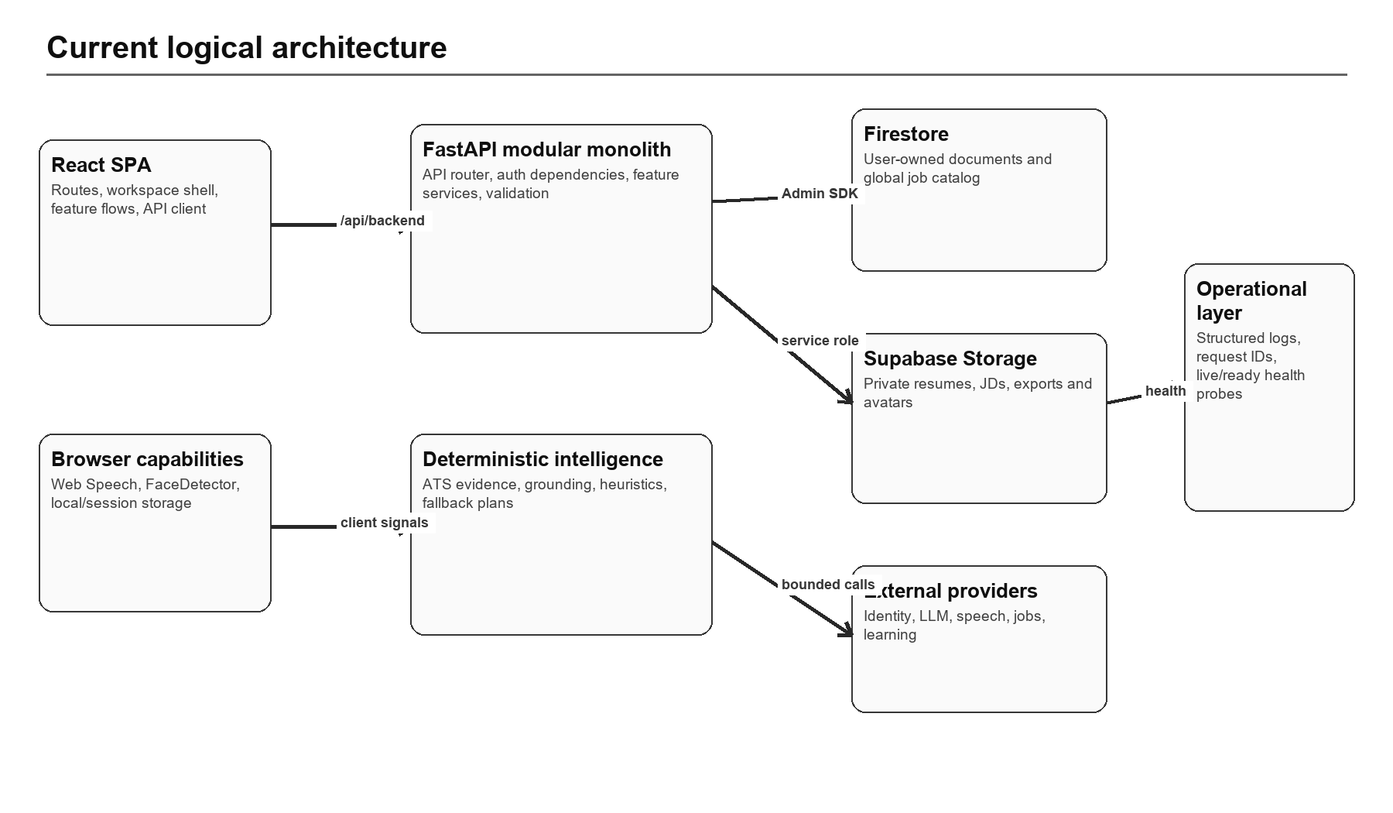
Figure 2 — Current logical architecture

5.2 Major boundaries
Boundary | Protocol / credential | Current control | Risk
Browser → SPA/API | HTTPS; app JWT bearer or JavaScript cookie | ProtectedRoute plus server authorization | Readable token; CORS/media-origin complexity
API → Firestore | Firebase Admin credentials | Allowlisted collection abstraction and user filters | Admin bypasses client rules; ownership mistakes are high impact
API → Supabase Storage | Service-role key | Private buckets, logical bucket allowlist, user-prefixed paths | Service role is broad; proxy streams consume API capacity
API → LLM providers | Server API key | Timeouts, RPM limiter, bounded retries and output validation | Process-local limiting; sensitive source text may leave system boundary
API → job/learning/speech APIs | Server API keys | Input caps and feature-specific validation | Availability, quota and content quality are external
Table 9 — Trust boundaries

5.3 Current deployment topology
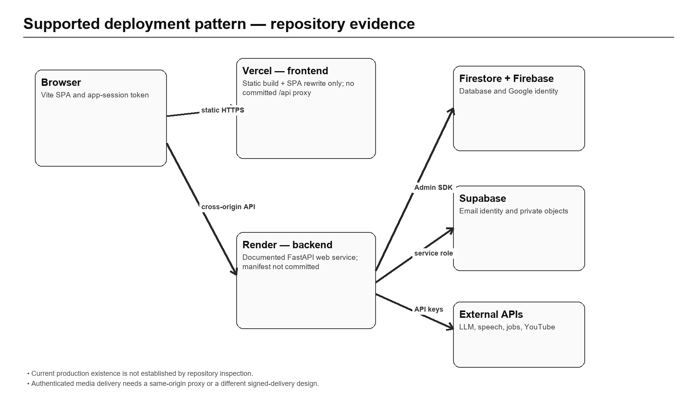
Figure 3 — Supported deployment pattern and repository gaps
Canonical repository prose describes a Vercel frontend and Render backend. frontend/vercel.json commits only a catch-all rewrite to index.html; there is no committed backend proxy, Render manifest, Dockerfile or infrastructure definition. Therefore the topology is a supported procedure, not a reproducible deployment artifact.
6 / DATA ARCHITECTURE

6. Data Architecture
Firestore collections, object storage, ownership, consistency and lifecycle
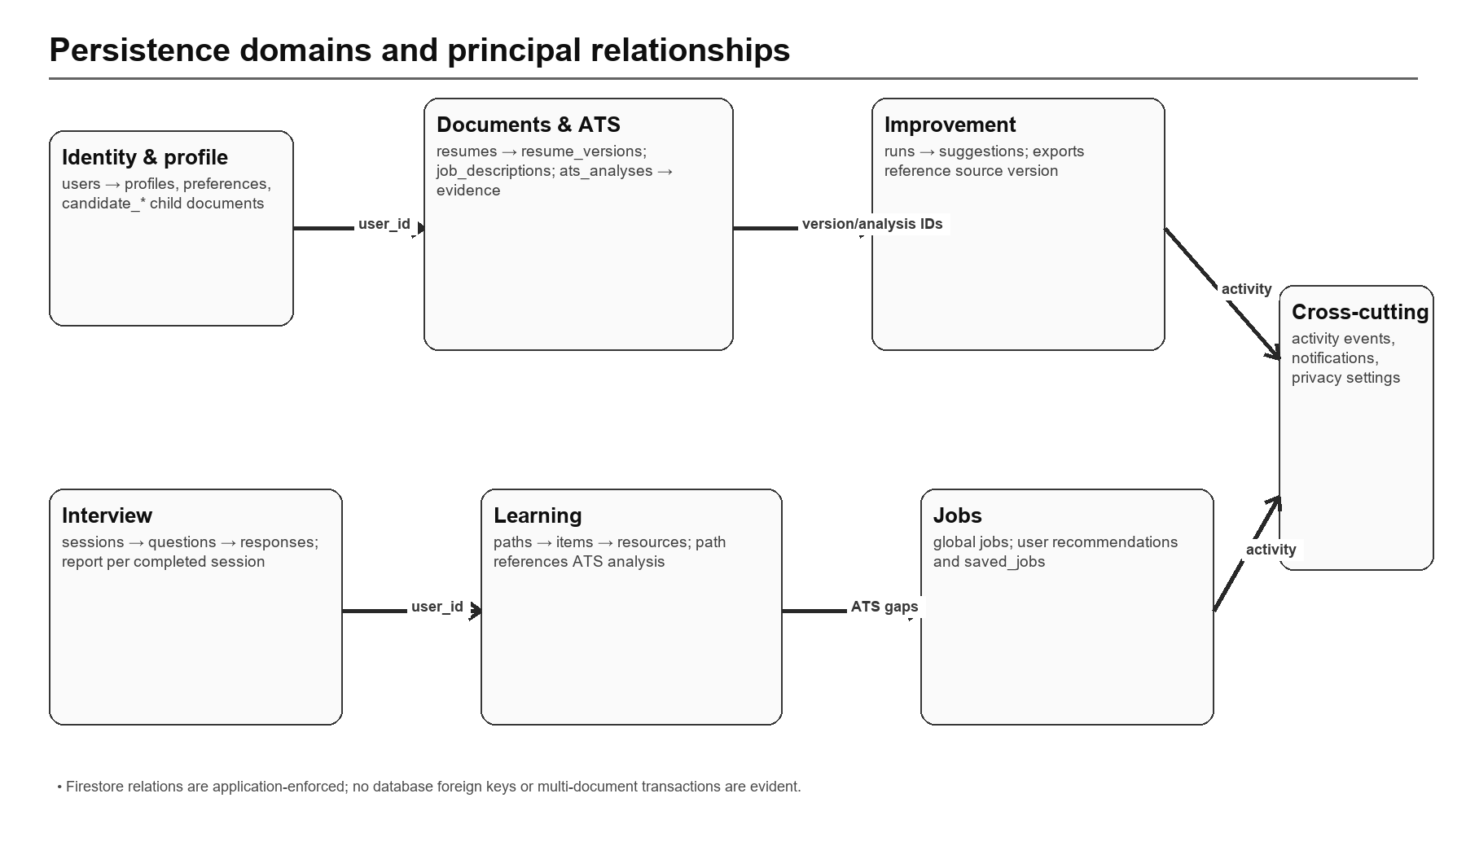
Figure 4 — High-level data domains and relationships

6.1 Persistence model
Firestore is accessed server-side through Firebase Admin SDK and a table-like adapter. Client Firestore and Firebase Storage rules deny direct client access. All personal data is expected to be filtered by user_id or owned by an id equal to the authenticated user. The jobs collection is shared; user recommendations and saved states are private.
Collection | Purpose | Keys / ownership | Access | Principal relationship
users | Internal identity, email, password/provider metadata, token version | id | self | profiles 1:1; all user-owned documents
profiles | Core candidate profile and avatar path | id=user_id | self | users 1:1
candidate_preferences | Roles, locations, work modes and job preferences | id/user_id | self | users 1:1 logical
candidate_skills | Skill name, level/source | id,user_id | self | users 1:N
candidate_experiences | Employment history | id,user_id | self | users 1:N
candidate_projects | Project portfolio | id,user_id | self | users 1:N
candidate_education | Education history | id,user_id | self | users 1:N
candidate_certifications | Certifications | id,user_id | self | users 1:N
candidate_languages | Language proficiency | id,user_id | self | users 1:N
candidate_links | Portfolio/social links | id,user_id | self | users 1:N
resumes | Resume container, active/soft-delete status | id,user_id | self | resume_versions 1:N
resume_versions | Source file metadata, extracted/structured text, confirmation | id,resume_id,user_id | self | resumes N:1; ATS/improvement refs
job_descriptions | JD source, metadata, extraction and confirmation | id,user_id | self | ATS analyses; interview prep
ats_analyses | Score, fingerprint, algorithm/provider summary and status | id,user_id | self | resume_version + JD; evidence 1:N
ats_evidence | Term classification, strength and exact source evidence | id,analysis_id,user_id | self | ats_analyses N:1
resume_suggestions | Proposed section change and candidate decision | id,run_id,user_id | self | improvement run N:1
resume_exports | Generated DOCX/PDF metadata and storage path | id,user_id | self | resume version/run refs
resume_improvement_runs | Improvement orchestration state and source refs | id,user_id | self | suggestions 1:N
interview_sessions | Mode, status, sources and overall progress | id,user_id | self | questions/responses/report
interview_questions | Ordered generated/template question | id,session_id,user_id | self | session N:1
interview_responses | Candidate answer, metrics and evaluation | id,session_id,question_id,user_id | self | question/session
interview_reports | Completed debrief and aggregate score | id,session_id,user_id | self | session 1:1 logical
learning_paths | ATS-derived or candidate-selected plan | id,user_id | self | ATS analysis; items 1:N
learning_items | Ordered skill/topic module and progress | id,path_id,user_id | self | path N:1; resources 1:N
learning_resources | Validated video/search/docs resource | id,item_id,user_id | self | item N:1
jobs | Shared normalized job catalog | id | authenticated readers | recommendation/saved refs
job_recommendations | Per-user deterministic job score and generation | id,user_id,job_id | self | jobs N:1
saved_jobs | Per-user saved/application state | id,user_id,job_id | self | jobs N:1
notification_preferences | Per-user notification toggles | id/user_id | self | users 1:1 logical
privacy_preferences | Per-user privacy choices | id/user_id | self | users 1:1 logical
activity_events | Recent user-visible activity | id,user_id | self | cross-feature events
user_notifications | In-app notifications | id,user_id | self | users 1:N
Table 10 — Firestore collection dictionary

6.2 Object storage
Logical bucket | Contents | Key pattern | Access path | Lifecycle
candidate-documents | Resume/JD uploads and generated exports | {user_id}/... | Authenticated FastAPI /files proxy | Removed on resource/account deletion where implemented
candidate-avatars | JPEG/PNG/WebP profile images | {user_id}/... | Authenticated FastAPI /files proxy | Previous avatar replaced; account purge enumerates prefix
Table 11 — Private object storage

6.3 Consistency and integrity
- Relationships are identifiers stored in documents and checked in service/router code; Firestore foreign keys do not exist.
- Singleton preferences and saved-job identifiers are deterministic to reduce duplication, but general uniqueness is application-enforced.
- User recency sorting and some filtering occur in application memory; oversized IN queries are chunked.
- Upload flows attempt compensating object deletion on metadata failures; account deletion and in-place improvement are multi-step and non-atomic.
- Soft-deleted resume parents are checked in ATS and recommendation paths, but orphan management and retention are not centrally enforced.
- No explicit backup, point-in-time recovery, retention schedule or migration framework is committed.
7 / API DESIGN

7. API Design
REST surface, authorization, envelopes, validation and versioning

7.1 API conventions
Concern | Current behavior
Base path | /api/v1 for versioned product APIs
Authentication | Application HS256 JWT accepted from Authorization: Bearer or career_copilot_session cookie
Errors | Structured ApiError envelope; unexpected exceptions logged and normalized
Request tracing | X-Request-ID accepted/generated and returned
Security headers | X-Content-Type-Options: nosniff; Referrer-Policy: strict-origin-when-cross-origin
CORS | Configured origin allowlist, methods and authorization/content/request-id headers
Pagination | Feature-specific page/limit or bounded recent lists; not a uniform cursor standard
Long work | Provider, parsing, export and sync work remains synchronous; no 202/job resource model
Table 12 — API conventions

7.2 Endpoint groups
Group | Route count | Representative responsibilities
account | 1 | Delete account
agents | 1 | Agent status
ats-analyses | 6 | Create ats, Delete ats, Get ats, List ats
auth | 9 | Auth firebase, Auth resend, Auth reset password, Auth session
files | 1 | Authenticated file
health | 4 | Health, Health database, Health live, Health ready
interview-preparation | 1 | Create interview preparation
interviews | 10 | Add response, Complete interview, Create interview, Delete interview
job-descriptions | 7 | Confirm jd, Create jd, Get jd, List jds
job-recommendations | 2 | Generate job recommendations, List job recommendations
jobs | 3 | Get job, List jobs, Sync external jobs
learning-paths | 6 | Create learning, Delete learning path, Generate learning path, Get learning
me | 2 | Bootstrap, List activity
profile | 13 | Apply profile from resume, Create candidate record, Delete candidate record, Delete profile avatar
resume-comparisons | 1 | Compare resume versions
resume-exports | 1 | Download resume export
resume-improvements | 5 | Apply improvement, Create improvement, Improvement capabilities, Read improvement
resume-suggestions | 1 | Update suggestion decision
resume-versions | 4 | Confirm resume extraction, Export resume version, Get resume version, Patch resume extraction
resumes | 8 | Activate resume, Create resume, Create resume version, Delete resume
saved-jobs | 4 | List saved jobs, Patch saved job, Save job, Unsave job
score | 1 | Score
settings | 3 | Get settings records, Update notifications, Update privacy
Table 13 — API group summary

7.3 Validation and authorization observations
- Most personal-resource routes use CurrentUser and repository ownership helpers; file reads additionally require a user-ID path prefix.
- Upload validation checks extension, MIME, signature and archive structure before parsing; avatar uploads have independent signature and size controls.
- The persisted ATS route requires confirmed sources. The stateless raw-text scoring route and mock-interview start represent intentional or accidental exceptions that need an explicit product policy.
- Health and agent capability endpoints are public but omit credentials. Production docs can be disabled through settings.
- A single large API router concentrates orchestration and increases review surface; incremental extraction into feature routers is advisable without forcing premature microservices.

7.4 API evolution recommendations
Concern | Recommended compatible change
Long-running work | Return 202 with an idempotent job resource, explicit status/progress, cancellation and retry-safe submission.
Pagination | Standardize bounded cursor pagination and stable sort keys for jobs, histories and activity-heavy collections.
Authorization | Move ownership/source-eligibility rules into shared policy/repository contracts and generate negative contract tests.
Versioning | Keep /api/v1; add response schema/version metadata for persisted AI artifacts and deprecate deliberately.
Files | Separate metadata authorization from byte delivery through same-origin proxying or short-lived capability URLs.
Errors/telemetry | Keep normalized error codes; add retryability, dependency, trace and job identifiers without exposing provider details.
Table 13A — API evolution priorities
8 / AI AND MACHINE-LEARNING ARCHITECTURE

8. AI and Machine-Learning Architecture
Deterministic intelligence, provider orchestration, prompts, grounding, scoring and fallbacks

8.1 AI operating principle
RESPONSIBLE-USE BOUNDARY
LLMs generate coaching and candidate-controlled suggestions. Deterministic evidence and candidate confirmation remain authoritative. The system does not make employment decisions and must not present practice scores as hiring predictions.

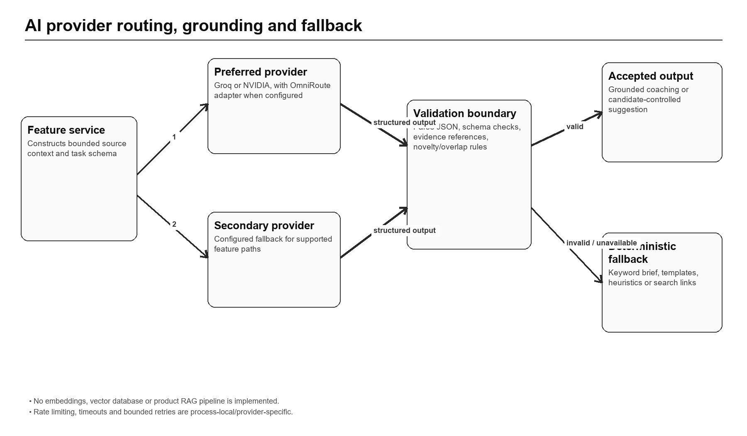
Figure 5 — Provider routing, validation and fallback boundary

8.2 Provider and agent registry
Capability | Provider order | Fallback | Control / caveat
ATS improvement brief | Configured preferred Groq/NVIDIA; OmniRoute may adapt | Deterministic missing-keyword brief | Grounded to evidence
Profile fill | Configured preferred Groq/NVIDIA | Deterministic mapping | Selected apply; explicit evidence filtering
Resume improvement | Configured preferred Groq/NVIDIA | Manual/export path and deterministic analysis | Novelty/entity/overlap validation
Interview questions | Groq only | Local templates | NVIDIA deliberately not used
Interview evaluation/report | Groq when configured | Heuristic scoring and filler detection | Coaching, not hiring
Interview preparation | Groq enhancement | Evidence/heuristic preparation | Confirmed resume + JD required
Learning plan | Groq planner | Deterministic gap plan | Video ID and URL safety validation
Document section LLM | Preferred providers in code | Structural parser | Not invoked by current upload route
Table 14 — AI capability registry

8.3 Deterministic ATS scoring
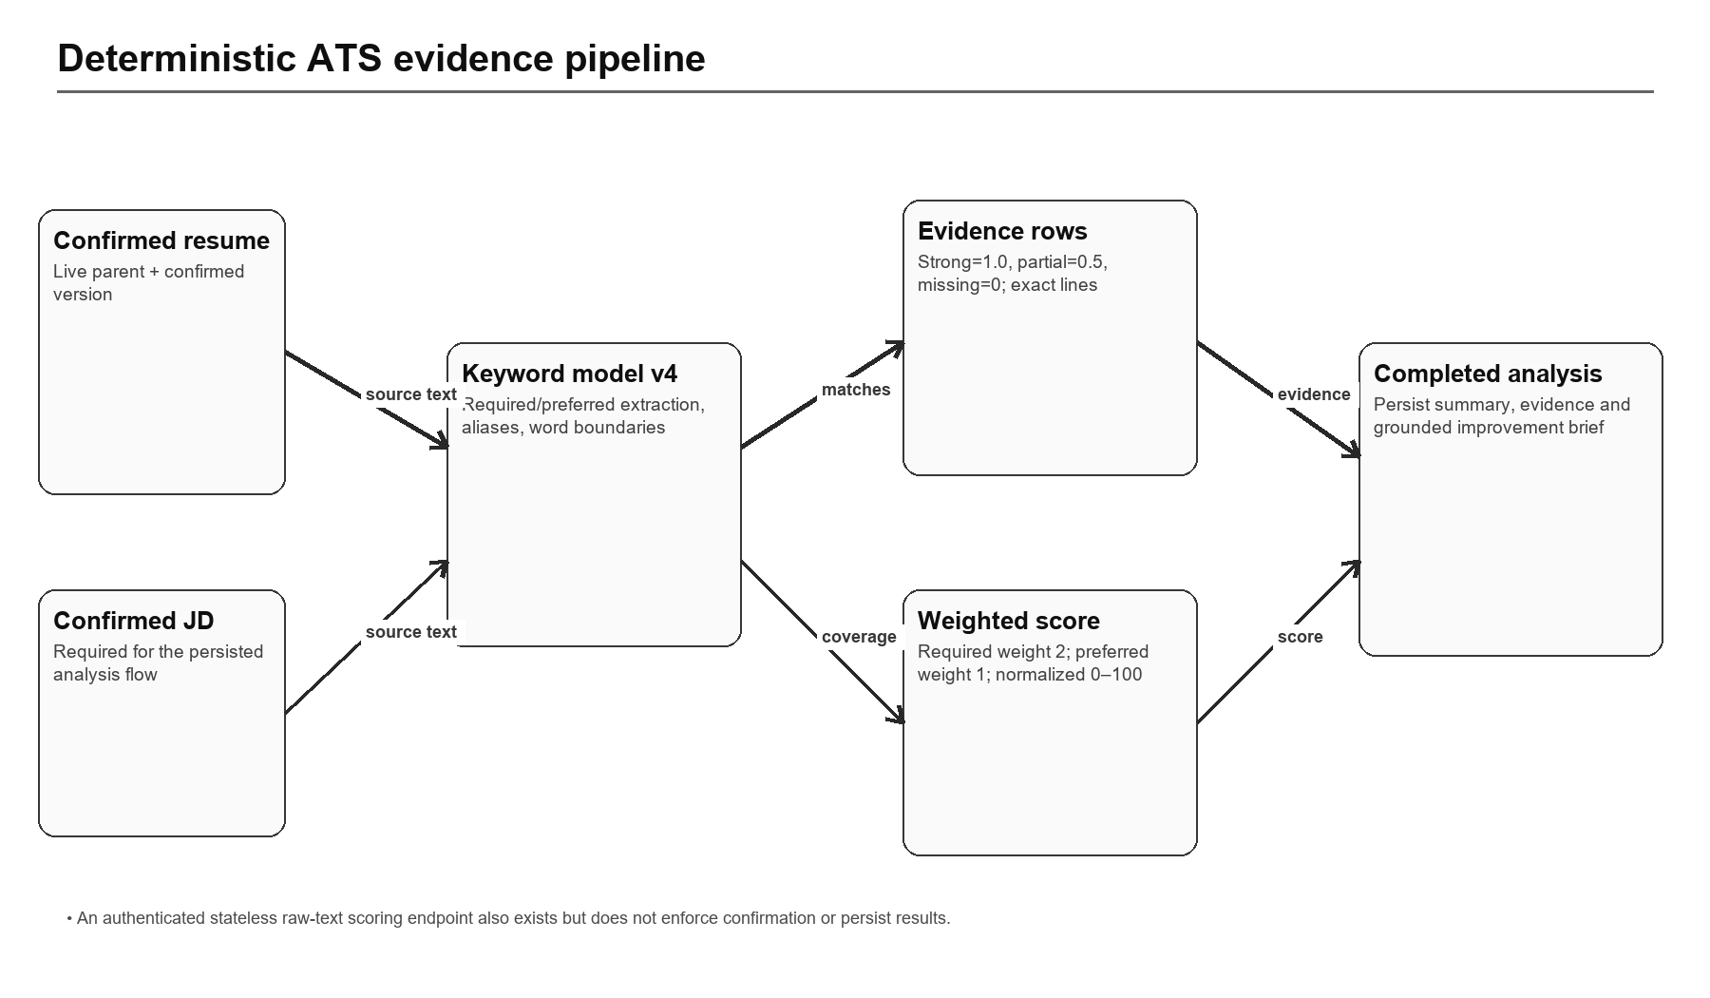
Figure 6 — Persisted ATS scoring and evidence pipeline
Algorithm evidence-keyword-coverage-v4 extracts bounded required and preferred technical terms from the job description, applies aliases and word-boundary matching against resume text, and records exact supporting lines/sections. Strong matches contribute 1.0, partial matches 0.5 and missing terms 0. Required terms are weighted 2 and preferred terms 1 before normalization to 0–100. A source fingerprint allows completed analyses to be reused when confirmed content is unchanged.

8.4 Prompt and structured-output controls
- Prompts are versioned text assets under backend/app/agents/prompts and referenced by the registry.
- Provider clients apply timeouts, bounded retry behavior for transient statuses and shared process-local requests-per-minute limiting.
- Groq structured generation can request strict JSON schema and perform a repair pass; both clients parse and cap JSON output.
- Feature services validate output against source evidence; resume improvement applies especially strict novelty and factual-change checks.
- Raw provider errors are normalized, but centralized token/cost telemetry and prompt-output audit retention are not implemented.

8.5 RAG, embeddings and memory
NOT IMPLEMENTED. No embedding model, vector index, semantic retrieval pipeline or retrieval-augmented generation component was found. The application passes bounded current source text/evidence directly into feature prompts. Firestore stores product records, not model memory. Any future RAG claim should remain PROPOSED until an index, ingestion lifecycle, retrieval evaluation and privacy/retention design are committed.

8.6 Model-risk and evaluation gaps
- No golden prompt dataset or provider regression benchmark is committed.
- No bias/fairness, calibration or subgroup evaluation is defined for coaching scores.
- No production output-quality sampling, cost budget or latency percentile telemetry is established.
- Feature fallbacks improve availability but can materially change output style and depth; the UI should identify fallback mode where useful.
- Source documents contain personal information; provider data-processing agreements, regional routing and retention settings are deployment responsibilities not established here.
9 / FEATURE-LEVEL DESIGN

9. Feature-Level Design
Consistent implementation detail for every significant current or partial capability

9.1 Landing, routing and workspace shell
Dimension | Code-backed description
Implementation status | CURRENT
Purpose | Public landing; protected workspace routes; lazy-loaded features; responsive shell; theme and development-only demo session.
Primary actors | Candidates
Inputs | Authenticated user context plus feature-specific JSON, path/query parameters or validated uploaded bytes.
Core processing / validation | React Router route guards, optimistic token bootstrap followed by background validation, and shared workspace bootstrap state.
Outputs | Persisted user-owned resources, deterministic evidence, candidate-controlled changes, file streams or feature-specific status/report JSON.
AI involvement | Feature-specific; deterministic-only where stated, otherwise bounded provider calls with validation/fallback.
Edge/error behavior | ApiError normalization; ownership/not-found checks; provider and storage failures are surfaced or handled with feature-specific fallback/compensation.
Security / privacy | Server-side authorization and user ownership; external provider disclosure applies when source content is sent for AI processing.
Current limitations | Demo data is explicitly development-only; transient bootstrap failures retain the last good snapshot.
Repository evidence | frontend/src/App.tsx; frontend/src/features/workspace; frontend/src/shared/demo-session.ts
Table 15 — Landing, routing and workspace shell design summary

9.2 Authentication and session exchange
Dimension | Code-backed description
Implementation status | CURRENT / SECURITY HARDENING NEEDED
Purpose | Supabase email identity, Firebase Google identity and legacy local/Firebase fallbacks exchange into an application JWT.
Primary actors | Candidates
Inputs | Authenticated user context plus feature-specific JSON, path/query parameters or validated uploaded bytes.
Core processing / validation | Provider tokens are server-validated; users are created or cautiously linked by verified email; JWT token_version is checked on protected requests.
Outputs | Persisted user-owned resources, deterministic evidence, candidate-controlled changes, file streams or feature-specific status/report JSON.
AI involvement | Feature-specific; deterministic-only where stated, otherwise bounded provider calls with validation/fallback.
Edge/error behavior | ApiError normalization; ownership/not-found checks; provider and storage failures are surfaced or handled with feature-specific fallback/compensation.
Security / privacy | Server-side authorization and user ownership; external provider disclosure applies when source content is sent for AI processing.
Current limitations | JavaScript-readable localStorage/cookie token increases XSS exposure; sign-out does not revoke a copied JWT; recovery paths are uneven across providers.
Repository evidence | frontend/src/features/auth; backend/app/features/auth; backend/app/core/config.py
Table 16 — Authentication and session exchange design summary
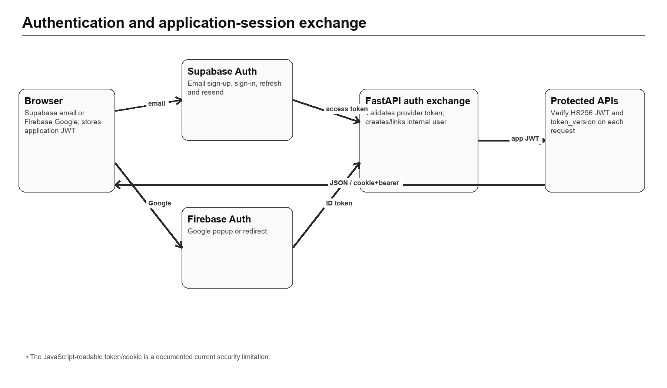
Figure 7 — Identity-provider exchange and application-session flow

9.3 Onboarding and profile management
Dimension | Code-backed description
Implementation status | CURRENT
Purpose | Profile, preferences, skills, experience, projects, education, certifications, languages, links and completion scoring.
Primary actors | Candidates
Inputs | Authenticated user context plus feature-specific JSON, path/query parameters or validated uploaded bytes.
Core processing / validation | Generic owned-resource CRUD, explicit validation, weighted completion recalculation and recent activity recording.
Outputs | Persisted user-owned resources, deterministic evidence, candidate-controlled changes, file streams or feature-specific status/report JSON.
AI involvement | Feature-specific; deterministic-only where stated, otherwise bounded provider calls with validation/fallback.
Edge/error behavior | ApiError normalization; ownership/not-found checks; provider and storage failures are surfaced or handled with feature-specific fallback/compensation.
Security / privacy | Server-side authorization and user ownership; external provider disclosure applies when source content is sent for AI processing.
Current limitations | Application-level ownership and relationships; no database constraints or transactions.
Repository evidence | backend/app/api/router.py; backend/app/database/repository.py; frontend/src/features/onboarding; frontend/src/features/settings
Table 17 — Onboarding and profile management design summary

9.4 Profile fill from resume
Dimension | Code-backed description
Implementation status | CURRENT
Purpose | Preview candidate profile fields inferred from resume content and selectively apply them.
Primary actors | Candidates
Inputs | Authenticated user context plus feature-specific JSON, path/query parameters or validated uploaded bytes.
Core processing / validation | Deterministic mapping with preferred-provider LLM enhancement, evidence filtering, selected-field apply and optional fill-empty-only behavior.
Outputs | Persisted user-owned resources, deterministic evidence, candidate-controlled changes, file streams or feature-specific status/report JSON.
AI involvement | Feature-specific; deterministic-only where stated, otherwise bounded provider calls with validation/fallback.
Edge/error behavior | ApiError normalization; ownership/not-found checks; provider and storage failures are surfaced or handled with feature-specific fallback/compensation.
Security / privacy | Server-side authorization and user ownership; external provider disclosure applies when source content is sent for AI processing.
Current limitations | Explicit experience years are required; inferred estimates are intentionally rejected. Preview/apply may use a source not confirmed for ATS.
Repository evidence | backend/app/api/router.py; backend/app/agents/prompts/fill_profile_from_resume_v1.txt
Table 18 — Profile fill from resume design summary

9.5 Avatar and private file delivery
Dimension | Code-backed description
Implementation status | CURRENT / DEPLOYMENT CAVEAT
Purpose | Upload and fetch avatars, source documents and generated exports without public buckets.
Primary actors | Candidates
Inputs | Authenticated user context plus feature-specific JSON, path/query parameters or validated uploaded bytes.
Core processing / validation | Signature/size/path validation; user-prefixed object keys; authenticated FastAPI file streaming from Supabase storage.
Outputs | Persisted user-owned resources, deterministic evidence, candidate-controlled changes, file streams or feature-specific status/report JSON.
AI involvement | Feature-specific; deterministic-only where stated, otherwise bounded provider calls with validation/fallback.
Edge/error behavior | ApiError normalization; ownership/not-found checks; provider and storage failures are surfaced or handled with feature-specific fallback/compensation.
Security / privacy | Server-side authorization and user ownership; external provider disclosure applies when source content is sent for AI processing.
Current limitations | Separate frontend/backend origins complicate cookie-authenticated image/file GETs unless a same-origin proxy or signed-delivery pattern is used.
Repository evidence | backend/app/api/router.py; backend/app/database/client.py; frontend/vite.config.mjs; frontend/vercel.json
Table 19 — Avatar and private file delivery design summary

9.6 Resume and job-description ingestion
Dimension | Code-backed description
Implementation status | CURRENT
Purpose | Upload PDF/DOCX, extract text and sections, review/edit, then confirm candidate-approved content.
Primary actors | Candidates
Inputs | Authenticated user context plus feature-specific JSON, path/query parameters or validated uploaded bytes.
Core processing / validation | Byte, MIME, signature and ZIP checks; off-event-loop extraction; structural section parsing; stored source hash and review status.
Outputs | Persisted user-owned resources, deterministic evidence, candidate-controlled changes, file streams or feature-specific status/report JSON.
AI involvement | Feature-specific; deterministic-only where stated, otherwise bounded provider calls with validation/fallback.
Edge/error behavior | ApiError normalization; ownership/not-found checks; provider and storage failures are surfaced or handled with feature-specific fallback/compensation.
Security / privacy | Server-side authorization and user ownership; external provider disclosure applies when source content is sent for AI processing.
Current limitations | No OCR; text-poor scans are rejected. LLM section extraction code exists but is not used by the current upload request path.
Repository evidence | backend/app/documents; backend/app/api/router.py; backend/tests/test_document_validation.py
Table 20 — Resume and job-description ingestion design summary
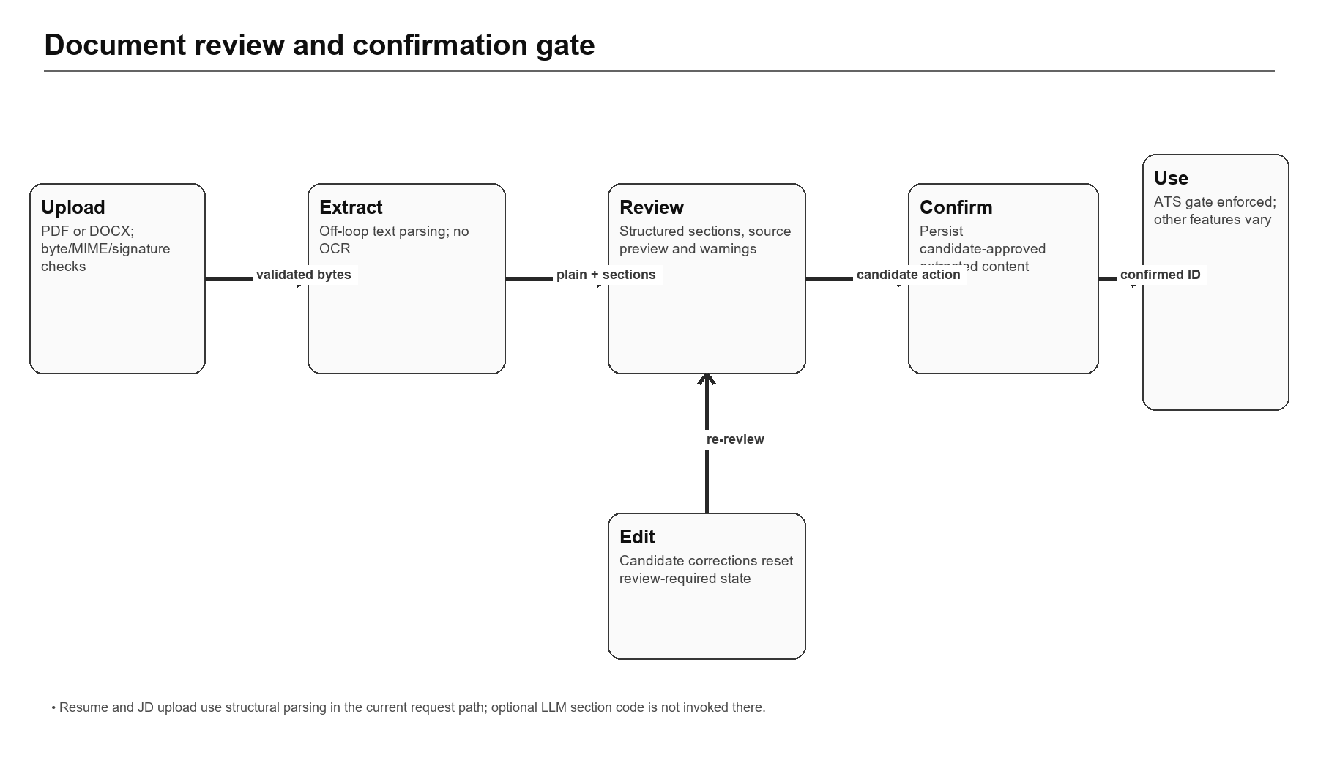
Figure 8 — Upload, review, edit and confirmation gate

9.7 Deterministic ATS analysis
Dimension | Code-backed description
Implementation status | CURRENT
Purpose | Compare confirmed resume and JD content and produce a reproducible, evidence-linked score.
Primary actors | Candidates
Inputs | Authenticated user context plus feature-specific JSON, path/query parameters or validated uploaded bytes.
Core processing / validation | Required/preferred term extraction, aliases, boundary matching, exact source-line evidence, weighted normalized score and fingerprint-based reuse.
Outputs | Persisted user-owned resources, deterministic evidence, candidate-controlled changes, file streams or feature-specific status/report JSON.
AI involvement | Feature-specific; deterministic-only where stated, otherwise bounded provider calls with validation/fallback.
Edge/error behavior | ApiError normalization; ownership/not-found checks; provider and storage failures are surfaced or handled with feature-specific fallback/compensation.
Security / privacy | Server-side authorization and user ownership; external provider disclosure applies when source content is sent for AI processing.
Current limitations | Authenticated stateless /ats/score accepts raw text without the persisted confirm gate. Keyword coverage is not a hiring prediction.
Repository evidence | backend/app/features/ats/ats_score.py; backend/app/api/router.py; backend/tests/test_ats*
Table 21 — Deterministic ATS analysis design summary

9.8 ATS improvement brief
Dimension | Code-backed description
Implementation status | CURRENT
Purpose | Explain prioritized missing terms without inventing experience.
Primary actors | Candidates
Inputs | Authenticated user context plus feature-specific JSON, path/query parameters or validated uploaded bytes.
Core processing / validation | Preferred Groq/NVIDIA order, bounded call, output grounding and deterministic missing-keyword fallback.
Outputs | Persisted user-owned resources, deterministic evidence, candidate-controlled changes, file streams or feature-specific status/report JSON.
AI involvement | Feature-specific; deterministic-only where stated, otherwise bounded provider calls with validation/fallback.
Edge/error behavior | ApiError normalization; ownership/not-found checks; provider and storage failures are surfaced or handled with feature-specific fallback/compensation.
Security / privacy | Server-side authorization and user ownership; external provider disclosure applies when source content is sent for AI processing.
Current limitations | Provider availability and prompt behavior are not covered by a formal model-evaluation suite.
Repository evidence | backend/app/features/ats; backend/app/agents/registry.py; backend/app/agents/prompts/ats_improvement_v1.txt
Table 22 — ATS improvement brief design summary

9.9 Resume improvement and exports
Dimension | Code-backed description
Implementation status | PARTIAL
Purpose | Generate evidence-checked section suggestions, capture candidate decisions, apply approved changes and export DOCX/PDF.
Primary actors | Candidates / API clients
Inputs | Authenticated user context plus feature-specific JSON, path/query parameters or validated uploaded bytes.
Core processing / validation | Sequential gap analysis, LLM generation, novelty/overlap/entity validation, accept/reject/confirm-edit controls, in-place or new-version apply.
Outputs | Persisted user-owned resources, deterministic evidence, candidate-controlled changes, file streams or feature-specific status/report JSON.
AI involvement | Feature-specific; deterministic-only where stated, otherwise bounded provider calls with validation/fallback.
Edge/error behavior | ApiError normalization; ownership/not-found checks; provider and storage failures are surfaced or handled with feature-specific fallback/compensation.
Security / privacy | Server-side authorization and user ownership; external provider disclosure applies when source content is sent for AI processing.
Current limitations | Backend is implemented and tested, but no complete workspace UI was found. In-place content update and ATS invalidation are not transactional; initial run provider metadata can be inaccurate.
Repository evidence | backend/app/features/resume_improvement; backend/app/api/router.py; backend/tests/test_resume_improvement*
Table 23 — Resume improvement and exports design summary
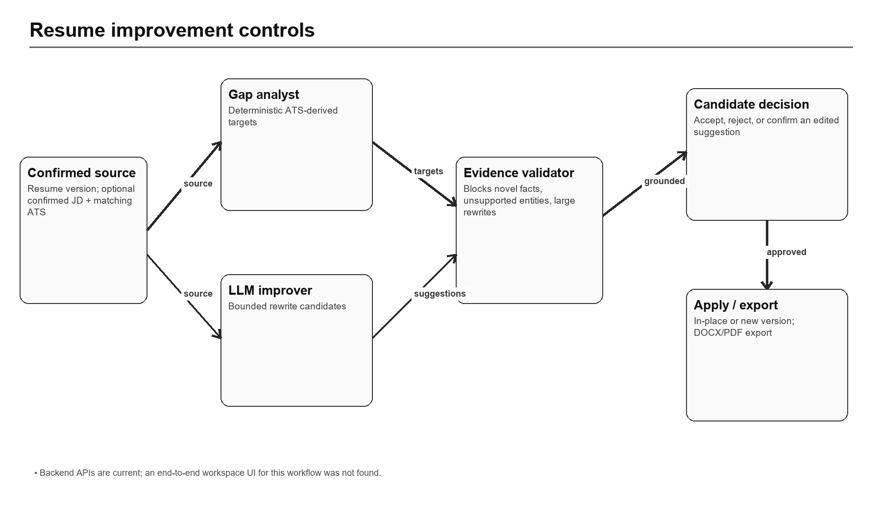
Figure 9 — Resume-improvement validation and candidate-control flow

9.10 Mock interview practice
Dimension | Code-backed description
Implementation status | CURRENT / GATE INCONSISTENCY
Purpose | Create sessions, generate questions, submit typed/transcribed answers, receive coaching and complete reports.
Primary actors | Candidates
Inputs | Authenticated user context plus feature-specific JSON, path/query parameters or validated uploaded bytes.
Core processing / validation | Groq question/evaluation paths with deterministic templates and heuristics; all questions must be answered before completion.
Outputs | Persisted user-owned resources, deterministic evidence, candidate-controlled changes, file streams or feature-specific status/report JSON.
AI involvement | Feature-specific; deterministic-only where stated, otherwise bounded provider calls with validation/fallback.
Edge/error behavior | ApiError normalization; ownership/not-found checks; provider and storage failures are surfaced or handled with feature-specific fallback/compensation.
Security / privacy | Server-side authorization and user ownership; external provider disclosure applies when source content is sent for AI processing.
Current limitations | Mock-session start does not universally enforce confirmed resume status, unlike interview preparation. Scores are coaching heuristics, not hiring decisions.
Repository evidence | backend/app/api/router.py; backend/app/agents/prompts/interview_*; frontend/src/features/interview
Table 24 — Mock interview practice design summary
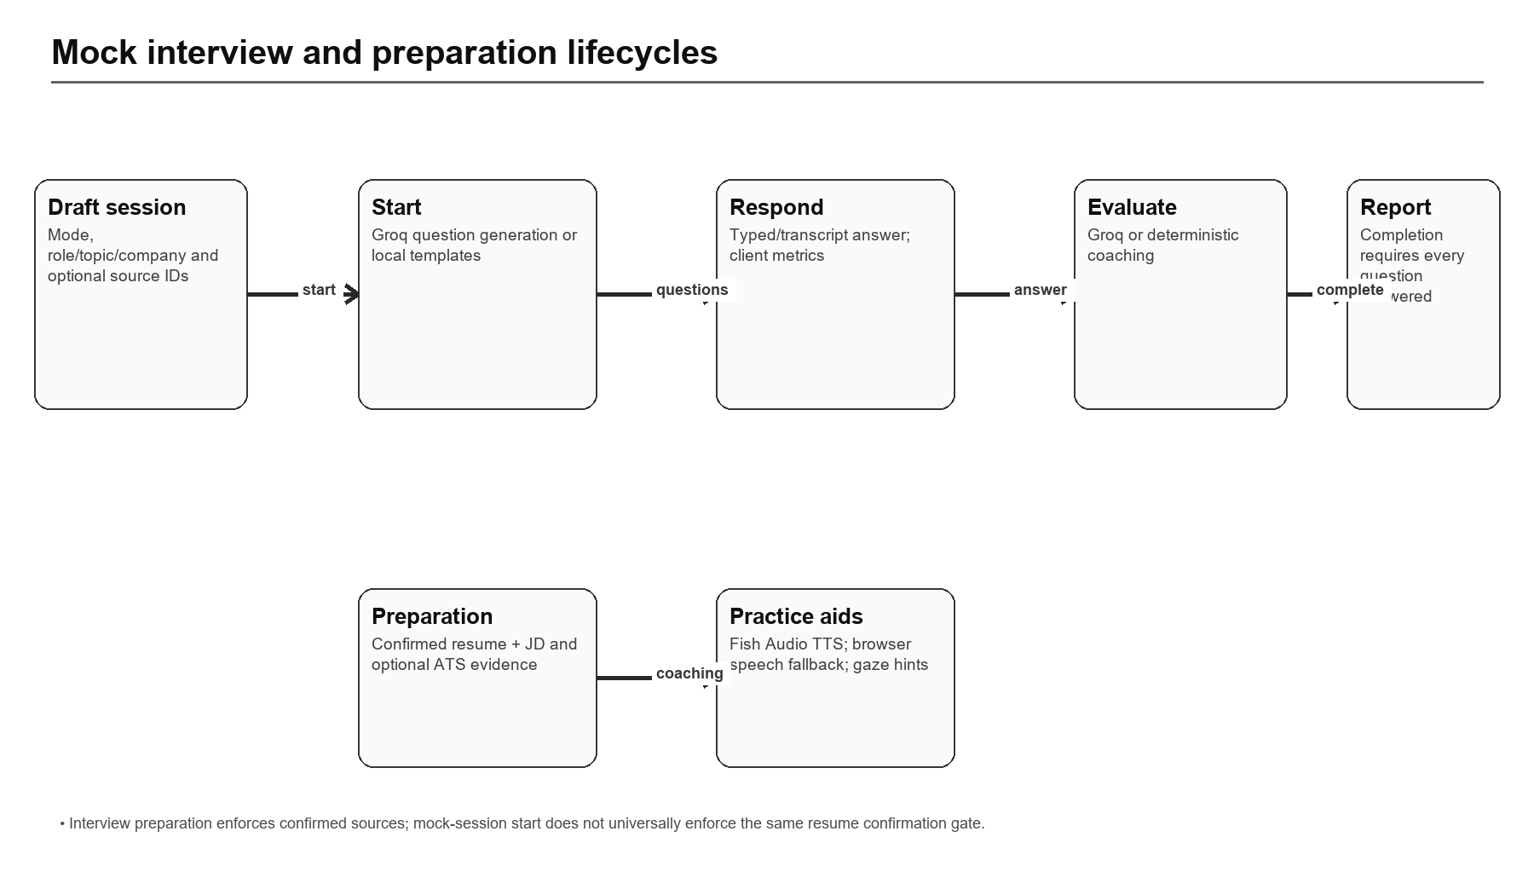
Figure 10 — Mock interview and preparation lifecycle

9.11 Voice, filler and gaze coaching
Dimension | Code-backed description
Implementation status | PARTIAL / ENVIRONMENT-DEPENDENT
Purpose | Read questions aloud and provide practice signals for delivery.
Primary actors | Candidates
Inputs | Authenticated user context plus feature-specific JSON, path/query parameters or validated uploaded bytes.
Core processing / validation | Fish Audio TTS server-side; browser speech-synthesis fallback; Web Speech transcripts; deterministic filler/pace metrics; browser FaceDetector gaze hints.
Outputs | Persisted user-owned resources, deterministic evidence, candidate-controlled changes, file streams or feature-specific status/report JSON.
AI involvement | Feature-specific; deterministic-only where stated, otherwise bounded provider calls with validation/fallback.
Edge/error behavior | ApiError normalization; ownership/not-found checks; provider and storage failures are surfaced or handled with feature-specific fallback/compensation.
Security / privacy | Server-side authorization and user ownership; external provider disclosure applies when source content is sent for AI processing.
Current limitations | Browser/API availability varies; raw audio/video upload is disabled by default and no persistent media-review pipeline exists.
Repository evidence | backend/app/integrations/fish_audio.py; frontend/src/features/interview; backend/app/core/config.py
Table 25 — Voice, filler and gaze coaching design summary

9.12 Interview preparation
Dimension | Code-backed description
Implementation status | CURRENT
Purpose | Build role/JD-specific preparation guidance from confirmed resume and JD content.
Primary actors | Candidates
Inputs | Authenticated user context plus feature-specific JSON, path/query parameters or validated uploaded bytes.
Core processing / validation | Requires confirmed sources, reuses matching ATS evidence when available, otherwise heuristics, with optional Groq enhancement.
Outputs | Persisted user-owned resources, deterministic evidence, candidate-controlled changes, file streams or feature-specific status/report JSON.
AI involvement | Feature-specific; deterministic-only where stated, otherwise bounded provider calls with validation/fallback.
Edge/error behavior | ApiError normalization; ownership/not-found checks; provider and storage failures are surfaced or handled with feature-specific fallback/compensation.
Security / privacy | Server-side authorization and user ownership; external provider disclosure applies when source content is sent for AI processing.
Current limitations | Synchronous provider work is request-bound; no queue or resumable job model.
Repository evidence | backend/app/api/router.py; backend/app/agents/prompts/interview_preparation_v1.txt
Table 26 — Interview preparation design summary

9.13 Learning-path generation
Dimension | Code-backed description
Implementation status | CURRENT
Purpose | Turn missing/partial ATS evidence into a sequenced learning plan with resources and progress.
Primary actors | Candidates
Inputs | Authenticated user context plus feature-specific JSON, path/query parameters or validated uploaded bytes.
Core processing / validation | Gap extraction, Groq or deterministic curriculum, YouTube API validation, safe search/docs fallbacks and persisted path/item/resource hierarchy.
Outputs | Persisted user-owned resources, deterministic evidence, candidate-controlled changes, file streams or feature-specific status/report JSON.
AI involvement | Feature-specific; deterministic-only where stated, otherwise bounded provider calls with validation/fallback.
Edge/error behavior | ApiError normalization; ownership/not-found checks; provider and storage failures are surfaced or handled with feature-specific fallback/compensation.
Security / privacy | Server-side authorization and user ownership; external provider disclosure applies when source content is sent for AI processing.
Current limitations | Manual path creation is exposed, but full manual item/resource authoring and a complete UI flow were not found.
Repository evidence | backend/app/features/learning; backend/app/api/router.py; frontend/src/features/learning
Table 27 — Learning-path generation design summary
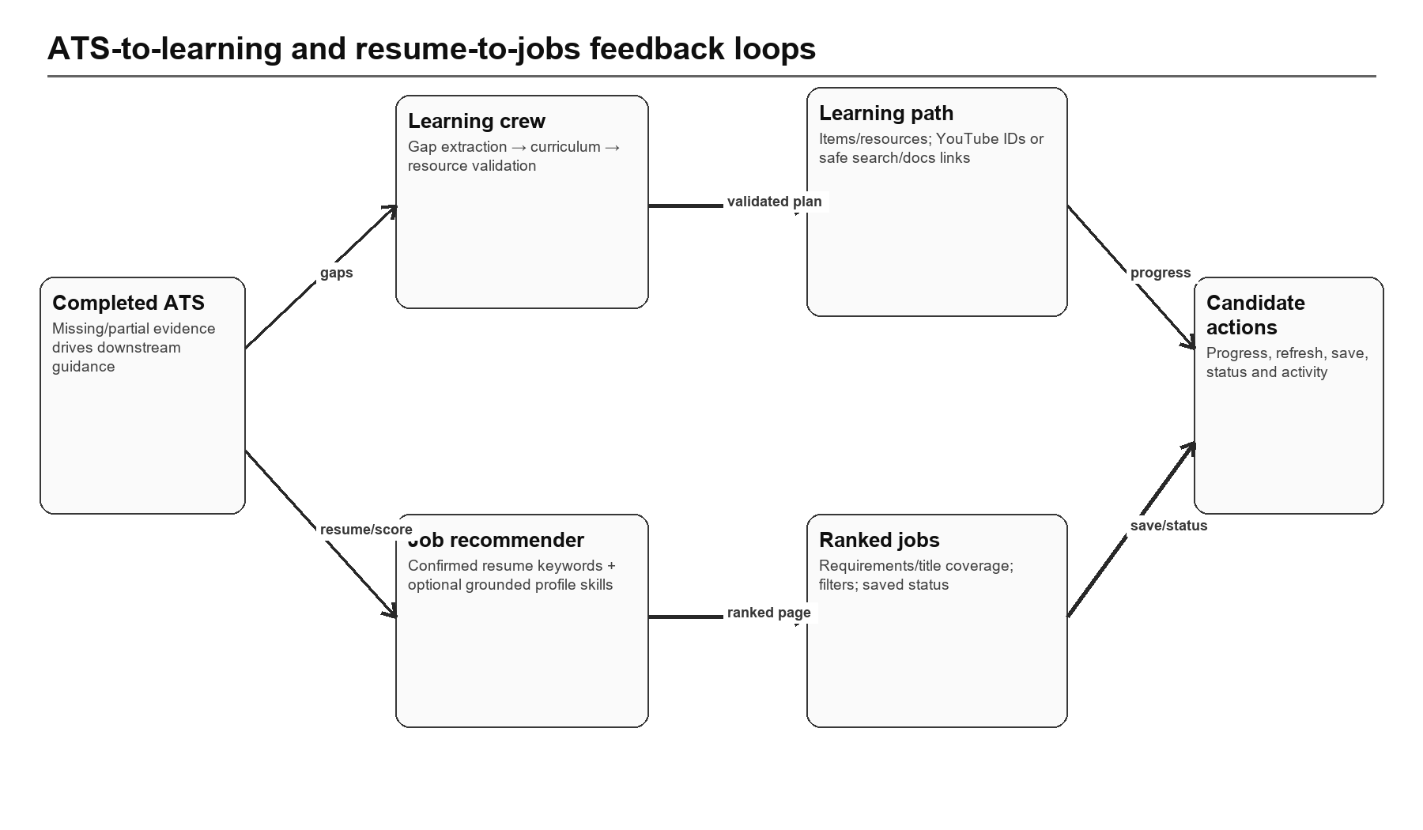
Figure 11 — ATS-driven learning and resume-driven job loops

9.14 Job catalog synchronization
Dimension | Code-backed description
Implementation status | PARTIAL / OPTIONAL PROVIDER
Purpose | Import job listings from Adzuna into a shared catalog.
Primary actors | Candidates / operators
Inputs | Authenticated user context plus feature-specific JSON, path/query parameters or validated uploaded bytes.
Core processing / validation | Authenticated sync, page-one fetch, capped results, upsert and process-local cooldown/lock.
Outputs | Persisted user-owned resources, deterministic evidence, candidate-controlled changes, file streams or feature-specific status/report JSON.
AI involvement | Feature-specific; deterministic-only where stated, otherwise bounded provider calls with validation/fallback.
Edge/error behavior | ApiError normalization; ownership/not-found checks; provider and storage failures are surfaced or handled with feature-specific fallback/compensation.
Security / privacy | Server-side authorization and user ownership; external provider disclosure applies when source content is sent for AI processing.
Current limitations | Provider credentials are optional; the global lock is per process, only page one is fetched and stale jobs are not archived.
Repository evidence | backend/app/integrations/adzuna.py; backend/app/api/router.py
Table 28 — Job catalog synchronization design summary

9.15 Job recommendations and saved jobs
Dimension | Code-backed description
Implementation status | CURRENT
Purpose | Rank catalog jobs against a confirmed resume, filter results and track saved application status.
Primary actors | Candidates
Inputs | Authenticated user context plus feature-specific JSON, path/query parameters or validated uploaded bytes.
Core processing / validation | Deterministic requirement/title coverage; profile skills count only when grounded in confirmed resume text; per-user recommendation rows.
Outputs | Persisted user-owned resources, deterministic evidence, candidate-controlled changes, file streams or feature-specific status/report JSON.
AI involvement | Feature-specific; deterministic-only where stated, otherwise bounded provider calls with validation/fallback.
Edge/error behavior | ApiError normalization; ownership/not-found checks; provider and storage failures are surfaced or handled with feature-specific fallback/compensation.
Security / privacy | Server-side authorization and user ownership; external provider disclosure applies when source content is sent for AI processing.
Current limitations | Reads at most 500 jobs; ranking is lexical; pagination/generation state is process-local and not suitable for multi-instance coordination.
Repository evidence | backend/app/features/jobs; backend/app/api/router.py; frontend/src/features/jobs
Table 29 — Job recommendations and saved jobs design summary

9.16 Settings, privacy and account deletion
Dimension | Code-backed description
Implementation status | CURRENT / NON-ATOMIC DELETION
Purpose | Manage notification/privacy preferences, update password and delete the account and stored files.
Primary actors | Candidates
Inputs | Authenticated user context plus feature-specific JSON, path/query parameters or validated uploaded bytes.
Core processing / validation | Explicit email plus DELETE MY ACCOUNT phrase; collection-by-collection user-data deletion; user-prefix storage enumeration and purge.
Outputs | Persisted user-owned resources, deterministic evidence, candidate-controlled changes, file streams or feature-specific status/report JSON.
AI involvement | Feature-specific; deterministic-only where stated, otherwise bounded provider calls with validation/fallback.
Edge/error behavior | ApiError normalization; ownership/not-found checks; provider and storage failures are surfaced or handled with feature-specific fallback/compensation.
Security / privacy | Server-side authorization and user ownership; external provider disclosure applies when source content is sent for AI processing.
Current limitations | Cross-service deletion is not atomic. A late failure can leave a partially deleted account requiring operational repair.
Repository evidence | backend/app/features/auth/account_deletion.py; backend/app/api/router.py; frontend/src/features/settings
Table 30 — Settings, privacy and account deletion design summary

9.17 Health, diagnostics and activity
Dimension | Code-backed description
Implementation status | CURRENT
Purpose | Expose liveness/readiness, agent capability status, request IDs, recent activity and workspace bootstrap.
Primary actors | Operators / candidates
Inputs | Authenticated user context plus feature-specific JSON, path/query parameters or validated uploaded bytes.
Core processing / validation | Bounded Firestore/storage probes, 503 fail-closed readiness, structured logging, response hardening headers and best-effort activity writes.
Outputs | Persisted user-owned resources, deterministic evidence, candidate-controlled changes, file streams or feature-specific status/report JSON.
AI involvement | Feature-specific; deterministic-only where stated, otherwise bounded provider calls with validation/fallback.
Edge/error behavior | ApiError normalization; ownership/not-found checks; provider and storage failures are surfaced or handled with feature-specific fallback/compensation.
Security / privacy | Server-side authorization and user ownership; external provider disclosure applies when source content is sent for AI processing.
Current limitations | No metrics backend, distributed tracing, alert rules, dashboards or SLO definitions are committed.
Repository evidence | backend/app/main.py; backend/app/api/router.py; backend/app/core/errors.py
Table 31 — Health, diagnostics and activity design summary
10 / SECURITY AND PRIVACY

10. Security and Privacy
Authentication, authorization, secrets, threat model, data protection and responsible AI

10.1 Current controls
- External provider tokens are verified server-side before an application JWT is minted.
- Local passwords use scrypt; password update increments token_version, invalidating older application tokens.
- Firebase token revocation checking is forced in production and verified email is required for provider linking.
- Firestore and Firebase Storage client rules deny all access; server code uses Admin/service credentials and application authorization.
- Allowed collections, logical buckets, safe identifiers and user-prefixed file paths reduce arbitrary access.
- CORS origins are configurable; response headers include request ID, nosniff and strict-origin referrer policy.
- Secret-pattern scan passes for committed files; environment values are excluded from this document.
- Account deletion requires exact phrase and matching email and attempts data/object purge.

10.2 Threat-model summary
Threat | Asset / path | Current mitigation | Residual risk / action
XSS token theft | localStorage and JS cookie app JWT | React escaping; expiry; token_version checks | High: move to server-set HttpOnly Secure SameSite cookie; CSP; minimize token lifetime
Broken object authorization | Firestore rows and private files | CurrentUser filters, safe path prefix, private buckets | High impact if a route omits ownership; add policy tests and centralized repository contracts
Provider data disclosure | Resume/JD/profile text sent to AI APIs | Server-only credentials, bounded context, feature validation | Establish consent, DPA/retention/region policy, redaction and audit trail
Prompt injection / malicious documents | Uploaded text embedded in prompts | Task-specific prompts, structured output, evidence validation | Add explicit untrusted-data delimiters, injection tests and output policy evaluation
Denial of service / cost abuse | Uploads, parsing, LLM/TTS/jobs endpoints | Size caps, timeouts, process RPM limiter, sync cooldown | Add per-user/global distributed quotas, queue backpressure and cost alarms
Partial deletion | Firestore + Supabase objects | Ordered deletion, fail-stop errors, path enumeration | Implement deletion job state, retries, audit evidence and operator repair
Cross-origin media auth | avatars/resume/export URLs | Authenticated backend proxy | Cookie may not cross frontend/backend origins; use BFF/same origin or expiring signed URL
Stolen JWT after sign-out | copied application token | Client clears token; expiry | Increment session family/token version or maintain revocation/session records
Table 32 — Threat model and treatment priorities

10.3 Privacy and retention
The product stores identity/profile information, employment and education history, uploaded resumes/JDs, interview answers, generated reports and application-tracking state. Private storage and per-user ownership are appropriate foundations, but no explicit retention schedule, backup lifecycle, legal basis/consent record, export-of-all-data flow or deletion audit certificate is committed. These are required before regulated or enterprise use.

10.4 Responsible AI
- Display deterministic ATS evidence and algorithm version so users can distinguish evidence from generated prose.
- Label interview and job scores as practice/ranking heuristics, not employability or hiring probabilities.
- Preserve candidate confirmation for source extraction and resume changes; never silently add experience, numbers, dates, employers or skills.
- Record provider/model/prompt version and fallback mode for audit without storing credentials or unnecessary raw personal content.
- Introduce dataset-based quality, safety, injection and fairness gates before provider/prompt upgrades.
11 / PERFORMANCE, RELIABILITY AND SCALABILITY

11. Performance, Reliability and Scalability
Request-path behavior, bottlenecks, concurrency and resiliency
Area | Current behavior | Bottleneck / failure mode | Recommended direction
API process | Single FastAPI modular monolith | Provider/parsing/export work consumes request capacity | Queue long tasks; preserve stateless API replicas
Firestore | Server Admin access; application sorting/filtering and bounded lists | Read amplification, missing indexes, no transactions | Query/index budget, repository contracts, batched/transactional patterns where needed
Object files | API streams private objects | Memory/bandwidth and cross-origin auth | Same-origin edge proxy or short-lived signed downloads with audit
LLM providers | Timeouts, retries, process RPM limiter | Multi-instance quotas uncoordinated; latency on user request | Distributed rate/cost budgets, async jobs, circuit breakers
Job sync | Page-one fetch, process lock, 60-second user cooldown | Multiple processes can sync simultaneously; stale catalog | Scheduled idempotent sync with distributed lease and archival
Frontend | Lazy routes, in-flight GET dedupe, last-good bootstrap | Large feature modules and optional 3D/media dependencies | Bundle budgets, route chunk analysis, error/performance telemetry
Health | Bounded DB/storage probes and fail-closed readiness | External-provider health not reflected; no SLO | Separate dependency indicators, metrics, alerts and synthetic journeys
Table 33 — Performance and reliability analysis

11.1 Capacity-sensitive paths
- Document extraction and DOCX/PDF export perform CPU/file work, partially offloaded but still tied to request completion.
- AI generation can incur provider timeouts/retries; interview and learning flows may hold connections while waiting.
- The jobs recommendation path reads a bounded set of up to 500 global jobs and scores them in-process.
- Authenticated file streaming routes every byte through the API and depends on the application session reaching the file origin.
- Account deletion performs collection and object operations serially and can leave partial state after a dependency failure.
12 / TESTING AND QUALITY

12. Testing and Quality
Verified checks, coverage shape, code quality and unverified test classes

12.1 Verification executed
Check | Result | Interpretation
Backend pytest | PASS — 220 tests in 7.78 s | Current backend suite passes in the repository virtual environment
Cross-boundary imports | PASS | Repository boundary policy script found no prohibited imports
Committed secret patterns | PASS | No committed credential patterns detected by project diagnostic
Frontend source-only ESLint | PASS with 33 warnings | No source errors; warnings concern explicit any, Fast Refresh and stale disable comments
Full frontend lint | BLOCKED / FAIL | Untracked legacy frontend/.next generated output is scanned, producing 2,514 errors and 81 warnings
Frontend typecheck/build | BLOCKED / FAIL | Local node_modules lacks declared Supabase and LiveKit packages
Frontend Vitest | PARTIAL | 9/10 suites loaded; 47 tests passed; one suite failed import resolution for missing Supabase package
Playwright E2E | NOT RUN | Requires installed browser/runtime and configured local services; not established in this audit
Table 34 — Verification evidence

12.2 Test architecture
Backend tests cover authentication, ownership, upload validation, ATS evidence/scoring, provider behaviors, interviews, learning, jobs, storage and resume improvement using in-memory or mocked dependencies. Frontend tests target selected API/client and feature behaviors; Playwright scenarios exist for landing/application flows. The suite is meaningful but does not establish production service integration, load behavior or provider output quality.

12.3 Quality observations
- Positive: feature packages, explicit provider adapters, deterministic fallbacks, comprehensive backend tests and boundary diagnostics.
- Debt: backend/app/api/router.py is approximately 4,095 lines; settings and interview/resume components exceed 1,500–2,300 lines, increasing review and regression risk.
- Debt: an untracked Next.js .next tree coexists with the Vite application and is not excluded by ESLint, obscuring clean validation.
- Debt: dependency installation is not reproducibly healthy in the reviewed workspace despite declared packages; use npm ci in a clean environment as a release prerequisite.
- Gap: contract tests against real Firestore/Supabase emulators, provider sandboxes and deployment smoke tests are not committed as an automated pipeline.
13 / CONFIGURATION AND INTEGRATIONS

13. Configuration and Integrations
Environment contracts, external services and failure behavior

13.1 Environment variable inventory
Variable names (values excluded) | Purpose
APP_ENV, API_HOST, API_PORT | Runtime mode and listener
CORS_ORIGINS, PUBLIC_API_BASE_URL | Browser origins and externally visible API base
APP_JWT_SECRET, APP_JWT_ALGORITHM, APP_JWT_EXPIRE_MINUTES | Application-session signing and lifetime
FIREBASE_PROJECT_ID, FIREBASE_CLIENT_EMAIL, FIREBASE_PRIVATE_KEY | Firebase Admin / Firestore credentials
FIREBASE_WEB_* | Frontend Firebase Google identity configuration
SUPABASE_URL, SUPABASE_ANON_KEY | Frontend/backend Supabase Auth configuration
SUPABASE_SERVICE_ROLE_KEY | Private object-storage administrative access
DOCUMENT_BUCKET, AVATAR_BUCKET, *_MAX_BYTES | Logical storage and upload caps
LLM_PROVIDER, LLM_RPM_LIMIT | Provider preference and process-local request budget
GROQ_API_KEY, GROQ_BASE_URL, GROQ_MODEL, GROQ_* | Groq endpoint/model/timeout/retry configuration
NVIDIA_API_KEY, NVIDIA_BASE_URL, NVIDIA_MODEL, NVIDIA_* | NVIDIA endpoint/model/timeout/retry configuration
OMNIROUTE_ENABLED, OMNIROUTE_* | Optional provider-routing adapter
FISH_AUDIO_API_KEY, FISH_AUDIO_* | Interview text-to-speech provider
ADZUNA_APP_ID, ADZUNA_APP_KEY, ADZUNA_* | External job-catalog integration
YOUTUBE_API_KEY, YOUTUBE_* | Learning video search/validation
INTERVIEW_MEDIA_UPLOAD_ENABLED | Raw interview media persistence feature flag; default disabled
RESUME_IMPROVEMENT_* | Provider timeout, context and suggestion caps
Table 35 — Environment contract

13.2 External integration matrix
Service | Data exchanged | Failure behavior | Current classification
Supabase Auth | Email/password/session tokens and identity attributes | Email auth unavailable; local/Firebase sign-in fallbacks vary | CURRENT
Firebase Auth | Google ID token and verified identity attributes | Google auth unavailable; email Supabase route remains | CURRENT
Firestore | All application record data | Readiness degrades/fails closed; most features unavailable | CURRENT / critical dependency
Supabase Storage | Private source/generated files and avatars | Readiness degraded; upload/download unavailable | CURRENT / critical dependency
Groq | Bounded source/evidence and prompts | Feature-specific deterministic fallback | OPTIONAL CURRENT
NVIDIA / OmniRoute | Bounded source/evidence and prompts | Secondary or adapted provider for supported features | OPTIONAL CURRENT
Fish Audio | Question text for TTS | Browser speech synthesis fallback | OPTIONAL CURRENT
Adzuna | Search parameters and public job results | Existing catalog remains; sync unavailable | OPTIONAL / PARTIAL
YouTube Data API | Gap/topic search and public video metadata | Safe YouTube search URL fallback | OPTIONAL CURRENT
Table 36 — Integration behavior
14 / DEPLOYMENT AND OPERATIONS

14. Deployment and Operations
Documented topology, runtime configuration, health, logging and release gaps

14.1 Deployment procedure
1. Install locked frontend dependencies with npm ci and backend dependencies for Python 3.11–3.13.
2. Configure Firebase Admin, Supabase Auth/Storage, application JWT and CORS/public API origins; add optional providers separately.
3. Build the Vite frontend and deploy static output with SPA routing.
4. Run FastAPI/Uvicorn as the backend web service and verify /api/v1/health/live and /api/v1/health/ready.
5. Verify authentication exchange, authenticated API access and file/avatar delivery from the actual browser origin.
6. Run smoke journeys for document confirmation, ATS, interview fallback, learning fallback, jobs and account deletion in a non-production account.
These steps describe the repository-supported pattern. Exact cloud project/resource configuration and successful production deployment are not established by committed artifacts.

14.2 Logging and observability
The backend emits structured application logs and correlates requests with X-Request-ID. Health endpoints distinguish liveness from readiness and perform bounded Firestore/storage probes. Agent capability status reports configured logical providers without exposing credentials. There is no committed trace exporter, metrics backend, dashboard, alert policy, error-tracking integration or SLO/error-budget definition.

14.3 Operational runbook minimum
Symptom | Immediate check | Safe response
Readiness 503 | Inspect dependency status and request-correlated logs | Stop new traffic; validate Firestore/storage config and outage status
AI feature fallback | Check agent status, provider quota/latency and normalized error logs | Keep deterministic path available; avoid retry storms
File image/download 401 | Compare browser origin, URL origin, cookie/bearer availability | Use same-origin proxy or authorized short-lived link design
Partial account deletion | Identify last successful collection/object step | Freeze account; run audited idempotent repair after ownership verification
Jobs stale | Check Adzuna configuration, cooldown/lock and last synced rows | Manual bounded sync; do not erase catalog without backup/plan
Frontend release blocked | Clean install, remove legacy generated tree from lint scope | Re-run lint/type/test/build in clean runner
Table 37 — Minimum operational runbook
15 / GAPS, RISKS AND TECHNICAL DEBT

15. Gaps, Risks and Technical Debt
Prioritized findings derived from current implementation and verification
ID | Severity | Finding | Impact | Treatment
R1 | Critical | Browser-readable application JWT | XSS or malicious extension can steal a reusable bearer token; sign-out does not revoke a copied token. | Server-set HttpOnly Secure SameSite session cookie, CSP, short TTL/refresh family and revocation/session record.
R2 | High | Authenticated file delivery across origins | Avatar/document/export GET cannot reliably attach the frontend-domain JavaScript cookie to a separate API origin. | Same-origin BFF/edge proxy or narrowly scoped expiring signed URLs; integration test in deployed topology.
R3 | High | Application-only ownership over Admin SDK | A missing user filter can expose/modify another user’s data despite deny-all client rules. | Central typed repositories/policies, ownership contract tests and security review for every route.
R4 | High | Non-atomic deletion and improvement apply | Cross-service or multi-document failure can leave partial deletion or stale analysis state. | Idempotent state machines, transaction/batch boundaries, retryable jobs and repair tooling.
R5 | High | Synchronous provider and CPU work | Long requests, timeouts, capacity exhaustion and duplicate retries under load. | Durable queue, idempotency keys, worker limits, status resources and cancellation.
R6 | High | Confirmation policy inconsistency | Mock interview may use unconfirmed resume while preparation/ATS enforce confirmed sources. | Central source-eligibility policy and feature tests; document any deliberate exception.
R7 | High | No reproducible release pipeline | Declared code cannot be promoted with consistent evidence; current workspace has dependency/build hygiene issues. | CI/CD with clean lockfile install, checks, artifact provenance, staging smoke and rollback.
R8 | Medium | Large router/components | Concentrated change surface and slow reviews increase regression risk. | Extract feature routers/services and split stateful UI flows incrementally.
R9 | Medium | Process-local rate limits/locks | Multiple instances exceed provider budgets or duplicate job syncs. | Distributed quotas/leases and cost budgets.
R10 | Medium | No formal model evaluation | Provider/prompt changes can regress grounding, safety, fairness or usefulness unnoticed. | Golden datasets, schema/grounding metrics, injection tests and release thresholds.
R11 | Medium | No explicit retention/backup policy | Personal data may be retained too long or unrecoverable after operational failure. | Data classification, retention schedule, backup/PITR plan, deletion evidence and exercises.
R12 | Low | Legacy/dead artifacts and metadata drift | Old .next output, legacy storage adapter and inaccurate run/provider metadata confuse validation and operations. | Remove/deprecate artifacts, add lint ignores appropriately and test metadata truthfulness.
Table 38 — Prioritized risk register
16 / TARGET ARCHITECTURE

16. Target Architecture
Recommended evolution that preserves current strengths and addresses scale/security gaps
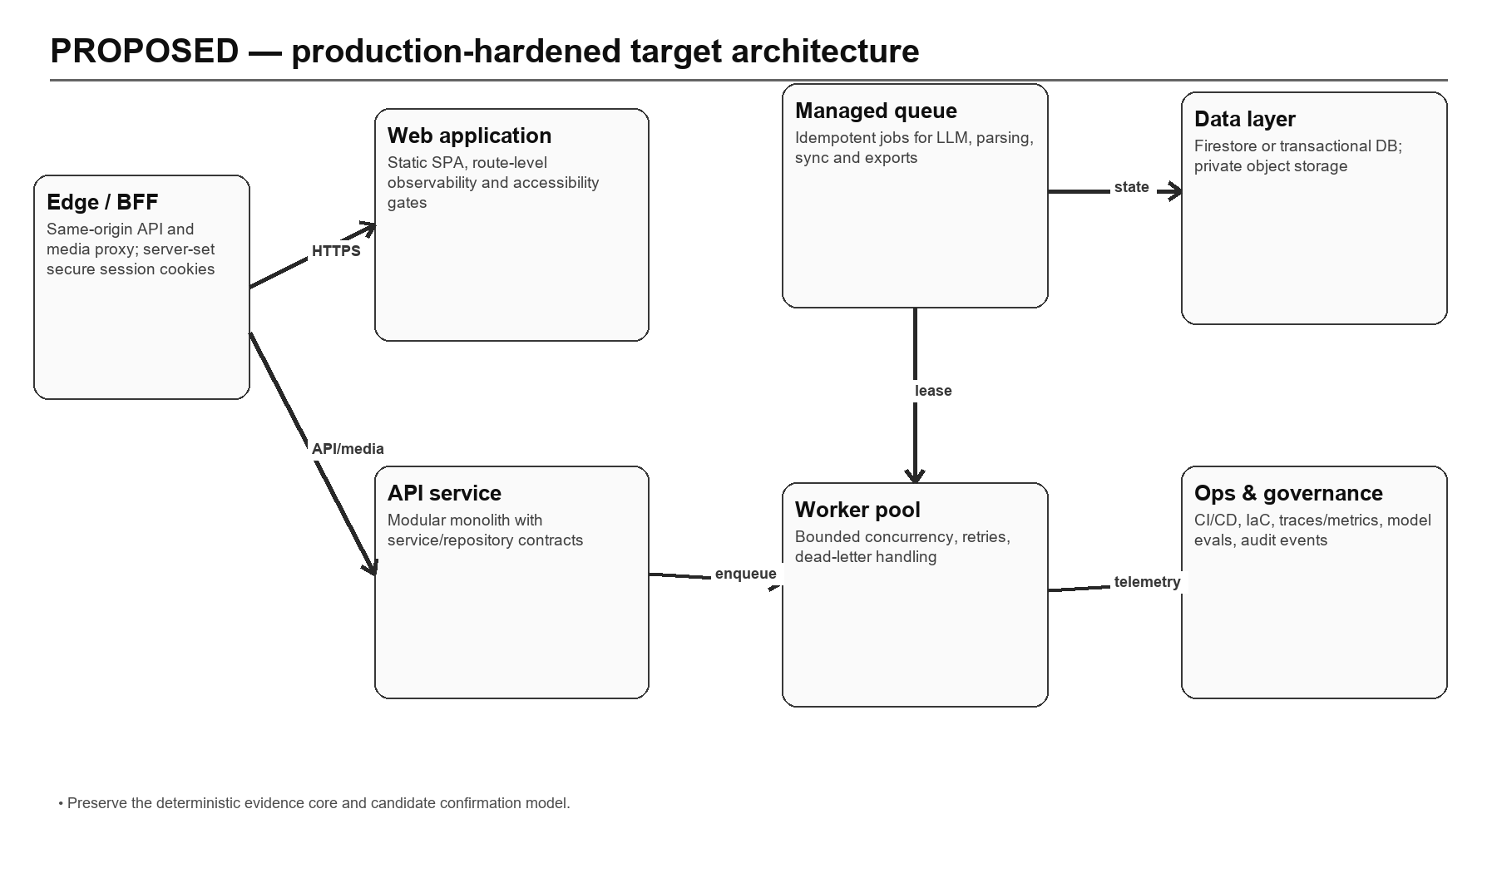
Figure 12 — Proposed production-hardened architecture

16.1 Architectural decisions
1. Keep a modular monolith for transactional product APIs until independently scaled domains are demonstrated; reduce the router surface through feature routers and service contracts.
2. Introduce a same-origin BFF/edge boundary that sets secure HttpOnly sessions and mediates authenticated file access.
3. Move parsing, LLM generation, exports, account deletion and catalog sync to durable idempotent jobs with explicit status and retry semantics.
4. Preserve deterministic ATS evidence and candidate confirmation as policy services shared by ATS, interview, learning and improvement flows.
5. Add repository-layer authorization invariants and transactional/batch boundaries; evaluate a relational database only where integrity/query needs justify migration.
6. Standardize provider gateways with distributed quotas, cost/latency telemetry, circuit breakers and versioned model/prompt records.
7. Add CI/CD, IaC, observability and model-evaluation controls before introducing additional AI providers or autonomous behavior.

16.2 Target component responsibilities
Component | Responsibility | Migration boundary
Edge/BFF | Session cookie, CSRF, CORS elimination, API/media routing | Can front current SPA/API without feature rewrite
API modular monolith | Authorization, fast CRUD, job submission, status and policy enforcement | Extract current feature routers/services incrementally
Job coordinator/workers | Long-running provider, parse, export, sync and deletion work | Adopt one workflow at a time with idempotency
Evidence/policy core | Confirmation eligibility, ATS algorithm, grounding and audit versions | Refactor current deterministic functions into stable contracts
Provider gateway | Routing, budgets, retry/circuit-breaker, structured output and telemetry | Wrap current Groq/NVIDIA/Fish/Adzuna/YouTube adapters
Data/object layer | Owned repositories, transactions/batches, private files and retention | Keep Firestore initially; add migration/backup discipline
Observability/evaluation | Logs, traces, metrics, cost, model quality and release evidence | Cross-cutting; instrument before scale
Table 39 — Target components
17 / IMPLEMENTATION ROADMAP

17. Implementation Roadmap
Sequenced delivery plan with dependencies and exit criteria
Phase | Priority | Deliverables | Dependencies | Exit criteria
0 — Baseline hygiene (1–2 weeks) | P0 | Clean lockfile install; exclude/remove legacy .next output; reproducible frontend checks; route/status inventory locked | Owner and clean runner | Backend + frontend checks pass from clean clone; no generated artifacts in lint scope
1 — Identity/media hardening (2–4 weeks) | P0 | HttpOnly secure session/BFF; CSRF policy; same-origin file access; revocable session family | Domain/TLS and auth migration | Cross-origin auth removed; stolen/sign-out token tests; deployed media E2E pass
2 — Policy and integrity (3–5 weeks) | P0 | Central ownership and confirmation policy; deletion/apply state machines; repair tooling | Repository contracts | No feature bypass; fault-injection recovery tests pass
3 — Async execution (4–7 weeks) | P1 | Durable queue/workers for parsing, AI, export, sync and deletion; idempotency/cancel/status | Managed queue/storage | No long provider work on API request; retry/dead-letter runbooks tested
4 — Delivery and operations (3–6 weeks) | P1 | CI/CD, IaC, staging, SBOM/scans, traces/metrics/alerts/SLOs | Cloud target decision | Reproducible promotion/rollback; dashboards and paging drill
5 — AI governance (ongoing) | P1 | Golden datasets, grounding/injection/fairness checks, cost/latency budgets, prompt registry | Telemetry and reviewer set | Provider/prompt releases meet defined thresholds
6 — Product completion (ongoing) | P2 | Resume-improvement UI, complete manual learning authoring, job-sync lifecycle and data export | Stable policy/job platform | End-to-end acceptance tests and documented user controls
Table 40 — Phased roadmap
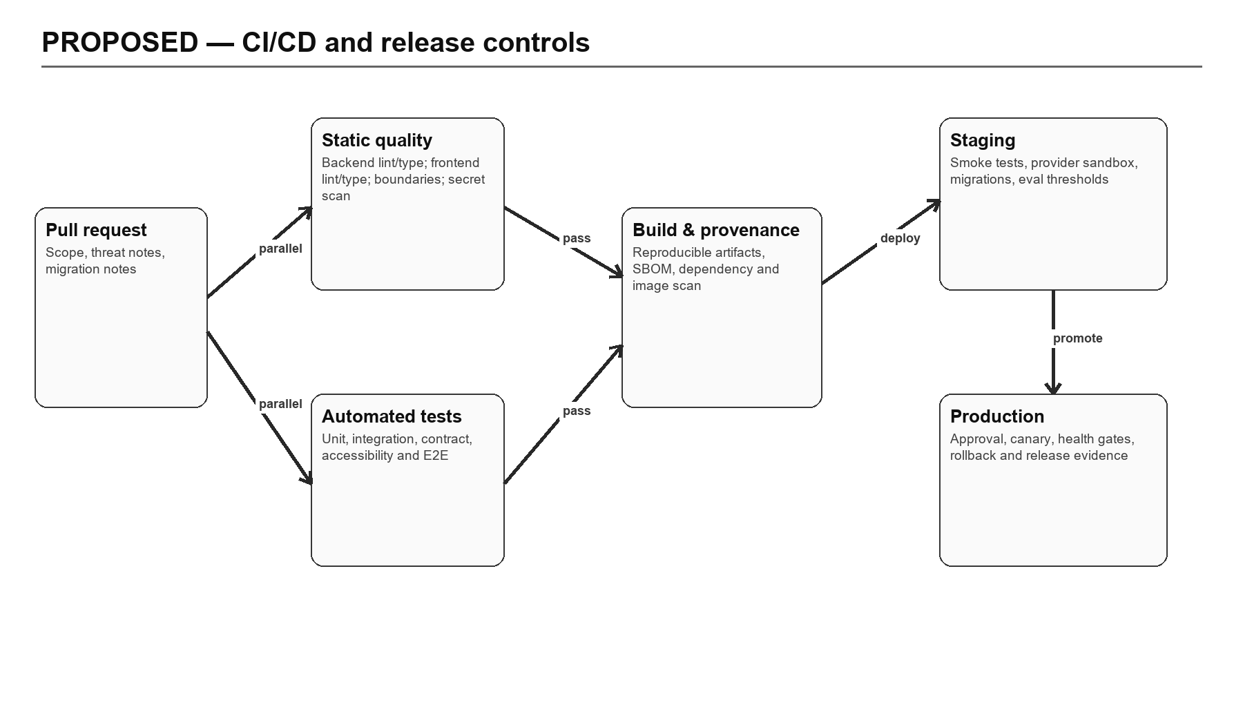
Figure 13 — Proposed CI/CD, staging and promotion flow

17.1 Recommended ownership
Workstream | Accountable owner | Consulted roles
Session/BFF and authorization | Backend/security lead | Frontend, platform, QA
Async jobs and integrity | Backend/platform lead | Data, AI/ML, operations
Frontend hygiene and product completion | Frontend lead | Product, UX, accessibility, QA
AI evaluation/governance | AI/ML lead | Product, security/privacy, domain reviewers
CI/CD/IaC/observability | Platform/SRE lead | All engineering leads
Retention/deletion/backup | Security/privacy owner | Platform, legal/compliance, backend
Table 41 — Suggested ownership model
18 / ASSUMPTIONS AND UNVERIFIED AREAS

18. Assumptions and Unverified Areas
Explicit limits on conclusions and follow-up evidence required
Area | What is known | What remains unverified | How to verify
Production deployment | Vercel/Render procedure is documented; Vercel SPA rewrite is committed | Whether live services exist, domains, TLS, proxy and environment values | Inspect cloud projects and execute deployed smoke tests
Data/storage | Firestore/Admin and Supabase private storage code exists | Indexes, rules deployed, backups, retention, regions and quotas | Review consoles/exported config; run restore exercise
Identity | Supabase/Firebase exchange code and tests exist | Production redirect URLs, email templates, MFA and abuse controls | Provider-console review and browser E2E
AI providers | Routing, prompts, validation and fallbacks are implemented | Production models, quotas, DPAs, retention, output quality and cost | Provider config audit plus golden-dataset evaluation
Frontend release | Source-only ESLint has no errors | Clean npm ci typecheck/test/build due incomplete local install | Run CI from clean clone with locked dependencies
Performance | Capacity-sensitive paths identified statically | Latency, throughput, memory, cost and failure thresholds | Load tests with realistic documents/jobs/provider stubs
Security | Controls and static threat model documented | Exploitability, dependency CVEs, cloud IAM and penetration resistance | SAST/SCA/DAST, IAM review and penetration test
Accessibility | Responsive UI components exist | WCAG conformance and assistive-technology behavior | Automated and manual accessibility audit
Table 42 — Unverified-area register

18.1 Key assumptions
- The reviewed Git commit represents the intended current baseline even though the working tree already contained untracked artifacts.
- Environment-variable names in .env.example are an intended configuration contract; no assumption is made that any value is configured in production.
- The in-memory test adapter approximates Firestore/storage behavior but cannot prove real-service consistency, indexing or IAM behavior.
- Provider fallbacks are part of product behavior; provider-specific quality is not assumed equivalent.
- The supplied earlier Word document is superseded where it refers to Next.js/SQLite or older commit state.
19 / GLOSSARY

19. Glossary
Project-specific and architectural terms
Term | Definition
Application JWT | Career Copilot token minted after external/local identity validation and checked on protected API requests.
ATS | Applicant tracking system; here, a deterministic keyword/evidence comparison aid, not an external ATS emulator.
BFF | Backend for frontend; a same-origin edge/server boundary tailored to the web client.
Candidate confirmation | Explicit approval that extracted resume/JD content is accurate enough for downstream evidence workflows.
CrewAI-compatible | Sequential agent/task shape that can use optional CrewAI, with an internal compatible runtime/fallback.
Deterministic fallback | Non-LLM behavior whose output follows fixed code/data rules when providers are unavailable or invalid.
Evidence grounding | Requiring generated content to reference or remain supported by candidate-controlled source material.
Firestore | Google managed document database used through Firebase Admin SDK.
Idempotency | Property that repeated execution of an operation has the same intended effect as one execution.
OmniRoute | Optional adapter that can route logical Groq/NVIDIA provider calls through another compatible endpoint.
RAG | Retrieval-augmented generation; not implemented in the current product.
Service role | Privileged Supabase credential used only by the backend for private storage administration.
Source fingerprint | Hash-derived identity of confirmed ATS inputs used to detect unchanged analyses.
Token version | Per-user value embedded in the app JWT and checked to invalidate older tokens after password change.
Table 43 — Glossary
20 / REFERENCES

20. References
Repository evidence used for this document
Evidence area | Paths / baseline
Repository baseline | Git branch main at bfa1f05ec597dec32f9c0b4fe9bb544d129a7327
Root runtime | package.json; scripts/setup; scripts/dev; scripts/diagnostics; scripts/verify-boundaries.mjs
Frontend runtime | frontend/package.json; frontend/vite.config.mjs; frontend/vercel.json; frontend/src/App.tsx
Frontend shared services | frontend/src/shared/api; frontend/src/features/auth; frontend/src/features/workspace
Frontend features | frontend/src/features/{onboarding,resume,interview,learning,jobs,settings}
Backend runtime | backend/pyproject.toml; backend/app/main.py; backend/app/core/{config,errors}.py
API surface | backend/app/api/router.py
Persistence | backend/app/database/{client,repository}.py; firestore.rules; storage.rules
Documents | backend/app/documents/*; backend/tests/test_document_*
ATS | backend/app/features/ats/*; backend/tests/test_ats*
AI providers | backend/app/agents/providers/*; backend/app/agents/registry.py; backend/app/agents/prompts/*
Resume improvement | backend/app/features/resume_improvement/*; backend/tests/test_resume_improvement*
Auth/deletion | backend/app/features/auth/*; backend/tests/test_auth*; backend/tests/test_account_deletion.py
Jobs/learning/integrations | backend/app/features/{jobs,learning}; backend/app/integrations; matching tests
Canonical docs | README.md; docs/{architecture,data-model,api-reference,flows,deployment,operations,frontend,code-map}.md
Secondary predecessor | C:/Users/prati/Downloads/Career_Copilot_Project_Documentation.docx
Table 44 — Evidence references
A / APPENDIX — COMPLETE API INVENTORY

A. Appendix — Complete API Inventory
Static inventory of all 94 FastAPI route decorators at the reviewed baseline
Purpose labels are derived from handler names. Authentication classification is based on route/dependency inspection and public-route policy. Exact request/response schemas remain defined by Pydantic models and route code.

A.account
Method | Endpoint | Purpose | Auth | Input | Output
DELETE | /api/v1/account | Delete account | App JWT (bearer or cookie) | Path parameters; confirmation body where applicable | JSON resource / status envelope

A.agents
Method | Endpoint | Purpose | Auth | Input | Output
GET | /api/v1/agents/status | Agent status | Public | Path/query parameters | JSON resource / status envelope

A.ats-analyses
Method | Endpoint | Purpose | Auth | Input | Output
GET | /api/v1/ats-analyses | List ats | App JWT (bearer or cookie) | Path/query parameters | JSON resource / status envelope
GET | /api/v1/ats-analyses/{analysis_id} | Get ats | App JWT (bearer or cookie) | Path/query parameters | JSON resource / status envelope
DELETE | /api/v1/ats-analyses/{analysis_id} | Delete ats | App JWT (bearer or cookie) | Path parameters; confirmation body where applicable | JSON resource / status envelope
POST | /api/v1/ats-analyses | Create ats | App JWT (bearer or cookie) | JSON body and/or path parameters | JSON resource / status envelope
GET | /api/v1/ats-analyses/{analysis_id}/evidence | List ats evidence | App JWT (bearer or cookie) | Path/query parameters | JSON resource / status envelope
GET | /api/v1/ats-analyses/{analysis_id}/suggestions | List suggestions | App JWT (bearer or cookie) | Path/query parameters | JSON resource / status envelope

A.auth
Method | Endpoint | Purpose | Auth | Input | Output
POST | /api/v1/auth/sign-up | Auth sign up | Public | JSON body and/or path parameters | JSON resource / status envelope
POST | /api/v1/auth/sign-in | Auth sign in | Public | JSON body and/or path parameters | JSON resource / status envelope
POST | /api/v1/auth/session | Auth session | App JWT (bearer or cookie) | JSON body and/or path parameters | JSON resource / status envelope
POST | /api/v1/auth/sign-out | Auth sign out | App JWT (bearer or cookie) | JSON body and/or path parameters | JSON resource / status envelope
POST | /api/v1/auth/firebase | Auth firebase | Public | JSON body and/or path parameters | JSON resource / status envelope
POST | /api/v1/auth/supabase | Auth supabase | Public | JSON body and/or path parameters | JSON resource / status envelope
POST | /api/v1/auth/resend | Auth resend | Public | JSON body and/or path parameters | JSON resource / status envelope
POST | /api/v1/auth/reset-password | Auth reset password | Public | JSON body and/or path parameters | JSON resource / status envelope
POST | /api/v1/auth/update-password | Auth update password | App JWT (bearer or cookie) | JSON body and/or path parameters | JSON resource / status envelope

A.files
Method | Endpoint | Purpose | Auth | Input | Output
GET | /api/v1/files/{bucket}/{path:path} | Authenticated file | App JWT (bearer or cookie) | Path/query parameters | File stream

A.health
Method | Endpoint | Purpose | Auth | Input | Output
GET | /api/v1/health/live | Health live | Public | Path/query parameters | JSON resource / status envelope
GET | /api/v1/health | Health | Public | Path/query parameters | JSON resource / status envelope
GET | /api/v1/health/ready | Health ready | Public | Path/query parameters | JSON resource / status envelope
GET | /api/v1/health/database | Health database | Public | Path/query parameters | JSON resource / status envelope

A.interview-preparation
Method | Endpoint | Purpose | Auth | Input | Output
POST | /api/v1/interview-preparation | Create interview preparation | App JWT (bearer or cookie) | JSON body and/or path parameters | JSON resource / status envelope

A.interviews
Method | Endpoint | Purpose | Auth | Input | Output
GET | /api/v1/interviews | List interviews | App JWT (bearer or cookie) | Path/query parameters | JSON resource / status envelope
GET | /api/v1/interviews/tts/status | Interview tts status | App JWT (bearer or cookie) | Path/query parameters | JSON resource / status envelope
POST | /api/v1/interviews/tts | Interview tts | App JWT (bearer or cookie) | JSON body and/or path parameters | JSON resource / status envelope
POST | /api/v1/interviews | Create interview | App JWT (bearer or cookie) | JSON body and/or path parameters | JSON resource / status envelope
GET | /api/v1/interviews/{session_id} | Get interview | App JWT (bearer or cookie) | Path/query parameters | JSON resource / status envelope
DELETE | /api/v1/interviews/{session_id} | Delete interview | App JWT (bearer or cookie) | Path parameters; confirmation body where applicable | JSON resource / status envelope
POST | /api/v1/interviews/{session_id}/start | Start interview | App JWT (bearer or cookie) | JSON body and/or path parameters | JSON resource / status envelope
POST | /api/v1/interviews/{session_id}/responses | Add response | App JWT (bearer or cookie) | JSON body and/or path parameters | JSON resource / status envelope
POST | /api/v1/interviews/{session_id}/complete | Complete interview | App JWT (bearer or cookie) | JSON body and/or path parameters | JSON resource / status envelope
GET | /api/v1/interviews/{session_id}/report | Get interview report | App JWT (bearer or cookie) | Path/query parameters | JSON resource / status envelope

A.job-descriptions
Method | Endpoint | Purpose | Auth | Input | Output
GET | /api/v1/job-descriptions | List jds | App JWT (bearer or cookie) | Path/query parameters | JSON resource / status envelope
POST | /api/v1/job-descriptions | Create jd | App JWT (bearer or cookie) | JSON body and/or path parameters | JSON resource / status envelope
POST | /api/v1/job-descriptions/upload | Upload jd | App JWT (bearer or cookie) | multipart/form-data or path parameters | JSON resource / status envelope
GET | /api/v1/job-descriptions/{jd_id} | Get jd | App JWT (bearer or cookie) | Path/query parameters | JSON resource / status envelope
PATCH | /api/v1/job-descriptions/{jd_id}/metadata | Patch jd metadata | App JWT (bearer or cookie) | JSON body and/or path parameters | JSON resource / status envelope
PATCH | /api/v1/job-descriptions/{jd_id}/extraction | Patch jd extraction | App JWT (bearer or cookie) | JSON body and/or path parameters | JSON resource / status envelope
POST | /api/v1/job-descriptions/{jd_id}/confirm | Confirm jd | App JWT (bearer or cookie) | JSON body and/or path parameters | JSON resource / status envelope

A.job-recommendations
Method | Endpoint | Purpose | Auth | Input | Output
GET | /api/v1/job-recommendations | List job recommendations | App JWT (bearer or cookie) | Path/query parameters | JSON resource / status envelope
POST | /api/v1/job-recommendations/generate | Generate job recommendations | App JWT (bearer or cookie) | JSON body and/or path parameters | JSON resource / status envelope

A.jobs
Method | Endpoint | Purpose | Auth | Input | Output
GET | /api/v1/jobs | List jobs | App JWT (bearer or cookie) | Path/query parameters | JSON resource / status envelope
POST | /api/v1/jobs/external/sync | Sync external jobs | App JWT (bearer or cookie) | JSON body and/or path parameters | JSON resource / status envelope
GET | /api/v1/jobs/{job_id} | Get job | App JWT (bearer or cookie) | Path/query parameters | JSON resource / status envelope

A.learning-paths
Method | Endpoint | Purpose | Auth | Input | Output
GET | /api/v1/learning-paths | List learning | App JWT (bearer or cookie) | Path/query parameters | JSON resource / status envelope
GET | /api/v1/learning-paths/{path_id} | Get learning | App JWT (bearer or cookie) | Path/query parameters | JSON resource / status envelope
DELETE | /api/v1/learning-paths/{path_id} | Delete learning path | App JWT (bearer or cookie) | Path parameters; confirmation body where applicable | JSON resource / status envelope
POST | /api/v1/learning-paths | Create learning | App JWT (bearer or cookie) | JSON body and/or path parameters | JSON resource / status envelope
POST | /api/v1/learning-paths/generate | Generate learning path | App JWT (bearer or cookie) | JSON body and/or path parameters | JSON resource / status envelope
PATCH | /api/v1/learning-paths/{path_id}/items/{item_id} | Update learning item | App JWT (bearer or cookie) | JSON body and/or path parameters | JSON resource / status envelope

A.me
Method | Endpoint | Purpose | Auth | Input | Output
GET | /api/v1/me/bootstrap | Bootstrap | App JWT (bearer or cookie) | Path/query parameters | JSON resource / status envelope
GET | /api/v1/me/activity | List activity | App JWT (bearer or cookie) | Path/query parameters | JSON resource / status envelope

A.profile
Method | Endpoint | Purpose | Auth | Input | Output
GET | /api/v1/profile | Get profile | App JWT (bearer or cookie) | Path/query parameters | JSON resource / status envelope
PATCH | /api/v1/profile | Update profile | App JWT (bearer or cookie) | JSON body and/or path parameters | JSON resource / status envelope
POST | /api/v1/profile/avatar | Upload profile avatar | App JWT (bearer or cookie) | multipart/form-data or path parameters | JSON resource / status envelope
DELETE | /api/v1/profile/avatar | Delete profile avatar | App JWT (bearer or cookie) | Path parameters; confirmation body where applicable | JSON resource / status envelope
PUT | /api/v1/profile/preferences | Update preferences | App JWT (bearer or cookie) | JSON body and/or path parameters | JSON resource / status envelope
POST | /api/v1/profile/skills/from-resume | Import skills from resume | App JWT (bearer or cookie) | JSON body and/or path parameters | JSON resource / status envelope
POST | /api/v1/profile/from-resume/preview | Preview profile from resume | App JWT (bearer or cookie) | JSON body and/or path parameters | JSON resource / status envelope
POST | /api/v1/profile/from-resume/preview-upload | Preview profile from resume upload | App JWT (bearer or cookie) | multipart/form-data or path parameters | JSON resource / status envelope
POST | /api/v1/profile/from-resume/apply | Apply profile from resume | App JWT (bearer or cookie) | JSON body and/or path parameters | JSON resource / status envelope
GET | /api/v1/profile/{resource} | List candidate records | App JWT (bearer or cookie) | Path/query parameters | JSON resource / status envelope
POST | /api/v1/profile/{resource} | Create candidate record | App JWT (bearer or cookie) | JSON body and/or path parameters | JSON resource / status envelope
PATCH | /api/v1/profile/{resource}/{record_id} | Update candidate record | App JWT (bearer or cookie) | JSON body and/or path parameters | JSON resource / status envelope
DELETE | /api/v1/profile/{resource}/{record_id} | Delete candidate record | App JWT (bearer or cookie) | Path parameters; confirmation body where applicable | JSON resource / status envelope

A.resume-comparisons
Method | Endpoint | Purpose | Auth | Input | Output
GET | /api/v1/resume-comparisons | Compare resume versions | App JWT (bearer or cookie) | Path/query parameters | JSON resource / status envelope

A.resume-exports
Method | Endpoint | Purpose | Auth | Input | Output
GET | /api/v1/resume-exports/{export_id}/download | Download resume export | App JWT (bearer or cookie) | Path/query parameters | File stream

A.resume-improvements
Method | Endpoint | Purpose | Auth | Input | Output
GET | /api/v1/resume-improvements/capabilities | Improvement capabilities | App JWT (bearer or cookie) | Path/query parameters | JSON resource / status envelope
POST | /api/v1/resume-improvements | Create improvement | App JWT (bearer or cookie) | JSON body and/or path parameters | JSON resource / status envelope
GET | /api/v1/resume-improvements/{run_id} | Read improvement | App JWT (bearer or cookie) | Path/query parameters | JSON resource / status envelope
GET | /api/v1/resume-improvements/{run_id}/suggestions | Read improvement suggestions | App JWT (bearer or cookie) | Path/query parameters | JSON resource / status envelope
POST | /api/v1/resume-improvements/{run_id}/apply | Apply improvement | App JWT (bearer or cookie) | JSON body and/or path parameters | JSON resource / status envelope

A.resume-suggestions
Method | Endpoint | Purpose | Auth | Input | Output
PATCH | /api/v1/resume-suggestions/{suggestion_id} | Update suggestion decision | App JWT (bearer or cookie) | JSON body and/or path parameters | JSON resource / status envelope

A.resume-versions
Method | Endpoint | Purpose | Auth | Input | Output
GET | /api/v1/resume-versions/{version_id} | Get resume version | App JWT (bearer or cookie) | Path/query parameters | JSON resource / status envelope
PATCH | /api/v1/resume-versions/{version_id}/extraction | Patch resume extraction | App JWT (bearer or cookie) | JSON body and/or path parameters | JSON resource / status envelope
POST | /api/v1/resume-versions/{version_id}/confirm | Confirm resume extraction | App JWT (bearer or cookie) | JSON body and/or path parameters | JSON resource / status envelope
POST | /api/v1/resume-versions/{version_id}/exports | Export resume version | App JWT (bearer or cookie) | JSON body and/or path parameters | JSON resource / status envelope

A.resumes
Method | Endpoint | Purpose | Auth | Input | Output
GET | /api/v1/resumes | List resumes | App JWT (bearer or cookie) | Path/query parameters | JSON resource / status envelope
POST | /api/v1/resumes | Create resume | App JWT (bearer or cookie) | JSON body and/or path parameters | JSON resource / status envelope
GET | /api/v1/resumes/{resume_id} | Get resume | App JWT (bearer or cookie) | Path/query parameters | JSON resource / status envelope
PATCH | /api/v1/resumes/{resume_id} | Patch resume | App JWT (bearer or cookie) | JSON body and/or path parameters | JSON resource / status envelope
DELETE | /api/v1/resumes/{resume_id} | Delete resume | App JWT (bearer or cookie) | Path parameters; confirmation body where applicable | JSON resource / status envelope
GET | /api/v1/resumes/{resume_id}/preview | Preview resume | App JWT (bearer or cookie) | Path/query parameters | JSON resource / status envelope
POST | /api/v1/resumes/{resume_id}/activate | Activate resume | App JWT (bearer or cookie) | JSON body and/or path parameters | JSON resource / status envelope
POST | /api/v1/resumes/{resume_id}/versions | Create resume version | App JWT (bearer or cookie) | JSON body and/or path parameters | JSON resource / status envelope

A.saved-jobs
Method | Endpoint | Purpose | Auth | Input | Output
GET | /api/v1/saved-jobs | List saved jobs | App JWT (bearer or cookie) | Path/query parameters | JSON resource / status envelope
POST | /api/v1/saved-jobs/{job_id} | Save job | App JWT (bearer or cookie) | JSON body and/or path parameters | JSON resource / status envelope
PATCH | /api/v1/saved-jobs/{job_id} | Patch saved job | App JWT (bearer or cookie) | JSON body and/or path parameters | JSON resource / status envelope
DELETE | /api/v1/saved-jobs/{job_id} | Unsave job | App JWT (bearer or cookie) | Path parameters; confirmation body where applicable | JSON resource / status envelope

A.score
Method | Endpoint | Purpose | Auth | Input | Output
POST | /api/v1/score | Score | App JWT (bearer or cookie) | JSON body and/or path parameters | JSON resource / status envelope

A.settings
Method | Endpoint | Purpose | Auth | Input | Output
GET | /api/v1/settings | Get settings records | App JWT (bearer or cookie) | Path/query parameters | JSON resource / status envelope
PUT | /api/v1/settings/notifications | Update notifications | App JWT (bearer or cookie) | JSON body and/or path parameters | JSON resource / status envelope
PUT | /api/v1/settings/privacy | Update privacy | App JWT (bearer or cookie) | JSON body and/or path parameters | JSON resource / status envelope
B / APPENDIX — DATA OWNERSHIP AND LIFECYCLE

B. Appendix — Data Ownership and Lifecycle
Cross-cutting ownership, state and deletion rules
Domain | Create/update authority | Read authority | Deletion / invalidation | Audit/version signal
Profile/preferences | Authenticated owner | Authenticated owner | Account deletion cascade | updated_at; completion recalculation
Resume/JD | Authenticated owner after upload validation | Authenticated owner | Resume parent soft delete; explicit record/object deletion paths | sha256; review status; confirmed_at
ATS | Authenticated owner with confirmed sources | Authenticated owner | Deleted explicitly or invalidated after in-place resume edit | algorithm version; fingerprint; timestamps
Improvement | Authenticated owner; candidate decision required | Authenticated owner | Cascade on account; source changes may stale analyses | run/provider/model; suggestion status
Interview | Authenticated owner | Authenticated owner | Session delete/account cascade | status; ordered questions; completed report
Learning | Authenticated owner from completed ATS | Authenticated owner | Path delete/account cascade | algorithm version; progress fields
Jobs | Authenticated sync writes global catalog; users own recs/saves | Authenticated catalog; owner-private state | User save/recs delete; no stale catalog archive | provider external_id; recommendation generation
Data lifecycle summary
C / APPENDIX — VERIFICATION RECORD

C. Appendix — Verification Record
Commands, results and interpretation at documentation time
Command / inspection | Result | Notes
git status / log / ls-files | Completed | Baseline and pre-existing untracked artifacts recorded; source not modified
backend/.venv/Scripts/python.exe -m pytest backend/tests -q | 220 passed | 7.78 seconds
npm run check:boundaries | Passed | Cross-boundary import verification
npm run check:secrets | Passed | Committed credential-pattern scan
eslint src | 0 errors; 33 warnings | Source-only check
npm run check:frontend | Blocked/fail | Legacy untracked .next tree scanned by ESLint
npm run typecheck / build | Blocked/fail | Declared Supabase/LiveKit modules absent from current installation
vitest run | 47 tests passed; 1 suite import failure | Missing Supabase module prevented one suite from loading
DOCX render and page inspection | PASS | Word-native PDF layout plus canonical page rasterization; every rendered page visually reviewed
Verification command record

