ACCOLADE Brief

Brief Summary

**Overview**

Accolade Global Pathways is a renowned consultancy firm dedicated to assisting individuals in achieving their dreams of studying and working abroad.

For those aspiring to study abroad, Accolade Global Pathways offers comprehensive counseling services for numerous countries, including the United States, Canada, Australia, the United Kingdom, New Zealand, and many others. Their experienced counseling team dispels myths and provides ethical guidance, paving the way for students to explore various career opportunities and reach new heights of success.

Accolade Global Pathways offers tailored support to students interested in pursuing education or work opportunities in the country. This support includes detailed guidance on visa requirements, financial planning, interview preparation, and personal development. By addressing every aspect related to overseas education, Accolade Global Pathways ensures a hassle-free experience for students, enabling them to fulfill their aspirations of studying abroad in Germany and beyond. Their Services include a Tourist Visa, Student Visa & Visitor Visa.

**Technology Stack**

Design: Figma

Link: [Accolade Figma link](https://www.figma.com/file/4RXqeTLA2cOwTRUzEjJUMw/Accolade?type=design&mode=design&t=PGAHzw4vbOK2oQVS-0)

Development: WordPress

Link: [Accolade Test link](https://cuneiformtest.com/accolade/)

**Modules:**

1. Home Page
2. Country pages

* USA
* Canada
* UK
* Australia
* New Zealand

1. About Us Page
2. Contact Us Page
3. Testimonials Page
4. FAQ’S Page

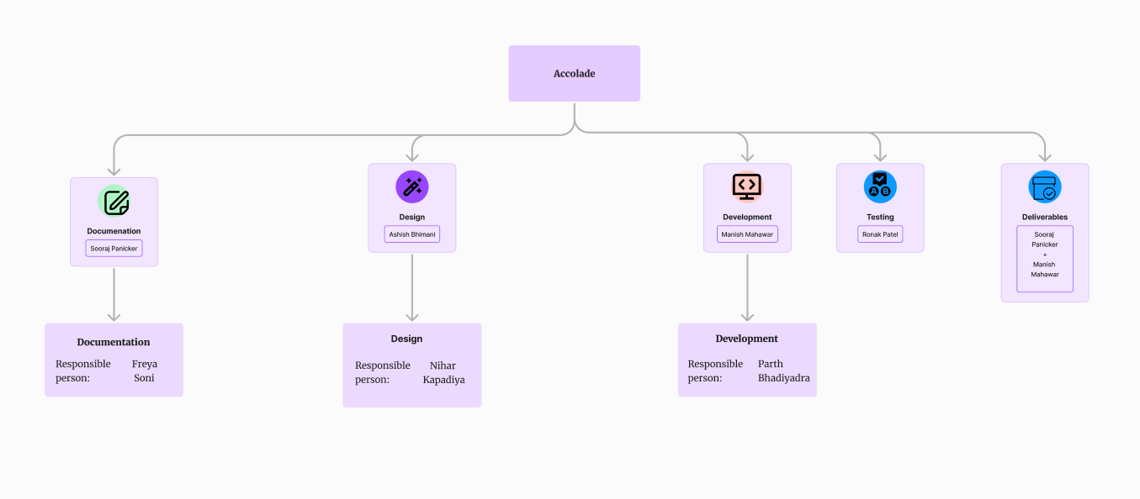Responsibility Distribution Chart: