**POS (Point Of Sales) Software**

Is a digital solution that allows businesses to conduct and manage sales transactions.

**Uses:**

* **Transaction Processing -** POS software is designed to handle sales transactions. This includes ringing up items, calculating totals, and applying discounts.
* **Inventory Management -** One of the primary functionalities of POS software is tracking items as they're sold. This means that businesses can keep track of stock levels in real-time, preventing inventory from being out of stock and facilitating prompt reordering schedules.
* **Sales reporting and analytics -** POS software can collect and present data on sales trends, popular products, and peak transaction times. These insights allow businesses to make informed decisions about purchasing, staffing, and marketing.
* **Customer management -** Keeping track of customer data, including purchase history and preferences, can lead to better customer service and targeted marketing campaigns.
* **Employee Management and tracking -** Beyond sales and inventory, POS software can also keep track of employee performance. Features may include logging hours, calculating commissions and even setting sales targets.
* **Loyalty and Promotion features -** To encourage customer retention and repeat business, POS software often has built-in capabilities to manage loyalty programmes, gift cards and special promotions.
* **Order management -** Especially relevant for restaurants or service-based establishments, POS software can manage special orders, table assignments, reservations or even service schedules, ensuring smooth operations and customer satisfaction.
* **Integration capabilities -** Modern POS software often has the capacity to integrate with other software tools or platforms. For instance, it may be possible to sync it with e-commerce services, accounting software or third-party customer relationship management (CRM) systems, to create a cohesive digital environment for businesses.

**Competitors:**

1. **Billberry –** Restaurants Outlets

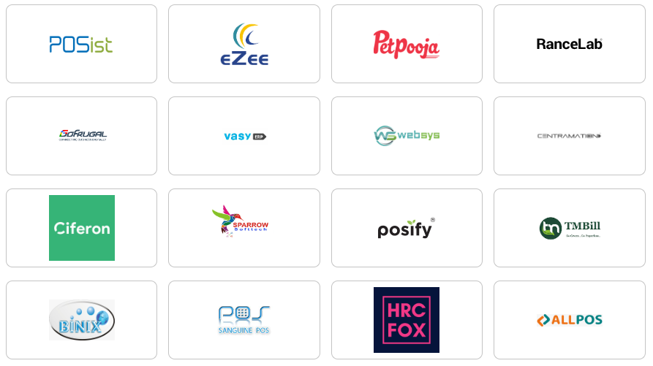

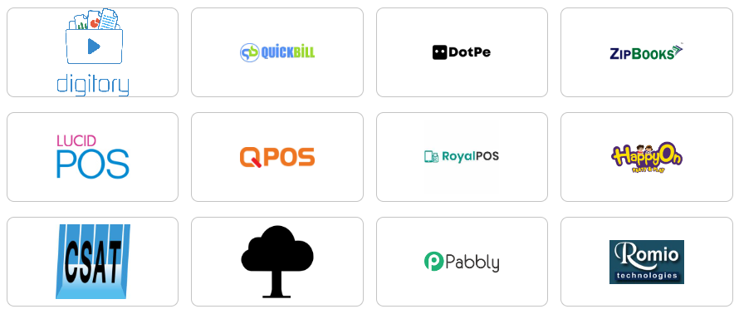

A Point of Sales software should have all features right from purchasing raw materials from vendors/suppliers, managing their quantities in the inventory, processing the raw materials to make food items, and selling the food items in restaurants.

* Reference - pet pooja POS

**Admin Users** – Super Admin, Admin, Restaurant owner, Bill counter, Waiter, kitchen.

**Application users** – Delivery boy, Customer

**Modules**

### Dashboard

* Overview of key metrics (sales, inventory, orders, etc.)
* Customizable widgets for real-time monitoring
* Filter reports by (weekly, monthly, quarterly, yearly)
* Ratings and reviews.
* Most sold item.
* Daily target income.
* Most favorite items.
* Recent order request.

### Order and Billing

* Order taking (dine-in, takeaway, delivery)
* Order tracking
* Billing and invoicing (multi-payment methods, split bills)
* Integration with Kitchen Display System (KDS)
* Payment processing and integration with gateways
* **User stories: -**
* Restaurant owner (billing)
* Take the orders from delivery boy.
* Check the order status.
* Check payment status.
* Waiter
* Take the order from customer.
* Send order to kitchen.
* Add, edit, and delete items from the order.
* Kitchen display system
* Will receive the order for table number and once the order is done, they can mark it as completed and the waiter and biller will receive a notification.

### Table management

* Table reservations and seat allocation
* Table status tracking (vacant, reserved, occupied)
* Waitlist management
* Table turnover reporting - refers to the analysis of how frequently tables in a restaurant are occupied and vacated during a given period. It tracks the time a customer spends at a table, the number of times a table is used for different seatings (turnovers), and the overall efficiency in serving customers.
* Change table arrangement.

### Raw material management

* Raw material tracking (quantities, stock levels)
* Expiration date management
* Waste and expired material management
* Consumption tracking (linked with recipes)

### Recipe management

* Ingredient and portion management
* Recipe-based raw material deduction from inventory
* Costing and yield management

### Menu management

* Dynamic menu creation and updates
* Linking of recipes to menu items
* Offers, discounts, and special promotions

### Vendor/Supplier management

* Supplier profiles and contracts
* Supplier comparison and pricing
* Purchase order (PO) creation and management
* Price discovery
* Purchase invoice settlement
* My enquires
* My offers/discounts
* My samples
* Samples enquires

### Purchase management

* Stock purchase and request for purchase
* Purchase invoice settlement
* Add purchase returns
* Purchase order approval workflows
* Samples management (requests, offers, inquiries)
* Price discovery for purchasing raw materials
* Stock purchase
* Request for purchase
* Add purchase return

### Inventory management

* Real-time inventory tracking and management
* Inventory categorization (raw materials, finished goods)
* Stock transfers between locations (outlets)
* Opening stock - Opening stock refers to the value or quantity of inventory that a restaurant has at the beginning of a specific accounting period (such as a day, week, month, or year). This includes raw materials, ingredients, and finished goods.
* Closing stock - Closing stock refers to the value or quantity of inventory left at the end of a specific accounting period. This includes whatever raw materials, ingredients, and finished goods are available after sales and consumption.
* Expiration date tracking
* Stock purchase and return management
* Purchase order approval
* Transfer items
* Request for sales return
* Consumption management
* Waste management
* Expired materials
* Closing stock

### Report management

* Opening/closing stock reports
* Purchase reports and supplier reports
* Food costing and order-wise consumption
* Monthly, weekly, and daily sales and consumption reports
* Financial and tax reporting
* Opening/closing report
* Purchase Report
* Supplier report
* Food costing
* Order-wise consumption
* Monthly report

### Customer Relationship Management (CRM)

* Customer profiles and purchase history
* Offers, discounts, and personalized promotions
* Feedback and surveys

### Accounting & payment management

* Payment processing (supplier payments, customer payments)
* Integration with accounting software (e.g., QuickBooks)
* Invoicing and payment reconciliation
* Tax calculation and compliance
* Expense management and financial statements

### Loyalty program management

* Points-based or tier-based loyalty systems
* Redemption tracking and management
* Customer insights and reward offers

### Central kitchen management

* Centralized food production for multi-location restaurants
* Stock transfers between central kitchen and restaurant branches
* Raw material and recipe management for central kitchen
* Order processing for multiple outlets

### Rate card & price management

* Vendor rate cards (for raw materials)
* Dynamic pricing (based on inventory or seasonal changes)
* Menu item pricing and updates

### User & Role Management

* Role-based access control (admin, cashier, kitchen staff, etc.)
* User creation and permission management
* Audit trails for user actions - refer to a detailed, chronological record of all activities or actions performed by users within a system, such as a point-of-sale (POS) software. These logs help track who did what, when, and where within the system.

### Email Template and configuration management

* Predefined email templates (invoices, order confirmations)
* System-wide configuration (taxes, currency, time zones)
* Notifications and alerts configuration

### Marketing and Promotions

* **Social media integration:** Connect with social media platforms to promote the restaurant, offer online ordering, and track customer engagement.
* **Loyalty program integration:** Integrate with loyalty programs to reward repeat customers and encourage return visits.
* **Email marketing:** Send targeted email campaigns for promotions, special offers, and customer feedback.
* **SMS marketing:** Send text message alerts for order updates, promotions, and loyalty program rewards.

### Delivery and Takeout

* **Delivery route optimization:** Use algorithms to optimize delivery routes and reduce delivery times.
* **Integration with delivery partners:** Partner with third-party delivery services to expand reach and provide convenient delivery options.
* **Online ordering:** Customers can place orders online or through a mobile app.
* **Curbside pickup:** Offer a convenient option for customers to pick up their orders from the restaurant without leaving their car.

### Analytics and Reporting

* **Customer segmentation:** Analyze customer data to identify customer segments and tailor marketing efforts accordingly.
* **Sales analysis:** Track sales trends, identify peak times, and analyze product popularity.
* **Cost analysis:** Analyze food costs, labor costs, and other expenses to identify areas for improvement.
* **Profitability analysis:** Evaluate the restaurant's overall profitability and identify areas for improvement.

### User Concern Management

* **Support Ticketing**: Allow users to raise concerns or complaints.
* **Feedback Collection**: Users can leave reviews or feedback after dining.
* **Concern Resolution Tracking**: Users can track the status of their complaints or issues.
* **Contact Support**: Direct contact options for customer support (email, chat, or phone).

### Notification Management

* **Order Status Updates**: Notifications on order confirmations, preparation, delivery, or pickup status.
* **Promotional Alerts**: Push notifications about offers, discounts, or events.
* **Loyalty Notifications**: Alerts for reward points earned or special loyalty program benefits.
* **Reservation Reminders**: Reminders for upcoming table reservations or catering orders.
* **Payment Alerts**: Notifications for successful payments, pending invoices, or payment failures.

### Reward Point Management

* **Earn Points**: Users earn points for every purchase or certain actions (e.g., referrals).
* **Redeem Points**: Ability to redeem points for discounts or free items.
* **Track Points**: Users can view their current reward point balance and history.
* **Loyalty Tiers**: Tier-based reward systems (e.g., Silver, Gold, Platinum).

### Authentication Management

* **User Sign-Up/Sign-In**: Secure registration and login for users via email, phone, or social media.
* **Password Management**: Users can reset or change passwords securely.
* **Two-Factor Authentication (2FA)**: Extra security layer for user accounts.
* **Auth Support**: Authentication via third-party services (Google, Facebook, etc.).

### Address Management

* **Add/Manage Addresses**: Users can save multiple delivery addresses.
* **Geolocation Integration**: Users can automatically detect location for faster ordering.
* **Favourite/Default Address**: Option to set a default delivery address for convenience.
* **Address Validation**: Validation of addresses for correct delivery zones.

### Cart Management

* **Add to Cart**: Users can add items to their cart from the menu.
* **Update Cart**: Modify quantities or remove items from the cart.
* **Save Cart**: Save a cart for future orders.
* **Multi-Cart Support**: Separate carts for dine-in, takeaway, or delivery.
* **Promo Code Application**: Apply promo codes or offers to cart items.

### Payment Management

* **Multiple Payment Methods**: Support for credit cards, debit cards, digital wallets (e.g., PayPal, Google Pay), and cash on delivery.
* **Payment History**: Users can view past payment details and receipts.
* **Payment Gateway Integration**: Secure payment gateway support for seamless transactions.
* **Partial Payments**: Allow split payments across different methods or users.
* **Refund Management**: Manage refunds for order cancellations or discrepancies.

### Catering Management

* **Catering Order Placement**: Users can place large orders for events with customizable menus.
* **Schedule Catering Orders**: Set specific dates and times for catering orders.
* **Customizable Packages**: Choose from pre-designed packages or create custom orders based on event size.
* **Order Tracking**: Track catering order progress from preparation to delivery.

### Streak Management

* **Daily Check-ins**: Users can earn points or rewards for checking in regularly or ordering daily.
* **Order Streaks**: Incentivize users to maintain streaks for ordering on consecutive days/weeks for bonuses.
* **Loyalty Rewards for Streaks**: Provide special offers or discounts based on consistent user activity or order streaks.
* **Streak Notifications**: Notify users about maintaining or breaking their streaks.

Outlet type:

Outlets can be grouped into 4 categories

COCO – Company Owned Company Operated

FOFO – Franchise Owned Franchise Operated

COFO – Company Owned Franchise Operated

FOCO – Franchise Owned Company Operated

Petpooja manages multiple outlets under a single brand by utilizing several core features that ensure seamless operations across different locations:

* Centralized Menu Management: The system allows brand owners to manage a uniform menu across all outlets. Any changes in menu items or pricing can be made centrally, which is reflected across outlets in real time. This feature also applies to both offline and online menus​.
* Centralized Inventory Management: Petpooja offers a robust inventory system where outlets can track stock, get low-stock alerts, and manage purchases. The system allows for transferring raw materials or prepared items between outlets from a central kitchen, ensuring that every outlet maintains optimal inventory levels​
* Zone Management: Outlets can be grouped based on region, city, or state, allowing owners to create operational zones. This helps in better management of logistics and regional preferences for items
* Centralized Monitoring and Reporting: Through a head office dashboard, businesses can monitor sales, staff performance, and other metrics across all outlets. It provides outlet-wise reports on sales, inventory, and operations, enabling owners to make data-driven decisions
* Purchase Management: The system helps raise purchase orders and manage deliveries to each outlet. A centralized system ensures that all outlets maintain a consistent supply of materials from approved vendors
* Centralized Dashboard: Petpooja offers a head office dashboard that allows managers to monitor all outlets' operations from a single location. This includes tracking sales, inventory, orders, and other financial metrics. Outlet-specific data can be pulled to view performance individually or across the entire chain​.
* Outlet-wise Billing and Sales Tracking: Each outlet processes its sales and billing independently, but all the data syncs with the central system. This allows the head office to generate outlet-wise sales and revenue reports, ensuring complete visibility of each branch's financial health.
* Bank Account Management: Revenue generated from each outlet can be tracked and assigned to different bank accounts. This flexibility enables brands to manage revenue separately for each outlet or consolidate it under a single account based on preference​.
* ERP Integration: For large chains, Petpooja integrates with enterprise resource planning (ERP) systems like Tally, SAP, and Microsoft Dynamics. This ensures that all financial data, including sales, expenses, and transactions from each outlet, is automatically pushed to a central system for better accounting and financial management​.