Below we will define an n-interesting polygon. Your task is to find the area of a polygon for a given n.

A 1-interesting polygon is just a square with a side of length 1. An n-interesting polygon is obtained by taking the n - 1-interesting polygon and appending 1-interesting polygons to its rim, side by side. You can see the 1-, 2-, 3- and 4-interesting polygons in the picture below.

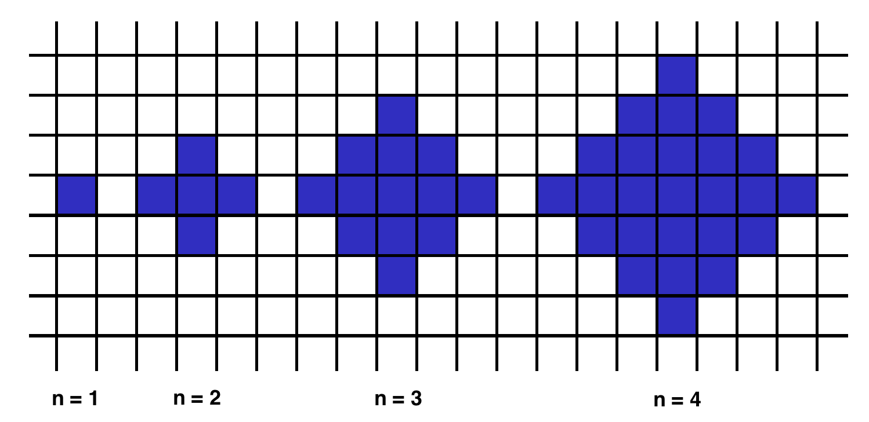

Example

* For n = 2, the output should be  
  shapeArea(n) = 5;
* For n = 3, the output should be  
  shapeArea(n) = 13.

Input/Output

* **[execution time limit] 3 seconds (java)**
* **[input] integer n**

*Guaranteed constraints:*  
1 ≤ n < 104.

* **[output] integer**
  + The area of the n-interesting polygon.

**[Java] Syntax Tips**

// Prints help message to the console

// Returns a string

//

// Globals declared here will cause a compilation error,

// declare variables inside the function instead!

String **helloWorld**(String name) {

System.out.println("This prints to the console when you Run Tests");

**return** "Hello, " + name;

}