Abstract- Avionics is a term used to describe all the electronic systems used on aircraft, artificial satellites and spacecraft. It was first used in the USA in the early 1950s and has since gained wide scale usage and acceptance. There is no doubt from our vantage point in 21st century that electronics plays an important role in aviation.
Design and Simulation of Avionics System for Military Aircraft
Ronald Christopher, Lokesh Kumar P.M
Dept. of Electronics and Communication, Nagarjuna College of Engineering and Technology, Bengaluru, India
E-mails: ronaldchristopher@hotmail.com, lokeshkumar.pm@gmail.com
The term ‘avionic system’ or ‘avionic sub-system’ is used to mean any system in the aircraft which is dependent on electronics for its operation, although the system may contain electro-mechanical elements. A flight control system depends on electronic digital computers for its effective operation, but there are also other equally essential elements in the system. These include solid state rate gyroscopes and accelerometers to measure the angular and linear motion of the aircraft and air data sensors to measure the height, airspeed and incidence.
The simulation for the above mentioned avionics system is to be created. The simulation thus created will have error correcting capabilities; i.e error induced into any subsystems should be detected and suitably corrected to produce accurate and reliable data to the pilot.

Index Terms- Air Data Computer (ADC), Attitude Heading Reference System (AHRS), Global Positioning System (GPS.)

I. INTRODUCTION
The avionics industry is a major multi-billion dollar industry world-wide and the avionics equipment on a modern military or civil aircraft can account for around 30% of the total cost of the aircraft. Modern general aviation aircraft’s also have significant avionics content. For example, color head down displays, GPS satellite navigation systems, radio communications equipment.
Avionic systems include communications, navigation, the display and management of multiple systems and the hundreds of systems that are fitted to aircraft to meet individual roles.
The avionic systems are essential to enable the flight crew to carry out the aircraft mission safely and efficiently, whether the mission is carrying passengers to their destination in the case of a civil airliner, or, in the military case, intercepting a hostile aircraft, attacking a ground target, reconnaissance or maritime patrol. A major driver in the development and introduction of avionic systems has been the need to meet the mission requirements with the minimum flight crew.
The Other very important drivers for avionic systems are increased safety, air traffic control requirements, all weather operation, and reduction in fuel consumption, improved aircraft performance and control and handling and reduction in maintenance costs.
Military avionic systems are also being driven by a continuing increase in the threats posed by the defensive and offensive capabilities of potential aggressors. It should be noted that unmanned aircraft (UMAs) are totally dependent on the avionic systems.
The simulation for portraying such system is done with the help of MATLAB. The name MATLAB stands for matrix laboratory MATLAB is a high- performance language for technical computing. It integrates computation, visualization, and programming in an easy-to-use environment where problems and solutions are expressed in familiar mathematical notation.
Simulink is an interactive environment for modeling, simulating, and analyzing dynamic, multi domain systems. It lets us build a block diagram, simulate the system’s behavior, evaluate its performance, and refine the design. Simulink integrates seamlessly with MATLAB, providing us with immediate access to an extensive range of analysis and design tools. These benefits make Simulink the tool of choice for aerospace system design, control system design, DSP design, communications system design, and other simulation applications.

II. DESIGN
The design of the simulation consists of the following devices.
A. Pitot Static System.
B. The Air Data Computer (ADC)
C. Attitude Heading Reference System (AHRS)
D. Global Positioning System (GPS)
E. Cockpit Display Instruments.

A. Pitot Static System:
The pitot/static system supplies dynamic and static air pressure to the ADC and to the Integrated Standby Instrument (ISI).
There are two major parts of the pitot-static system: the impact pressure chamber and lines, and the static pressure chamber and lines. They provide the source of ambient air pressure for the operation of the altimeter, vertical speed indicator (vertical velocity indicator), and the airspeed indicator.

B. ADC:
The ADC is a computer module used to perform mathematical functions production various outputs depending on the three inputs. Temperature static and total pressure are the inputs fed to the ADC. This is depicted in fig 2.2. The heart of any ADC is the pressure sensor. The accuracy of the entire system is based on the sensor. The two types of pressure sensors used are absolute sensor for the static port and a differential sensor for the pitot system. There are three common sensor designs employed and they are: bonded strain gauge, deposited or ion implanted piezo resistive elements and capacitive. These pressure transducers are simply an Electro-mechanical device for translating fluid pressure values into voltages across a high-impedance. The piezo resistive sensor design employs a fully active Wheatstone bridge. Applied pressure presents a distributed load to the diaphragm, which provides bending stresses. This stress creates a strain proportional to the applied pressure, which results in a bridge imbalance. With an applied voltage across the bridge the unbalance produces a millivolt output. The capacitive type provide the highest sensitivity, least aging effects and provide very accurate low pressure sensing. This capacitive sensing technique measures atmospheric pressure through the change in voltage across the capacitive element, one plate of which deflects slightly with changes in applied pressure. The sensitivity of a transducer is defined as the ratio of its electrical output to its mechanical input.

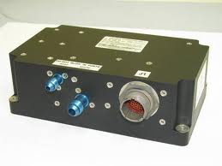
Fig.2.1: ADC Unit

The Total air temperature (TAT) probe serves as an input mechanism for temperature. The TAT probe design could be of two types: aspirated and non-aspirated. The air temperature is used to calibrate the impact pressure as well as in determining air density. The air density will affect the force of the air. This measured temperature will vary from the standard lapse rate of .65° C / 100 meters and this value will vary up or down depending on location and the local weather. The ADC is used to calculate various parameters. These include Calibrated air speed, indicated air speed, Mach number and pressure altitude. Fig. 2.1 shows the basic ADC unit.

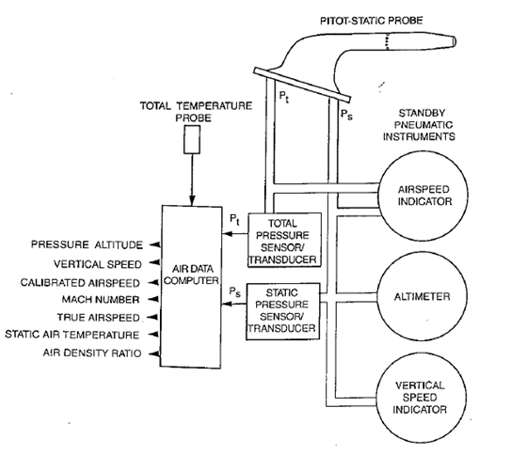
Fig.2.2: Block Diagram of Air Data Computer

The equations are standard avionics equations and are obtained from, Principles of Avionic by Albert Helfrick.

C. AHRS:
The AHRS estimates the roll, pitch and yaw angles of a body relative to a reference frame. The AHRS system uses gyroscopes, accelerometers and magnetometers on all three axes to estimate the attitude. Usually a Kalman filter is used to combine all the measurements. A typical AHRS unit is shown in fig 2.3. The AHRS also estimates the ground speed through true airspeed which is very essential and important parameter for the pilot while flying.
An important function of AHRS is to calculate ground speed through True Airspeed (TAS) which is obtained from the ADC. Ground speed is the speed of an aircraft relative to the ground. Information displayed to passengers through the entertainment system often gives the aircraft groundspeed rather than airspeed. Ground speed can be determined by the vector sum of the aircraft's true airspeed and the current wind speed and direction; a headwind subtracts from the ground speed, while a tailwind adds to it. Winds at other angles to the heading will have components of either headwind or tailwind as well as a crosswind component.
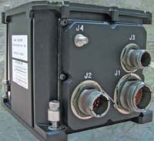
Fig.2.3: AHRS Unit
An airspeed indicator can only indicate the aircraft's speed relative to the air mass. The air mass as a whole may be moving over the ground due to wind, and therefore some additional means to provide position over the ground is required. This might be through navigation using landmarks, radio aided position location, inertial navigation system, or GPS. True airspeed (TAS) of an aircraft is the speed of the aircraft relative to the air mass in which it is flying. True airspeed is important information for accurate navigation of an aircraft.
The vector calculation of Ground speed is standardized equations obtained from reference [1].

D. GPS:
GPS has been under development in the USA since 1973. The US Department of Defense as a worldwide navigation and positioning resource for military as well as civilian use for 24 hours and all weather conditions primarily developed it. In its final configuration, NAVSTAR GPS consists of 21 satellites (plus 3 active spares) at an altitude of 20200 km above the earth’s surface. These satellites are so arranged in orbits to have at least four satellites visible above the horizon anywhere on the earth, at any time of the day. GPS Satellites transmit at frequencies L1=1575.42 MHz and L2=1227.6 MHz modulated with two types of code viz. P-code and C/A code and with navigation message. Mainly two types of observable are of interest to the user. In pseudo ranging the distance between the satellite and the GPS receiver plus a small corrective term for receiver clock error is observed for positioning whereas in carrier phase techniques, the difference between the phase of the carrier signal transmitted by the satellite and the phase of the receiver oscillator at the epoch is observed to derive the precise information. The GPS satellites act as reference points from which receivers on the ground detect their position. The fundamental navigation principle is based on the measurement of pseudo-ranges between the user and four satellites. Fig 2.4 helps us understand the concept of the functioning of the GPS. Ground stations precisely monitor the orbit of every satellite and by measuring the travel time of the signals transmitted from the satellite four distances between receiver and satellites will yield accurate position, direction and speed. Though three-range measurements are sufficient, the fourth observation is essential for solving clock synchronization error between receiver and satellite. Thus, the term “pseudo-ranges” is derived. The secret of GPS measurement is due to the ability of measuring carrier phases to about 1/100 of a cycle equaling to 2 to 3 mm in linear distance. Moreover the high frequency L1 and L2 carrier signal can easily penetrate the ionosphere to reduce its effect. Dual frequency observations are important for large station separation and for eliminating most of the error parameters.
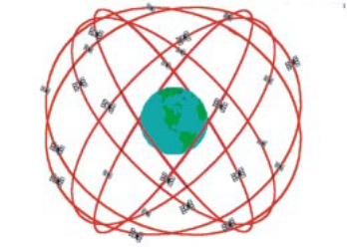
Fig.2.4: GPS, 21-Satellite Configuration

GPS has been designed to provide navigational accuracy of ±10 m to ±15m. However, sub meter accuracy in differential mode has been achieved and it has been proved that broad varieties of problems in geodesy and geodynamics can be tackled through GPS. The outcome of a typical GPS survey includes geocentric position accurate to 10 m and relative positions between receiver locations to centimeter level or better.

E. Cockpit Display Instruments:

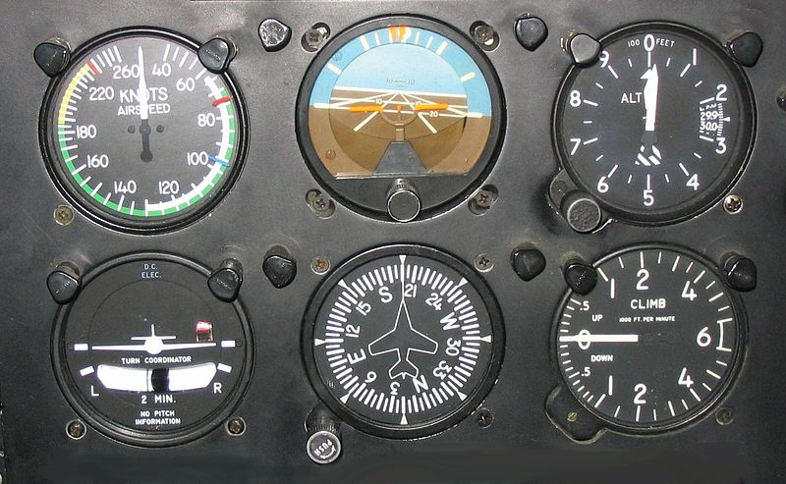
Fig.2.5: Display instruments
A cockpit is the area, usually near the front of an aircraft, from which a pilot controls the aircraft. Cockpit as a term for the pilot's compartment in an aircraft first appeared in 1914.The cockpit is usually referred to as the flight deck. This term derives from its use by the RAF for the separate, upper platform where the pilot and co-pilot sat in large flying boats. The cockpit of an aircraft contains flight instruments on an instrument panel, and the controls which enable the pilot to fly the aircraft. In most airliners, a door separates the cockpit from the passenger compartment. The use of instruments as an aid to flight enables the pilot to operate the airplane more precisely, and therefore, obtain maximum performance and enhanced safety. This is particularly true when flying greater distances. Flight instruments are the instruments in the cockpit of an aircraft that provide the pilot with information about the flight situation of that aircraft, such as altitude, speed and direction. The flight instruments are of particular use in conditions of poor visibility, such as in clouds, when such information is not available from visual reference outside the aircraft. Prior to the 1970s, cockpits did not typically use any electronic instruments or displays. Improvements in computer technology, the need for enhancement of situational awareness in more complex environments, and the rapid growth of commercial air transportation, together with continued military competitiveness, led to increased levels of integration in the cockpit. Flight instruments include the electronic flight instrument systems, standby instruments and clocks. Data for the flight instruments is provided by an air data system, radio altimeter and AHRS. Fig 2.5 shows a few display instruments which are present on the cockpit.

III. FLOWCHART OF ENTIRE SYSTEM

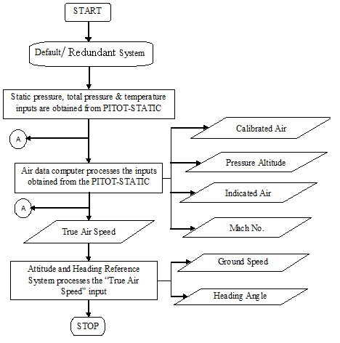

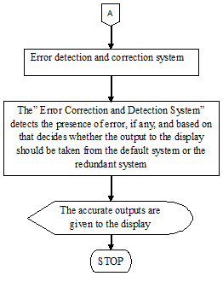
Fig.3: Flow Chart of the Entire System

The flow diagram shown if fig.3 is a self-explanatory chart describing the functioning of the entire system.

IV. principle of the detection process:
This module consists of two subsystems, i.e. “Error detection & Correction module for Default System” and “Error detection & Correction module for Redundant System”. These two sub-systems operate on the “Default Systems” and “Redundant Systems” respectively, but their functionality is identical.
The “Error detection & Correction module” compares the various input and output values of the “Default Systems” and “Redundant Systems” with the respective reference values obtained from GPS unit-1 & GPS unit-2. The results of comparison are given as “Error Check” values, i.e. if there is an error detected the corresponding “Error Check” value is assigned a constant (In case of “Default Systems” it is “+1” , and in case of “Redundant Systems” it is “-1”), elsewhere the “Error Check” value is assigned “0”.The “Error Check” values are plotted in the graphs, “Error Spotting Graph 1” and “Error Spotting Graph 2”.
In both the sub-systems the error check values are added respectively to give “Error Check Output” values, and the sum of “Error Check Output” values from both sub-systems are added to give the control signal value “Select”. This “Select” value is given to the switching block, which based on this value decides whether error has been detected, and if it is detected where is its location, i.e. “Default Systems” or “Redundant Systems”, and suitably decides from where does the accurate output flow to the “Display Instruments”.

The “Switch Block” performs the switching operation based on the control signal value “Switch”. It makes it decision as follows:
- If control signal value “Select” is less than “0”, then an error has been detected in the “Redundant Systems”. Hence the output now flows to the “Display Instruments” from the “Default systems”.
- If control signal value “Select” is greater than “0”, then an error has been detected in the “Default Systems”. Hence the output now flows to the “Display Instruments” from the “Redundant systems”.
- If control signal value “Select” is equal to “0”, then the entire system, i.e. “Default Systems” and “Redundant Systems”, is Error-Free. The output now flows to the “Display Instruments” from the “Default systems”.
The error detection in the input and output values of the “Default Systems”, follows the following steps:
- Obtain input values from the “Default Systems” and the respective values from the reference GPS unit.
- Subtract the obtained input values from the “Default Systems” and GPS unit.
- If the difference is equal to 0; there is no error detected and the corresponding “Error Check” value is “0”.
- If the difference is not equal to 0; there is an error detected and the corresponding “Error Check” value is assigned as “+1”.
The error detection in the input and output values of the “Redundant Systems”, follows the following steps:
- Obtain input values from the “Redundant Systems” and the respective values from the reference GPS unit.
- Subtract the obtained input values from the “Default Systems” and GPS unit.
- If the difference is equal to 0; there is no error detected and the corresponding “Error Check” value is “0”.
- If the difference is not equal to 0; there is an error detected and the corresponding “Error Check” value is assigned as “-1”.

V. Simulation Result of Entire System:

A. System without Error:
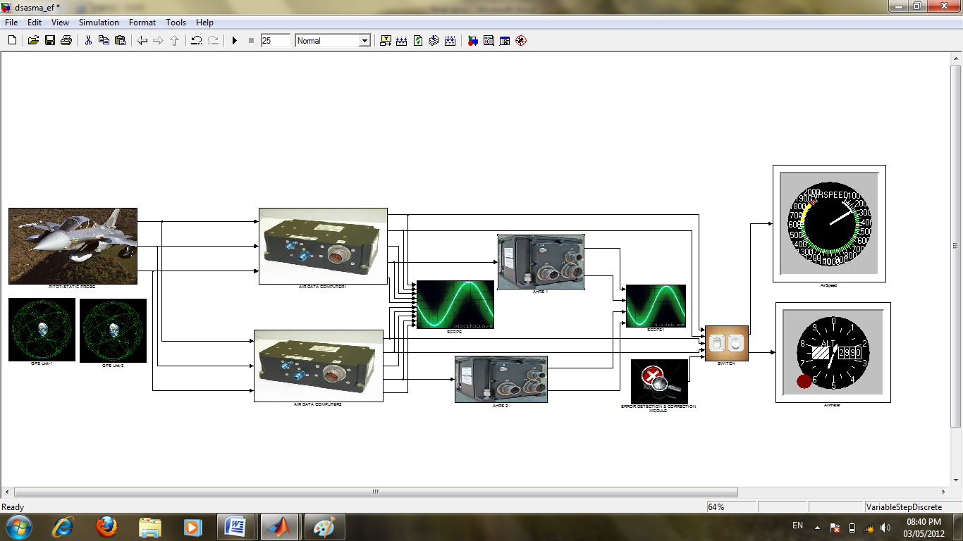
Fig.5.1: System without Error
Fig 5.1 shows the entire system constructed on the Simulink interface.
1. Comparison of Outputs:

The outputs are compared between the default and the redundant systems. The various parameters are verified with the GPS unit and sent to their corresponding display instruments.

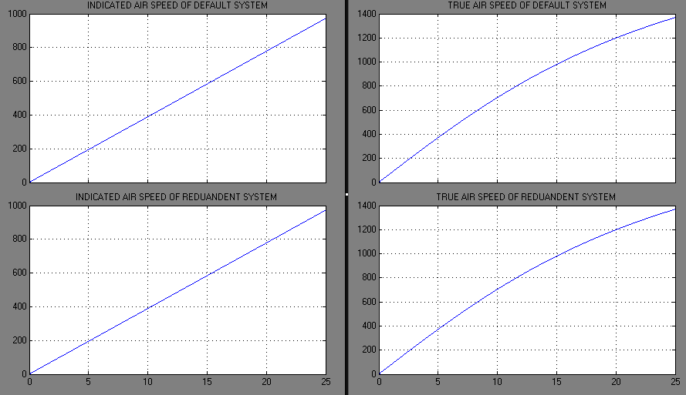
Fig.5.1.1: Graphs of Indicated Air Speed & True Air Speed
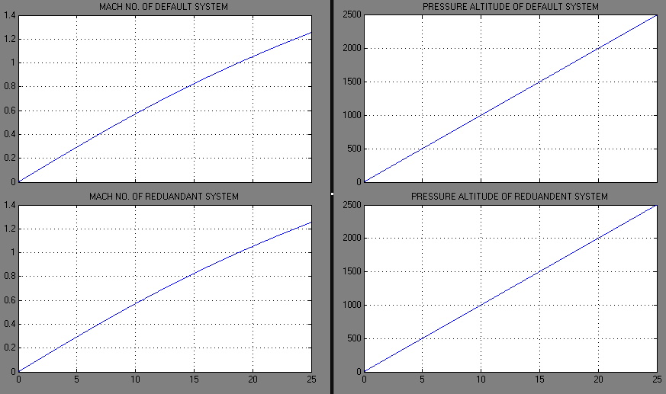
Fig.5.1.2: Graphs of Mach No. & Pressure Altitude

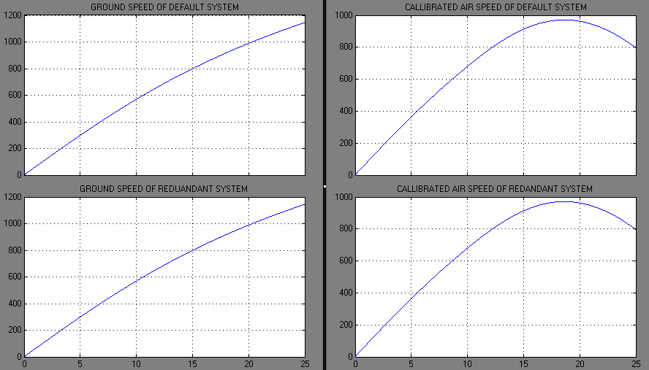
Fig.5.1.3: Graphs of Ground Speed & Calibrated Air Speed
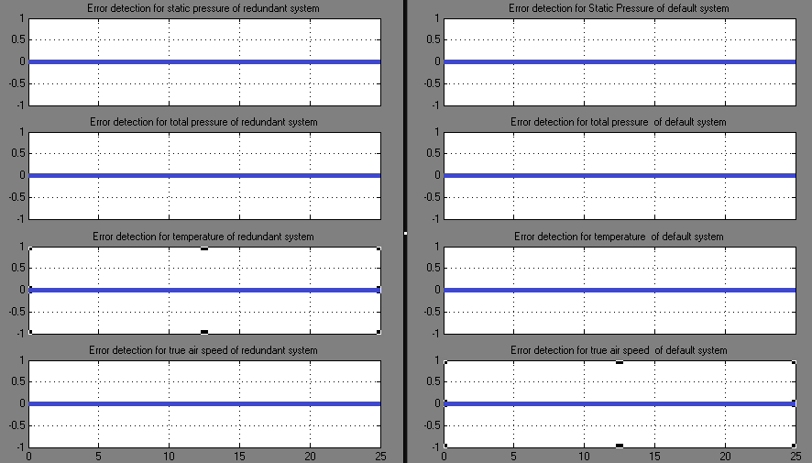
Fig.5.1.4: Error Spotting Graph

B. Default System with Error:

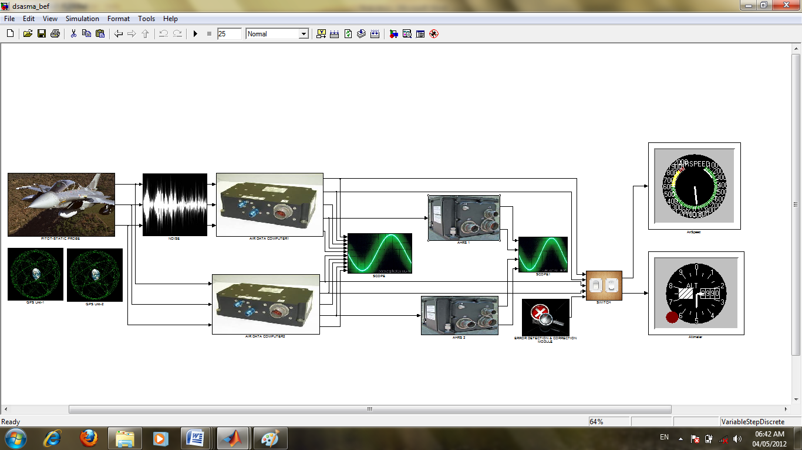
Fig.5.2: Default System with Error
Fig. 5.2 shows an error induced system. The error is present in the default system.

1. Comparison of Outputs:
The noise present in the default system induces errors in this system and thus there are erroneous values obtained. The graph in Fig.5.2.4 shows there is an error in the default system and thus the pilot has to switch to the redundant system.
The series of Figs.5.2 shown in the graphs below indicate the noise induced in the default system as compared to the redundant system.
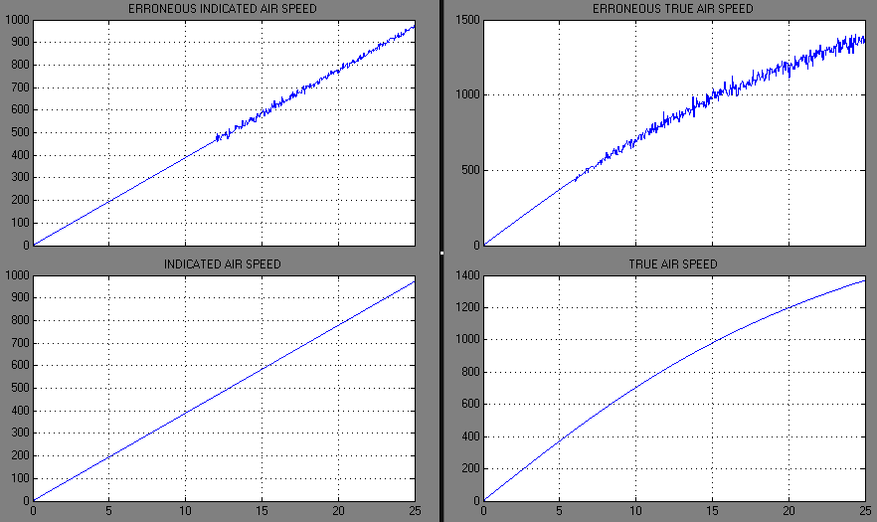
Fig5.2.1: Graphs of Indicated Air Speed &True Air Speed
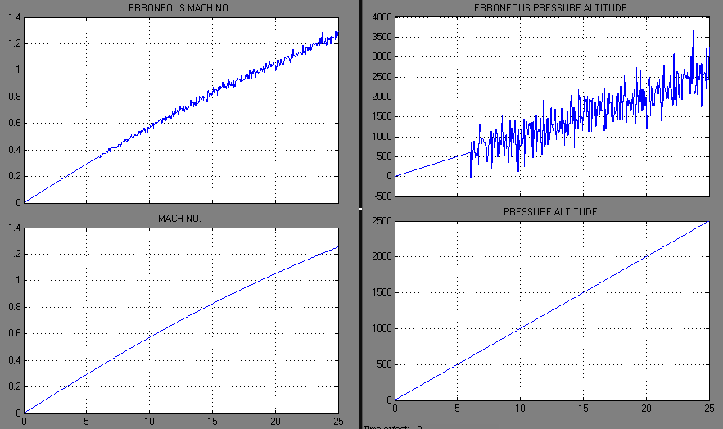
Fig.5.2.2: Graphs of Mach No. & Pressure Altitude
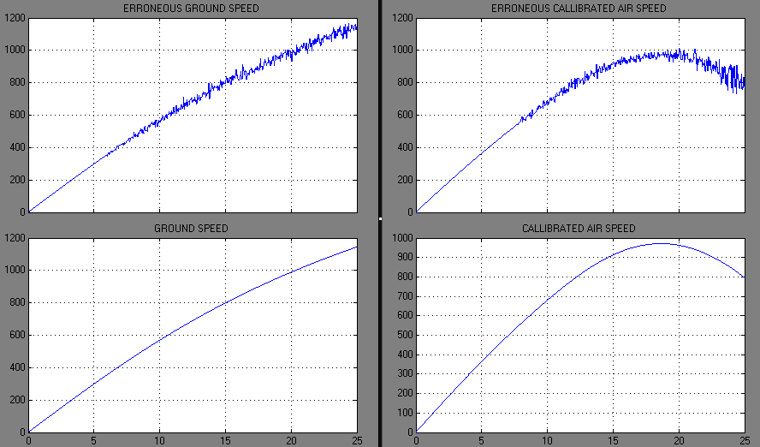
Fig5.2.3: Graphs of Ground Speed &Calibrated Air Speed
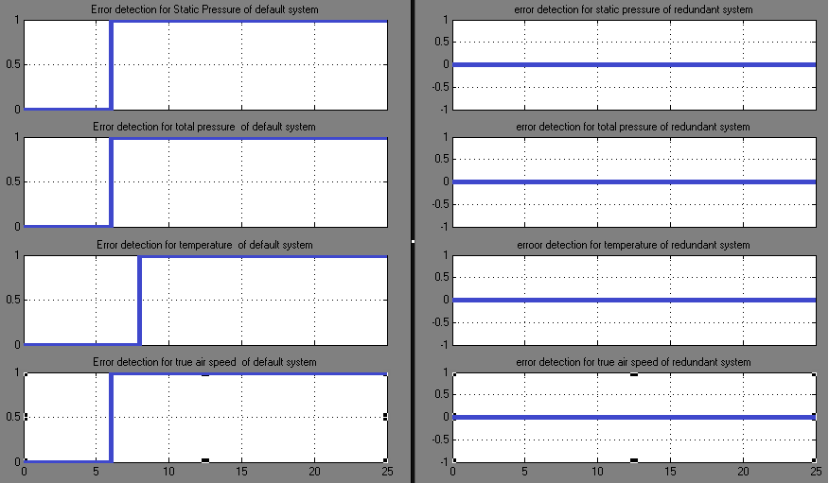
Fig.5.2.4: Error Spotting Graph

In the same way research shows that when an error is introduced in the redundant system similar observations of the outputs are obtained.

VI. Conclusion
The design and simulation of avionics system for military aircraft was accomplished successfully. The Air data quantities are needed for a multitude of tasks, including flight safety, control, navigation, weapons delivery, flight test, and flight research. Keeping this information in our minds, we have created a design and its simulation which produces accurate outputs needed for the functioning of the military aircraft by the pilot.
These quantities generally need to be measured and then calibrated to remove errors, thus design created has error detecting and correcting capabilities, thereby producing accurate and reliable outputs continuously through the time of flight of aircraft.

REFERENCES

- Albert Helfrick, Principles Of Avionics, 2nd Addition, Avionics Communication Inc, 2002.
- C M Anand “Civil Aircraft Advanced Avionics Architectures-An Insight into Saras avionics, Present And Future Perspective” Aerospace Electronics System Division, National Aerospace Laboratories.
- Chris delong et al. The Avionics Handbook, CRC Press LLC, 2001 ISBN 0-8493-8348-X.
- Gracey, William, “Measurement of Aircraft Speed and Altitude”.
- Johan Bijker, “Development of an Attitude Heading Reference System”.
- Lawford, J.A. and Nippress, K.R., “Calibration of Air-Data Systems and Flow Direction Sensors,” AGARD-AG-300, vol. 1, Sep. 1983.
- Linlin Xia, Jianguo Wang and Gangui Yan,” MEMS AHRS”.
- Webb, Lannie D. and Washington, Harold P, “Flight Calibration of Pitot-Static Airspeed Probes and there Application.
- Whitmore, Stephen A., “Construction of the Air Data Parameters,” AIAA 83-2097S, Aug. 1983.

*****

 

