Setup before opening the PC store e-commerce

1. Put the web application files in XAMPP/htdocs folder in your computer.

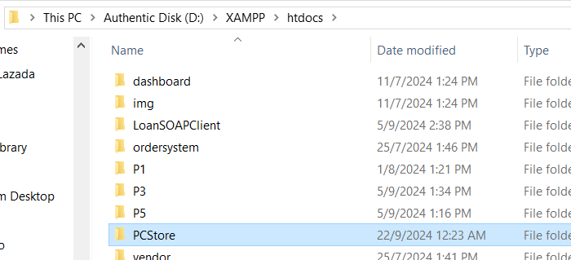

1. Use XAMPP Control Panel to start Apache and MySQL.

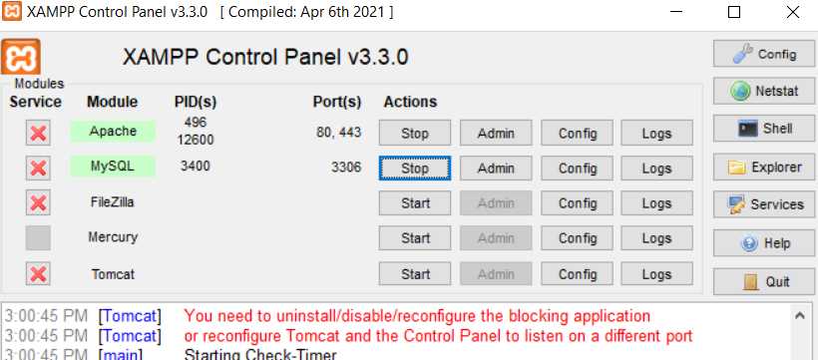

1. Create 2 databases in MySQL called ‘csweb’ and ‘pcstore’

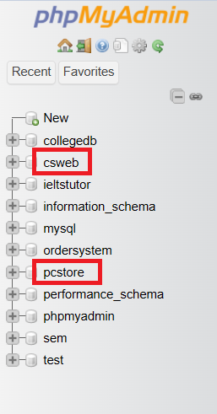

1. Run pcstore.sql on pcstore database (Note: csweb doesn’t have sql to run as the web services created has code to automatically create the table)

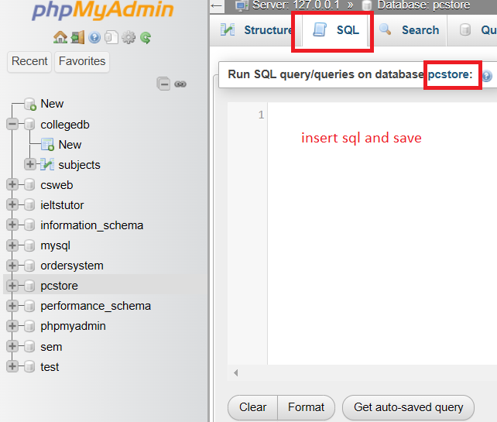

1. Uncomment `extension=xsl` in php.ini located in XAMPP/php folder

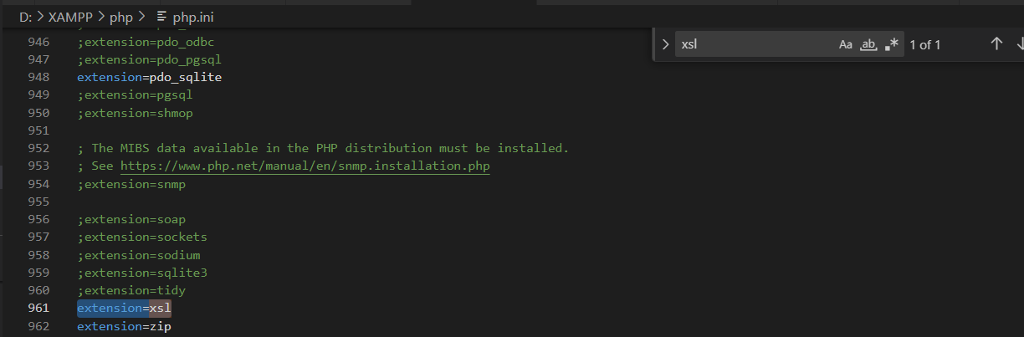

1. Open .env in the PCStore folder and change the DB_USERNAME and password settings according to your mysql to allow access to the database

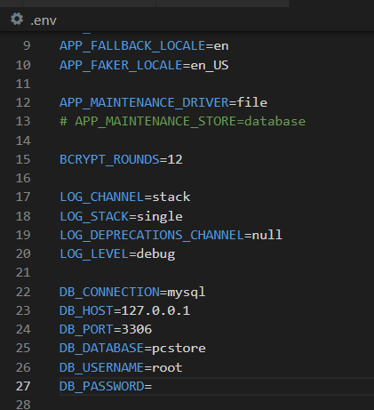

1. Open one terminal to host the web service. Change directory to PCStore/api/CSServices . run “npm run start”

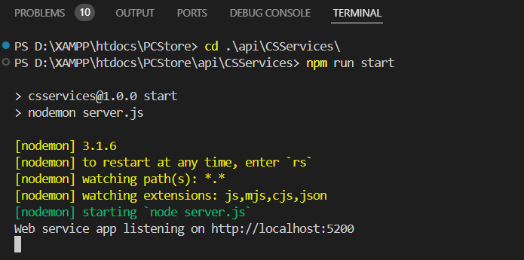

1. Open another terminal while the first terminal is running. Go to directory PCStore. Run “php artisan serve”

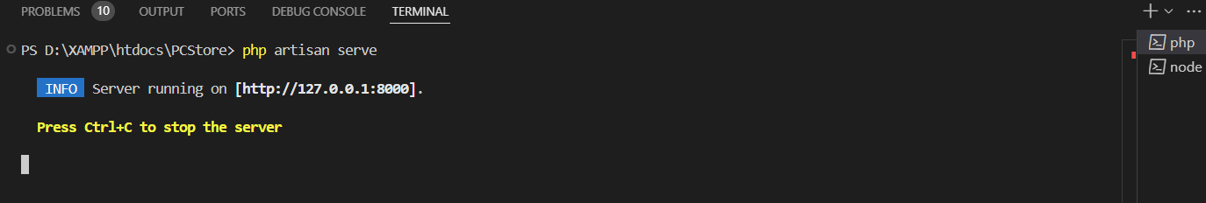

1. After XAMPP is started, open <http://localhost:8000> to access the e-commerce and <http://localhost:8000/admin/login> for admin website

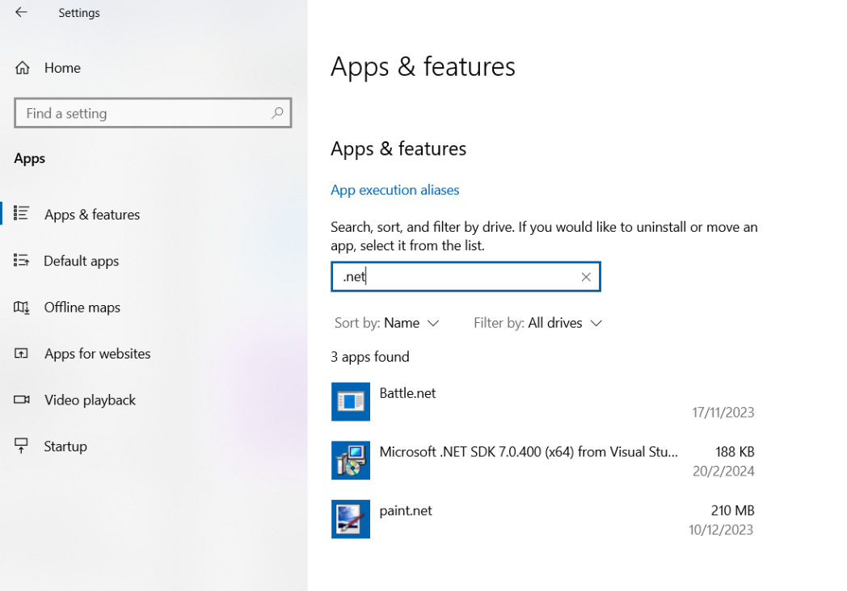

<https://dotnet.microsoft.com/en-us/download/dotnet/8.0>

