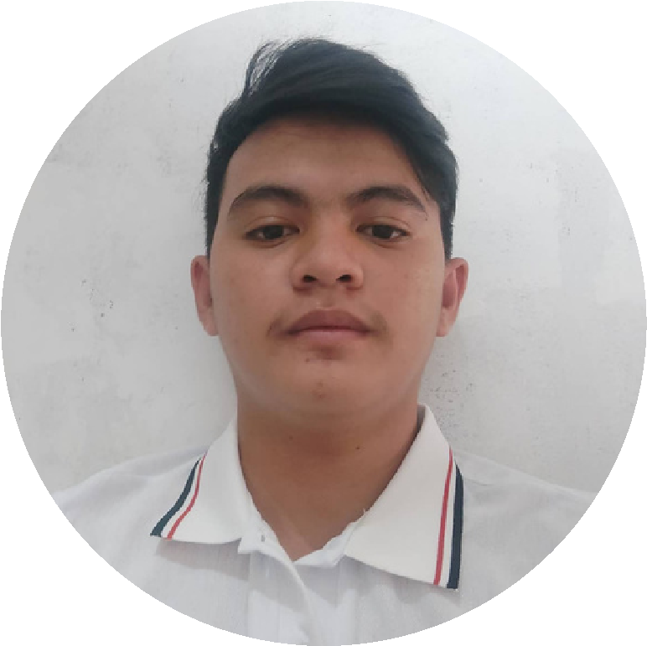

## PROFILE

Bachelor of Science in Information Technology student

## CONTACT ME

+639519645687

ronaldjrlabrado87@gmail.co m

Blk13 lot 5 phase 1 sitio looban nova q.c

### RONALDJR. E. LABRADO

### Student

### EDUCATION

#### LAGRO HIGH SCHOOL

*Junior High 2014-2018*

*Senior High 2018-2021*

#### TECHNOLOGICAL UNIVERSITY OF THE PHILIPPINES - MANILA

[*Ayala Blvd. corner San Marcelino St. Ermita*](https://www.google.com/maps/dir/?api=1&destination=14.587474219525%2C120.98452650077&fbclid=IwAR2lLLDTWDnPmX8jrWG95XUxU30793QvOVdSBApG_F5aBsDNyaVT3HybrZE)

[*1000 Manila, Philippines*](https://www.google.com/maps/dir/?api=1&destination=14.587474219525%2C120.98452650077&fbclid=IwAR2lLLDTWDnPmX8jrWG95XUxU30793QvOVdSBApG_F5aBsDNyaVT3HybrZE)

### LANGUAGE

English. Filipino

**COMPUTER SKILLS**

Basic editing

# VOLUNTEER EXPERIENCE

## CHILDREN INTERNATIONAL

Organize program like giving a free food to a children.

## PROFILE

Bachelor of Science in Information Technology student.