**Virtual Reality Medical Simulator**

Members: Ronald Alhazov and Ohad Goldberg

**Introduction**

This project aims to develop a virtual reality medical simulator designed to simulate a variety of basic medical scenarios and their treatments. The central concept involves mapping a physical mannequin into a virtual environment to create realistic medical scenarios.

**Problem Statement and Significance**

In recent months, both team members participated in conflicts in Israel and experienced firsthand the critical importance of medical operations on the battlefield. Timely medical interventions were observed to have a significant impact on outcomes and the ability to save lives. This project aims to underscore the importance of medical operations and enhance success rates for those performing medical procedures in real-life situations. Individuals often find themselves in situations where they need to perform medical actions, and utilizing simulations can potentially increase success rates.

**Objectives**

1. Develop a realistic virtual environment for simulating medical scenarios.

2. Integrate a physical mannequin into the virtual environment to provide a hands-on experience.

3. Create a range of medical scenarios with varying levels of complexity.

4. Implement a scoring and feedback system to evaluate user performance.

5. Provide an accessible platform for non-professionals to practice medical procedures.

**Game interface**

Game users:

One user that gives the medical treatment.  
The main player is part of a situation in which he functions as a one of others and not necessarily the one who leads the situation (for example : the one who seats next to driver) and he actually performs the medical treatment on the person he is called upon to treat.

**Screens Structure**   
1.Main menu

1.1. Check the mannequin and equipment is connected.

* 1. . Select medical scenario   
     1.2.1. Driving accident  
     1.2.2. Battle field
  2. . Check my treatment history and medical information
  3. . Exit

**Screen overview**

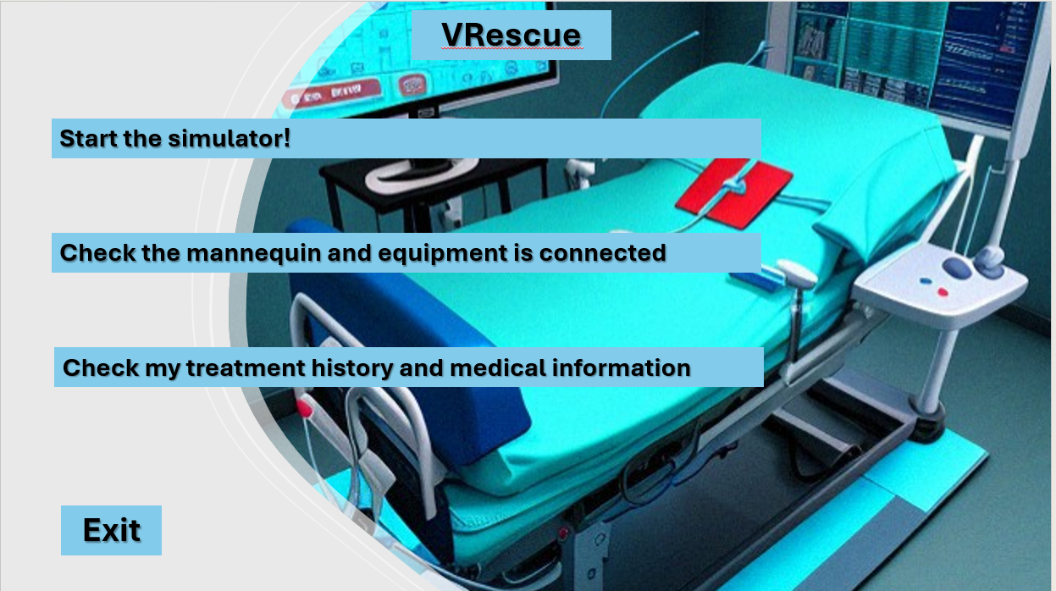Main menu  
The game main menu will display the home screen of the simulator where the player can choose the option he wants.  
check the mannequin and VR equipment, select medical scenario, treatment history or exit.

Select medical scenario

The player will choose which medical scenario he wants to practice.  
The difference between the scenarios is in the atmosphere it takes place and in some of the injuries the player will need to treat.  
The injuries will be related to the scenarios where it takes place. For example: in car accident is more likely to interface in front resuscitation, bones fractures whereas in battle field is more likely   
to inter face with bleedings breakout, limps injuries and etc.

**Medical scenarios:**

The main player controls his medical treatment by using the VR kit.  
the injure person will demonstrated by the physical mannequin  
and the player will follow the instructions of the medical treatment  
that will show on his screen.  
In the end of the scenarios the player will get a feedback on his medical treatment.

Car accident scenario

In this scenario the player will demonstrate the person who seats next to the driver.  
in start, a video will play on the screen and in some point the accident will take place. from that moment the main player will start to give the medical treatment.

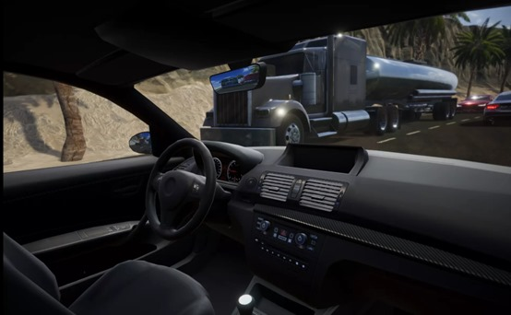

Battle field scenario

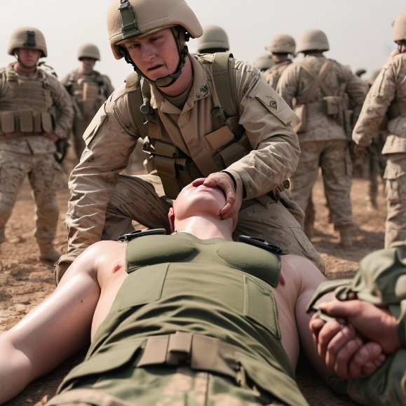In this scenario the player will demonstrate one of a soldiers from a group of soldiers.  
in start, a video will play on the screen and in some point one of the soldiers will get heart. from that moment the main player will start to give the medical treatment.

Treatment history

The player can watch the history of treatments that has been made over the simulator and to get medical information about the professionals ways to treat the medical injuries he can inter face when he use the simulator.

**Target Audience**

The primary target audience for this project includes medical non -professionals, students, and anyone interested in experiencing the process of administering medical treatment.

**Methodology**

For this project, we'll be using a mix of hardware and software to make a virtual reality medical simulator. The main parts we'll need are a main processing unit like Raspberry Pi or Arduino uno as the main computer, an ESP32 or Arduino microcontroller for connecting sensors, a motion sensor like MPU6050, and a VR kit so users can experience it in virtual reality.

The main processing unit will be the brain of the system, running the Unity game engine and handling all the main simulation stuff.  
 In the Unity platform we will create the virtual environment and let users interact with the 3D medical scenarios.

To track the movements of the physical mannequin, we'll attach an motion sensor to it.   
An ESP32 or Arduino Uno can be the sensor controller, connecting to the motion sensor , processing the raw sensor data, and sending it over to the main processing unit through a wired or wireless connection.

The main processing unit will constantly get this real-time motion data from the microcontroller and use it to update the position and movements of the virtual mannequin inside the Unity environment.  
 This way, the virtual mannequin will mimic the exact movements of the physical one.

With the VR kit, users can interact with mannequin and to perform the medical treatment.

**Features and Functionality**

- Realistic scenario selection and customization.

- Mannequin mapping and integration of real-world objects.

- Virtual medical equipment and tools.

- Performance evaluation and feedback system .

- User interface for navigation and control.

**Other or Similar Approaches**

In recent years, advancements in technology have given rise to various medical simulation approaches, providing innovative ways to train and educate medical professionals, as well as non-professionals interested in learning medical procedures. These approaches range from mobile applications to sophisticated simulators in medical education.

1. Virtual Reality (VR) Medical Simulation Platforms: Companies like SimX offer immersive virtual reality simulations specifically designed for emergency medical services (EMS) training. These platforms create realistic VR environments where users can practice responding to various medical scenarios and performing critical procedures.

2. Mannequin-based Simulations: Physical mannequins or patient simulators that can mimic various medical conditions and responses are commonly used for hands-on practice of procedures like CPR, intubation, or wound care.

3. Mobile Applications: With the widespread availability of smartphones and tablets, medical simulation apps have emerged, providing on-the-go training opportunities. These applications range from interactive

anatomy lessons and emergency response simulations to medical calculators and reference tools.

**Conclusion**

This project aims to develop a virtual reality medical simulator that provides a realistic experience for practicing medical procedures. By integrating a physical mannequin into a virtual environment, the simulator will offer a hands-on approach to medical training, accessible to both professionals and non-professionals. The project has the potential to enhance success rates in real-life medical situations by providing a safe and controlled environment for practice and skill development.