Ronaldo Harris
2209590
Individual Assignment #2
Thursday @ 1pm
Web Programming (CIT2011)

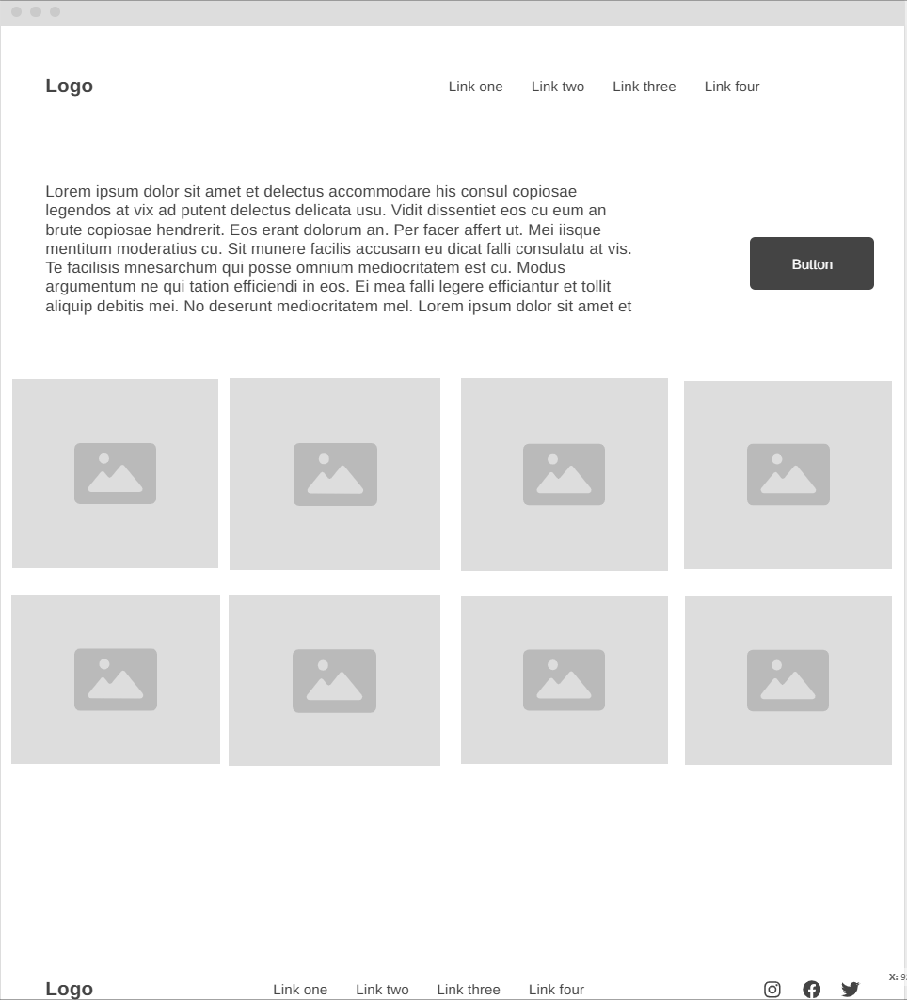
Desktop Wireframe

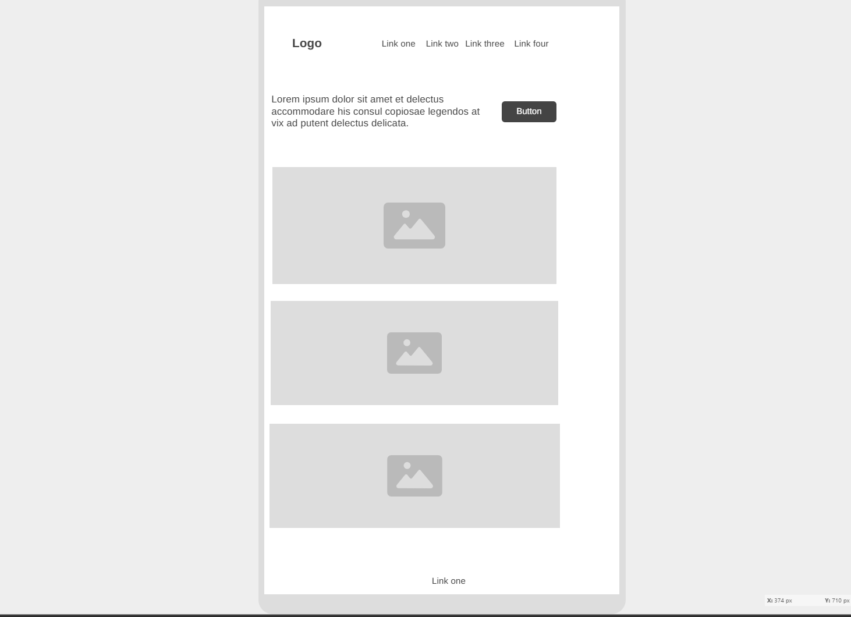
Mobile Wireframe

Business Name: ArcadeHub
Logo:
A bold “AH” monogram inside a rounded square, using teal and amber gradients. The style matches the modern and athletic look of performance footwear brands.
Slogan:
“Fuel Your Game.”

Mission Statement:
To provide athletes, football enthusiasts, and everyday players with high-quality football shoes presented through a clean, modern, and easy-to-use e-commerce platform.
Vision Statement:
To become the most trusted online destination for stylish, durable, and performance-driven football footwear while demonstrating professional web development and user interface practices.
Business Description:
ArcadeHub is a modern online store that sells high-quality football shoes for players of all ages and skill levels. The business focuses on offering stylish, durable, and performance-ready boots at affordable prices. With a clean and easy-to-use shopping experience, ArcadeHub helps athletes find the perfect pair of football shoes that match their playing style and budget.

Justification of the Colour Palette
• Teal (#0ea5a4) – Primary brand colour
• Gold/Amber (#f59e0b) – Accent/highlight colour
• Dark Navy (#0f172a / #0b1220) – Background
• Light Gray/White (#e6eef6) – Text and readability
✔ Why this palette fits a football shoe brand:
1. Teal (Trust, Energy, Movement)
Teal is commonly linked to:
- Athletic performance
- Speed
- Freshness
- Innovation
In sports marketing, teal stands out against dark backgrounds, making it perfect for buttons, calls-to-action, and branding.
It also communicates trust, which is important for online stores.
2. Gold/Amber (Highlight + Competitive Edge)
Gold represents:
- Confidence
- Achievement
- Energy
- Action
3. Dark Navy Background (Professional, Strong, Athletic)
In colour psychology, dark blues convey:
- Strength
- Reliability
- Focus
Sports brands often use dark backgrounds (Adidas, Nike, Puma) because they make product images “pop” and improve contrast.
Gradient (#020617 → #071032) creates a stadium-like, premium sports feel.
4. Light Text (High Contrast / Accessibility)
The light off-white text ensures readability, especially on dark backgrounds, improving accessibility for users with visual challenges.

iv. Intended Audience for the Website
Because the website now sells football shoes, the intended audience changes:
1. Football Players (Ages 13–35+)
Includes:
- High school footballers
- Club players
- Weekend athletes
- Semi-pro and recreational players
These users look for:
- Stylish boots
- Good prices
- Comfortable designs
- Easy browsing experience
2. Sports Fans / Consumers
People who enjoy sports fashion or streetwear often buy football boots as part of their athletic lifestyle.
3. Parents Buying for Children
Parents often shop for kids’ football boots. My clean website design makes purchasing simple and clear.

