- Problem Statement
The problem is how to identify at an early stage the customers who are likely to churn so that proactive measures can be implemented to prevent these customers from leaving.
We would like to predict whether a customer will churn or not churn based on certain attributes like customer satisfaction scores, how long the customer has been with the company, payment failures, customer location, customer engagement level and the contract type.
It is critical to find the reasons why customers stop using the company's products. When these factors are known, the customers who are likely to churn can be identified early enough and special programs can be implemented to prevent these customers from churning. In this way, the company's continued profitability is assured.
Customer retention makes a lot of business sense - it costs around five (5) times more to acquire new customers than to retain existing customers. A reduction in customer churn can significantly increase revenue. The reasons for customer churn and who are these customers can be predicted before churn happens.
Engaging with unhappy customers, resolving issues and building stronger relationships directly impact customer retention.

Success can be measured in terms of a reduction in churn rate. Also, a Profit/Loss analysis is made by considering the increase in revenue against the money spent for customer retention.

The models that are produced can be used by marketing teams for retention campaigns, by customer support teams for proactive outreach, and by product teams for feature improvements. Leadership can also be guided by the model for churn strategy and forecasting.
- Model Outcomes or Predictions
The type of learning is classification. The expected output of the selected model is the prediction of customers who are likely to churn and the features that drive churn. Supervised machine learning algorithms are used to build predictive models.
The models are expected to be able to catch churners quite well so that proactive measures can be designed at an early stage to prevent them from leaving. At the same time, a profit/loss analysis will make sure that these measures are profitable. The models will also demonstrate a capability to make useful predictions and highlight the features mostly affecting churn so that retention programs are suitably targeted.
- Data
The Customer Churn Prediction Business Dataset comes from Kaggle. This dataset is synthetically generated for educational, research, and portfolio purposes. While it reflects realistic business patterns, it does not represent real customer data.
The less obvious meaning of some features in the data are as follows: ‘csat_score’ is Customer Satisfaction Score that measures short-term happiness with a specific event. 'nps_score' is Net Promoter Score that measures long term loyalty.

'email_open_rate' indicates if customers find subject lines and sender information compelling enough to open the mail. Declining rates of these features predict disinterest and potential churn. High open rates suggest relevance and connection, while low rates flag a need to improve content, segmentation or timing to prevent users from becoming disengaged and leaving.
- Data Preprocessing/Preparation
The 'customer_id' column is dropped because it does not add value to the modeling effort: df.drop(columns=['customer_id'])
Any leading and trailing white spaces from categorical columns are removed:
string_cols = df.select_dtypes(include=['object']).columns
df[string_cols] = df[string_cols].apply(lambda x: x.str.strip())
The column with missing values is identified: df.columns[df.isnull().any()].tolist()
The percentage of missing values is calculated: df['complaint_type'].isnull().sum()/df.shape[0]*100
The percentage of missing values is not high enough to warrant dropping the column. The missing values are instead replaced with the column mode:
mode_column = df['complaint_type'].mode()
df['complaint_type'] = df['complaint_type'].fillna(str(mode_column))
Inconsistent data is replaced, for example: df['complaint_type'] = df['complaint_type'].replace({'0 Technical\nName: complaint_type, dtype: object':'Technical'})
There are no duplicate rows:
duplicates = len(df[df.duplicated()])
The distributions of categorical columns are verified:
categorical_cols = df.select_dtypes(include=['object']).columns.tolist()
for i in categorical_cols:
value_count_column = df[i].value_counts(normalize=True)
print(f'The value count for column {value_count_column} \n')
Box plots of numerical features are analyzed prior to removal of outliers to visualize the presence of outliers.
Outliers are removed from numeric features using the interquartile range (IQR) rule:
for col in numeric_list:
Q1 = df[col].quantile(0.25)
Q3 = df[col].quantile(0.75)
IQR = Q3 - Q1
lower_bound = Q1 - 1.5*IQR
upper_bound = Q3 + 1.5*IQR
df = df[(df[col] >= lower_bound) & (df[col] <= upper_bound)]
Box plots of numerical features are re-analyzed after the removal of outliers. The remaining outliers are allowed to stay to conserve data.
For the box plots, particular attention is given to when the ‘churn’ median line is lower than the ‘no churn’ median line, churn is more likely here. Overlapping ‘churn’ and ‘no churn’ boxes indicate that the feature might not be a good predictor. Separation of the churn and no churn boxes is a strong signal for good predictors.
Stacked bars of categorical features (in percentages) are plotted. The color ratios of the stacked bars highlight features which have slightly more churn.
Histograms are plotted to visualize the distribution of numerical features to help uncover trends and patterns.
Heat maps of numeric features are displayed to highlight significant positive and negative correlations especially with ‘churn’.
total_revenue is positively correlated with tenure_months (0.62) and monthly_fee (0.60) which is considered high. total_revenue does not add new predictive signal beyond tenure_months and monthly_fee since total_revenue is the product of tenure_months and monthly_fee. This means that total_revenue is mostly redundant and is, therefore, dropped.
Feature engineering is applied by creating a new feature (tenure_fee_interaction) which is a product of tenure_months and monthly_fee.
df[‘tenure_fee_interaction’] = df[‘tenure_months’] * df[‘monthly_fee’]
df = df.drop(columns=['total_revenue'])
A pair plot analysis of the top six (6) numeric features is made to verify the distribution of churn in these numeric features.
The features and target variable are defined:
X = df.drop(['churn'], axis=1)
y = df['churn']
and then split into training and test sets:
X_train, X_test, y_train, y_test = train_test_split(X, y, test_size=0.20, random_state=42, stratify=y)
Scaling is not used in DecisionTreeClassifier while LogisticRegression, KNeighborsClassifier and SVC (Support Vector Classifier) use scaling. StandardScaler is used. KNeighborsClassifier and SVC (Support Vector Classifier)are especially sensitive to the scale of input features.
Categorial features are encoded using OneHotEncoder and OrdinalEncoder.
- Modeling
Seven (7) supervised machine learning classification algorithms are used to build predictive models:
LogisticRegression, DecisionTreeClassifier, KNeighborsClassifier, SVC (Support Vector Classifier), Random Forest Classifier, Keras Classifier, and XGBoost Classifier
The class imbalance is verified:
val_count_churn = df['churn'].value_counts(normalize=True)
print(val_count_churn)
churn
0 0.906262
1 0.093738
Name: proportion, dtype: float64
In order to address the class imbalance, SMOTE-NC (Synthetic Minority Oversampling Technique for Nominal and Continuous features)is used by KNeighborsClassifier while other models use the parameter class_weight='balanced'.
Transformers like make_column_transformer and ColumnTransformer are used to prepare the data for encoding and scaling, as required, and fed to a Pipeline.
A baseline model is built to benchmark the models to be designed. Simple models of the various algorithms are initially created to further benchmark the modeling effort.
classification_report and confusion_matrix provide the Accuracy, Precision, and Recall of the models. F2 score is calculated and a Profit/Loss analysis is also made.
The models hyperparameters are optimized using HalvingRandomSearchCV, GridSearchCV, and RandomizedSearchCV.
The ROC (Receiver Operating Characteristic) Curve is plotted to display the AUC (Area Under Curve)which is a measure of the predictive power of the model and to calculate the optimal threshold using the Youden’s J method.
The Precision-Recall Curve is also plotted to demonstrate the relationship between Precision and Recall. Precision and Recall are evaluated at different thresholds. The threshold that maximizes profit is determined.
For each classifier, models are constructed and their respective performances are compared to each other. In addition to Accuracy, Precision, Recall, F2 score, and AUC, the best model is chosen based on business goals that consider the relative cost of missing a churner (false negatives - predicted not to churn but churned, loss of lifetime value), cost of false alarms (false positives - predicted to churn but stayed, cost of retention offer) and true positives (predicted to stay and actually stayed, saved lifetime value less the cost of retention offer).
In this particular case of customer churn, missing churners (Recall) is more expensive than false alarms (precision). Recall is, therefore, optimized at the expense of precision and accuracy.
Prediction is demonstrated using samples from the test data.
Identification of customers likely to churn is also shown.
Model hyperparameters are optimized using grid search to maximize model performance particularly addressing overfitting.
Feature selection of encoded features reduces the number of features by around 40% to improve the model and to lessen noise. When there is less noise, the interpretability of feature importance improves. Noise in this context is irrelevant information that obscures underlying patterns or relationships the model is trying to learn.
The features and their importances are identified particularly those features whose increase or decrease correspondingly raise or lower the likelihood of customer churn. The features and their importances are determined to verify the magnitude of features influence.
After feature selection, the results of feature importance from the top three (3) models are fed to a Generative AI (GenAI) model for interpretation. That part of the code containing API key is later removed due to privacy issues.
- Model Evaluation
The GenAI model provided the following feature importance analysis on the results of the top three (3) classification models. There are slight changes between runs and theyt usually come from randomness in the pipeline but the ranking is generally maintained.
Decision Tree
csat_score (0.323722): This is the most significant feature in predicting customer churn. A high csat_score is associated with lower churn rates, suggesting that customers who are satisfied with the service are less likely to leave.
tenure_months (0.278752): Long-term customers are less likely to churn, indicating that tenure is a strong predictor of customer loyalty.
monthly_logins (0.198848): Customers who actively use the service are more likely to remain as customers, whereas inactive customers may be more prone to churning.
Recommendations:
1. Monitor csat_score: Regularly track scores to identify potential issues with service quality or satisfaction.
2. Focus on long-term customers: Develop strategies to retain long-term customers and prevent them from churning.
3. Address payment issues: Investigate payment failures and resolve any issues related to billing or transactions.
4. Improve customer engagement: Increase customer engagement by offering incentives for regular use and referrals.
5. Re-evaluate feature development: Consider removing or re-evaluating features that do not significantly impact customer churn.
Random Forest
csat_score (0.071467): This indicates that customer satisfaction is a strong predictor of churn.
tenure_months (0.042717): Longer tenure (i.e., time with the company) increases the likelihood of churn.
monthly_logins (0.025251): Customers who log in more frequently are less likely to churn, suggesting that regular usage is a crucial factor in customer retention.
payment_failures (0.021220): Payment-related issues can lead to churn, highlighting the importance of reliable payment processes.
Recommendations:
1. Focus on improving customer satisfaction (csat_score) to reduce churn.
2. Analyze payment-related issues (payment_failures) and implement measures to prevent failures.
3. Engage with customers through regular interactions (monthly_logins).
4. Review pricing models (tenure_fee_interaction) to ensure they do not negatively impact customer retention.
5. Develop targeted marketing strategies for male customers and SMEs.
This analysis provides a starting point for understanding the most influential factors driving customer churn. Further investigation and modeling can refine the insights and inform data-driven decisions to improve customer retention.
XG Boost
csat_score : The most important feature at 21.3% in predicting customer churn, which is a measure of customer satisfaction. This highlights the significance of ensuring customers are satisfied with the service.
tenure_months : The second most important feature at 17.1%, which indicates that customers who have been with the service for a longer period are less likely to churn. This might be an opportunity to retain customers through loyalty programs or targeted promotions.
payment_failures : A significant feature at 11.5% in predicting churn, suggesting that customers who have experienced payment failures are more likely to leave the service.
Recommendations:
1. Prioritize improving csat_score through service quality improvements or targeted customer satisfaction initiatives.
2. Develop strategies to retain long-tenured customers through loyalty programs or personalized promotions.
3. Investigate and resolve payment failures promptly to prevent churn.
4. Consider revising pricing strategies to focus on other factors that affect churn.
These insights should guide further exploration and potential interventions to mitigate customer churn.
Overall Model Summary
Based on the metrics of Accuracy, Precision, Recall, F2 Score, AUC and Profit/Loss, the Random Forest Classifier and XGBoost Classifier are virtually tied for the top spot (the slight lead of Random Forest Classifier could be within the statistical margin of error) while Decision Tree Classifier is not very far away (see the comparison dataframe and plot below).
For this particular dataset, either XGBoost Classifier or Random Forest Classifier is the recommended machine learning algorithm.
The feature importance reported by Generative AI is consistent with what is highlighted in the Heatmap of Significant Correlations in the following order: csat_score, tenure_months, payment_failures, and monthly_logins.
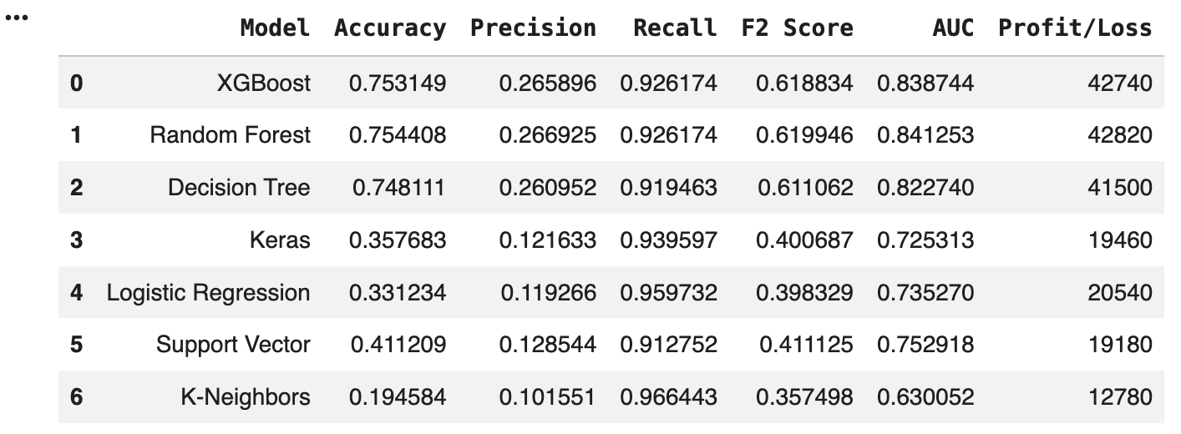
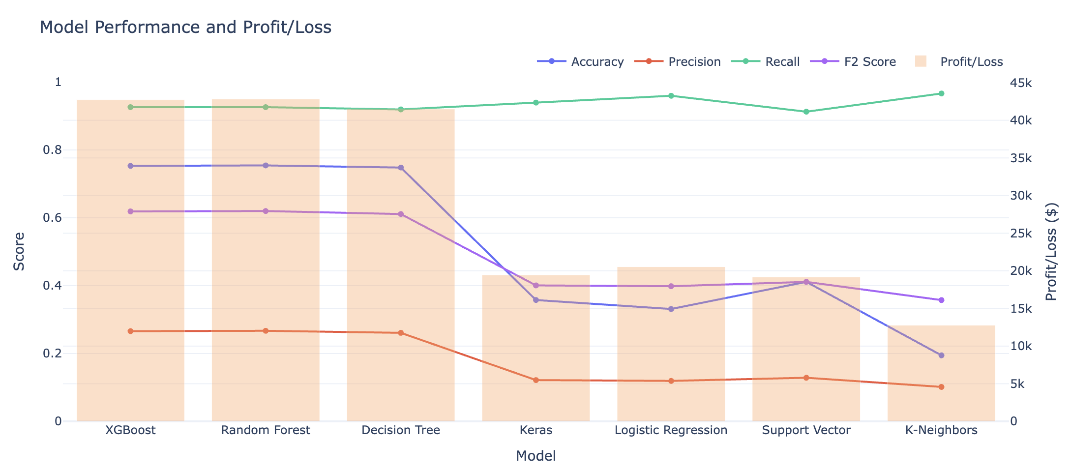
Next Steps and Further Recommendations
- Confirm the model that will suit the business needs in terms of the optimal level of churn identification and precision.
- Continue model development to include actual identification of clients who are likely to churn.
- Tune the thresholds to maximize profit using realistic lifetime value and cost of retention assumptions.
- Deploy and apply the model for the use of relevant business groups like marketing teams for retention campaigns, customer support teams for proactive outreach, and product teams for feature improvements. Leadership can also be guided by the model for churn strategy and forecasting.
- Continue model development to validate the features relative importance to guide management on which features need to be given particular attention in order to prevent churn.
Churn in this dataset is primarily driven by customer satisfaction and engagement levels rather than pricing. Improving user experience and increasing product adoption would likely have the strongest impact on reducing churn.

