ENGG1100 – Heated Target System

Introduction
This document provides an overview of the Heated Targets used in the ENGG1100 Test Arena. The targets simulate a fire for students to extinguish. This is achieved by heating a metal puck and monitoring its temperature. Indication of the fire being extinguished is announced via audio and visual indications as well as though a computer display.
Each target has a metal puck (red) which is heated to 150 deg C via an electronic control system. Over the top of this is a guard mesh (green) which prevents accidental contact with the heated metal surface.
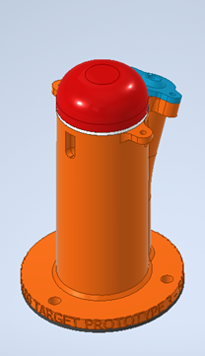
Figure 1 - Rendering of the Heated Target
Left: Target with aeroplane shaped mesh. Right: Mesh removed for clarity.
Orange: Main structure, Red: heated metal puck, Green: mesh guard

Heated Puck Specifications
The heated puck target’s details are recorded below for reference.
- Material: Aluminium 6061-T6
- Volume: 28350.5 mm^3
- Mass: 0.077 kg
- Thermal Conductivity: 155 W/m.K (23 deg C)
- Specific Heat Capacity: 916 J/kg.K (23 deg C)
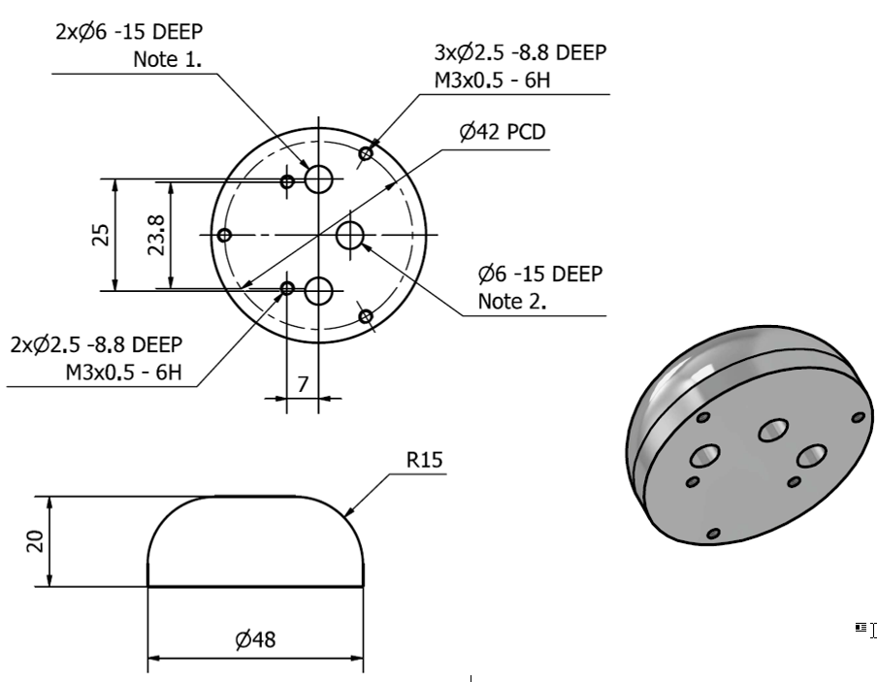
Figure 2 - Mechanical drawings of the heated metal puck

Electrical Sub System
Two 50W heating elements impart energy into the metal puck. The control system uses a PID controller to achieve and then maintain the 150 deg C set point.
When the setpoint is reached the system changes to ‘monitor’ mode where the PID controller is limited to 60% output. The controller then monitors for a drop in temperature to indicate that the fire is being put out.
When the drop in temperature is detected the timer in the software starts and will stop when the temperature drops below 100 deg C. At which point audio and visual indicators are executed to demonstrate that the ‘fire’ is extinguished.
Note that the PID is always active so stopping short of 100 deg C will see the temperature raise back up to 150 deg C.
The target then restores the puck to 150 deg C in preparation for the next student.

Software Sub System
The system is monitored via a dashboard built using LabView. Each target's temperature is displayed as well as the time taken to extinguish on an individual and collective basis.
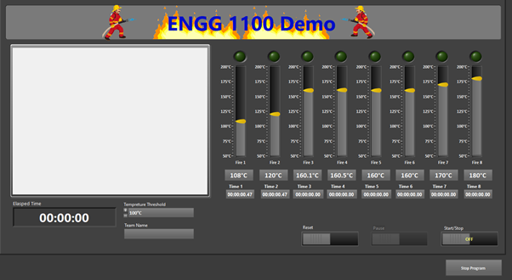
Figure 3 – Software Dashboard for monitoring the targets status

Each target has an individual indicator shown below.
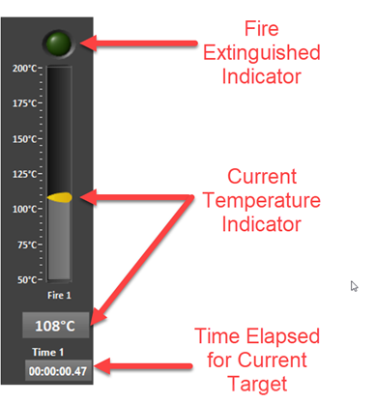
Figure 4 – Each target has its own indicator tracking temperature and timing

The system starts recording a time upon pressing the Start/Stop control and finalises the time when pressed for the second time by the operator.

The system can issue a reset command to the heated targets when needed. This will drive their temperatures back to 150 deg C and into the ready state.

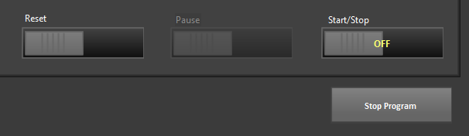

Figure 5 - Start and stop controls of the User Interface

Credits

This project is developed by the Innovation Group
https://makerspace.uq.edu.au/

