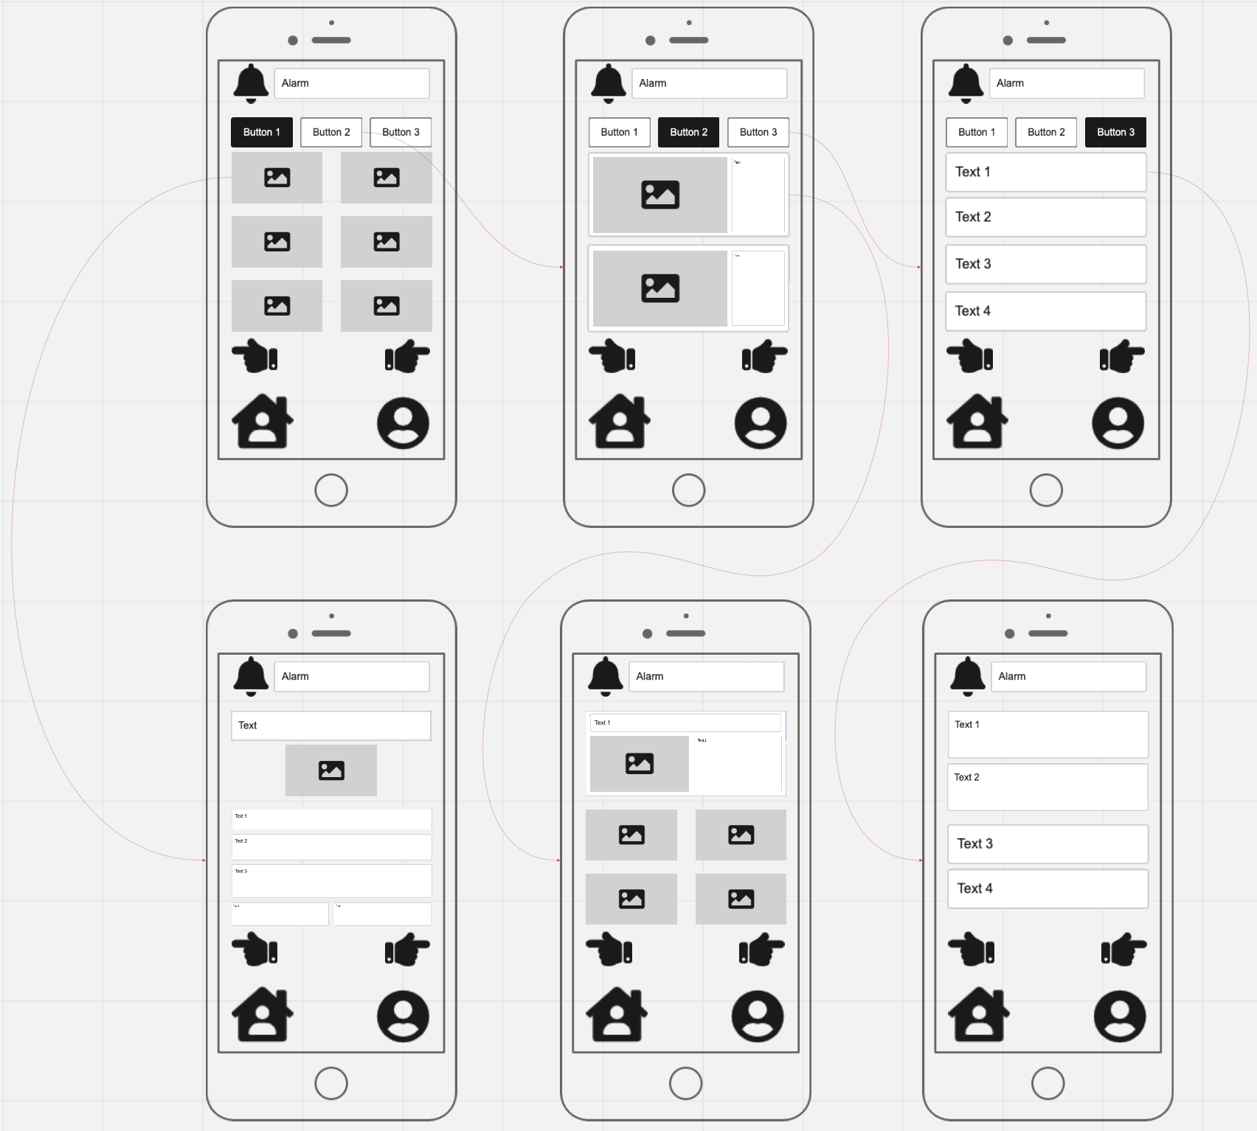
- A picture of the preferred device of this space will be placed here, it can set by the user, and is usually the most frequently used device. After clicking on one of the devices, the system will also jump to the relevant space detail page.

This page is the space detail page, this system will display all the information of the relevant space according to the space clicked by the user.

- The health option will be placed here. After clicking on one of the options, this system jumps directly to the relevant details page, containing all the data in the health option.

- This page is the third picture of this system, and this last picture is the user health detection and control page.

- This page is the second picture of this system and the summary page of the space where the device is located and concentrated in the spatial distribution.

- A picture of the space will be placed here. After clicking on one of the spaces, the system will jump directly to the relevant space detail page including all the devices in this space.

- This page is the home page of this system, and the default page is the summary page of all devices in units.

- Profile: After clicking on this key, this system will go to the profile page.

- Home: After clicking on this key, this system will directly jump to the home page which is the summary page of all the devices.

- Alarm: The icon on the left is to display the warning type, and the text on the right is to describe the warning details.

- Alarm: The icon on the left is to display the warning type, and the text on the right is to describe the warning details.

- Rolling: the gesture to left is to move to the previous page, while the gesture to right is to move to the next page. Since this system is aimed at elderly users, using the direction of the gesture to indicate the forward and backward will be more vivid and easy to understand for them.

- Option: These are the device page, space page, and health page listed from left to right.

This page is the device detail page, this system will display all the information of the relevant device according to the device clicked by the user.

This page is the health detail page, and this system will display all the information of the relevant health according to the health clicked by the user.

