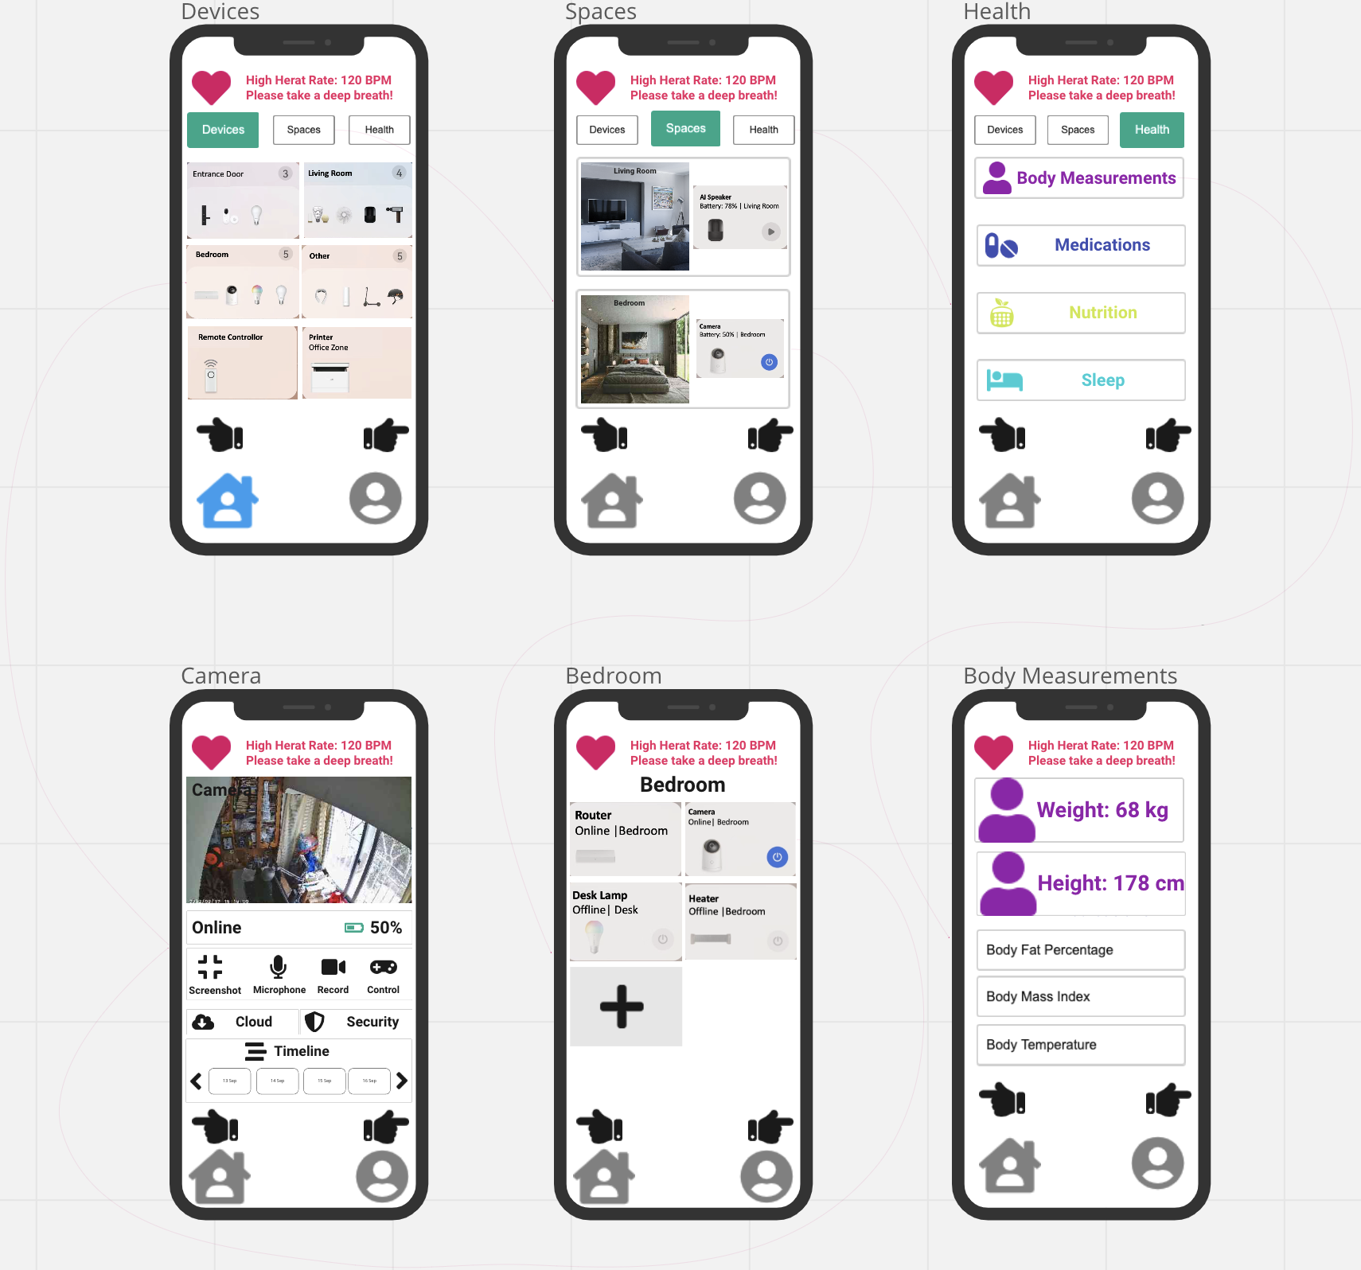
- Alarm: The more urgent matter, the more eye-catching color this system will use to attract the attention of users.

The body measurement health is taken as an example here: The detailed health matter and data can be managed in this body measurement health detail page, and the more detailed page can be entered by clicking on the detailed health matter and data.

A bedroom space example is taken here: The included device can be managed in this bedroom space detail page, including adding or deleting the device, and the device detail page can be directly entered by clicking on the device.

A camera device example is taken here: The real-time live, the online situation and the quantity of electric charge, and the relevant control ways and settings to this camera can be saw by the user in this camera device detail page. This system enables the user to retrieve monitoring records of different dates in the cloud space.

The icon of the health is indicated on the left, while the description of the health is indicated on the right.

The left side of the space icon is the space picture, and the right side of the space icon is the device picture in this space and shows the status of this device.

- The left upper side of the device icon is the name of this device, or the space merged by the device when multiple devices are set in the same space, the right upper side of the device icon is the number of the devices integrated in the same space if this space contains multiple devices, and the below side of the device icon is the picture of the device in the order from left to right.

- Home: The addition of blue will prompt the user that this page is the home page of this system, and the blue will also give users a sense of calm while using this application.

- Option: When the user clicks, the icon enlarges, and the background turns green to prompt the user to know the page location where the user is and what the page is doing.

