Xianglong Ronaldo Lin

My biggest expectation for myself is to never stop studying to improve myself and challenge myself to break my limits in every aspect and detail, whether from the individual or the team. No one is perfect, but the perfection can be approached by the efforts, so I believe that as long as I stick to my expectation, my study career in UQ will be more substantial and valuable.

- Individual

As a member of the team, I knew that the importance of the member would not be reduced because of the position, such as whether I was the captain or not. I state that in the DECO2500 study, I had excellently and well completed the study tasks and achieved the learning goals, and reminded and helped my teammates when necessary: some teammates were sometimes not so active or absent from the meeting, I abstracted the important information to message on the social software (i.e., Instagram and Facebook), and sometimes inspired with my own experience; sometimes my teammates lost track for a while, I contacted the other teammates to finish the part of the work that we were responsible for and could be done first; when not all the necessary works (i.e., the Google Slides and the speech drafts) were successfully completed to rehearse on the Tuesday of the presentation week, I also made the more important urging on the social software.

- Team

A group is like a football team, sometimes the captain may be absent due to injury, then the vice-captain or the other members must support the whole team as the mainstay not only in the spiritual encouragement but also in the practical motivation. No pain, no gain. Even if many contributions were unknown, I always believed that while I was selfless in my dedication, my teammates would see and remember in their mind, and they would also work hard for this team, including me. Such as in the presentation, some members might be too shy and timid, then the others would stand up; in the group assignment, all the members shared their points to benefit by mutual discussion. Study is complementary, I contribute and share my knowledge and experience, meanwhile my teammates also convey to me their different views and opinions, so we develop and improve together.

When the members exchanged the ideas and the experience, and drew the lessons from each other, we might have the conflict of the opinions because of the different countries and the cultural backgrounds, including the different starting points and the consideration factors. At the same time, the different mother tongues might also lead to the incomplete and inaccurate meaning expressions. However, this was also a learning process of our team, and the modern technology could solve this problem to a large extent. Moreover, the collisions of ideas also had the unexpected benefits, which made our group assignment have richer views and insights.

The following is my personal summary of studying DECO2500 in this semester in the form of a graph. I believe I can live up to the expectations of myself, the classmates, the tutors, and the teachers to learn more knowledge from taking more advanced DECO courses and constantly achieve a better self!

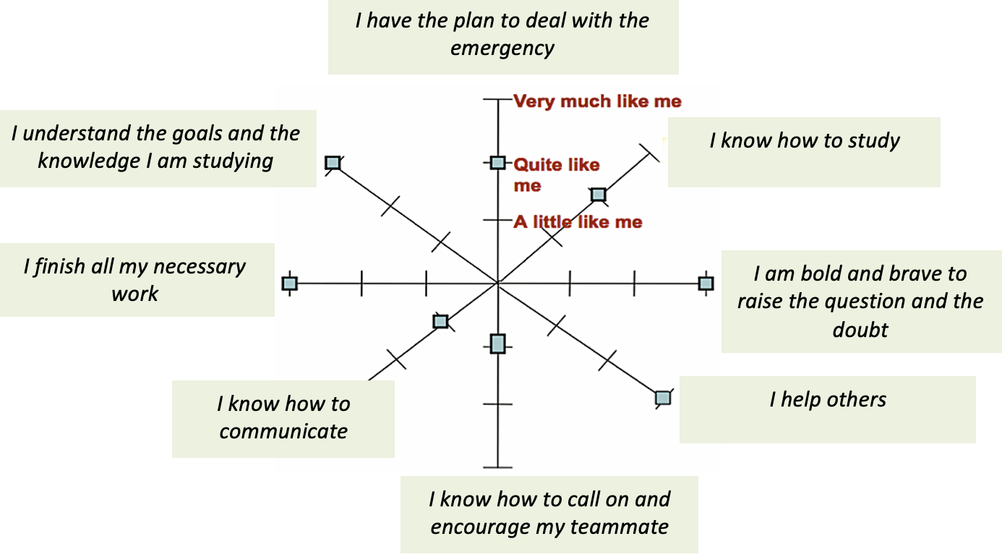(https://assessment.tki.org.nz/Reporting-to-parents-whanau/Examples-and-templates/Student-self-assessment-and-reflection)
F(). The Individual Reflection Graph

