DECO2500 Team 2 Evaluation Report
Clancy Heyworth – s4704329, You Lu – s4568181, Xianglong Lin – s45791439, Entong To

Executive Summary 3
Evaluation Plan 4
System Usability Scale (SUS) 4
TAM 4
Time on Task / Think Aloud 5
Nielsen’s Ten Usability Heuristics 5
Evaluation Activities 6
Time on Task / Think Aloud 6
System Usability Scale (SUS) 7
Nielsen’s Ten Usability Heuristics 8
​Results 9
Time on Task / Think Aloud 9
System Usability Scale (SUS) 11
Nielsen’s Ten Usability Heuristics 15
Future Directions 17
Appendix 17
Individual Reflection 17
En Tong To 17
Xianglong Ronaldo Lin 18
You Lu 20
Clancy Heyworth 20
Bibliography 40

Executive Summary
Through research within the domain of health and wellbeing, the group identified elderly persons as a demographic underserved by new and developing technologies, primarily due to a failure of designers to correctly address their needs. Due to a higher likelihood to experience debilitating health issues, many elderly persons are condemned to stay in health facilities that fail to provide a mentally comfortable environment.
The group decided that smart homes present a profound opportunity to improve this age group’s quality of life by allowing older users to live at home whilst being monitored and aided with day-to-day tasks by an integrated system tailored to their needs. Smart homes are an integrated system of appliances that can be controlled remotely through a mobile device. Functions that a user can normally expect to have on such systems include controlling security access, temperature, and lighting.
Hence, the group designed an application for a smart home on a mobile device that could fulfil the typical tasks associated with smart homes, as well as provide medical-related safety, data collecting and emergency systems comparable to that of medical institutions from within the comfort of elderly users’ own homes.
Fundamentally, the design was attempting to address the issue of the elderly being reluctant to embrace such technologies, even though one could argue that not doing as such was to their detriment. Our efforts came from a recognition of the fact that this reluctance stemmed from a failure of past developments of this technology to adequately design around those of greater ages, instead choosing to cater to younger demographics.
The group utilised Time on Task / Think Aloud to diagnose bottlenecks in the prototype’s design and the actual efficiency of the potential application with its target user base through usage of paper versions of the prototypes. Additionally, TAM and SUS evaluations provided quantitative data to analyse the viability of the app overall, as well as a solid basis to identify key design flaws from a user perspective. Finally, Nielsen’s Heuristics were fitted to our application to gain an appreciation of our design’s simplicity and functionality.
From these evaluations, the group determined that the app would have greater viability if the iconography were more conforming to existing standards. Moreover, the addition of shortcuts for users more familiar with the application would be an ideal implementation to increase user’s efficiency in completing actions. However, the application’s design had performed well in the evaluations and was evidenced to have completed many of the target heuristics.

Evaluation Plan

System Usability Scale (SUS)

SUS is a 10 item questionnaire for evaluating the usability. The features and properties of the SUS match the smart home usability requirements: in terms of the cost, the SUS is cheap, there are no specific requirements and scenarios to apply; in terms of the timeliness, the SUS is a quick shortcut for the overall evaluation with short time and little effort; in terms of the simplicity, the SUS is easily managed, it only contains a small number of questions and is completed in the form of a questionnaire; in terms of the standard, It meets the industrial standard, and is widely applied in many research papers with a very high reference significance and use value; in terms of the effectiveness, all the data obtained through the SUS is valid and meaningful. [1] In summary, the SUS is in line with our requirements to evaluate the smart home usability with a small cost but a valid and rapid access to the overall evaluation based on the small sample.

Meanwhile, the SUS also has some drawbacks, this also made us need to change and make up through the other measures: the scoring and computing system of the SUS is more complex, so we would utilise the online SUS calculator [2] and the Excel function and equation programs to ensure that the calculation processes and results were calculated without error; the results of the SUS are not presented in percentage so not intuitive, so we would apply the Box and Whisker Plot to change the representation to reflect and improve; the existence of the problems is revealed by the SUS, but not the specific problems and the practices to improve, and the SUS cannot be applied independently, so we would apply and combine with the other evaluation methods (the Time on Task, the Think Aloud, the TAM and the Heuristic) for the details.

Therefore, we decided to apply the SUS in the evaluation activities as one of the quantitative evaluations for smart home usability with the other quantitative and qualitative methods.

TAM

We choose to employ Technology Acceptance Model (TAM) in our evaluation process to find out our prototype’s behaviour on different dimensions, what we did well and what needs to be improved. Since TAM evaluation also takes external and social influences into consideration, it will also help us determine if the prototype works for its dedicated users. Participants will be required to use the prototype to accomplish the task of controlling home appliances and rate the prototype from 0 to 7 on criteria like Perceived Usefulness, Perceived Ease of Use, Attitude towards using and Behavioural Intention to use. We will write our survey based on the TAM survey template, with 6 questions regarding the Perceived Usefulness of the prototype and 3 questions each for the other criteria. We choose to focus our TAM survey questions on Perceived Usefulness as we want to identify if the prototype does what it’s built for and help in completing daily tasks. By analysing the results from TAM evaluation, we wish to find the right direction for future improvement, based on this, we can conduct further evaluation to determine how to improve the defects.

To fully understand participants’ thoughts on the prototype and make the most out of the evaluation, think aloud is applied to understand how the participant is approaching the interface. By using this technology, we wish to have participants verbalise their thoughts without biassing them to obtain clear and neutral results. Before asking participants to perform tasks, they were instructed to speak out their thoughts whenever they got stuck and not sure what to do next. Evaluators will not talk to participants in any other form once participants have started to perform tasks to prevent biassing participants which could cause inaccurate results. By using this technique, we wish to collect intuitive feedback from participants about why our current design makes users find it hard to use and how we might improve it.

Time on Task / Think Aloud
Time on task evaluation techniques concern tests where potential users or stakeholders are given early prototypes of a selected design and are expected to complete tasks utilising these prototypes. The time it takes a participant to complete a task is recorded and used to quantitatively analyse the potential issues with different features or aspects of the interface through comparison of time differentials. More specifically, time on task evaluation can aid in determining where bottlenecks occur in a user’s process, and which features, iconography or other aspects of design are unintuitive. Taken over multiple attempts, the data from time on task can also relate to the difficulty with which users would become more familiar with the interface. These examinations of the different times taken in task completion give a more nuanced perspective for how efficiently the app can be used to accomplish actions, and thus will allow us insight into failures in the app’s design.
Moreover, Time on Task evaluations can be paired with think aloud evaluations, wherein participants are asked to verbally communicate their difficulties or feelings with the design whilst they are interacting with it. This addition to the existing time on task methods provides a qualitative aspect such that detailed explanations of flaws in a design can be given in real time, however, possesses a large potential to reduce the meaningfulness of the recorded times, as participants’ efforts are likely to be hampered by the expectation of speaking their issues. Nevertheless, Think Aloud was still selected as an evaluation method due to its invaluable procurement of problems for the user as they arise, whereas with other methods, the information is only garnered from users after the fact, where they may have forgotten some details.

Nielsen’s Ten Usability Heuristics

As a discount usability technique, Nielsen’s Ten Usability Heuristics are the general principles for designing software products. Ten evaluators are given an interface design and asked to comment on it in the informal usability analysis technique known as heuristic evaluation. So along with other testing methodologies, we also used Nielsen’s Heuristic as an efficient way to evaluate the system. The advantage of using the method is gaining quick and inexpensive feedback from the experts so that designers can make changes at the early stage.

Evaluation Activities

Time on Task / Think Aloud
The Time on Task / Think Aloud evaluation method involved a singular surveyor from the group interacting with seven elderly persons individually. Elderly persons were selected as the participants due to their being the targeted user demographic for the application. A paper prototype of the application’s design was placed in front of a participant, and they were requested to treat the paper representations as if they were an actual app on a mobile phone. The participant was given a task to complete and were asked to state what difficulties they were experiencing or any other feelings whilst they worked. The time from start to completion of each task was recorded, as well as any comments they made.
The four tasks were as such:
1. Determine your heart rate.
2. Find your energy consumption over the past three months.
3. Create a new shopping list in the reminder section.
4. Turn off the lights in the smart home.
These tasks were chosen because they were determined to theoretically require the same amount of actions on the interface, but were accessed separately. Hence, by having the participants complete these tasks, we could garner valuable information relating to the improvements that need to be made to specific design aspects of the process of these tasks, and which aspects could be implemented to improve other tasks’ efficiency.
The surveyor had each participant complete these tasks three times each. The benefit of repeating the tasks would be to observe if there was a downward trend in time completion, implicating that the users found the tasks easier within the interface as they do them again, which would give credence to the interface having fulfilled Nielsen’s heuristics.
The times taken until completion can be analysed visually and mathematically using multiple structures. For instance, a graphical line representation of the four tasks averaged across the seven participants could indicate variance in participant’s time for each task and the variance of time between tasks, as in which tasks proved more difficult for the participants than others. A box and whisker chart for both aspects would demonstrate a more nuanced view of the median time of tasks, as well as demonstrate the range in which the average times took place. Moreover, an analysis of participants’ times could be related to a linear regression of the times and the number of years a participant has owned a smartphone and how this could cause error over the limited sample size.
In terms of Think Aloud, the comments recorded by the participants could be examined qualitatively in conjunction with the recorded times to see how the difficulties diagnosed by the participants affected their efficiency.

System Usability Scale (SUS)

Firstly, after the Time on Task and the Think Aloud, but before the TAM, the SUS was also conducted and completed online by the users [2]. Since the users had already experienced the long-time tasks in the previous evaluations, and they were very likely to be distracted and tired from the follow-up evaluation. [3] This means that the users were beginning to engender the cognitive fatigue and overload, and it was now difficult and no longer appropriate for the evaluation requiring much more mental, energy, and time. Also based on the users having completed long-time and qualitative evaluations here, so we would consider introducing the SUS at this time point. Moreover, we divided the 10 questions of the SUS into 10 pages rather than passing all the questions to the users at once, otherwise the users would be disgusted by this evaluation and very likely to complete the evaluation impatiently and abnormally with an attitude to copy with, and the data obtained would not be accurate and meaningful enough.

Next, the scores range from 1 to 5 from small to large for the 5 different consent levels from "Strongly disagree" to "Strongly agree", expressing the abstract experience feeling of the users to the smart home usability in the vivid numbers.

After the users scored, the scores on the questions with the odd sequence (Q1, 3, 5, 7, 9) would be retained after subtracting 1, while the scores on the questions with the even sequence (Q2, 4, 6, 8, 10) would be retained after subtracting from 5 to achieve that the odd numbers were positively rated, and even numbers were negatively rated. [1]

Finally, the total values of the 10 questions per user multiplied by 2.5 and the average values for each question were calculated for the subsequent comparisons to the graphs to draw the conclusions. So far, all the basic and necessary calculation procedures for SUS had been completed and ended.

Subsequently, the basis of whole smart home usability could be known by comparing the total values and the System Usability Scale and the SUS Score Graph, and each usability part could be understood by combining the average values and the Box and Whisker Plot derived from all the data.

The System Usability Scale could show the net promoter score (NPS),the acceptable, the adjective, the grade, and the corresponding SUS score,but the comparison between the percentile rank and the SUS score was not as intuitive as the SUS Score Graph. So our approach was to obtain the SUS score corresponding to the percentile rank, which is the total score of 10 questions per user, from the SUS Score Graph, and then get the the corresponding description and interpretation in the NPS, the acceptable, and adjective in the System Usability Scale.

Furthermore, compared with the traditional histogram, the Box and Whisker Plot provides more additional details than showing the basis of the multiple data sets, which includes the upper whisker, the upper quartile, the middle quartile / median, the lower quartile, and the lower whisker. [4]
Technology Acceptance Model (TAM):
During the prototype’s TAM evaluation, participants were instructed to navigate to the bedroom, turn on the heater before going back to the main page, browse to the entrance door and use the camera to record a video. In this process, participants would perform tasks using the smart home appliances control function which was the main feature of the prototype. By undergoing the steps above, participants would have used all the screens related to the appliance control feature and experienced the performance of the prototype. Then, the participants were asked to complete the TAM surveys and the results of surveys were later analysed to determine future directions.

Nielsen’s Ten Usability Heuristics
The evaluation included a participant who had taken DECO2500 before, who already comprehended the heuristics, to apply Nielsen’s Ten Usability on the system.

The steps of the evaluation are as follow:
1. Give general information about the system to the expert
2. The expert will go through the system
3. The expert fills out the evaluation form while collating the system

​Results

Time on Task / Think Aloud
Utilising the times recorded from the participants over the four tasks in each of the three attempts, a preliminary analysis can be garnered from the averaged times across the tasks and participants.
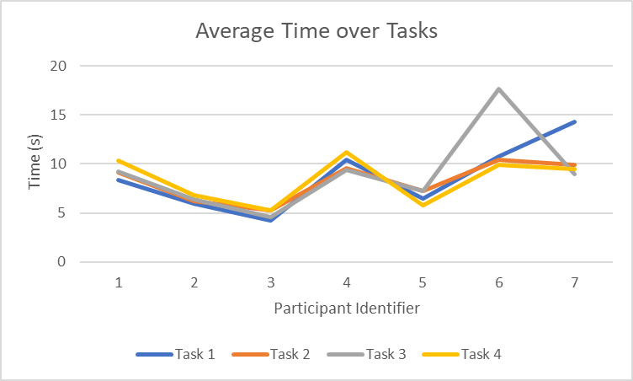
Visually, one can observe that participants had little variation of the time they needed to complete any one task compared to the other three tasks with some outliers. This implies that the prototype is designed such that no task creates greater difficulty for the user than another. This is supported by calculating the variance of average time for each task across participants, wherein we observe that variance remains low (< 1) for all participants when outliers are excluded.
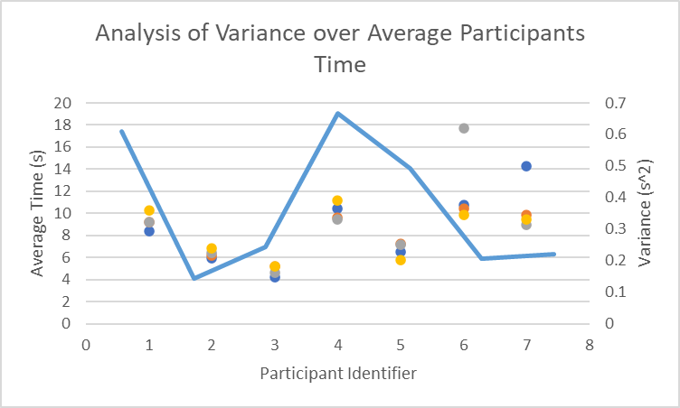
Moreover, tasks can be demonstrated to occur in roughly the same time frame regardless of participant, as shown in the following box and whisker chart wherein the median and range of values is roughly consistent across tasks.
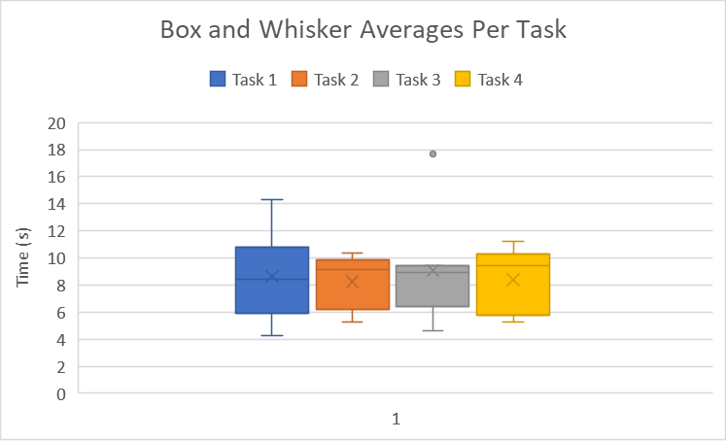
Additionally, analysis of the change in time across attempts for the tasks reveals that both the median time and interquartile range of average task times decreased dramatically with each attempt. This implies that the application’s design was such that users could easily recall how tasks were accomplished as their familiarity increased.
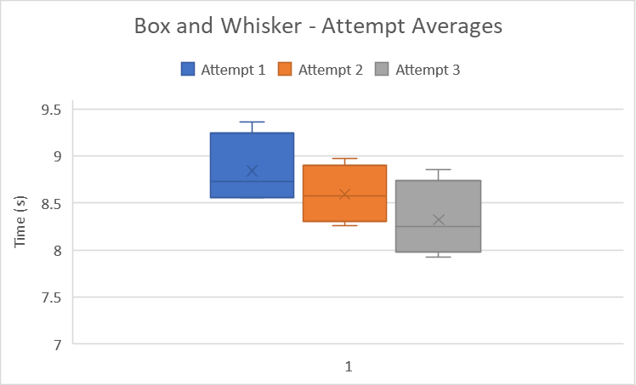

The results obtained through think aloud revealed that some icons employed in the prototype were not self-explanatory enough. Participants would tap on an icon, expecting it to act like a button to trigger actions while the icon was actually a label for display purpose only. This could misguide users and decrease the usability. Some distinctive icons were used to make the prototype look unique, however, these icons were not aligned with those used in other apps which decreased the consistency of the prototype.

System Usability Scale (SUS)

Finally, the total scores of each question is generally in the interval of C and B of the SUS Score Graph, this shows that the smart home usability was not very satisfactory, and there were still many aspects to improve. More specifically, the SUS scores in the interval of C and B indicates the NPS was passive, the acceptable was between marginal and acceptable, and the adjective was between good and ok. This means that the smart home usability was in a moderate position, the overall performance of the system was passive, the users held a neutral acceptance attitude, and the overall usability was good or ok. All in all, the users could accept and affirm the smart home usability, but some aspects could be revealed to be followed up to improve and perfect the usability.
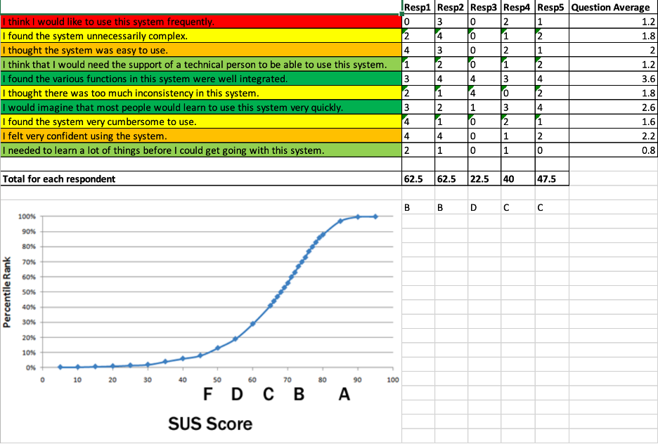
F(). The values, the scores, and the SUS Score Graph

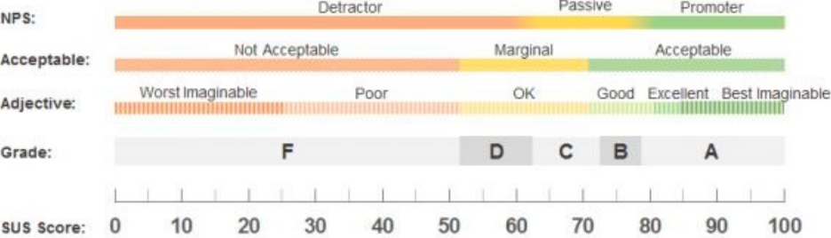
F(). The System Usability Scale (SUS) [1]

Besides, the Box and Whisker Plot illustrates that the user score medians of the 1st item (I think I would like to use this system frequently.), the 4th item (I think that I would need the support of a technical person to be able to use this system.), and the 10th item (I needed to learn a lot of things before I could get going with this system.) are relatively low. This indicates that the majority of the users disagreed or strongly disagreed. And this also means that the users believed that they were able to master the smart home system under the environment or the condition with the technical support or the aforehand learning, but the users did not really think they would use the system frequently in the future. Furthermore, the system deserves the affirmation and praise to be well used independently by most of the users, but the reason why the users would not often use the system needs to be further analysed and modified by taking some action.

In addition, the Box and Whisker Plot also demonstrates the user score medians of the 5th item (I found the various functions in this system were well integrated.) and the 7th item (I would imagine that most people would learn to use this system very quickly.) are relatively high. This indicates that a majority of the users agreed or strongly agreed. And this also means that users expressed that the smart home system was easy enough for the new user to use, even with the multiple features in one. Furthermore, the system showed an excellent performance in the functional compatibility and the use difficulty, which was user-friendly. The high scores of the 2 items are concordant and uncontradicted with the previous low scores of the 4th and the 10th items.

For the other 5 items, the Box and Whisker Plot represents that the medians and the overall distributions of the user scores are respectively moderate and centralised, and the results were basically arranged in and formed a normal distribution. However, the score spans of some items from 0.5 to 3 are relatively small, i.e. the 2nd item (I found the system unnecessarily complex.), the 6th item (I thought there was too much inconsistency in this system.), and the 8th item (I found the system very cumbersome to use.), while the score spans of the rest of the items from 0.5 to 3.5 or 4 are relatively large, i.e. the 3rd item (I thought the system was easy to use.) and the 9th item (I felt very confident using the system.).

This suggests that the majority of the users were neutral, neither agreed nor disagreed, and it also states that the smart home system was not difficult but also not easy to be learnt to use. This further implies that the smart home system could be modified and improved in the use difficulty, the system complexity and the interface consistency. This also helps to achieve the UX Goal mentioned by the UX metrics in the design proposal to quickly consult and retrieve the information needed after as few and simple operations as possible.
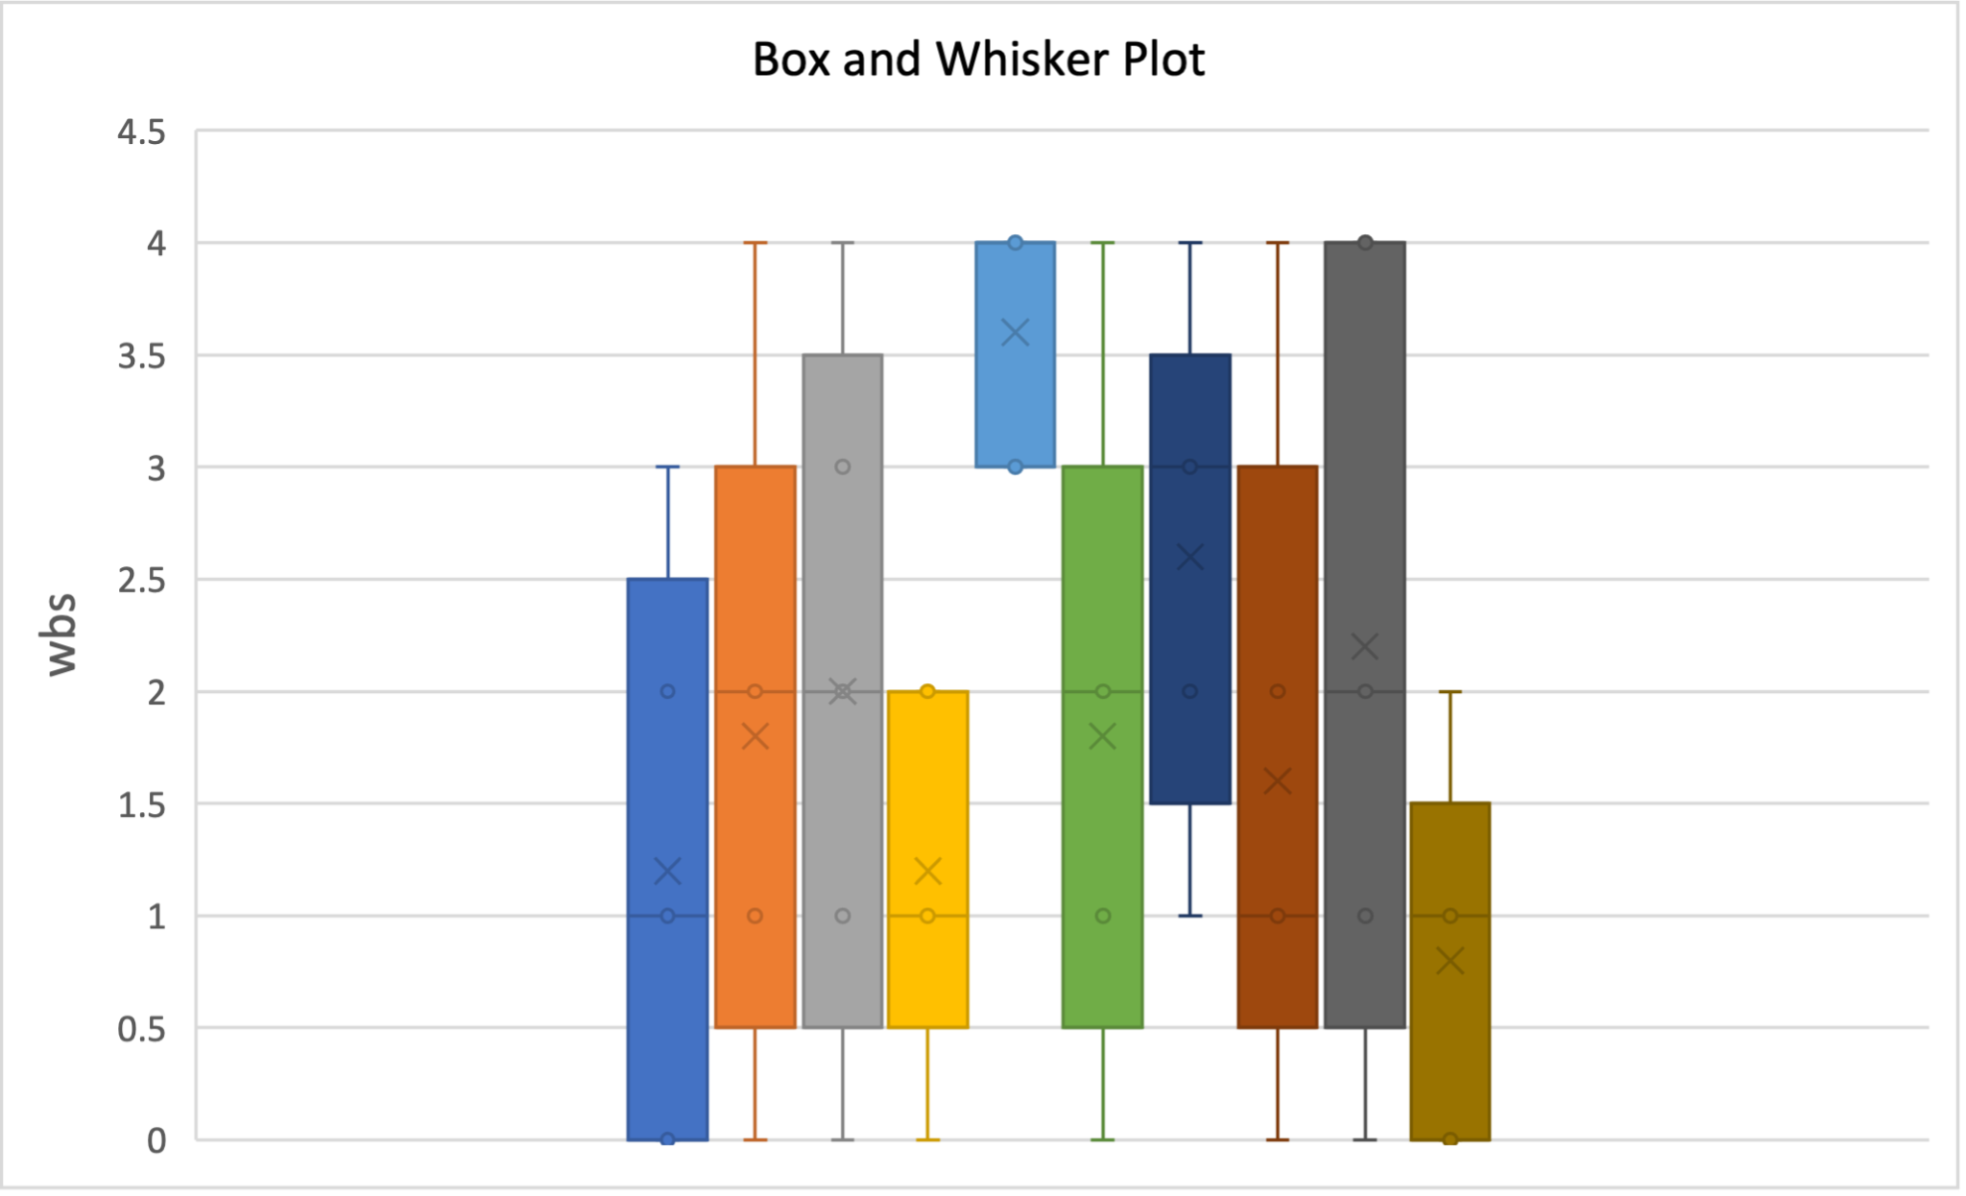
F(). The Box and Whisker Plot

By conducting TAM evaluation with 5 participants, we were able to get 5 surveys rating the prototype from 0 to 7. By summarizing all the surveys in the same table, we could use that table to produce a distribution plot to have a clear view on the prototype’s behavior. We decided not to evaluate the prototype using average scores as they would ignore extreme scores. If one participant gave a low score on one criterion while the other gave it a high score, the average score on this criteria would still be above the average and evaluators would not be able to discover issues related with this criteria.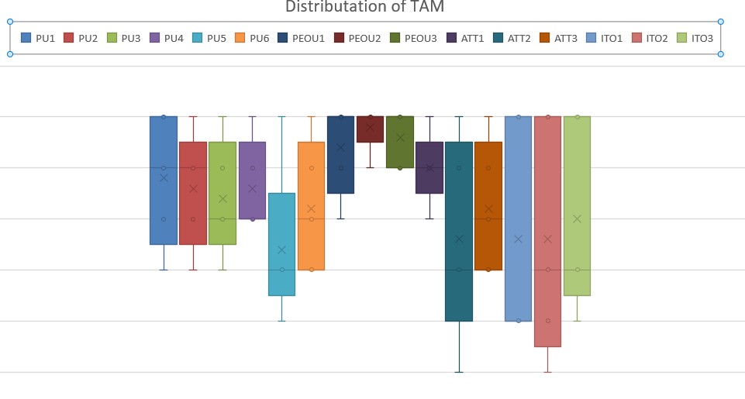
Based on the summarised table, we were able to produce a box and whisker plot as above. According to the plot, we could tell that the scores we received for Perceived of Usefulness are alright with all the medians above 4. The boxes are not stretched too much with short interquartile ranges which indicates that there is little spread among participants’ responses. The Perceived Ease of Use criteria is where we did well as the entire plot can be found in the high score range, the boxes are compressed with short interquartile ranges which shows that all participants agreed to rate the prototype as easy to use. However, the prototype’s behaviour in Attitude Toward Using and Behavioural Intention to Use are not as ideal as the others. Although the median values for both topics are still rated above 4, these topics have their boxes stretching across almost the whole score range. This indicates that although some users rated themselves as likely to use the app in the future, there were also other users giving a low score that they would not tend to use the app. Taking participants’ background into consideration, the high scores in Attitude Towards Using and Behavioural Intention to Use all came from elderly participants while young participants were more likely to give a low mark on these criterias. This appears to be reasonable as the prototype was designed with special care towards the elderly, if the app includes too many fancy functionalities, despite the possibility that this might attract more young users to use the app, it will also become harder for the elderly to use the app which is against the design proposal.

Nielsen’s Ten Usability Heuristics
Screen / element description | Usability issue | Heuristic category | Probable effect on user
Undo and next icons coarsely situated on every page | The exit sign is not clear, and the way to exit the current page is through the undo button | User control and freedom | Confusing
Font design and colour usage | Inconsistency throughout the system | Consistency and standards | Distracting
Camera monitoring page is overload of navigation options | Visual overload | Aesthetic and minimalist design | Difficult to use
Medication intake editor | Editing tools not provided | Flexibility and efficiency of use | Unable to customize the medication timetable
Reminder function access | No obvious way to access Reminder from home page | Match between system and the real world | Spending extra time to find for the function
Medication Intake days/ calendar | Hard to see | Aesthetic and minimalist design | Overlook the medication intake time

Through this evaluation, it was significant that several fundamental design issues must be solved to comply with the usability heuristics. From the result, we know that the undo and redo arrows are confusing. First, the hands take up too much space, and we should hide them and only allow their appearance when action is made and requires the go-back function. Secondly, we should unify the font design and colour usage. Third, we learned that the camera monitoring page is over technically complicated for the general public. Fourth, there are tools deficient need to be fixed. Fifth, the connectivity of every main page needs to be included. Lastly, we have to beware of the aesthetic design of our system.

Future Directions
According to results from TAM evaluation, most participants found the prototype easy to use but, some young participants were not finding themselves likely to become a frequent user. An ideal improvement is to enable shortcuts for experienced users which will enhance the user experience for young users while keeping the ease of use for the elderly. For young users, due to their high acceptance towards technologies, they will quickly master the app and they can use the shortcuts to enrich their user experience. For the elderly, they can simply choose not to use the shortcuts which will do no harm and they will still find the app easy to use. Based on participants’ comments from think aloud, icons used in the app should be as consistent as possible with other apps that the backward and forward button should be replaced by normal arrows to be more intuitive. The results from time on task showed that varied tasks consume the same amount of time, implying that the problems identified from think aloud exist throughout all aspects of the design.

When we started the design proposal, we decided to use mobile devices as the platform to build our prototype as we thought everyone would have access to mobile devices and it would be easier to control. However, by conducting future investigations, we noticed that the elderly sometimes forgot where they left their mobile devices and had trouble finding them. Moreover, prototypes that get built on mobile devices usually utilise interaction modes like manipulating and instructing like selecting from menus and pressing buttons. Although the prototype has been designed to be easy to use for the elderly, its usability could be further enhanced by allowing verbal control. Voice detectors could be deployed in users’ houses so that even if the users don’t have their mobile devices in hand, they would still be able to send commands to the prototype.

Appendix

Individual Reflection

En Tong To

Working in a group can sometimes be very challenging. Different individuals with diverse viewpoints might only sometimes accord with one another. Therefore, I acted as a cooperative team member for numerous tasks. I made sure to attend every meeting and involve in discussions. During the group meetings, I will propose the problem I found with our project and discuss a solution we all agree on.

Additionally, I made sure to complete the appointed task on time. After taking advice from the tutors, all of us were involved in every part of the group project, despite dividing sections for each individual. Specifically, I am involved in the research, system concept statement, function requirements statement, creating a persona and scenario, and designing the prototype.

Together as a group, we gathered ideas from each other and came to an agreement. At first, I had varying opinions about the group approach, such as we are not having a prominent role in the group. However, such an approach seemed okay. By the time it was all said and done, we had actively participated and completed the project. We all keep track of the assignment we individually got from the discussions and look at others' work uploaded on the GoogleDrive. I learned that trusting your teammates is crucial in group work, as loosening the tension is an excellent thing for everyone to complete the job when each of us has different assignment dues and a different pace of doing things.

Xianglong Ronaldo Lin

My biggest expectation for myself is to never stop studying to improve myself and challenge myself to break my limits in every aspect and detail, whether from the individual or the team. No one is perfect, but the perfection can be approached by the efforts, so I believe that as long as I stick to my expectation, my study career in UQ will be more substantial and valuable.

1. Individual

As a member of the team, I knew that the importance of the member would not be reduced because of the position, such as whether I was the captain or not. I state that in the DECO2500 study, I had excellently and well completed the study tasks and achieved the learning goals, and reminded and helped my teammates when necessary: some teammates were sometimes not so active or absent from the meeting, I abstracted the important information to message on the social software (i.e., Instagram and Facebook), and sometimes inspired with my own experience; sometimes my teammates lost track for a while, I contacted the other teammates to finish the part of the work that we were responsible for and could be done first; when not all the necessary works (i.e., the Google Slides and the speech drafts) were successfully completed to rehearse on the Tuesday of the presentation week, I also made the more important urging on the social software.

2. Team

A group is like a football team, sometimes the captain may be absent due to injury, then the vice-captain or the other members must support the whole team as the mainstay not only in the spiritual encouragement but also in the practical motivation. No pain, no gain. Even if many contributions were unknown, I always believed that while I was selfless in my dedication, my teammates would see and remember in their minds, and they would also work hard for this team, including me. Such as in the presentation, some members might be too shy and timid, then the others would stand up; in the group assignment, all the members shared their points to benefit by mutual discussion. Study is complementary, I contribute and share my knowledge and experience, meanwhile my teammates also convey to me their different views and opinions, so we develop and improve together.

When the members exchanged the ideas and the experience, and drew the lessons from each other, we might have the conflict of the opinions because of the different countries and the cultural backgrounds, including the different starting points and the consideration factors. At the same time, the different mother tongues might also lead to the incomplete and inaccurate meaning expressions. However, this was also a learning process of our team, and the modern technology could solve this problem to a large extent. Moreover, the collisions of ideas also had the unexpected benefits, which made our group assignment have richer views and insights.

The following is my personal summary of studying DECO2500 in this semester in the form of a graph. I believe I can live up to the expectations of myself, the classmates, the tutors, and the teachers to learn more knowledge from taking more advanced DECO courses and constantly achieve a better self!

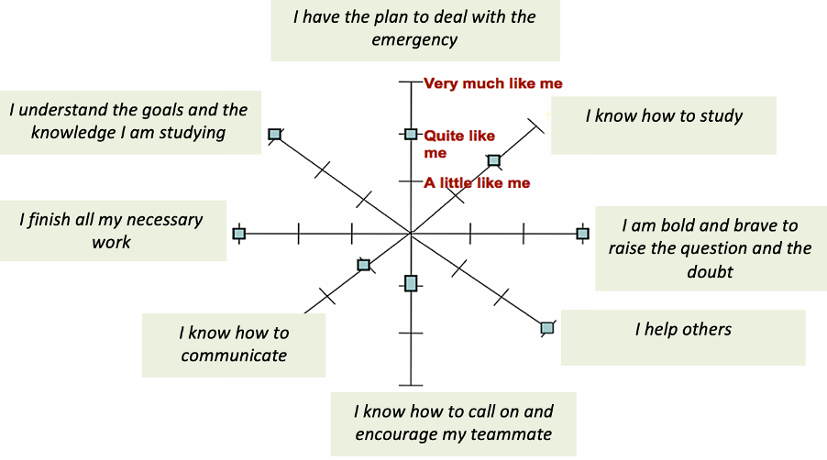
(https://assessment.tki.org.nz/Reporting-to-parents-whanau/Examples-and-templates/Student-self-assessment-and-reflection)
F(). The Individual Reflection Graph

You Lu
The experience of working in a group project is totally different from individual assignments. We are not only required to complete individual parts to high standards, but also make sure that our section is consistent with other team members’. During the design phase, I didn’t realise that some of the functions I included in my design had already been included by another group member. It led to a great amount of time wasted to redesign my part’s functionality and this could be prevented by sufficient communication at the start. When we first started designing the product, we were having trouble settling down a topic for our prototype to focus on. We were all constrained by what we wrote before in individual assignments and couldn’t break out to explore new opportunities. However, by communicating and exchanging ideas, we were able to combine our ideas and find a new topic to work on.
Working as a team also provides the opportunity of peer reviewing and having my work reviewed by another team member. It was hard for me to detect errors in my own work as I was likely to review my product following the same mindset as I was designing it, however, by having other team members evaluate my product, they were able to see those errors I wasn’t able to find and give me suggestions for improvement based on their points of view.
In this project, I was responsible for designing the energy saving function and doing TAM evaluation. Before starting designing the product, I first identified our target users and their expectations on the product, then, I was able to build the product with these expectations in mind and followed the design protocols we set as a team. When I was doing the TAM evaluation, I ensured that the same evaluation protocol was followed with all the participants so that the results obtained would not be biassed. If I am to do this project again, I will expand the investigation on target users to include their culture backgrounds as well to design a product that fits target users better. I will also be more conscious with the choice of participants for evaluation to include more elderly people as they are the main users targeted by the app.

Clancy Heyworth
I have often been one to loathe the prospect of group assignments given that I am not a social person at even the best of times and my propensity to fail to properly vocalise my ideas. This assignment, I am happy to say, was a deviation from that norm in what I hope will be a new trend for my future collaborative projects.
When we were first considering the nature of the application we would create together, I drew back on my individual report and suggested that we might consider elderly persons as an interesting focus. My previous research had led me to believe that nascent technologies underserved this demographic, and therefore presented a unique opportunity to describe the failure of existing interfaces to cater to them, and the design metrics we could use to better serve the older age groups. From this starting point, the group identified a mobile app for smart homes as the idea we would build around.
Within the design report, the group faced difficulties as disagreements occurred over which features to focus on or disregard with the issue of page limit in mind. Within an individual assignment, I would have steadfastly gone with whatever I wished, but in a group setting I came to realise that it would be better to let go of my proposals where other members of the group could give more fleshed-out plans with theirs through drawing their experiences from their own individual reports.
Due to my prior report containing information relating to our target user base for the app, I undertook much of the research for the interface regarding the health benefits of smart homes for the elderly, as well as discussing the human values associated with our application. Consequently, I also designed the prototypes for the app’s health aspects. Whilst doing the report, different pairings of group members would often interact on various aspects, and I would find myself highly involved in some parts and not involved at all in others. As a result, I learned to trust that my group members were doing their roles, just as they trusted me to do mine.
During our evaluation process, I directed my efforts towards the Think Aloud and Time on Task methods, as well as other areas. Those evaluations gave our group insight into what parts of the app were inefficient or confusing to potential users, and where our iconography had failed to conform to existing archetypes.
Were I to undertake this task again, I would expand design choices to better conform to elderly persons beyond what we accomplished within our initial designs..
Meeting logs:
Date: 19th September 2022, 23rd September 2022
Teaching Week/Studio #: Week 9

Team Name: Team 2

Items Discussed/Worked On
We completed the system concept and system requirements statement. We came out with the personas and the interaction scenarios. We did the final touch on prototyping.
The final report has been reviewed and submitted.

Issues That Arose
We exceeded the maximum limit of content pages.

Actions Required
Reconstruct the paragraphs and trim down some content.

Signed and Accepted

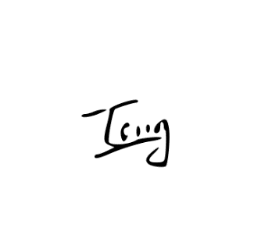
En Tong, To


You, Lu

Clancy Heyworth


XiangLong Lin
Date: 02/09/2022
Teaching Week/Studio #: Week6

Team Name: Team 02

Items Discussed/Worked On
Team formation, filling up team charter
Report topic

Issues That Arose
Determine the team leader
Find the right time for everyone to have a meeting

Actions Required
NA

Deliverables/Plan To Be Completed By The Next Week
Make research based on the topic of smart home control system

Other Comments
NA

Signed and Accepted

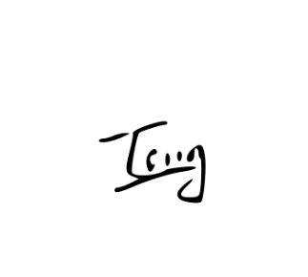



XiangLong Lin
Date: 06/09/2022, 09/09/2022
Teaching Week/Studio #: Week7

Team Name: Team 2

Items Discussed/Worked On
We’ve finished our research on the overview of the system by answering questions like what is the challenge space and why is it important? Who’s our target users and what should we offer to them?
We also discussed if we should design our prototype in such a way that it’s easier to use for a specific group of users.
We’ve decided that our current proposal is to build a smart home system that can make life easier, monitor and save energy and is intuitive for elderly people.

Issues That Arose
Briefly, we could not agree on what we should consider the target users for this design. Smart homes have a highly generic and broad range of users, which would make it difficult to appeal to any single demographic in a meaningful way. However, after further research and deliberation, it was determined that the elderly represent an interesting group of users with determinable issues. More specifically, older persons were found to have the possibly most to benefit from the smart systems we were researching, such as quality of life improvements by aiding with daily tasks and health monitoring systems. After this conclusion was reached, collectively we decided that although there is still room for change as more information is garnered from research, the elderly represented the most promising and rewarding target users for our proposal.

Deliverables/Plan To Be Completed By The Next Week
Doing more research focusing on existing systems in our domain, reading through their reviews and finding their limitations, deciding what we can improve in our prototype based on those limitations.

We will begin to do interviews with the targeted audience of elderly persons, with questions pertaining to difficulties with daily tasks and their general health.

Signed and Accepted

You Lu


En Tong To

Clancy Heyworth

XiangLong Lin
Date: 13 September 2022, 16 September 2022
Teaching Week/Studio #: Week 8

Team Name: Team 2

Items Discussed/Worked On
We are working on getting most of the report done before Tuesday next week. Our system designs will have 4 features and each of us will be responsible for one of the features. For the feature we choose, we will write the system requirement which generates this feature and create the prototype for it.
Each of us will develop a persona of our target users and we will use guidelines adapted from Norman’s design Principle, android design principles and apple design guidelines.

Issues That Arose
We weren’t sure how to separate and assign the task of interaction scenarios.
We were arguing which platform should we design the system on and how many persona should be design

Deliverables/Plan To Be Completed By The Next Week
We will try to have system requirements and prototyping done by next Tuesday and we will finalise our report by Friday.

Signed and Accepted
You Lu


XiangLong Lin

EnTong To
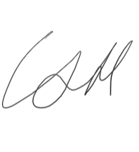
Clancy Heyworth
Date: 07/10/2022
Teaching Week/Studio #: 10

Team Name: Team 02

Items Discussed/Worked On
We discussed which methods we should use to evaluate our prototype.
How will we record and analyse the results we get from users.
Based on the users we choose to test our prototype, we will evaluate their needs based on their personal background and consider this together with their feed backs

Issues That Arose
We had to re-organise our meeting time as we will focus on our individual HCI reports first.

Deliverables/Plan To Be Completed By The Next Week
Finish our individual HCI reports

Signed and Accepted
You Lu

Clancy Heyworth
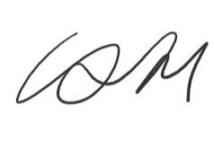
XiangLong Lin

Entong To

Date: 14/10/2022
Teaching Week/Studio #: Week11

Team Name: Team 02

Items Discussed/Worked On
Apart from user-based evaluations, we will also do some expert-based evaluations.
We will decide what evaluation methods work well on different features of our prototype.
We will focus on the presentation first; we will present our individual functions and how we are going to evaluate them. We will make sure that the PowerPoint is consistent and coherent.

Deliverables/Plan To Be Completed By The Next Week
We will finish our presentation slides and practise our presentation.

Signed and Accepted
XiangLong Lin

You Lu

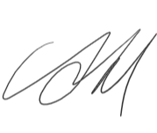
Clancy Heyworth

En Tong To
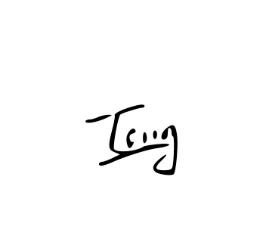

Date: 21/10/2022
Teaching Week/Studio #: 12

Team Name: 02

Items Discussed/Worked On
We rescheduled the evaluation plan to evaluate the project as a whole but each team member will use a different evaluation method to evaluate the project.

We decided to finish the PowerPoint by next Tuesday so we can practise in our next meeting

Deliverables/Plan To Be Completed By The Next Week
Do evaluations over the weekend.
Finish the PowerPoint by next Tuesday.

Signed and Accepted

XiangLong Lin

You Lu


Clancy Heyworth
En Tong To

Date: 25/10/2022, 28/10/2022
Teaching Week/Studio #: week13

Team Name: 02

Items Discussed/Worked On
We finalised our slides for presentation and did practise for the presentation at the studio this afternoon.
We checked our evaluated data against our evaluate plan to make sure we are following the correct protocol.
We are further analysing our evaluation results to find future improvements.

Deliverables/Plan To Be Completed By The Next Week
Complete the draft of final report

Signed and Accepted

Clancy Heyworth

You Lu


En Tong To

XiangLong Lin

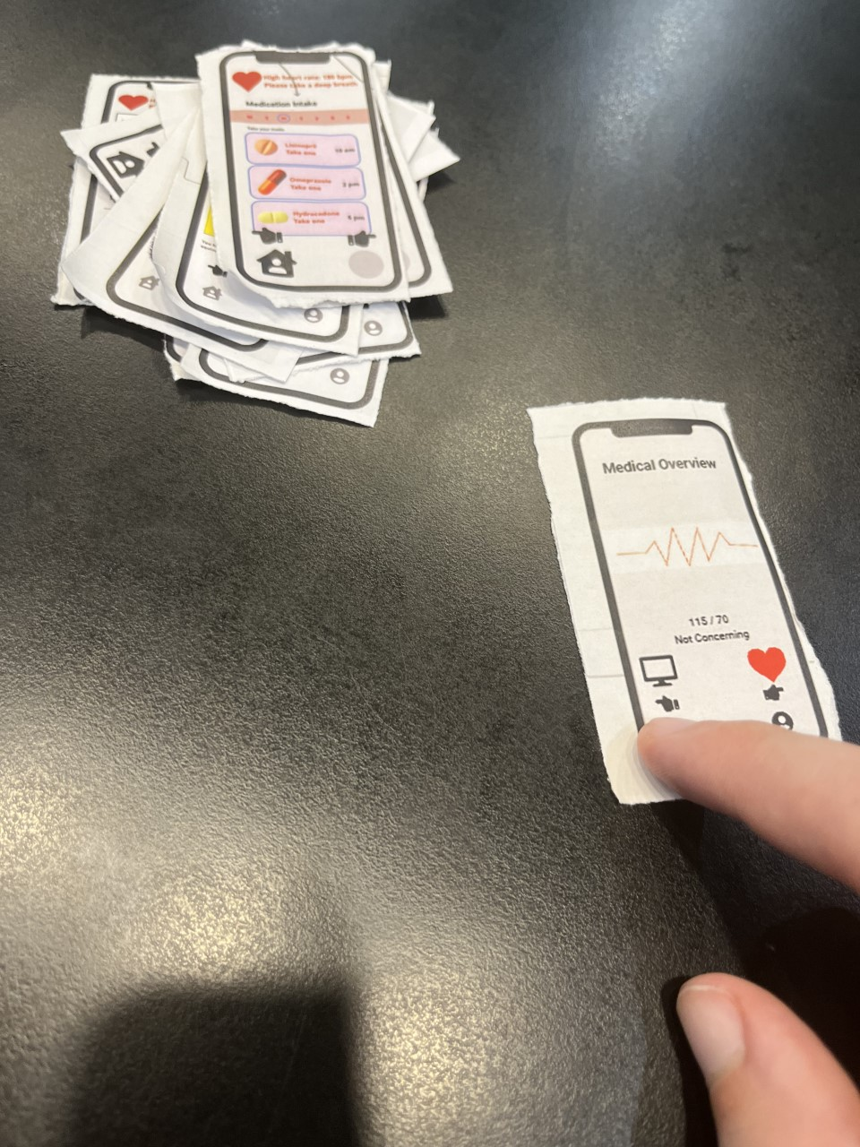
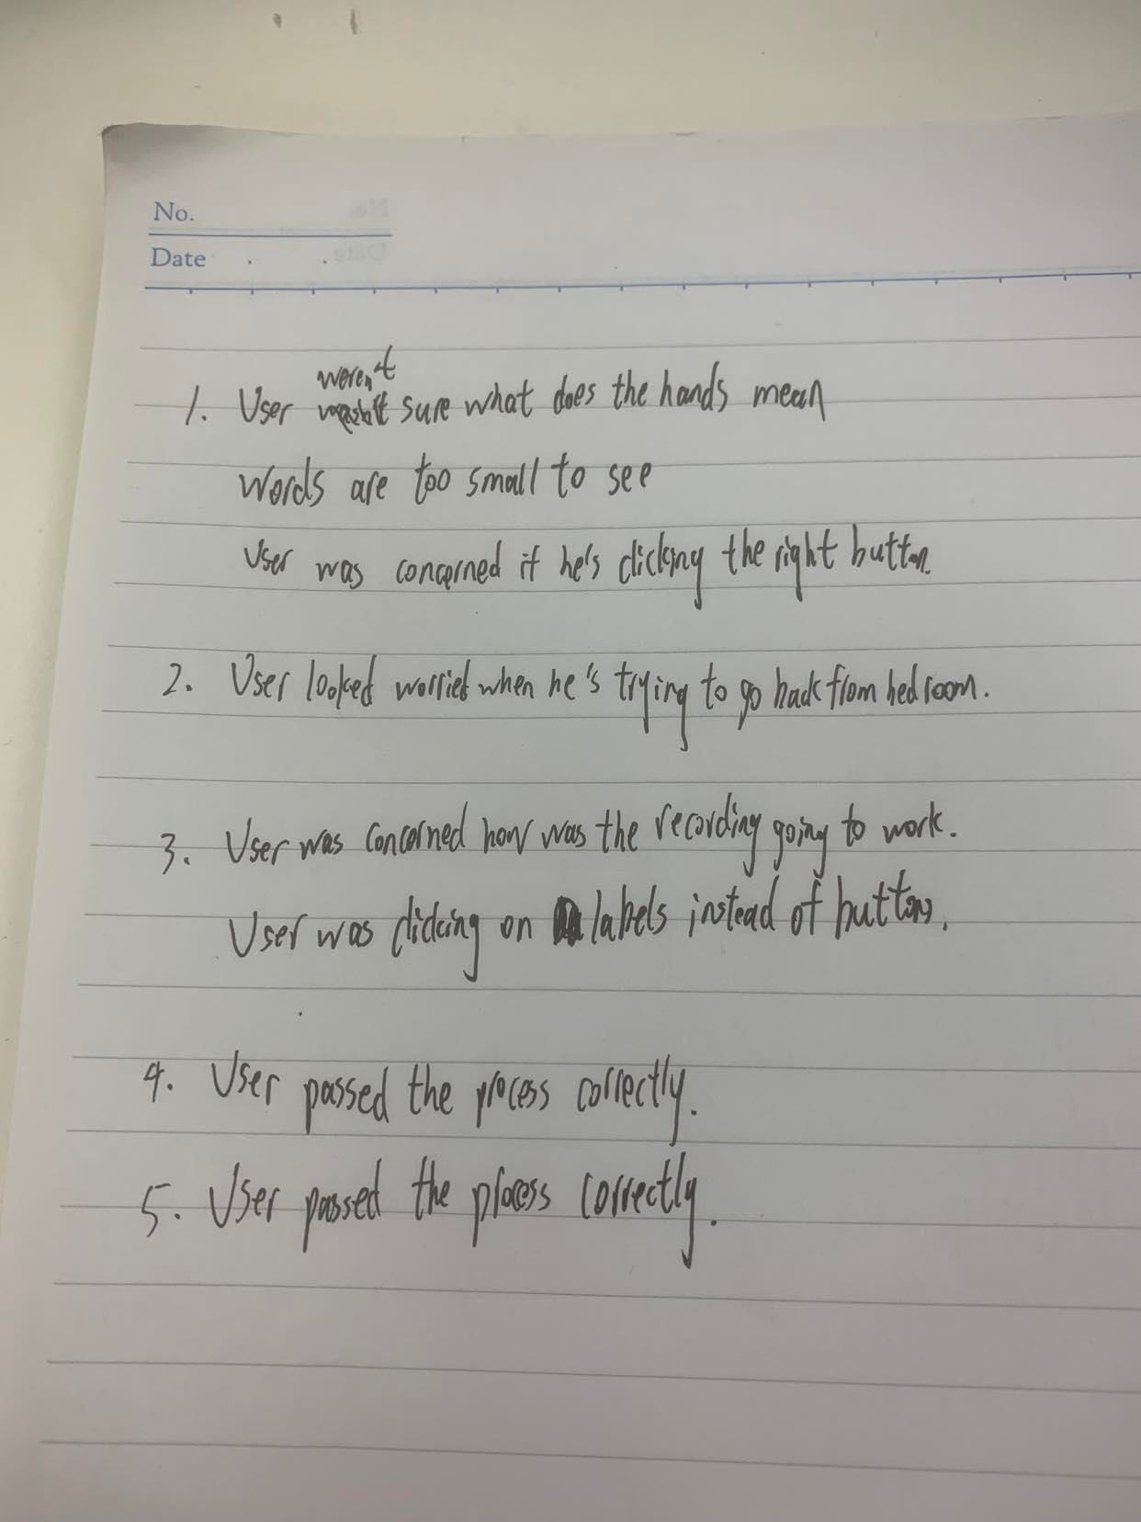
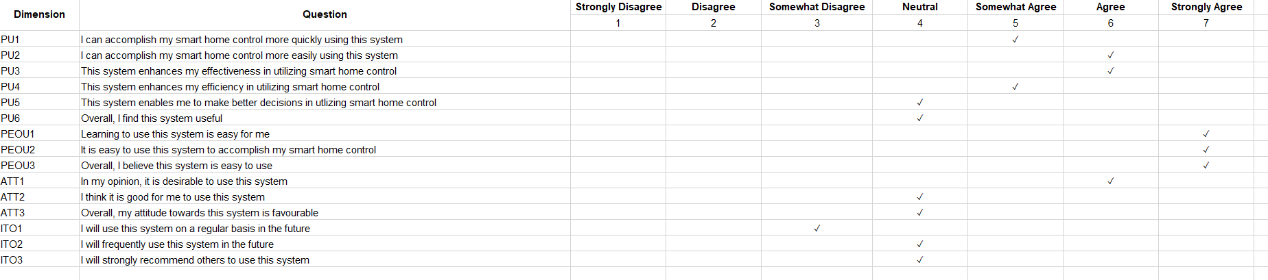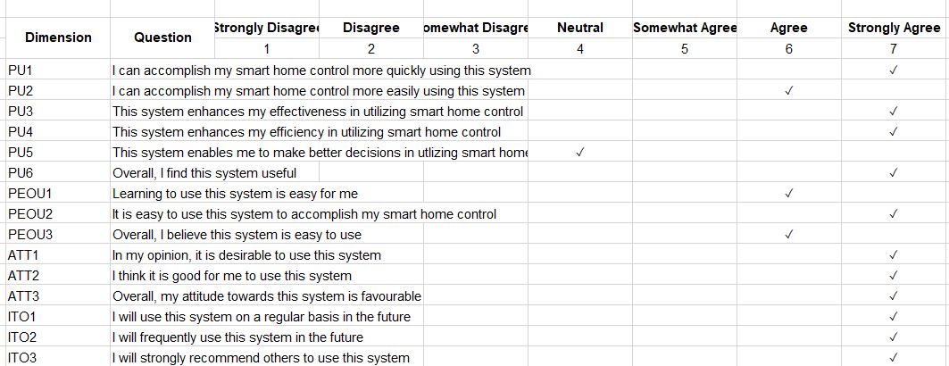
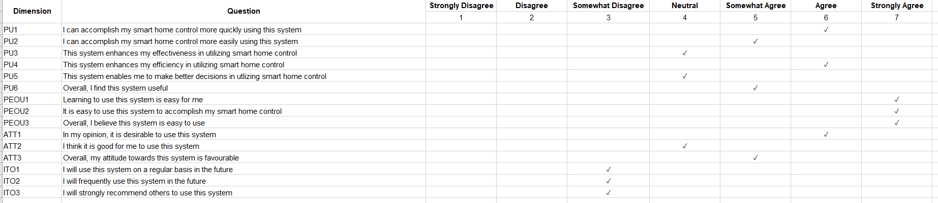
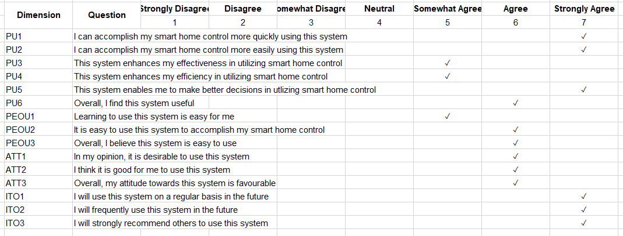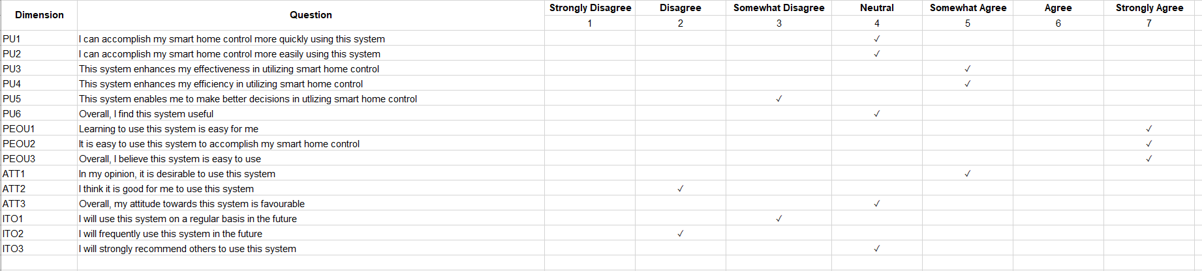

Bibliography

[1] | University of Queensland - DECO2500, “Blackboard,” 2022. [Online].
[2] | Ballpark App, “Ballpark SUS Evaluation,” 2022. [Online]. Available: https://app.ballparkhq.com/record/a332bb44-8bd7-499b-9e93-06a74897ec32). .
[3] | M. R. Drew, B. Falcone and W. L. Baccus, “What Does the System Usability Scale (SUS) Measure?,” Design, User Experience, and Usability: Theory and Practice, p. 356–366, 2018.
[4] | ASQ, “WHAT IS A BOX AND WHISKER PLOT?,” ASQ, [Online]. Available: https://asq.org/quality-resources/box-whisker-plot.
[5] | UIUX Trend, “SUS Calculator,” 2022. [Online]. Available: https://uiuxtrend.com/sus-calculator/) .

