Introduction and Overview

The CocaCola Company, a behemoth in the beverage industry, has an illustrious presence that spans over a century, with its products sold in more than 200 countries worldwide. Known for its flagship product, CocaCola, the company has diversified its portfolio to include a wide range of soft drinks, water, and juices, catering to a global audience with varying tastes and preferences.

Over the past decade, CocaCola's sales narrative has been one of significant ebbs and flows. The company witnessed a remarkable peak in sales revenue in 2013, a figure that has since served as a highwater mark for annual performance. However, the years following this zenith saw a gradual decline, suggesting a period of market challenges and strategic realignment. Despite these hurdles, the data illustrates a resilient brand, with a noticeable uptick in sales as the decade drew to a close, hinting at a successful adaptation to the evolving marketplace and consumer habits.

This overview sets the stage for a deeper dive into CocaCola's sales strategy and market performance, providing a glimpse into the company's ability to navigate through a dynamic economic landscape. The following pages will explore this journey in greater detail, offering insights into CocaCola's operational successes and the areas ripe for strategic enhancement.

**Detailed Analysis**

The bar graph detailing CocaCola's sales over a decade illustrates a journey of market resilience and strategic pivots. After a significant sales peak in 2012, the trend experienced a steady decline, possibly indicating shifts in consumer preferences or intensified competition. However, the slight uptick in 2019 suggests a rebound, potentially due to innovative marketing strategies or new product launches responding to market demands. CocaCola's sales narrative over these years reflects the company's enduring brand strength and its ability to adapt to a rapidly changing beverage industry landscape.

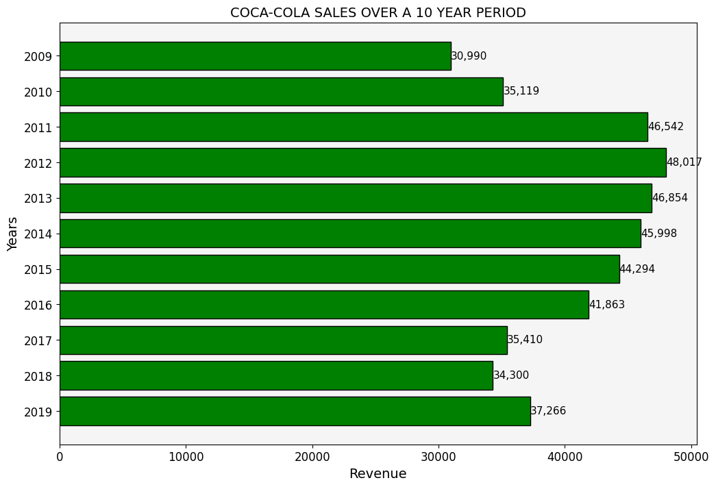

Exploring CocaCola's sales and profit data year by year, we can discern the company's economic narrative. A significant sales peak in 2012 suggests a successful alignment of product, market, and consumer demand, while the subsequent sales decline points to market challenges or shifts in consumer behavior. The profits, though somewhat proportional to sales, exhibit their own fluctuations, indicating variances in operational costs or investments that may not have immediately translated into increased profitability.

The late decade's recovery in sales, as shown by the 2019 upswing, is indicative of CocaCola's strategic response to market demands, potentially through product innovation, targeted marketing, or operational adjustments.

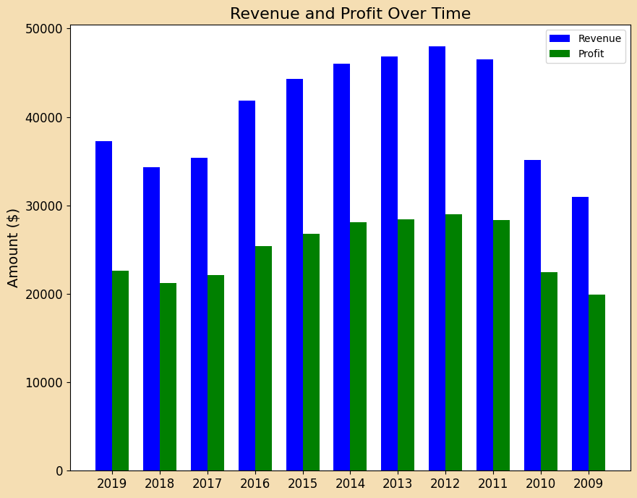

**Conclusion and Recommendations**

Upon reviewing CocaCola's sales and profit trends over the past decade, it is evident that the company has navigated a complex global market with notable agility. Despite facing fluctuations, CocaCola has demonstrated market adaptability and resilience, particularly in its ability to rebound in 2019.

Key Observations:

* Peak performance in 2012, followed by a period of sales decline.
* Discrepancies between sales and profit margins suggest operational and market challenges.
* Recovery in 2019 indicates effective strategic adjustments.

Strategic Recommendations:

* Market Diversification: Pursue new markets to mitigate against volatility in traditional strongholds.
* Cost Optimization: Tighten cost controls to better align sales with profit margins.
* Product Innovation: Continue to innovate, focusing on health trends and sustainability.
* Investment in Analytics: Increase investment in data analytics to forecast trends and consumer preferences.
* Strengthen Digital Presence: Bolster digital marketing efforts to connect with younger consumers.

The recommendations aim to build upon Coca-Cola's strengths while addressing the identified challenges to foster sustained growth.