SIMPLE SCHEDULE REMINDER MANAGEMENT SYSTEM
-------------------------------------------------------------------------------
A Introduction to Computing Project
Presented to the
Faculty of the College of Information Technology
Cagayan de Oro College
Cagayan de Oro City
-------------------------------------------------------------------------------
In Partial Fulfillment
of the Requirements for the Degree
Bachelor of Science in Information Technology
-------------------------------------------------------------------------------
NAME OF RESEARCHER
JAMES EDUARD AZARES
CHESTER ABECIA
RONALD BRACERO
HECIL DADSANAN GALARPE
HANNAH JANE YUCO
MONTH, 2025

  - Introduction
In today’s world, managing time efficiently has become a significant part of people’s daily lives. Many people, especially students and professionals, struggle to keep track of their important dates, tasks, and deadlines due to busy schedules. The use of technology has influenced how people organize their daily activities, and one effective solution is the use of reminder systems or scheduling applications. According to Lopez and Rivera (2021), digital reminder tools help enhance productivity and reduce stress by assisting users in prioritizing their daily responsibilities.
The proposed Schedule Reminder Management System is designed to help users record, view, and delete reminders easily through a simple console-based interface. This system serves as a digital assistant that reminds users to do of their tasks and schedules by helping them stay organized and efficient. With its user-friendly design, the program allows the users to manage their time effectively without relying on complex or expensive applications.
In the Philippines, where both students and working individuals often struggle multiple responsibilities, having a reminder system is especially important. As stated by Dela Cruz and Santos (2020), time management applications contribute to better task performance and reduce the tendency of forgetting responsibilities. The proposed system applies basic programming concepts such as conditionals, loops, and lists in Python, demonstrating how simple code can be used to create a practical and functional tool for everyday life.
Through this project, the researchers aim to provide a convenient way to enhance productivity and organization while showcasing how programming can address real-world problems. As technology continues to advance, systems like this play a hugely important role in promoting efficiency and discipline among users, making it a beneficial innovation in today’s era.

  - Statement of the Problem
General Problem
Time management is one of the major challenges faced by many students and professionals today. Without a proper reminder system, individuals often forget important dates, tasks, or appointments, leading to decreased productivity and missed opportunities. The absence of a personal schedule reminder tool makes it difficult for users to organize their daily activities effectively.

Specific Problems
- Difficulty in Managing Schedules and Tasks
Without an automated reminder system, users tend to forget their responsibilities, deadlines, or important events, resulting in poor time management.
- Lack of an Accessible and Organized Record of Tasks
Individuals may rely on memory or manual notes that are easily lost or forgotten, making it hard to keep track of schedules and daily priorities.
- Limited Productivity Due to Missed Reminders
Failure to remember scheduled tasks can lead to stress, lower productivity, and inefficiency in completing important activities on time.

1.3 General Objective
The main objective of this study is to design and develop a Schedule Reminder Management System that allows users to efficiently record, view, and delete their reminders. The system aims to improve personal organization, enhance productivity, and promote better time management among users.

1.4 Specific Objectives
- To develop a simple console-based system that enables users to add, view, and delete reminders conveniently.
- To help users manage their daily activities effectively by storing and displaying their upcoming tasks.
- To design an easy-to-use program interface that helps users focus on important schedules and deadlines.
- To demonstrate the application of basic Python programming concepts in creating practical, real-life solutions.

1.5 Scope
The proposed Schedule Reminder Management System focuses on providing users with a simple, text-based platform to manage their reminders.
- Users can add a reminder with a specific date and task description.
- Users can view all stored reminders in a list format.
- Users can delete any reminder from the list.
- The system runs entirely on the console and does not require internet access.
- The system allows users to return to the main menu or exit the program at any time.

1.6 Limitation
The system is limited to basic console functions and does not include a database or file-saving capability; all data will be lost once the program is closed. It also lacks advanced features such as notifications, alarms, or synchronization with mobile devices. The program can only handle one user at a time and does not provide login security or password protection. Since it is console-based, the system is suitable for demonstration or learning purposes only.
1.7 System Requirements
Hardware Requirements:
- Processor: Intel Core i3 or equivalent
- Memory (RAM): Minimum of 2 GB
- Storage: At least 50 MB of free space
- Display: Any screen that supports text-based output
- Keyboard: For entering user input
Software Requirements:
- Operating System: Windows, macOS, or Linux
- Programming Language: Python (version 3.8 or higher)
- Code Editor: Visual Studio Code, PyCharm, or any preferred IDE
- Console or Terminal: Command Prompt, PowerShell, or Terminal
User Functional Requirements
- Add Reminder
  - Allows the user to input a specific date and task to create a new reminder.
- View Reminders
  - Displays all stored reminders with their corresponding dates and descriptions.
- Delete Reminder
  - Enables the user to remove a specific reminder from the list.
- Exit System
  - Returns the user to the main menu or exits the program.

1.8 Flowchart

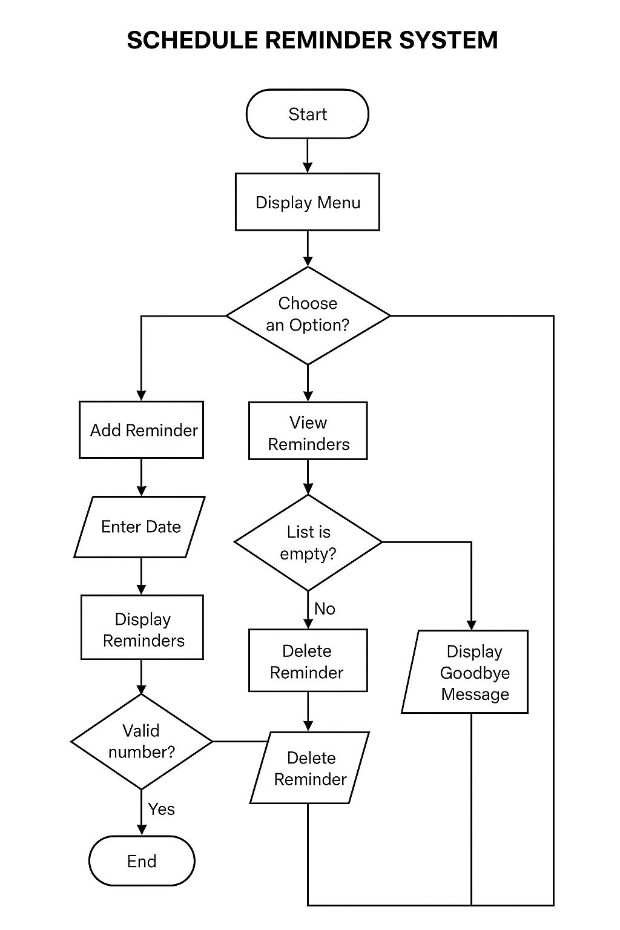

The flowchart shows how the Schedule Reminder Management System works. It starts by displaying a menu where users can add, view, or delete reminders. Each process involves entering data or viewing stored reminders, with decisions made based on user input. The system loops back to the menu after each action and ends when the user chooses to exit.

1.9 Code Snippet of Schedule Reminder Management System works

