Unit 1

Cloud Computing Fundamental



Cloud Computing Architecture and Management



Unit 2

Cloud Deployment Models



Cloud Service Models



Virtualization



Unit 3

Technological Drivers for Cloud Computing



Open Source Support for Cloud



Cloud Computing Economics

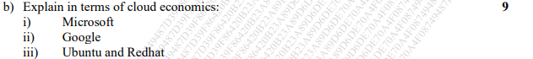

Unit 4

Cloud Service Providers



Application Development



Don’t know



Chapter 14 next two questions