Normal SHutdown

pR-ope-5003
Prepared by: | R P. Del Mundo | Date Created: | 03-18-2024
Reviewed by: | G T. Borja  K R. Mendoza  N L. Falcunit  M P. Castro | Rev No. | 1
Approved by: | Joel D. Ysip | Date Approved

Document Revision Register Page
Revision No. | Description | Date Created | Date Approved | Author
00 | Initial Issue | 07-01-2017
01 | Format Update | 03-18-2024 |  | R P. Del Mundo
01 | Change of company name and logo | 03-18-2024 |  | R P. Del Mundo
01 | Change of signatories | 03-18-2024 |  | R P. Del Mundo

- 1. PURPOSE AND SCOPE

  - This procedure provides the initial conditions, precautions, limitations instructions for a normal shutdown of the Turbine/Generator and Boiler Unit.

  - It covers activities related to a Controlled Shutdown in accordance with the Instruction Manual of the Turbine Generator and Boiler supplier.

- INITIAL CONDITIONS

  - The unit is operating at full load on automatic control.

  - The intention is to reduce the pressure to zero and cool the boiler completely.

  - An order was received by the Shift Superintendent to shut down the TG.

  - Necessary clearance/s from Grid SO (System Operator) to shut down has been obtained. Proper communications are set up within the plant and the Grid Operator.

- PRECAUTIONS AND LIMITATIONS

  - Before implementing any procedure, users of this document must read all information contained herein including the relevant references to ensure proper operations, satisfactory performance and safety of personnel.

  - Shift Personnel shall follow the “Shutdown to Cold” curve.

  - Care must be exercised to prevent water from entering the main steam line, the hot reheat line and the cold reheat line to the turbine from any source during and after the shutdown process. This is to prevent possible water damage to the turbine during a subsequent restart. Possible sources of water are:

    - Overflow from the drum into the superheater as a result of high water level.
    - Water entering the superheater or reheater through the desuperheater due to open desuperheater control valves or possible valve leakage with the feed pumps running.

  - Operators should be alert to detect the symptoms of water carryover from the boiler and introduction of water into the turbine such as:

    - A sudden unexplained drop in steam temperature in either the main steam or hot reheat line.
    - Vibration in the steam piping resulting from water hammer.
    - Abnormal vibration and differential expansion readings from the turbine supervisory instrumentation. Operators must be prepared to take actions necessary to prevent turbine damage upon detection of water introduction. Refer to turbine manufacturer’s instruction for specific actions to be taken.

  - Immediately after the unit is off the line (turbine valves closed and all fires out), superheater drains are opened as required for the desired pressure reduction.

  - If the unit is shut down to cold, the drum vents should be opened when the drum pressure drops to 25 psig.

  - If pressure parts inspection or maintenance is required, the water temperature should be reduced to 95°C (200°F) before draining the boiler. Fans may be operated as required to achieve the desired rate of cooling.

  - The cooling rate must not exceed 85°C (150°F) per hour saturated steam temperature decrease.

  - NOTE: A reduction in furnace temperature as measured by thermocouples located at the startup burner elevation should not exceed 153°C per hour. Basis should be according to the following references:

    - The Curve of “Shutdown to Cold”: Shutdown Curve (Cold).
    - Maximum allowable rate of pressure change for normal start-ups and shutdowns: Maximum Allowable Rate of Pressure Change.
    - The cooling rate of drum steam temperature could be lower depending on the refractory heat-down rate: Refractory Manufacturer Temperature Curve - (Source/reference not found yet).

  - Some back sifting of bed material from the furnace into the air plenum may occur during operation below 50% load where primary air flow is significantly reduced below the full load value. If the plenum is not periodically drained of this material, its sufficient amount to impact PAF performance could possibly damage the plenum support structure. It is therefore recommended that the plenum drains be operated periodically during this boiler load rating.

  - Do not allow idle boilers to remain partially filled with water for any appreciable length of time. If the Shutdown will amount to several weeks, temporarily preserve the Unit by Lay-up to protect the boiler metal against deterioration due to corrosion. Refer to Lay Up Procedure in such condition.

  - When the unit is to be out of service for several days or longer, all ash, soot deposits and bed material should be removed since moisture absorbed by these materials cause corrosion.

  - Temperature differentials between inner and outer surfaces should be minimized and held below that recommended by “Allowable Temperature Differences” in section 7.

  - Prevent damage in bearings of the Turbine Generator; be observant that the oil supply to the bearings is not interrupted.
  - Prevent overheating of the generator during operation, be observant that the supply of cooling water to air coolers and to the oil bearings is not interrupted.

  - Operate the generator within the generator capability curve.

- DEFINITIONS

  - PAF – Primary Air Fan

  - SAF – Secondary Air Fan

  - IDF – Induced Draft Fan

  - FAB – Fluidizing Air Blower

  - TCP - Turbine Control Panel

  - DCS - Distributed Control System

  - VV - Ventilator Valve

  - MSV - Main Stop Valve

  - RSV - Reheat Stop Valve

  - MOP - Main Oil Pump

  - EOP - Emergency Oil Pump

  - TG - Turbine Generator

  - SSFV - Steam Seal Feed Valve

  - PB - Push Button Switch

- PROCEDURES
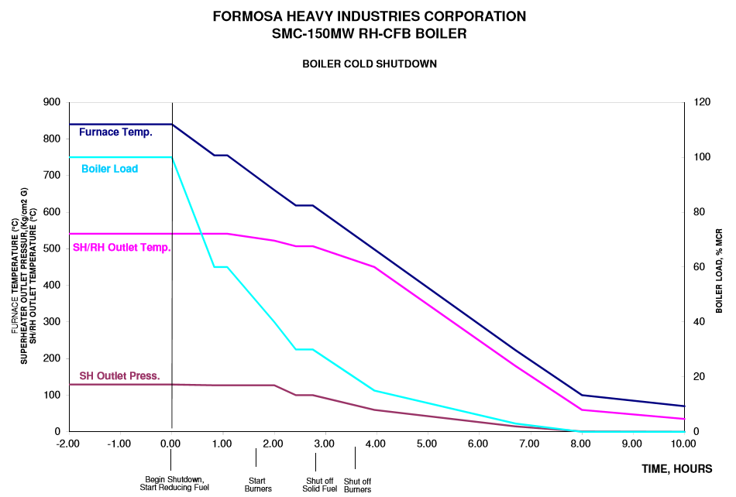
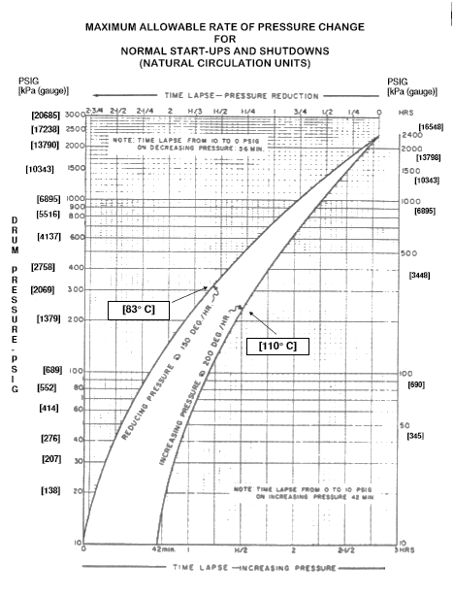
Equipment/Procedure | Tag no. | Operating Limits |  |  | Responsible |  |  |  |  | Status
Equipment/Procedure | Tag no. | Normal | Alarm | Trip | SS/SV | CRO | AO | WTP | MH | Status
NORMAL SHUTDOWN
- Ensure back up power from NGCP. (15-16MW)

Ensure diesel tank is at normal level.

Ensure demineralized tank is at normal level.
- Reduce load. (Manual Operation)
- 150-90MW: 1.2 MW/MIN
- 90-45MW : 0.6 MW/MIN
- 45-30MW : 0.4 MW/ MIN

Note: 0.6t/h of coal = 1MW

Note: During normal shutdown, bypass turbine trip alarm at MFT and boiler interlock to maintain boiler operation.

- Maintain MS Pressure (123-126 ksc)
- Regulate pressure with BOV and soot blowing.
- Maintain bed temperature gradient of -1°C /min.
- Continue bottom ash removal system.
- At approximately 90MW or 60%L (hold for 8-10min)
- At approximately 72 MW or 230t/h MSF, put level control to 1 element.

At less than 120t/h MSF, change level control from main to start-up then put to auto.
At less than 60t/h, control by manual.
- At 60MW, maintain normal MS operating pressure and temperature as possible.

Manual staging air control follows
Set upper to 10%.
Set lower to 15-20%.
(Balance bed temperature.)
- At 750°C bed temperature,
- Put SAF and PAF damper to manual. Increase SAF damper opening, preparation for SUB firing
- Stop limestone and sand feeding. Maintain ESP operation
- Start Air Preheater sootblowing in Continues mode
- Fire SUB one by one. Upon firing, maintain normal SAF air pressure (>1200mmAq, DP of PAF and SAF must not be greater than 600 mmAq to avoid back flow on staging air duct). Increase damper if necessary.
- Note: 2.5t/h of coal = 1t/h of diesel
- Gradually increase diesel flow while reducing coal flow up to minimum, i.e. 4t/h per feeder.
- Maintain bed temperature gradient of -1°C /min.
- At approx. 45MW (Hold for 8-10min) Maintain normal MS operating pressure and temperature as possible.

At <9.5ksc or <230°C or CRH pressure and temperature or turbine trip, auxiliary steam supply will automatically change from MS.
- At 40 MW  - Remove extraction 3, 2 and 1.  - Set D/A pressure control valve to 2.5ksc. | PCVAS1030
- At 700°C bed temperature
- Stop coal feeder one by one.
- Reduce diesel flow. (Cooling rate is -1°C/min.)
- Gradually reduce PAF damper opening until 20%
- Maintain ESP operation as needed
- At 30MW,
  - Remove extraction 5 and 4
  - Turbine shutdown/turbine trip.
  - Condition Upon TG trip,
    - 52G and FCB open.
    - Ventilator valve opens.
    - MSVs, CVs, CRVs close.
  - Turbine operation will shift to bypass system upon TG trip, HP and LP bypass and RH BOV will automatically open to maintain RHP SV=7.6ksc.
  - Monitor:
    - MS Pressure – Regulate at MS BOV.
    - Drum level (Delay of 5 minutes for HH) – maintain normal level
    - Hot well level – maintain normal level
    - Put Biasing damper to manual, RH=10% and MS=90%.
- Maintain Bypass system operation until Cyclone exit temperature reaches less than 535°C
- Put HP bypass to manual, open HP Bypass valve to 12% opening to minimize pressure drop
- At less than 535°C cyclone exit temperature
- Stop Coal feeders if not yet stop
- Stop SUB
- Stop Bypass operation (MS Blow off close)
- Purge boiler
- Stop draft system as fast as possible to minimize temperature drop (PAF & SAF Dampers close, IDF Damper 3-5% opening)
- Stop Ejector.
(Make sure all drains going to hotwell and flash chamber are closed before stopping vacuum.)
- Open Vacuum breaker
- Stop gland sealing
- Close Auxiliary steam supply.
- Maintain normal drum level.
(Run BFP with chemical as needed.)
Before stopping BFP, set the drum level near to HH. (blow down valve must be close) (Restart BFP if needed)
- At 1rpm, turning device will engage
(Lube oil is still running.)

