**PRODUCT TITLE**

LOGO

PROJECT TEAM

PICTURE

PICTURE

PICTURE

PICTURE

NAME NAME NAME NAME

**Business Model Canvas**

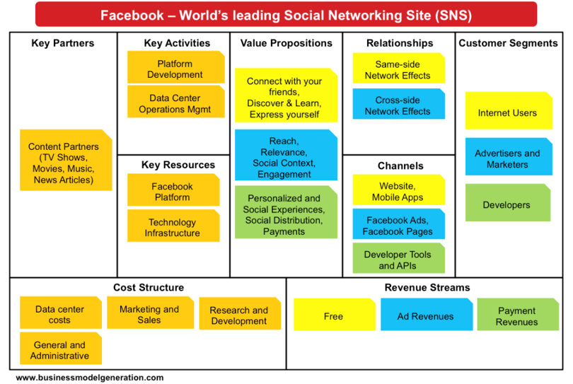

|  |  |  |  |  |  |
| --- | --- | --- | --- | --- | --- |
| **Key Partners**  **Local Government Units** | **Key Activities**  System Development  Maintenance and Updates  Customer Feedback | **Value Propositions**  Reduces paperwork  Provides easy access to documents through a web-based platform  Simple and intuitive design | | **Relationships**  Personal Assistance  Self-Service | **Customer Segments**  Municipal Staff  Barangay Officials  Administrative Staff |
| **Key Resources**  Servers and Hosting  Technical Team | **Channels**  Website  Partnerships |
| **Cost Structure**  **Development Costs**  **Hosting Costs** | | | **Revenue Streams**  Government Funding  Service Fees  Consulting Fees | | |

**SIMPLIFIED VALIDATION BOARD**

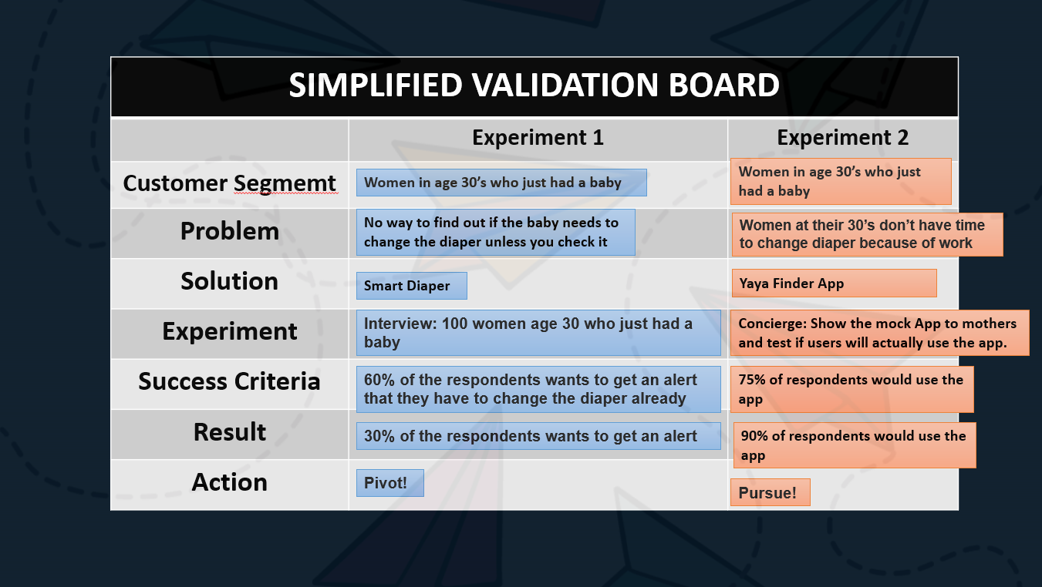

**PROTOTYPE**

(PICTURES/SCREENSHOT)

Organization runs information and it has a particular way of gathering, storing, and having a quick fill- up forms. Information for collecting and storing documents are compiled through paper; nevertheless, management systems have completely revolutionized the process of applying forms in each program. The developed system’s concern is to help the Department of Interior and Local Government to resolve some problems regarding their document management.

The system "E-GovDocs: Web-Based Document Management and Tracking System for Municipal Hall of San Teodoro" is a comprehensive solution designed to ease the way of managing documents of each barangays in San Teodoro. The system can minimize paper works which can lead to an efficient and effective system. Additionally, it provides a user-friendly graphical user interface for both the administrator and the user. Having a system will improve the productivity process considering the high rate of the population to have a more effective and hassle-free management of the documents.