**Chapter I  
INTRODUCTION**

**Project Context**

In the digital age, the transformation of traditional governance practices has become imperative to enhance efficiency, transparency, and accessibility. Municipalities, as fundamental units of local administration, are increasingly embracing innovative solutions to streamline their operations. This research focuses on the implementation of an E-governance portal and a web-based document management and tracking system tailored for the Municipal Hall of San Teodoro, Oriental Mindoro.

E-governance, an umbrella term encompassing various electronic means to facilitate government operations, has emerged as a pivotal tool for modernizing administrative processes. The envisioned E-governance portal for San Teodoro promises to revolutionize the way municipal services are delivered, fostering a more responsive and citizen-centric approach. By leveraging web-based technologies, this portal aims to optimize information management, communication, and service delivery.

The proposed web-based record management system is a crucial component of this initiative, seeking to address the challenges associated with traditional paper-based recordkeeping. The system is designed to enhance the accuracy, accessibility, and security of municipal records, ensuring that information is readily available to authorized personnel while safeguarding against data loss or damage.

This research will delve into the specific features, benefits, and potential challenges associated with the implementation of the E-governance portal and document management and tracking system in the context of San Teodoro. By examining case studies, best practices, and feedback from stakeholders, the study aims to provide insights into the practical implications and outcomes of adopting such technological solutions. Ultimately, the goal is to contribute valuable recommendations for the successful integration of E-governance tools in the municipal administration of San Teodoro, Oriental Mindoro.(Palomo-Navarro & Navío-Marco, 2020)

The Municipal Hall of San Teodoro, Oriental Mindoro, stands as a pivotal institution anchoring the local governance and civic life of the community. Nestled in the heart of Oriental Mindoro, this administrative hub plays a crucial role in shaping the socio-economic landscape of the municipality. From orchestrating public services to fostering community engagement, the Municipal Hall serves as a nexus for local governance, embodying the aspirations and initiatives that define San Teodoro. This research endeavors to delve into the historical roots, organizational structure, and multifaceted functions of the Municipal Hall, shedding light on its significance in the context of local development and governance in Oriental Mindoro.(Sobczak & Ziora, 2021)

By digitizing record-keeping procedures, an E-Governance Portal with a Web-Based document Management and tracking System seeks to increase efficiency. Transparency and accessibility are encouraged by the ease with which government records can be managed, stored, and retrieved online. Information can be securely accessed by users, cutting down on paperwork and simplifying administrative duties. To improve government accessibility, efficiency, and transparency, an online records management system integrated with an e-governance portal is essential. It permits an effective document management system and lowers the possibility of data loss or improper handling by enabling the systematic and safe storage of government records.

**Objectives of the Study**

The main objective of this project is to develop a system that can manage the record for Municipal Hall of San Teodoro that will organize the data and information that will be stored, updating the records, and will enable faster and more efficient storage.

Specifically, the project aims to fulfill the following:

1. To develop a user-friendly website for the document management of the Municipal Hall of San Teodoro;
2. Integrate the platform with a tracking system for managing the documents;
3. Ensure secure and efficient document management; and
4. Implement a reliable record management and tracking system for the employees on the organization.

**Scope and Limitation of the Study**

The scope of " E-Governance Portal: Web-Based Document Management and Tracking System for Municipal Hall of San Teodoro" encompasses the development and implementation of an integrated digital platform that aims to improve various aspects of Municipal record data management.

The limitations of the system are the municipality records, security, and privacy challenges; while efforts will be made to enhance data and information security, there may still be inherent security and privacy challenges that cannot be eliminated. The proposed system will accommodate the transactions of the Municipal hall in municipality of San Teodoro Oriental Mindoro, Philippines.

**Significance of the Study**

The significance of the study justifies the need to conduct this study. It specifies the group of people who benefit from the study. The result of this study benefits the following:

**Administrator**. This study helps the Administrator to gather and organize the data from different barangay/LGU representatives the staff and user.

**LGU Representative**. This study helps the LGU representatives to easily input the data needed by the department. The data were also monitored by the administrator in the management system.

**Researchers**. The proposed project enhanced the knowledge and skills of the proponents as they continuously discovered new ideas during the development of the system.

**Future Researchers**. This study serves as a handy reference for the other researchers who embark on a similar study in the future especially on certain aspects not derived into by the present study.

**Conceptual Framework**

This conceptual framework represents the organization of ideas of the system E-Governance Portal. It also shows the interrelation of different components and ideas utilized and used in the development of the project.

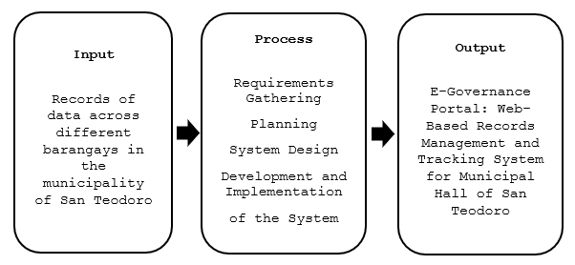

**Figure 1. Conceptual Network**

Figure 1 shows the conceptual framework of the E-Governance Portal: Web-Based Record Management and Tracking System for Municipal Hall of San Teodoro. It aims to enhance the user experience and improve the efficiency of document management. With a user-friendly interface and intuitive design, it simplifies the recordkeeping process, enabling the organization to manage their documents and monitor the status of each documents seamlessly.

**Definition of Terms**

The key terms in the study are listed and defined below.

**E-Governance Portal.** A Web-Based Record Management and Tracking System for Municipal Hall of San Teodoro.

**Municipal hall.** A use that provides for conducting local government business, services and activities and related public services and activities, within offices, meeting rooms or Council chambers.

**Web Application**. Internet-based software for easy access to system functionalities.

**Administrator.**  A person who manages the information of the users and the system.

**Chapter II**

**REVIEW OF RELATED LITERATURE/SYSTEM**

The researchers researched relevant and related studies to be the basis and to gain ideas about the project. These provided the researchers with ideas on how the system may work.

**Related Literature**

Governments have a major role in the efficacy of a functioning society. Governments ensure that citizens do not encroach on the rights of others. They also ensure that citizens follow the rules and regulations which have been instituted by the state.(Singh, 2019) and (Negro-Calduch et al., 2021) Electronic governance (e-governance) is the application of information and communication technology (ICT) to provide government services to citizens, organizations and government digitally (Iyer and Rao, 2019; Joseph, 2019; Heeks, 2020; Gupta and Jana, 2020). E-government comprises strategies and course of actions; carried out through person, substantial technology and procedures. E-governance initiatives were successfully implemented and achieved new growth level in the developed and developing countries. But there is an immense difference in growth achieved by both type of countries (Liu et al., 2019).

E-Government is commonly conceptualized as governments' use of Information and Communication Technologies (ICTs) combined with organizational change to improve the structures and operations of government (Field, Muller, Lau, Gadriot-Renard, & Vergez, 2020). Also, the implementation of e-government is expected to help governments deliver services and transform relations with barangay citizens, data and other arms of government (Grönlund & Horan, 2019; Guida & Crow, 2019)and (Twizeyimana & Andersson, 2019).

The literature on e-governance has highlighted the potential of ICTs to enable good governance and socioeconomic development by leveraging stakeholders and resources within and outside the government to address specific challenges.(Smith et al., 2020) A significant challenge in many developing countries is the inability of large segments of the population—particularly, the vulnerable poor—to receive and benefit from services or public provisions because they lack a means of formal identification. Various digital identity projects worldwide have attempted to address the problem through an umbrella approach dubbed identification for development (ID4D). However, little is known about how digital identity advances e-governance by enabling socioeconomic development through inclusion.(Addo & Senyo, 2021).

However, intends to nurture digital ecosystems across all the sectors including health, education, agriculture, resources, financial services etc. The concept of e-governance is to involve IT in all the government processes. “e-Governance or electronic Governance is understood as the use of Information and Communications Technology (ICT) at all the level of Government in order to provide services to the citizens, interaction with business enterprises and communication and exchange of information between different agencies of the Government in a speedy, convenient, efficient and transparent manner” (Ministry of Electronics & Information Technology, Government of India). “E-governance, in essence, is the application of Information and Communications Technology to government functioning in order to create ‘Simple, Moral, Accountable, Responsive and Transparent (SMART)’ governance”.(Growth & Wadhwa, 2020)

In the pursuit of government intensification, Lappas et al. (2019) Through their paper “An evaluation scheme for local e-government and local e-democracy: the case of Greek municipalities” the study is focused on the development of a citizen-centric framework for the evaluation of municipal websites that is validated in the context of Greek local governments.(Vaidya, 2020)

Vaidya, (2020) and Asamoah, (2019). Today connectivity, convergence, internet and networks are essential for the success of Networked Economy. The new information and communication technologies (ICTs) have been recognized as the engine for growth and a source of energy for the social and economic empowerment of any country. These technologies have all the attributes that E-governance initiatives in Chandigarh (India) 5 go into the making of Good Governance. Creative convergence of technologies will result in easier access to public services, transparency, cost effectiveness and other features of good governance.

However, the challenges associated the recent global pandemic has highlighted the importance of efficient communication between the government and its citizens through online platforms. While approximately 90% of governments around the world have opened up their websites to provide government information and public services, many have been criticized for their quality issues. The unsatisfactory upkeep of government websites may be due to the lack of adequate guidelines and evaluation tools for public managers, which would enable them to achieve the superior goals of e-government initiatives.(Hanif et al., 2018) (Sethi et al., 2020). Various countries are implementing e-governance to curb corruption and red-Taoism and enhance transparency, accountability and responsiveness to the stakeholders. To ensure this, e-governance practitioners are reengineering the old government processes to make them fit to deliver services as per the expectations of citizens.(Hooda & Singla, 2020)

Addressing the challenges in government related from municipalities, from the demand side, the need to build e-Governance capacities and expertise is increasing and requires more and more sophisticated knowledge and competencies to fulfil the stakeholders’ needs. The e-Governance profession and skills needs are also becoming more diverse and more specialized. From the supply side, we can also witness a growing interest in the e-Governance learning and programs worldwide at different level. However the programs offered are often not well aligned adapting neither to the government’s, nor to the public service needs. The e-Governance curriculum is a key success factor to reduce the gap.(Dhaou et al., 2019). With technological advancement and innovation, service delivery has become more open and accessible in many developed countries (Finger & Pecoud, 2019). Technological innovation has also been adopted in the developing world, changing the nature of service delivery (Baroi & Alam, 2020). In recent years, many governments have been attracted by the promise of digital financial platforms to reduce this leakage. By enabling “just-in-time” financing, such platforms can end the need for advance funds disbursement. Funds are only disbursed in response to a specific invoice, which makes it much easier to verify that they are used as claimed; all auditors have to do is to check with the final beneficiary named in the invoice that they have been paid. This can reduce leakage and lower expenditures on monitoring(Baroi & Alam, 2020).

In connection with e-governance systems, e-government refers to the use, by government agencies, of information technologies that have the ability to transform relations with citizens, business, and other government departments. These technologies can serve a variety of different ends: better delivery of government services to citizens, improved interaction with business and industry, citizen empowerment through access to information, or more efficient government management(For et al., n.d.). The impact of e-governance practices has increased the excellence of good governance. E-Governance became a vital tool to enhance the standard of government services to the people. It has been creating more transparency in services. It reduces the corruption and cost for people as well. It drives government services more accessible (Gupta R, 2019). The strong political power and social acceptability of e-governance are the essential elements of the development. The term e-government was developed in the late 1990s. E-governance is known as electronic governance. It explains the utilization of Information and Communication Technology (ICTs) to allow citizens and organizations with more appealing government services and information.(Reji & Vidyapeetham, 2021)

The digital age has led to a substantial increase in internet users in the Philippines, particularly in engaging with e-government activities. The World Economic Forum on readiness and development of ICTs of major economies have also become the basis for the judgment of national competitiveness. In addition, Waseda University e-government research emphasize the importance of open government, government chief information officer, etc. From the perspective of good governance, e-governance must still account for public values such as participation, transparency, accountability, sustainability, and equity, and avoid becoming a one-dimensional system hijacked by efficiency. The development and application of ICTs should not deviate from its fundamental goal of responding to public value. Due to the promising nature of e-governance, it appears that identifying the factors that would help facilitate public value of information technology is extremely important. However, most e-governance evaluation indicators are based on either infrastructural dimensions or operational public values. There is still a lack of attention on dimensions of society and sustainability(Data & Concepts, 2018).

Palma et al(2023) the same challenges are being experienced by our government today, especially in implementing digital technologies for public services. However, the COVID-19 pandemic made digital transformation the new normal (Elsersy et al., 2021). The government had to play its part in providing clear, up-to-date information to the public, health workers, and local authorities while reducing the spread of fake news and lowering the risk of potential cybersecurity and data privacy issues (Farrell et al., 2020). A review done by the United Nations Department of Economic and Social Affairs (UN DESA) shows that among 193 UN Member States’ national portals, the researchers have 188 countries (97.5%) that were able to set up a dedicated government portal for information sharing and monitoring (Department of Economic and Social Affairs, 2020). In addition for this study the urban was allocated and give a contribution for different sector in government,(C. H. H. Wong et al., 2021) in the process of identifying relevant studies, Web of Science was chosen as the search engine as it stores peer-reviewed research literature with multi-disciplinary nature, which is essential for building energy simulation study as it is related to the branches of structural engineering, physics, data science, spatial planning and urban design to name a few. Financial literacy is defined as the ability of an individual to make informed judgements and take effective decisions regarding the use and management of financial resources (Nkundabanyanga & Kasozi, 2019). As noticed, knowledge about finance is very essential, not only for individuals but also for enterprises as well. Hence, financial literacy has been identified as a basic tool for growth, development of organizations and individual’s financial stability.(Tuffour et al., 2022)

**Related System**

As government continues to evolve, technological advancements have played a pivotal role in enhancing efficiency and sustainability. One notable development is the integration of intelligent systems to address various aspects of recording data. (Authors, 2019)E-Governance in economy is seen as a complementary subject of information security where e-service delivery ensuring the IT policy development is the main focus. Apart from important instructions, the policies in the segment of e-Governance framework are important for implementing procedures and security controls in various organizations and sectors. In order to frame security IT policy and support the process of e-services delivery to citizen, the area of information security governance is more challenging in the context of meeting the Indian objectives of sustainable development. Various implementing frameworks and routes have been developed as processes to fill the present gaps of the governmental development, where many actors are involved in the process of e-Governance process implementation. Leading actors i.e. the Ministry of Electronics and Information Technology (MeitY), the Government has taken a number of policy measures in the recent years of e-Governance. It is hard to imagine any government function or governance process that does not involve extensive use of information and technology. The use of information and communication technologies (ICT) in government, and the explosion of digital information throughout society, offers the possibility of a more efficient, transparent, and effective government. At the same time, these trends challenge traditional notions of administration, management, organization, accountability, and engagement(Gil-garcia et al., 2019).

Record of data governance refers to the exercise of authority and control over the management of data.(Assiri et al., 2020) The purpose of data governance is to increase the value of data and minimize data-related cost and risk. Despite data governance gaining in importance in recent years, a holistic view on data governance, which could guide both practitioners and researchers, is missing. (J. K. W. Wong et al., 2018)In this review paper, we aim to close this gap and develop a conceptual framework for data governance, synthesize the literature, and provide a research agenda. We identify the major building blocks of data governance and decompose them along six dimensions. (Abraham et al., 2019)

Technologies & Waziri (2020) the importance of proper management of records cannot be overemphasized. Many organizations today rely on various records for their activities. Some organization cannot even protect their organization against litigation without their records. It is evident that records play a vital role in an organization today, it can be seen today that many organizations have realized the importance of records and are racing towards the introduction of a robust system to help protect and manage their records. Many developed countries have since introduced roadmaps and policies to guide their records management. Some of them have already moved to the electronic system of records. The public service in some countries is mandated to use the Electronic Records Management system (ERMS) in a bid to ensure the security, safety, and quality of records in the country.

**Synthesis**

The advancement of digital technology (DT) has had a profound impact on the way many traditional industries perform their daily functions. Easy access to information and acceleration of the pace of communication has revolutionized most knowledge-based industries, including the government sector. While advances in computer-aided design (CAD) software and building information modelling (BIM) have progressively changed traditional design practices and communication methods. The adoption of electronic governance of record management of municipal hall in the management of municipal records signifies a fundamental change from conventional paper-based systems to digital platforms. A key component of this transformative process is the complete digitization of records, which makes maintenance, retrieval, and storage more effective. Municipalities can provide online services through e-governance, giving citizens easy access to a range of services without requiring their physical presence. This leads to a more responsive and citizen-centric approach to governance while also improving citizen convenience. Since e-governance makes it easier for citizens to access public records, it is essential for promoting accountability and transparency in government benefits of digitization are best exemplified by the gains in productivity and efficiency that result from automating record-keeping processes. However, concerns about data security and privacy, the potential for a digital divide, and the necessity of continuous capacity building for municipal workers must all be taken into consideration. A town's capacity to adapt to technological developments while upholding inclusive, secure, and dependable systems is essential to the effectiveness of e-governance in record keeping. In essence, the synopsis emphasizes the intricate connection between e-governance and municipal record keeping, highlighting the advantages of doing so as well as the need to address associated problems in order to have a successful and sustainable digital transition.

**Chapter III**

**METHODOLOGY**

This chapter focused on the methodology used by the researchers in the development of the system.

**Development Method**

This study utilized quantitative as a research design, this design produces logical, statistical, and unbiased findings. Data was collected in an organized manner and on larger sample that were representative of the total population. Quantitative research collects information from existing and potential customer using sampling methods and sending out online surveys or questionnaires, the result of which can be depicted in the form of numerical.

**Figure 2. Agile Methodology**

**Planning**

In the initial phase of the Agile SDLC for E-Governance Portal, researchers proposed a solution to enhance the recordkeeping of local government units, leading to the idea of developing a web-based document management system. Objectives and scope were formulated after an extensive brainstorming session, laying the groundwork for the development plan.

**Data Gathering/Analyzing**

During the data gathering and analysis phase, researchers scoured the internet for relevant literature and assessed software and hardware specifications. Interviews

with potential users provided valuable input, and an extensive review of related literature ensured a strong foundational understanding. The significance of E-Governance Portal was sustained through comprehensive research.

**Designing**

In the design phase, researchers created system flowcharts and diagrams, focusing on a logical graphical user interface (GUI). Incorporating ideas from interviews, the GUI was designed to minimize errors and enhance user experience.

**Coding**

In the coding phase, researchers utilized web development tools like Visual Studio Code and Laragon, employing HTML, CSS, and JavaScript skills. PHP served as the primary programming language, Bootstrap as the development framework, and MySQL as the database platform.

**Testing and Debugging**

Testing involved rigorous evaluation of E-Governance Portal’s functionalities to identify areas for improvement. Continuous testing, involving both researchers and users, ensured the system met expectations. Bugs and errors were addressed, and necessary changes were made for a polished final output.

**Evaluating**

Researchers conducted evaluations with target users (LGU and barangay staffs), students, and IT experts to gauge user satisfaction. Collected responses informed a conclusive evaluation, and results were tabulated and presented with corresponding verbal interpretations.

**Gantt Chart**

In most project management, gantt chart is commonly used. It presents the project schedule and work completed over a span of time from year November 2023 until January 2024. This helped the researchers monitor the progress and oversee every aspect of the system and the research.

Moreover, the gantt chart on the next page also shows how the researchers divided the different tasks in a timely manner. The chart also became the basis to know which task to do next to avoid bypassing the formal process.

Listed on the left side of the table are the activities conducted in the development of the project. Below each activity are the subtasks or activity breakdown to make the development more concise and manageable. The topmost part of the table is the time scale such as the months and weeks consumed. Below the months are the number representation of weeks that a month has.

Each activity demanded a corresponding amount of time and each of such is represented by a yellow bar. The length of a bar reflects the period that an activity is spent. Please see the chart to know more about the timeline and details.

**Table 1. Gantt Chart**

|  |  |  |  |  |  |  |  |  |  |  |  |  |  |  |  |  |  |  |  |  |
| --- | --- | --- | --- | --- | --- | --- | --- | --- | --- | --- | --- | --- | --- | --- | --- | --- | --- | --- | --- | --- |
| **Task Name** | **Task Date** | | | | | | | | | | | | | | | | | | | |
| Nov | | | | Dec | | | | Jan | | | | Feb | | | | Mar | | | |
| Week 1 | Week 2 | Week 3 | Week 4 | Week 1 | Week 2 | Week 3 | Week 4 | Week 1 | Week 2 | Week 3 | Week 4 | Week 1 | Week 2 | Week 3 | Week 4 | Week 1 | Week 2 | Week 3 | Week 4 |
| **1.Planning** |  |  |  |  |  |  |  |  |  |  |  |  |  |  |  |  |  |  |  |  |
| 1.1 Conduct an interview |  |  |  |  |  |  |  |  |  |  |  |  |  |  |  |  |  |  |  |  |
| 1.2 Define project objectives |  |  |  |  |  |  |  |  |  |  |  |  |  |  |  |  |  |  |  |  |
| 1.3 Define project plan |  |  |  |  |  |  |  |  |  |  |  |  |  |  |  |  |  |  |  |  |
| 1.4 Approval of project plan |  |  |  |  |  |  |  |  |  |  |  |  |  |  |  |  |  |  |  |  |
| **2.Requirements Gathering** |  |  |  |  |  |  |  |  |  |  |  |  |  |  |  |  |  |  |  |  |
| 2.1 Data Collection |  |  |  |  |  |  |  |  |  |  |  |  |  |  |  |  |  |  |  |  |
| 2.2 Functional |  |  |  |  |  |  |  |  |  |  |  |  |  |  |  |  |  |  |  |  |
| 2.3 Non-Functional |  |  |  |  |  |  |  |  |  |  |  |  |  |  |  |  |  |  |  |  |
| **3.Design** |  |  |  |  |  |  |  |  |  |  |  |  |  |  |  |  |  |  |  |  |
| 3.1 Frontend software design |  |  |  |  |  |  |  |  |  |  |  |  |  |  |  |  |  |  |  |  |
| **4.Development** |  |  |  |  |  |  |  |  |  |  |  |  |  |  |  |  |  |  |  |  |
| 4.1 Back-end coding |  |  |  |  |  |  |  |  |  |  |  |  |  |  |  |  |  |  |  |  |
| **5.Testing** |  |  |  |  |  |  |  |  |  |  |  |  |  |  |  |  |  |  |  |  |
| 5.1 Functionality testing |  |  |  |  |  |  |  |  |  |  |  |  |  |  |  |  |  |  |  |  |
| 5.2 User interface testing |  |  |  |  |  |  |  |  |  |  |  |  |  |  |  |  |  |  |  |  |
| **6.Implementation** |  |  |  |  |  |  |  |  |  |  |  |  |  |  |  |  |  |  |  |  |
| **7.Maintenance** |  |  |  |  |  |  |  |  |  |  |  |  |  |  |  |  |  |  |  |  |
| 7.1 Project monitoring |  |  |  |  |  |  |  |  |  |  |  |  |  |  |  |  |  |  |  |  |
| 7.2 Resolve system errors |  |  |  |  |  |  |  |  |  |  |  |  |  |  |  |  |  |  |  |  |

This gantt chart shows the progress and status of work done throughout the past months of 2023 up to 2024. Phases of SDLC such as coding together with testing debugging, consumed a longer amount of time.

**Requirements Specifications**

The requirements specification is a set of collected requirements that should be satisfied by the system or project E-Governance Portal.

**Functional Requirements**

The project “E-Governance Portal: Web-Based Document Management and Tracking System for Municipal Hall of San Teodoro” was developed with the following functional requirements. The requirements below are incorporated into the project.

**Table 2. Functional Requirements**

|  |  |
| --- | --- |
| **Features** | **Description** |
| **1.** Records Classification and Identification | The admin can organize and classify the electronic records in a structured manner based on the subject and type of records. |
| **2.** File Management | Capturing the content of documents/files in different file formats which were created, received or sent through a wide range of sources and managing them in the system. |
| **3.** Use of Records | Supporting users to search, retrieve, print, download, etc. in accordance with the security and access  control of records |
| **4.** Security and Access Control | Protecting records from unintentional or unauthorized alteration, deletion, access and retrieval; and monitoring the integrity of  records through audit trails. |
| **5.** Document/File Upload | The barangay officials/users can upload documents in the system. |
| **6.** QR Code Generation | The system should provide a qr code feature to track the status of the documents. |
| **7.** Data Visualization | Include visual representations of data such as all documents including incoming and outgoing documents, for easy analysis by administrators. |

Table 2. shows that the E-Governance Portal: Web-Based Document Management and Tracking System for Municipal Hall of San Teodoro consists of Document Management, Tracking, Records Classification and Identification, File Management, Use of Records, Security and Access Control, Retention and Disposal, and Document/File Upload.

**User Interface**

The user interface of the system shows the register page of the system. This is where the user will initially direct to the moment they access the website.

  
**Figure 3. User Interface**

The researchers chose a website design that would complement the E-Governance Portal GUI. The design has a minimalist style and color palette with a red color, combined with black as the background which some users may find too plain, but the majority find visually appealing owing to the well-chosen color choices.

**Hardware Interface**

The hardware used in this project follows the required specifications in in developing this system. The hardware interface included in this method defines the logical and physical characteristic of each interface between the software product and the hardware component of the system. The researchers used an Acer Aspire i3 and 4GB Random Access Memory and a hardware of 512 GB storage that would be sufficient for the storage of the OS, databases, files, and other important things to be used.

**Software Interface**

The software interface is one of the most important interfaces because it describes the difference between the system and other software components (name and version) including database, operating system, tools, libraries, and integrated commercial components. The researchers used different applications such as Visual Studio Code, PhpMyAdmin for database management and others to be mention in software specification.

**Security Requirements**

Before determining if the program is secured, the researchers first determined exactly what a security requirement is all about. The researchers ensured that the system is accessed only by authorized persons. Through username and password, the admin and users can have access to the system.

**Technical Background**

The technical background gives important information regarding technical aspects of the project which makes it easier to define what is required in easy-to-understand words for developers. The next sections go over hardware and software specifications.

**Hardware Specifications**

The “E-Governance Portal: Web-Based Record Management and Tracking System for Municipal Hall of San Teodoro” requires the following hardware specifications:

**Table 3. Hardware Specifications**

|  |  |  |  |  |
| --- | --- | --- | --- | --- |
| **Hardware** | **Functions** | **Specification** | | **Unit** |
| **Minimum** | **Recommended** |
| **Computer/**  **Processors** | Computers and Servers, it is Use for hosting the software applications. Adequate processing power, memory, and storage capacity. | **Intel(R) Celeron(R) N4020 CPU** | **I3 and above of versions** | **1** |
| **RAM** | It serves as a type of volatile computer memory that is used to store and provide quick access to data that is actively being used and processed by a computer's CPU (Central Processing Unit). | **2gb** | **4gb** | **2** |

The table above shows the laptop hardware specifications used in the development of the system. Following is the minimum specification that should make the development of the web application fast and easy.

**Software Specifications**

The “E-Governance Portal: Web-Based Record Management and Tracking System for Municipal Hall of San Teodoro” requires the following software specifications.

**Table 4. Software Specifications**

|  |  |  |
| --- | --- | --- |
| **Software Used** | **Minimum Specification** | **Recommended Specifications** |
| Operating System | Windows 8 64 bit | Windows 10 or the Latest |
| Visual Studio Code | Version 5.2.2 | Version 5.2.2 or above |
| Code Igniter 4 | Code Igniter 4.4.1 | Version 4.4.1 or the Latest |
| PhpMyadmin 5.2.1 | PhpMyadmin 5.2.1 | Version 5.2.1 |
| Laragon 5.2 | Laragon 5.2 | Version 5.2 or the Latest |
| Web browser | Google Chrome | Brave browser |

The table indicates the software specifications of the desktop device needed for system development. The minimum and recommended software specifications for laptop are included as well such as the operating system, application system, web browser, database, and web server.

**System Analysis and Design**

The system analysis and design deals with how the researchers are going to develop the system through a projection of what a system should do.

**System Overview**

The system "E-Governance Portal: Web-Based Document Management and Tracking System for Municipal Hall of San Teodoro" is a comprehensive solution designed to ease the way of managing documents of each barangays in San Teodoro. The system can minimize paper works which can lead to an efficient and effective system. Additionally, it provides a user-friendly graphical user interface for both the administrator and the user. Having a system will improve the productivity process considering the high rate of the population to have a more effective and hassle-free management of the documents.

**System Architecture**

The system architecture below defines the structure and behavior of the website E-Governance Portal. The website is composed of several components such as the web-based system, database (MySQL), and server (Laragon). All those components are interconnected to the behavior of the website.

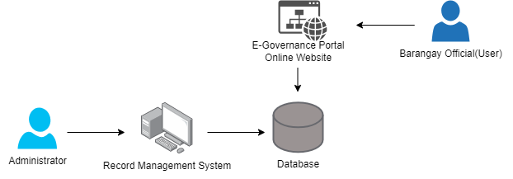

**Figure 5. System Architecture**

Shows the system architecture of the development of the E-Governance Portal. It displays the flow and how the system work.

**Use Case Diagram**

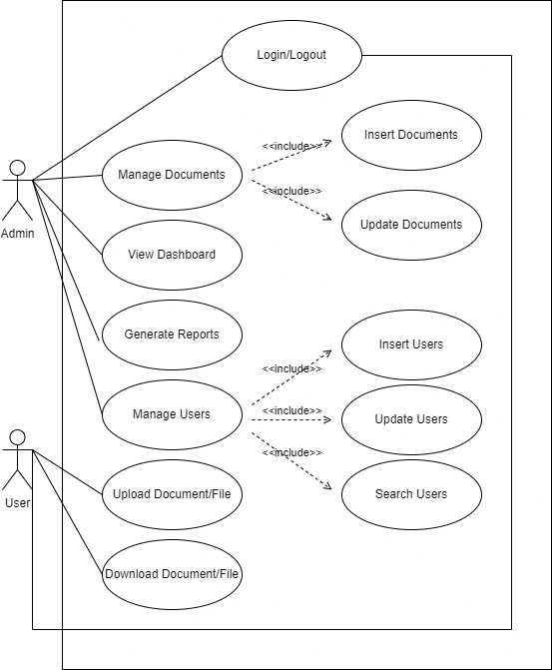The use case diagram of “E-Governance Portal: Web-Based Record Management and Tracking System for Municipal Hall of San Teodoro” implies what features of the website can be used by a specific user.

**Figure 6. Use Case Diagram**

The diagram shows the roles of both the administrator and the user to be executed in the whole process of the system. The administrator has the capability to manage documents, including adding and updating them. Additionally, the administrator can manage user accounts by creating, updating, or searching user profiles. A dashboard is accessible to the administrator, displaying relevant statistics and information about the system. The administrator can also generate various reports related to document management. As for the users, they can upload documents to the system, and they can also download documents from the system.

**Activity Diagram**

The users will sign up/create an account on the system. After creating an account, they can now log in to the system. The users can upload documents and manage them.

**Data Flow Diagram**

The Data Flow Diagram of E-Governance Portal presents how the process of data in the website flows. It also shows the relationships among different entities.

**Context Diagram**

This presents the basic overview of the whole system or process being analyzed.

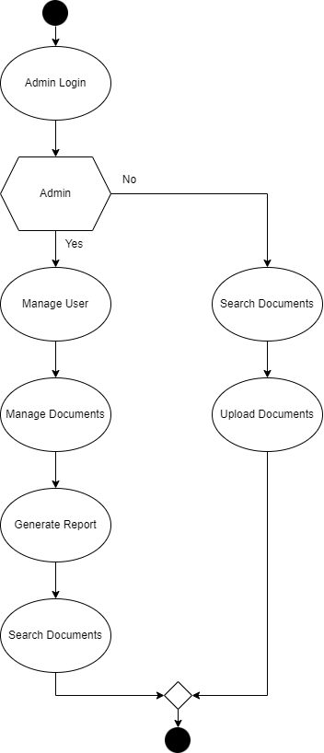

**Figure 8. Context Diagram**

Figure 8 context diagram/level 0 shows the sequence of the system on the admin side. The system indicates all the functions that the admin and the users can do. Admin can select any of the following bases on how they need it and use the system.

**Database Schema**

The Database Schema shows the layout of how data in the database are defined. It also describes how the necessary data are organized and connected.

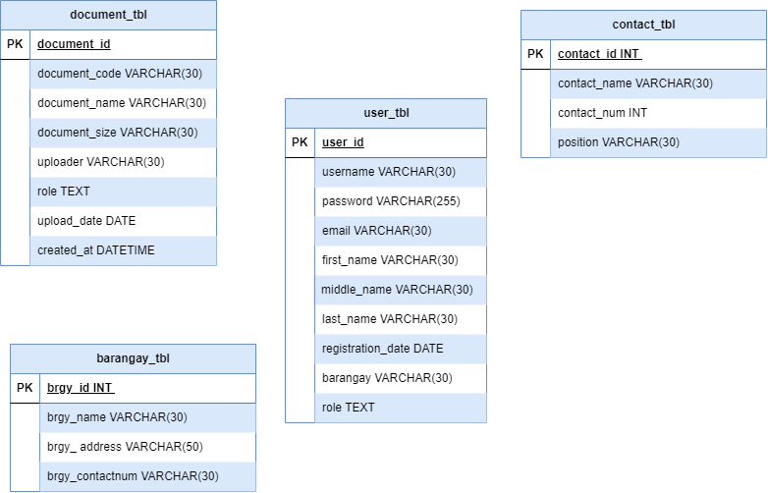

**Figure 9. Database Schema**

System design was an important stage in the study's development. This phase displayed the properties of the entities in the system. This allows the user to view the attributes of existing entities. It describes the data from the study.

**Testing and Evaluation**

This is the type of task that must be completed for all components of the system to be thoroughly tested and the system to be effectively implemented. The system has undergone various revisions in order to maximize the number of services that it can provide. We also make certain that the system is usable.

**Implementation Plan**

Before the actual implementation of the project, testing and debugging were done to ensure that there are no bugs that would become a hindrance from getting the expected implementation output. Consistent trial and error assessments were conducted.

**Bibliography**

Abraham, R., Schneider, J., & Brocke, J. (2019). International Journal of Information Management Data governance : A conceptual framework , structured review , and research agenda. *International Journal of Information Management*, *49*(July), 424–438. https://doi.org/10.1016/j.ijinfomgt.2019.07.008

Addo, A., & Senyo, P. K. (2021). Advancing E-governance for development: Digital identification and its link to socioeconomic inclusion. *Government Information Quarterly*, *38*(2), 101568. https://doi.org/10.1016/j.giq.2021.101568

Asamoah, K. (2019). E-governance in Africa’s local governments: Do district assemblies in Ghana optimize the use of websites and social media? *Electronic Journal of Information Systems in Developing Countries*, *85*(4), 1–13. https://doi.org/10.1002/isd2.12082

Assiri, H., Nanda, P., & Mohanty, M. (2020). Secure E-Governance Using Blockchain. *EasyChair Preprint*. www.ebsco.com/

Authors, F. (2016). *Information & Computer Security Transforming Information Security Governance in India ( A SAP-LAP based Case Study of Security , IT Policy and e-Governance )*.

Baroi, H. S., & Alam, S. (2020). Operationalizing the Right to Information Act through E-Governance in Bangladesh : Challenges and Opportunities Operationalizing the Right to Information Act through E-Governance in Bangladesh : Challenges and Opportunities. *International Journal of Public Administration*, *00*(00), 1–14. https://doi.org/10.1080/01900692.2020.1747489

Data, G., & Concepts, C. C. S. (2018). *Open Data in Support of E-governance Evaluation : A Public Value Framework*. 338–343. https://doi.org/10.1145/3209415.3209433

Dhaou, S. Ben, Ronzhyn, A., Pereira, G. V., & Charalabidis, Y. (2019). *The Evolving e-Governance Curriculum : A Worldwide mapping of Education Programs*. 378–386.

For, E., The, R. F. O. R., The, Y. O. F., & For, O. (n.d.). *(CEMA) Nguy ễ n Vi ệ t Hùng 1 , Phan Văn Hùng 2 , and B ế Trung Anh 3*. 1–9.

Gil-garcia, J. R., Dawes, S. S., Pardo, T. A., Dawes, S. S., & Digital, T. A. P. (2017). Digital government and public management research : finding the crossroads. *Public Management Review*, *00*(00), 1–14. https://doi.org/10.1080/14719037.2017.1327181

Growth, T., & Wadhwa, M. (2020). *e-Governance in healthcare sector in India*. *March*.

Hanif, A., Jamal, F. Q., & Imran, M. (2018). Extending the technology acceptance model for use of e-learning systems by digital learners. *IEEE Access*, *6*, 73395–73404. https://doi.org/10.1109/ACCESS.2018.2881384

Hooda, A., & Singla, M. L. (2020). *Reengineering as a strategic stance for e-governance success - mediating role of core competencies A mixed method study*. *14*(2), 205–235. https://doi.org/10.1108/TG-01-2020-0017

Negro-Calduch, E., Azzopardi-Muscat, N., Krishnamurthy, R. S., & Novillo-Ortiz, D. (2021). Technological progress in electronic health record system optimization: Systematic review of systematic literature reviews. *International Journal of Medical Informatics*, *152*, 104507. https://doi.org/10.1016/j.ijmedinf.2021.104507

Palma, J. P. B., Mag-iba, M. A. J., & Dayrit, D. J. A. (2023). *e-Governance : A Critical Review of e-Government Systems Features and Frameworks for Success*. *7*, 2004–2017. https://doi.org/10.25147/ijcsr.2017.001.1.138

Reji, S. K., & Vidyapeetham, A. V. (2021). *International Virtual Conference on “ Media , Culture and Society .”* *May*.

Sethi, K. K., Dutta, A., Palai, G., & Sarkar, P. (2020). Hairpin structure band-pass filter for iot band application. In *Advances in Intelligent Systems and Computing* (Vol. 1030). https://doi.org/10.1007/978-981-13-9330-3_40

Singh, M. (2018). Study of E-Governance Implementation: A Literature Review Using Classification Approach. *International Journal of Electronic Governance*, *10*(3), 1. https://doi.org/10.1504/ijeg.2018.10011935

Smith, G., Wynne, H., & Hartnagel, T. (2003). Examining police records to assess gambling impacts: A study of gambling-related crime in the City of Edmonton. *Edmonton, AB: Alberta Gaming Research Institute*, *March*, 117.

Technologies, E., & Waziri, N. H. (2020). *THE ROLE OF IMPLEMENTING PAPERLESS MANAGEMENT SYSTEM IN ENHANCING PUBLIC SERVICE DELIVERY ( CASE STUDY OF KADUNA STATE SCHOLARSHIPS AND LOANS BOARD , PÕHIMÕTETE RAKENDAMINE AVALIKE TEENUSTE PARENDAMISEKS ( KADUNA LAENUSÜSTEEMI JUHTUMI NÄITEL*.

Tuffour, J. K., Amoako, A. A., & Amartey, E. O. (2022). Assessing the Effect of Financial Literacy Among Managers on the Performance of Small-Scale Enterprises. *Global Business Review*, *23*(5), 1200–1217. https://doi.org/10.1177/0972150919899753

Twizeyimana, J. D., & Andersson, A. (2019). The public value of E-Government – A literature review. *Government Information Quarterly*, *36*(2), 167–178. https://doi.org/10.1016/j.giq.2019.01.001

Vaidya, M. (2020). E-governance initiatives in Chandigarh (India): An analytical study. *International Journal of Electronic Governance*, *12*(1), 4–25. https://doi.org/10.1504/IJEG.2020.106995

Wong, C. H. H., Cai, M., Ren, C., Huang, Y., Liao, C., & Yin, S. (2021). Modelling building energy use at urban scale: A review on their account for the urban environment. *Building and Environment*, *205*(August), 108235. https://doi.org/10.1016/j.buildenv.2021.108235

Wong, J. K. W., Ge, J., & He, S. X. (2018). Digitisation in facilities management: A literature review and future research directions. *Automation in Construction*, *92*(April), 312–326. https://doi.org/10.1016/j.autcon.2018.04.006

Lee-Geiller, S., & Lee, T. (David). (2019). Using government websites to enhance democratic E-governance: A conceptual model for evaluation. *Government Information Quarterly*, *36*(2), 208–225. https://doi.org/10.1016/j.giq.2019.01.003

Nehemia, M., Iyamu, T., & Shaanika, I. (2019). A Comparative Analysis of E-Governance and IT Governance. 2019 Open Innovations Conference, OI 2019, 288–296. <https://doi.org/10.1109/OI.2019.8908186>

Pappel, I., Tsap, V., & Draheim, D. (2021). The e-LocGov model for introducing e-governance into local governments: An estonian case study. IEEE Transactions on Emerging Topics in Computing, 9(2), 597–611. <https://doi.org/10.1109/TETC.2019.2910199>

Lee-Geiller, S., & Lee, T. (David). (2019). Using government websites to enhance democratic E-governance: A conceptual model for evaluation. Government Information Quarterly, 36(2), 208–225. <https://doi.org/10.1016/j.giq.2019.01.003>

Singh, M. (2018). Study of E-Governance Implementation: A Literature Review Using Classification Approach. International Journal of Electronic Governance, 10(3), 1. <https://doi.org/10.1504/ijeg.2018.10011935>