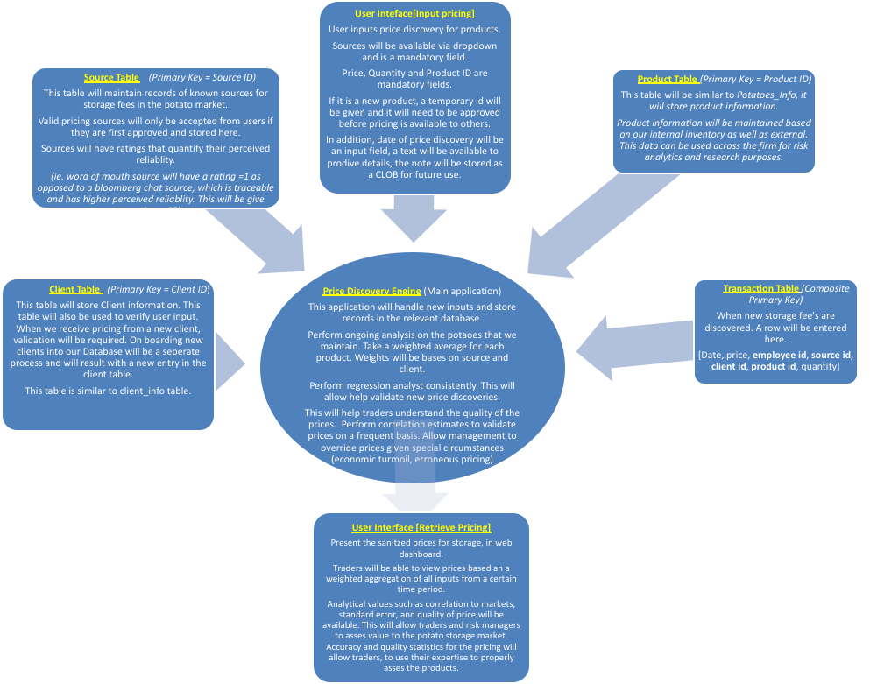

**Input new product pricing**



**Process results and store**

