Waste Sorting Efficiency: A CNN-Based Approach for Recognizing Metal, Paper, Plastic, and Cardboard Image Classification

Jasmin Clores   
College of Computer Science and Engineering  
Jose Rizal UniversityMandaluyong, Philippines  
jasmin.clores@my.jru.edu

Mark Joshua Lodriga  
College of Computer Science and Engineering  
Jose Rizal UniversityMandaluyong City, Philippines  
mark.lodriga@my.jru.edu

Mhargielyn Miñeque  
College of Computer Science and Engineering  
Jose Rizal UniversityMandaluyong City, Philippines  
mhargielyn.mineque@my.jru.edu

***Abstract*—** **This study aims to enhance waste management practices by using a single-image classification method. Wherein it utilizes CNN models to address the significant problem of enhancing the efficiency of waste sorting procedures, particularly in the classification and categorization of materials such as metal, cardboard, paper, and plastic. The foundation of this study is built through existing literature in the field of waste management, serving as a framework for further refinement. The progression of this study initiates with the implementation of preprocessing methods, ensuring alignment with the prediction model. Furthermore, various techniques are incorporated into the CNN model for effectively distinguishing between different waste varieties. And a thorough analysis is performed to provide researchers with an in-depth analysis of the needs for the prediction model to attain ideal efficiency and produce high-quality results. With the used of graphical user interface provides a user-friendly experience, which improves the display of results and simplify the model's navigation. The result achieved through this experiment helps with addressing the problems to waste material classification.**

**Keywords— Image Classification,** **Convolutional Neural Networks, Waste Categorization**

# I. research objectives

1. Perform a study about the waste sorting efficiency domain to identify essential features and challenges to collect information to help build a Convolutional Neural Network (CNN) model that differentiates between paper, metal, plastic, and cardboard within waste management.

2. To develop a CNN-based model to improve waste sorting to accurately classify metal, paper, plastic, and cardboard items in waste images.

3. To assess the real-world use of the developed waste classification model. This achieved by evaluating its effectiveness in correctly identifying metal, paper, plastic, and cardboard objects.

II. INTRODUCTION

Convolutional Neural Networks (CNN) is a technique developed to address several tasks, such as NLP. The successful performance of this method shows improvements in image classification [1]. This method changes that offers independent recognition of complex features from raw pixel data [2]. It also involves recognizing forms and texture elements using traditional methods. This also achieved in recognition for great performance in image classification [3]. It also has become an effective tool for intricate frameworks to understand and gather data from different sources. This technique can extract more conceptual models of the visual features [4]. The application of CNNs improved the field by allowing the automated extraction of information from raw visual data through self-learning.

With regard to several problems encountered in this field, including  the efficient classification of waste objects. This study involves collecting and storing various waste items from home and business processes. One of the primary disadvantages of this field is the absence of adequate sorting techniques, which affect the recycling process. Another disadvantage is incorrect sorting processes, which lead to the pollution of recyclable materials that reduce their overall appropriateness. Overall, this type of contamination often results in increased refusal rates and elevated landfill disposal that impact the procedure's overall efficiency.

Through this study it involves utilizing waste management approaches in a more expansive domain of image classification. The goal is to enable a significant transformation in this field and addresses the current demand for improved waste sorting systems that are more effective while also driving past the limits of image categorization approaches. Our research expands the range of traditional image classification algorithms by tackling the various obstacles encountered in this field and examines the development of techniques for categorizing different complex waste products. Moreover, it modifies CNN models to accurately to determine the specific materials and elements distinct from certain waste classifications.

III. LITERATURE REVIEW

**Waste Classification Using Improved CNN Architecture**

This literature presents the application of CNNs that address the waste management problem. It also aims to use actual image capture to enable the classification of different forms of waste that address efficient sorting methods [5]. The objective of this study is to determine the biodegradable and non-biodegradable waste products, which are often overlooked in traditional waste management systems. This presents an optimistic possibility to facilitate waste sorting methods to improve recycling process by emphasizing recycled materials. The study focuses on categorizing garbage based on its category, which is a measure of promoting understanding of various waste classifications among the general public. It also explores the challenges caused by insufficient public awareness in this domain. The study divides a dataset, 70% for training and 30% for validation. This paper presents a chart with the different results between food and garbage, which provides an effective waste classification model that has potential to improve these methods and encourage sustainable utilization of resources.

**Solid Domestic Waste classification using Image Processing and Machine Learning**

This article analyzes the integration of CNNs to improve the image categorization of solid domestic trash. It also underscored the problems related to feature vectors obtained from pixel data, emphasizing the significance of object focusing. Logistic regression encounters difficulties in dealing with complex datasets from images that have undergone edge filtering [6]. This shows the importance of advanced algorithms that are capable of prediction. Furthermore, the literature review demonstrates the significance of CNNs in waste image categorization, showing its ability to extract complex features automatically without explicit engineering. Furthermore, CNNs are acknowledged by researchers as useful instruments for acquiring structured representations, effectively identifying the difficulties presented by huge datasets. In summary, the capability of this technique aids to detect and understand patterns in images making them highly promising method for enhancing the precision of trash classification systems.

**Identification and Classification of Waste using CNN in Waste Management**

This paper examines the utilization of CNNs in the waste classification, evaluating the efficacy of CNNs in classifying different categories (plastic, paper, and metal). The researchers have found problems with adjusting hyperparameters that limited the performance of the CNN [7]. This study emphasizes the significance of dealing with these challenges in order for CNN to achieve its full capabilities. On the other hand, further limitations were discovered in which indicated that these problems are addressed, and through CNNs it has the potential to outperform it in terms of accuracy. Furthermore, the study incorporated two recognized CNN architectures, the VGG16 and FastNet-34. Wherein the experiment indicated improved accuracy in garbage classification compared to previous research work by using a dataset of 22,564 waste photos that were divided into recyclable and organic categories. This article highlights the ability of CNNs to change waste management methods substantially. However, it underlines the importance of overcoming problems related to hyperparameter optimization to achieve better accuracy in computer vision. Overall, this study provides a potential approach for future improvements in trash management.

**A Method for Waste Segregation using Convolutional Neural Networks**

This study employs an innovative approach that utilizes CNNs to address the worldwide dilemma of garbage segregation by accurately differentiating between organic and recyclable waste [8]. The trash disposal still one of the most problem we are facing today, regardless of the progress made by technology innovations. Moreover, the study highlights the pressing need for innovative solutions in waste management and recycling sectors, acknowledging trash disposal's significance. This study examines two commonly used waste classification methods, which are human and automated. It highlights the potential of CNNs as a powerful tool for addressing the difficulties in categorizing trash images. Overall, the article indicates that by efficiently utilizing deep learning algorithms, a substantial advancement in waste management technology can be attained, providing a potential opportunity for enhanced waste management practices worldwide.

**Recycling Waste Classification Using Optimized Convolutional Neural Network**

In this paper, the researchers aim to create a classification model that can effectively identify and sort waste in order to apply them in the real-world recycling process. The researchers will be using the TrashNet dataset which includes a total of 2527 images divided into 6 classes (cardboard, glass, metal, paper, plastic, and trash). The DenseNet121 model will also be utilized as the base model for the researchers' model [9]. In the experiment findings of the paper, the huge impact of both data augmentation and fine-tuning of fully connected layers in enhancing waste classification models is discussed. Hyperparameter tuning is also mentioned and given importance as it helped the researchers achieve their top-performing model, contributing to creating state-of-the-art waste classification models, or prediction models in general. The researchers' study, gives valuable information on the advancement of recycling facilities and shows many great possibilities for solving environmental problems with the use of prediction models.

**Classification of Waste Materials using CNN Based on Transfer Learning**

In this paper, the researchers aim to help in the waste management domain has led them to create a model that can aid in the waste sorting process. Their main goal is to create a model that utilizes transfer learning in order to create a robust and state-of-the-art model waste classification model that can reliably classify multiple classes, specifically cardboard, glass, metal, organic, paper, plastic, and trash. The researchers' methodologies include dataset preparation wherein they have a total of 2590 training sets, and 653 validation sets, transfer learning wherein they would utilize various pre0trianed models to see which model gives the best performance, Image preprocessing to normalize their data, feature extraction, fine-tuning of the model to ensure they get the top model, and lastly the training of the model [10]. The result of their experiments show that DenseNet201 gave the best model performance out of all the pre-trained models. Performance metrics for the DenseNet201 also show that the highest class it is able to predict with the highest accuracy is the organic class. These findings signify a significant step forward in leveraging transfer learning for waste classification, with practical implications for efficient waste management systems.

IV. METHODOLOGY

1. Present and discuss the dataset used in this experiment and its characteristics.

The primary objective of creating the Garbage Image Dataset was to gain insights into waste categorization by utilizing deep learning models. The classification comprises four distinct categories: Cardboard, Metal, Paper, and Plastic. Furthermore, the dataset has 350 images in each category, which produces a total of 1,400 images. The goal is to help individuals accurately classify garbage and facilitate the industry's advancement toward environmental sustainability. Additionally, it serves as a practical tool for conducting tests and assessments in the field of picture classification, with a primary emphasis on approaches for sorting garbage. As a result, it is significant to conduct a study that enhances methodologies for accurately identifying waste materials in order to better waste management techniques.

1. Explain the preprocessing steps applied to clean and prepare the dataset for modeling

In the preprocessing phase of this experiment, the custom dataset, as established in the previous activities, has already undergone essential preprocessing techniques. These tasks involved transforming images into a uniform format, notably JPEG, to guarantee uniformity in their display. Each image was precisely labeled by the total number of photos, indicating its corresponding category. Furthermore, it was essential to maintain a well-balanced dataset, guaranteeing a fair distribution of gathered images among classes.

The previous process has been effective in this study, such that it only requires minimal adjustments to its preprocessing approach. This dataset comprises thoroughly annotated images tailored to the specific needs of training and evaluating the CNN model. In this experiment, the training and testing images were organized into a folder structure with distinct subsets for training and testing, each having separate folders for different categories. The model was trained using an annotated dataset, specifically a collection of waste images categorized into their specific material (metal, plastic, paper, and cardboard). The dataset, comprising 350 images per category and a total of 1400 images, allocated the range of 1-280 for the training set and 281-350 for the testing data within each category. Having a well-balanced dataset leads to improved accuracy during training and reducing the possibility of imbalanced outcomes. Furthermore, the preprocessing methods utilize in the model are designed to mitigate overfitting, while the integration of a distinct validation dataset enables a thorough evaluation of the model's performance.

1. Discuss the details of the initial CNN architecture that will be used for the image classifier model as well as the performance metrics that will be applied.

In the initial design of our CNN architecture, we've opted for simplicity to establish a baseline. As our base model we will be using the VGG16 model, for our initial fine-tuned model, we have implemented a single hidden layer featuring 1024 neurons. This layer is configured with a learning rate of 0.0001, a batch size of 32, and the number of epochs set to 10. These hyperparameters have been chosen as a starting point, to subject them to further modification and refinement in the subsequent phases of our experimentation. The reasoning behind this iterative approach is to systematically optimize the model's performance by adjusting these key parameters. The selected hyperparameters are not static and they will undergo a process of careful evaluation and adjustment. This dynamic tuning process is essential for achieving a top-performing model with vital and good performance.

1. Discuss the strategy formulated by the group to adjust the different hyperparameters of the CNN to get the best model. Note: There is no limit to the hyperparameters that will be covered in this exercise.

The strategy that we have implemented in this experiment is through the use of the hyperparameter optimization techniques. Initially, we considered employing the grid search method. However, we encountered challenges mid-experiment, including its time-consuming nature, prompting us to change this method. Instead, we chose to employ a more practical approach, which entailed manually fine-tuning the hyperparameters for each iteration of the model. The technique, referred to as "babysitting" hyperparameters, demonstrated its effectiveness in acquiring a desirable set of values, guaranteeing that no significant elements affecting performance were disregarded.

Another strategy involved is saving the trained model after each successful training session. By engaging this process, we were able to construct a collection of trained models that will be utilized in our CNN model prediction.  More precisely, after we reach a desirable level of accuracy on the training set, we include code snippets that allow us to store the trained model in a h5 file format. This optimized our procedures, improving effectiveness and developing credibility in the model's ability to classify single images accurately. The application of saved, highly trained models enhance the dependability and accuracy of our prediction.

1. Discuss the format of the Excel file that you will use to record the results of each run in your experiment.

The Excel file provides a thorough overview of the results achieved from our experiment, which presents the performance of different models and represents different used of hyperparameters. Each member was assigned the responsibility to create more models in order to achieve the best model performance. The hyperparameter used in this experiment are learning rate, batch size, number of epochs, and neurons in hidden layers. The learning rate is the first hyperparameter, which represents the magnitude of each step executed during the model training. The batch size is a number of data samples of model processes before changing their weights. An epoch represents an iteration between the entire dataset during the training process. The number of neurons for hidden layers involves the complex structure of the neural network. Furthermore, the accuracy results indicate the model's ability to predict and classify them effectively. Therefore, our recorded experiments involve hyperparameters with accuracy results can enable us to determine which specific hyperparameter we need to adjust to improve the performance. It also allows us to correctly classify the images and to attain the optimal model performance.

IV. RESULTS

1. Present and discuss the results of your experiments.



*Figure 1: Accuracy Result of Training Model*

In this experiment, the top-performing model which is Model 7 resulted in an accuracy percentage of 81% along with its validation accuracy of 83 %. The process of obtaining this result metric involves the utilization of a CNN model, specifically adapted from the VGG16 architecture, which was modified for the waste classification task. The model was pre-trained on the ImageNet dataset and subsequently completed adaptation for the new task with the integration of custom dense layers. Moreover, the hyperparameters selected for this experiment comprised a learning rate of 0.01, a batch size of 60, and training for 30 epochs. The dense layers in the model architecture were set to 1200 and 1300 neurons, indicating the model's ability to effectively capture intricate patterns in the data. A learning rate of 0.01 is a suitable option, ensuring a balanced approach throughout optimization. The batch size of 60 suggests that 60 data were processed simultaneously while updating the model weights and training for 30 epochs implying iterating over the entire dataset 30 times throughout the training phase.

The top-performing model achieved an accuracy of 81.25% and a validation accuracy of 83%, demonstrating its outstanding accuracy on previously unknown validation data. Acquiring this outcome allowed us to own a highly optimized trained model that we have inserted through our graphical user interface (GUI), making the single image classification of waste sorts effective and the images that will be fed into the prediction model.

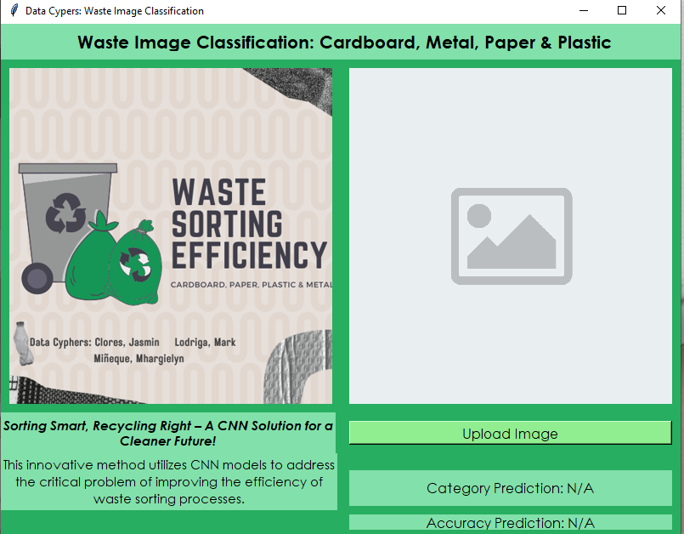

*Figure 2: GUI Layout*

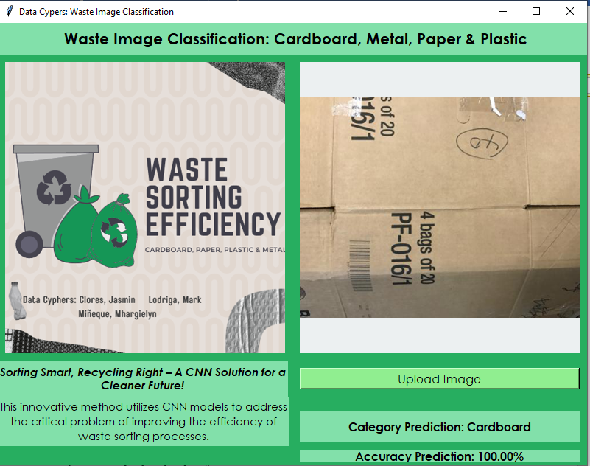

*Figure 3: Prediction Result for Cardboard*

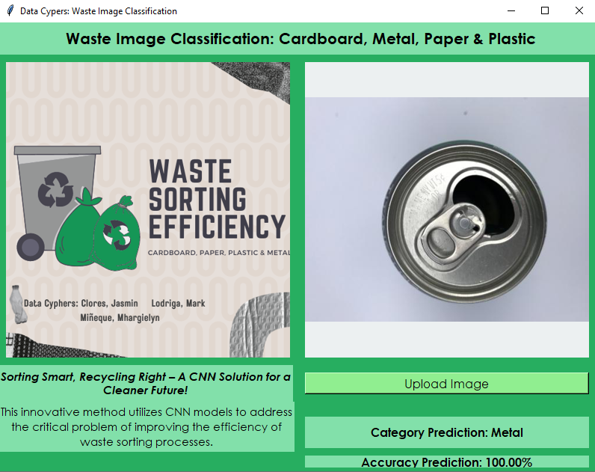

*Figure 4: Prediction Result for Metal*

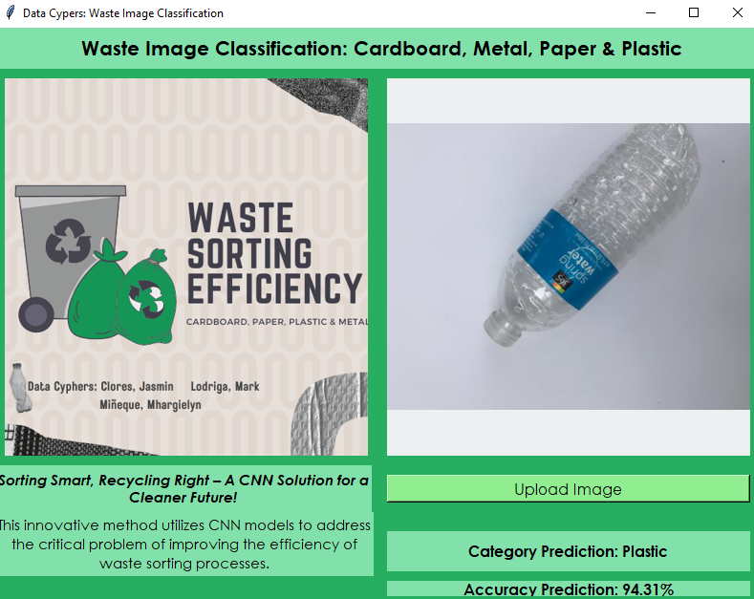

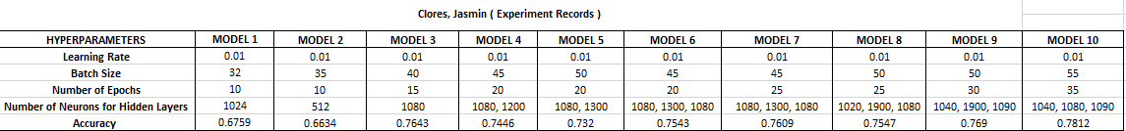

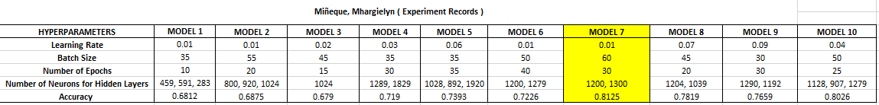

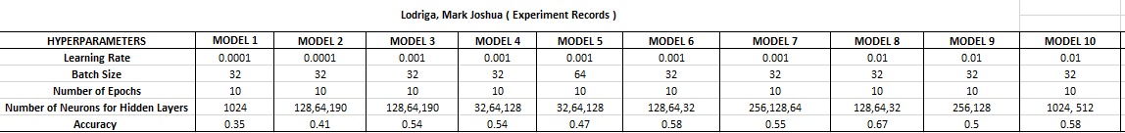

*Figure 5: Prediction Result for Plastic*

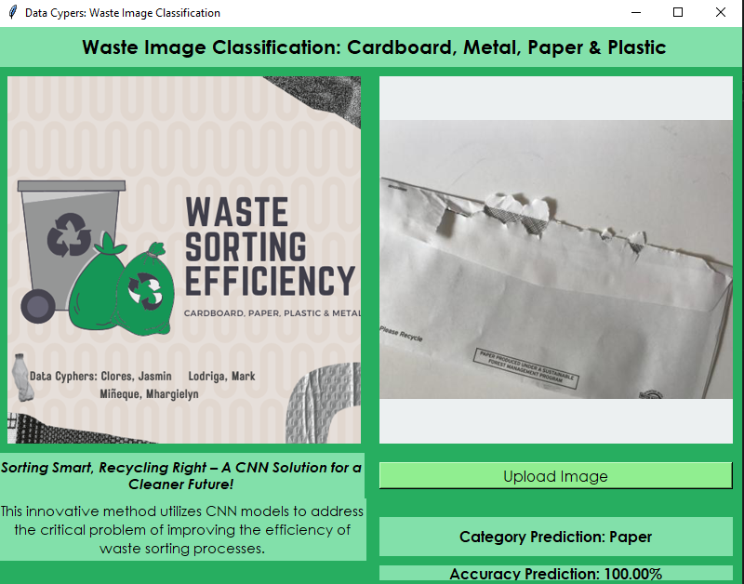

*Figure 6: Prediction Result for Paper*

In our graphical user interface (GUI), we have integrated a user-friendly interface experience for users to easily access a prediction model focused on waste classification. Our GUI includes a button that enables a user to upload an image, a label that shows the category prediction of the model, and the accuracy of the prediction which indicates how confident the model is in making a certain prediction. Our GUI is only made possible to load fast and skip the training process of the model. The Hierarchical Data Format file that uses the .h5 extension, within this file is our saved model architecture, along with its learned parameters, which allows us to simply call the .h5 file instead of having to wait and train the model before opening the windows for the GUI. Our GUI works by using the loaded fine-tuned model from the .h5 file and then showing the windows for the users to upload an image. Once an image is uploaded by the user, the model will now make a prediction on what waste category the image belongs to, we have trained our model to identify four categories of waste which include cardboard, metal, plastic, and paper. The GUI will then show in the category prediction the category that has the highest prediction rate, along with it is the label accuracy prediction, this label displays the percentage that reflects the model's highest category prediction.

V. ANALYSIS

1. Interpret the results based on your observation.

*Figure 7: Experiment Result*

*Figure 7: Experiment Results*

The training history of our top model shows that both its training and validation show a very consistent decline in loss across all 30 epochs. Training and validation accuracy also shows consistent improvement which highly indicates that the model is learning very well and can effectively predict new unseen data. Furthermore, the difference in the training and validation accuracy across all epochs indicates no sign of overfitting. The final training accuracy showed a value of 0.81 and the validation accuracy was 0.83 showing a promising model in our fine-tuned model that is ready to be implemented and used by users in our GUI windows.

Observations was made, once the fine-tuned is implemented into our GUI to start making real-time predictions, show that it is able to correctly predict three classes with high prediction accuracy. However, it is evident that the model has a hard time predicting some plastic images correctly when comparing the prediction performance of the model to its prediction with the other three categories (cardboard, metal, and paper). A way to mitigate and possibly solve this issue is to create a class-specific metric in the process of training our model, this way we are able to see the performance of the model in predicting each class and tracking the possible problems will also be easier when implementing this class-specific metric. Despite having good final training and validation accuracy, being aware of the class-specific performance of the model is also important as it allows us to track underlying problems when predicting a specific class.

1. Discuss any challenges or limitations you encountered during the experiments.

In our experiment, we encountered numerous challenges which demanded careful analysis. One of the challenges involved is adjusting different hyperparameters, such as the learning rate, batch size, hidden layers in neural network architecture, and number of neurons. It is also challenging for us since adding epochs to improve the training accuracy takes longer to achieve the result, leading to time consumption. Furthermore, these adjustments impact our laptop's performance and cause a lag during experimentation. Another challenge we discovered was to achieve the best performance for the model. It is also a challenge for us to achieve the suitable level of accuracy. This impact the prediction results within the GUI, specifically when performed with a low level of accuracy. The inability to correctly predict categories and probabilities indicated the difficulties in developing a reliable model. Overall, these challenges underscored the complex and various aspects of optimizing models in achieving dependable predictions within an easy-to-use interface. The encountered challenges are an important part of our project, which enhances the overall experience and impacts the understanding level.

VI. CONCLUSIONS

In conclusion, the conducted study into waste categorization using CNN to predict four categories presents different findings. In this study, we discovered the complex relationships between the accuracy of the model and the adjustment of hyperparameters. We gain knowledge that adjusting different hyperparameters has a significant effect on the model's ability to correctly determine and categorize waste images. The performed method emphasized the challenges of parameter optimization and the balance of computational power to achieve the best model performance. Furthermore, this study underscored the importance of accurate waste categorization. In addition, the ability to correctly categorize waste images has implications for the implementation of sustainable waste management strategies. We also learned that the practical implementation of CNNs for image classification of waste objects can potentially change recycling processes. This improvement can lead to the development of more efficient sorting systems, which will lead to improved accuracy and sustainable methods of managing waste. This valuable study improved our understanding of CNNs in image classification. It also emphasized our ability to address important environmental problems that provide an optimistic future for waste management through innovative technological methods.

# REFERENCES

1. “Human verification.” <https://www.semanticscholar.org/paper/Convolutional-Neural-Networks-Kamath-Liu/617650f74baed588d5428071434a4a39482fef7e>
2. N. V. Gawali, “Image classification using convolutional neural networks,” 2023. <https://www.semanticscholar.org/paper/Image-Classification-Using-Convolutional-Neural-Gawali/a79df7d0cca28f655161a0d3bc834e1f5fad2293>
3. J. L. Crowley, “Convolutional neural networks,” 2020. https://www.semanticscholar.org/paper/Convolutional-Neural-Networks-Yal%C3%A7in/fe70eec562bc677205a322189fd0f852a5d5d31b
4. W. Wang, “Development of convolutional neural network and its application in image classification: a survey,” 2019. https://www.semanticscholar.org/paper/Development-of-convolutional-neural-network-and-its-Wang-Yang/811563ce6683ab64fa4f86ede0f4397adb5c3098
5. M. Chhabra, B. Sharan, K. Gupta, and R. Astya, “Waste classification using improved CNN architecture,” Social Science Research Network, Jan. 2022, doi: 10.2139/ssrn.4157549.
6. O. G. D. & T. Mauricio, “Solid Domestic Waste classification using Image Processing and Machine Learning,” ideas.repec.org, Jun. 2021, [Online]. Available: https://ideas.repec.org/p/osf/osfxxx/yzcfk.html
7. “Identification and Classification of Waste using CNN in Waste Management,” IEEE Conference Publication | IEEE Xplore, Apr. 07, 2023. <https://ieeexplore.ieee.org/document/10126312>
8. J. Shah and S. Kamat, “A Method for Waste Segregation using Convolutional Neural Networks,” ResearchGate, Feb. 2022, [Online]. Available: <https://www.researchgate.net/publication/358846063_A_Method_for_Waste_Segregation_using_Convolutional_Neural_Networks>
9. W. Mao, W. Chen, C.-T. Wang, and Y.-H. Lin, “Recycling waste classification using optimized convolutional neural network,” Resources, Conservation and Recycling, vol. 164, p. 105132, Jan. 2021, doi: 10.1016/j.resconrec.2020.105132.
10. S. Poudel and P. Poudyal, “Classification of Waste Materials using CNN Based on Transfer Learning,” Research Gate, Dec. 2022, doi: 10.1145/3574318.3574345.

‌