Group Project – Group 4

- Alexander Bouwhuis
- Yuri Koller
- Yuhong Lin
- Roney Thomas Mannoocheril

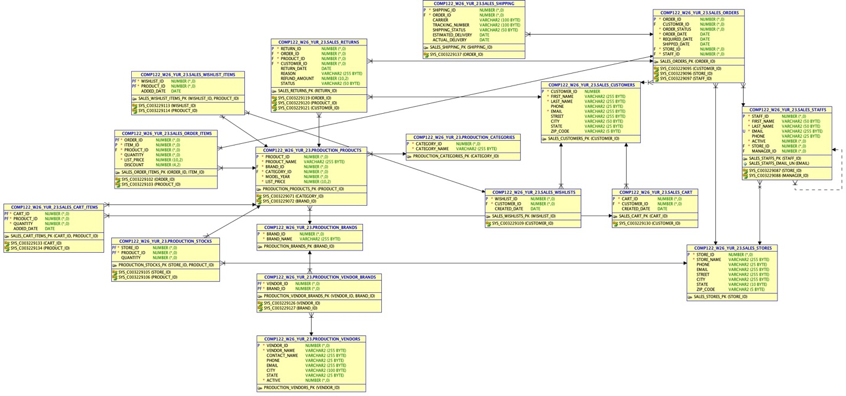

(Diagram is bit hard to read here, diagram included as separate image file in submission.)

ER Diagram Description

1. Overall System Description

This database represents a bike store sales management system designed
to manage customers, orders, products, inventory, and extended business
features such as wishlists and returns.

The system integrates both operational data (customers, orders, staff)
and product management data (brands, categories, inventory), providing a
complete structure for retail operations.

2. Core Entities

Customers and Orders
The sales_customers entity stores customer information such as name,
contact details, and address.
The sales_orders entity represents purchase transactions and links
customers, stores, and staff.

- One customer can place many orders (1:M)
- Each order belongs to one customer

Order Details
The sales_order_items table is an associative entity that connects
orders and products.

- One order can contain multiple products
- One product can appear in multiple orders

This resolves a many-to-many (M:N) relationship between orders and
products.

Products and Classification
The production_products entity stores product information and is linked
to both brands and categories.

- One brand has many products (1:M)
- One category has many products (1:M)

Inventory Management
The production_stocks table represents inventory levels of products in
stores.

- One store can stock many products
- One product can be available in many stores

Stores and Staff
The sales_stores entity stores store information.
The sales_staff entity stores employee information.

- One store employs many staff members (1:M)

Recursive Relationship (Staff Hierarchy)
The sales_staff entity includes a foreign key manager_id that references
staff_id in the same table.

- One manager can supervise multiple staff members (1:M)
- Each staff member reports to one manager

Shopping Cart System
The shopping cart feature allows customers to temporarily store products before completing a purchase.

Entities:
sales_cart
sales_cart_items

Relationships:
One customer can have one active cart (1:1)
One cart can contain multiple items (1:M)
Each cart item references a product (M:1)

Design Explanation:
The sales_cart table stores cart-level information (customer_id, created_date)
The sales_cart_items table resolves the many-to-many relationship between carts and products
Quantity is stored at the cart item level to support multiple units of the same product

Vendor Management System
The vendor system manages suppliers responsible for providing products to the store.

Entities:
production_vendors
production_vendor_brands (linking table)

Relationships:
One vendor can supply multiple brands (1:M)
One brand can be supplied by multiple vendors (M:N)

This results in a many-to-many relationship between vendors and brands.

Implementation (Resolving M:N Relationship):
The many-to-many relationship is resolved using the linking table:
production_vendor_brands(vendor_id, brand_id)
This table connects vendors to the brands they supply.

Design Explanation:
production_vendors stores supplier information (name, contact details, etc.)
production_brands represents manufacturers
The linking table production_vendor_brands allows:
A vendor to supply multiple brands
A brand to be supplied by multiple vendors

3. Extended Features

Wishlist
The sales_wishlists entity stores customer wishlists.
The sales_wishlist_items table connects wishlists and products.

- One customer can have multiple wishlists (1:M)
- One wishlist can contain multiple products

Returns and Refunds
The sales_returns entity manages returned items and refund processing.

- Each return is linked to one order
- Each return is linked to one product
- Each return is linked to one customer

4. Key Design Concepts

Foreign keys enforce relationships and maintain referential integrity.
Many-to-many relationships are resolved using associative tables.
Primary keys ensure uniqueness.
The design supports scalability and future extensions.

5. Conclusion

This ER diagram models a real-world retail system and ensures data
integrity, scalability, and clear relationships.

10 Business Requirement Queries Implemented
- Search products by category
- Manage shopping cart
- Register/unregister user
- Track shipping status
- Manage vendors
- Monthly sales report
- Most popular products
- Customer tiers by purchase history
- Wish list items
- Returns and refunds

- Search products by category, Returns all products in a given category with brand info. Change the category_name value to search a different category.
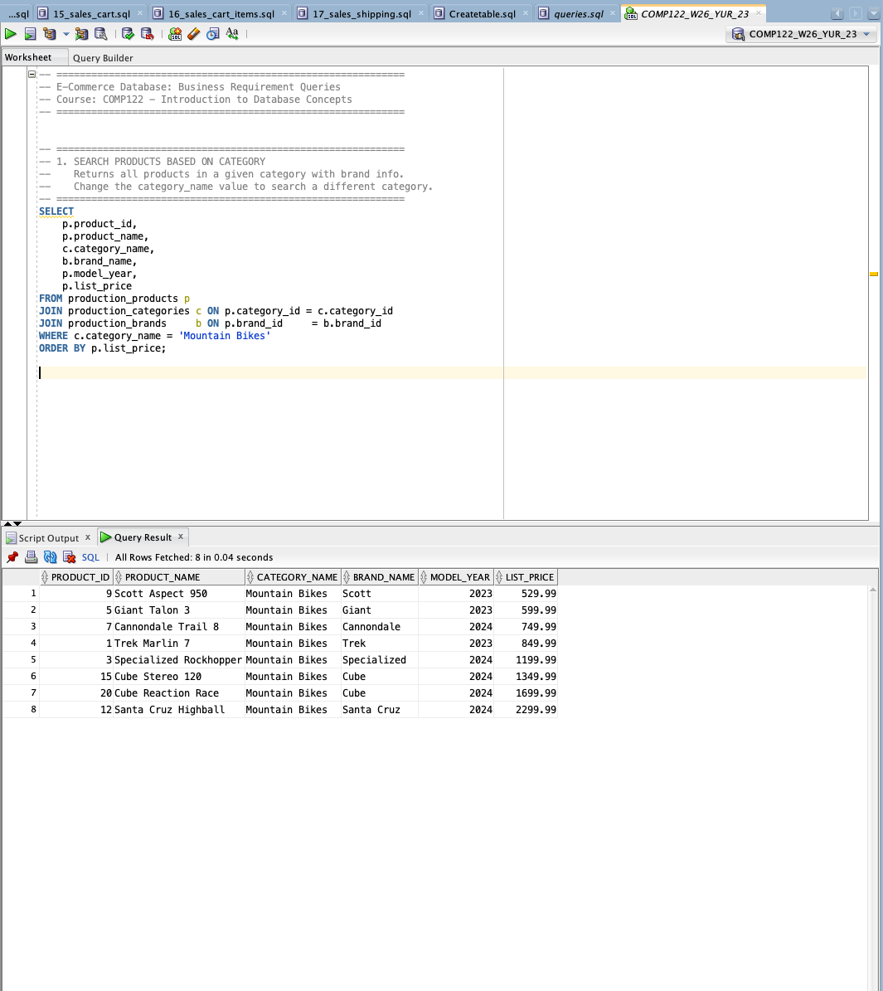

- Manage shopping cart
  - Add an item to a customer's cart

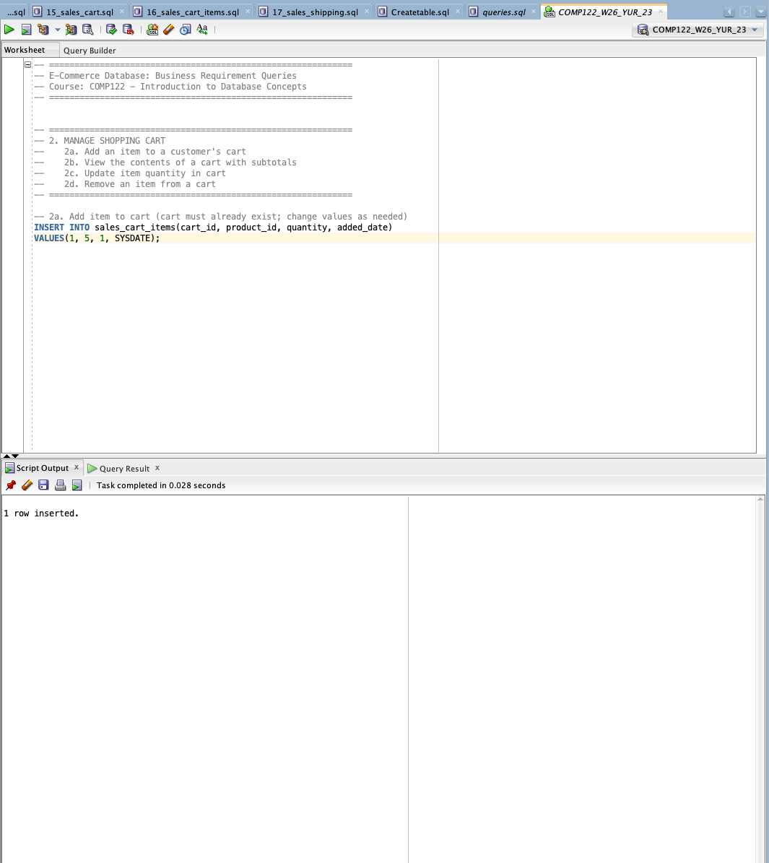

  - View the contents of a cart with subtotals

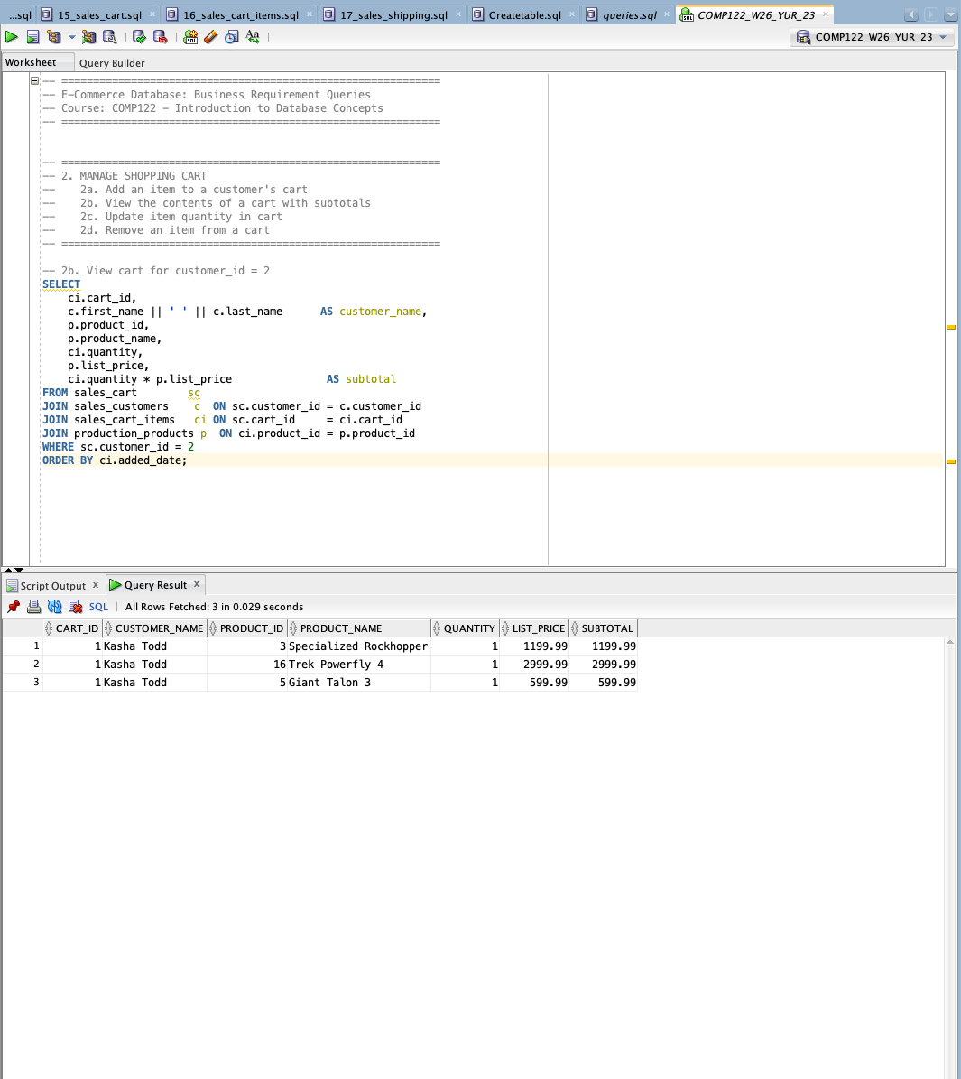

  - Update item quantity in cart

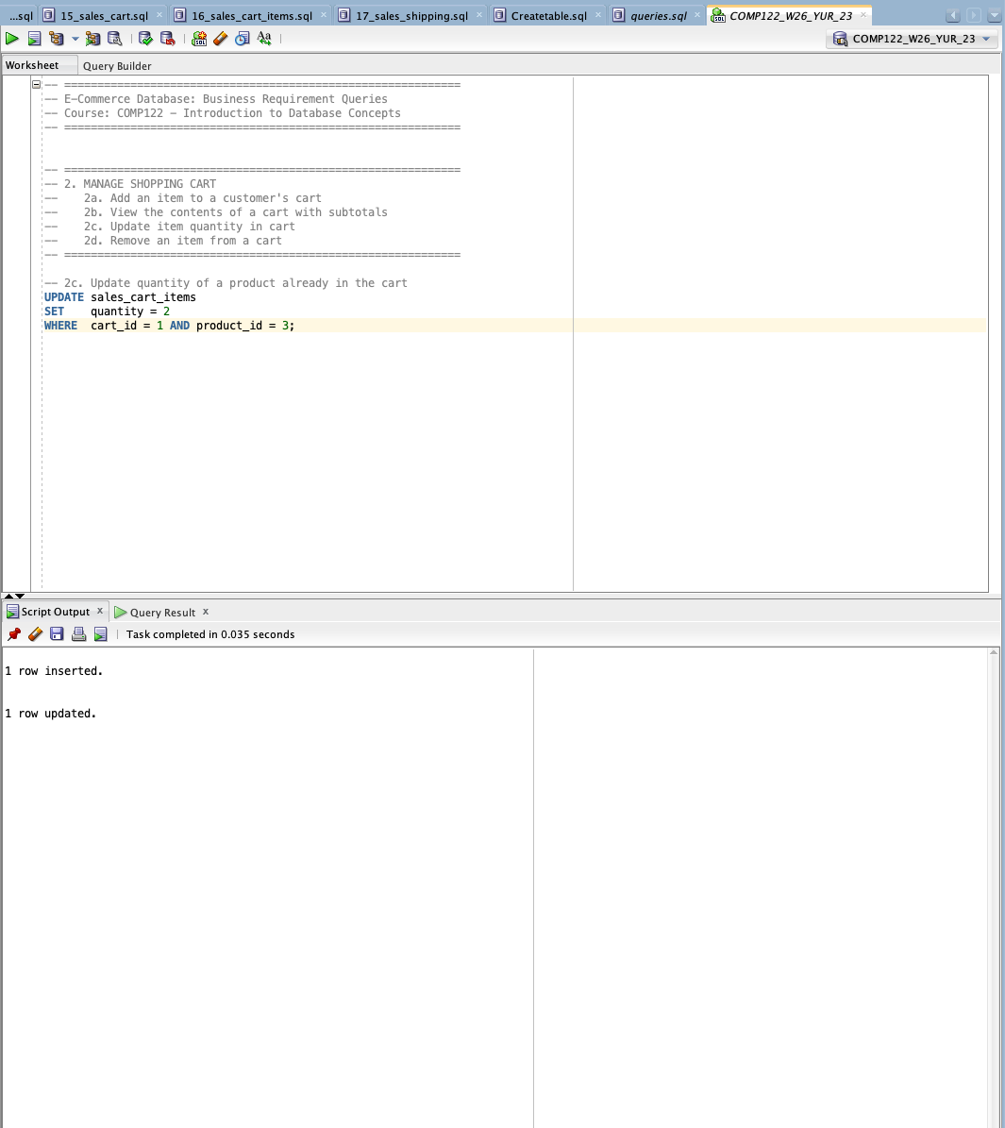

  - Remove an item from a cart

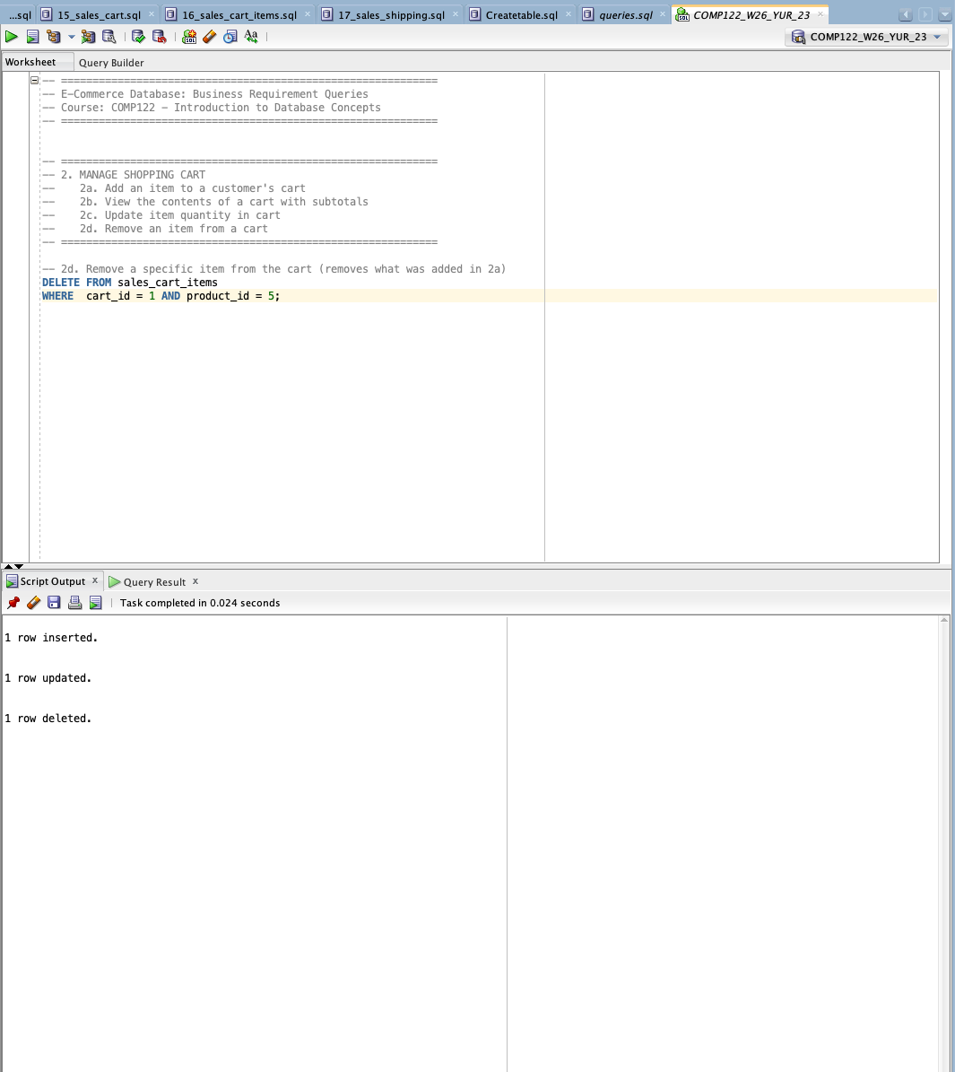

- Register/Unregister User
  - Register a new customer
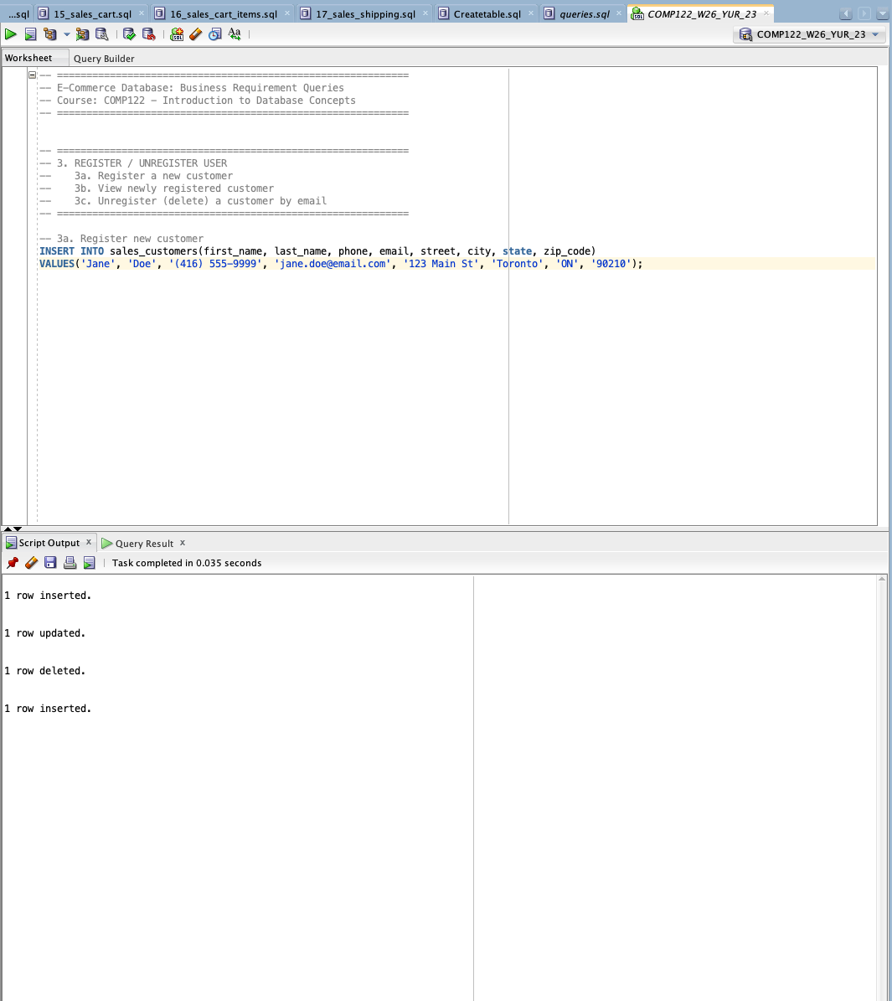

  - View newly registered customer
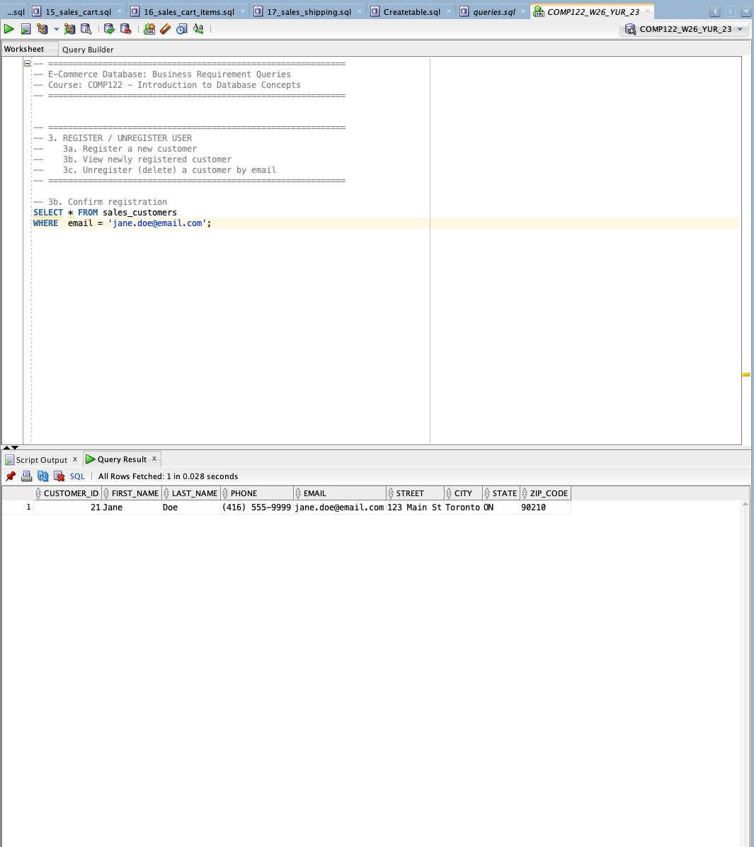

  - Unregister (delete) a customer by email
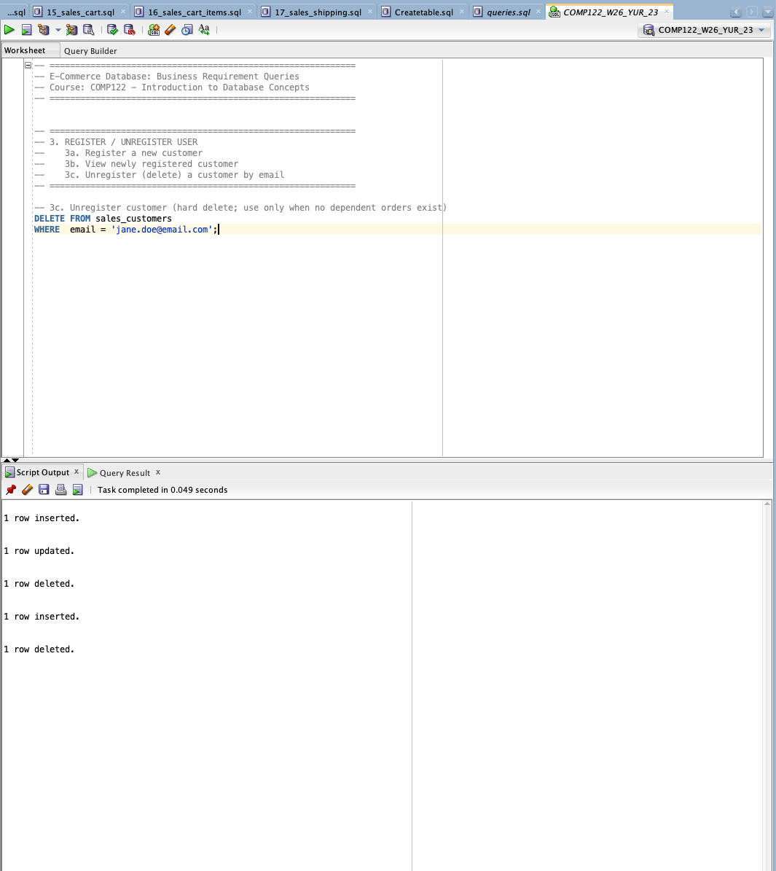

- Track shipping status. Shows the shipping/tracking details for every order belonging to a specific customer.
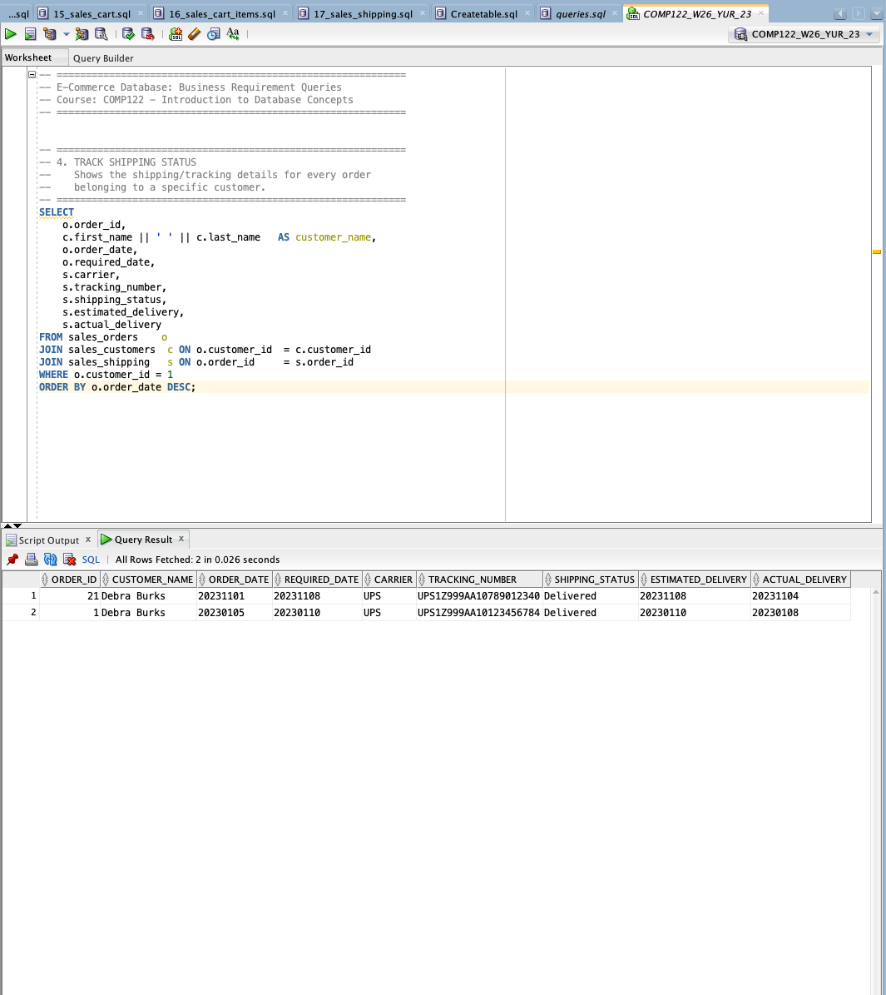

- Manage Vendors
  - Add a new vendor
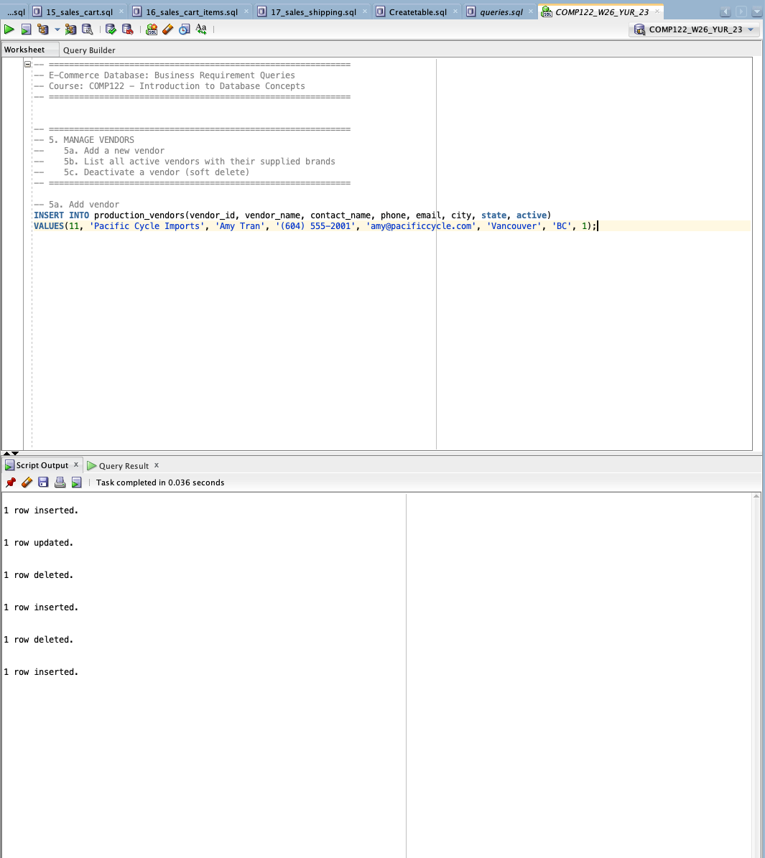

  - List all active vendors with their supplied brands
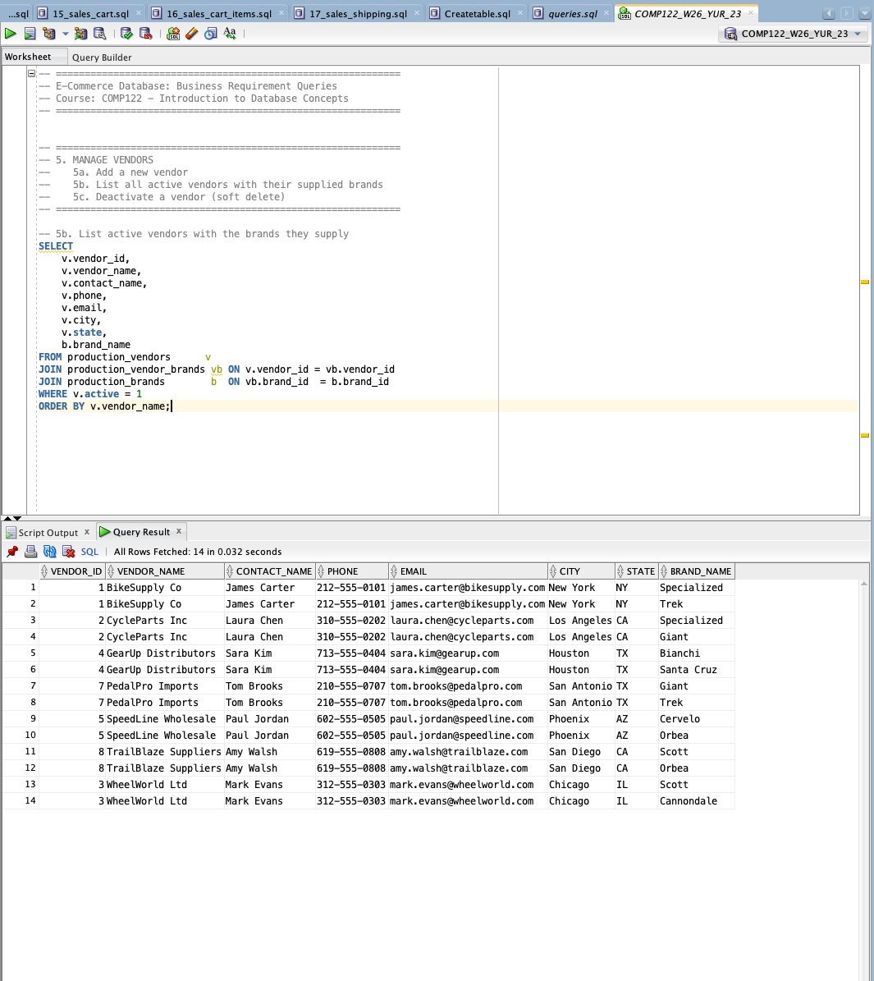

  - Deactivate a vendor (soft delete)
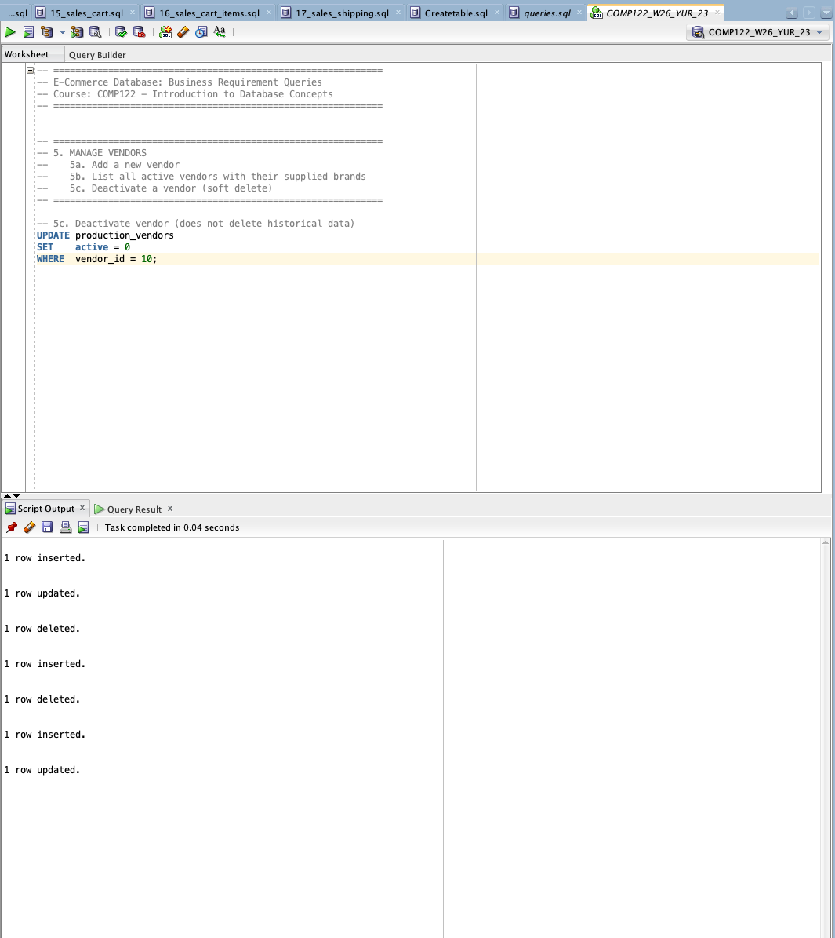

- Generate monthly sales report. Aggregates completed orders by month.
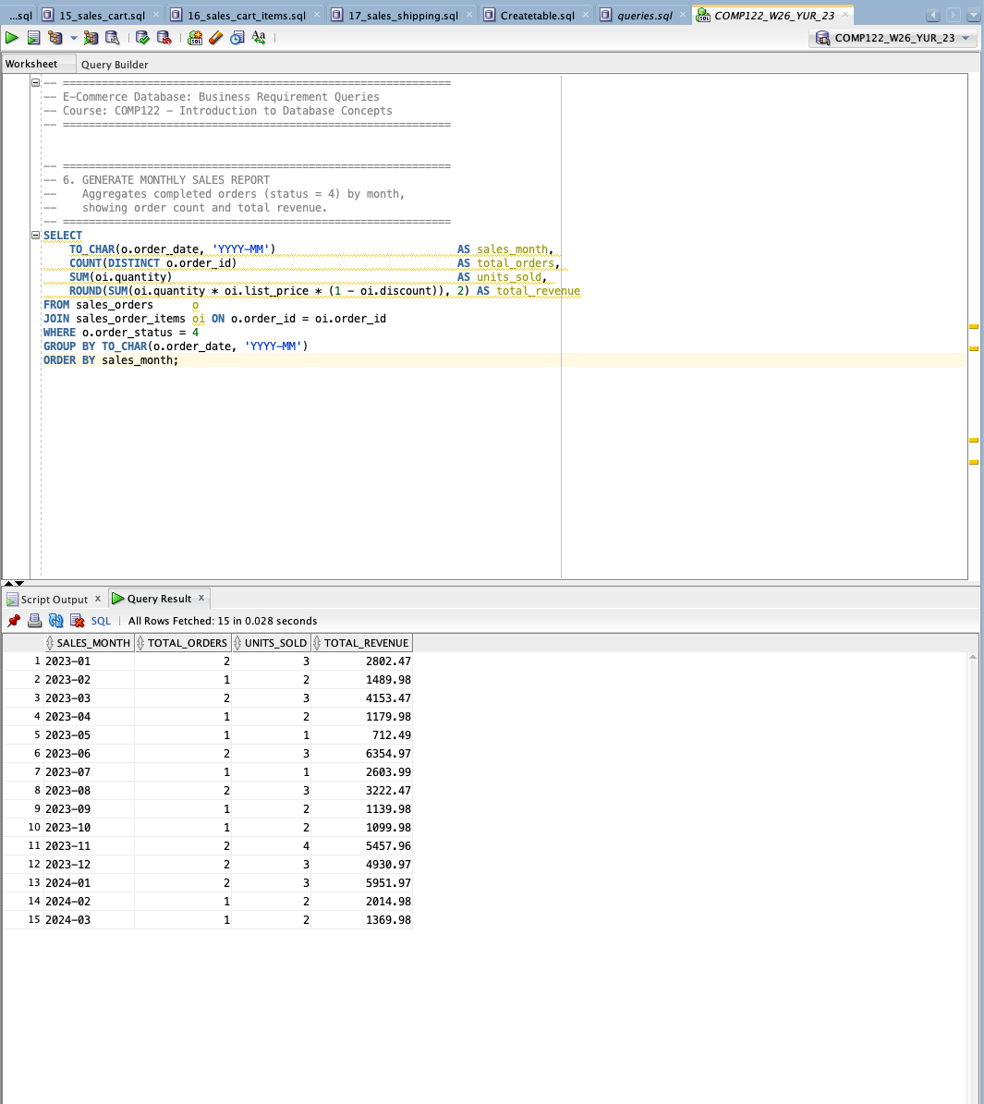

- Find the most popular products
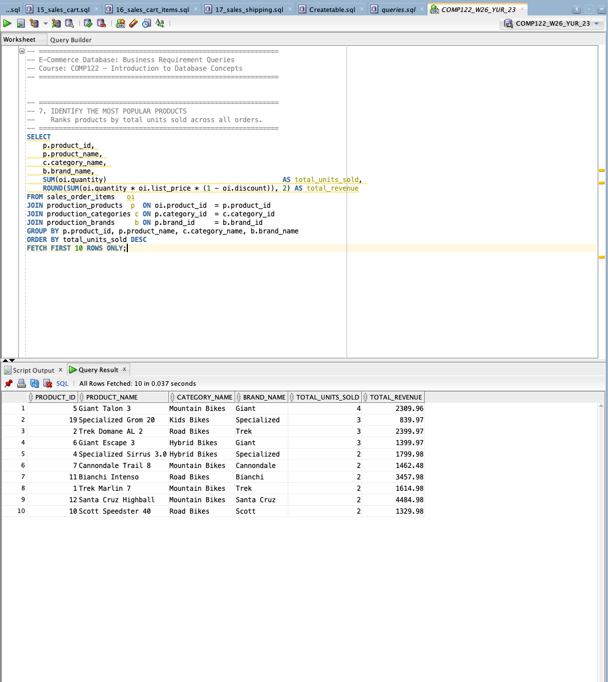

- Categorize customers based on purchase history
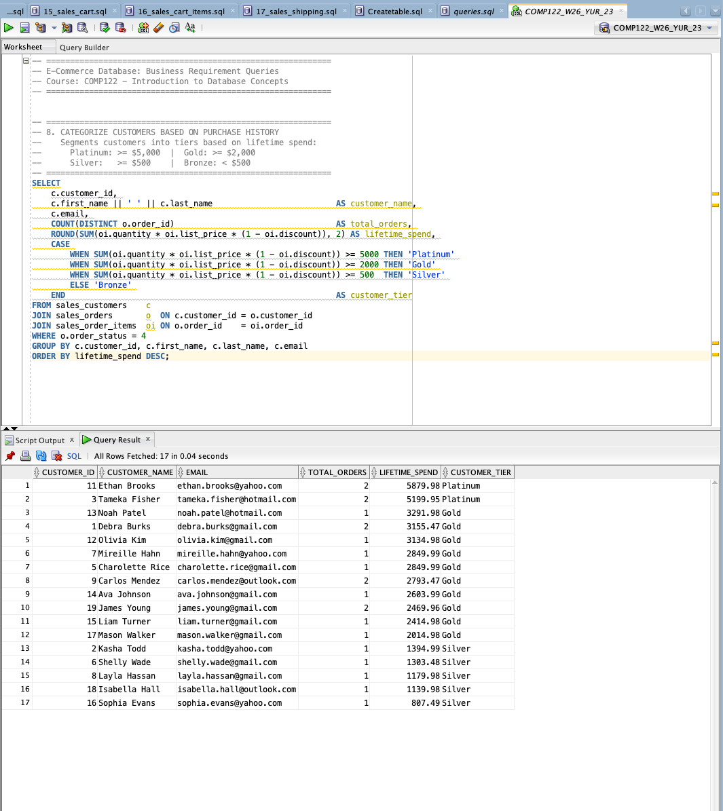

- List all items on a user’s wish list
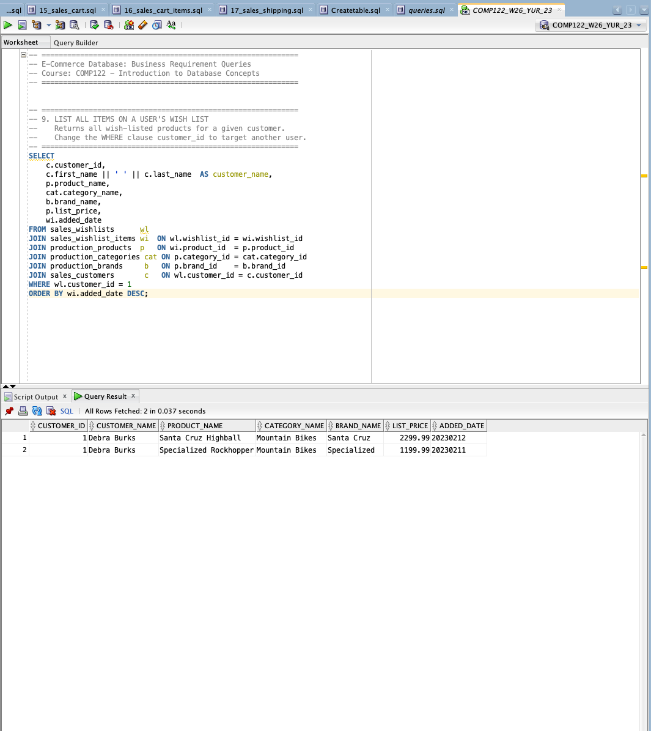

- Handle returns and refunds
  - Submit a return request
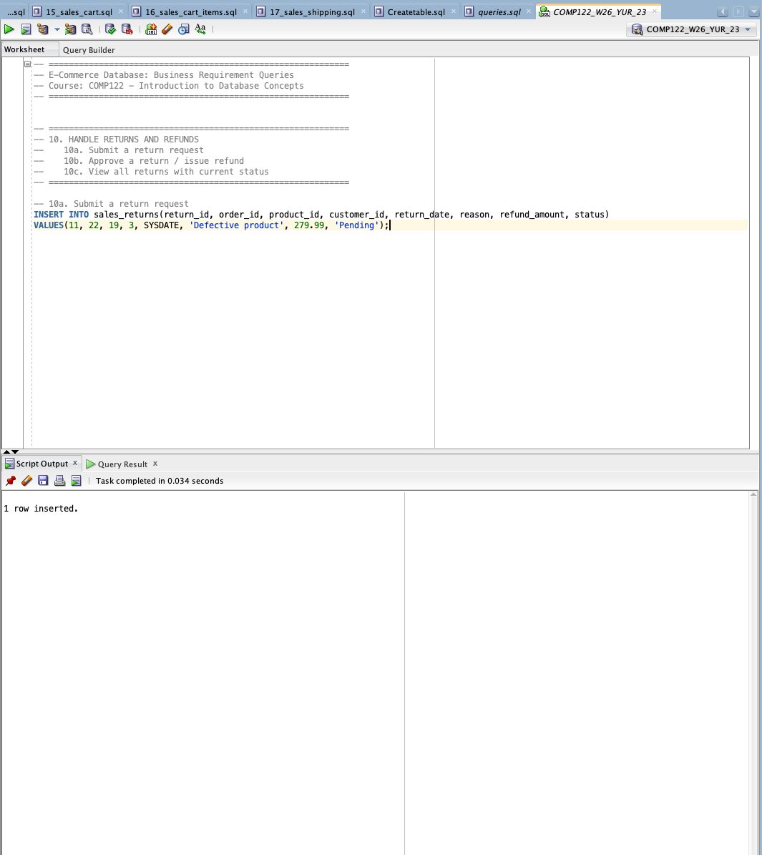

  - Approve a return / issue refund
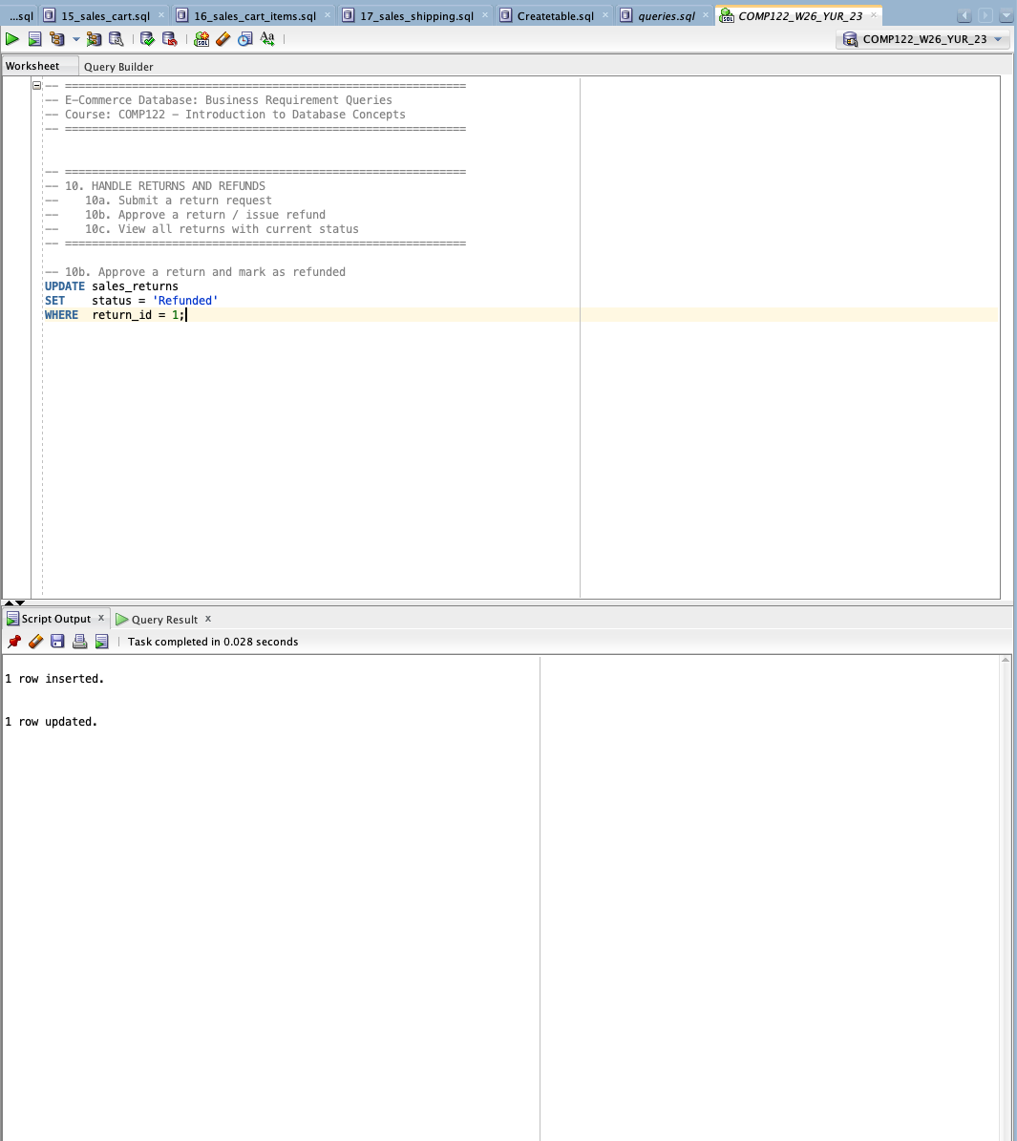

  - View all returns with current status
