初始化类：

On initialization, ATP generates TrainType according to DataPlugContent.CCTrainType from the CC data plug.



[iTC_CC_ATP-SwRS-0740]

VIOM1VitalInputsLastAge，记录收到最新的**END_1**端VIOM的存活时间为多少。

Records the survival time of received vital inputs from VIOM1.

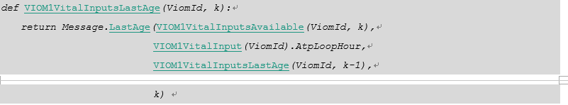

[iTC_CC_ATP-SwRS-0572]

LatestVIOM1LoopHourVIOM，记录当前收到最新的**END_1**端VIOM的周期时间信息。

* 初始化时LatestVIOM1LoopHourVIOM为VIOM周期号的最小值0；
* 如果收到可用的VIOM1信息，或之前的VIOM1消息已无效但又新收到一条VIOM1消息，则将相应的LatestVIOM1LoopHourVIOM设置为新收到消息中的viomLoopHour值；
* 否则，LatestVIOM1LoopHourVIOM保持不变。

ATP records the latest cycle time information of VIOM in **END_1** by the term LatestVIOM1LoopHourVIOM.

* In initialization, set LatestVIOM1LoopHourVIOM as the zero;
* If receiving an available VIOM1 message, or a new message and the previous one has invalid, ATP will set the related value of LatestVIOM1LoopHourVIOM as the viomLoopHour of the message.

Otherwise, LatestVIOM1LoopHourVIOM keeps unchanged.



[iTC_CC_ATP-SwRS-0614]

VIOM2VitalInputsReceived，收到并校验正确来自VIOM2的安全输出消息。

ATP determines whether received a safety input message from VIOM2.



[iTC_CC_ATP-SwRS-0449]

VIOM2VitalInputsAvailable，通过通信接口，获取来自VIOM2的安全输入消息，并判断消息传输的时间有效性以及顺序的正确性。

Through the communication, ATP gets the vital input message from VIOM2 and decides the time effectiveness and the correctness of the sequence of the message, which defined as VIOM2VitalInputsAvailable.



[iTC_CC_ATP-SwRS-0538]

VIOM1VitalInputsValid，判断来自**END_1**的VIOM安全输入信息是否在有效时间内。

ATP determines whether the vital inputs message from VIOM1 valid.



[iTC_CC_ATP-SwRS-0075]

CoupledByEnd1或CoupledByEnd2，列车两端连挂其他车辆。如果该项目未配置连挂输入的采集，则认为列车未与其他车连挂。其状态来自于项目可配置的列车输入采集。

CoupledByEnd1 or CoupledByEnd2 shows that both ends of train connect with other trains. If the project is not configured with the capture of coupling input, it is certain that the train does not connect with other trains.



[iTC_CC_ATP-SwRS-0540]

OtherATPmessageValid，接收到的冗余ATP消息是否在有效期内。如果该消息已失效，则设置OtherATPmessageValid为**False**；否则为**True**。

OtherATPmessageValid represents the effectiveness of the messages from redundant ATP. If this message is invalid, ATP will set OtherATPmessageValid as **False**; otherwise, it is set as **True**.



[iTC_CC_ATP-SwRS-0081]

OtherATPminTime，本端ATP维护的冗余ATP的最小时间。设置规则如下：

* 初始化时根据所在车头设置OtherATPminTime为默认值；
* 否则，如果本周期收新的冗余ATP消息可用，则更新OtherATPminTime为消息中的currentTime；
* 否则，如果冗余ATP消息仍然在有效期内，则对OtherATPminTime每周期加1，若越界则重新等于初始化值；
* 否则，如果当前收到的新的冗余ATP消息（但不可用），则将OtherATPminTime更新为消息中的时间；
* 其他情况，OtherATPminTime累加1，若越界则重新等于初始化值。

The OtherATPminTime stands for the local ATP maintained minimum time of the redundant ATP. The setting rule is as following:

* In initialization, ATP set the OtherATPminTime as default value based on the CoreId of the redundant ATP.
* Or else:, if the updating message from the new redundant ATP in this cycle is available, ATP will update OtherATPminTime as the current time in the message.
* Or else:, if the redundant ATP message is still effective, ATP will add 1 in the OtherATPminTime until it is out of bound, and set is as initialization value.
* Or else:, If the received a new redundant ATP message, but it was not available, ATP shall update OtherATPminTime as in the message.
* Otherwise, accumulate OtherATPminTime.

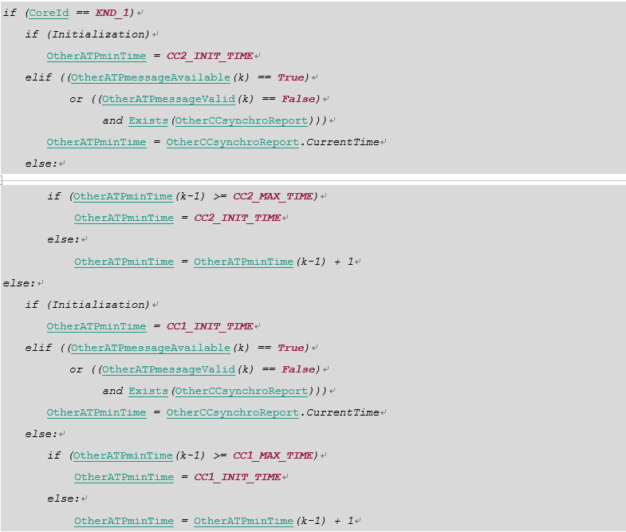

[iTC_CC_ATP-SwRS-0080]

OtherATP，解析并存储远端ATP的消息。

* 初始化或者远端消息过期时，设置相应的值为默认状态；
* 当本周期收到新的远端消息时，将其设置为新收到消息的值；
* 否则，保持不变

OtherATP, parse and store messages from the distant ATP.

* In initialization or the message has expired, set all variables as default value;
* when new message available, set the corresponding value from the new message;
* otherwise, remain unchanged.

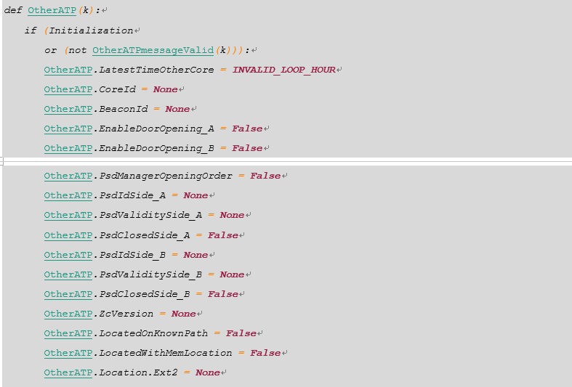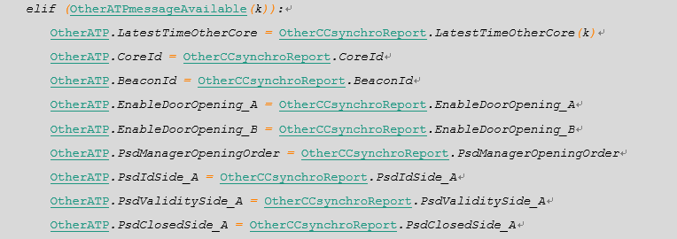

[iTC_CC_ATP-SwRS-0067]

BlockModeUsed，当前是否现在选择BM模式。其状态来自于项目可配置的列车输入采集。

BlockModeUsed represents that either of train end chooses BM mode.



[iTC_CC_ATP-SwRS-0066]

BMvariantValidWhileTemporallyValid，当前是否使用BM变量。其状态来自于项目可配置的列车输入采集。

The status of BMvariantValidWhileTemporallyValid shows whether it is in the BM mode.



[iTC_CC_ATP-SwRS-0617]

BMbeaconReadAge，记录读取BM信标到当前的时间，默认值为**REPORT_AGE_MAX**。

* 如果BM信标变量无效，该值应被设置为默认值，BM信标变量无效的条件如下：
* 初始化；
* 或当前不在BM模式(not BMvariantValidWhileTemporallyValid)；
* 或BMbeaconReadAge已大于ATPsetting.VariantsBMfullValidityTime；
* 或本周期收到的BM信标（BeaconVariantsUpdating为**True**）中DefaultMessage为**True**或BlockModeVariantAvailable为**False**；
* 或本周期列车由定位转为失位状态；
* 或当前使用的BM信标方向与已定位的列车运营方向TrainFrontOrientation不同。
* 否则，如果本周期更新BM信标，则将该变量的初始值设置为1（因为ATP使用的是上个周期读到的信标信息）。
* 其他情况，累加该变量。

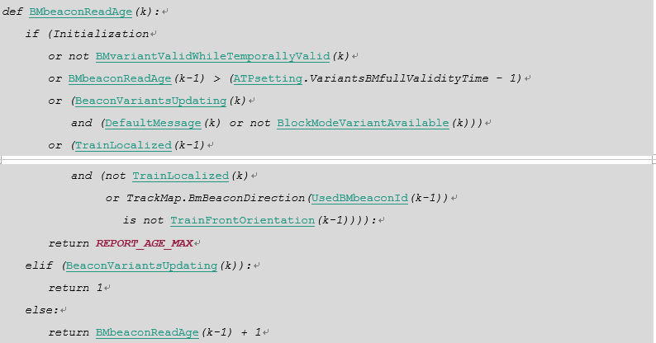

[iTC_CC_ATP-SwRS-0148]

UsedBMbeaconId用于记录当前所使用的BM变量来自哪个BM信标，判断条件如下：

* 当初始化，非使用BM变量（not BMvariantValidWhileTemporallyValid），该信标方向与当前车头方向不符，或列车失位时，清除UsedBMbeaconId；
* 否则，如果收到有效的BM信标，记录该信标id到UsedBMbeaconId；
* 否则，保持UsedBMbeaconId不变。

UsedBMbeaconId records the used BM variants came from which BM beacon:

* When one of the following conditions fulfilled, ATP clear the UsedBMbeaconId:
* initialization,
* the BLOCK MODE variant is not temporally valid,
* the direction of the used BM beacon is not as same as train front orientation,
* the train is not localized.
* Or else:, when received a valid BM beacon, ATP update UsedBMbeaconId;
* Otherwise, keep this value unchanged.

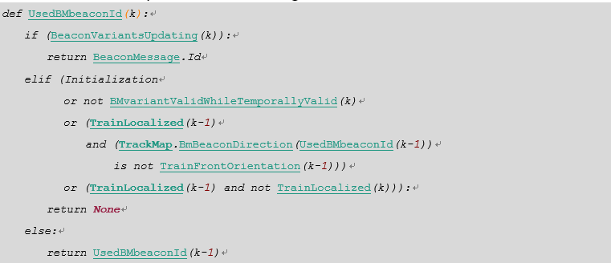

[iTC_CC_ATP-SwRS-0121]

如果本周期BeaconMessageReceive为**True**，则从LockedBeaconMsgByte中获取信标ID，设置BeaconMessage.ID；其他情况保持不变。

If the status of BeaconMessageReceive is **True**, the BeaconMessage.ID is obtained by LockedBeaconMsgByte; Otherwise, keep it unchanged.



[iTC_CC_ATP-SwRS-0123]

如果本周期BeaconMessageReceive为**True**，则从LockedBeaconMsgByte中判断是否默认消息，设置BeaconMessage.DefaultMessage；若本周期未读到新的信标则保持不变。

If the BeaconMessageReceive is **True**, the default message is judged by LockedBeaconMsgByteand ATP set the BeaconMessage.DefaultMessage; if there is no new beacon read, it keeps unchanged.

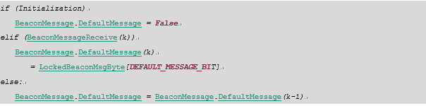

[iTC_CC_ATP-SwRS-0171]

WheelStopped，如果当前在进行传感器测试，且任一中断中未发生三路全通或全堵错误，且一个周期所有中断内三路传感器的导通状态都与上周期的结果相同时，输出WheelStopped为**True**。否则为**False**。

Wheel shall consider safely stopped WheelStopped at cycle k if the following conditions are fulfilled:

* sensors test has been performed,
* and at least one sensor out of three sensors C1, C2, C3 has detected expected sequence,
* and at least one sensor out of three sensors C1, C2, C3 has not detected expected sequence,
* and sensors test result combination on three sensors C1, C2, C3 has not changed between cycle k-1 and k.

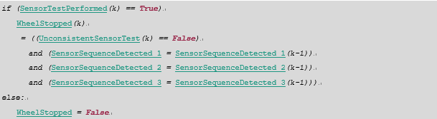

[iTC_CC_ATP-SwRS-0172]

WheelFilteredStopped，判断本周期车轮是否处于滤过停止状态，规则如下：

* 如果WheelFilteredStopped上周期为**False**，而本周期WheelStopped由**False**变为**True**，则认为本周期为**True**。
* 在此条件下，记录停车时的齿数LastStopCogPosition为当前齿数
* WheelFilteredStopped由**True**变为**False**的条件：
* 齿数移动超过1个齿

At cycle k, WheelFilteredStopped shall change from **False** to **True** on raising edge of WheelStopped information, That is, if:

* WheelStopped information was **False** at cycle k-1,
* and WheelStopped information was **True** at cycle k.
* and then:
* LastStopCogPosition is assigned to TeethCounter,

At cycle k, WheelFilteredStopped shall change from **True** to **False**, according following expression:

* the cog moved more than one cog;

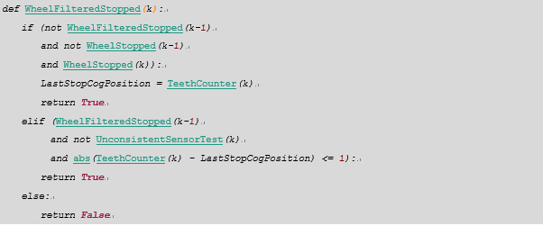

[iTC_CC_ATP-SwRS-0177]

里程计状态由**NOT_INITIALIZED**变为**WAITING_COG_POSITION_CODE_READY**的条件是:

* 上周期在**NOT_INITIALIZED**；
* 上周期在WheelFilteredStopped；
* 本周期未WheelFilteredStopped而且未检测到传感器测试失败

At cycle k, ATP shall consider that OdometerState changes from **NOT_INITIALIZED** to **WAITING_COG_POSITION_CODE_READY** if:

* a falling edge is detected on [WheelFilteredStopped](#WheelFilteredStopped) information,
* and sensors test is consistent at cycle k and was consistent at cycle k-1,

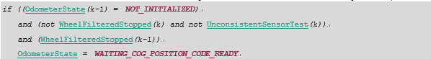

[iTC_CC_ATP-SwRS-0178]

若检测到传感器三路全通或全堵，则进入**INVALID**传感器无效

At cycle k, ATP shall consider that OdometerState changes from **NOT_INITIALIZED** to **INVALID**

* if sensors test is not consistent at cycle k.



[iTC_CC_ATP-SwRS-0180]

由**WAITING_COG_POSITION_CODE_READY**转回**NOT_INITIALIZED**状态的条件：

At cycle k, ATP shall consider that OdometerState changes from **WAITING_COG_POSITION_CODE_READY** to **NOT_INITIALIZED** if:

* wheel is detected stopped ([WheelFilteredStopped](#WheelFilteredStopped)),
* and cog position remains unknown (not OdometerCogPositionReady),
* and there is no sensors test inconsistency,
* and time elapsed since last time OdometerState was **NOT_INITIALIZED** (InitializationTimer) is strictly less than ATPsetting.OdoInitTimeout



[iTC_CC_ATP-SwRS-0181]

由**WAITING_COG_POSITION_CODE_READY**转入**INITIALIZED**状态的条件：

At cycle k, ATP shall consider that OdometerState changes from **WAITING_COG_POSITION_CODE_READY** to **INITIALIZED**

If:

* Cog position is safely known which means that wheel angular position is well-known;
* and there is no sensors test inconsistency;
* and time elapsed since last time OdometerState was **NOT_INITIALIZED** (InitializationTimer) is strictly less than ATPsetting.OdoInitTimeout.

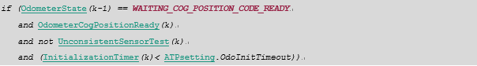

[iTC_CC_ATP-SwRS-0182]

由**WAITING_COG_POSITION_CODE_READY**转入**INVALID**的条件：

At cycle k, ATP shall consider that OdometerState changes from **WAITING_COG_POSITION_CODE_READY** to **INVALID** if:

* sensors test inconsistency is detected,
* or time elapsed since last time OdometerState was **NOT_INITIALIZED** (InitializationTimer) is more than or equal to the ATPsetting.OdoInitTimeout



[iTC_CC_ATP-SwRS-0186]

当上周期里程计已在**INITIALIZED**状态，并满足以下条件之一时，里程计状态由**INITIALIZED**变为**INVALID**：

* 传感器测试检测出三路全通全堵；
* 或者，非停车状态，而且齿数齿号也不一致。

At cycle k, ATP shall consider that OdometerState changes from **INITIALIZED** to **INVALID** if:

* OdometerState was evaluated Initialized at cycle k-1,
* And:
* Sensors test result is inconsistent;
* Or neither wheel filtered stopped nor cog position ready.



[iTC_CC_ATP-SwRS-0187]

在**INITIALIZED**状态，如果齿数齿号匹配，则计算车轮最大最小位移依据伪代码中的公式：

If motion and speed are available at cycle k, then wheel curvilinear movement calculates as follows:



[iTC_CC_ATP-SwRS-0189]

在无效状态停车，并未检测到传感器错误，则能回到非初始化状态。

At cycle k, ATP shall consider that OdometerState changes from **INVALID** to **NOT_INITIALIZED** if:

* OdometerState was evaluated Invalid at cycle k-1,
* and wheel is detected stopped ([WheelFilteredStopped](#WheelFilteredStopped)),
* and there is no sensors test inconsistency.



[iTC_CC_ATP-SwRS-0578]

在里程计无效状态下，ATP直接使用测得值计算车轮位移（因为此时列车运动学失效，后续功能并不使用测得的列车车轮位移）。

In invalid status, ATP shall calculate wheel movement by using measured value of the odometer.



[iTC_CC_ATP-SwRS-0201]

InstantaneousWheelAcceleration，在进行最大位移过估算法之前，需计算瞬时车轮加速度（为减少采样周期过短使得采样误差导致的加速度大幅变化，ATP使用相邻2个周期的算术平均加速度作为瞬时加速度）。

When wheel motion and acceleration are measurable, then instantaneous acceleration computed according following expression:



[iTC_CC_ATP-SwRS-0227]

MaxMotionOdometerSignChanged，用于监控是否发生了测得车轮位移反向.

If the reversed motion during braking or sliding state is greater than a project defined distance, ATP shall consider the motion sign changed.



[iTC_CC_ATP-SwRS-0788]

OverestimatedMotionMax，根据打滑状态机，对里程计测得的最大位移进行补偿。

如果本周期在**BRAKING**状态，按如下规则更新列车最大位移：

* 如果本周期测得车轮位移与StartBrakingMovementMax方向相同，且前者的绝对值大于后者的绝对值，表明由于采样齿数波动，测得位移大于StartBrakingMovementMax，此时使用测得位移作为最大列车位移；
* 否则，根据配置对测得位移进行补偿，取StartBrakingMovementMax与补偿后的测得位移中绝对值较小的一个，位移方向与StartBrakingMovementMax相同。

In **BRAKING** state, the maximum train motion overestimated as ATPsetting.SlidingCoefficient (15% normally) at most. If the overestimated motion has greater than the start braking movement, ATP shall use the start breaking movement as the current train motion. That said the train speed during braking could not faster than before.

如果本周期在**SLIDING**状态时，按如下规则更新列车最大位移：

* 如果本周期测得车轮位移与StartBrakingMovementMax方向相同，且前者的绝对值大于后者的绝对值，表明由于采样齿数波动，使得测得位移大于StartBrakingMovementMax。此时使用测得位移作为最大列车位移；
* 否则，使用StartBrakingMovementMax

In state **SLIDING**:

* If both WheelMaximumMovement and StartBrakingMovementMax are same direction, and the absolute value of the former is greater than the absolute value of the latter, indicating that due to the sampling error makes the measured movement greater than StartBrakingMovementMax. In this case, ATP shall uses WheelMaximumMovement as current train maximum motion.
* Otherwise, uses StartBrakingMovementMax as train maximum motion.

其他状态下，无需对测得最大位移进行补偿。

In other state (**COASTING**, **SKIDDING**), uses measured wheel maximum movement as current overestimated maximum train motion.

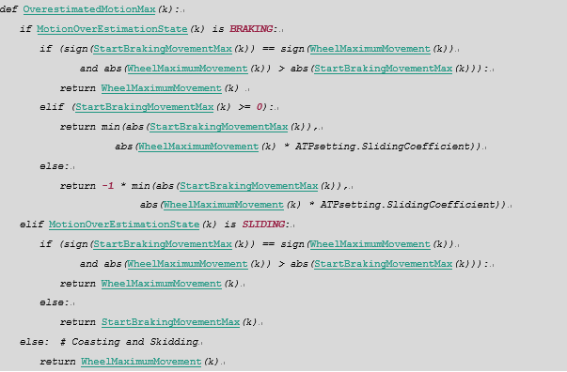

[iTC_CC_ATP-SwRS-0191]

SlipSlideDetected，是否检测到打滑空转

For calibration validation purpose, ATP shall consider that slip/side detected if:

* motion overestimation modeling status is not coasting nor braking,
* or motion underestimation modeling status is not coasting nor motoring.



[iTC_CC_ATP-SwRS-0228]

SlipSlideModellingFault，打滑补偿模型错误

When the overestimation or underesimation state is **SKIDDING**, or the motion signed changed in **BRAKING** or **SLIDING** state, ATP shall consider the overestimation model as fault.

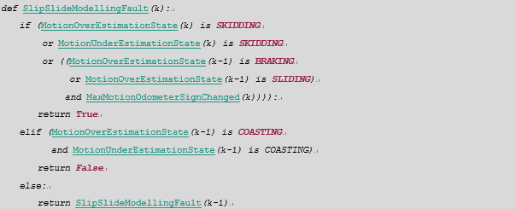

[iTC_CC_ATP-SwRS-0230]

OdometerSpeedUnderThreshold，本端里程计测速低于阈值。

ATP shall detect whether the measured wheel speed is under threshold.



[iTC_CC_ATP-SwRS-0128]

ReferenceSpeedUnderThreshold_1，来自CCNV的参考速度1是否小于指定阈值。

ReferenceSpeedUnderThreshold_1 defines whether the referenced speed 1 from CCNV is lower than a configurable threshold.

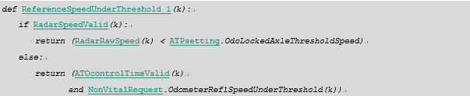

[iTC_CC_ATP-SwRS-0234]

OdometerRef_2.PossiblyEnabled，当本端里程计和参考速度2均可用且测得列车在动时，认为参考速度2可能已恢复有效。

The independent source of odometry reference 2 said to enable if following conditions reached:

* local source of odometry is available,
* and OdometerSpeedUnderThreshold indicates that train speed is greater than reference speed threshold,
* and source of odometry reference 2 is available,
* and odometer reference 2 indicates that train speed is greater than reference speed threshold.



[iTC_CC_ATP-SwRS-0236]

OdometerRef_2.OutOfOrder，当判断参考速度2可能不可用时，延迟一段时间，若仍不可用，则判断参考速度2失效。

The independent source of odometry reference 2 is said to be out of order if it is possibly disabled during more than ATPsetting.OdoLockedAxleDisablingLatency.

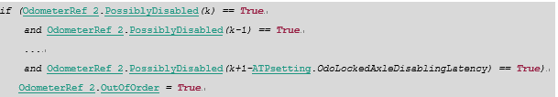

[iTC_CC_ATP-SwRS-0237]

OdometerRef_1.Contradictory，若参考速度1有效且判断车动，而本端里程计判断车静止，则认为参考速度1判断出里程计可能故障。

The source of odometry reference 1 said to be contradictory with local source of odometry if:

* local source of odometry is available (ValidWheelKinematic)
* and OdometerSpeedUnderThreshold indicates that wheel speed is less than reference speed threshold,
* and source of odometry reference 1 is available and not out of order,
* and odometer reference 1 indicates that train speed is greater than reference speed threshold.



[iTC_CC_ATP-SwRS-0239]

AxlePossiblyLocked，在两路参考速度都正常（没有失效out of order）的情况下，当两路参考速度均判断本端里程计可能故障的情况下，认为当前可能轴锁。或者，当有一路参考速度认为轴锁，而另一路参考速度失效或不可用，也认为当前可能轴锁。

Odometer axle shall consider possibly locked if:

* Both independent sources of odometry indicates a contradiction with local odometer,
* Or one source of odometry is contradictory and the other one is out of order (or not available).

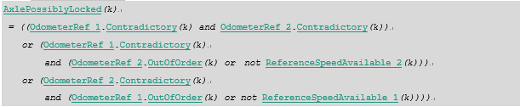

[iTC_CC_ATP-SwRS-0241]

AxleLockedDetectionAvailable，只要有一路参考速度可以工作，就认为轴锁侦测可用。

If only one or no source of odometry is available, then ATP shall invalidate kinematic while this situation lasting.



[iTC_CC_ATP-SwRS-0242]

WheelTrainKinematicCorrelation，车轮和列车的速度一致性

Wheel and train kinematic shall consider correctly correlated if and only if:

* odometer axle is not detected locked,
* and odometer axle detection is available



[iTC_CC_ATP-SwRS-0245]

TrainFilteredStopped，列车准静止判断。

Train shall consider stopped with the tolerance of one cog detection if:

* wheel is detected at filtered stop,
* and train kinematic elaboration is valid,
* and wheel is not detected sliding.



[iTC_CC_ATP-SwRS-0194]

当读到线路地图中与之前MTIB1匹配的MTIB2时，根据经过的齿数值，在ATPsetting中查表得到最大最小齿距，并比较测得的齿距结果：

* 如果测得的最大最小齿距在理论值范围内，则齿距校准状态从**CALI_MEASURING**到**CALI_VALIDATING**；
* 如果在理论范围外，则状态从**CALI_MEASURING**转入**CALI_WAITING**。

If ATP is in the state of **CALI_MEASURING and** following conditions fulfilled:

* a valid beacon has been received and the beacon and first memorized calibration beacon is one of possible dedicated couple of calibration,
* and train kinematic was valid,
* and no excessive slip/slide effect was detected,
* and sign of train motion is still identical to thus detected on first beacon signaling,

Then,

* if resulting calibration range is included in default calibration range, then ATP shall:
* memorize:
* position of the wheel before and after top location signal of received beacon,
* the id of received beacon,
* and shall consider itself as **CALI_VALIDATING**.
* else: ATP shall consider that calibration process has failed and back to **CALI_WAITING**.

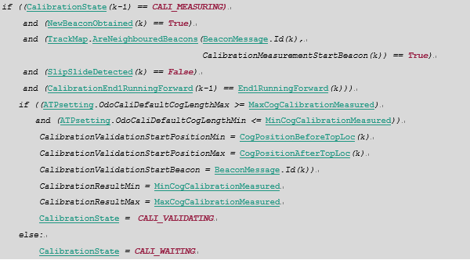

[iTC_CC_ATP-SwRS-0195]

如果校准过程中发生下列情况，则从**CALI_MEASURING**回到**CALI_WAITING**

If ATP is in the state of **CALI_MEASURING and** following conditions fulfilled:

* train kinematic has been detected not valid,
* or excessive slip/slide effect has been detected,
* or WheelMinimumMovement sign is in the opposite direction of thus observed on first beacon or becomes null,
* or an unexpected beacon has been received. That is, a beacon not belonging calibration measurement couple.

Then, ATP shall abort calibration process and back to **CALI_WAITING**.

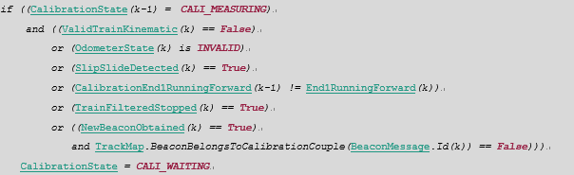

[iTC_CC_ATP-SwRS-0197]

当读到有效的验证信标，并判断之前测得齿距在有效范围内时，认为校准成功，转入**CALI_COMPLETED**状态；

否则，校准失败，返回**CALI_WATING**状态。

If ATP is in the state of calibration validation in progress and following conditions fulfilled:

* a valid beacon has been received and this beacon is one of possible confirmation beacons related to second beacon signaled of calibration measurement,
* and train kinematic was valid,
* and no excessive slip/slide effect was detected,
* and sign of train motion is still identical to thus detected on first beacon signaling,
* and WheelMinimumMovement is not null.

Then,

* if resulting calibration range **fully includes** the calibration range in track map, then ATP shall:
* update ATP minimum and maximum calibration with last calibration computed on beacons,
* and shall consider that calibration process is **CALI_COMPLETED**.
* else: ATP shall consider that calibration process is not usable and so back to **CALI_WATING** waiting for new measurement calibration beacons.

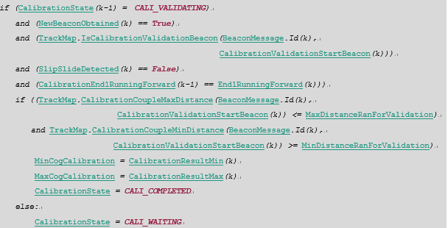

Where:

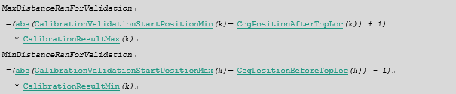

[iTC_CC_ATP-SwRS-0254]

LocationUntravelable，判断车身范围内是否有线路边界或者状态不符的道岔

* 当上周期列车定位，并满足以下条件时，本周期设置为**True**。
* 如果车尾最小定位到车头最大定位之间存在状态未知的道岔(包括发散或汇聚节点)；
* 或者，如果车尾最小定位到车头最大定位之间存在变量状态与之前列车位置不符的发散汇聚节点；
* 或者，轨道边界在列车定位范围内；
* 否则，设置该值为**False**。

ATP shall determine whether there is an unknown-status point intersecting with the train location.

* If the train has localized at the previous cycle, and fulfills one of the following conditions:
* There is an unknown-status divergence of convergence located in the range from train tail to train head, then ATP shall set as **True**;
* Or else:, if there is a convergence with reverse route located in the range from train tail to train head, the ATP shall set as **True**;
* Or else, train crossed the boundary of ATC area, shall set as **True**.
* Otherwise, set as **False**.

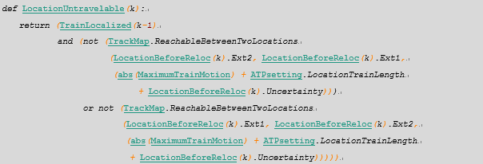

[iTC_CC_ATP-SwRS-0253]

LocationUncertaintyExceed，列车定位状态下，每周期计算列车外侧定位和内侧之间的距离是否超过最大允许误差。

ATP shall calculate the uncertain distance between the external and internal locations of train **END_2**.



[iTC_CC_ATP-SwRS-0074]

TrainUnitIntegrity，任一端车头能保证列车完整性，则认为车辆完整性能被保证。如果该项目未配置列车完整性采集，则认为列车完整性已由车辆保证。其状态来自于项目可配置的列车输入采集。

If either of ends can ensure the train integrity, ATP shall set TrainUnitIntegrity as **True**. If the project is not configured with the capture of train integrity, it is sure that the train can guarantees the integrity.



[iTC_CC_ATP-SwRS-0076]

DriverInCab_1或DriverInCab_2，如果采集到某端的驾驶室被激活，则ATP认为司机在该端驾驶室。其状态来自于项目可配置的列车输入采集。

ATP shall consider the driver is in this cab if it captures that either end of cab activated, which shown by the data from DriverInCab_1 or DriverInCab_2.

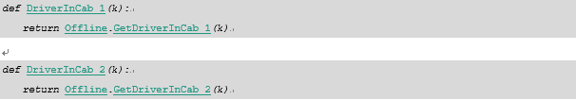

[iTC_CC_ATP-SwRS-0139]

DriverInTrain，当前是否有司机在车内

If the active status is different between two ENDs of the train, ATP consider there is a driver in train.



[iTC_CC_ATP-SwRS-0281]

TrainFrontOrientation，列车运营方向.

The train front orientation is the orientation of the active train END.

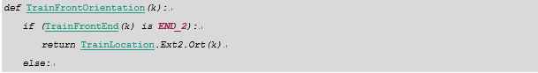

[iTC_CC_ATP-SwRS-0653]

TrainLocatedOnKnownPath，判断列车是否定位并已知LocationPathKnown

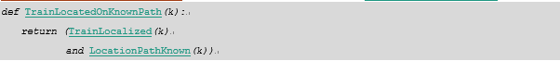

[iTC_CC_ATP-SwRS-0660]

ClearingMemLocRequest，是否清除记忆定位

When train has moved and does not fulfill the condition of writing memory location, ATP shall clear memorized location information.



[iTC_CC_ATP-SwRS-0270]

RestrictiveSignalOverrun，BM模式下，本周期列车车头最大定位是否冒进限制状态的信号机。

* 当满足以下所有条件时，ATP认为列车冒进了限制状态的信号机，需设置RestrictiveSignalOverrun为**True**。
* 本周期列车已定位，即TrainLocalized为**True**；
* 本周期使用BM变量；
* 上周期RestrictiveSignalOverrun为**False**；
* 本周期列车位移MaximumTrainMotion向激活的驾驶室方向运行；
* 本周期列车车头最大定位TrainFrontLocation经过了一个信号机奇点；
* 该信号机为限制状态，或者建立了Overlap的状态。
* 否则，设置RestrictiveSignalOverrun为**False**。

RestrictiveSignalOverrun, ATP shall determine whether the location of maximum train head overruns a restricted signal in BLOCK mode.

* When all of the following conditions fulfilled, ATP considers the train has overrun a restricted signal in this cycle, and set RestrictiveSignalOverrun as **True**.
* Train has localized;
* And the current type of EOA is **BLOCK_MODE_EOA**;
* And RestrictiveSignalOverrun was **False** at the last cycle;
* And the moving direction in current cycle is toward on the train front end;
* And the maximum location of train front end passes the position of the signal in this cycle;
* And the status of the signal is restriction or overlap established.
* Otherwise, ATP set RestrictiveSignalOverrun as **False**.

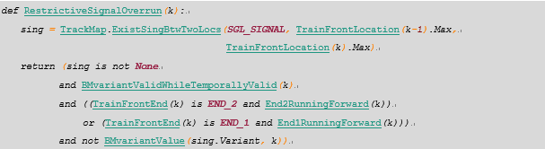

[iTC_CC_ATP-SwRS-0141]

TractionAuthorisedSenseEnd1，如果EOA有效且在**END_1**方向，则ATP授权列车向**END_1**方向运行。

If current EOA is valid and whose orientation is **END_1**, ATP shall authorize the train can move toward **END_1**.

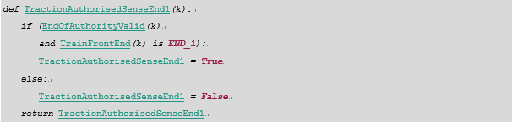

[iTC_CC_ATP-SwRS-0069]

TSRcontrolInhibition，不处理TSR信息。其状态来自于项目可配置的列车输入采集。

According to the status of TSRcontrollinhibition, ATP can judge whether it is necessary to handle TSR information.



[iTC_CC_ATP-SwRS-0324]

PointVSLNotExceed，判断有无限制点超能。

ATP shall determine whether train exceeds the vital speed limitation of the restrictive point, by comparing the energy between the energy of the train and the kinetic added potential energy of the point.

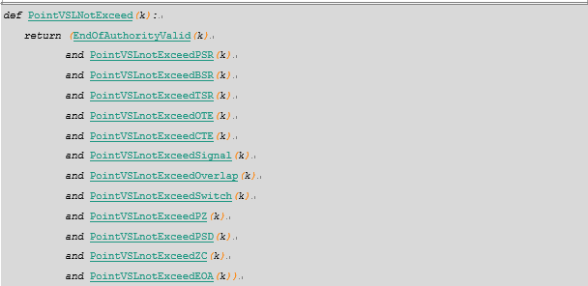

[iTC_CC_ATP-SwRS-0325]

TrainPossiblyInOverEnergy，列车能量大于限制点或限制区能量，即超能。

If the train energy exceeds the zone of point vital speed limitation, ATP shall consider the train possibly over energy.

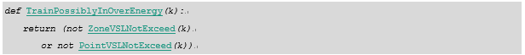

[iTC_CC_ATP-SwRS-0326]

TrainEnergyControlDisabled，在RM模式下不报超能。

If the RMF or RMR mode selected, ATP shall not monitor the train energy.



[iTC_CC_ATP-SwRS-0327]

EBforOverEnergy，超能后是否输出EB

ATP shall request emergency braking if train is possibly in over-energy and train speed control enabled and if following conditions fulfilled:

* the train is not detected at filtered stop,
* or the train is detected at filtered stop and:
* safe immobilization customization setting for this control indicates to use emergency brake,
* or safe immobilization customization setting for this control indicates to use emergency brake when it was already applied.

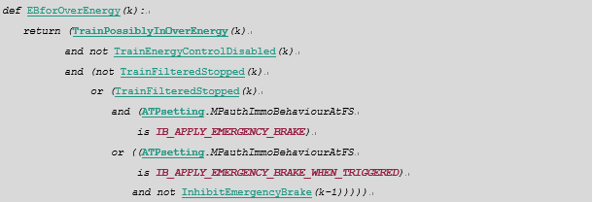

[iTC_CC_ATP-SwRS-0328]

PBforOverEnergy，超能停车后是否继续输出PB

ATP shall request parking braking if train is possibly in over-energy and train speed control enabled and if following conditions fulfilled:

* the train is detected at filtered stop,
* and safe immobilization customization setting for this control indicates to use parking brake.

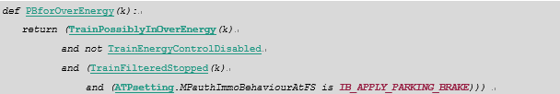

[iTC_CC_ATP-SwRS-0294]

RouteExclusivityGuaranted_1，如果列车在车头1对应方向且限制状态的模糊时间区内超过项目设定时间，则ATP应将该值设为限制状态。其中MoralTimeTimer_1为记录列车在车头1对应方向的限制状态模糊时间区内的时间。

If ATP cannot determine train is NotOnRestrictiveMoralTimeArea_1, and if this situation lasts more than ATPsetting. MTtimeout cycles, ATP shall consider that route exclusivity is not guaranteed and RouteExclusivityGuaranted_1 shall be set to **False**.

If ATP detects that train is NotOnRestrictiveMoralTimeArea_1, route exclusivity shall consider as guaranteed for that direction of travel and RouteExclusivityGuaranted_1 shall set to **True**

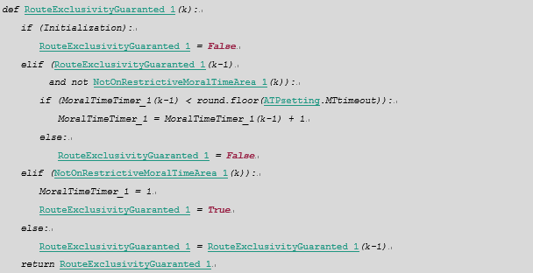

[iTC_CC_ATP-SwRS-0296]

HazardousMotionOnNonExclusiveRoute，非RM的BM模式下，如果列车在激活端车头方向的限制状态的Moral Time区停止超时预设时间，则ATP认为当前处于“非独占进路”的风险之中。

If RouteExclusivityGuaranted_1 is **False**, ATP shall request emergency braking if and only if:

* TrainFrontEnd is not **END_2**,
* RM forward nor RM reverse are not selected,
* and block mode is not selected.

If RouteExclusivityGuaranted_2 is **False**, ATP shall request emergency braking if and only if:

* TrainFrontEnd is not **END_1**,
* RM forward nor RM reverse driving mode are not selected,
* and block mode is not selected.

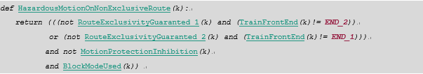

[iTC_CC_ATP-SwRS-0297]

PBonNonExclusiveRoute，当由于MoralTime监控导致的停车后，是否保持输出停车制动的取决于项目配置。

ATP shall request parking braking if train considered too near from a non-exclusive route and if following conditions are fulfilled:

* the train is detected at filtered stop,
* safe immobilization customization setting for this control indicates to use parking brake.





[iTC_CC_ATP-SwRS-0298]

EBonNonExclusiveRoute，如果当前处于“非独占进路”的风险中，且列车在移动，则ATP应当输出EB；如果当前已停车，则是否继续输出EB取决于项目配置。

ATP shall request emergency braking if train considered too near from a non-exclusive route and if following conditions are fulfilled:

* the train is not detected at filtered stop,
* or the train is detected at filtered stop and:
* safe immobilization customization setting for this control indicates to use emergency brake,

or safe immobilization customization setting for this control indicates to use emergency brake when it was already applied

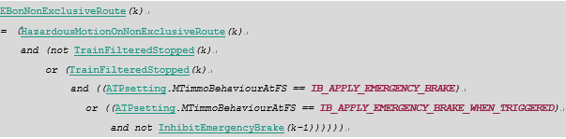

[iTC_CC_ATP-SwRS-0582]

NoUndetectableDanger_1，已监控向**END_1**方向的运行，其状态来自于项目可配置的列车输入采集。

The No Undetectable Danger in Extremity 1 shall be consider as permissive status according to project configuration.



[iTC_CC_ATP-SwRS-0285]

UndetectableDangerRiskForNoNUDE，当前两端车头都没有NUDE输入，则认为列车存在“无法侦测的风险”。

If there is neither No Undetectable Danger in Extremity 1 nor No Undetectable Danger in Extremity 2 inputs, ATP shall consider the train is possible under the risk of undetectable danger.



[iTC_CC_ATP-SwRS-0286]

PBforUndetectableDangerRisk，当停车且存在“无法侦测的风险”时，如果项目配置为输出停车制动，则ATP应当输出停车制动。

ATP shall request a parking braking if the possibility of an undetected danger has proven to be and if following conditions are fulfilled:

* the train is detected at filtered stop,
* safe immobilization customization setting for this control indicates to use parking brake.

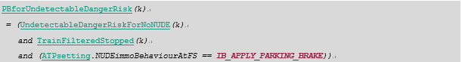

[iTC_CC_ATP-SwRS-0287]

NUDEdistanceAccount_1，监控当司机未授权向**END_1**方向运行时，列车向**END_1**方向运行的距离，该值为非负数，

* 若在初始化阶段，或NUDE1为**True**，或已经EB并停车，则等于0；
* 否则，当测速无效时，将其设置为默认值
* 否则，当里程计已初始化后：
* 如果MaximumTrainMotion大于0，则等于上周期累加距离加上本周期最大位移，最小取0。
* 而如果MaximumTrainMotion小于等于0，则使用上周期值加最小位移（实际上就是减小该累加值，倒车），最小取0
* 否则，保持累加距离不变。

When the driver does not authorize the train running toward the **END_1**, ATP shall accumulate the distance of the train running toward to the **END_1**.

* If in initialization, or the NoUndetectableDanger_1 is **True**, or the train has triggered EB and has stopped, ATP set this distance to 0;
* Else if train kinematic has invalid, ATP set this distance to the default value.
* Else if the odometer has initialized:
* If the MaximumTrainMotionis greater than 0, ATP accumulate the maximum movement in this cycle with the distance of last cycle;
* Or if the MaximumTrainMotionis less than or equal to 0, ATP use the minimum movement of this cycle plus to the distance last cycle (in fact, decrease the accumulated distance). The minimum of this accumulated distance is 0.
* Otherwise, keep the distance unchanged.

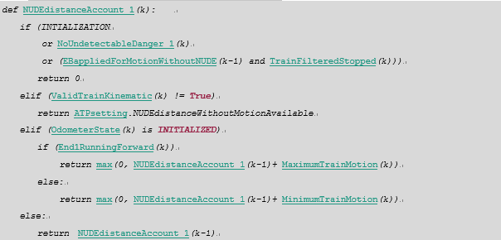

[iTC_CC_ATP-SwRS-0290]

EBappliedForMotionWithoutNUDE，保证由NUDE导致的EB会延迟一段时间。即：

* 当UndetectDangerMotionWithoutNUDE为**True**时，设置EBappliedForMotionWithoutNUDE为**True**；
* 当UndetectDangerMotionWithoutNUDE由**True**变为**False**后，还需保持EBappliedForMotionWithoutNUDE 在ATPsetting.NUDEtrainStopDurationBeforeEBrelease时间内为**True**；
* 超过上述时间后，该值为**False**。

The EB request shall be maintained to **True** during the application time ATPsetting.NUDEtrainStopDurationBeforeEBrelease, if the train has moved without NUDE more than project restricted distance.

* When UndetectDangerMotionWithoutNUDE is **True**, ATP shall set EBappliedForMotionWithoutNUDE to **True**;
* When UndetectDangerMotionWithoutNUDE change from **True** to **False**, ATP shall maintain EBappliedForMotionWithoutNUDE to **True** in period ATPsetting.NUDEtrainStopDurationBeforeEBrelease；

Over the time, set this value to **False**.

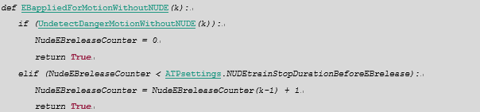

[iTC_CC_ATP-SwRS-0291]

EBforUndetectableDangerRisk，由“无法侦测的危险”导致EB并停车后，ATP应当根据项目配置判断是否输出EB。

When the train has triggered emergency brake causing by the "undetectable danger risk" and has stopped, ATP shall determine whether keeping the EB output according to the project configuration.

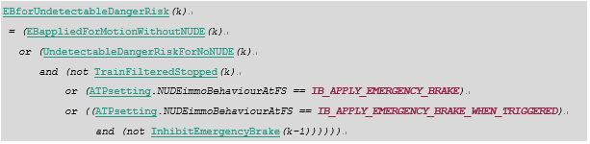

[iTC_CC_ATP-SwRS-0497]

NoDangerForRMoverSpeed，列车速度小于等于RM模式下的限速。

ATP estimates that current train maximum speed not exceeds the RM limit speed.



[iTC_CC_ATP-SwRS-0302]

UnrecoverableRollbackOverSpeed，如果ATP检测到列车已经回退超过项目限制的最大距离，则设置永久回退超速

From ATP power-up, UnrecoverableRollbackOverSpeed shall initialize to **False**.

UnrecoverableRollbackOverSpeed shall be set to **True** if and only if following conditions are fulfilled:

* driving selector indicates that traction effort is supposed to be in the direction of travel,
* train front extremity is **END_2** or **END_1**,
* and rollback limit speed currently applicable is null for this direction of travel.

Once UnrecoverableRollbackOverSpeed set as **True**, it shall stay at state **True** while ATP is not reboot.

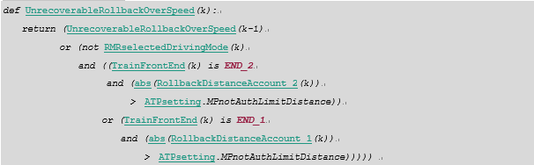

[iTC_CC_ATP-SwRS-0759]

LongDistanceReverseAuthorized，长距离倒车模式是否授权，其状态来自于项目可配置的列车输入采集。

LongDistanceReverseAuthorized represents the authorization of long distance reverse.



[iTC_CC_ATP-SwRS-0305]

ReverseDistanceAccount_1，累加RMR模式下的倒车距离（负值表示倒车）：

* 初始化时设置该值为0；
* 否则，如果列车运动学无效，则设置为配置参数的默认值；
* 否则，在**END_1**激活且非长距离倒车授权的前提下：
* 若里程计已初始化，且列车向**END_1**方向运行，则减小倒车距离绝对值，大于零则等于0
* 否则，如果里程计已初始化，且选择RMR模式，则累加倒车距离
* 否则，即里程计还未初始化，则保持距离不变。
* 其他情况，保持累计距离不变。

When train front extremity is **END_1** and traction effort is supposed to be in the opposite direction of travel, ReverseDistanceAccount_1 is the estimated maximum distance which separates current front extremity 1 position to last most forward position reached by this extremity. ATP shall evaluate ReverseDistanceAccount_1 in order to control that speed does not exceed reverse speed limit function.

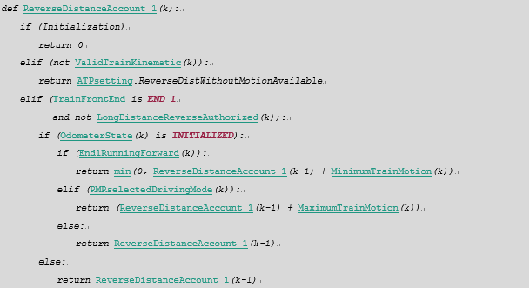



[iTC_CC_ATP-SwRS-0307]

ReverseOverSpeed，超过RMR模式限速的条件：

ReverseOverSpeed shall be **True** if following conditions fulfilled:

* driving selector indicates that traction effort is supposed to be in the opposite direction of travel,
* train front extremity is **END_2** or **END_1**,
* and movement observed is the opposite direction of travel,
* and:
* over-estimated train speed is greater than reverse speed restrictions currently applicable for this direction of travel,
* or else: if reverse speed restrictions currently applicable is null for this direction of travel,
* Or else: train kinematic is invalid.

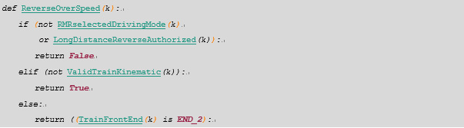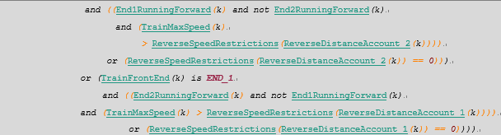

[iTC_CC_ATP-SwRS-0073]

TrainParkingBrakeApplied，任一端车头已施加停车制动，则认为停车制动已施加。其状态来自于项目可配置的列车输入采集。

The term TrainParkingBrakeApplied stands for that either of the train ends is in parking brake.



[iTC_CC_ATP-SwRS-0329]

TrainSafelyImmobilised，判断是否已经安全停车

ATP shall consider that train safely immobilized if:

* Train brake has detected safely applied, or train parking brake is detected;
* And train is detected at filtered stop.

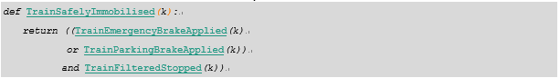

[iTC_CC_ATP-SwRS-0330]

LocalATPenableDoorOpening_A，本ATP是否在站内允许开A侧车门：

ATP shall determine whether train doors on side A opening. The rules are following:

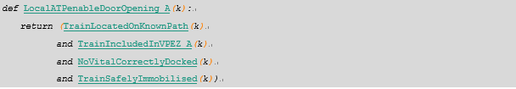

[iTC_CC_ATP-SwRS-0467]

CommunicateWithPSD，ATP根据CCNV的请求，判断是否与联锁建立通信。

* 当本周期来自CCNV的PSDoperation_A或PSDoperation_B不全为**None**时，设置CommunicateWithPSD为**True**；
* 否则，设置CommunicateWithPSD为**False**。

ATP shall determine whether to establish communication with the correlative CI according to request from CCNV:

* When there is at least one id of PSDoperation_A or PSDoperation_B is not none, ATP shall set CommunicatedWithPSD to **True**:
* Otherwise, set CommunicatedWithPSD to **False**.



[iTC_CC_ATP-SwRS-0332]

UsingPSDstatusFromCI，只有当列车定位与PSD区域有交集，且列车静止或刚发车时，ATP使用来自CI的PSD状态信息。

Only when the train fulfilled the following conditions, ATP shall use the PSD status from the CI:

* The train location intersects with a PSD zone;
* And the train is filtered stopped or just started moving.



[iTC_CC_ATP-SwRS-0134]

MasterCCcore，来自CCNV的当前是否为主控CC信息

MasterCCcore shows whether the status from CCNV is the main controlled CC.



[iTC_CC_ATP-SwRS-0336]

PSDopeningCommand，本ATP或者冗余端ATP当前是否在发送开PSD命令.

ATP shall determine whether itself or the redundant ATP opening the PSD in this cycle.





[iTC_CC_ATP-SwRS-0749]

EBforDepartureWithoutTDCL，若ATP监控发车时丢失TDCL的情况，则输出EB。

If ATP needs to monitor the status of train doors, ATP shall trigger EB if train determine without TDCL:



[iTC_CC_ATP-SwRS-0343]

EBforUnexpectedPSDopening，PSD区域内刚发车时PSD门开，则输出EB.

If in charge of the PSD control, ATP shall trigger emergency brake when train just started moving but PSD does not closed.



[iTC_CC_ATP-SwRS-0349]

HoldDoorsClosedTrainEnd1，未拉**END_1**端驾驶室的逃生门紧急手柄，或者车在运动时，锁闭**END_1**端逃生门。

ATP shall keep hold the train **END_1** door closed when one of the following conditions fulfilled:

* Train kinematics is valid and the train does not stop;
* Or the emergency handle of **END_1** is not pulled;



[iTC_CC_ATP-SwRS-0354]

TrainDockedInStation，根据开门授权条件判断是否车停在站内。

ATP shall determine whether the train has docked in the station correctly according to conditions of train stopping and doors opening enable.

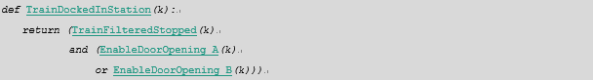

[iTC_CC_ATP-SwRS-0355]

TrainLeavingStation，判断是否在离站过程中。

* 从TrainDockedInStation由**True**变为**False**开始，如果列车测速有效，累加MaximumTrainMotion距离：
* 如果其绝对值在[**0**, ATPsetting.EvacuationStationAreaLength]范围内，则设置TrainLeavingStation为**True**；否则为**False**。
* 即如果列车出站后又倒车回到上述范围内，也应认为是TrainLeavingStation。
* 如果列车运动学无效，则设置该值为**False**并清除累加距离。

The train is said to be leaving the station:

* if since last time train has been detected docked in station (TrainDockedInStation), the cumulated of the absolute value of MaximumTrainMotion is in the range [**0**, ATPsetting.EvacuationStationAreaLength] and no train kinematic invalidation occurs.
* or else, if the train kinematics is invalid, ATP shall set TrainLeavingStation as **False** and clear the cumulated distance.

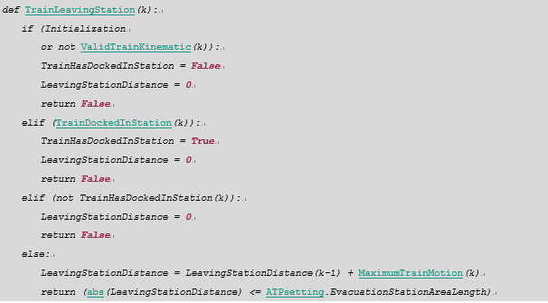

[iTC_CC_ATP-SwRS-0748]

EBforEvacuationWithTrainStopped，站间停车时的逃生请求EB.

If the train stopped evacuation has been required, ATP shall trigger the emergency brake.



[iTC_CC_ATP-SwRS-0359]

TrainParkingBrakeRequested，判断本周期是否需要施加停车制动。条件如下：

* 由于moral time 导致需要输出停车制动；
* 或者，由于超能导致需要输出停车制动；
* 或者，由于在PSD区域内车门未关闭而导致需要输出停车制动；
* 或者，由于NUDE导致需要输出停车制动；
* 或者，CCNV请求需要输出停车制动；
* 或者，由于PSD未关闭而导致需要输出停车制动
* 或者，本周期已请求EB输出。

TrainParkingBrakeRequested, determine whether to apply parking brake. This variable shall be **True** when one of the following conditions met:

* Train is in front of a possibly non-exclusive route,
* Synthesis of speed constraints on the train implies that it is not allowed to move anymore. Any movement may lead to an hazardous situation,
* Train is located on a passenger exchange area with PSD and train doors are not proven closed and locked,
* Train is located on a passenger exchange area with PSD and PSD are not proven closed and locked,
* There is a possibility of undetectable dangers,
* An operational parking brake is requested,
* The PSD are opened and are under the supervision of ATP,
* The EB has been requested in this cycle.

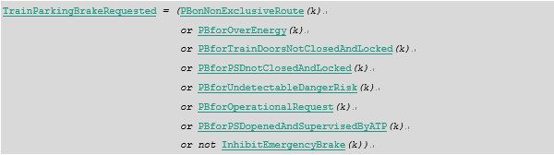

[iTC_CC_ATP-SwRS-0360]

InhibitParkingBrake，当前不施加停车制动。

InhibitParkingBrake，ATP software do not apply the parking brake.



[iTC_CC_ATP-SwRS-0361]

TrainEmergencyBrakeRequested，判断本周期是否需要施加EB。

ATP shall control emergency brake output according following emergency braking requests from control functions:

* moral-time control function has detected an hazardous situation (route exclusivity violation);
* train speed is no longer compliant with respect of whole speed restriction of guide way;
* an approachable speed limit has been over-run (RM speed limit or memorized location speed limit);
* an over-speed in reverse direction of travel has been detected;
* an emergency evacuation is required for passengers;
* train departure with not all doors closed and locked has been detected;
* the train starts to move on a PSD zone which status is not "all PSD proven closed and locked";
* train has moved although there are potential undetectable dangers;
* an operational emergency braking has been requested by CC-Non Vital;
* train end doors are not closed and locked;
* not all doors closed and locked has been detected on a PSD zone and parking brake is not applied,
* not all PSD closed and locked has been detected on a PSD zone and parking brake is not applied;
* the approachable signal is overrun;
* the VLE-2 safe timer failed;
* the information of Dataplug in both ends of cab is inconsistent.



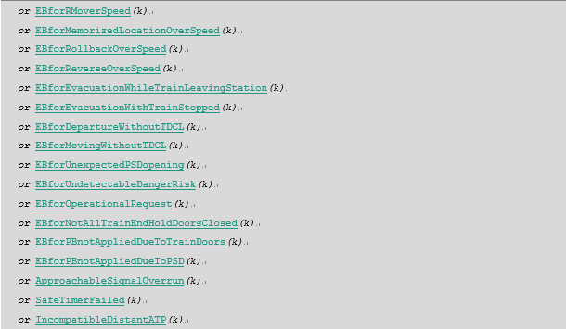

[iTC_CC_ATP-SwRS-0546]

CCworkOvertime，监控CC是否连续工作超过**MAX_RESET_TIME**时间(该时间小于**MAX_ATP_LOOP_HOUR**)。如果CC运行超过**MAX_RESET_TIME**时间，则ATP需将所有对VIOM输出的端口置为限制状态。

ATP shall monitor the CC continuous work time. If the CC is running more than **MAX_RESET_TIME** (the value is far less than **MAX_ATP_LOOP_HOUR**), the ATP shall set all output to VIOM as restricted status.



[iTC_CC_ATP-SwRS-0403]

TrainHeadMinLocation，车头最小定位位置。

根据[REF5]，在LocReport中的坐标单位为0.5米，因此需进行单位转换。转换时应当向列车的“后方”即上游方向取整。

* 如果列车失位，则设置相关定位信息为无效值；
* 否则，如果列车向**UP**方向运行，则：
* 车头最小定位所在BLOCK号不变；
* 车头最小定位所在坐标以0.5米为单位向下取整；
* 车头方向为**LOCREPORT_DIRECTION_UP**。
* 否则，如果车头最小定位坐标加0.5米小于该BLOCK长度，则：
* 车头最小定位所在BLOCK号不变；
* 车头最小定位所在坐标以0.5米为单位向上取整；
* 车头方向为**LOCREPORT_DIRECTION_DOWN**。
* 否则，如果车头最小定位所在BLOCK，与该BLOCK的**UP**方向下个BLOCK之间存在灯泡线极点，则：
* 车头最小定位所在BLOCK需改为其**UP**方向的下个BLOCK；
* 车头最小定位所在坐标为下个BLOCK长度以0.5米为单位向下取整；
* 车头方向为**LOCREPORT_DIRECTION_UP**。
* 否则：
* 车头最小定位所在BLOCK需改为其**UP**方向的下个BLOCK；
* 车头最小定位所在坐标为0；

车头方向为**LOCREPORT_DIRECTION_DOWN**

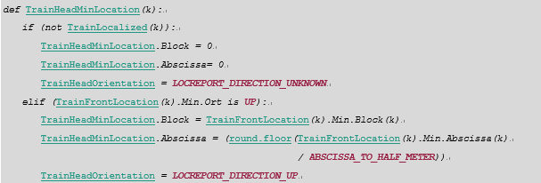

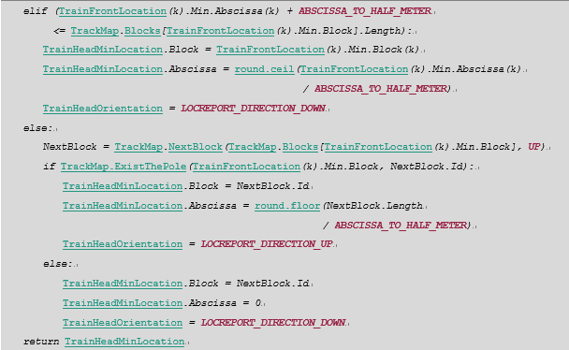

[iTC_CC_ATP-SwRS-0068]

RouteSetNotNeededSendable，是否可以发送RSNN信息。其状态来自于项目可配置的列车输入采集。

According to the status of RouteSetNotNeededSendable, ATP can judge whether it is necessary to send RSNN information.



[iTC_CC_ATP-SwRS-0094]

DateSynchronisationReportAvailable用于判断当前周期收到的LC安全时间消息是否可用。当满足以下条件时，设置DateSynchronisationReportAvailable为**True**。否则，设置DateSynchronisationReportAvailable为**False**。

* 本周期收到来自LC的DateSynchronizationReport消息，并且校核字正确；
* 如果收到LC消息是LC应答本端CC发出的消息，且满足以下条件时:
* 当前ATP时间应大于消息中所带的ccLoopHour;
* 并且当前ATP时间与消息中所带的ccLoopHour的差值应当小于之前ATP使用的LC消息时间。
* 如果该消息是LC应答远端CC发出的消息，则应满足以下条件:
* 当前ATP维护的远端ATP最小时间应大于消息中所带的ccLoopHour;
* 并且当前ATP维护的远端ATP最大时间时间与消息中所带的ccLoopHour的差值，应当小于之前ATP使用的LC消息时间。

DateSynchronisationReportAvailable used to judge whether the LC synchronization message could use or not. When the below conditions fulfilled, DateSynchronisationReportAvailable shall set as **True**. Otherwise, it set as **False**.

* If ATP Receives the DateSynchronizationReport message from LC, and the checksum is correct.
* And If the received message is LC to respond the local CC, ATP shall qualify with below conditions:
* The current ATP time is more than ccLoopHour in the message
* The different value between the current ATP time and the ccLoopHour is less than the LC message time in the previous ATP.
* Or else:, If the received message is LC to respond the remote CC, and it should be qualified with below conditions:
* The minimum time in remote ATP maintained by current ATP is more than the ccLoopHour
* The different value between maximum time in remote ATP maintained by current ATP and the ccLoopHour is less than the LC message time in the previous ATP.



[iTC_CC_ATP-SwRS-0446]

RTCtime，ATP维护的非安全时钟：

* ATP软件在初始化时从VLE-2后板上获取RTC时钟信息；
* 之后，ATP软件每秒钟将该RTC时钟加1；
* 但如果RTC时钟与来自CCNV的NTP时间差超过**MAX_NTP_TIME_ERROR**，则使用NTP时间更新RTC时间。

ATP software shall maintain the RTC time for non-vital functions.

* In initialization, ATP software get RTC time from VLE-2 board;
* And then, ATP software updates the RTC time every second;
* And if the difference between RTC time ATP used and the NTP time CCNV sent is greater than **MAX_NTP_TIME_ERROR**, ATP shall reset the RTC time as NTP time.

