Corresponding Letter

We are grateful to the referee for their comprehensive report and valuable suggestions, which have substantially improved the manuscript. We have addressed all comments in detail below (highlighted in orange), and all modifications to the text are indicated in color. The main changes are as follows: a) inclusion of an EW plus velocity dispersion cut to isolate purely star-forming regions; b) validation of our key results even for more coarse spatial resolution (~500pc) to confirm that our results are not affected by over resolving star-forming regions or incorrect stellar mass determinations; c) confirming that our deltaSFR-deltaO/H relations are not driven by correlated errors, etc. All these additional analyses have not affected our main results and conclusions of the paper, and they have reinforced the manuscript. As such, we are grateful to the referee. We trust that the referee will find this revised version acceptable for publication.

Reviewer's Comments:
Reviewer: Sebastian Sanchez

Comments to the Author
Referee report on the manuscript entitled “MAUVE--MUSE: When
Metallicity Follows or Fights StarFormation---A Mass-Dependent
Inversion in Virgo Galaxies”.

I read with a particular interest the current manuscript, as this is
one of my main research topics. In summary, the authors explore the
gas-phase spatially resolved mass-metallicity relation (MZR) at
sub-kpc scales (~100pc) using IFS provided by the MAUVE-MUSE survey
focused on 14 spiral galaxies within the Virgo cluster.

Using these data, and adopting performing a standard stellar
population analysis based on synthesis model (pPXF) and the analysis
of a set of bright emission lines (including the strong Hb, [OIII],
Ha, [NII] and [SII] accessible in the considered wavelength range),
they generate spatially resolved, spaxel wise, maps of (I) stellar
mass surface density (Σ*), (II) star-formation rate surface density
(ΣSFR), based on dust-corrected Ha luminosities, and (III) gas-phase
oxygen abundance (Zgas), using a set of strong-line indicators
(although the main analysis is based on two calibrators using the O3N2
indicator). Using these maps they revisit the resolved
mass-metallicity relation (rMZR), focused on the potential existence
of a secondary relation with the SFR (i.e., a secondary realtion of
the Zgas with ΣSFR when removing the dependence on the stellar mass
surface density, Σ*)

The authors confirm that the explored galaxies follow the expected
resolved mass–metallicity relation, where regions of higher stellar
mass surface density exhibit higher gas-phase metallicity, following
the shape previously described in the literature (in general).
However, when examining the relation between metallicity and star
formation rate surface density at fixed Σ*, they identify a
mass-dependent behaviour: (i) at low stellar mass surface density,
metallicity and ΣSFR show an anti-correlation, thus, regions with
higher star formation activity tend to be more metal-poor (in
agreement with the expectations of a resolved FMR, or rFMR), however
(ii) at high stellar mass surface density, the trend reverses and
becomes a positive correlation, with higher ΣSFR associated with
higher metallicity. The transition is described at stellar surface
density of Σ* ~ 7.5-8.0 log(M_sun,kpc^-2). Furthermore, both
regimes are found in the same individual galaxies, suggesting that
the change in the dependence from negative to positive are
driven (mostly) by local processes rather than global ones.

Authors proposed a physical interpretation implementing an analytical
spatially resolved gas-regulator model, suggesting that the observed
behaviour results from the competition between two processes that
affect the local Zgas: (i) SFR fluctiations that enrich the ISM,
driven the positive correlation, and (ii) Gas-supply due to inflows or
metal-poor(er) (not necesarely pristine) that dilute the local Zgas
and enhance the SFR at the same time (i.e., the ussualy proposed
explanation for the FMR and the rFMR). The competition between those
processes requires a differential time-scale between both of them and
the mixing of metals with the local environment. Beside that, the
authors suggest that the dominant mechanism depends on the local
Σ*. In this way, low stellar mass density regions are influenced by
gas inflows, while high-density ones are dominated by internal
enrichment processes. Within this framework, the observed inversion
of the Zgas–ΣSFR relation emerges naturally as the relative importance
of these processes changes across the galaxies. Finally, the authors
considered that this behaviour can also explain the secondary relation
of the MZR with the sFR observed in integrated/global properties of
galaxies.

I consider that the article present novel results and should be
considered for publication. However, I have some concerns regarding
certain aspects of the methodology that could affect the results and
their interpretation by the authors. I consider that a moderate revision
is required before recommending it for being accepted for publication.

Major Concerns:

1) Incorrect assumption that combined used of the O3-N2 and O3-S2 BPT
diagrams guarantees the selection of star-forming ionized regions.

Authors select the Hii regions based just on their location in these
two BPT diagram. However, it is well known that other sources of
ionization may populate that region (see Sanchez 2020 ARA&A and
references in there). The broadly accepted claim that those line
ratios below the Kauffmann curve can only be produced by SF is a wrong
(but broadly spread) statement. This is even worst for the Kewley
curve, thus when authors discuss the inclusion of ionized regions
included in the so-called "composite" regime. The generally adopted scheme to
claim that below the K03 curve all ionisation is due to SF, in between
the K03 and K01 curves the ionisation has a mixed nature, and above
the K01 is mostly AGNs or LINER-like (what ever the physical source a
LINER could be), is an oversimplification and it is essentially wrong.

The demarcation curves, as described in the literature, define the
upper limit of the line ratios that can be produced by young stars
(see K01 article for further details). This defines an
envelop. However, they cannot define definitive boundaries just using
the BPT diagrams. Other additional parameters are required, and
in general they are not enough per se. One of the
most promising is the EW(Ha), that tight the emission in Halpha with
the properties of the underlying stellar population. In general, if
the EW(Ha) is below 6A (for the apertures defined by the SDSS
observations) it is difficult to justify that the observed ionisation
is due to star-formation. Authors should read Stasinska et al. 2008;
Cid-Fernandes et al. 2010; Sanchez et al. 2014, Lacerda et al. 2018;
2020, and the reviews suggested before in this regards.

Another procedure is to explore the shape of the ionizing structure,
what can be done in the current data due to the spatial resolution (allegated
to be ~100pc). The selection of clumpy (peaky) and roundish regions
helps to select regions ionized by a young stellar cluster (i.e., recently
formed), as demonstrated in Lugo-Aranda et al. 2023. The exploration
of the fraction of young stars based on the stellar decomposition
explored by the authors, as implemented in Espinosa-Ponce et al. 2020,
also helps in this regards. This way the authors could guaranteed that the
fraction of young stars at the location of the selected candidates
to Hii regions is large enough to produce the observed ionization?

I am particularly worried about other sources of ionization, like
shocks, that may affect the results somehow, and the DIG associated
with post-AGB stars, frequently found in galaxies of the morphology
of the ones explored by the authors (I will discuss on that later).
The distribution of ionized regions in Fig.1 (BPT O3-N2 and O3-S2 diagrams),
do correspond mostly with the expected from this kind of ionization
(see Fig. 5 of Sánchez 2020, or Fig. 2 and Fig. 6 of Sánchez et al. 2021).

Authors quote Lacerda et al. 2020 as an example of the adopted chassification
scheme. However, the BPT diagrams shown and used by Lacerda et al. 2020
corresponds just to the central regions of galaxies, in which the ionizing
sources are dominated by processes than in general are not the same
as the ones found along their full optical extensions (again, Fig. 2, of Sánchez
et al. 2021). Beside that, authors did not mention that in the classification
scheme adopted in that article they include the EW(Ha) as an additional selection
criteria. Furthermore, as indicated before, the demarcation lines should
be interpreated as the maximum envelop of line ratios that could be generated
by SF (thus, what is above them in the BPT diagrams could not be ionized by SF),
but not the contrary (i.e., what it is below them could be ionized by many
different sources: shocks, post-AGBs, low-metallicity AGNs).

This point is extremelly important, as two of the primary quantities analyzed
by the authors in this study (SFR derived from Ha, and Zgas derived from strong-line
indicators) depends the selection of just SF regions. Any contamination by
other sources of ionization could alter the estimated quantities and produce any short
of unexpected secondary relations. Quoting Kumari et al. in this regards it is indeed
very unfortunate, as the way that that article associate SF regions and non-SF regions
was also based on the use of the BPT diagram. As already discussed with the authors
of that article in many cases what they claim to be SF regions are filaments from
outflows, and putting together the complex and diverse DIG in a single box was indeed
very unfortunate. That particular article and the sequence of results derived from
it has endanger our knowledge of the spatial resolved ISM in galaxies in a tremendous
way and it will be so difficult to correct this path. I strongly recommend
the authors to critical inspect the content and conclusion on that article before using it.

In summary, I consider that the selection of HII-like/SF regions
should be revised in the article, using criteria that guarantee a
clean selection of pure SF regions, not contaminated (or at least
mitigating the possible contamination) of other ionizing sources. A
minimum criteria would be (i) to select just clumpy regions using any
kind of toold accesible (HIIphot, phHIIextractor...), or remove smooth regions
(clearly associated with other ionizing soruces, (ii) introduce additional cuts
considering the EW(Ha) or the velocity dispersion (e.g., Sánchez et al. 2023, 2025),
(iii) remove those regions in which the stellar synthesis analysis did not provide
with enough young stars to guarantee that the ionization is produced by them.

With the current analysis on hand by the authors, the easier ones would be
an EW(Ha) criteria (>6AA) and a rejection of those regions without a clear presence
of young stars (based on the pPXF analysis). A clumpiness criteria would help a lot
or the introduction of the velocity dispersion, but that would require a stronger
effort.

We thank the referee for this suggestion and have now implemented additional EW(Ha) and Ha dispersion criterion in our star-forming spaxel selection. Specifically, we require EW(Ha) > 6A and sigma(Halpha)<45km/s in addition to our BPT-based HII classification, and we have updated Section 2.3 accordingly. Figure 1 is now colour-coded by EW(Ha) to illustrate this revised selection, and all relevant figures in the manuscript have been regenerated using the updated mask. Importantly, our main results remain unchanged under this more conservative definition of star-forming spaxels: the mass-dependent behaviour of the Zgas​–Sigma_SFR​ relation is preserved, including the sign change across Sigma_*​. We therefore conclude that our main findings are not driven by contamination from low-EW regions.

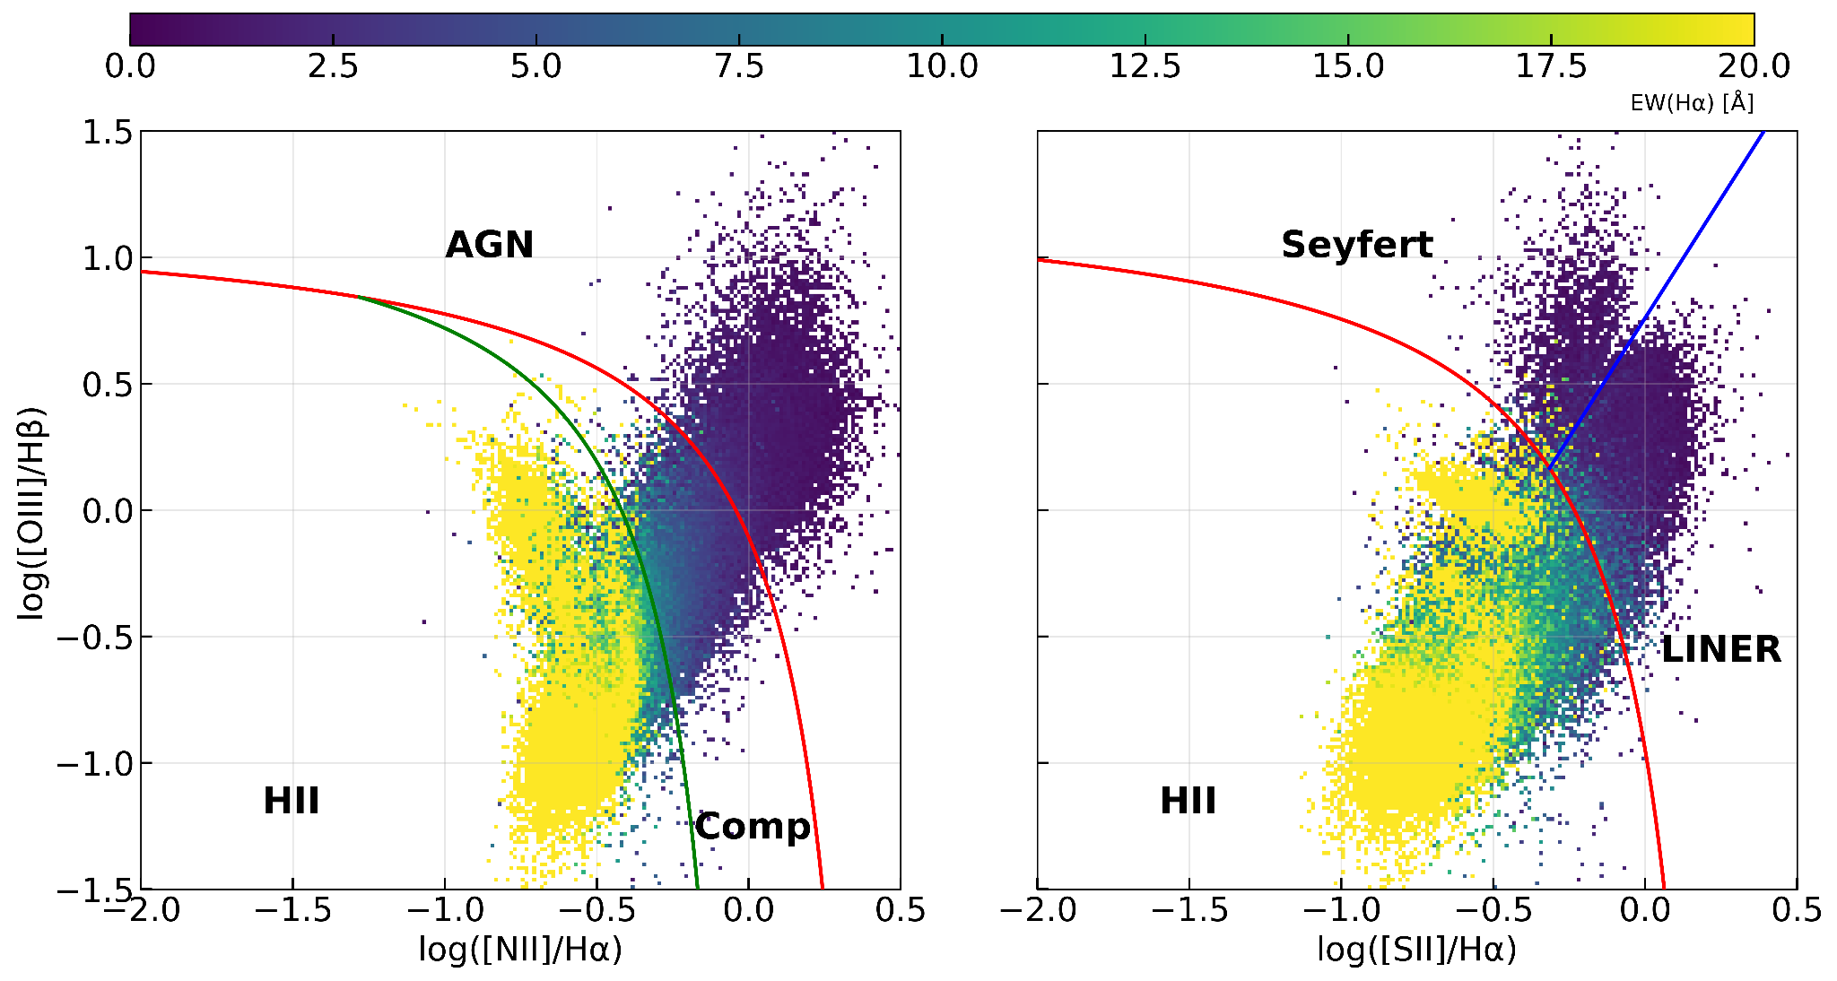

2) In my previous remark I highlighted the need to select regions purely ionized
by young massive stars or at least dominated by that ionization, in order to derive
the spatial resolved SFR and Zgas. It is extremelly important to understand that those
quantities are derived using calibrators that are based on two assumptions: (i) the
ionization is due to this kind of sources, and (ii) the nebula ionized by these massive
recently formed young stars (OB) are fully integrated. If the ionized regions are
spatially resolved then neither the Ha luminosity informs about the local SFR nor the
line ratios inform about the oxygen abundance. This is an extremely important point
considering the spatial resolution of the analyzed data (~100pc), at which a substantial
fraction of the HII regions and cluster could be spatially resolved, in particular
the brighter ones. Unfortunately there is no characteristic scale for HII regions, as
their size depends on their luminosity. However, there is a some-kind "maximum" size
for the known more luminous HII regions (e.g., 30 Doradus), that it is the size
of a largest molecular clouds too, i.e., ~500 pc. Below this size, there is a risk
that you are resolving the nebula, and therefore the Ha luminosity would not measure
the amount of ionized photons produced by the young stellar ionizing cluster, and the
line ratios would inform about the structure of the nebula, and not about the abundance.
This problem works in the oposite direction of the previous one, as it will affect more
the brightest/more luminous and therefore larger HII-regions (while the contamination
by additional ionizing sources may affect more clearly the low-luminosity, smaller
HII-regions, more affected by the pollution of other weak ionizing sources).

Indeed, a visual inspection of Fig. 4, shows what I could identify as the effect of
resolving the ionized nebula in certain locations, in particular in the bright HII region
at the S-E, and some of the HII regions in the N-W of this particular galaxy.

The way to address this problem is to integrate the full ionizing
nebula before deriving the spatial resolved SFR and Zgas, either by
degrading the spatial resolution across the entire extension of
galaxies (following Sanchez-Menguiano et al. 2020,
https://aus01.safelinks.protection.outlook.com/?url=https%3A%2F%2Fui.adsabs.harvard.edu%2Fabs%2F2020MNRAS.492.4149S%2Fabstract&data=05%7C02%7Crongjun.huang%40research.uwa.edu.au%7C77a7dbe8a8674336b1e808de867bf62e%7C05894af0cb2846d8871674cdb46e2226%7C0%7C0%7C639096064194087835%7CUnknown%7CTWFpbGZsb3d8eyJFbXB0eU1hcGkiOnRydWUsIlYiOiIwLjAuMDAwMCIsIlAiOiJXaW4zMiIsIkFOIjoiTWFpbCIsIldUIjoyfQ%3D%3D%7C0%7C%7C%7C&sdata=95h18aOyqJN%2FiOJtnAGH2bGNwGT7DLI7U07TFHphZlI%3D&reserved=0), or
select and integrate individual HII regions with different apertures
depending on their luminosity (following Lugo-Aranda et al. 2024,
MNRAS, 528, 6099). The problem is even more critical when exploring
secondary relations between the involved parameters. My own personal
analysis indicate that the primary relations are well preserved, with
an increase in the scatter introduced by the fact that none Zgas
neigher Sigma_SFR are indeed the exact correct value along the
distributions. However, the secondary trends are in general wrong.
This is the case of Erroz et al. (quoted by the authors), in which a
reanalysis of their results degrading the resolution to ~1kpc shown
that most the differences with previous publised results are introduced
by the fact that their are resolving the ionizing structure of the
analyzed nebulae.

In this regards, authors could consult also this presentation:
https://aus01.safelinks.protection.outlook.com/?url=https%3A%2F%2Fui.adsabs.harvard.edu%2Fabs%2F2018wtl..confE...2M%2Fabstract&data=05%7C02%7Crongjun.huang%40research.uwa.edu.au%7C77a7dbe8a8674336b1e808de867bf62e%7C05894af0cb2846d8871674cdb46e2226%7C0%7C0%7C639096064194109212%7CUnknown%7CTWFpbGZsb3d8eyJFbXB0eU1hcGkiOnRydWUsIlYiOiIwLjAuMDAwMCIsIlAiOiJXaW4zMiIsIkFOIjoiTWFpbCIsIldUIjoyfQ%3D%3D%7C0%7C%7C%7C&sdata=edcXPdLALIPeiQR%2FLGpm%2BNdkNeDZQEmD7gJxrcr8VVU%3D&reserved=0

My recommendation in this regards is that authors should degrade the
data to a resolution in which both the SFR and Zgas could be derived
using the proposed methodology. A better approach would be to select
variable apertures depending on the luminosity, but I consider
that this is far more demanding.

We thank the referee for highlighting an important and well-known limitation of spatially resolved nebular diagnostics. We agree that strong-line metallicity calibrators and Hα-based SFR indicators rely on the assumptions that (i) the ionization is dominated by young massive stars and (ii) the nebula ionized by these stars is reasonably integrated. We therefore acknowledge that, at sufficiently high physical resolution, partially resolving individual HII regions may in principle bias both Σ_SFR and Z_gas measurements, particularly for the most luminous and extended regions.

At the same time, we emphasize that this concern acts in the opposite direction to the DIG-contamination issue raised in the previous point. Specifically, while resolving large HII regions may affect the brightest regions, degrading the data to coarser resolution inevitably increases the mixing of compact HII regions with surrounding DIG and other non–star-forming emission, thereby violating assumption (i). In that sense, there is no single “optimal” spatial scale at which both effects are simultaneously eliminated; instead, one must quantify which regime dominates for the dataset under consideration and test the robustness of the results.

In our case, several lines of evidence indicate that the partial resolution of HII regions is not an issue for our data and does not drive our conclusions.

First, while there is no unique characteristic size for HII regions, extensive work from PHANGS–MUSE shows that the majority of HII regions lie below or close to our ≈100pc physical resolution. Kreckel et al.(2019) find that the HII-region size distribution follows a power law with a rapid decline beyond ≈100–120pc, with only a very small fraction (<1%) reaching sizes ≳200pc. Santoro et al.(2022) and Groves et al.(2023), using ≳20,000 regions across 19 PHANGS–MUSE galaxies, further show that ≈90% of HII regions have diameters ≲120pc. Thus, while the very largest and brightest complexes (e.g. 30 Doradus–like regions) may be partially resolved, these objects represent a minority of the population and do not dominate the statistics.

Second, exploiting the established size–luminosity relation of HII regions, any bias introduced by partial resolution would primarily affect only the highest Σ_SFR bins. Quantitatively, this regime corresponds to logΣ_SFR≳−1 (Msun/yr/kpc-2), while the overwhelming majority of our spaxels populate lower surface-density bins. Our primary relations are therefore constrained mainly by regions where regions are unresolved or only marginally resolved, and where the assumptions underlying the calibrators remain valid.

Third, and most importantly, we explicitly tested the referee’s concern by degrading the data to coarser spatial resolution for two of our galaxies at the two extremes of our sample (see reply to the point below). Our main trends and conclusions remain unchanged. This demonstrates that the results are not sensitive to whether the brightest HII regions are marginally resolved at ≈100pc resolution.

We have clarified these points in the revised manuscript and now explicitly discuss the competing effects of partial -region resolution versus DIG contamination, as well as the resolution tests performed.

3) The derivation of the third explored parameter, the surface density
of the stellar mass (Σ*), could be also be affected by the physical
resolution of the analyzed data. The derivation of the stellar mass
is based on the assumption that it is possible to use the
continuum (V-band) luminosity into stellar mass through a M/L.
For doing so, the authors relies on the pPXF decomosition that relies on
the stellar synthesis method (Tinsley et al. 1976), that in essence
required the sampling of the entire (I)MF in each considered
aperture. The actual number of stars required to fully sampling
the mass-function is still under devate, but it is assumed
at a least it is required of the order of ~10^5-6 stars. Considering the
range of Surface stellar masses described in the article (10^6-5-9.5
M_sun / kpc^2), for a ~100 pc, only above 10^9 the synthesis method
could be applied (i.e., the stellar decomposition based on SSP, and the derivation of
an stellar mass afterwards). Below that stellar mass density the
stochastics sampling of the IMF should be considered, which complicates
the derivation of the stellar mass surface density and in general
the overall analysis proposed along this article.

Indeed this was one of the reasons why some of the major IFS galaxy surveys,
such as CALIFA or MaNGA, selected to sample galaxies at ~1kpc scale or above
, although it is usually not quoted.

In this regards, the authors could attempt to perform an analysis using
an stochastic sampling of the IMF (following Cerviño et al.), but I think
that would complicate the analysis beyond the scope of the current goals
of this article. The most simple approach, once again, would be to
resample the data to a more coarse spatial resolution in which the
current method could be applied. I consider that resampling the datacubes
to ~500 pc spaxels would indeed solve the problem, in agreement with the
resolution required for a proper derivation of the other two parameters
involved in this study, as indicated before.

BTW, this problem also affect to the derivation of the SFR based on Ha, for
the very same reasons. The method adopted by Kennicutt et al. 1998 and
other articles to link both parameters relies on the stellar synthesis
method and it is only valid at a physical scale in which the entire IMF
is sampled. Thus, using the Ha luminosity to trace the SFR at lower
physical scales is not correct either for this reason too.

We thank the referee for this important point. To test whether our results are driven by the native ~100 pc sampling used for the stellar-mass, Halpha-SFR, and metallicity measurements, we reran nGIST for two representative galaxies, NGC4396 (low-mass and negative Spearman trend) and NGC4501 (high-mass and positive Spearman trend), using a much higher continuum threshold (S/N > 200), which yields a substantially coarser effective spatial scale of about ~500 pc. NGC4396 was chosen as a representative low-mass case and NGC4501 as a representative high-mass case. Below we show the original stellar maas estimation vs the new SNR200 ones.

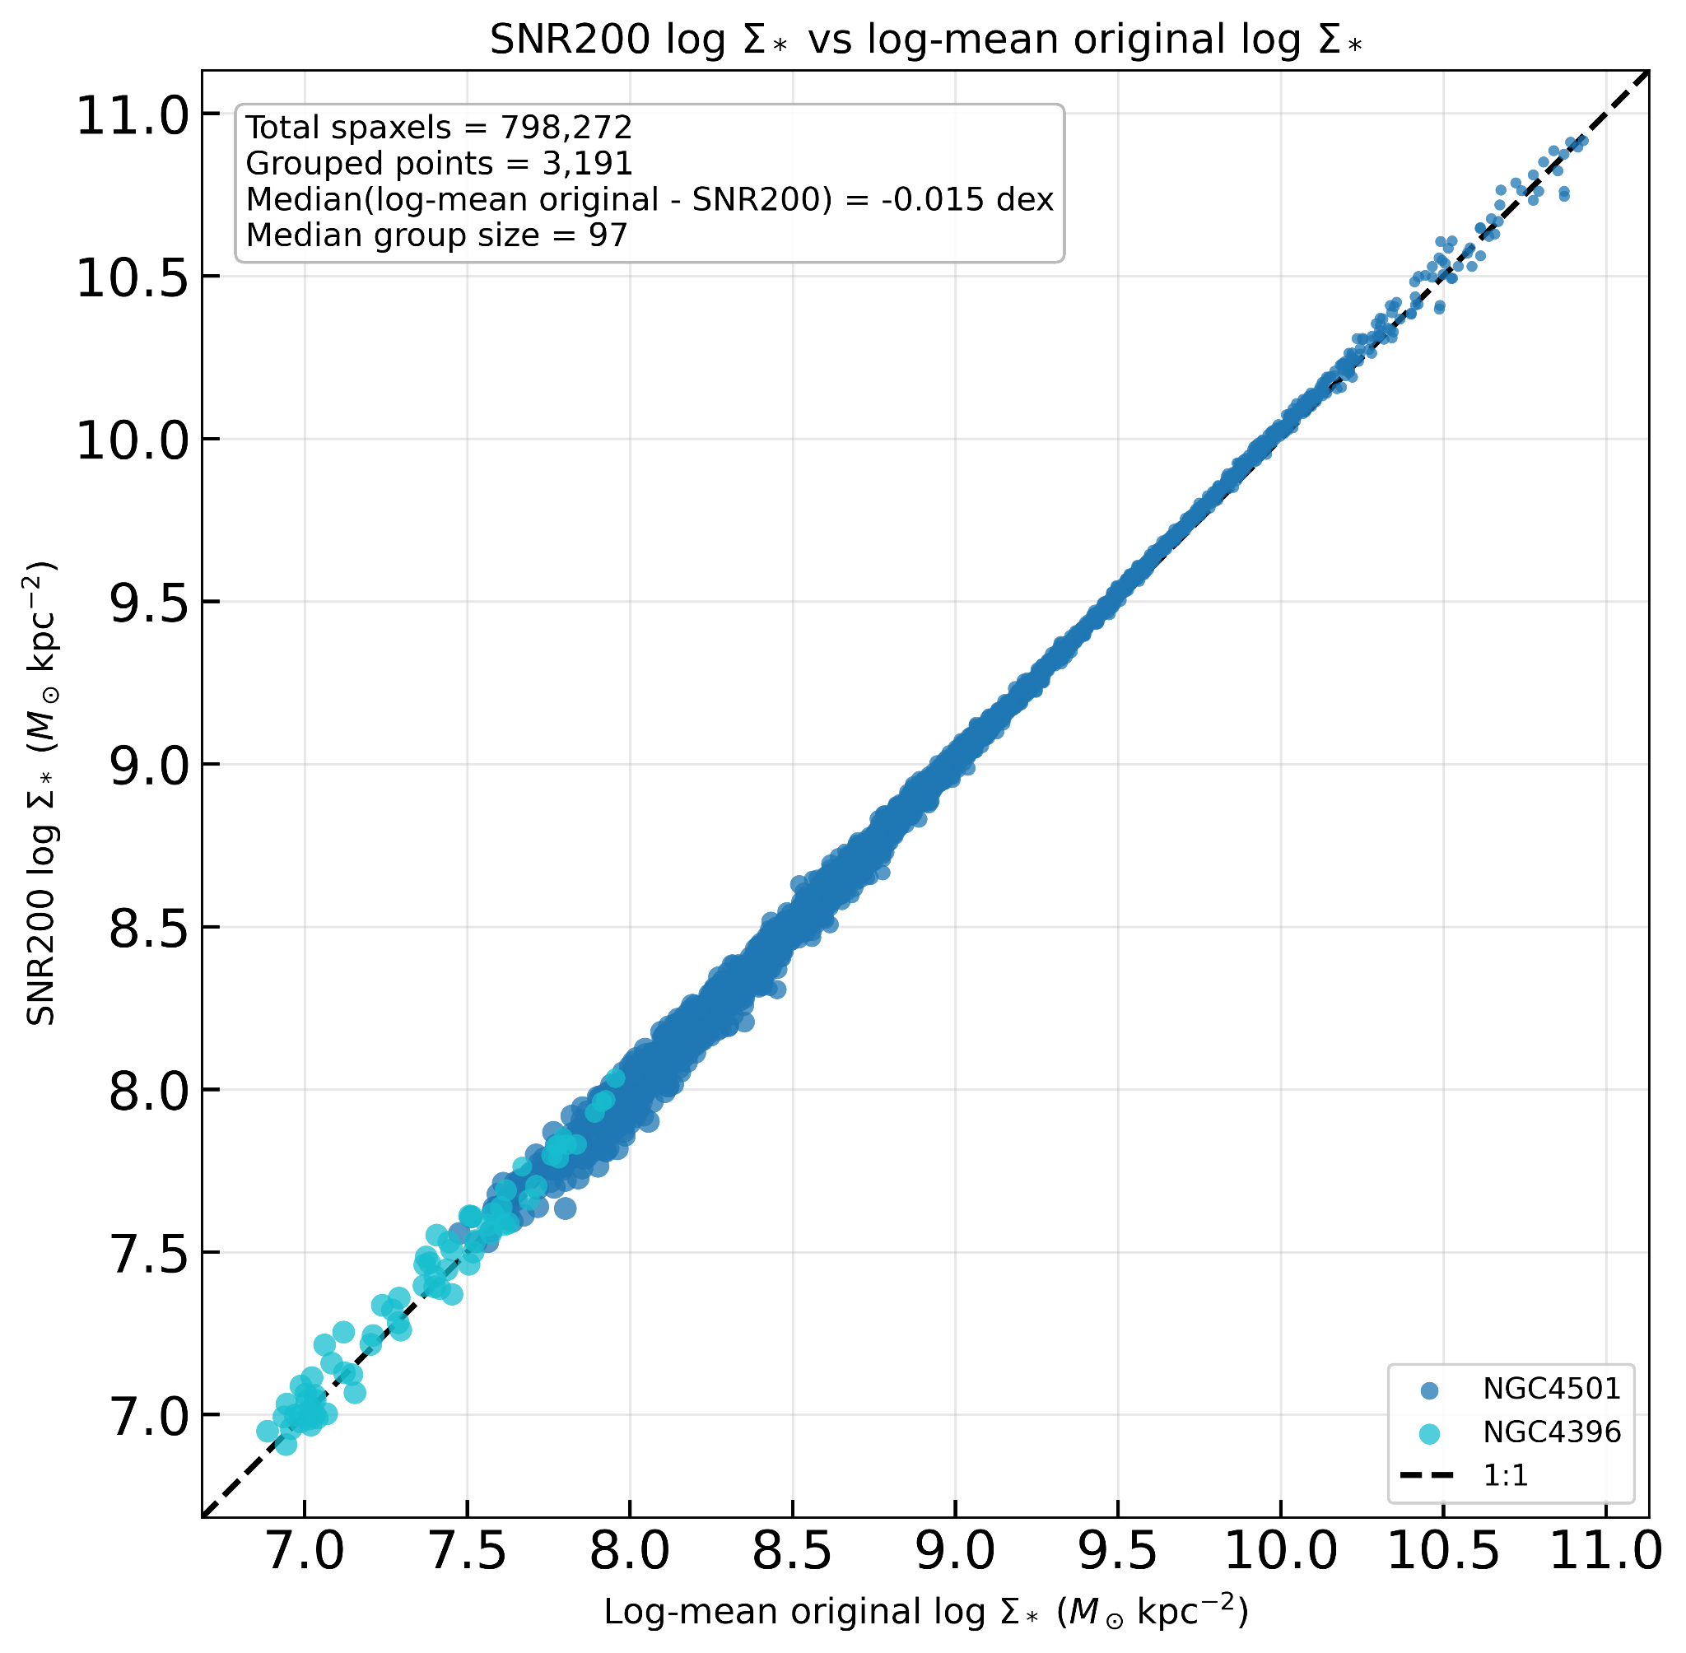

First, as shown in the Figure above, the stellar mass surface density estimates are perfectly consistent. Secondly, and most importantly, our main result remains unchanged under this coarser-resolution test. In particular, the Spearman trend still shows the same qualitative inversion, with the transition occurring around log(Sigma_*) ~ 7.5 - 8.0. Therefore, degrading the analysis to ~500 pc does not remove the observed mass-dependent sign change or the associated spatial patterns.

We therefore conclude that the main result is not an artifact of deriving Sigma_*, Sigma_SFR, and Zgas at the native ~100 pc scale. This demonstrates that the reported Zgas-Sigma_SFR inversion is robust to re-analysis at a substantially coarser effective resolution, and is therefore unlikely to be driven by stochastic IMF-sampling effects or by the use of ~100 pc-scale measurements alone. This coarser-resolution test also partially addresses the previous major concern 2), since it shows that our conclusions do not depend on resolving the smallest-scale nebular structure. We now mention this additional resolution test in the revised manuscript as a robustness check at the end of Section 5.2.

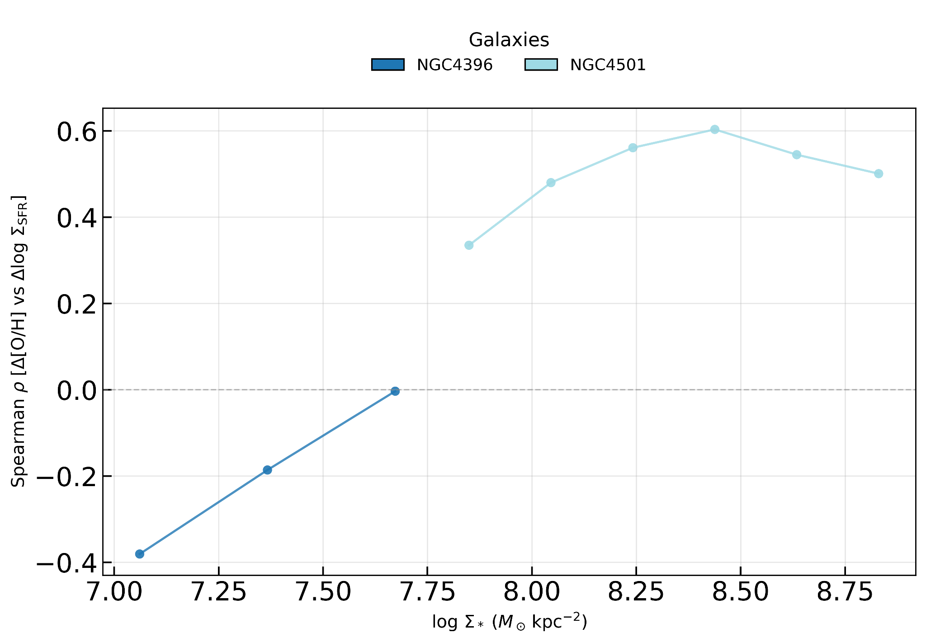

4) The main conclusions of the article depends on the existence of secondary
relations between the SFR and the Zgas once removed the primari dependence
on the stellar mass, spatially resolved, at the resolution of the data.
For exploring this possible secondary dependence the authors adopted two
different methods, that relies on the removal of the main relation between
the SFR and Zgas with the stellar mass, by computing Delta_Sigma_SFR and Delta_[O/H],
once removed the primary dependence with Sigma_*. They reported a strong correlation
between both parameters, suggesting the existence of a secondary relation of
a physical origin. Then, they analyze the positive/negative trends between these local parameters, using a method that weight these trends by the local errors, finding that there
is no single pattern, even within the same galaxies.

In this regards, when looking for secondary relations between physical
quantities which errors and indicators are not fully uncorrelated, as
the three parameters explored in this analysis, the fact that the
residuals from a primary relation present a clear correlation does not
guarantee the physical origin of that correlation. For instance, in
Sanchez et al. 2021, MNRAS, 503, 1615S, we demonstrated that even
Poissonian errors could induce secondary relations between the analyzed
parameters in the presence of covariances between the considered parameters.
For instance, the separation from the rSFMS of a point could be due to a
differential error in either Sigma_* or Sigma_Ha or a correlated error among both
of them, that affects differently Z_gas. The only way to determine if
the residuals of two three relation may present a clear correlation with
requiring any secondary relation is to simulate them, and observe if
the residual present a pure roundinsh distribution (no artificial correlation)
or not (artificial correlation). This is widely ignored in the field and
it could be a potential source of problems.

Therefore, I strongly recommend to run a very simple simulation,
distributing randomly points along the shown rMZR and the not shown rSMFS distribution,
subtract the average relations and explore the possible correlations between
the residuals, comparing that distribution with the one shown by the current data.
A proper propagation of the errors is really important (i.e., the
errors are in general larger for lower values of Sigma_SFR and Sigma_*).
Showing the distribution of spaxels in a Delta_SFR vs Delta_[O/H] diagram
would also help to understand how strong are the reported correlations.

We thank the referee for this important suggestion, and for pointing out the Sanchez et al. (2021) approach. We do agree with the referee that correlations between residuals calculated from linear fits of scaling relations can be driven by correlated errors between the variables involved. However, this would not necessarily affect our results as our residuals are measured in bins of stellar mass where every bin is treated independently. In other words, for every individual stellar mass bin, the Spearman correlation coefficient between Delta SFR and Delta O/H is nearly identical to what would be obtained by looking at the correlation between SFR and O/H. The removal of the stellar mass dependence is done primarily to allow a more easy comparison between different stellar mass bins and different galaxies.

Despite this, for full completeness, we performed the requested null test suggested by the referee anyway, following the logic of Sanchez et al. (2021, Sec. 3.4), to assess whether the observed mass-dependent secondary relation between Delta log Sigma_SFR and Delta[O/H] could arise artificially from independent primary relations plus measurement uncertainties/covariance.

Specifically, we constructed a null model in which log Sigma_SFR and [O/H] are independent at fixed log Sigma_*, i.e. the mock data contain only the primary rSFMS and rMZR relations and no intrinsic secondary coupling. We then propagated the observed per-spaxel uncertainties in log Sigma_SFR and [O/H], included a conservative proxy for uncertainty in log Sigma_*, and reran the identical residual-analysis pipeline used in the paper.

The result is clear. The null realizations do not reproduce the observed residual distribution or the observed mass-dependent Spearman trend. In the real data, the correlation changes from negative at low log Sigma_* to positive at high log Sigma_*, whereas the null simulations remain close to zero in all mass bins. The null residual cloud is also approximately symmetric, unlike the more structured cloud seen in the observations. This is shown in the new ensemble null-test figure.

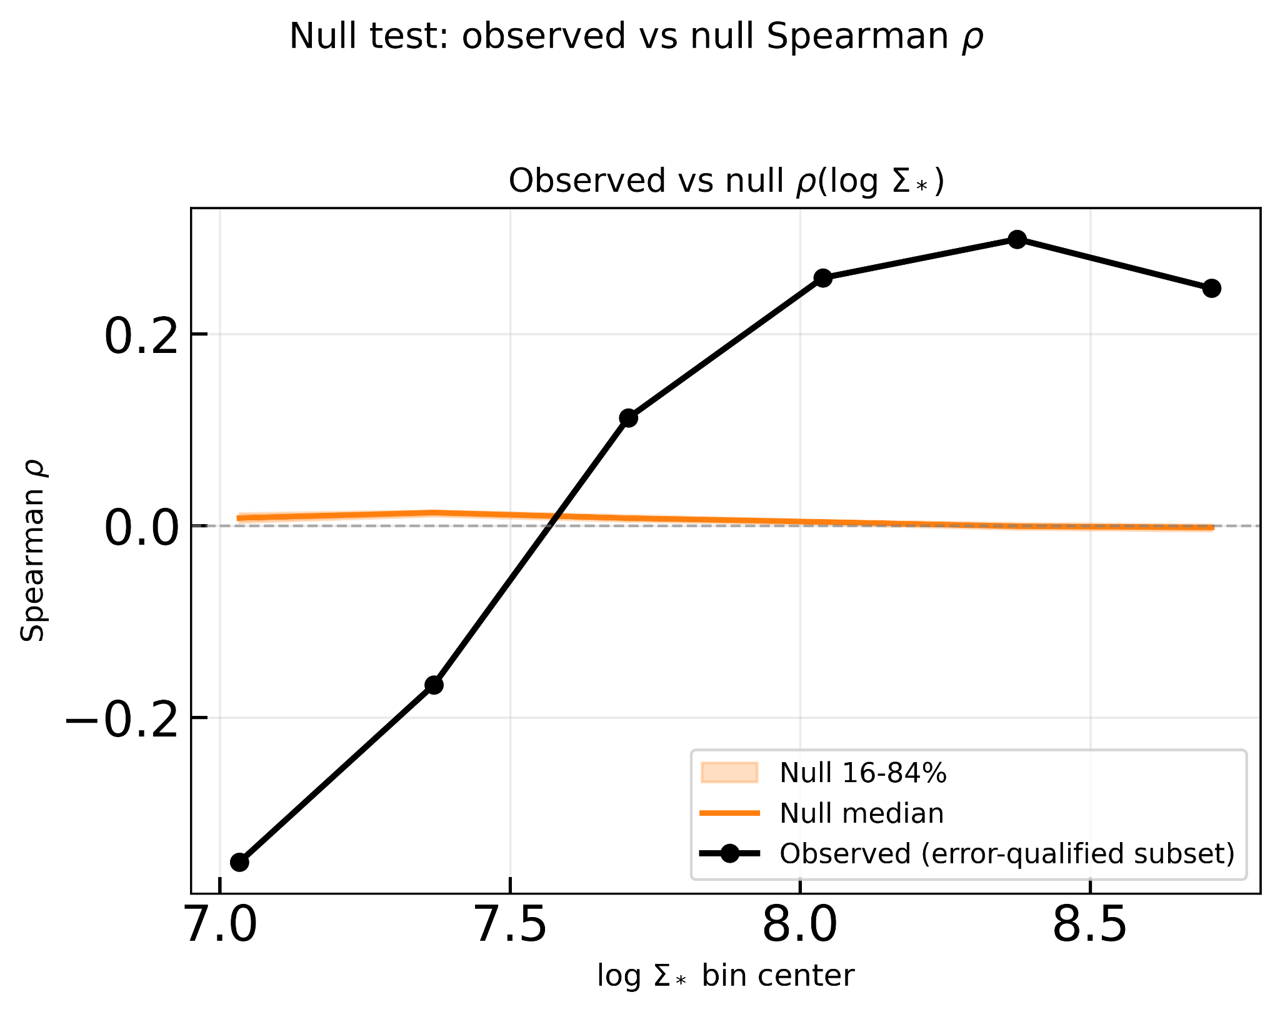

We further repeated the test on a galaxy-by-galaxy basis and found the same conclusion: the observed per-galaxy trends frequently depart strongly from the null envelope, showing that the ensemble inversion is not driven solely by propagated formal uncertainties.

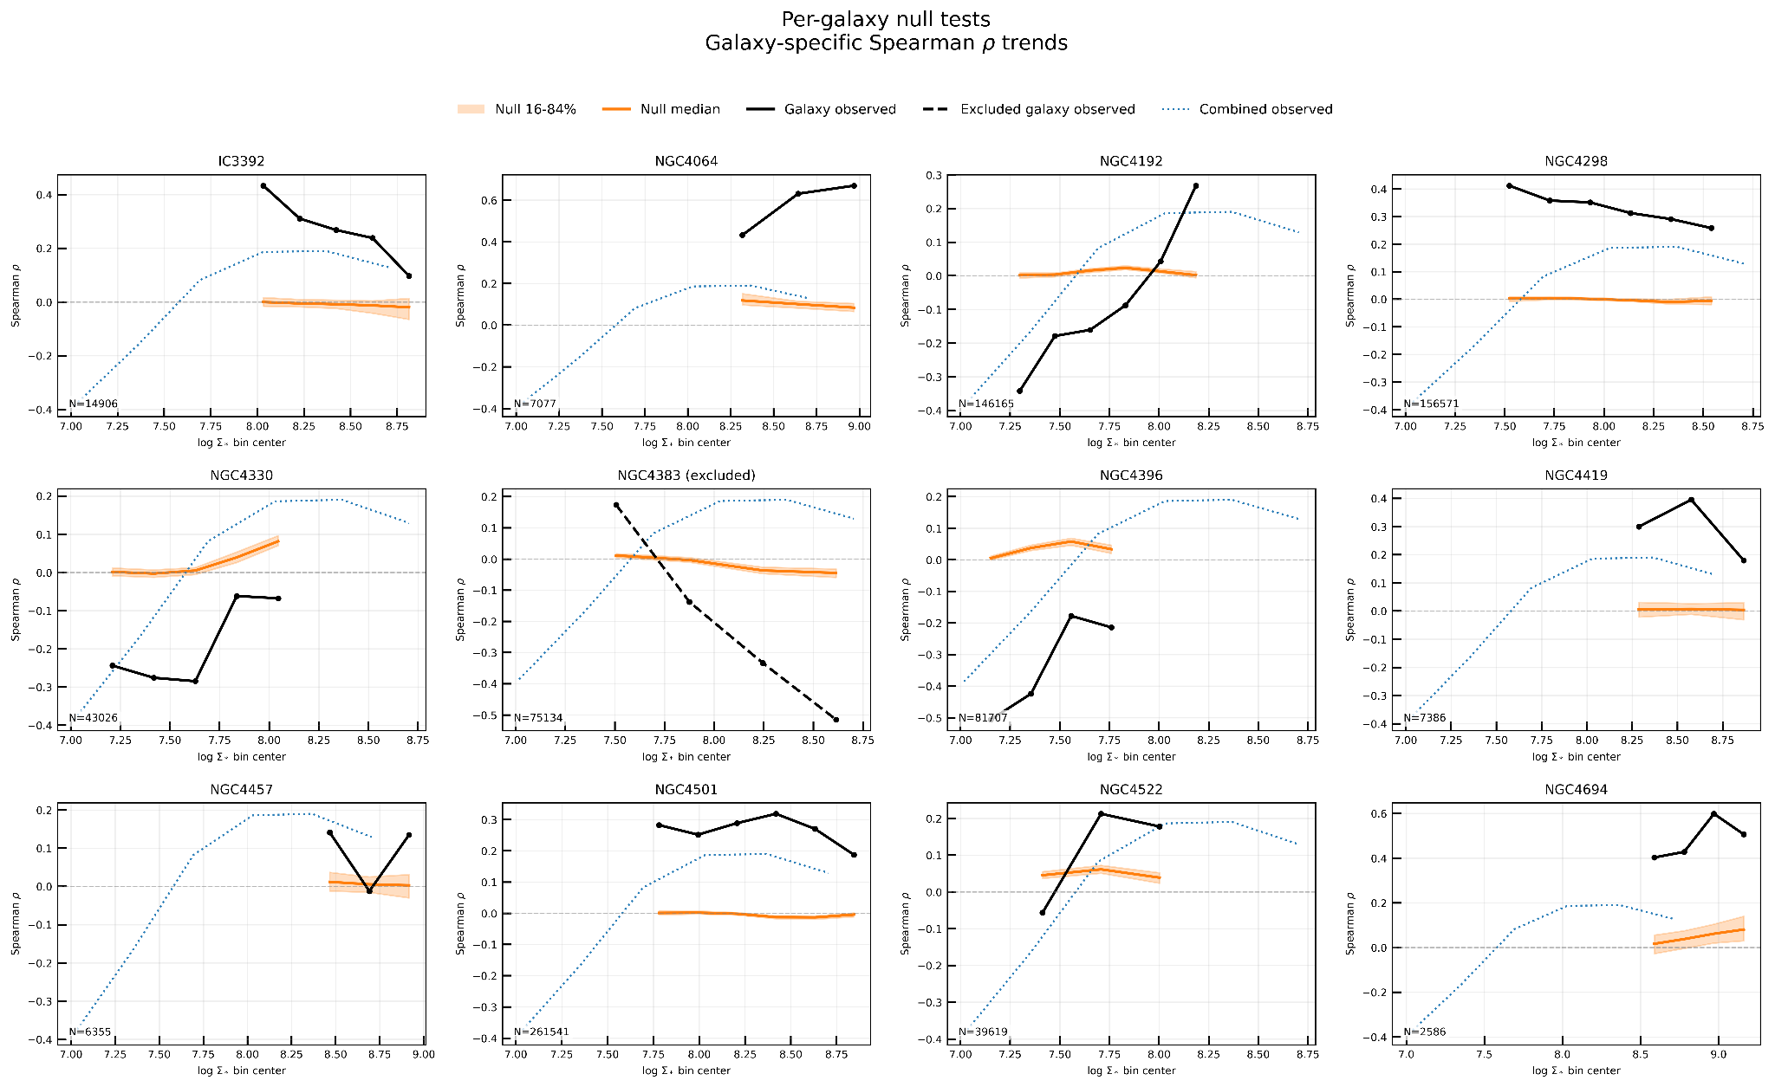

As an additional stress test, we imposed a direct correlation between the mock uncertainties in log Sigma_SFR and [O/H], and also repeated the exercise after boosting the amplitude of this correlated error pattern by a factor of 10. Even under these intentionally conservative assumptions, the null simulations still fail to reproduce the observed residual structure and the mass-dependent sign reversal.

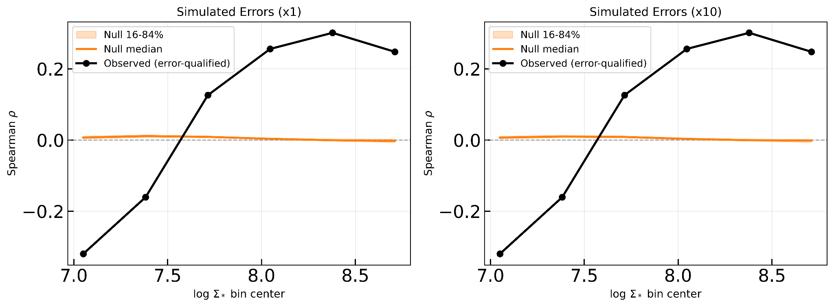

We therefore conclude that the reported secondary relation is not a trivial artefact of subtracting the primary relations in the presence of the propagated uncertainties considered here.

5) It is not entirely accurate to state that the FMR is only
questioned or poorely explored at sub-galactic scales. There is a body
of literature that questions the existence or extent of the FMR at
galactic scales as well. Many studies have found that the secondary
dependence of the MZR on the SFR is either weaker than originally
proposed, not observed, or limited to a specific range of stellar
masses not covered by the current study. In this regard, the authors
could consult Sánchez et al. (2019), particularly the introduction and
references therein:

https://aus01.safelinks.protection.outlook.com/?url=http%3A%2F%2Fadsabs.harvard.edu%2Fabs%2F2019MNRAS.484.3042S&data=05%7C02%7Crongjun.huang%40research.uwa.edu.au%7C77a7dbe8a8674336b1e808de867bf62e%7C05894af0cb2846d8871674cdb46e2226%7C0%7C0%7C639096064194130419%7CUnknown%7CTWFpbGZsb3d8eyJFbXB0eU1hcGkiOnRydWUsIlYiOiIwLjAuMDAwMCIsIlAiOiJXaW4zMiIsIkFOIjoiTWFpbCIsIldUIjoyfQ%3D%3D%7C0%7C%7C%7C&sdata=6jqGvgRXibMjc4TfHkz%2FmRyJGDsfD7G4Mws4wzfupFQ%3D&reserved=0

Analyses using CALIFA, MaNGA, SAMI, and even re-evaluations of the
original SDSS dataset used by Mannucci et al. (2010) with different
oxygen abundance calibrators have questioned whether the FMR is
indeed fundamental or even whether it exists. In fact, even in the
seminal work by Tremonti et al. (2004), no secondary correlation was
found between the scatter in the MZR and EW(Hα), a proxy for sSFR
(which is essentially the residual of the SFMS if the slope is
one). While the vast majority of the community accepts the FMR as a
fact, it remains an open question.

Regarding the exploration at resolved scales, I must mention that in the
original article in which the rMZR was first presented, Sánchez et al. 2013,
there is first exploration of the possible dependence of the rMZR with the
SFR, finding a very weak, non-significant relation.

We thank the referee for this clarification. We agree that the global FMR is also actively debated, and that our original wording did not sufficiently reflect this broader literature. We have therefore revised the Introduction to clarify that the existence and strength of the FMR remain unsettled even at galaxy-integrated scales, with conclusions depending on sample selection, stellar-mass range, and metallicity calibration.

Additional Comments:

Beside the major comments described before, I have a set of minor comments that could be
relevant to address:

1) The authors should present the analyzed sample of galaxies in more
detail. In particular, it is important know the star-formation stage
of these galaxies (if they are located within the SFMS or below it,
i.e., in the green valley, quenching regime), their morphology (a
quick scan through the literature, SIMBAD and Hyperleda, suggest that
most of them are Sa galaxies, that are partially quenched, what could
have an implication in the global and local relations too, e.g.,
Cano-Diaz et al. 2019), the presence of absence of galactic outflows,
interaction stage, and so on. In particular, when discussing the case
of NGC4383, it would be relevant to know if this galaxy is off the general
trends and why.

To show the location of the galaxies in the global Zgas-M* and SFR-M* plane,
compared with published samples (e.g,. the full MaNGA sample, which data
are available, por instance, or the SDSS sample) would help to fix the discussion
of this article.

We agree that placing the MAUVE--MUSE galaxies in the context of global scaling relations helps clarify the nature of the sample. We have therefore added a new appendix (the figure below) showing the location of our galaxies on the integrated SFR--M* plane, the integrated Zgas--M* plane, and the observed versus FMR-predicted metallicity plane, using CALIFA galaxies in the background for comparison. The integrated stellar masses and SFRs are taken from Leroy et al. (2019), while the integrated metallicities are measured by collapsing all valid MAUVE--MUSE spaxels in each galaxy, correcting the spectra via the Balmer decrement, and applying the O3N2-M13 calibration. The comparison shows that several of our Virgo galaxies lie below the local SFMS, consistent with environmentally suppressed star formation, while NGC4383 lies above the SFMS, consistent with its starburst/outflow nature. Deviations from the integrated M-Z are less dramatic, with at least half of the sample full consistent with the integrated M-Z relation and FMZ and potentially up to 5 galaxies slightly more metal rich than the average. However, we note that, by construction, given the peculiarities of our sample caution mush be taken when interpreting deviations from global scaling relations. This is even more clear once we consider that our sample is fully consistent with the resolved MZ relation and the resolved star formation main sequence (see below)

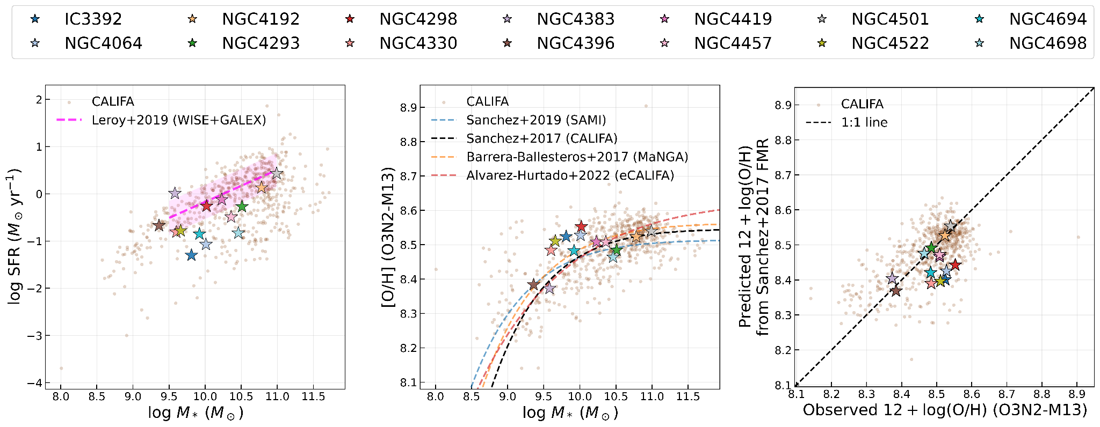

2) I strongly recommend to include the distribution in the Sigma_SFR - Sigma_*
plane, in a complementary figure to Fig. 3. If the analyzes spaxels do not follow
the known rSFMS (e.g., Cano-Diaz et al. 2016), then most probably there is a
contamination by other ionizing sources or by an extra stellar mass (following
Mendez-Abreu et al. 2019). Just showing the rMZR trend (Fig. 3) it is not enough
to follow the adopted procedure (i.e., show the general trend and then remove it).

For instance, if it was adopted an incorrect SFMS slope, how the results would be
affected? A visual inspection of the distribution of points and the adopted average
trend would help to identify that potential issues (or clarify them).

We thank the referee for this suggestion. While we fully acknowledge the importance and interest of the rSFMS properties of our sample, a proper analysis of this parameter space, together with a rigorous comparison to previous kpc‑scale studies, —would require a substantial additional effort and lies well beyond the scope of the present paper. As clearly discussed by Pessa et al. (2021), analyses on ∼100 pc scales demand particular care in both the parametrisation of the SFMS and in the treatment of non‑detections. Failure to do so can lead to biased slope estimates and artificial offsets. Moreover, at these spatial scales, a simple linear fit is not always the most appropriate way to characterise the distribution of points.

Nevertheless, in the figure below we compare the parameter space covered by our data with that presented in Pessa et al. (2021). We additionally provide two different estimators of the mean relation, computed either in linear or logarithmic space, without accounting for upper limits. This comparison demonstrates that our measurements are fully consistent with those of the PHANGS‑MUSE sample, despite the latter having lower global star‑formation rates, as discussed above. Importantly, this confirms that, given our current selection criteria, our spaxels are reliably tracing regions ionised by star formation.

However, our paper is focused on the resolved Zgas - Sigma_SFR relation rather than on rederiving the resolved SFMS itself. For this reason, and to avoid expanding the manuscript too much, we prefer not to add this comparison figure to the main text. Instead, we use it here to demonstrate that the adopted HII selection yields a sensible resolved star-forming sequence and that the main conclusions are not driven by an obviously anomalous Sigma_SFR - Sigma_* distribution.

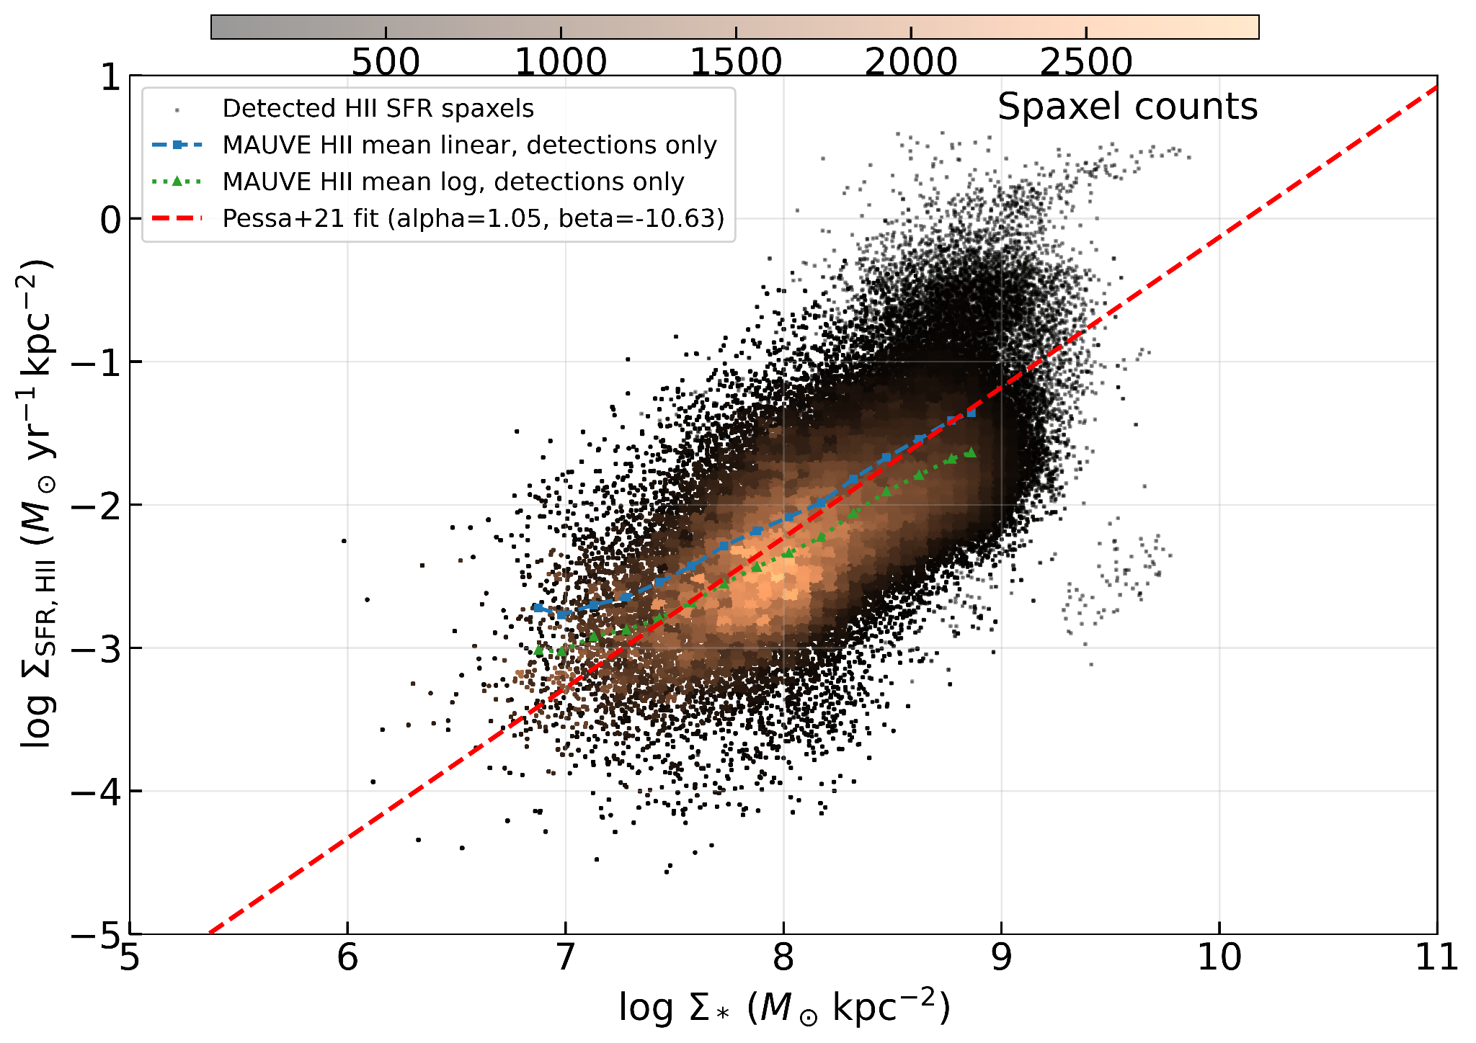

3) The fact that the results depends on the adopted calibrators is worrisome and
should be highlighted from the very begining. Calibrators using N2 and S2 are suitable
to be affected by the contamination of non-SF ionizations more than other ones, and
as indicated before, the selection of SF-regions purely based on the BPT diagrams
suggests a considerable amount of contamination.

I strongly recommend that this is clearly stated in the abstract and
the conclusions. Other explorations on similar topics, clearly
reported that the very existence of an FMR strongly depends on the
adopted calibrator (e.g, Barrera-Ballesteros et al. 2017).

We agree that the dependence of the result on the adopted metallicity calibration should be made clearer. We have therefore revised both the abstract and the conclusions to state that explicitly.

4) Introduction, I think it is worth citing Tinsley et al. 1976, both regarding
the stellar synthesis and the gas-regulator. For articles doing similar explorations
those of Barrera-Ballesteros et al. on the topic would relevant (as they proposed
very similar analytical methods on IFS datasets).

References are added in the introduction.

5) Introduction, 2nd page, 2nd column, when talking about the constant SFE, I think
some references are required.

We have now clarified this is WL21’s framework in the Introduction by explicitly attaching the reference to that sentence.

6) Sec. 2.2: How the dust attenuation is handle in the derivation of the stellar
mass surface density? It is obtained from pPXF? It is not clear to me how this
is addressed. Fig., 4, bottom-right panel suggest a differential Sigma_* from the
S-W reange of the galaxy than from the N-E that may suggest that the dust attenuation
affecting the stellar population was not properly derived or not applied to the
presented Sigma_*

In our current analysis, the stellar mass surface density is not derived from a simple observed-band luminosity alone, but from the nGIST/pPXF spectral fitting, following the same general approach adopted in PHANGS analyses (Pessa et al. 2021). In particular, the SFH weights used to determine the resolved stellar M/L are obtained from the full spectral decomposition, which already inherently accounts for the effect of internal dust attenuation within the fit.

7) Eq. (3). Where the value q_o = 0.2 is taken from? Reference is needed.

References are added.

8) The process described at the end of Sec. 2.2, to transform the Sigma_* derived for
each Voxel to each spaxel is known as deszonification and was introduced by
Cid-Fernandes et al. 2013.

References are added.

9) Sec. 2.3, a cut in Hb of F_line/Sigma>3 implies directly a very severe cut in Ha
of above 10. That is indeed a lot. How this affects the results?

The referee is correct, but we stand behind this choice as it allows us to remove unreliable fits. Given the sensitivity of our data, this cut allows us to probe relatively low SFR surface densities anyway (e.g.~10^-3.5 Msun/yr/kpc^2) and a significant fraction of spaxels close to our quality threshold are excluded anyway by the EW+BPT+velocity dispersion cuts. Of course, we cannot exclude that our cuts bias us against heavily obscured HII regions but the agreement we find with previous works when it comes to resolved scaling relations indicate that our sample is not significantly more biased than previous work. We have added some text in Section 2.3 to clarify this point.

10) When Hb is not measurable and dust cannot be estimated, the best is to use a local
average of the nearby dust, not taking a zero, and propagating the errors according
to the level of uncertainty introduced.

We stress that we are not taking a zero, but excluding these spaxels from the analysis. As mentioned above, this does not impact on our ability to trace SFR across a wide dynamical range.

11) The adopted value of 2.86 for the non-dust Ha/Hb ratio is not cannonical and it is
hardly justified that for an entire galaxy this values is constant. Indeed, it is not.
It would be important to propagate through the errors of all involved quantities the
uncertainty in this ratio, that covers a range between 2.7-3.1 in most of the cases
(e.g., Osterbrock et al. 1989). This way the recovered secondary relations could be
isolated from the potential effect of this unknown quantity.

We acknowledge that this introduces an additional source of systematic uncertainty in the attenuation correction, but we expect its effect to be sub-dominant compared with the larger uncertainties associated with line-flux measurements, strong-line metallicity calibrations, and excitation selection. We have clarified this assumption in the manuscript. Mathematically, varying the intrinsic Balmer ratio from 2.86 to 2.7 or 3.1 changes the absolute attenuation-corrected Halpha fluxes, and thus the Sigma_SFR scale, by about +14.6% (+0.059 dex) and −17.3% (−0.083 dex), respectively. This is well within the range of the values obtained for the simulation described above confirming that our correlation between O/H and SFR is not driven by changes in Balmer ratio assumptions.

12) Use the dust corrected fluxes to derive the abundances do not produce any effect in
calibrators like O3N2, and could produce a bias, in particular due to the large cut
in S/N applied to derive the dust attenuation.

We agree that for O3N2-based diagnostics the direct impact of dust correction is small, because the relevant line ratios involve pairs of lines close in wavelength. In that sense, the main potential concern here is not the extinction correction itself, but whether the Balmer-line quality control used to estimate gas-phase extinction introduces an additional selection bias. However, in our analysis, again, low-S/N Balmer spaxels are not used in the final star-forming sample entering the resolved metallicity analysis; the Balmer-decrement treatment is only used to stabilise the map construction, while the science analysis is based on the conservative HII-selected sample with robust line measurements.

13) Which IMF has been adopted along the article?

We use a Chabrier IMF, as clarified in Sec. 2.2 .

14) Sec. 3.3, Authors indicate that only a 20% of the points present a
clear (anti-)correlation between SFR and Zgas, based on the I-maps
analysis, with an 80% of the points lying within the abs(I)<1 value.
How much is expected from a pure random distribution of points?
How significant is that result?

We have now addressed it directly using the null simulations described in our response to major comment 4. In those simulations, which represent the expectation for a purely random residual field built from independent primary relations plus propagated errors, the Moran-like maps are overwhelmingly featureless: for both NGC4192 and NGC4501, about 97% of spaxels satisfy abs(I) <= 1, with only about 1.4-1.5% in either tail. By contrast, in the observed maps only about 80% of spaxels lie within abs(I) <= 1, meaning that the positive and negative tails are enhanced by nearly an order of magnitude relative to the null expectation. This demonstrates that the observed I-map structures are significant and are not consistent with a purely random distribution of residuals.

15) Fig. 3, bottom-right panel, clearly shows that the rFMR, if
exists, it is limited to a very particular regime. That is not
what it was originally claimed by Mannucci et al. 2010. I think
this must be more clearly stating in the abstract.

Abstract is updated to reflect this.

16) The analyzed galaxies are mostly early spirals with a substantial budge (e.g.,
Fig 4). How the bulge and its stellar mass surface density could affect the
results? In this regards, I recommend to explore the results by Mendez-Abreu et al.
2019, in its analysis of the SFMS in the presence of bulge dominated galaxies.
How they could affect the MZR, and the corresponding resolved relations?

Our sample spans a wide range of morphologies, but it is indeed the case that in the high stellar mass surface density regime we are probing into regions where the contribution of (pseudo) bulges to the stellar mass budget will be significant. The presence of bulges might indeed provide a physical explanation for the correlation between O/H and SFR observed at high-stellar masses, and we have added a couple of sentences to discuss this in Sec.5.2.

17) I think it is required a much clear understanding of the situation of NGC4383.

We have expanded our discussion of NGC4383 in S5.3 as requested. Admittedly, this galaxy is the only one where the new (more stringent) cuts introduced in the revised version remove a significant fraction of spaxels, reinforcing our narrative and overall conclusion. Primarily, the deviation of NGC4383 at high stellar mass surface densities from the rest of the sample is perfectly in line with the recent gas accretion history of this galaxy.

Beside that, I think authors would benefit from a revision of the literature
in this regards, and in particular the following articles:

Sanchez 2020, ARA&A
https://aus01.safelinks.protection.outlook.com/?url=https%3A%2F%2Fui.adsabs.harvard.edu%2Fabs%2F2020ARA%2526A..58...99S%2Fabstract&data=05%7C02%7Crongjun.huang%40research.uwa.edu.au%7C77a7dbe8a8674336b1e808de867bf62e%7C05894af0cb2846d8871674cdb46e2226%7C0%7C0%7C639096064194151438%7CUnknown%7CTWFpbGZsb3d8eyJFbXB0eU1hcGkiOnRydWUsIlYiOiIwLjAuMDAwMCIsIlAiOiJXaW4zMiIsIkFOIjoiTWFpbCIsIldUIjoyfQ%3D%3D%7C0%7C%7C%7C&sdata=NKETQBBjX3xb4GQZ4%2BZp6BCe5hOgmSKGjWyad%2FRfFd0%3D&reserved=0
Sanchez et al. 2021, RMxAA
https://aus01.safelinks.protection.outlook.com/?url=https%3A%2F%2Fui.adsabs.harvard.edu%2Fabs%2F2021RMxAA..57....3S%2Fabstract&data=05%7C02%7Crongjun.huang%40research.uwa.edu.au%7C77a7dbe8a8674336b1e808de867bf62e%7C05894af0cb2846d8871674cdb46e2226%7C0%7C0%7C639096064194172201%7CUnknown%7CTWFpbGZsb3d8eyJFbXB0eU1hcGkiOnRydWUsIlYiOiIwLjAuMDAwMCIsIlAiOiJXaW4zMiIsIkFOIjoiTWFpbCIsIldUIjoyfQ%3D%3D%7C0%7C%7C%7C&sdata=Azf85vglLwc9rwsMaaqhtutfKVJ7VPXbHVGkemJZ8vk%3D&reserved=0

We thank the referee for these suggestions and made sure these works are taken into account.

